Assignment 4
Recovering and Inspecting deleted files
- Check for Deleted Files
- Recover the Deleted Files
- Analyzing and Inspecting the recovered files
Step 1:- Install Recovery tool like ‘Recuva’
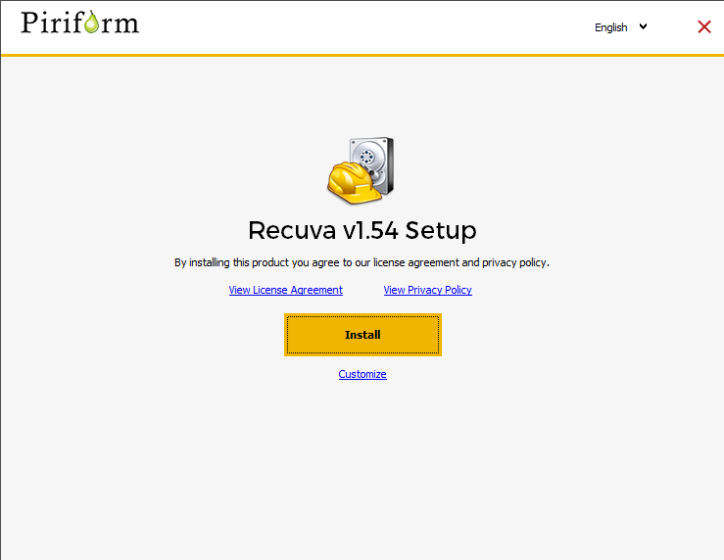
Step 2:- Start the recovery process as follows
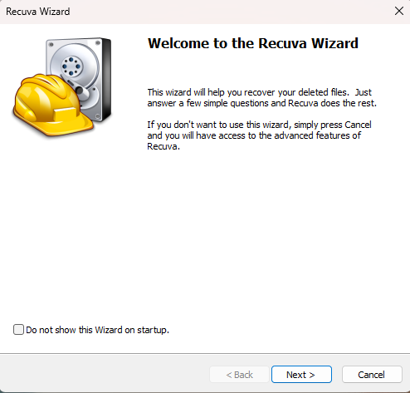
Step 3: - Select file types to recover
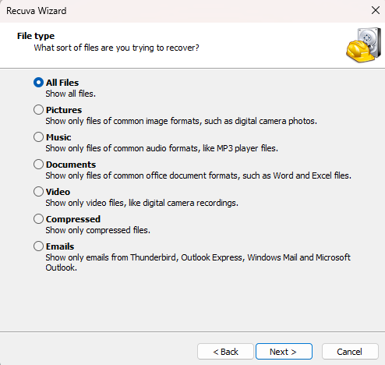
Step 4:- Select Options to recover from exact location
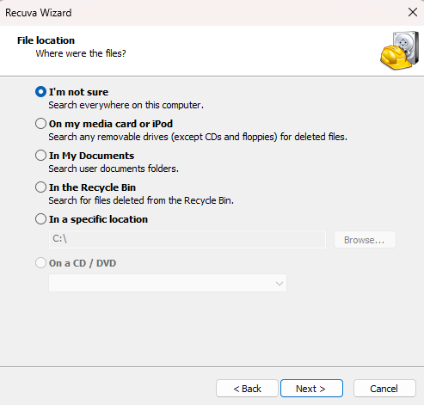
Step 5:- Select deep scan for selective probability
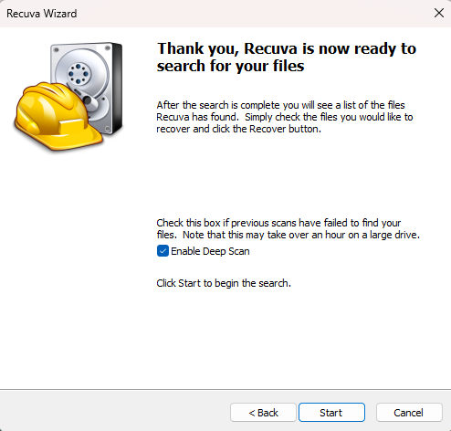
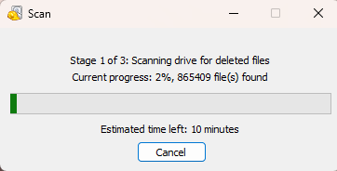

Step 6:- search lost file and click on recover
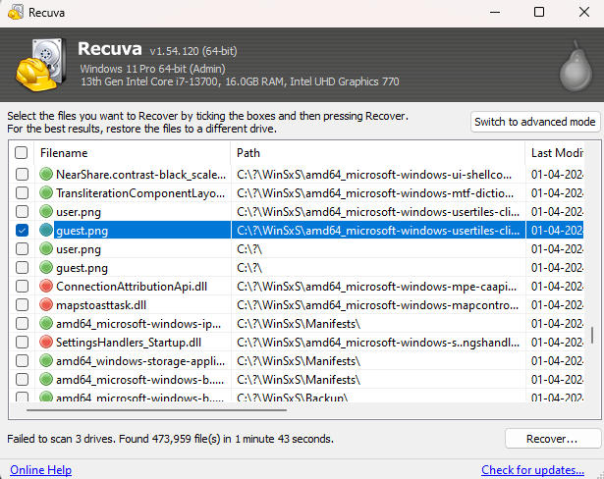
Step 7:- Select the location to recover found file
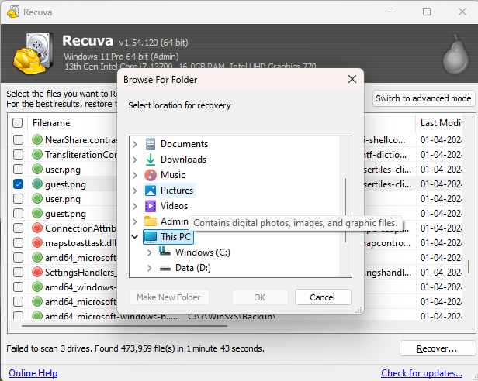
Step 8:- Successfully recover the lost file
