Forensic toolkit imager (FTK)
Step 1: Search with your preferred search engine for FTK Imager toolkit 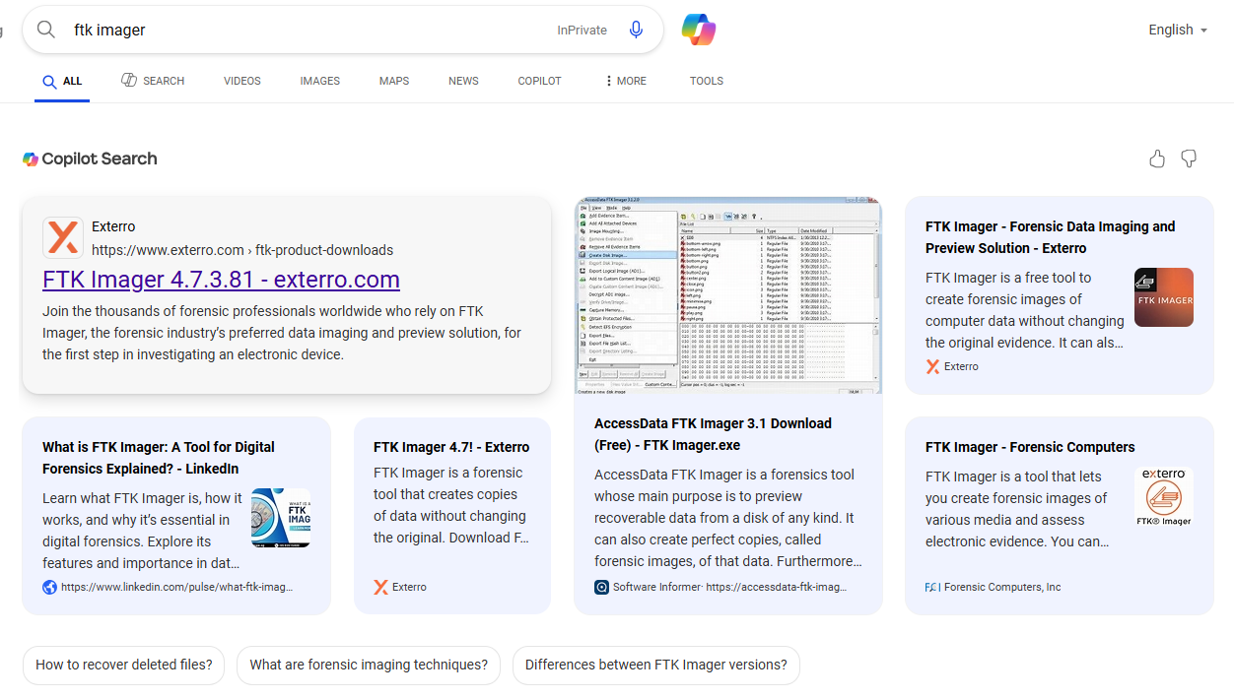
Step 2: Open the first Link you can find and you will visit their official Exterro.com
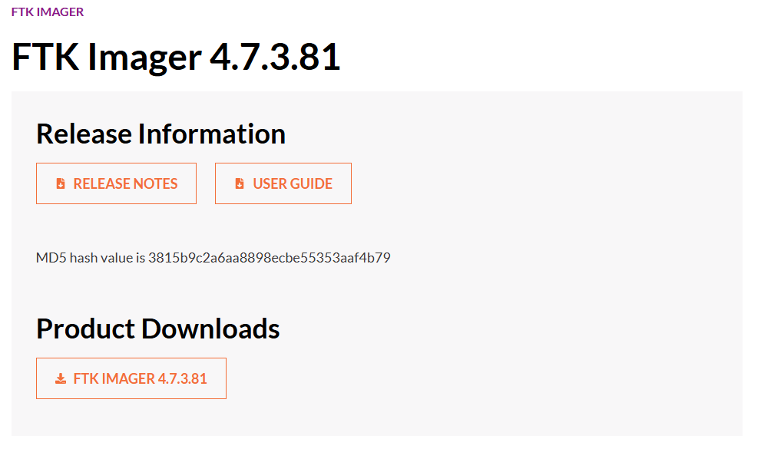
Step 3: Download the imager from provided link to your PC
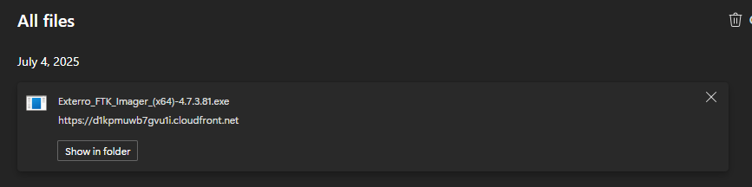
Step 4: Run the installation
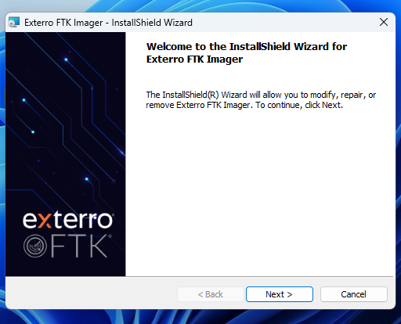
Step 5: Continue with installation procedure
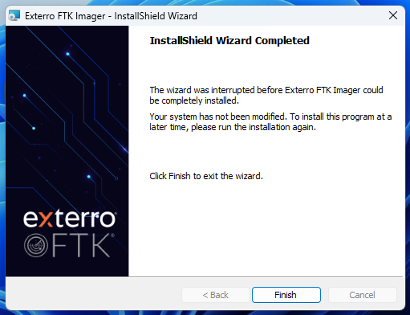

Step 6: Your will be greeted with Home screen
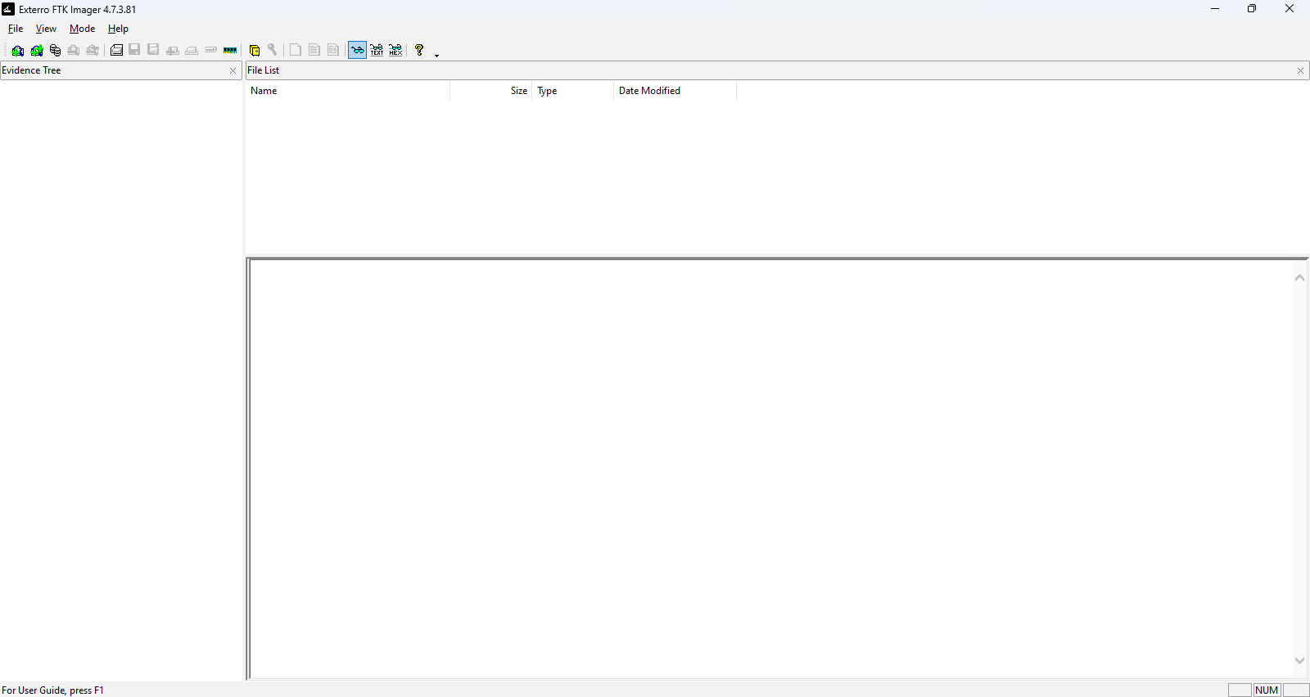
Step 7: Click on files menu and select “Create Disk Image”
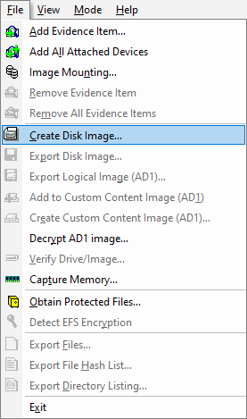
Step 8: Select Source of Evidences 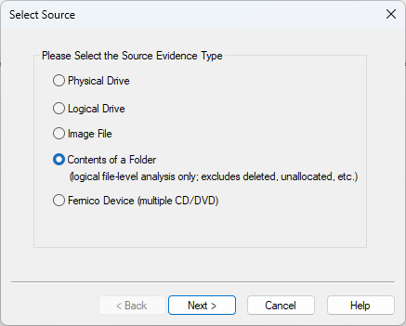
Step 9: Select path of folder which contain your Evidences
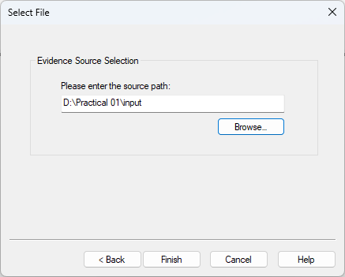

Step 10: Fill in Proper Credentials
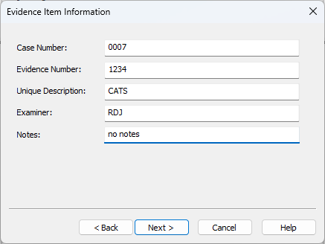
Step 11: Select Destination Folder
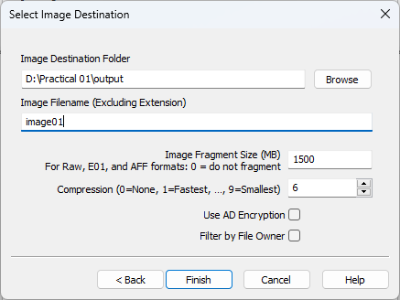
Step 12: It will generate MD5 hash and SHA1 hash 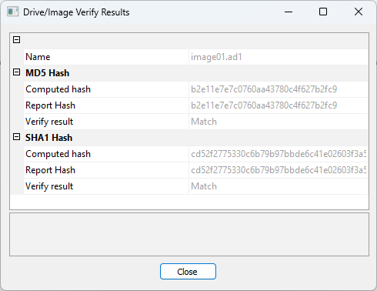
Step 13: Now Image is generate Select Files menu for Opening that image and chose “Add evidence item”
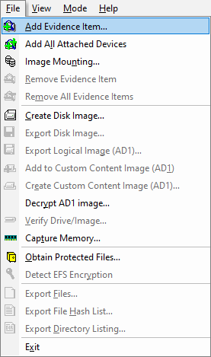
Step 14: Select source as image file
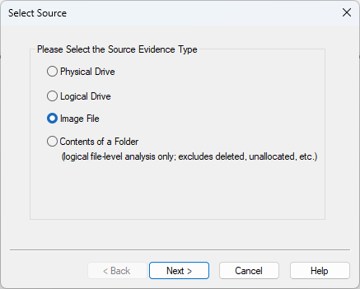
Step 15: Select Destination with image file ( .ad1 extension )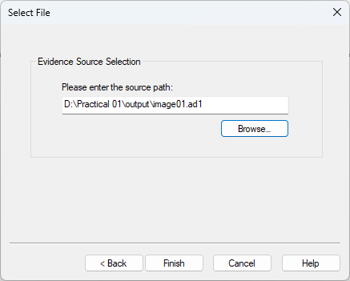
Step 16: For further Investigation we again select “content of folder” in files menu
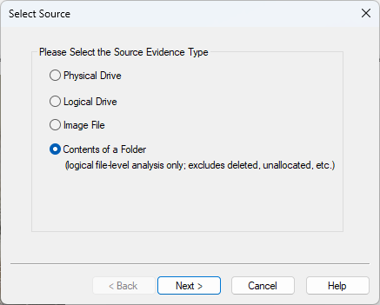
Step 16: Select Directory with evidence file where we have created Image file
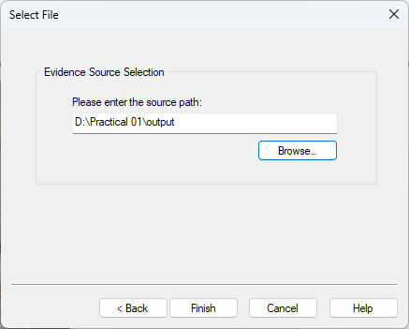
Step 17: After opening files one by one you will able to see all evidence we have extracted from files
