Digital Forensics 1

Capturing and analyzing network packets using Wireshark (Fundamentals)
Identification the live network
Capture Packets
Analyze the captured packets

Set up your wireshark application
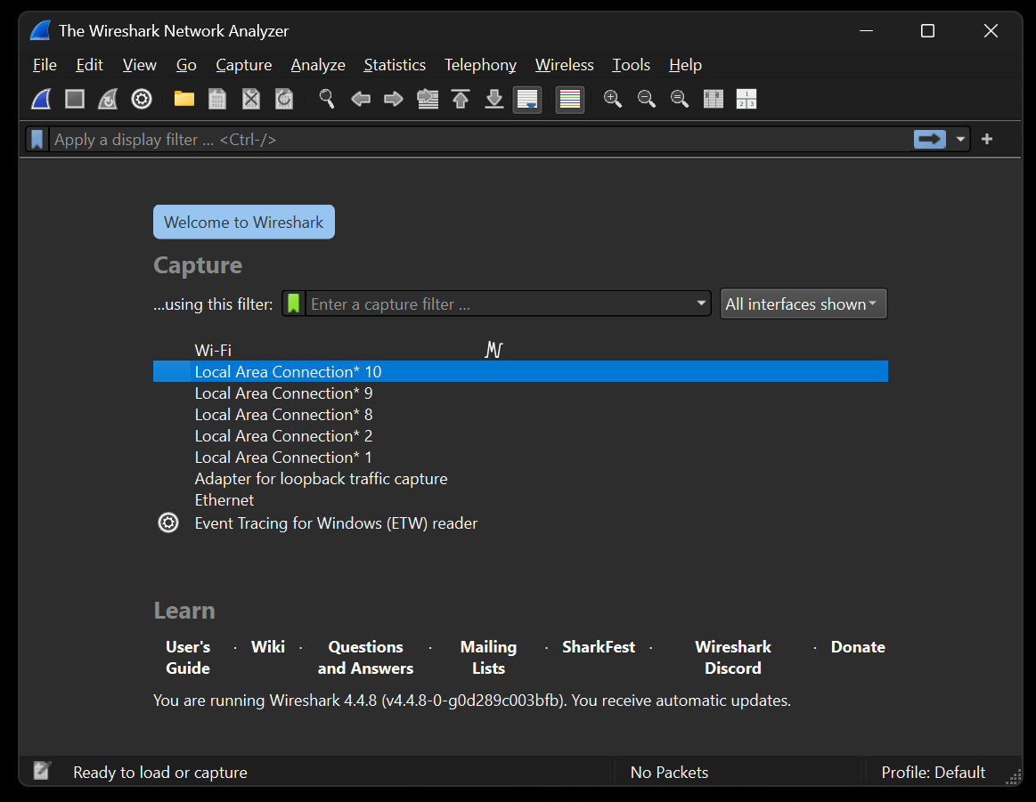

Click on the connected network to capture live packets
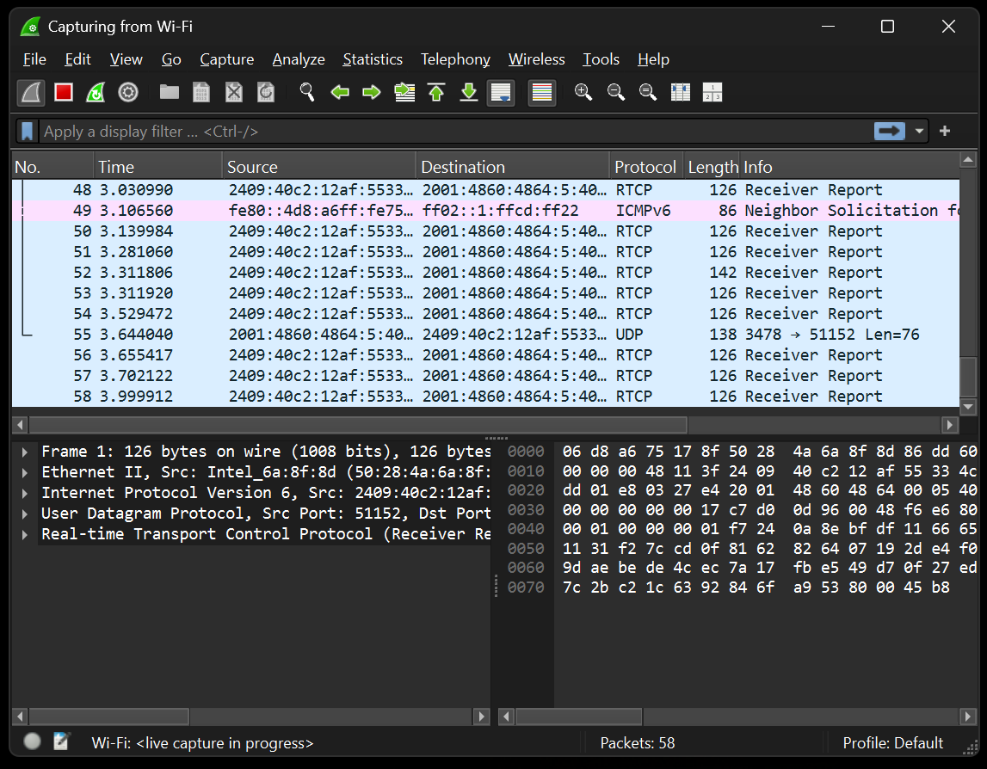
Visit a login website to find vulnerabilities
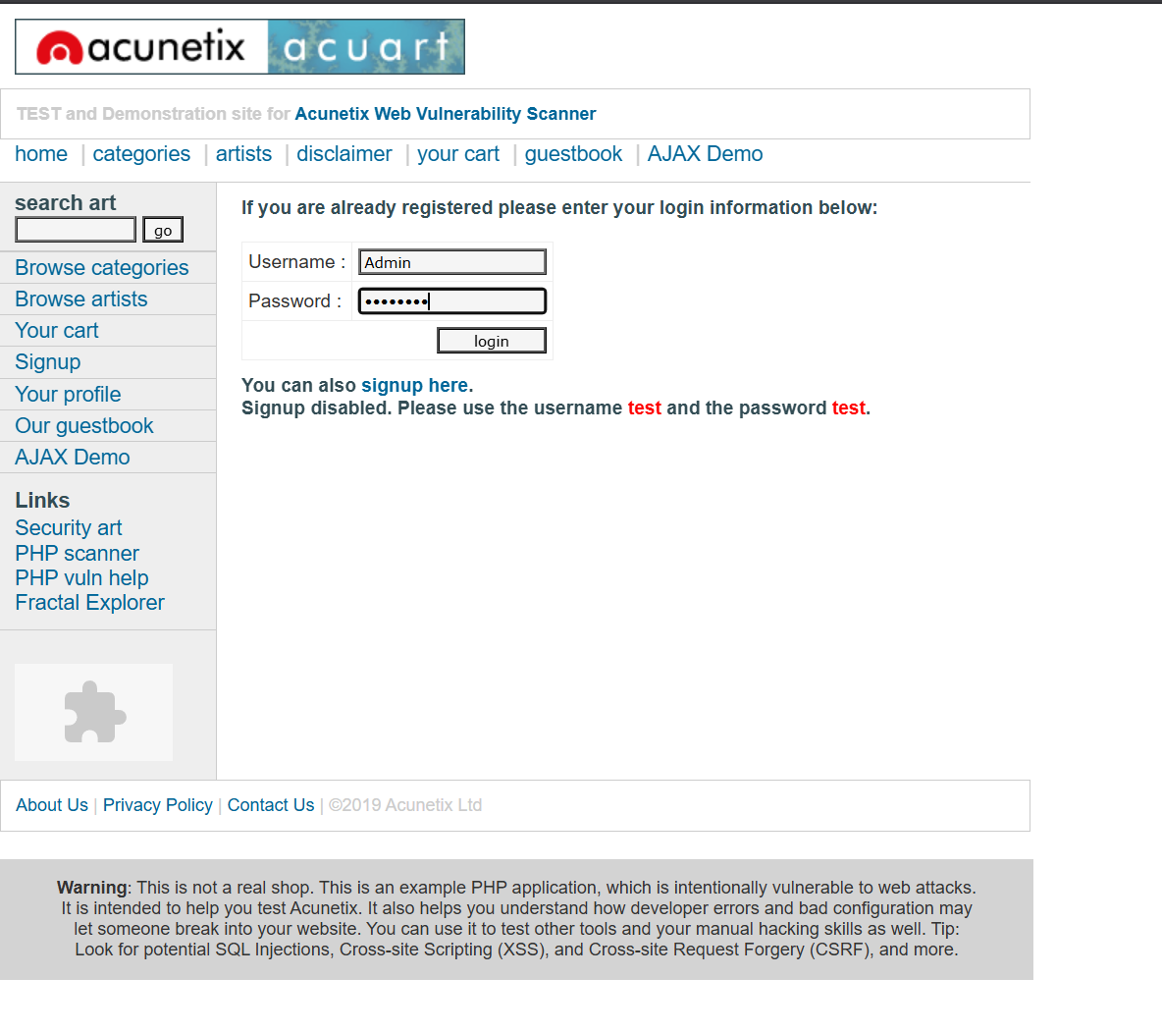

Enter your filter to the (filter section) and look for the request to the server and look for vulnerabilities
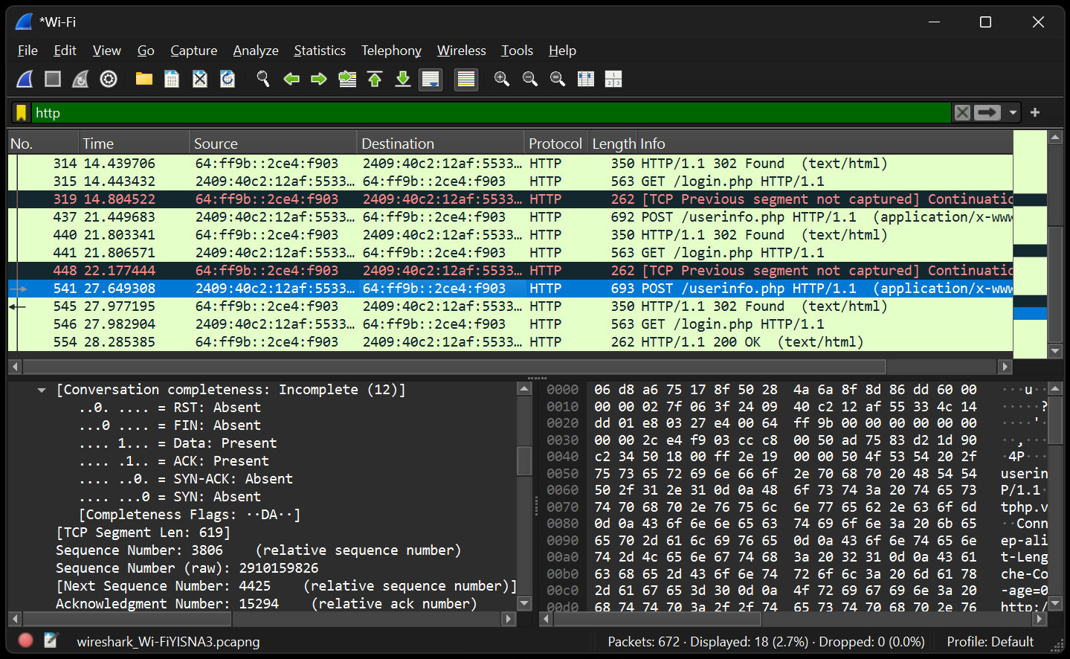

We can find our password which is not encrypted due to HTTP protocol rather using HTTPs protocol
