Practical no 3

- Forensics Case Study: Solve the Case study (image file) provide in lab using Encase Investigator.
- Forensics Case Study: Solve the Case study (image file) provide in lab using Autopsy.

Step 1: Find Appropriate Softwares to create an image for the device to perform forensics
FTK Imager or Encase and install.
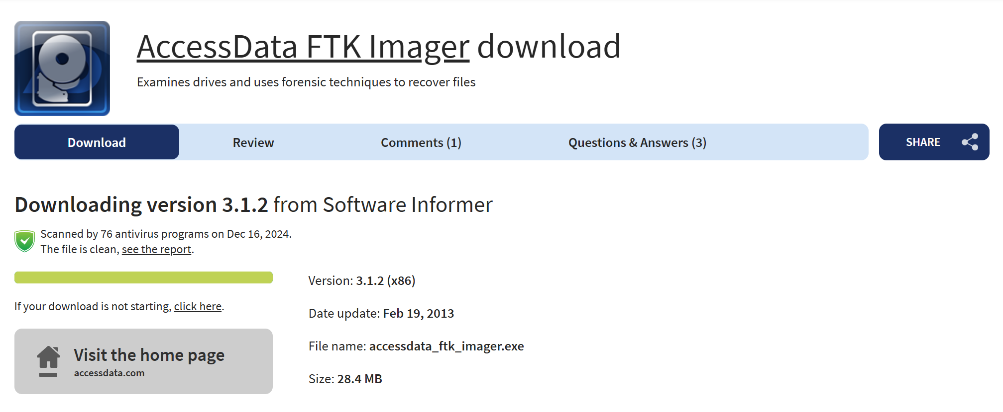
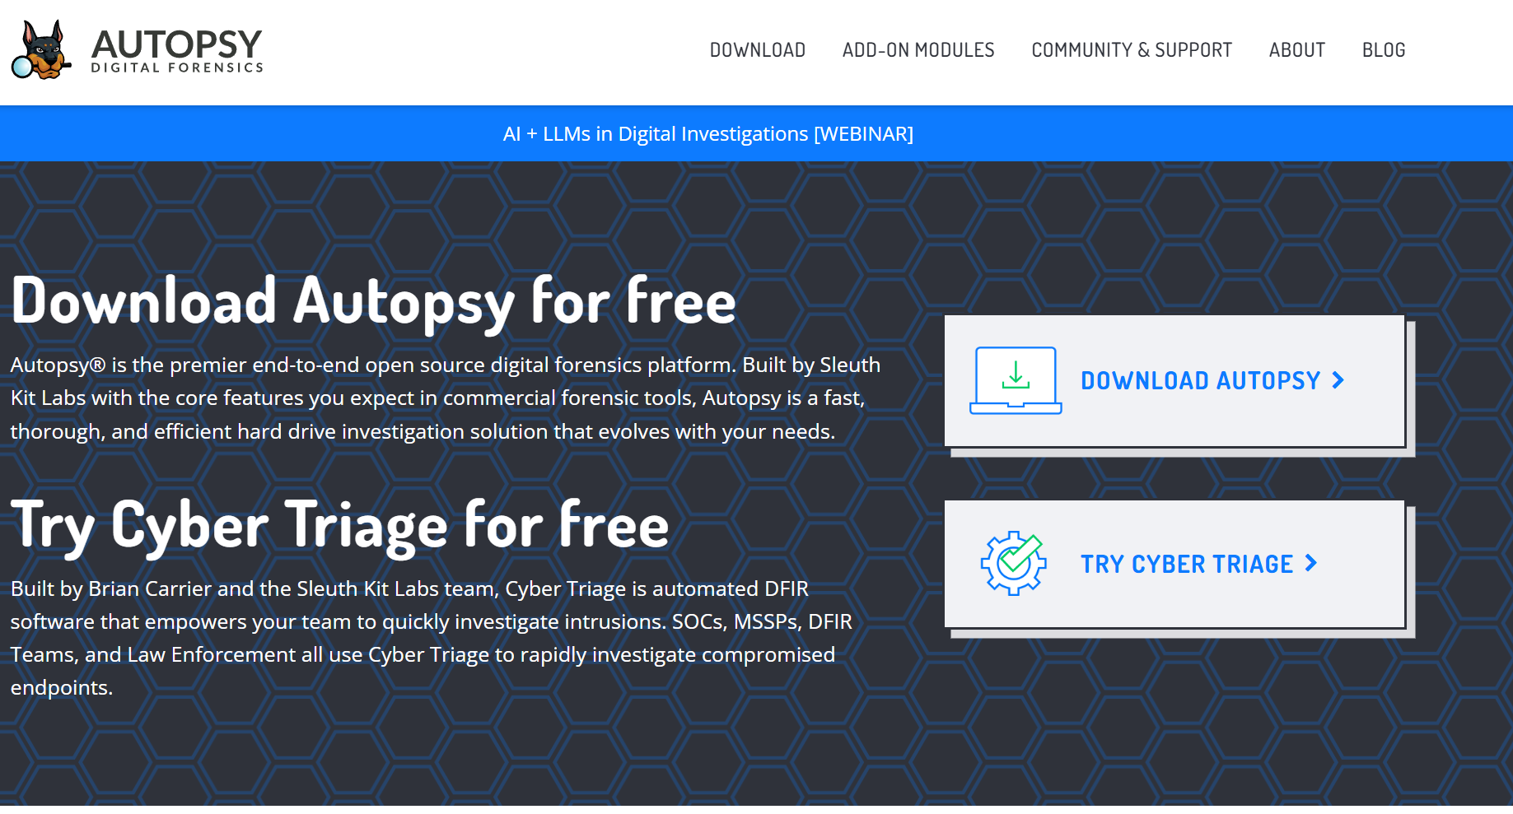

Step 2: Run the image create forensics tool select the source evidence type
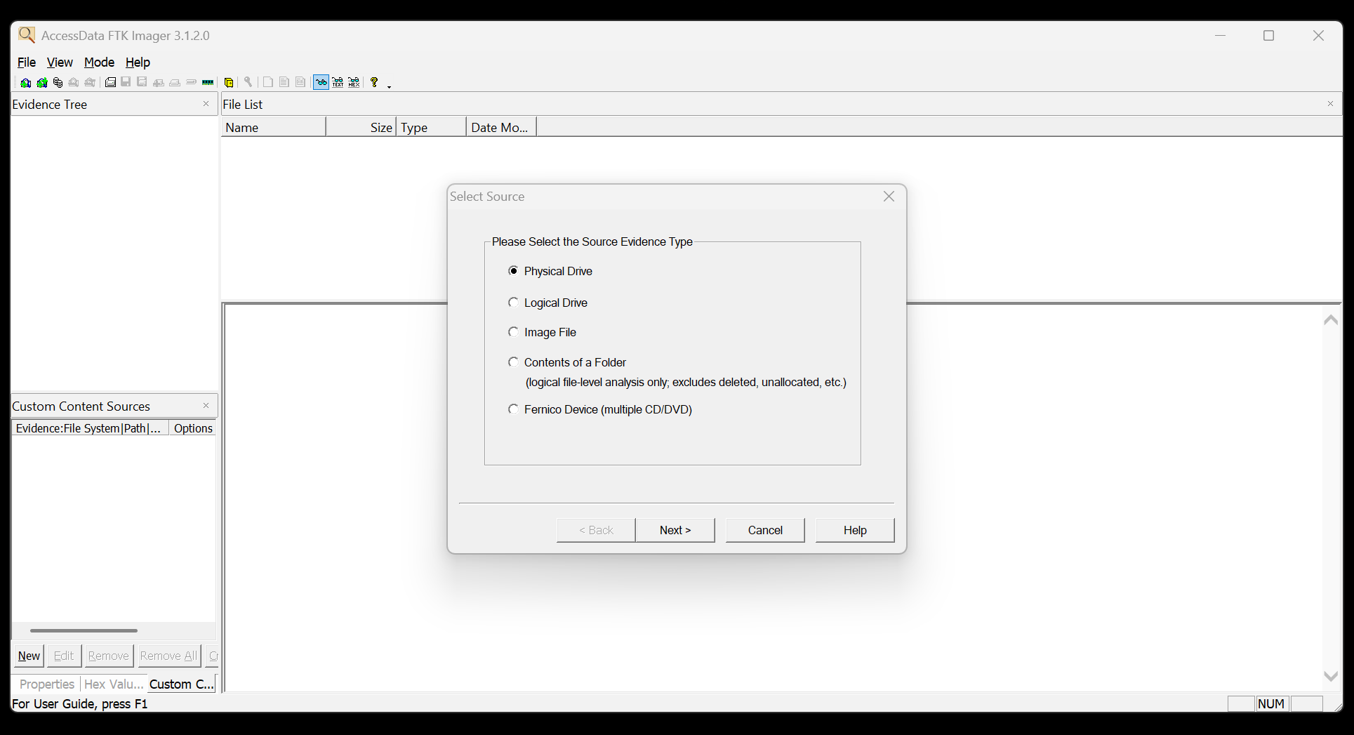

Step 3: select the drive to perform logical evidence forensics
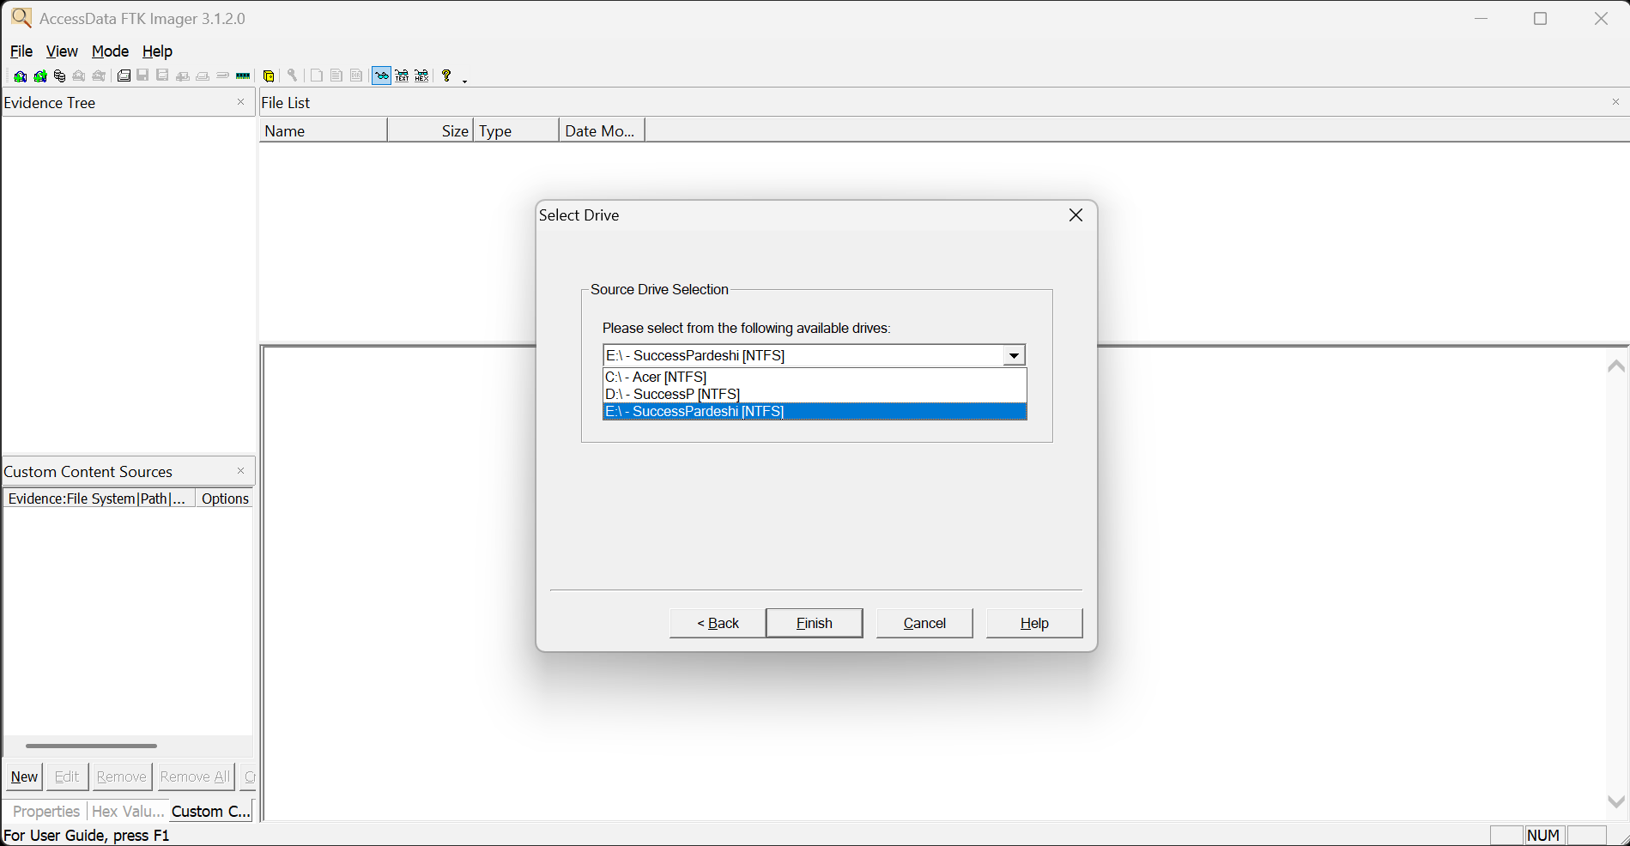

Step 4 : Select the image destination to save perform forensics image generated

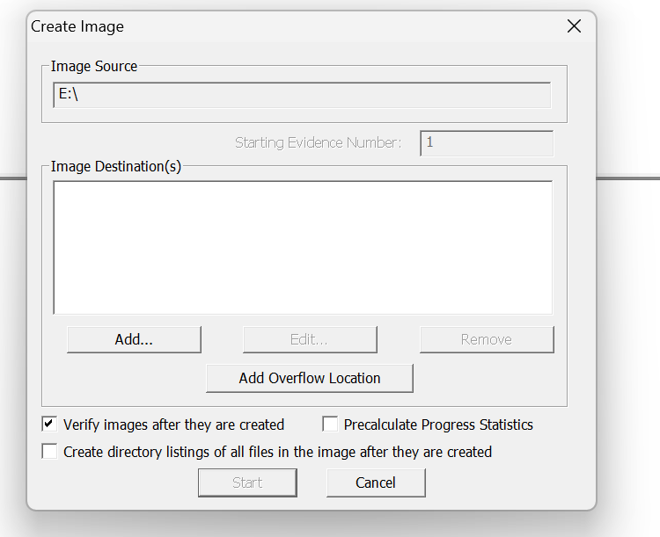
Step 5 : Start the process

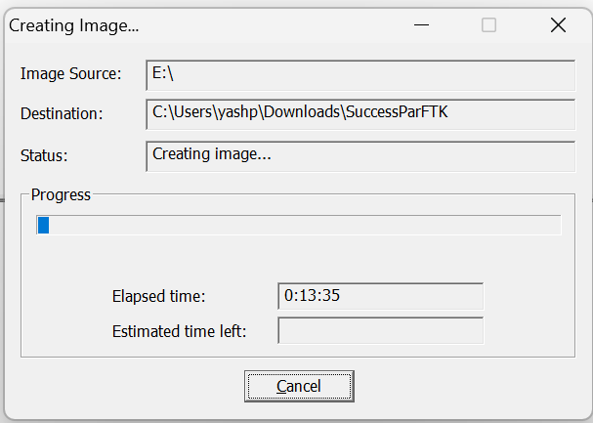

Step 6 : Run Autopsy software creating new case select the destination to save the case and select the
