Wireshark Practical Report
This document covers the fundamentals of capturing and analyzing network packets using Wireshark, demonstrated with screenshots from a real session. Wireshark is a powerful open-source network protocol analyzer used for troubleshooting, analysis, software and communications protocol development, and education.

Step 1: Identify the Live Network
Open Wireshark and identify the live network interface from the list. The interface with the most traffic (visible as a moving graph) is likely the one in use (e.g., Wi-Fi).
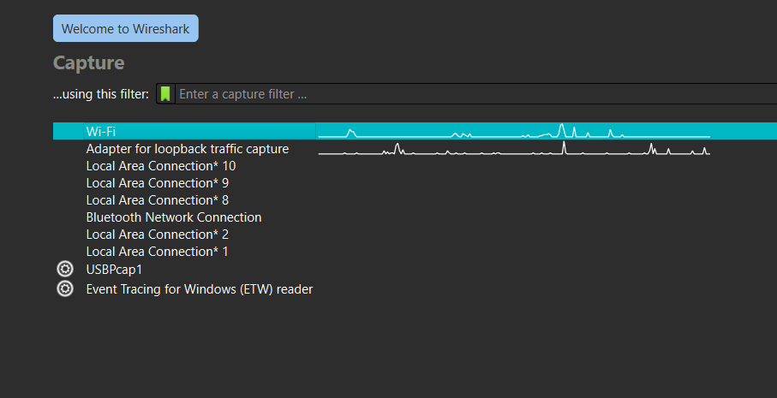

Step 2: Start Capturing Packets
Click the blue shark fin icon or double-click the network interface name to begin capturing live traffic. Wireshark will start displaying packets in real time.
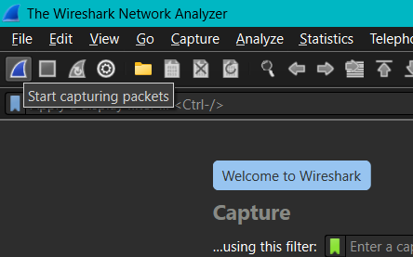

Step 3: Analyze Captured Packets
Once the packets are captured, you can see various protocol layers, such as TCP, UDP, DNS, and HTTP. Each row represents a single packet. Detailed information is shown below and on the right side (hex + ASCII view).
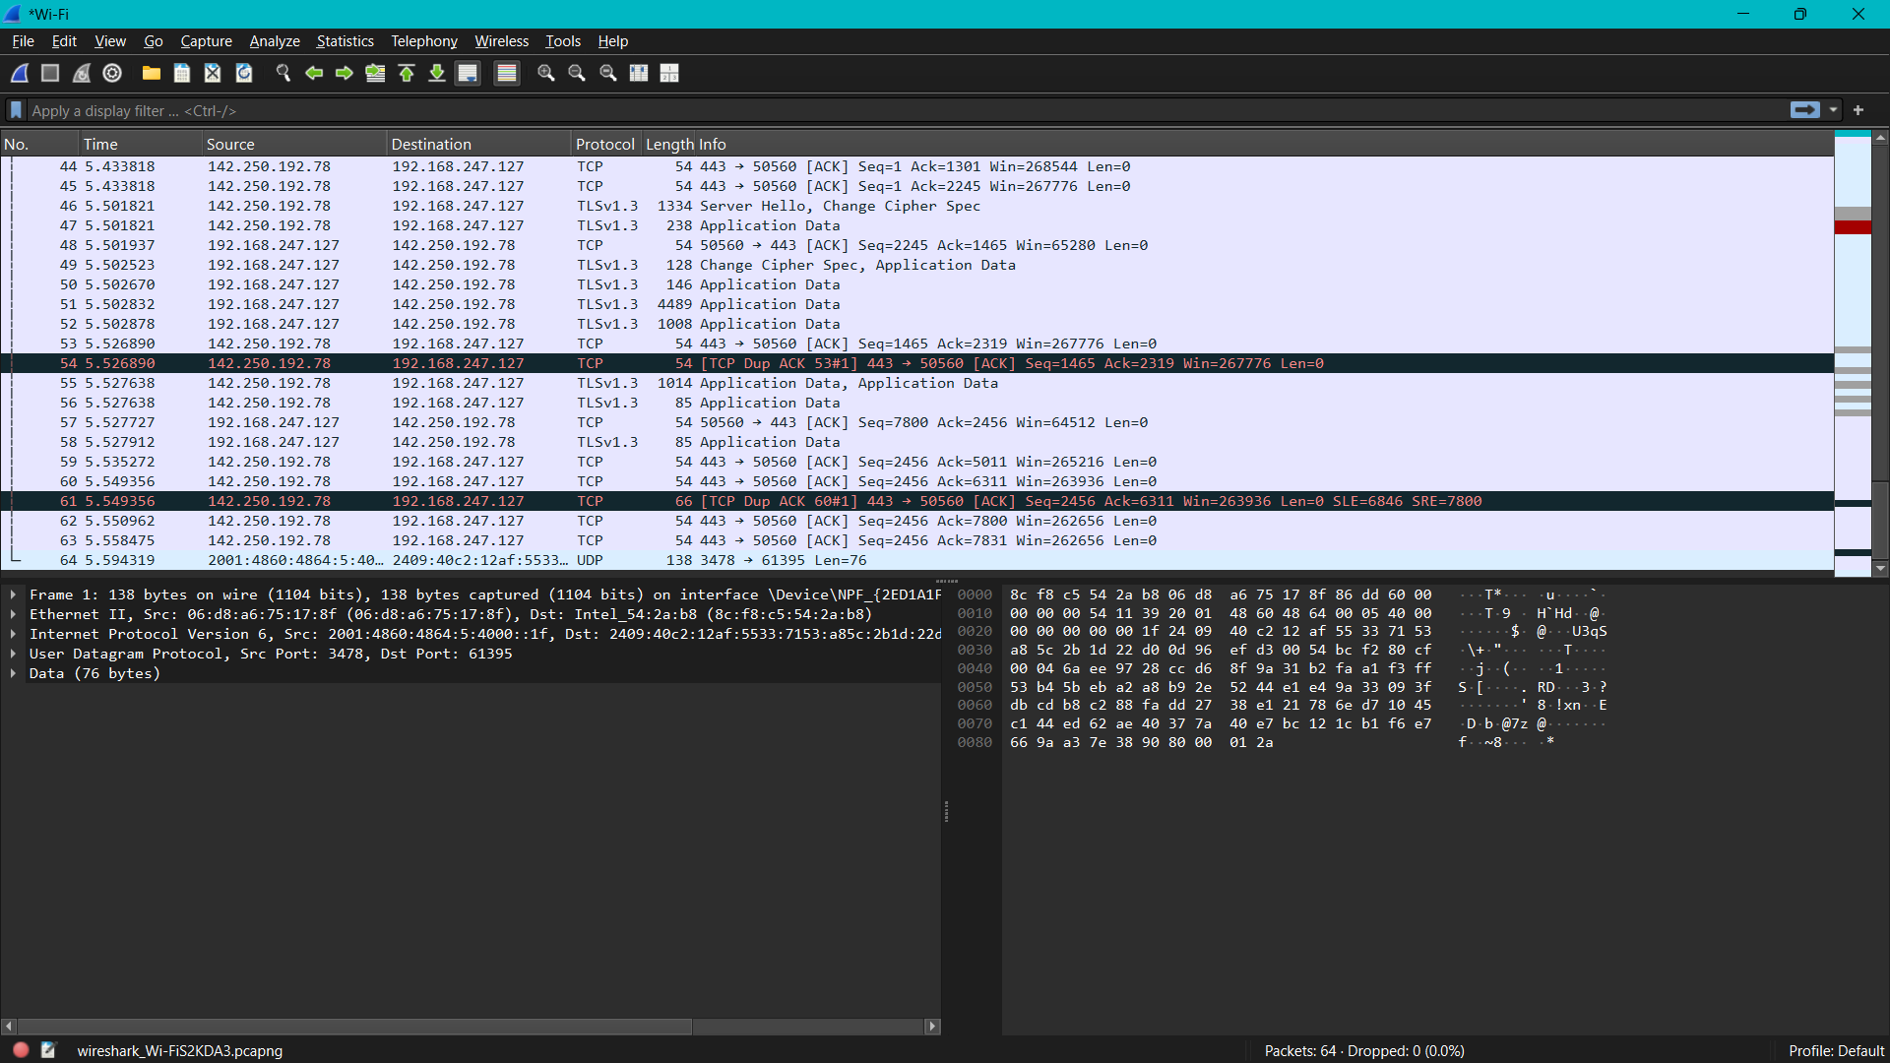

Step 4: Analyze Capture Statistics
Navigate to the 'Statistics' menu to access advanced analysis tools such as Protocol Hierarchy, Endpoints, Conversations, and Packet Lengths. These tools help summarize and understand traffic flow patterns.
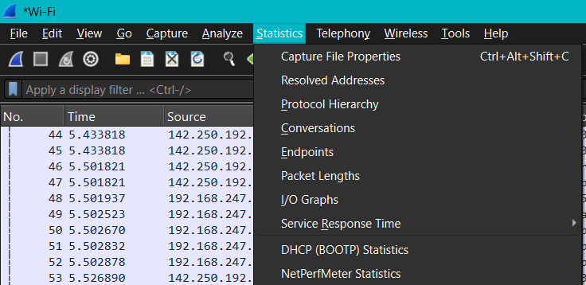

Step 5: File Properties and Session Summary
Select 'Capture File Properties' to view metadata about the capture session, such as total packets, duration, average packet size, and capture settings.
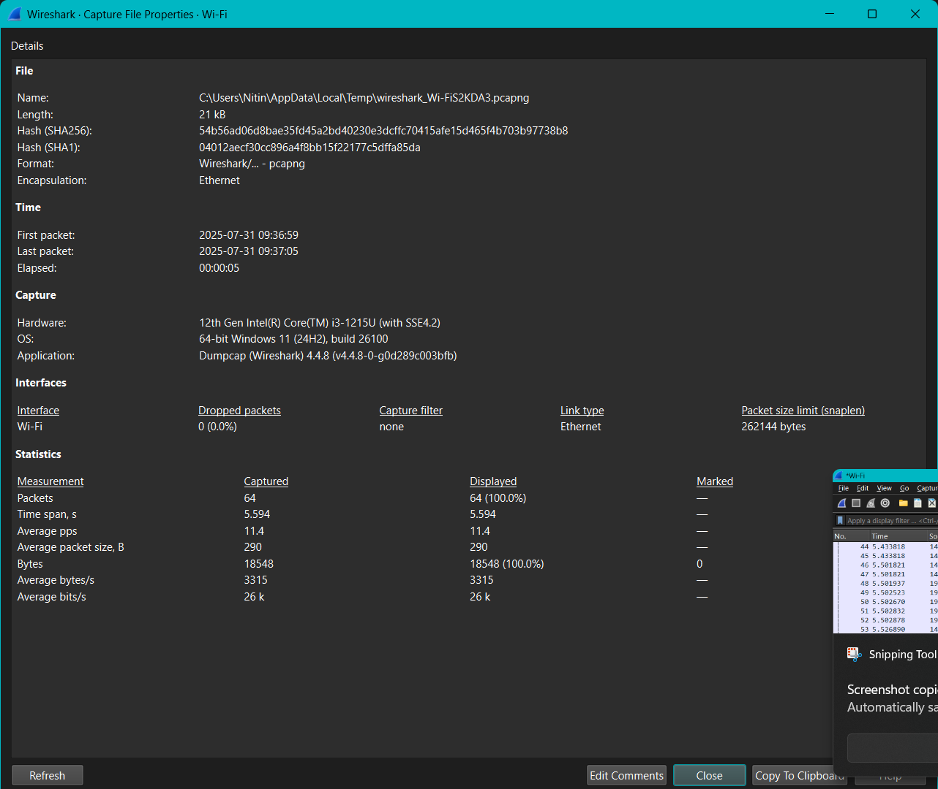

Conclusion
Wireshark provides a detailed view of network traffic, helping users understand what data is being transmitted and how it behaves across protocols. This demonstrated how to identify interfaces, capture traffic, analyze packets, and summarize results.

