Slip 1:
  - Use a threat intelligence platform (e.g., MISP or ThreatConnect) to collect and analyze indicators of compromise (IoCs) related to a recent cyber attack. [15]
Solution:
For recent cyber-attacks we can search for a website named: Threatfox
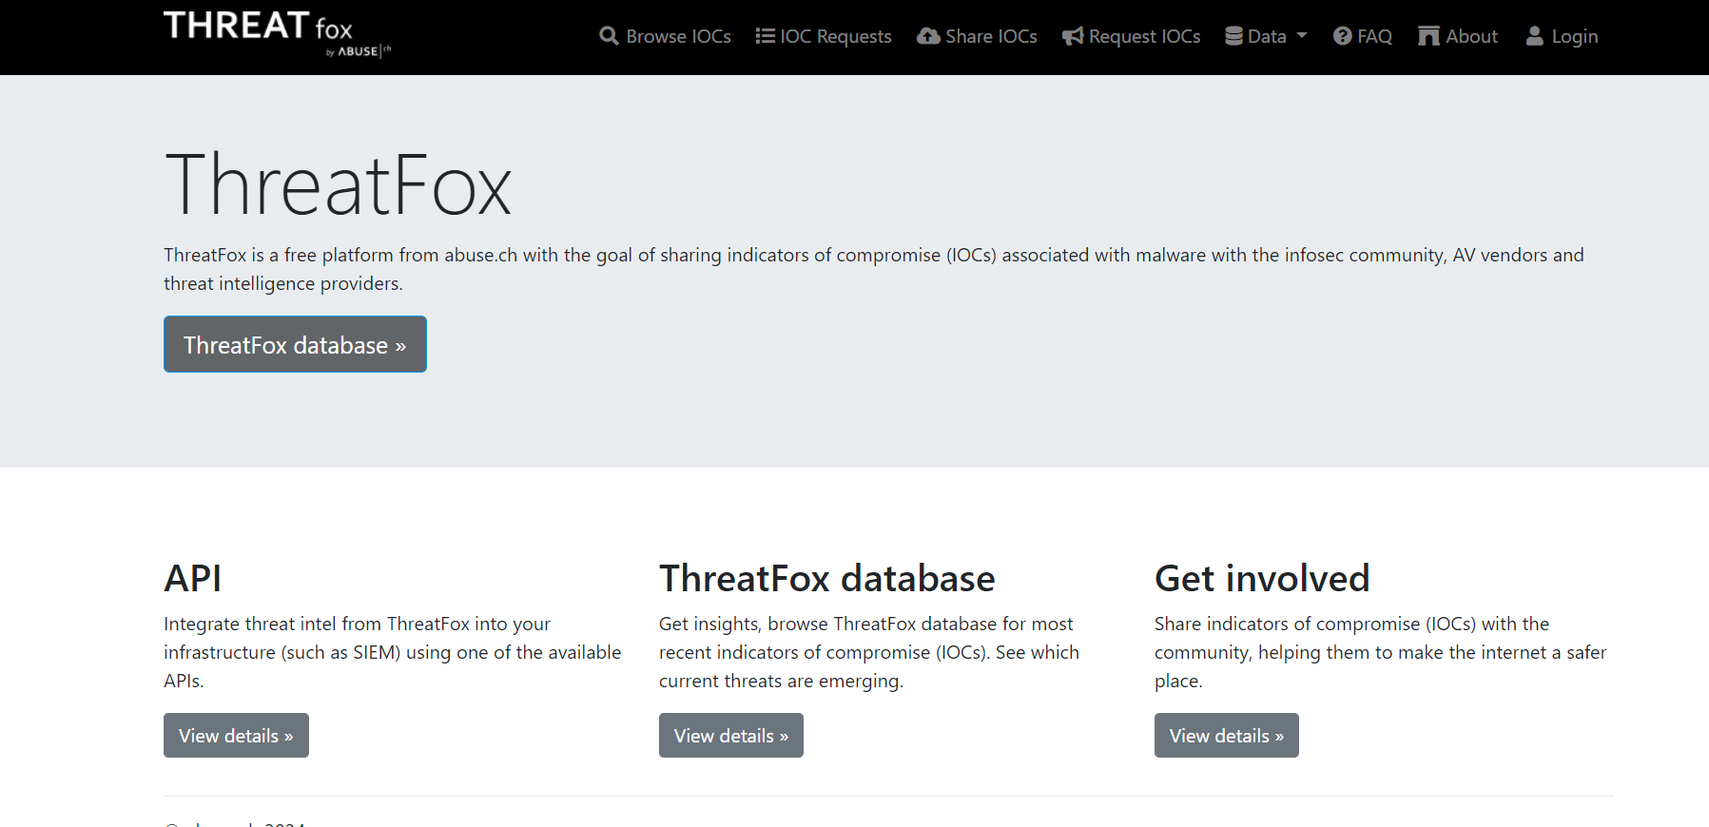
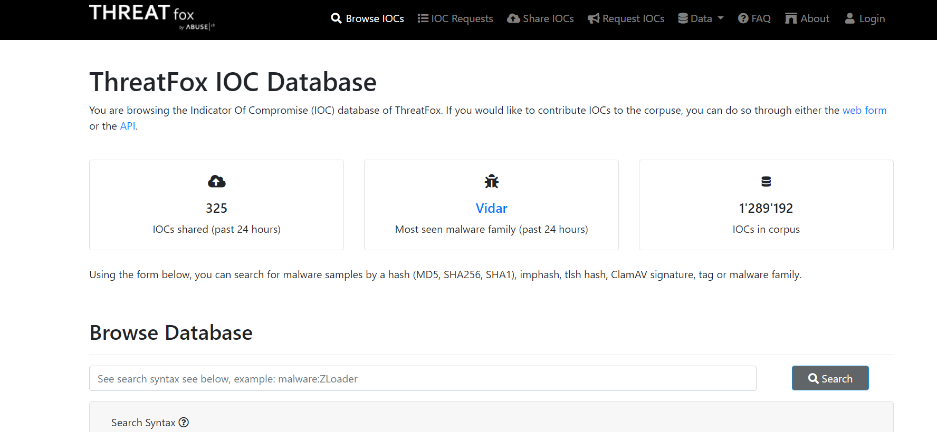
On this website we can find all the recent malware or suspicious IP address. Using these ip addresses and domain names we can search for the IoCs. Following the steps Mentioned below:
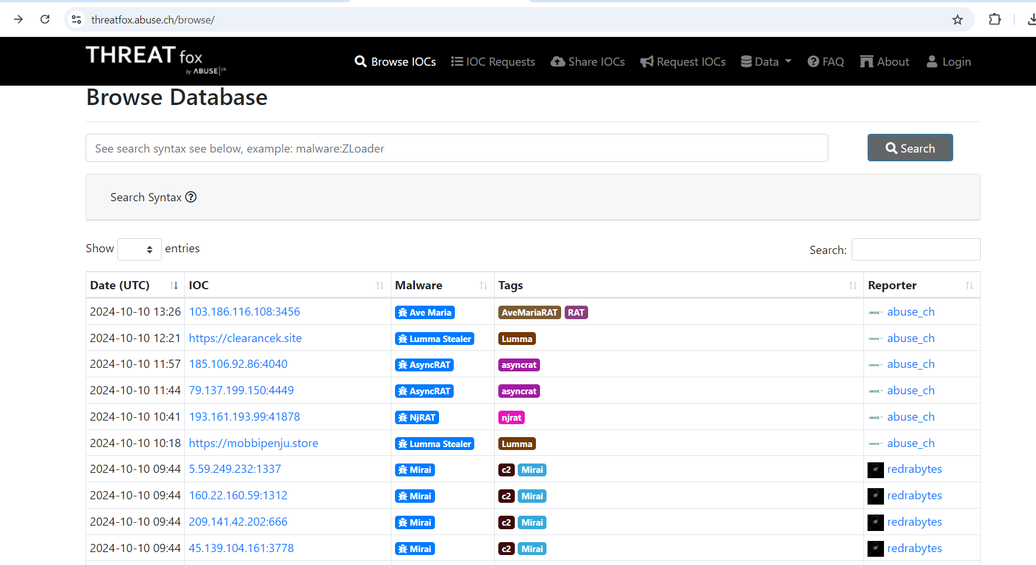

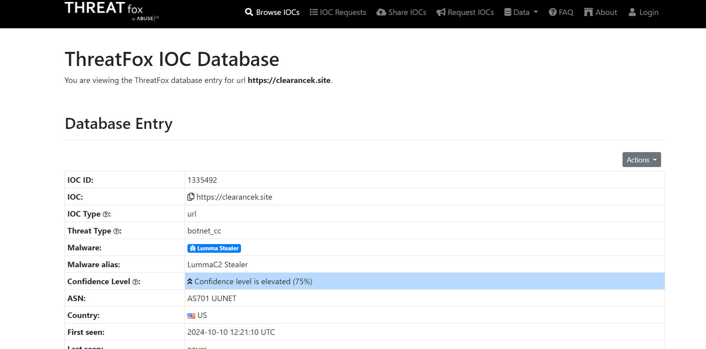
Here we can see the IoC related to the specific attack we have selected and with these IoCs we can prepare a report by searching for it on google.

  - Perform a WHOIS lookup on a suspicious domain and analyze its registration details for potential threat indicators. [10]
Solution:
So, like we find out some suspicious domains, Ip addresses database from threatfox consider on eurl from that database and search for the WHOIS Lookup.
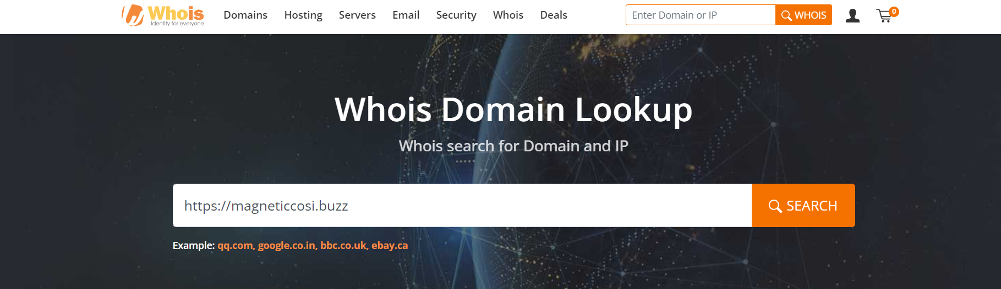
Here we will find the detailed info about this domain registrar and other info.
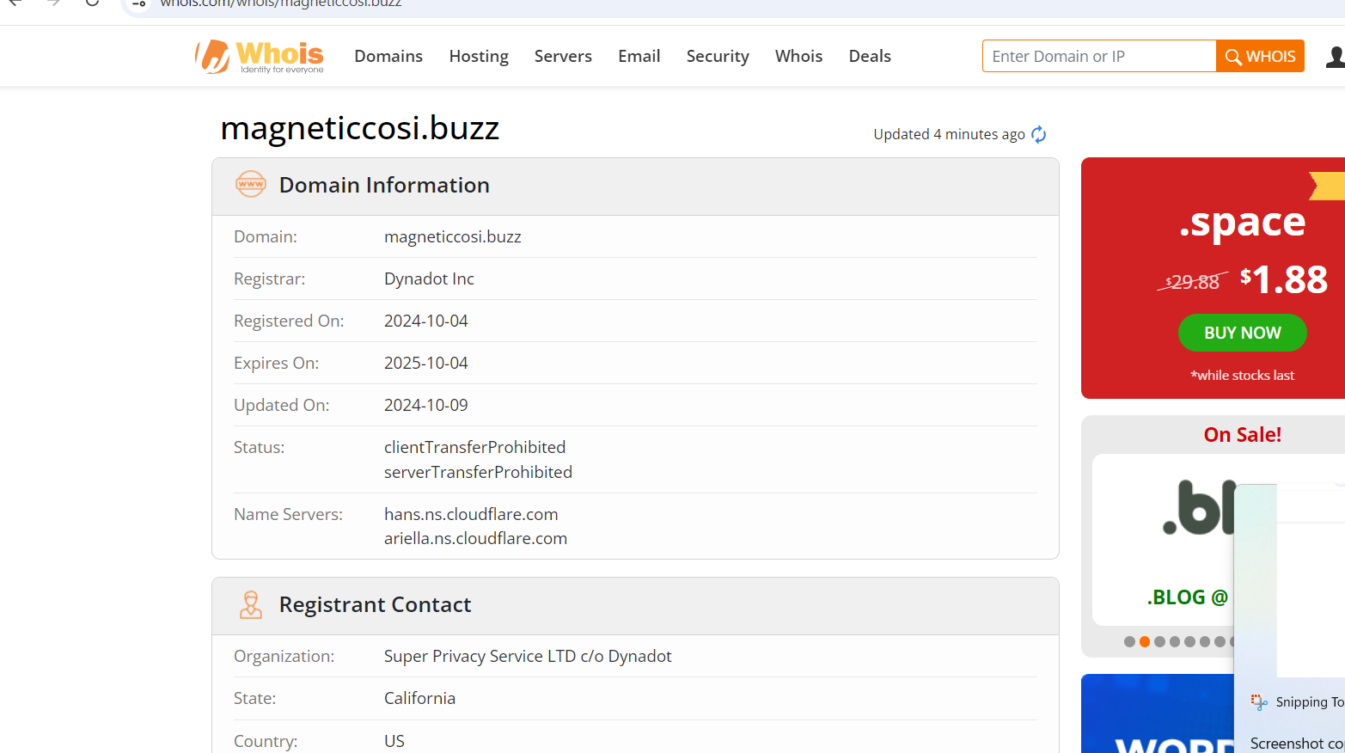

Slip 2:

Q1. Use VirusTotal to analyze a suspicious file or URL and summarize its threat intelligence

data.
Solution:

Same here, we can search for Threatfox Database and consider suspicious url.

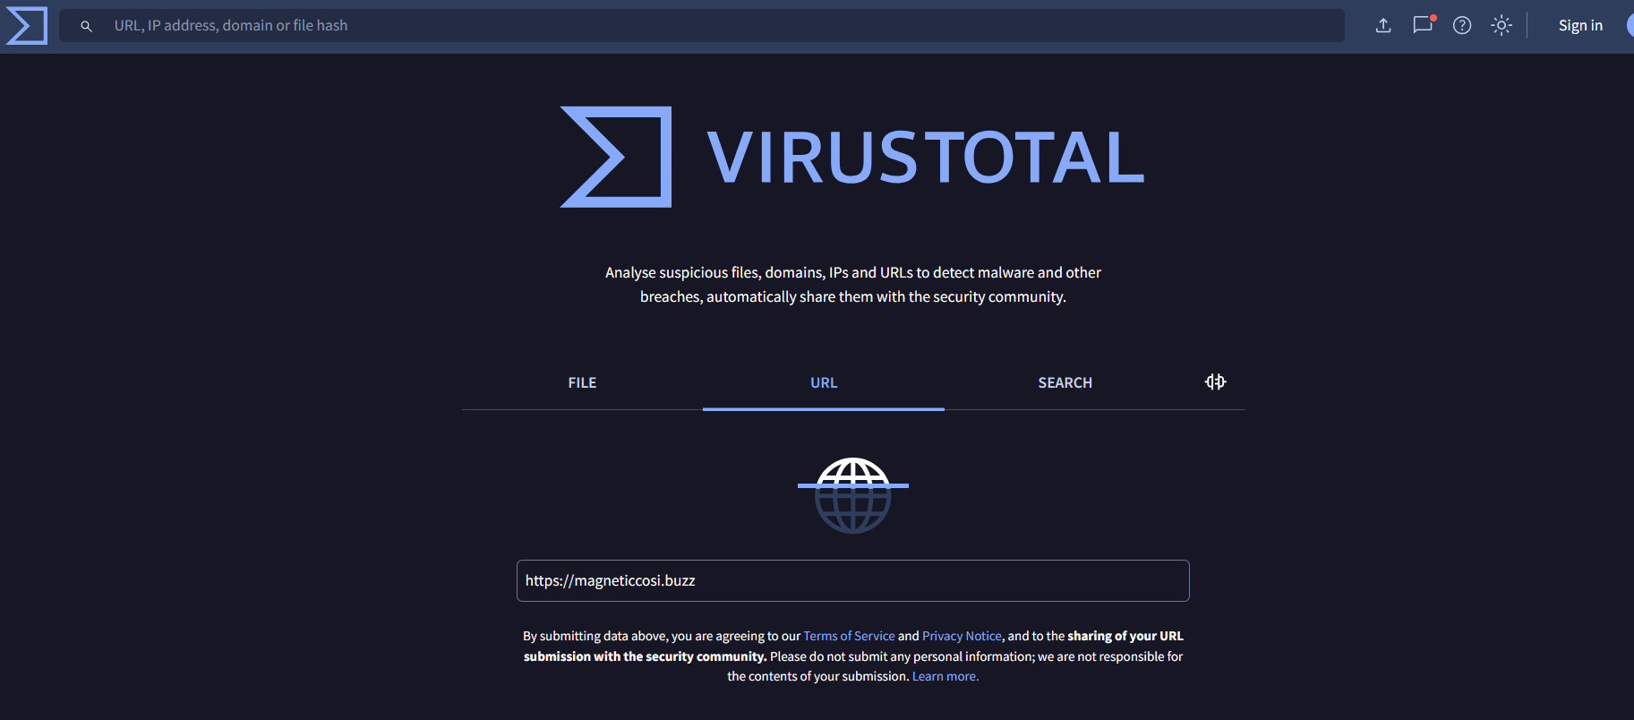

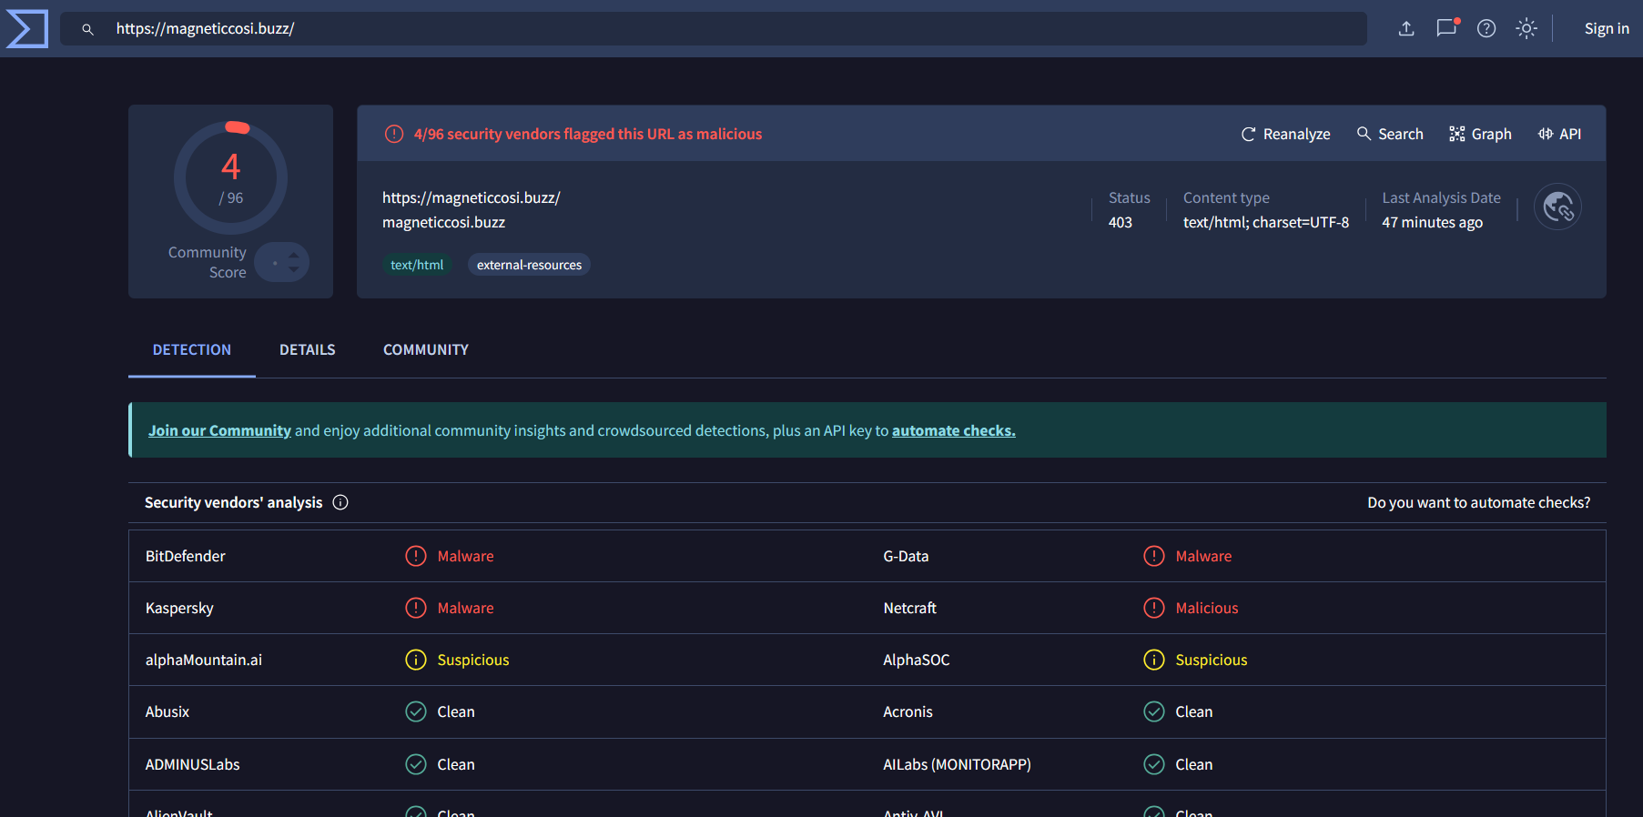

Click on the website url.

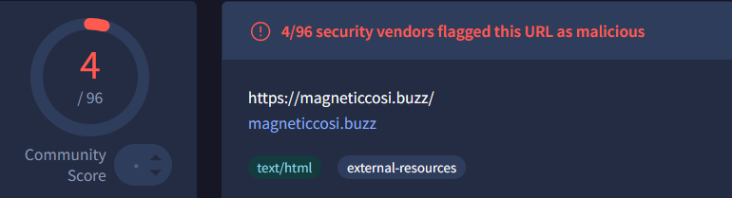

By observing the details section history data, passive dns, sunbdomains etc., info we can create a report on the domain by using virustotal.

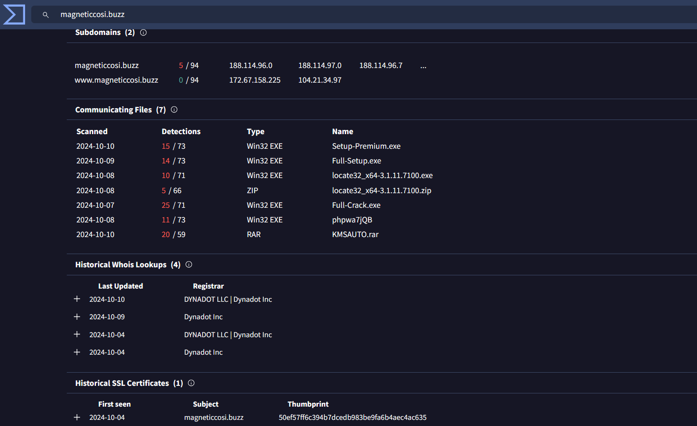

Q2. Perform OSINT (Open Source Intelligence) on a given IP address to identify any known threats associated with it.

Solution:

Here we will consider one IP address: 120.78.65.206

For OSINT on this IP address we can search for many websites like whois, virustotal, AbuseIPDB and many more I have mentioned below from where we can collect info with the IP.

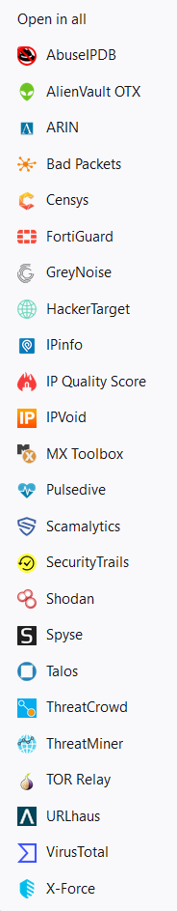

We will try to use few of them.

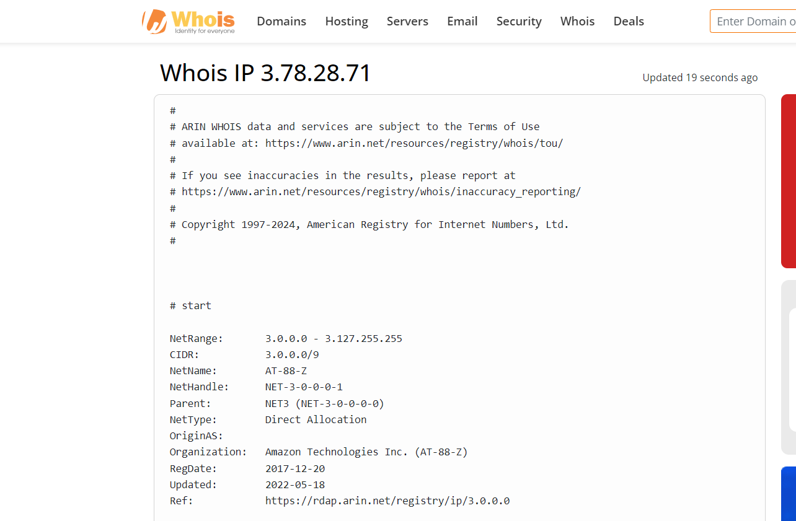

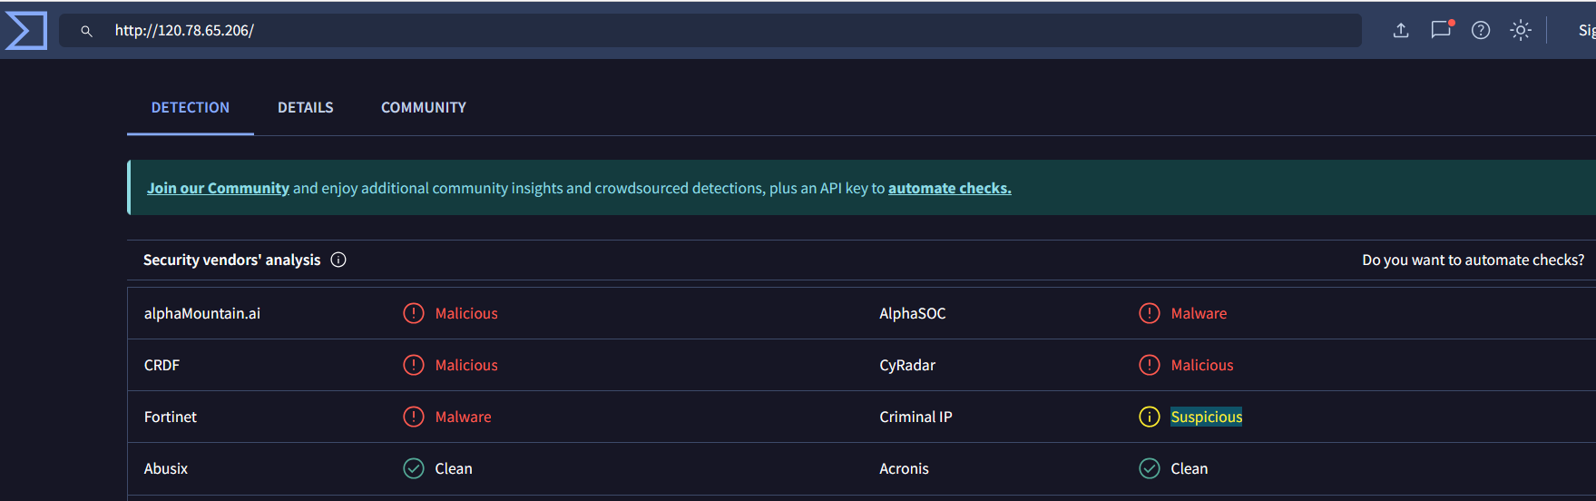

Here Criminal IP is showing this IP address Suspicious so we will search on the criminal IP.

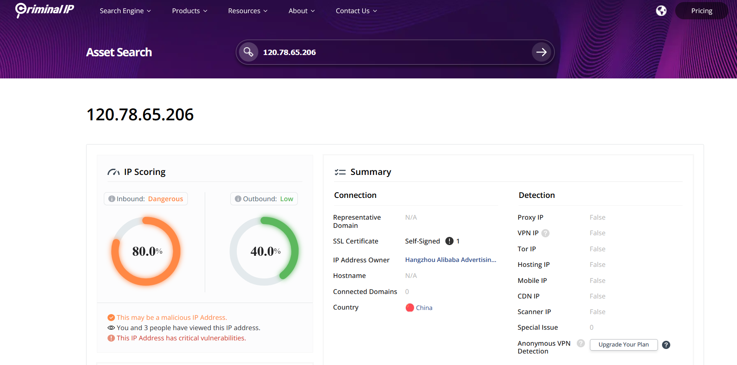

Here we can see that this website is showing this IP 80% dangerous.

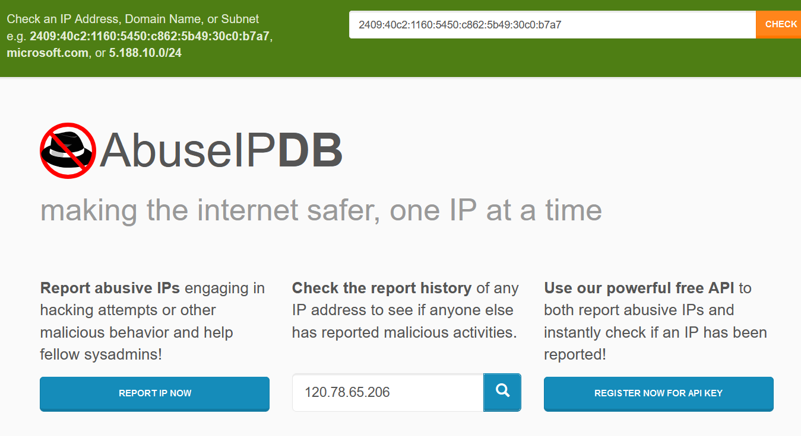

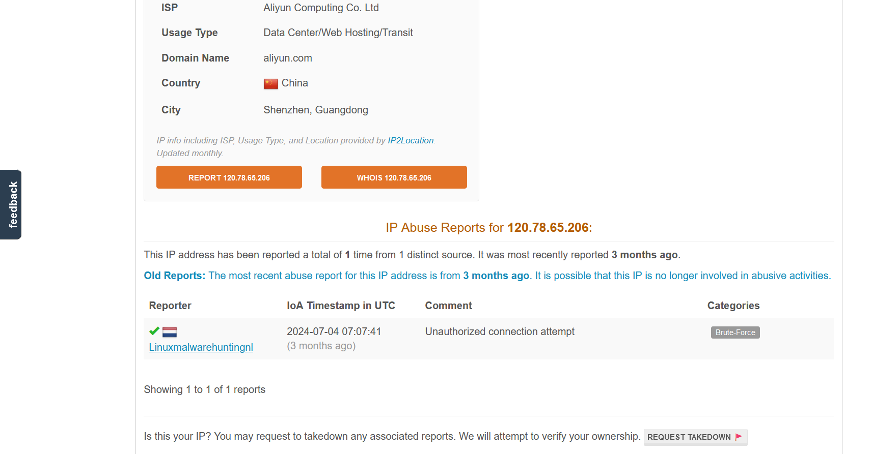

Here we can find the category of the ip address, IoC, etc. By using this info collected through all various websites we can prepare a report of OSINT.

Slip 3:

Q.1) Use Shodan to identify vulnerabilities in a specific IP address or range of IPs and report the findings.

Solution:

We will consider the same IP on the Shodan: 120.78.65.206

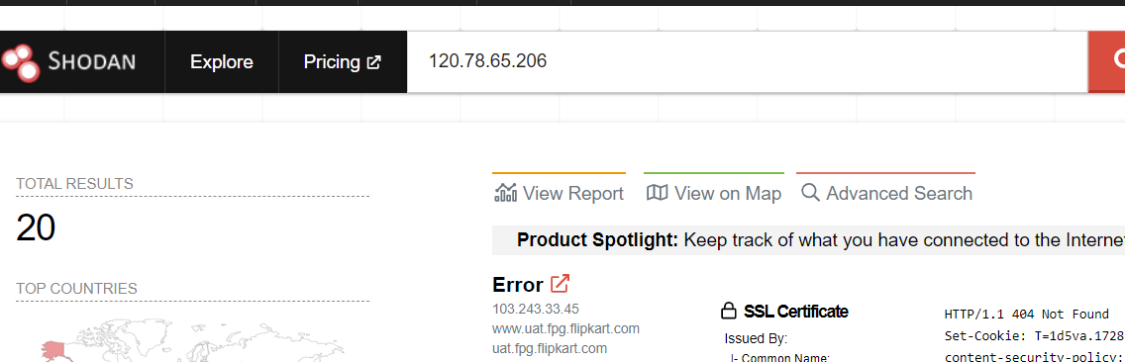

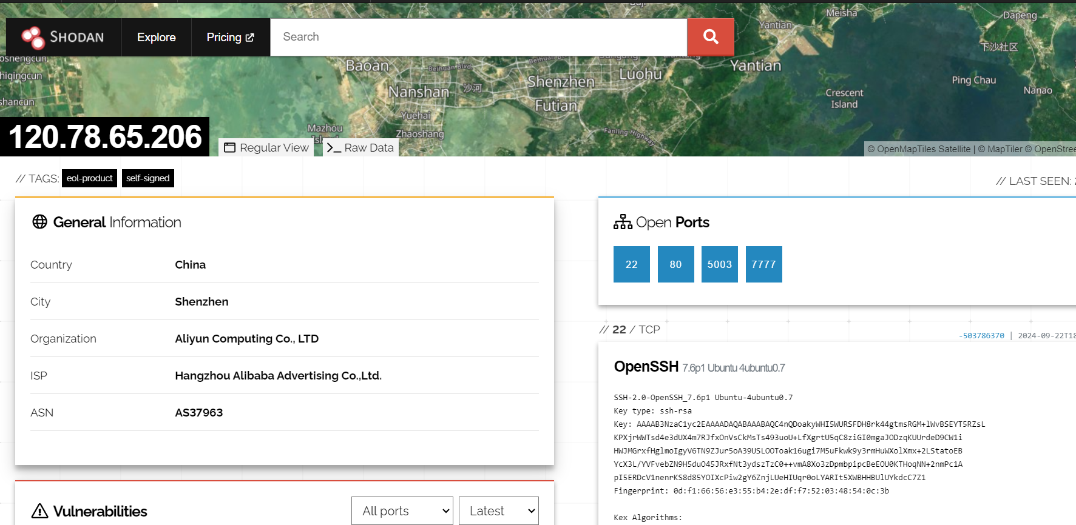

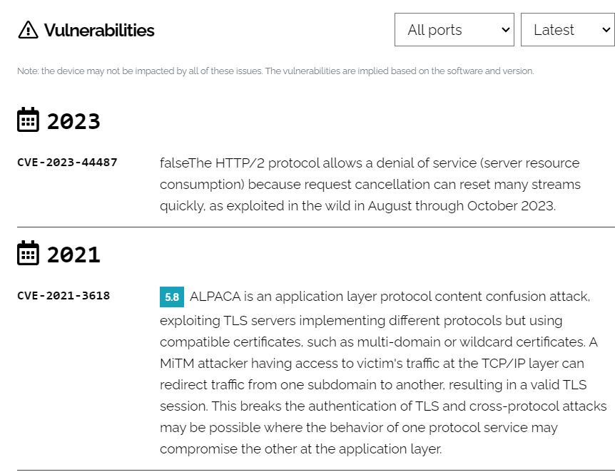

Next steps will be finding out for these vulnerabilities we will use google;

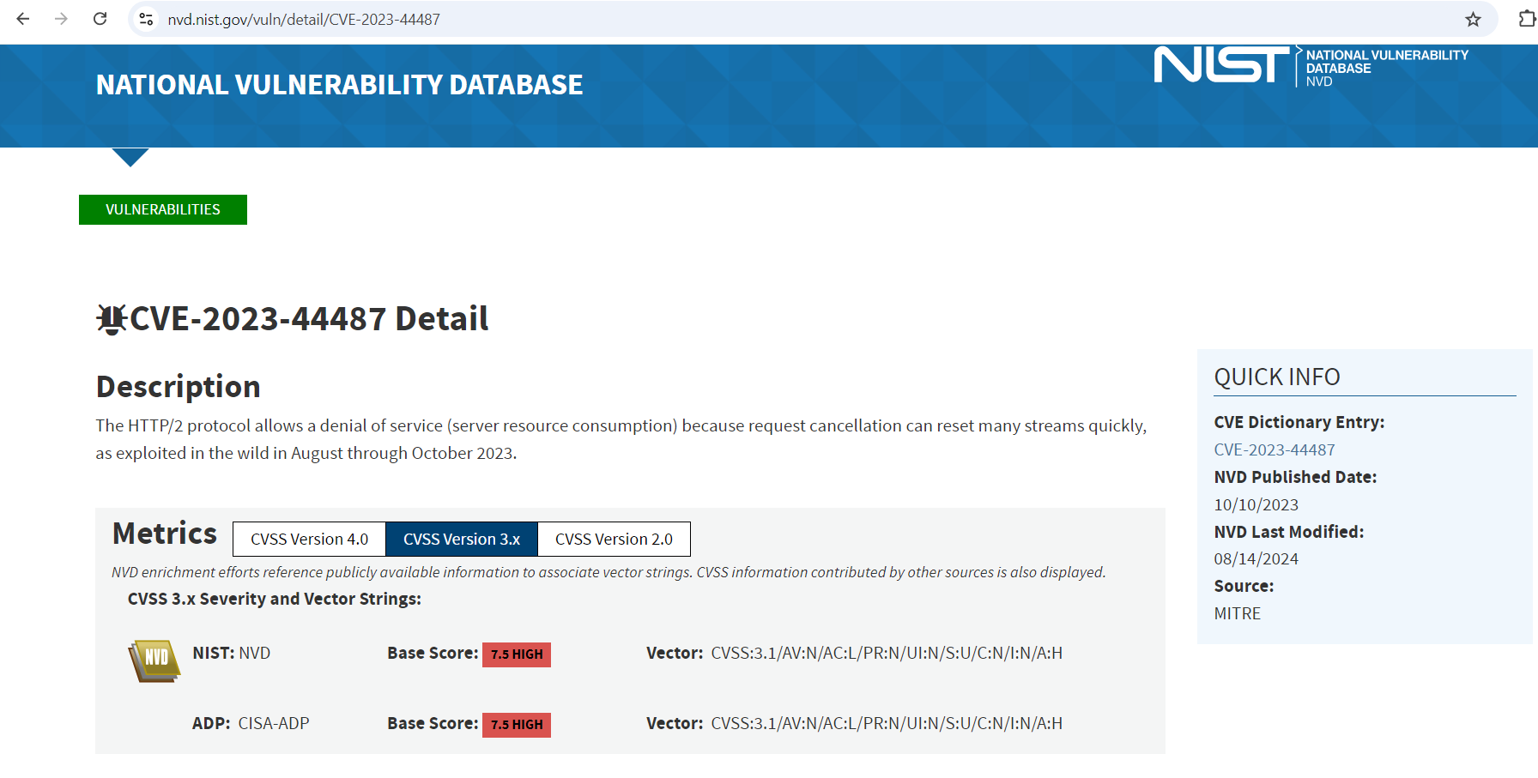

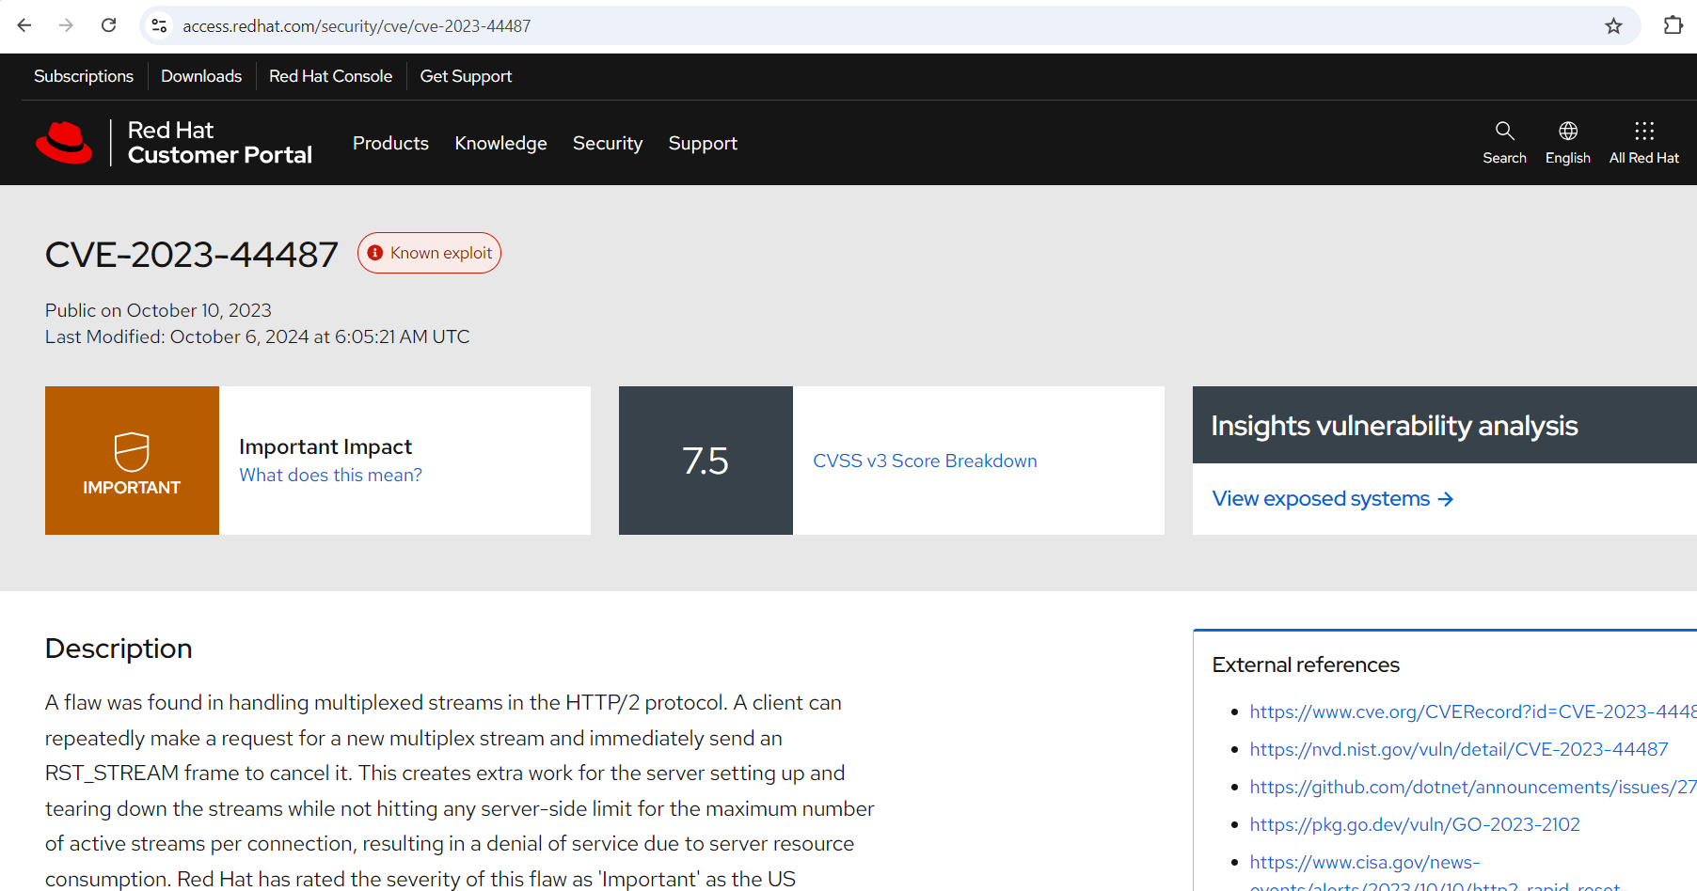

By finding about these vulnerabilities through google from various websites like two of them are mentioned above we can prepare a vulnerability report.

Q2. Perform passive DNS analysis to track the historical domain resolution for a given

malicious domain.

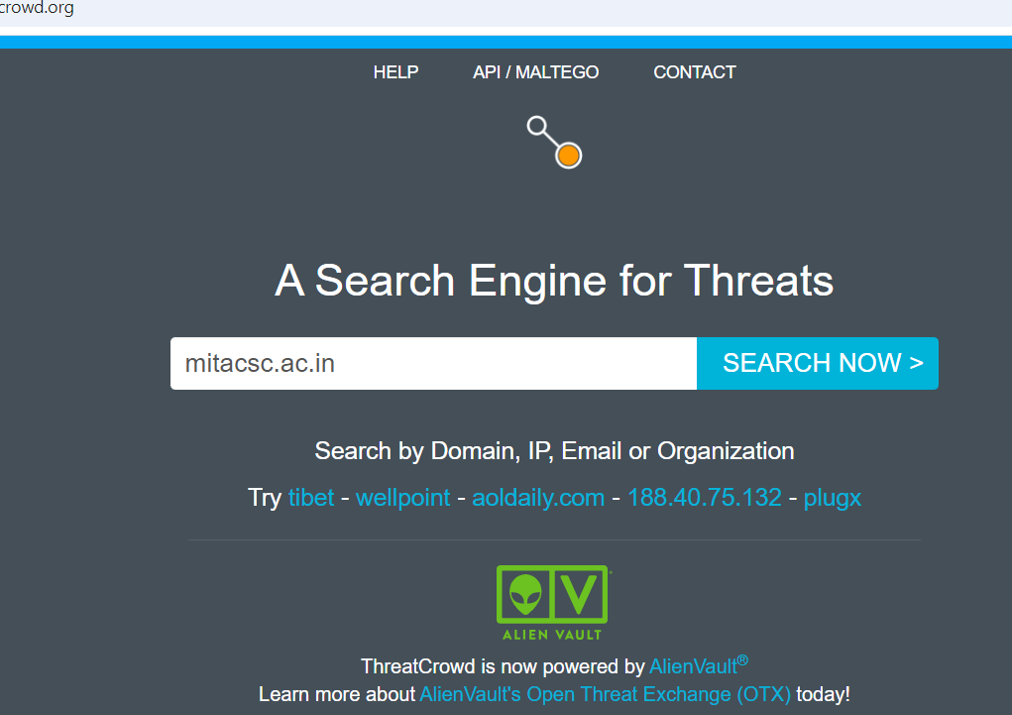

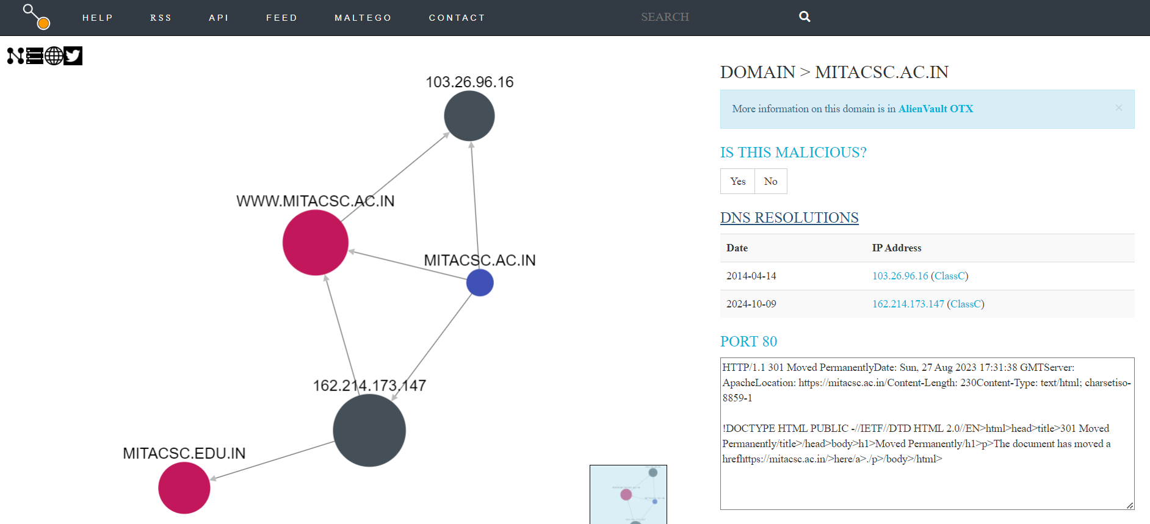

Open with Alien Vault OTX

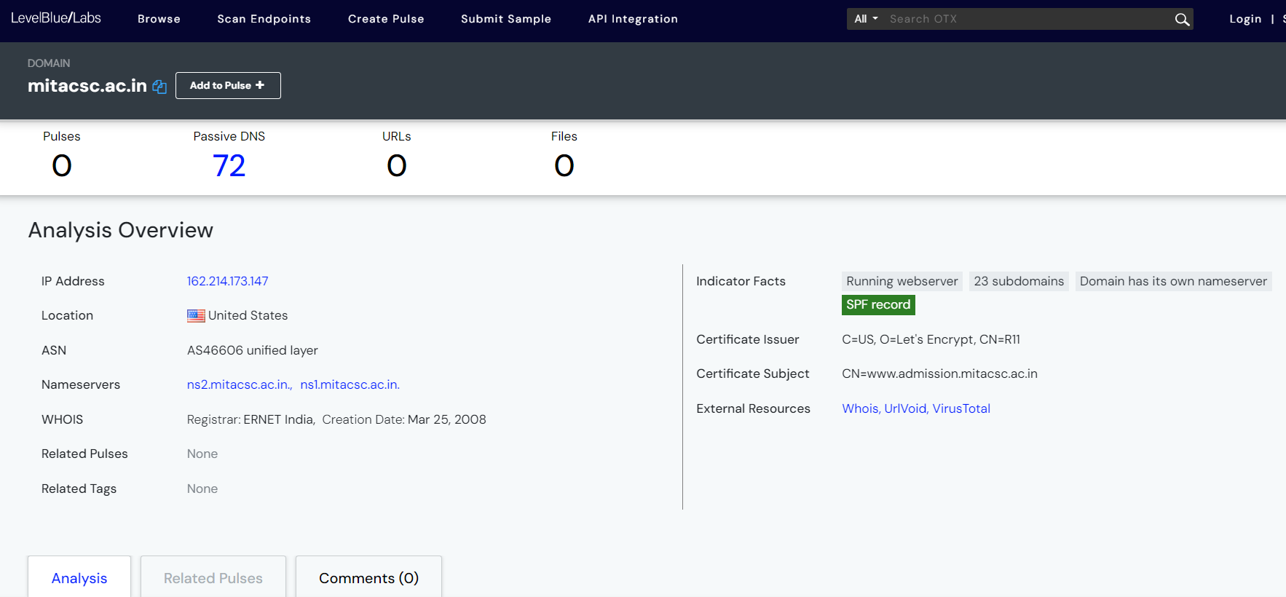

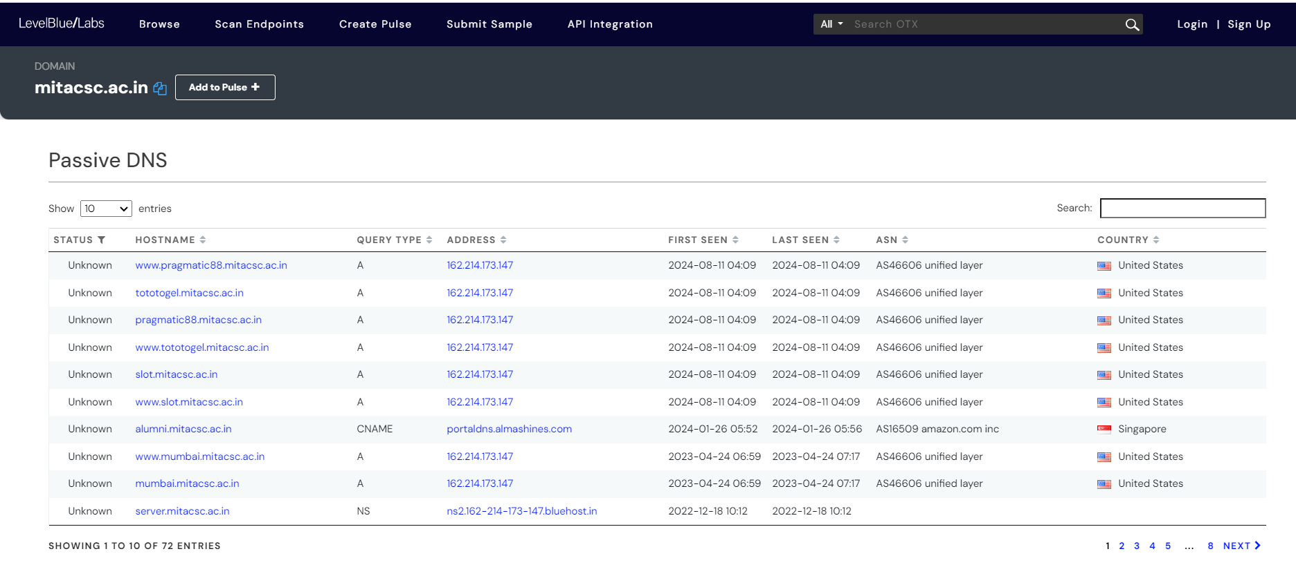

By scrolling on this website we will find the allocated Passive DNS to the domain.

Slip 4:

Q1. Analyze a threat actor profile using a threat intelligence database (e.g., MITRE ATT&CK)

and identify their tactics, techniques, and procedures (TTPs).

Solution:

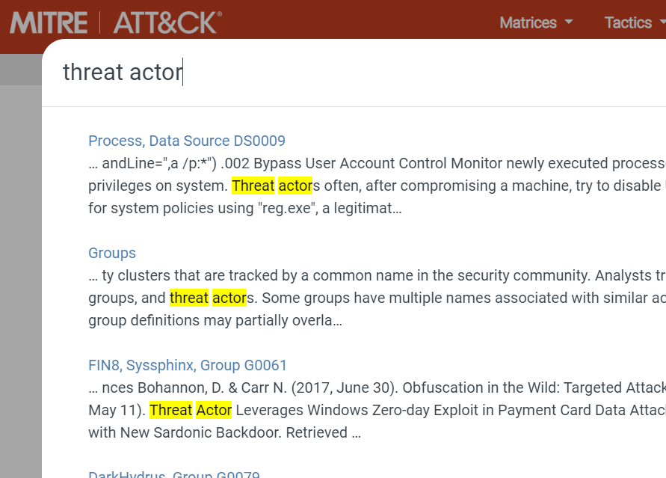

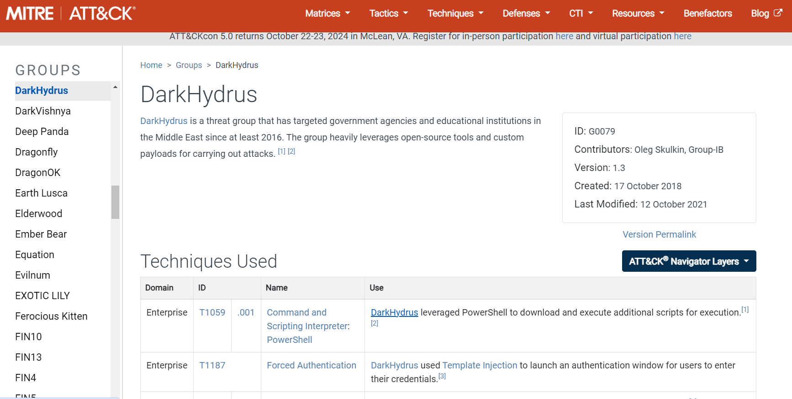Q2. Use Maltego to visualize relationships between various entities (domains, IPs, emails) and

create a threat intelligence report.

Slip 5:
Q2:
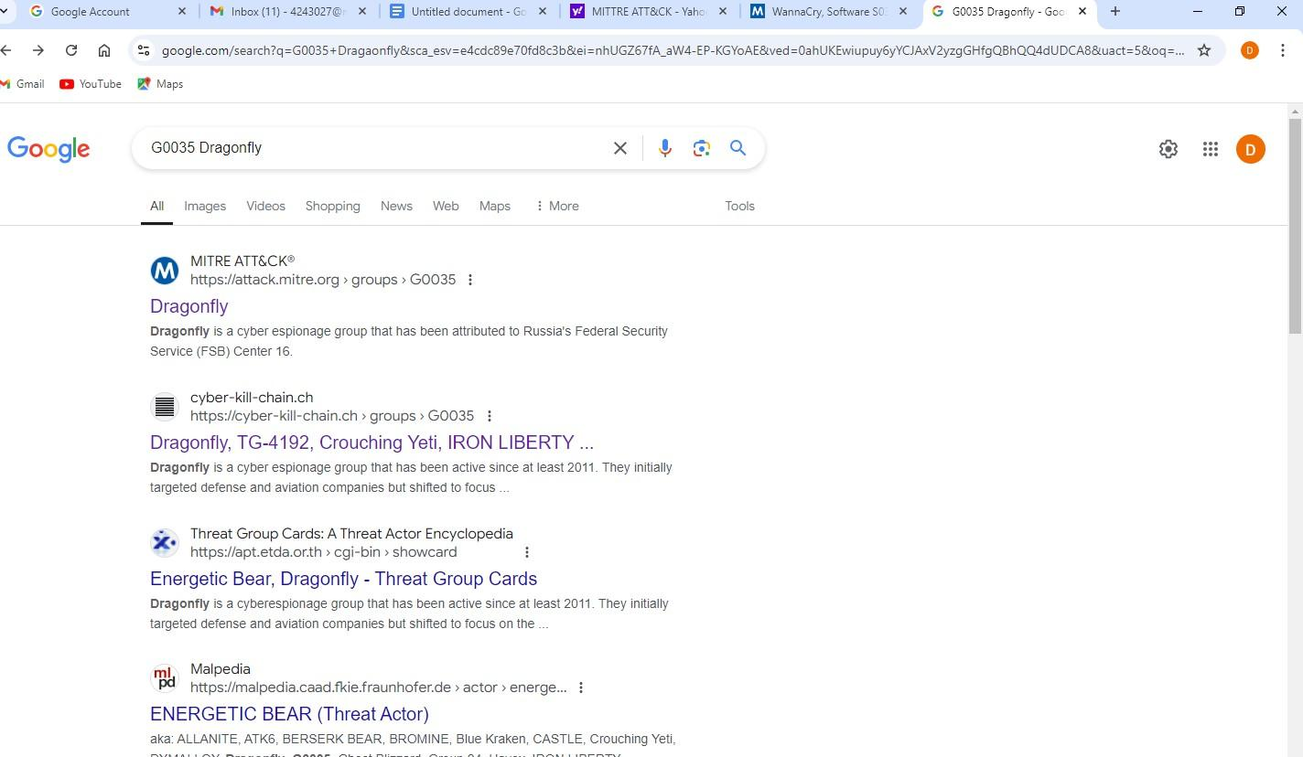
Perform OSINT to gather intelligence on a threat actor's online activities and summarize the findings.MITTRE ATT&CK

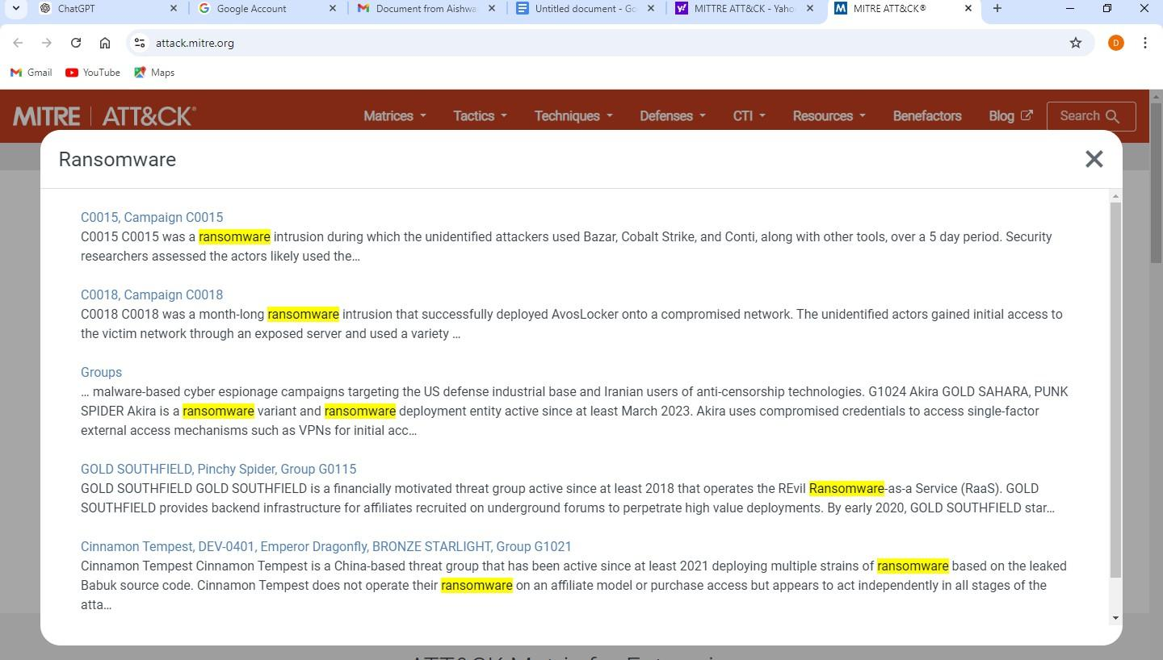

Q.1) Track and analyze phishing campaigns using Threat Intelligence feeds and report on

recurring patterns or key indicators.

Solution:

The phishing url e.g.: https://main.d1twpaab3dc3ll.amplifyapp.com/

We can collect such phishing urls from PhishTank website.

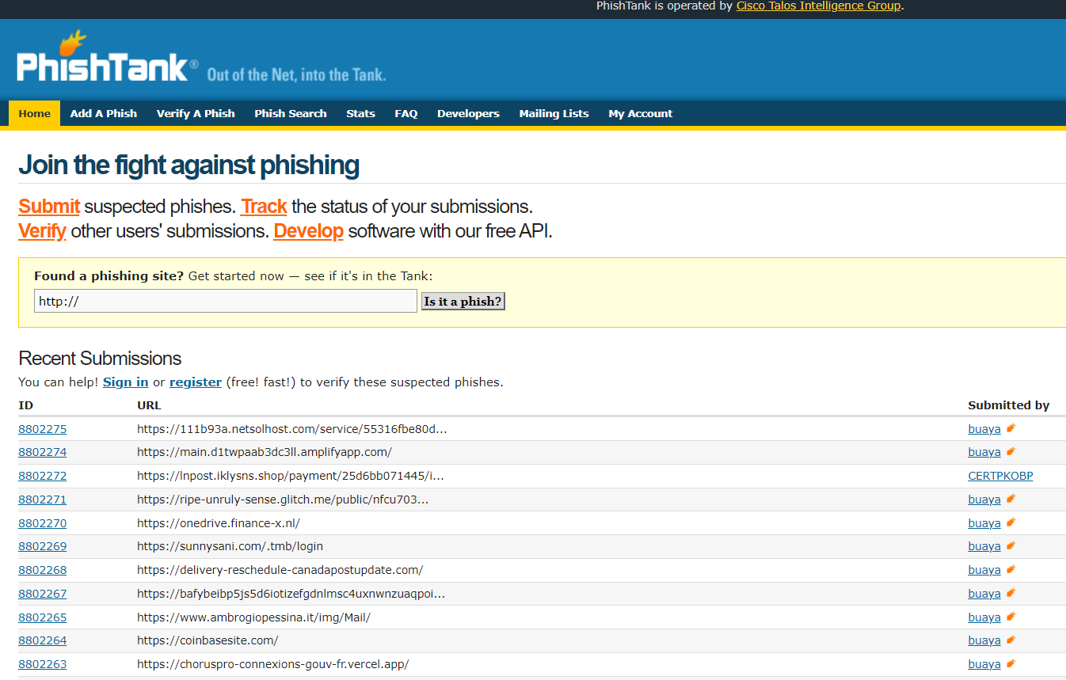

For Threat Intelligence Feed:

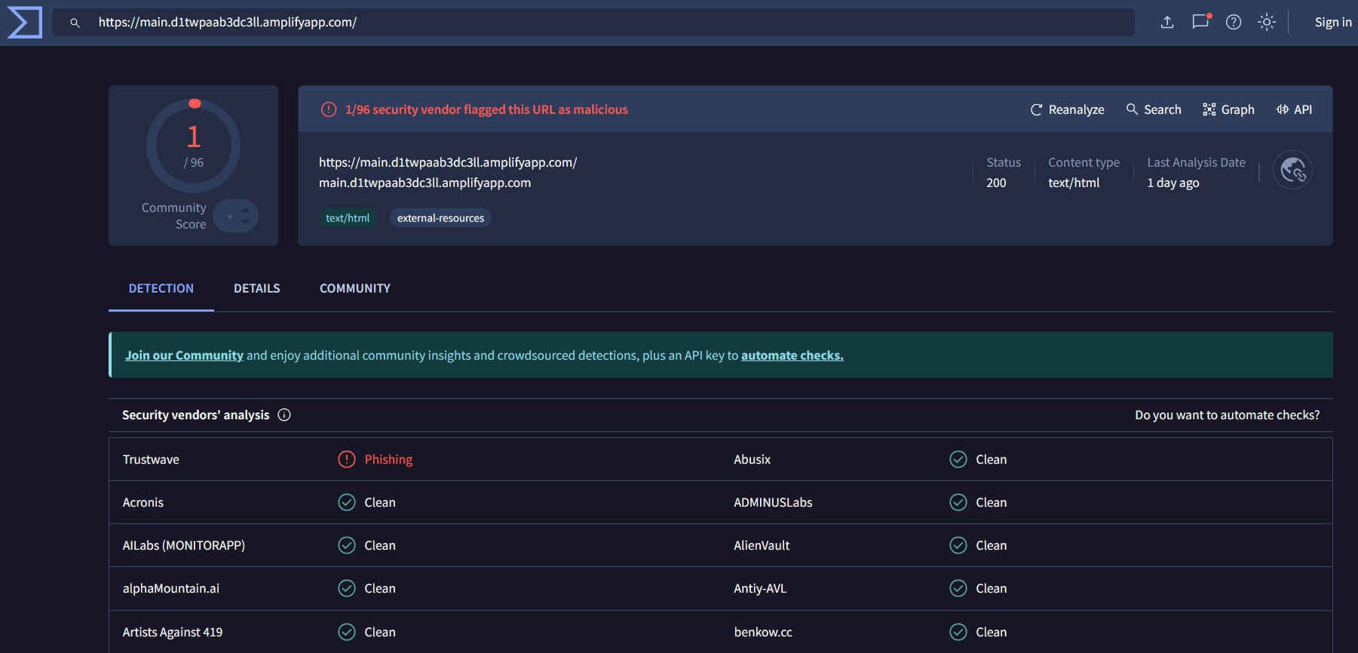

Here, trustwave has detected this url as phishing url so, we will find more on trustwave.

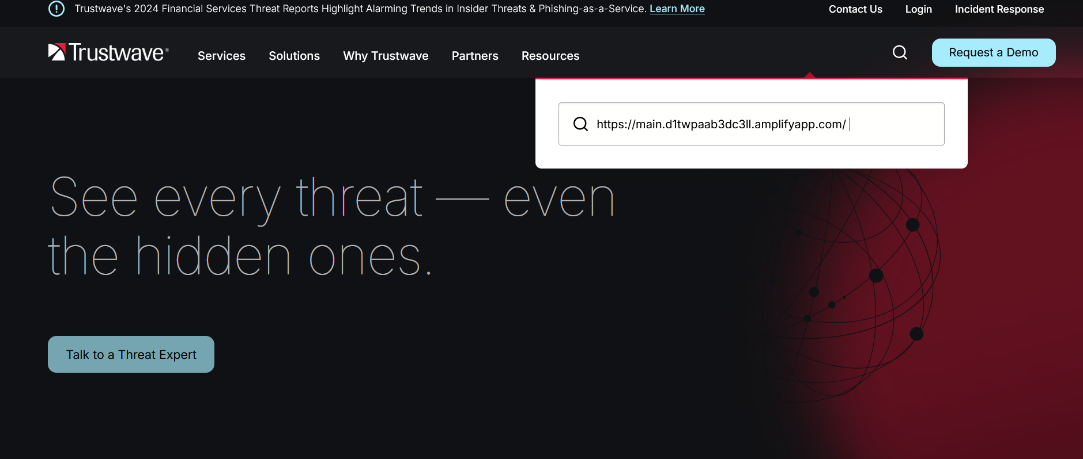

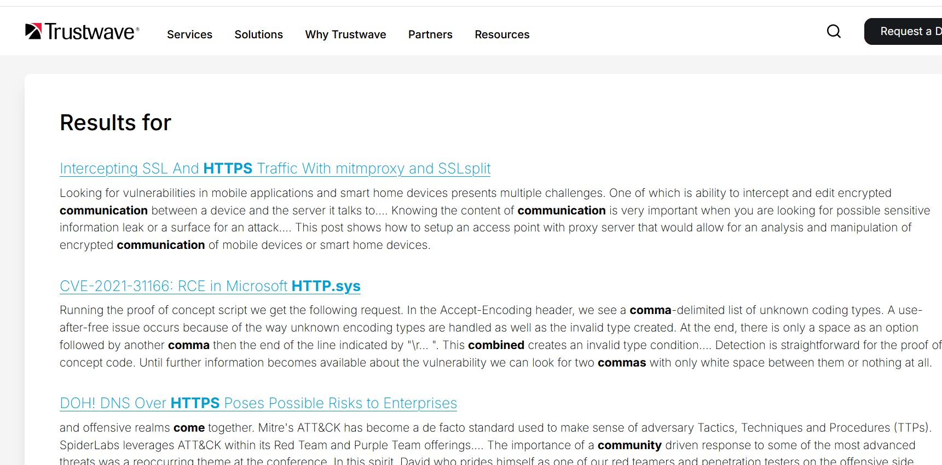

On this website we can observe the key indicators, TTPs they are using, we have to use this data for report findings.

Q2. Investigate suspicious email headers and extract information to determine if the email is part of a known phishing attempt.

Solution:

Go, to any suspicious spam email from gmail and click on the three dots and show original



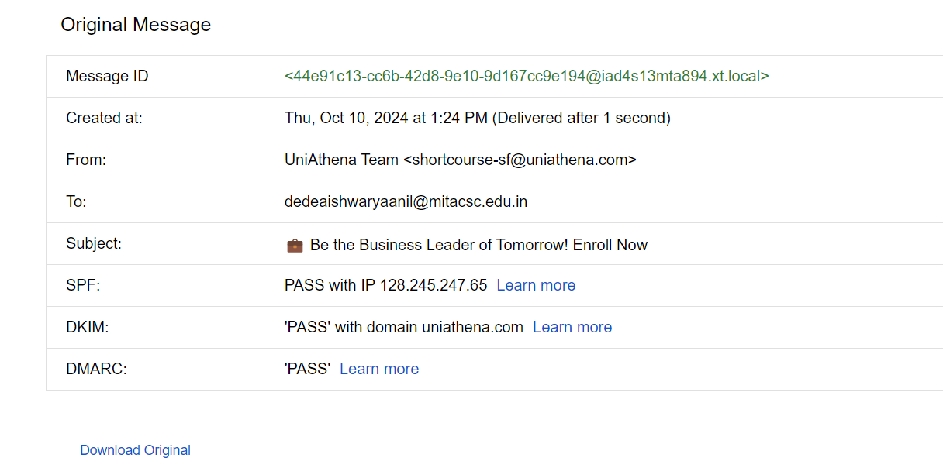

By using the IP address mentioned in above info we can search for the details on various websites.

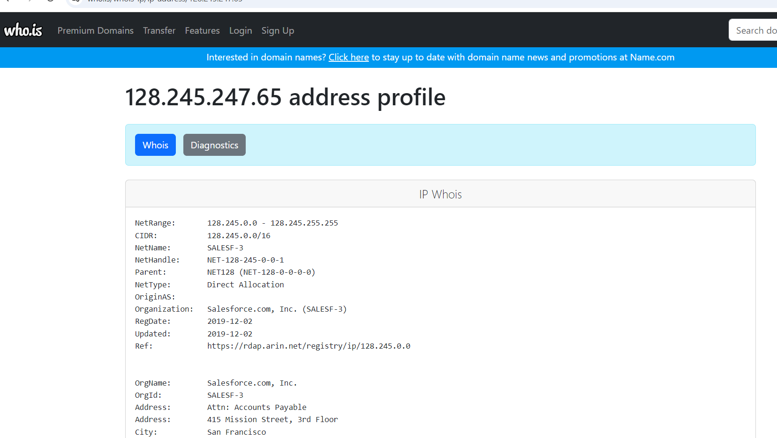

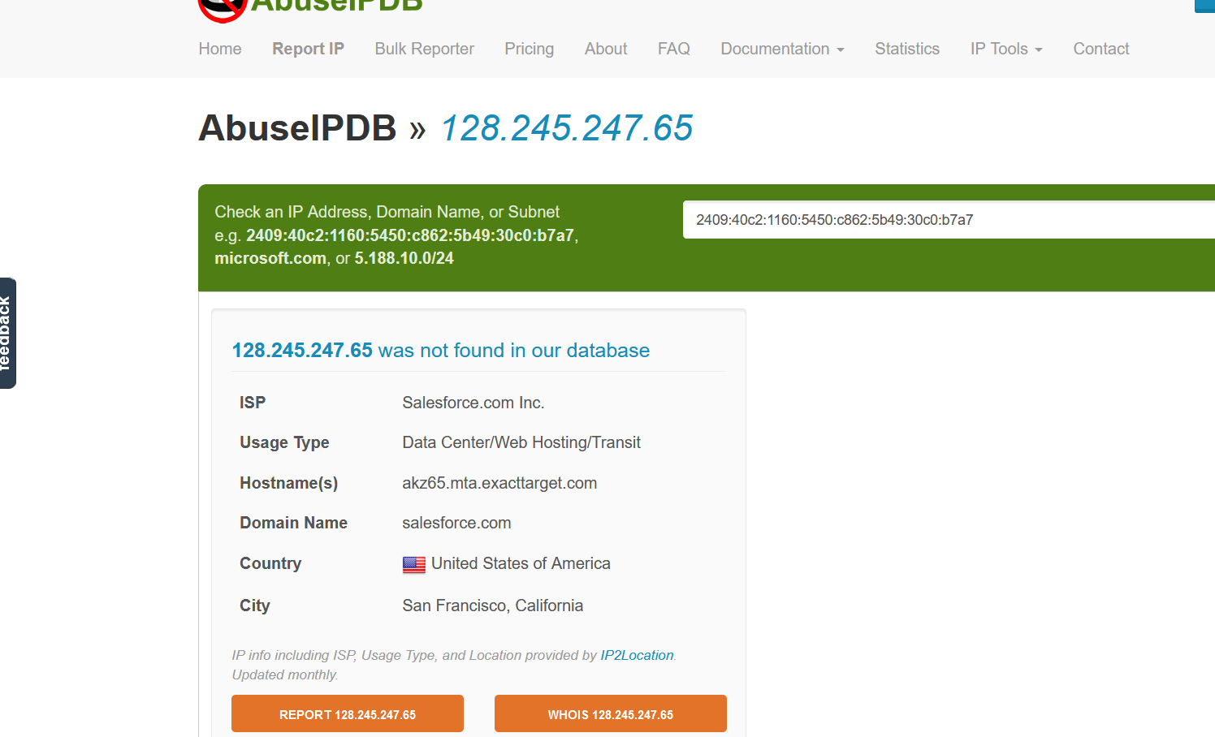

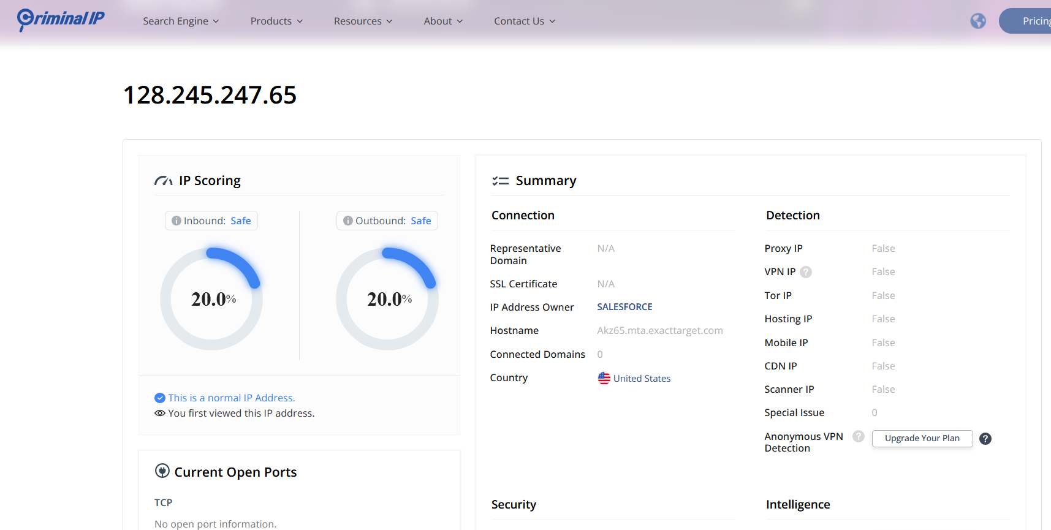

By considering all the above findings we can say that this IP is a non-suspicious. Hence it is a legitimate mail.

Slip 6:

Incomplete

Slip 7:
Q2:

Perform OSINT to gather intelligence on a threat actor's online activities and summarize the findings.MITTRE ATT&CK



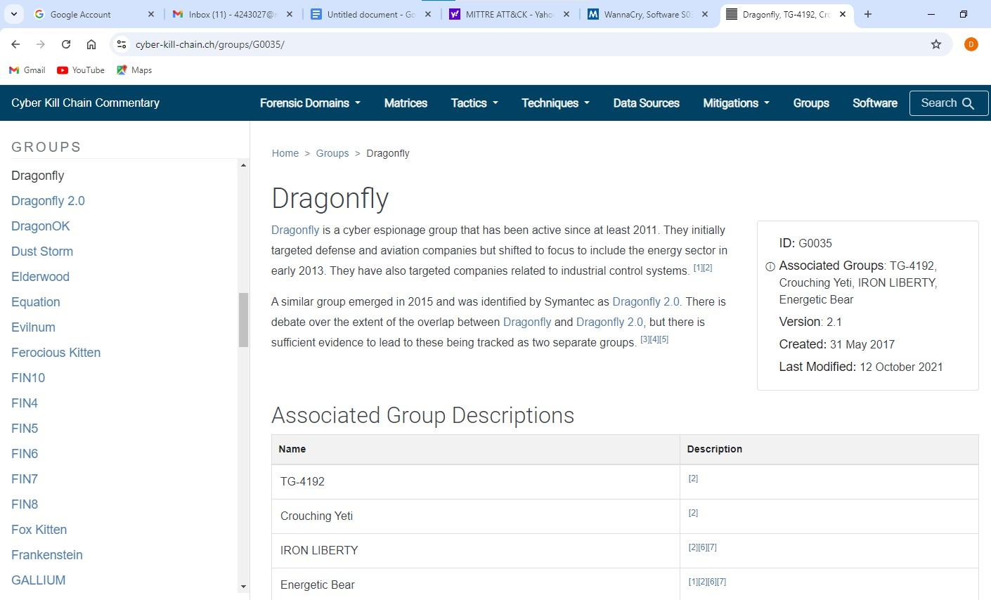
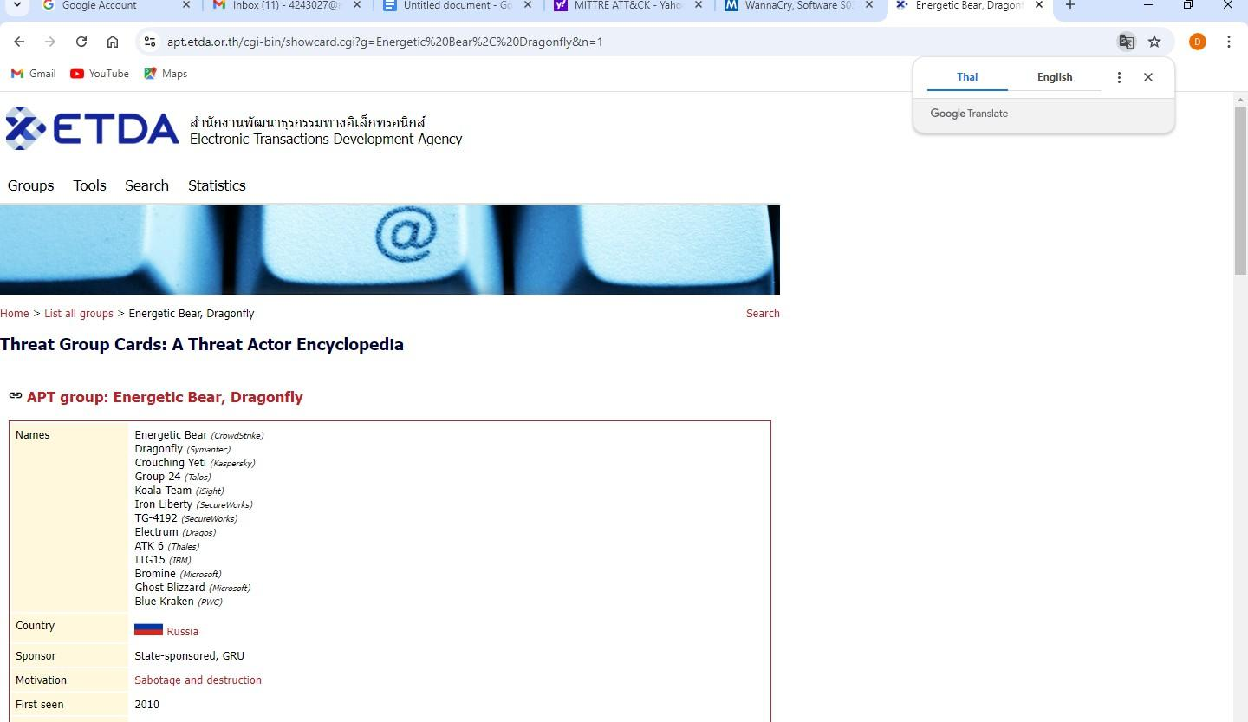
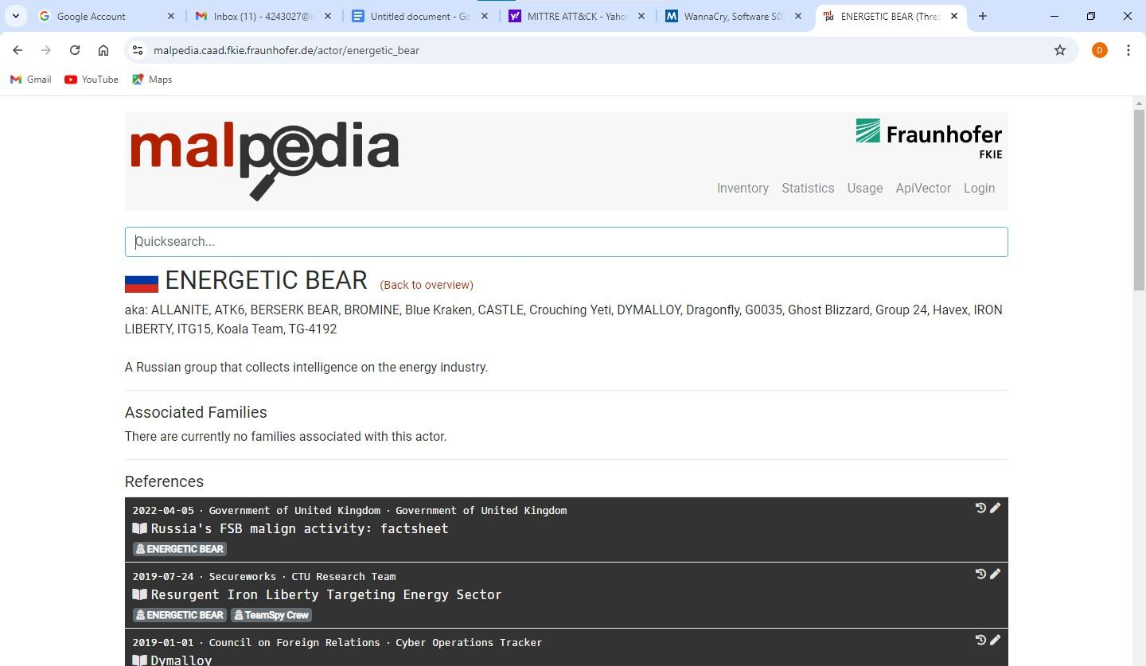

Q1:
Use a Threat Intelligence Platform (TIP) to correlate threat data from multiple sources and generate actionable insights.
Collect data from the various websites about the attack such as Threat Crowd, Threat Connect, Crowdstrike
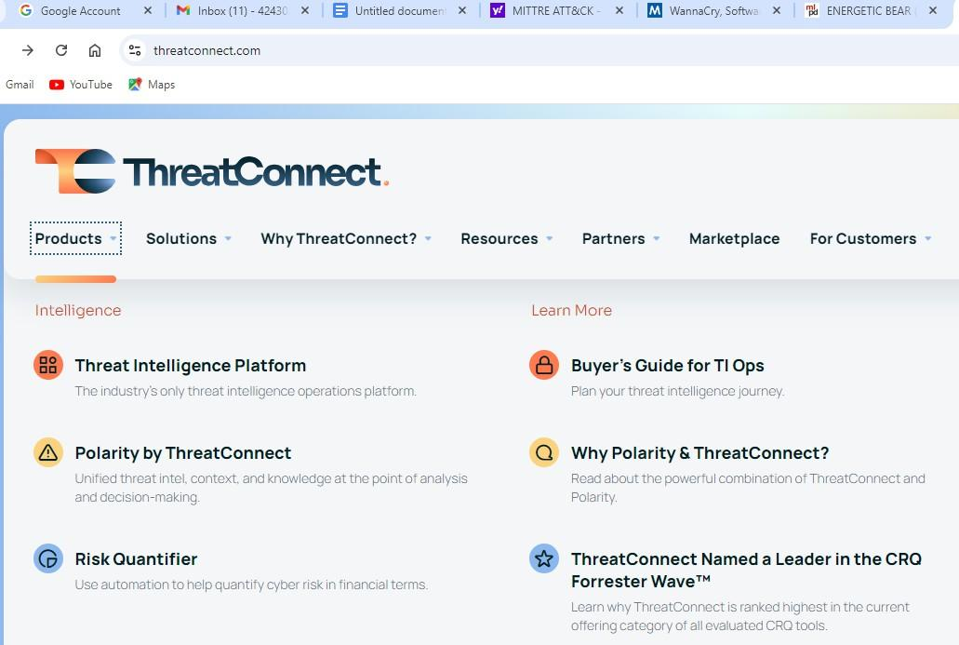
Find out the key findings in the websites and mention in detail correlate the data you finded you can get the threat intelligence and hunting report on crowdstrike.
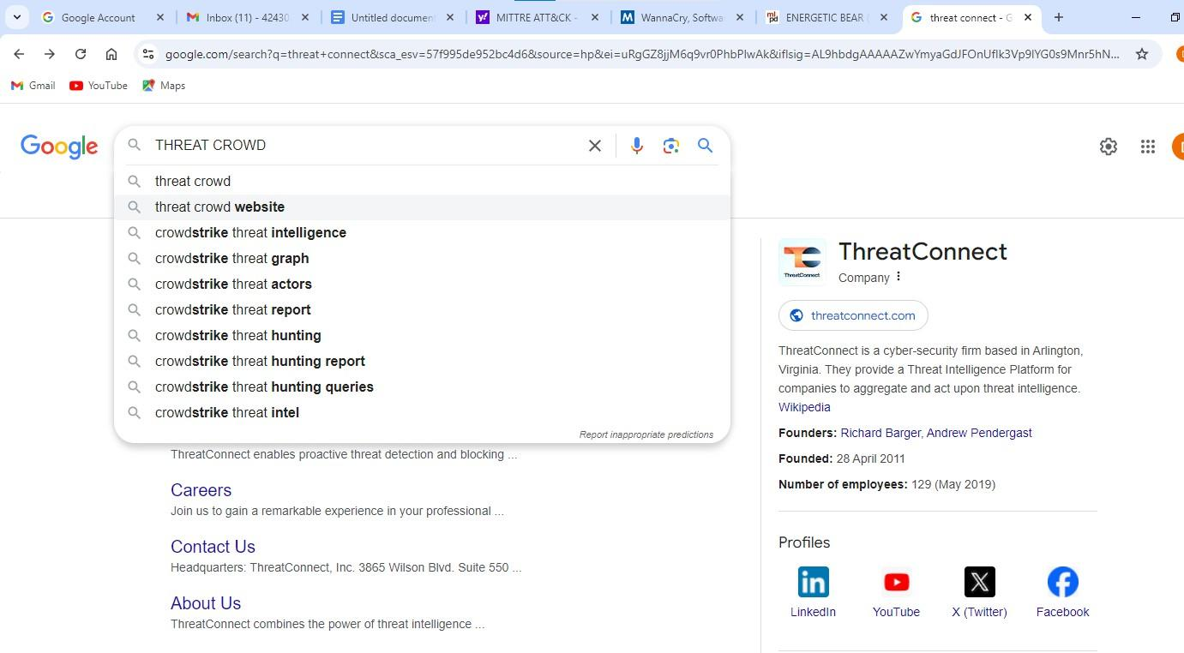
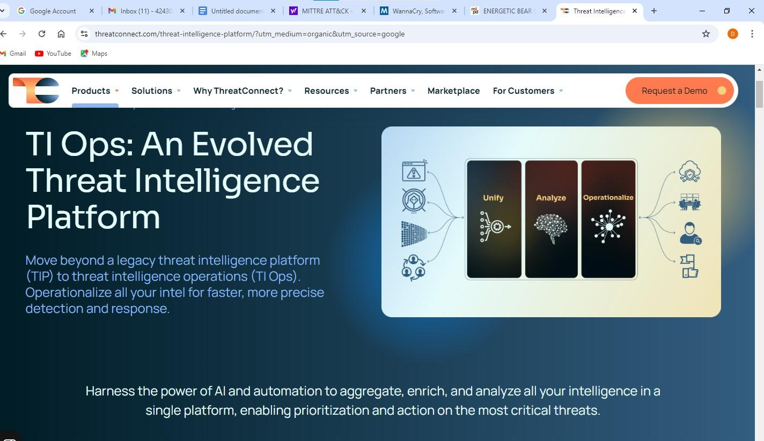
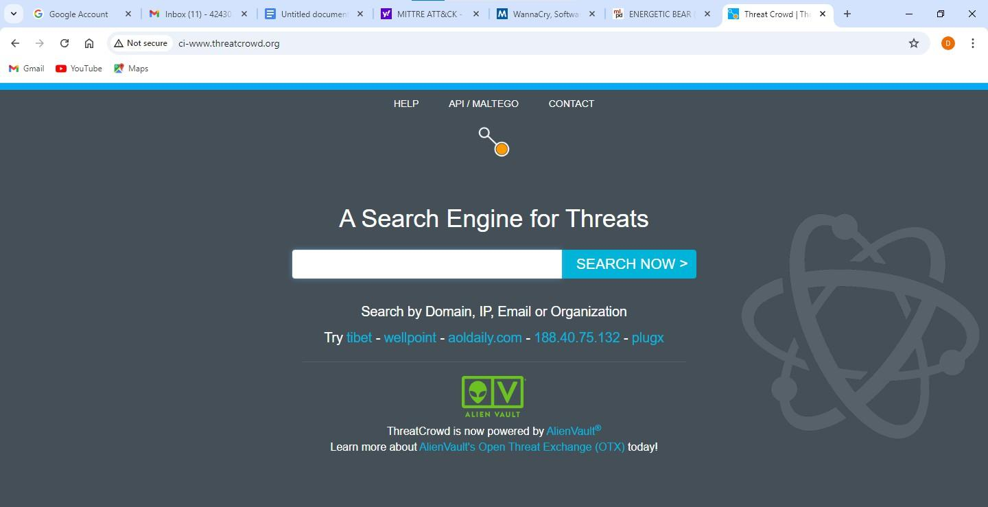
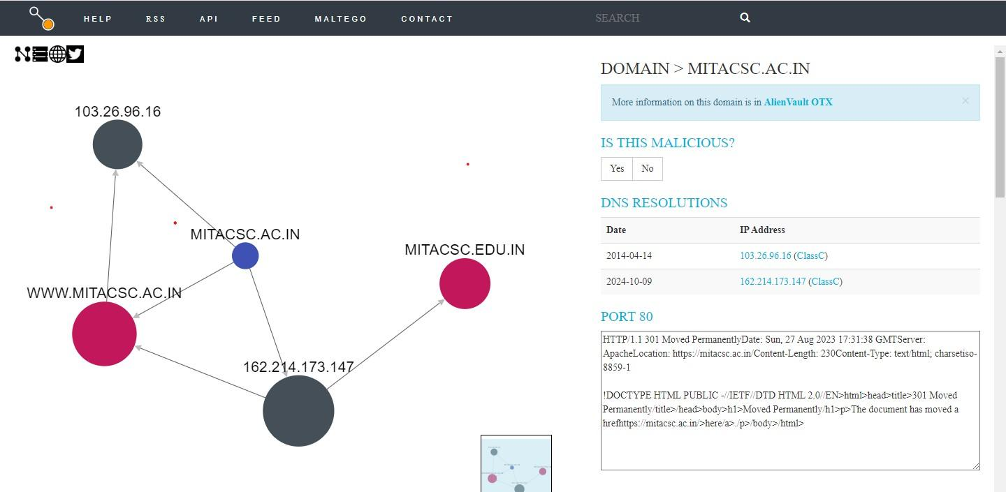
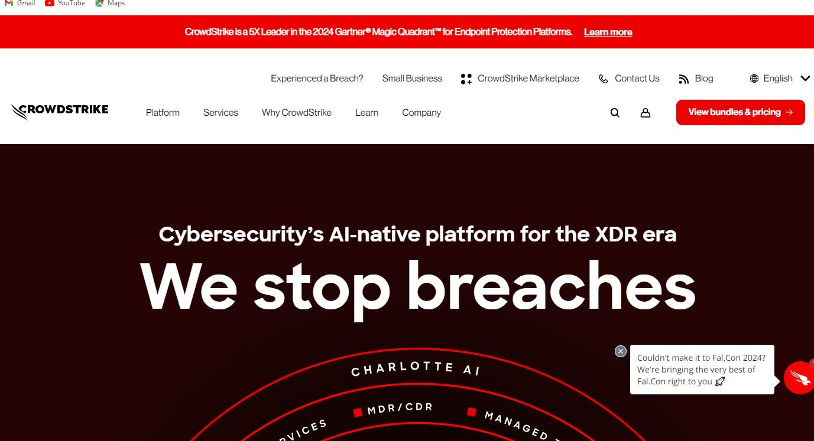

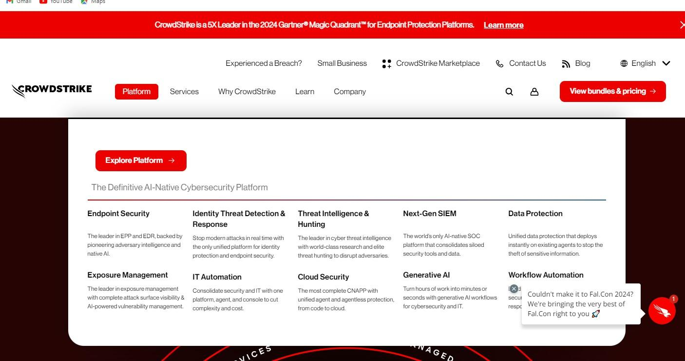
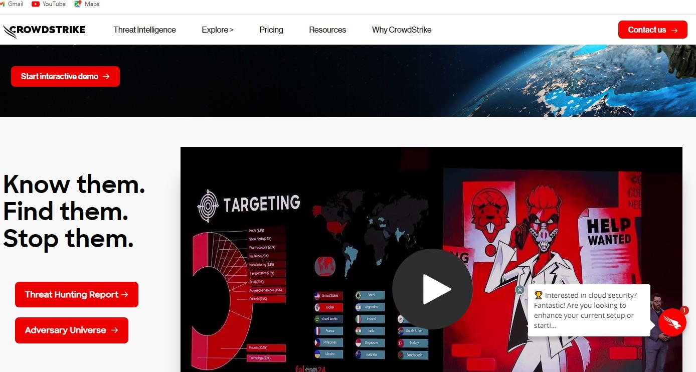

Download the report on the website.

Slip 8:

Q1:
Use AlienVault’s Open Threat Exchange (OTX) to investigate a recent cyber threat and list the IoCs associated with it.

Solution:
Search for the website
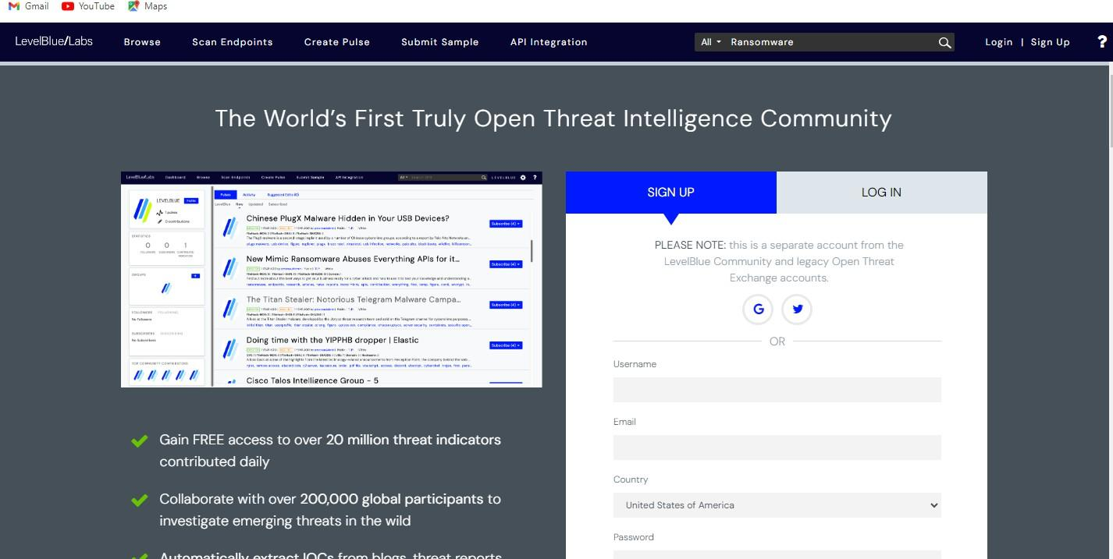
Search for the attack or threat you want to explore
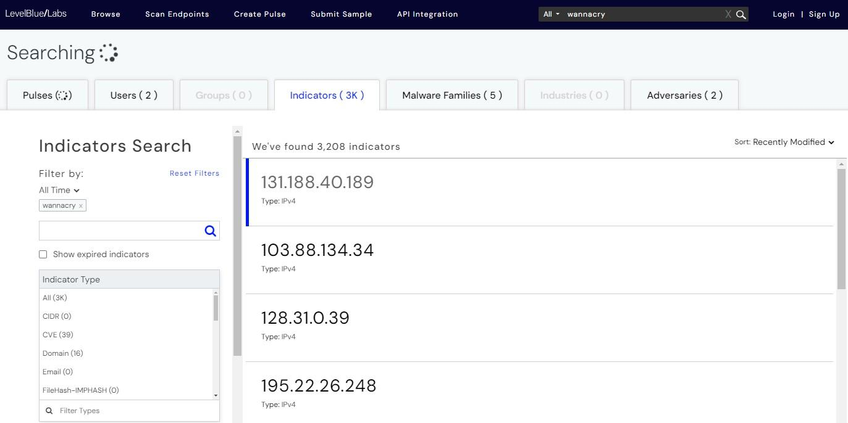
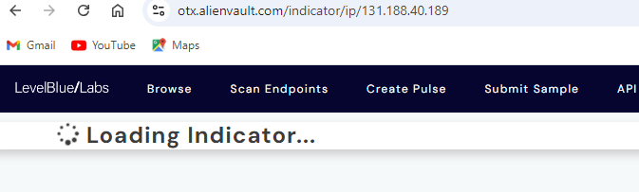
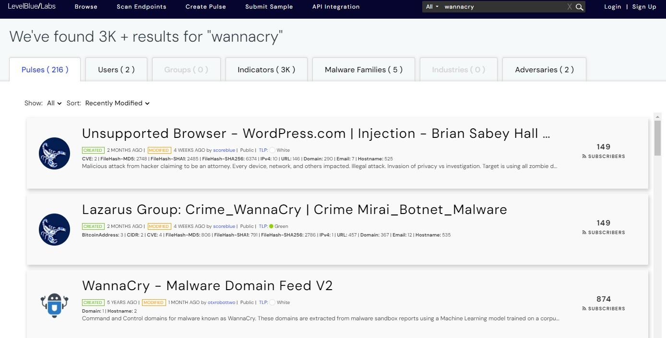
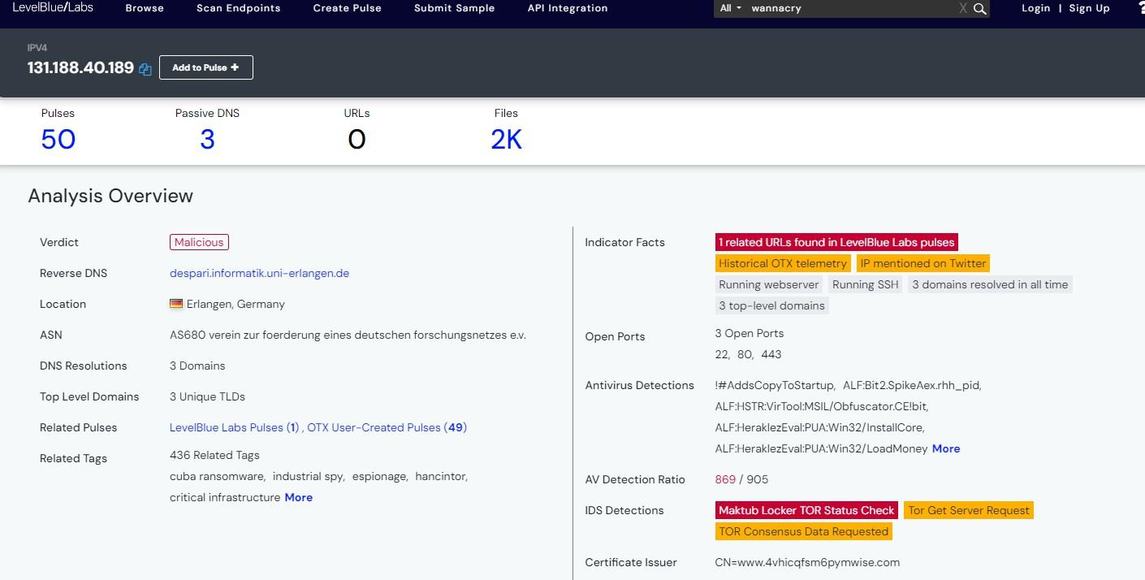
Q2:

Analyze network traffic logs using a tool like Splunk to identify suspicious patterns or potential threa

Incomplete

Slip 9:

Q.1) Analyze a malware sample using online sandboxes (e.g., Any.Run or Cuckoo) to extract
threat intelligence data such as network connections, file modifications, and registry changes.

Solution:
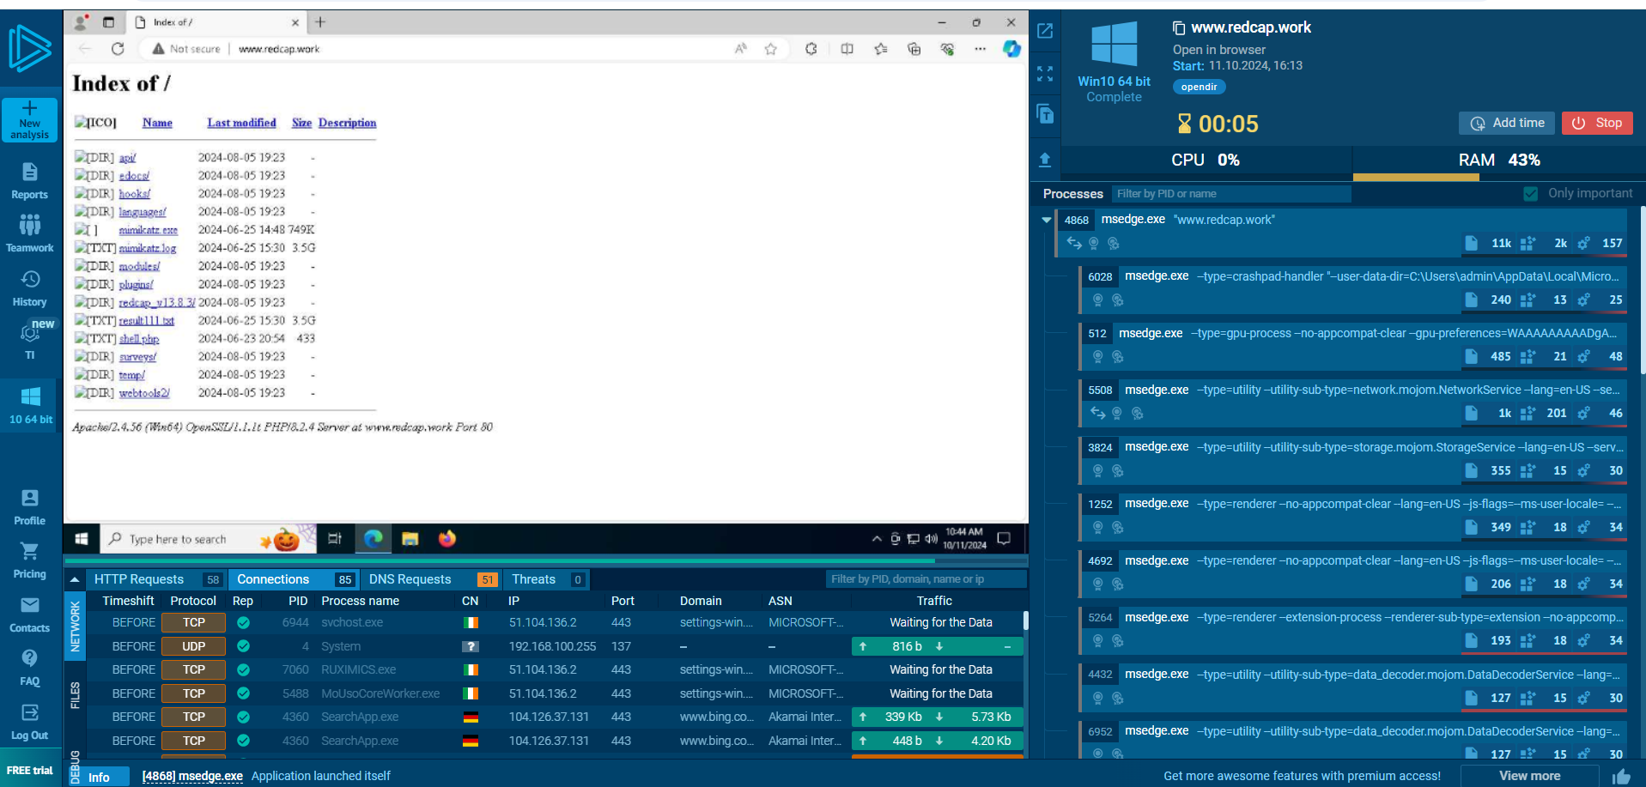
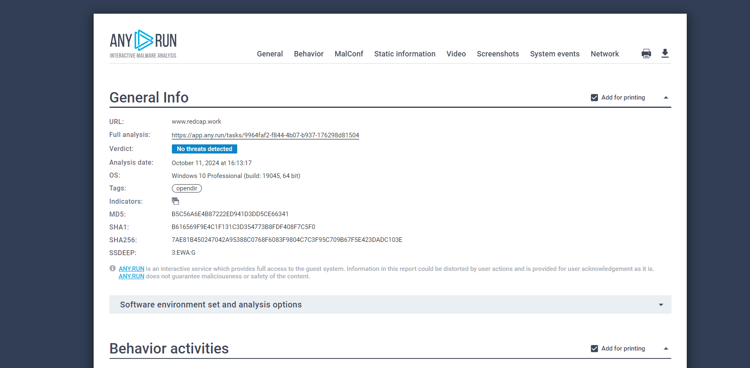

Q.2) Use a geo-IP tool to trace the origin of an attack and correlate it with known threat actors
from a particular region.

Solution:

Geo-IP Tool:

IPinfo.io

MaxMind GeoIP

WhoisXML API

GeoIP2

Select a particular malicious IP address: 120.78.65.206

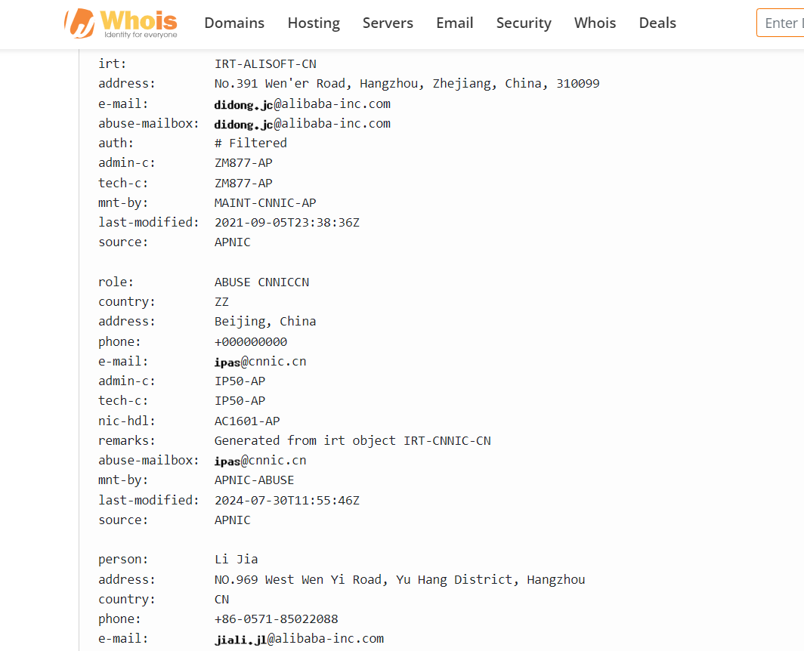

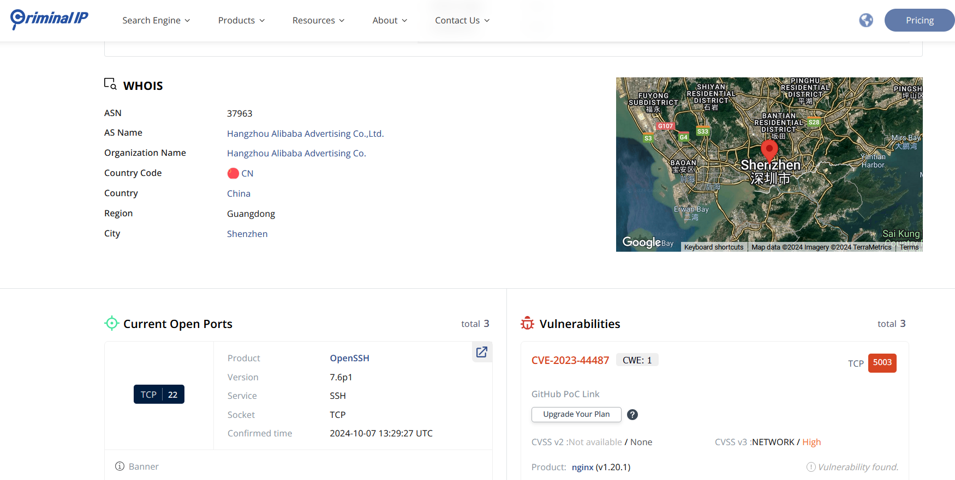

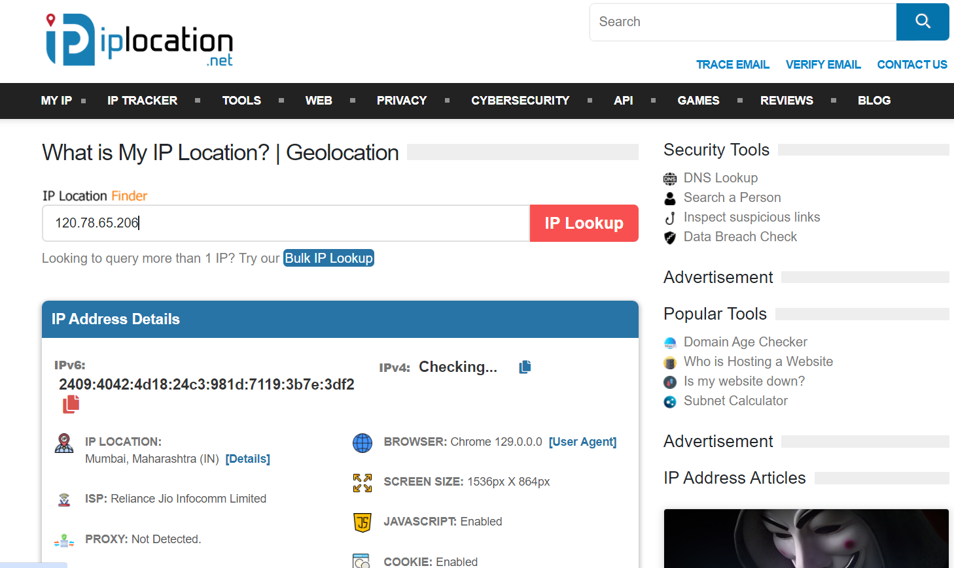

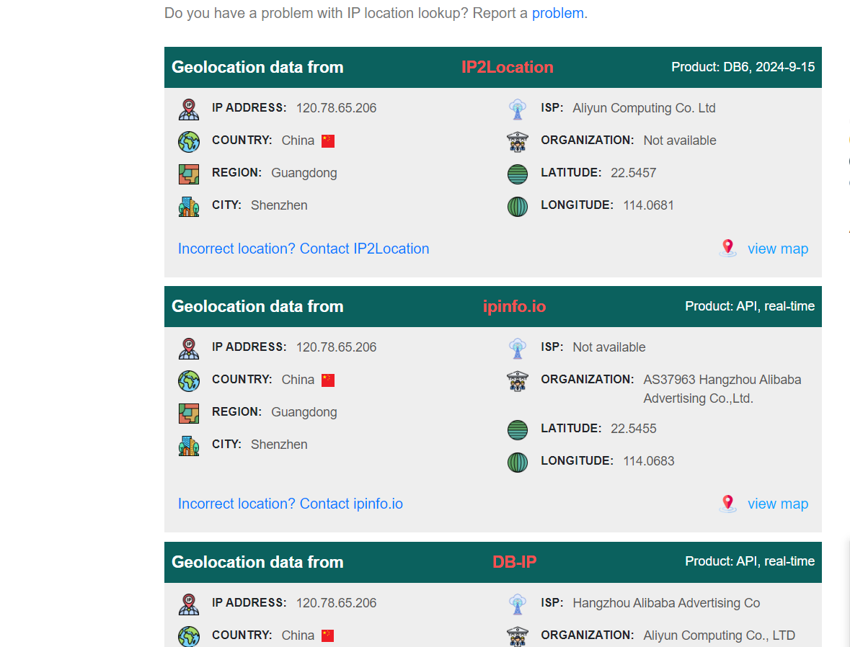

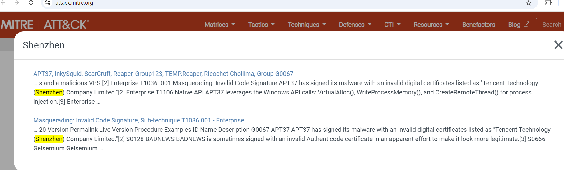

These are ethe attacks performed through the particular region of the IP address.

Slip 10:

Q.1) Investigate and analyze threat feeds (e.g., AbuseIPDB, Spamhaus) to compile a list of

malicious IPs associated with recent attacks.

Solution:

Search for the database of recent malicious IPs.

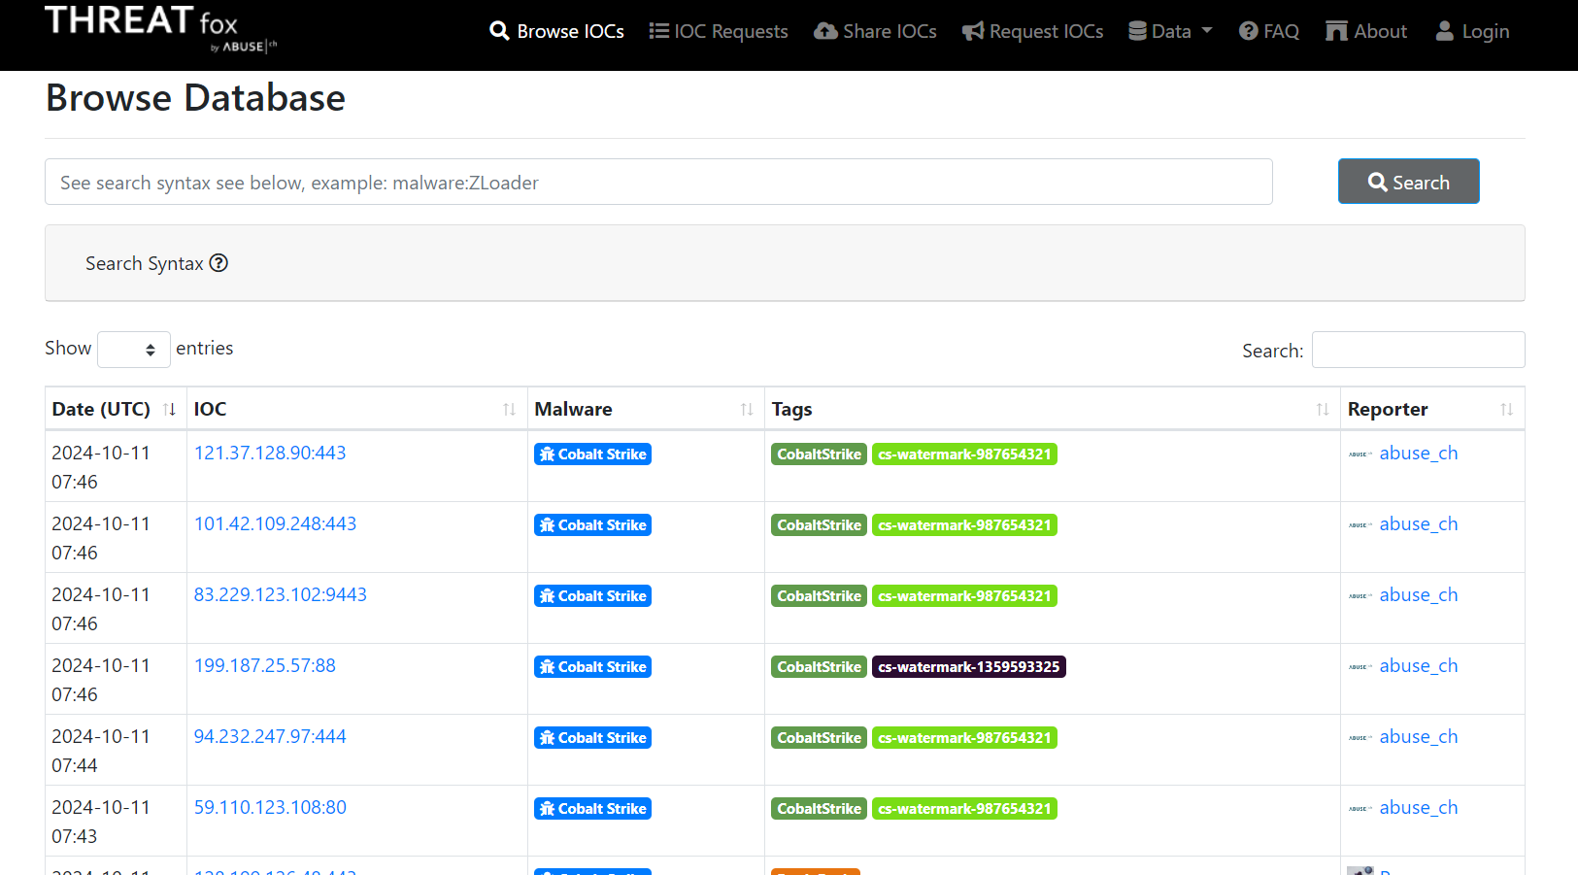

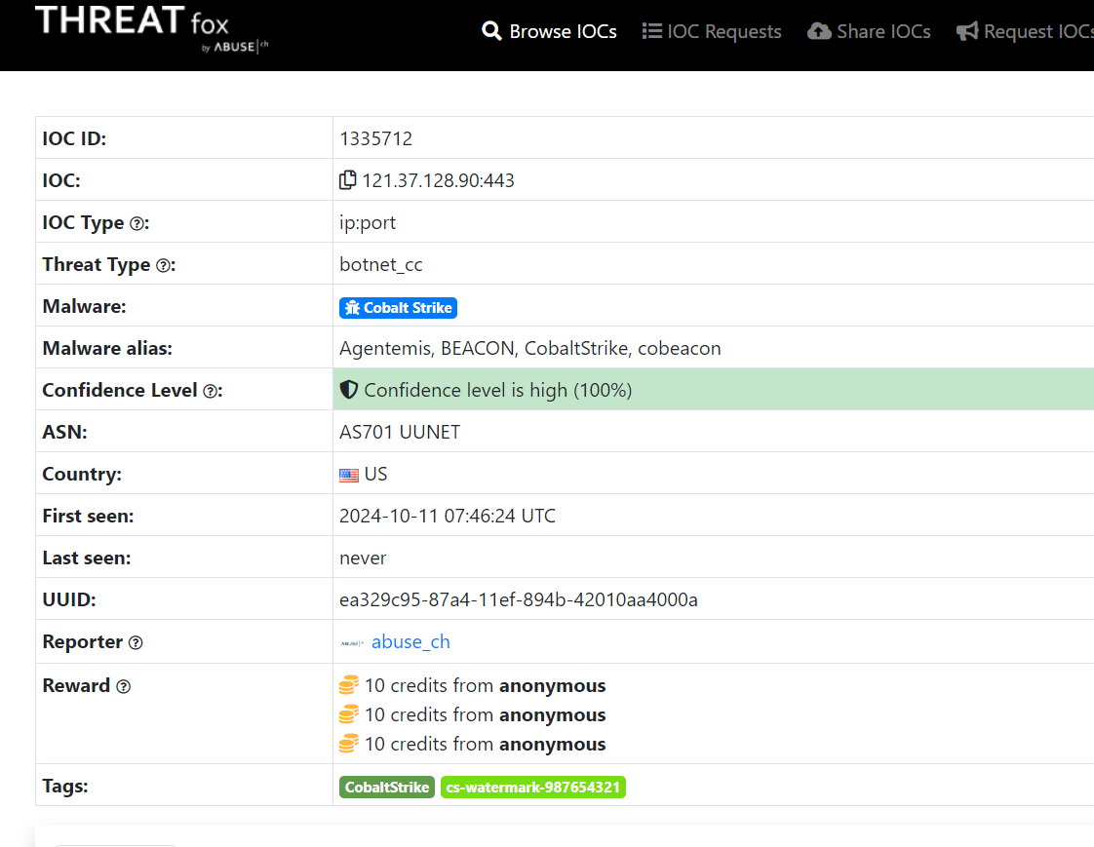

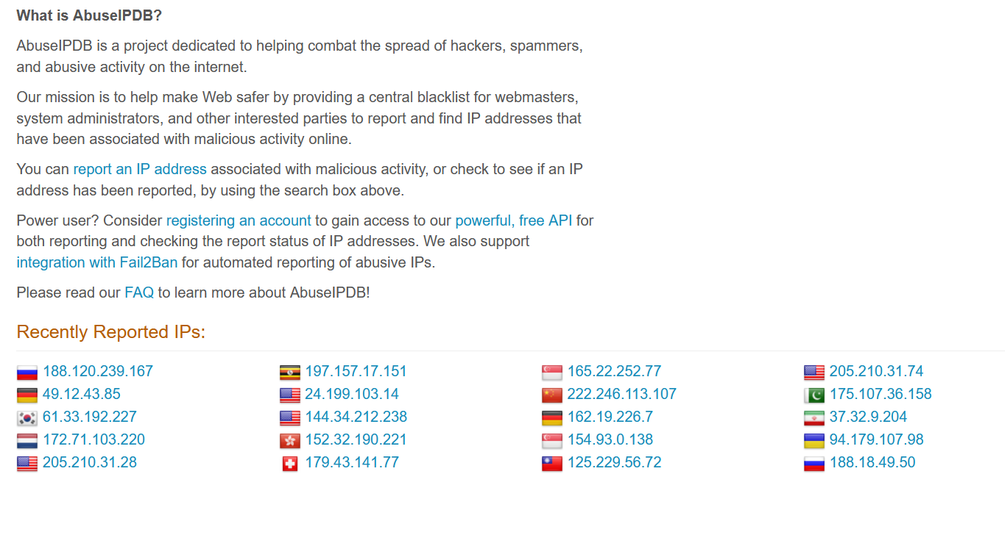

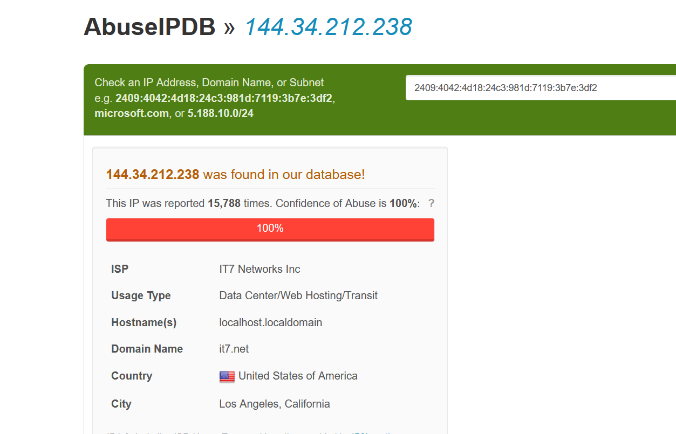


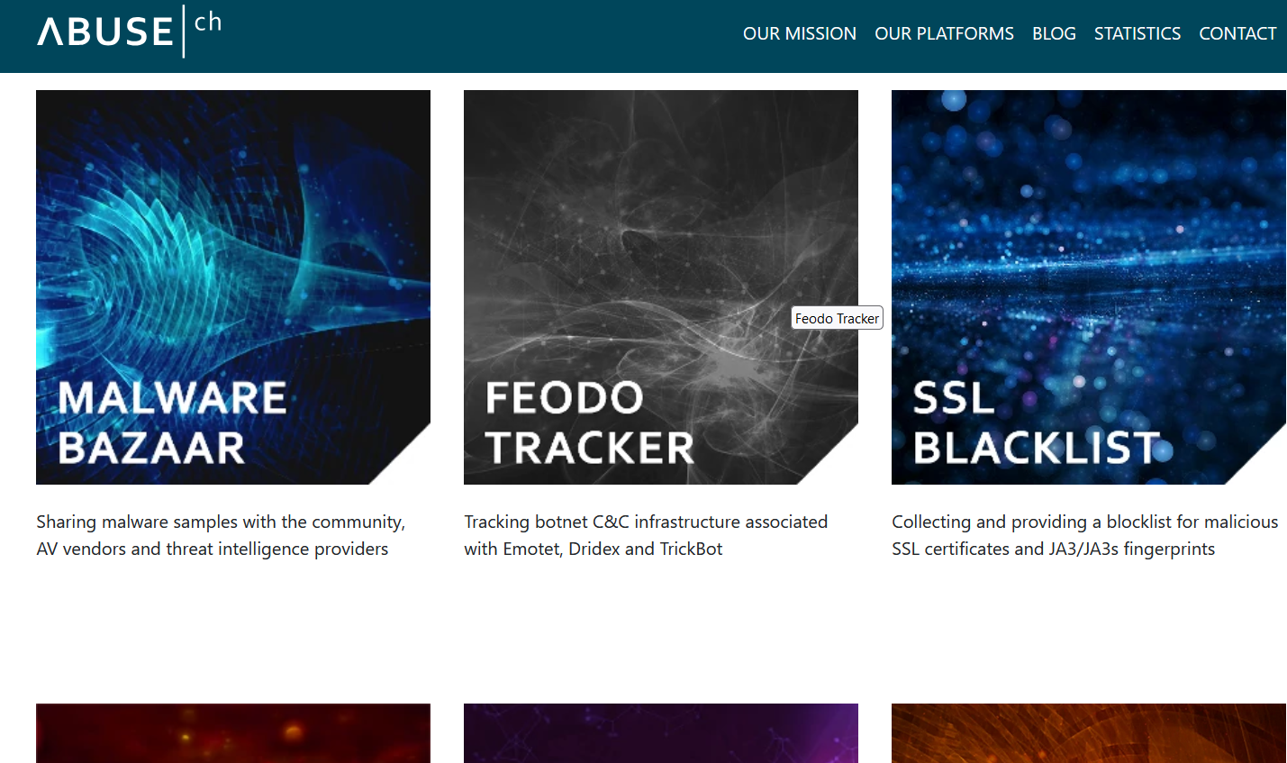
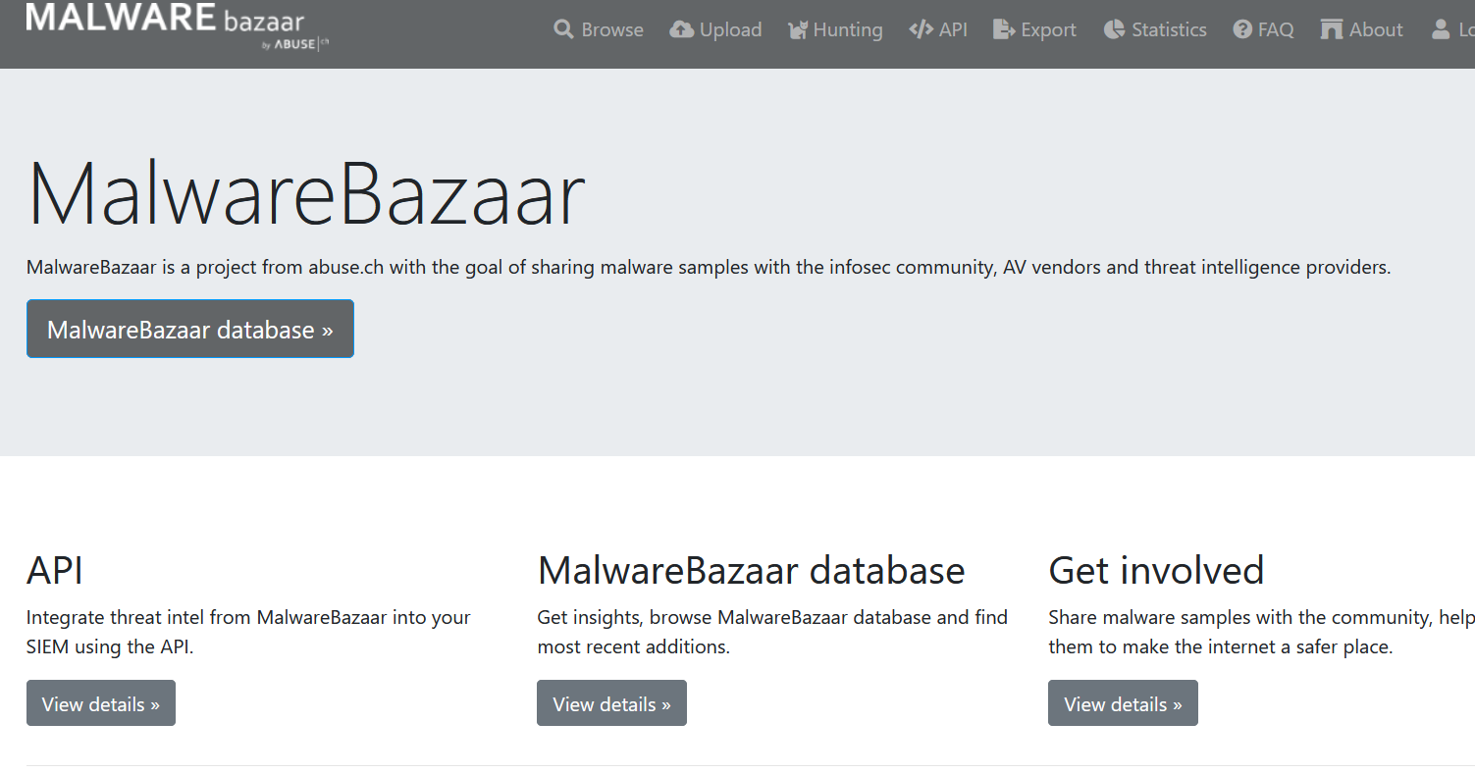
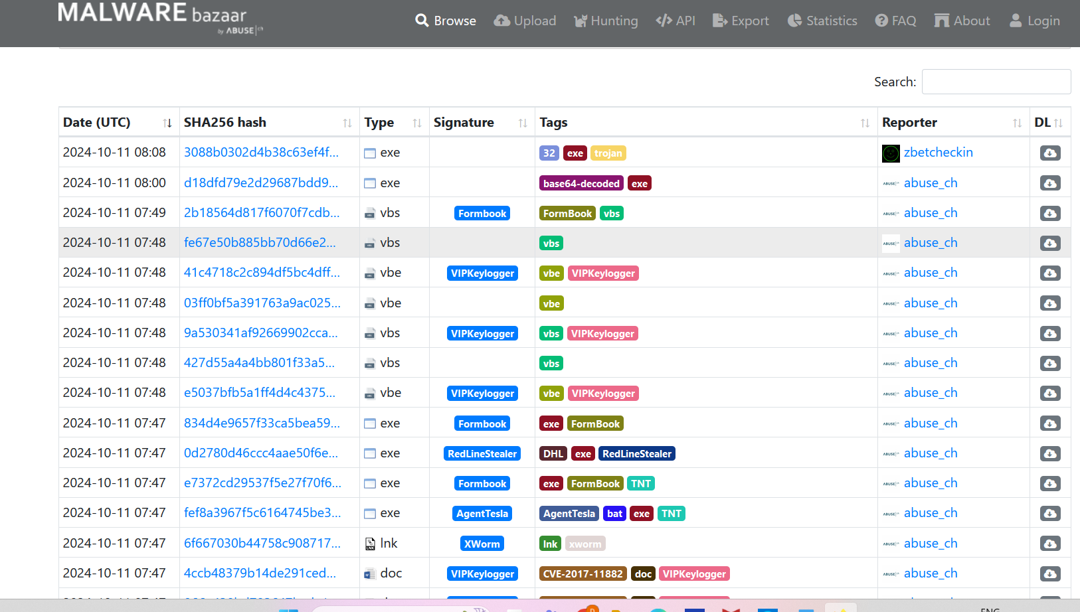
By using all these websites, we can collect the data of malicious IP addresses.

Q.2) Use the Cyber Kill Chain model to map out the stages of a real-world cyber-attack and identify the attacker’s methods.

Solution:

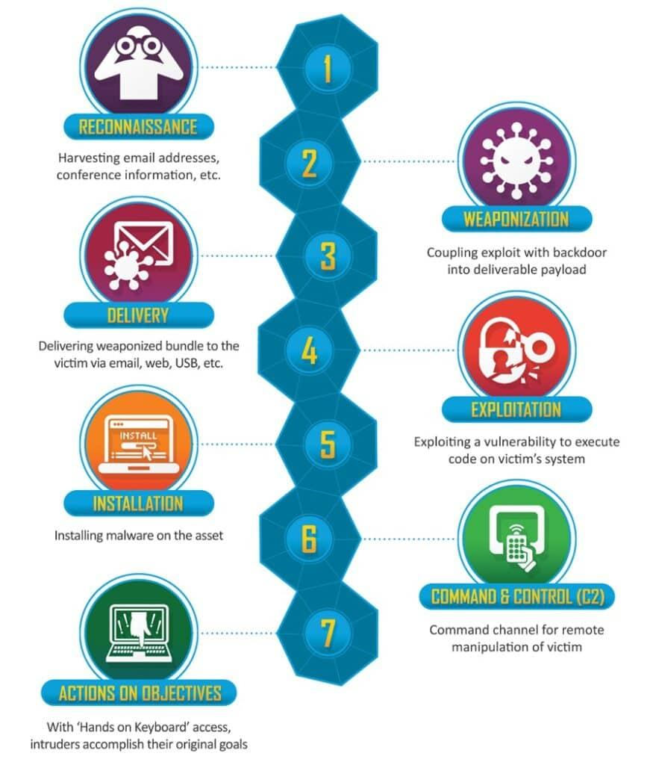

Slip 11:

Q.1) Use the MITRE ATT&CK framework to analyze an advanced persistent threat (APT) and
identify its TTPs.
Solution:
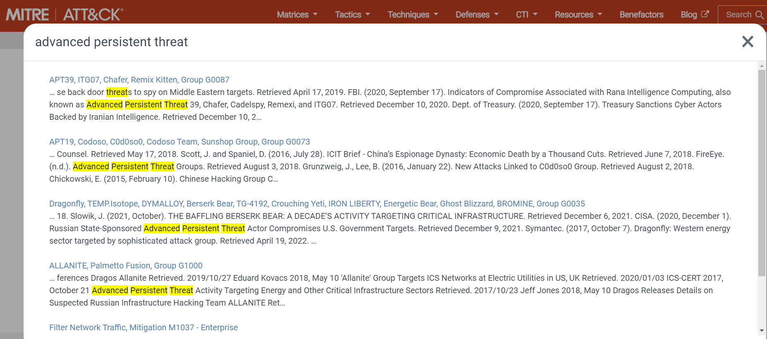

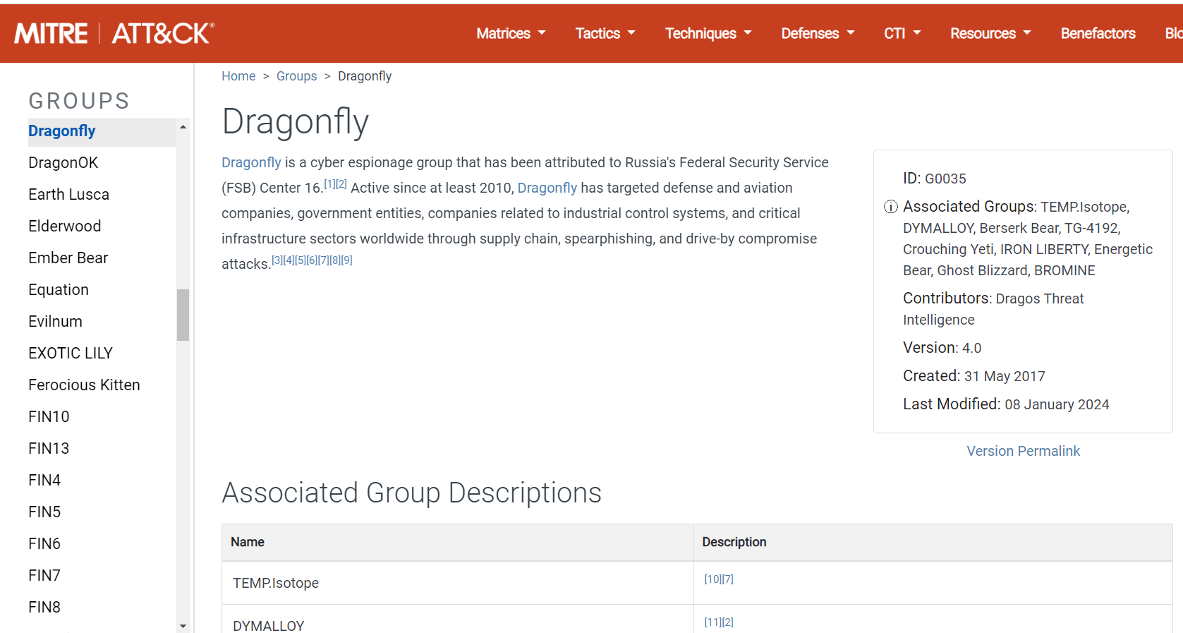
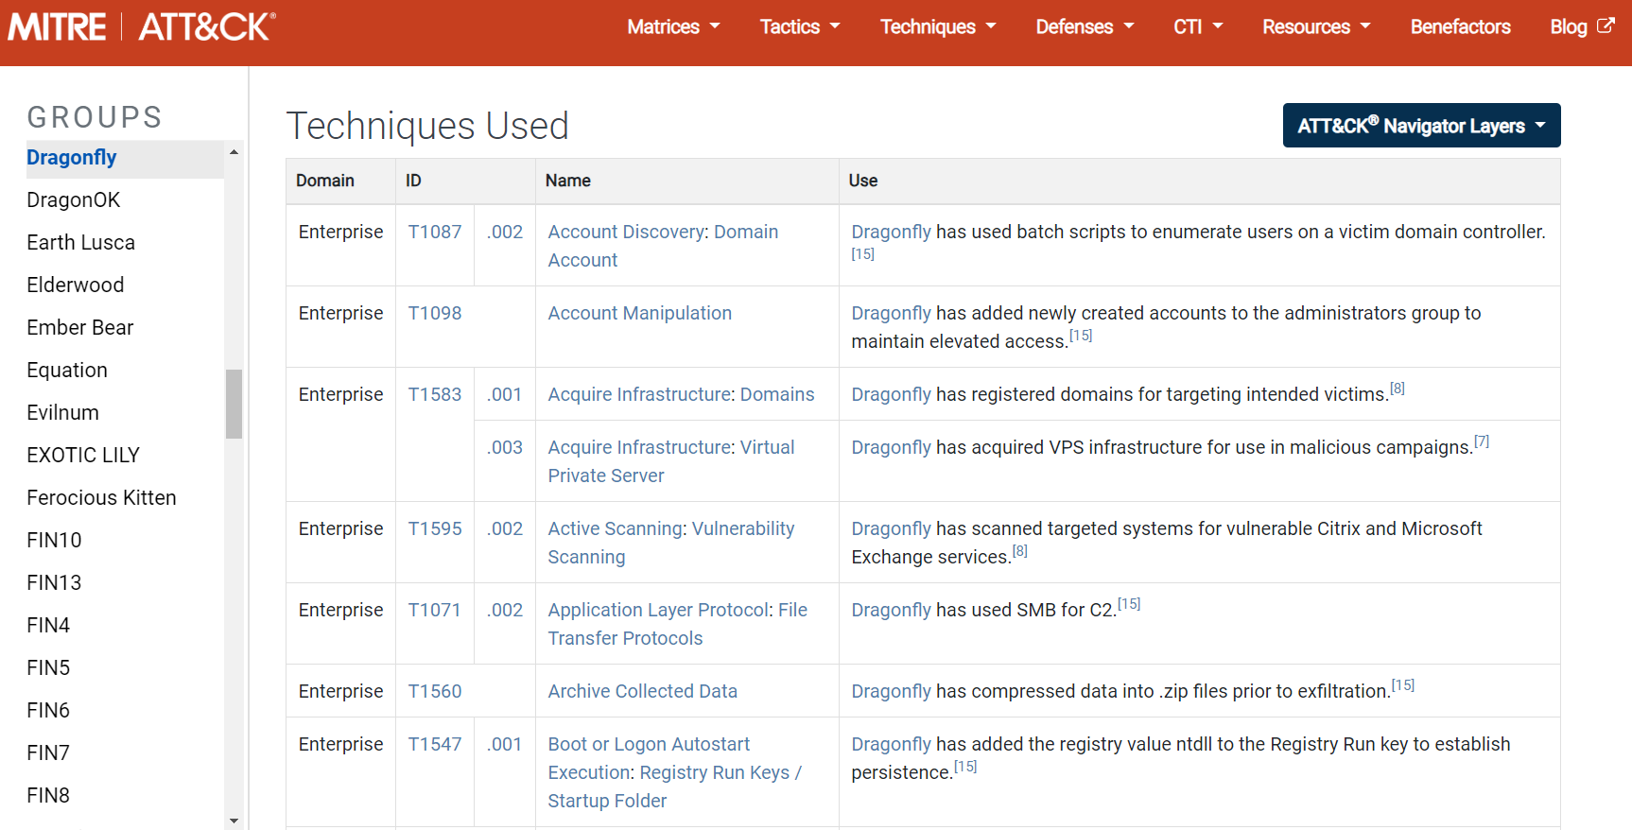
Q.2) Analyze a suspicious URL using ThreatCrowd and determine its threat level based on
associated IPs, domains, and files.
Solution:
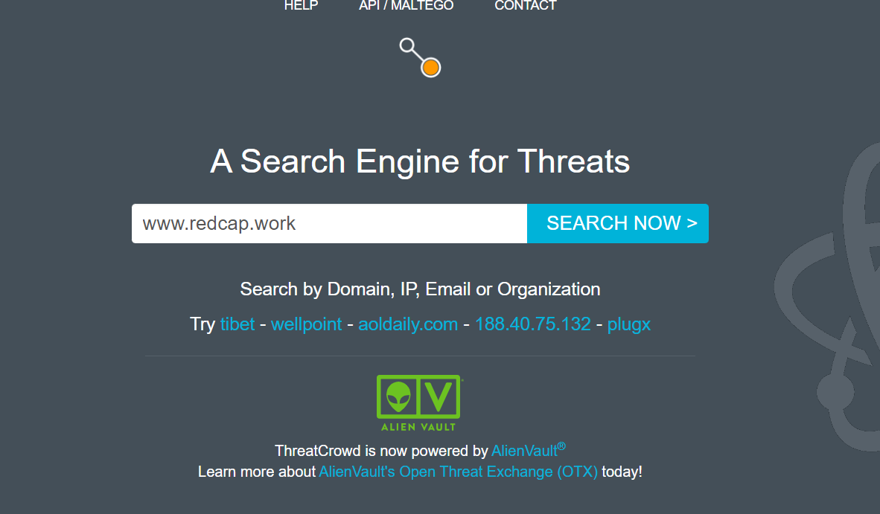
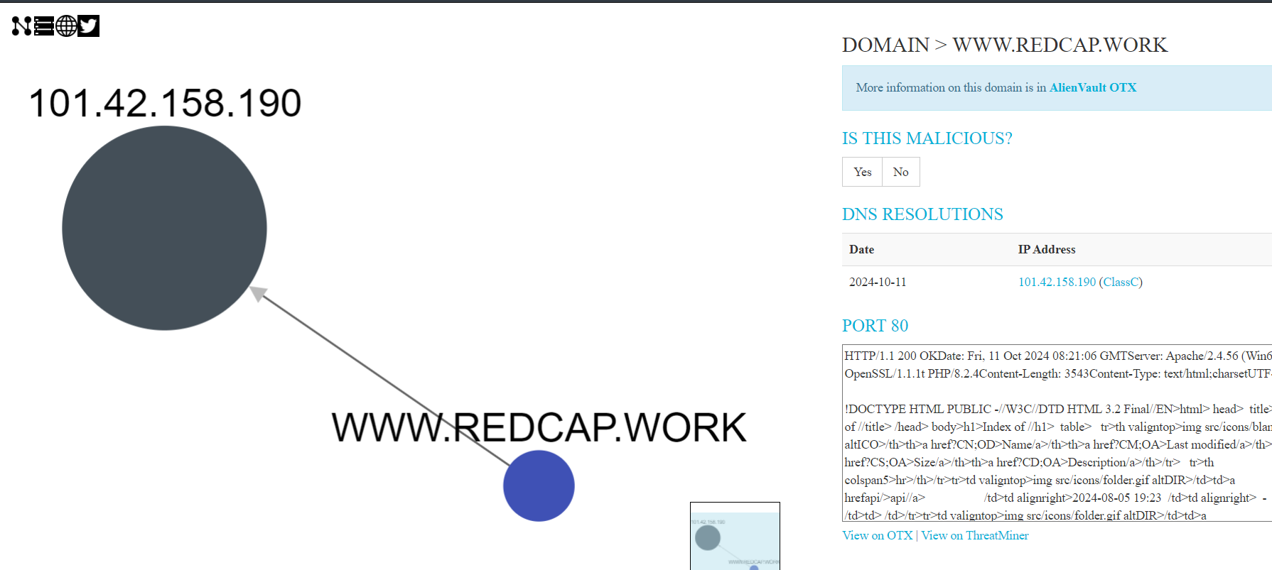

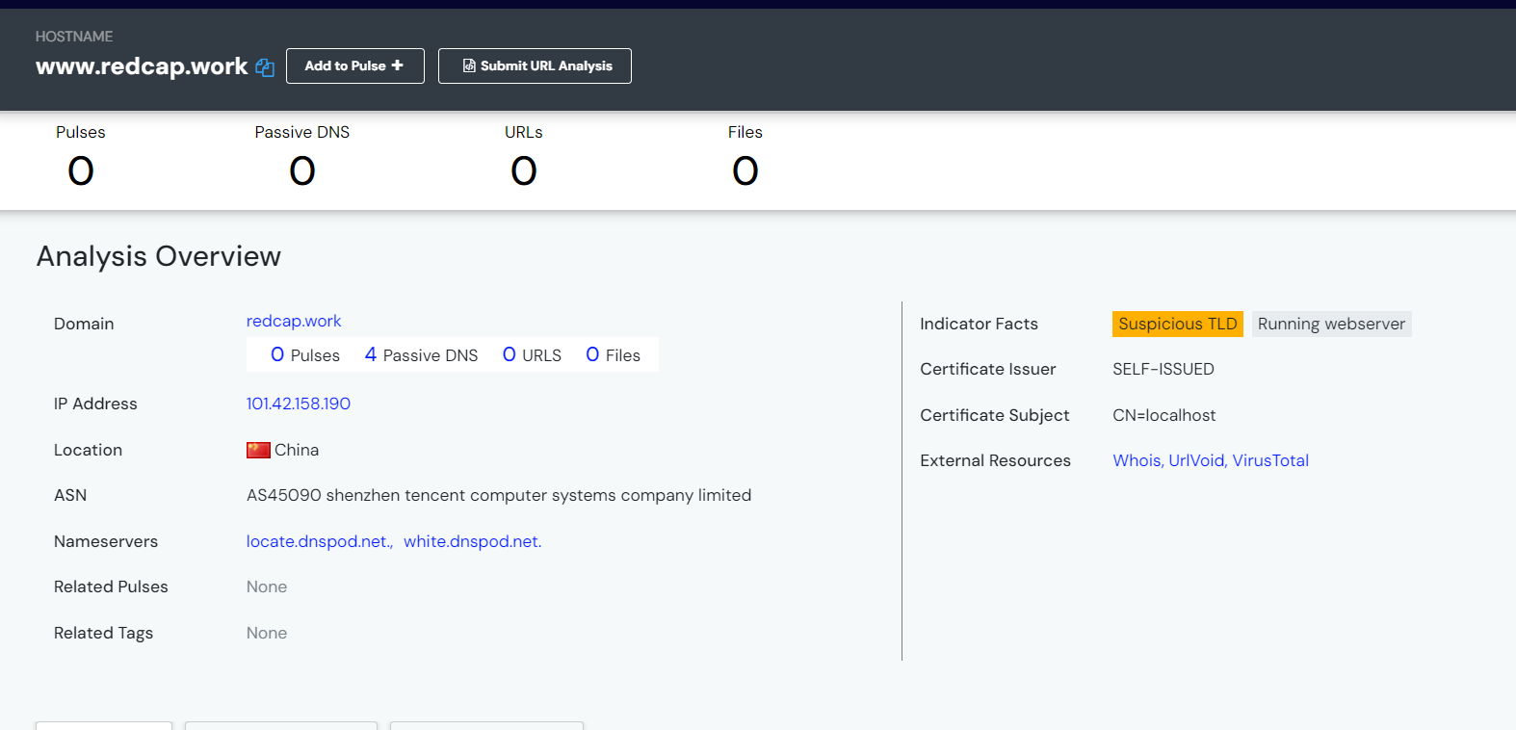
So, we will search for the IP address associated with the website on various OSINT platforms.
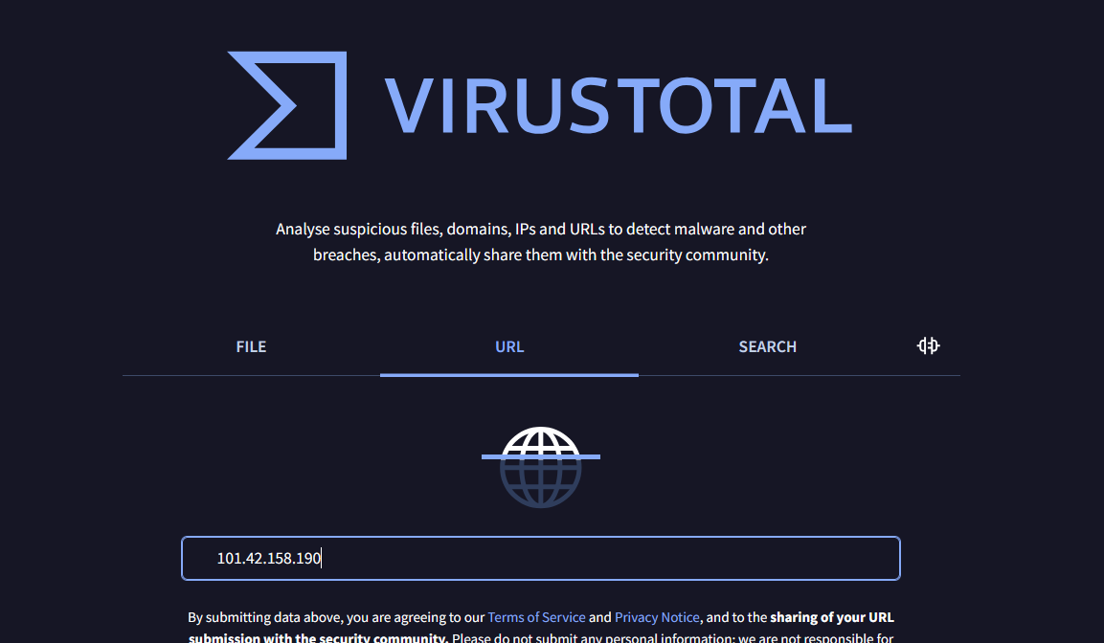
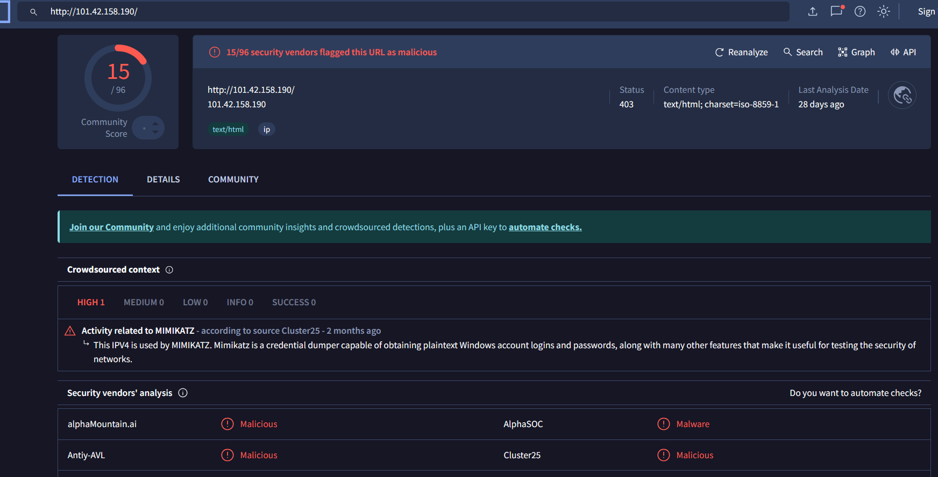

Criminalip website
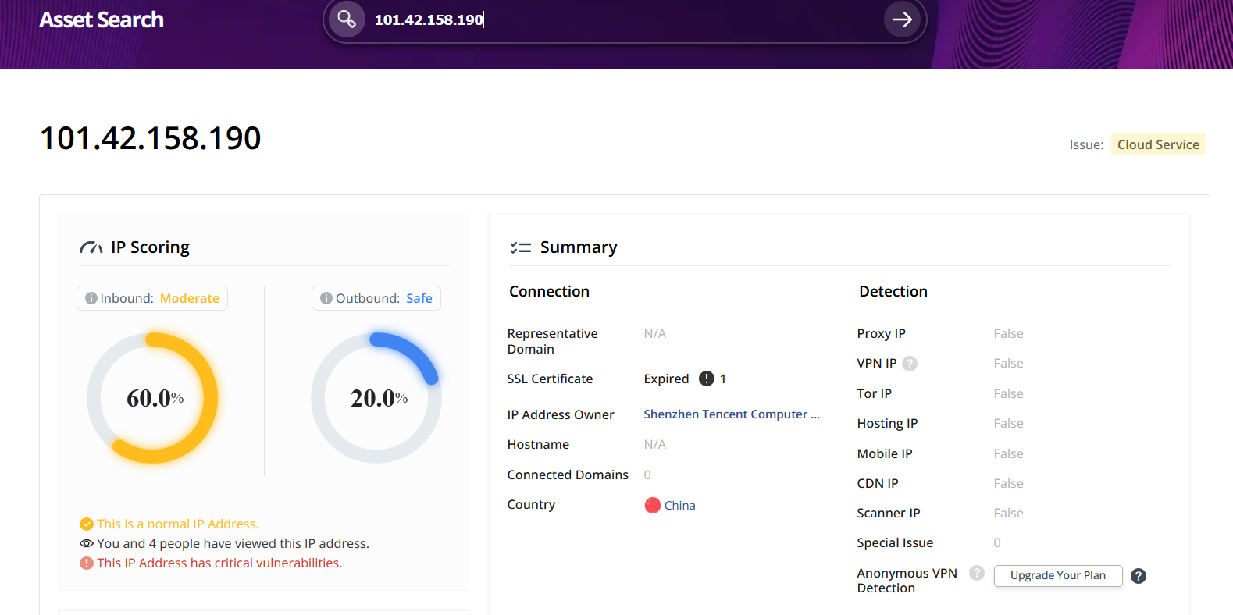By collecting and examining all the info we can say the IP is malicious.

Slip 12:
Q.1) Use a threat intelligence dashboard (e.g., ThreatMiner) to track the timeline of a cyber
attack and generate a report on its evolution.
Solution:
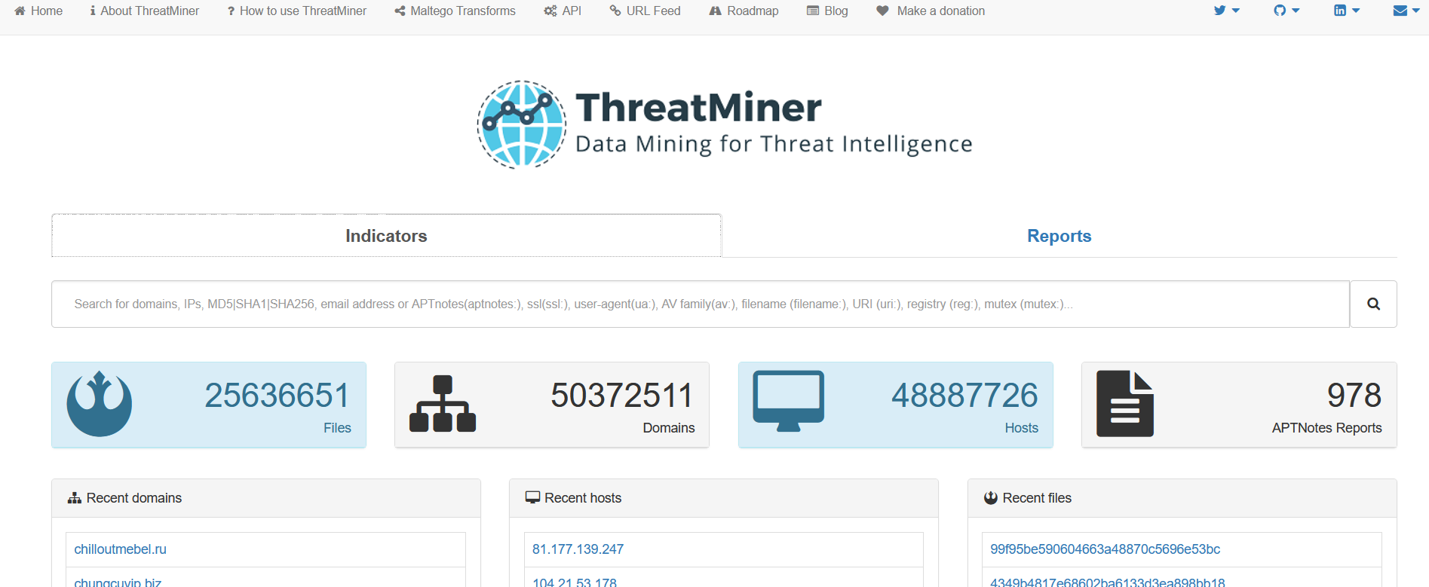

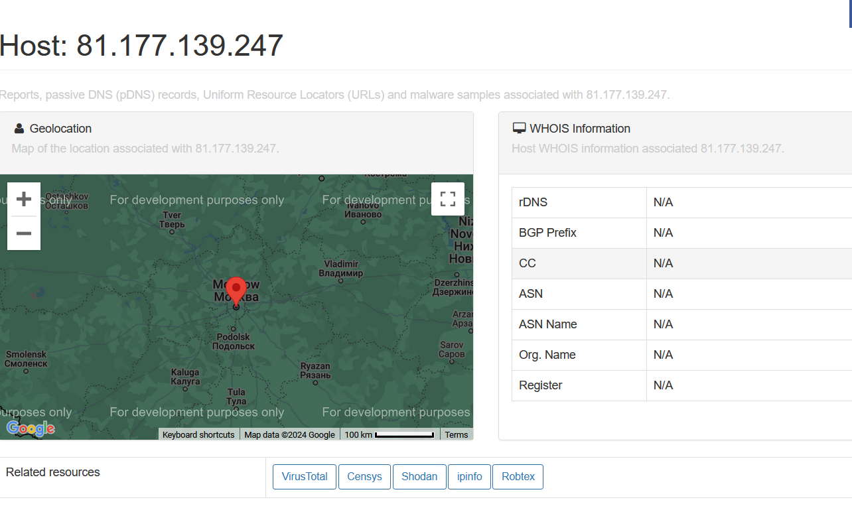
Here, they have mentioned the websites for OSINT so, we can collect data from the mentioned sources.

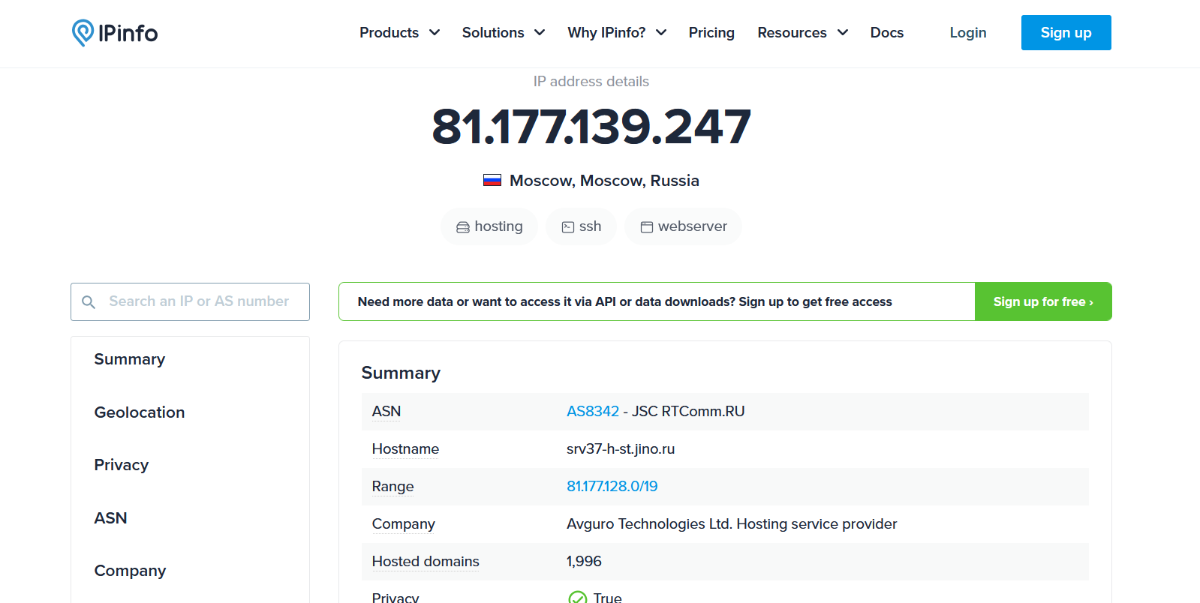

Q.2) Perform analysis of a DNS query log to detect any signs of DNS tunneling or exfiltration.

Incomplete

Slip 13:
Q.1) Use Threat Intelligence feeds to detect malicious file hashes and analyze their spread across
multiple campaigns.
Solution:
We can get malicious file hashes from malware bazaar: Abuse.ch
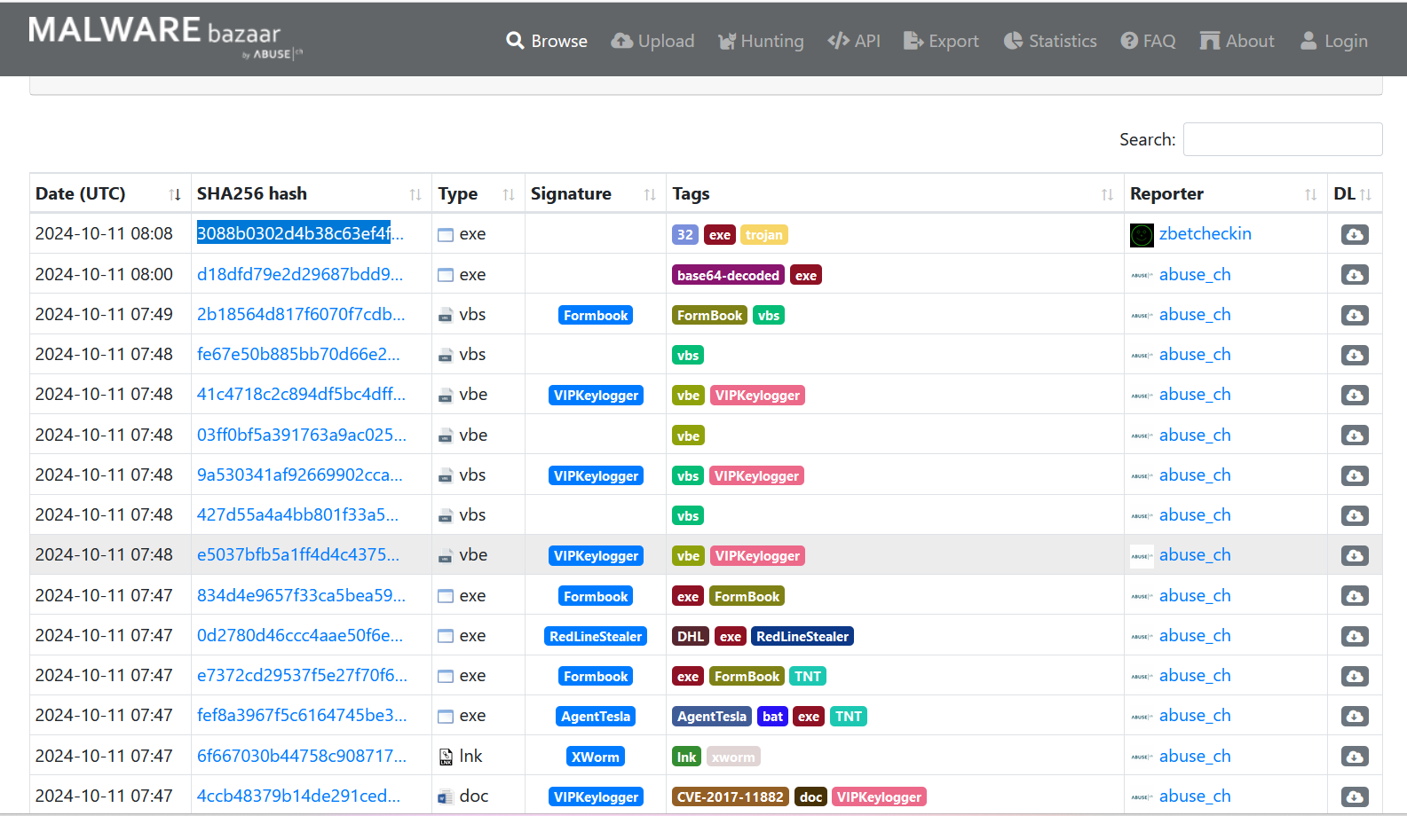
Now, we can examine these file hashes from threat intelligence feeds for e.g.:
- AlienVault Open Threat Exchange (OTX) 4. Anomali
- VirusTotal 5. Recorded Future
- Cisco Talos Intelligence

Cisco Talos Intelligence platform:
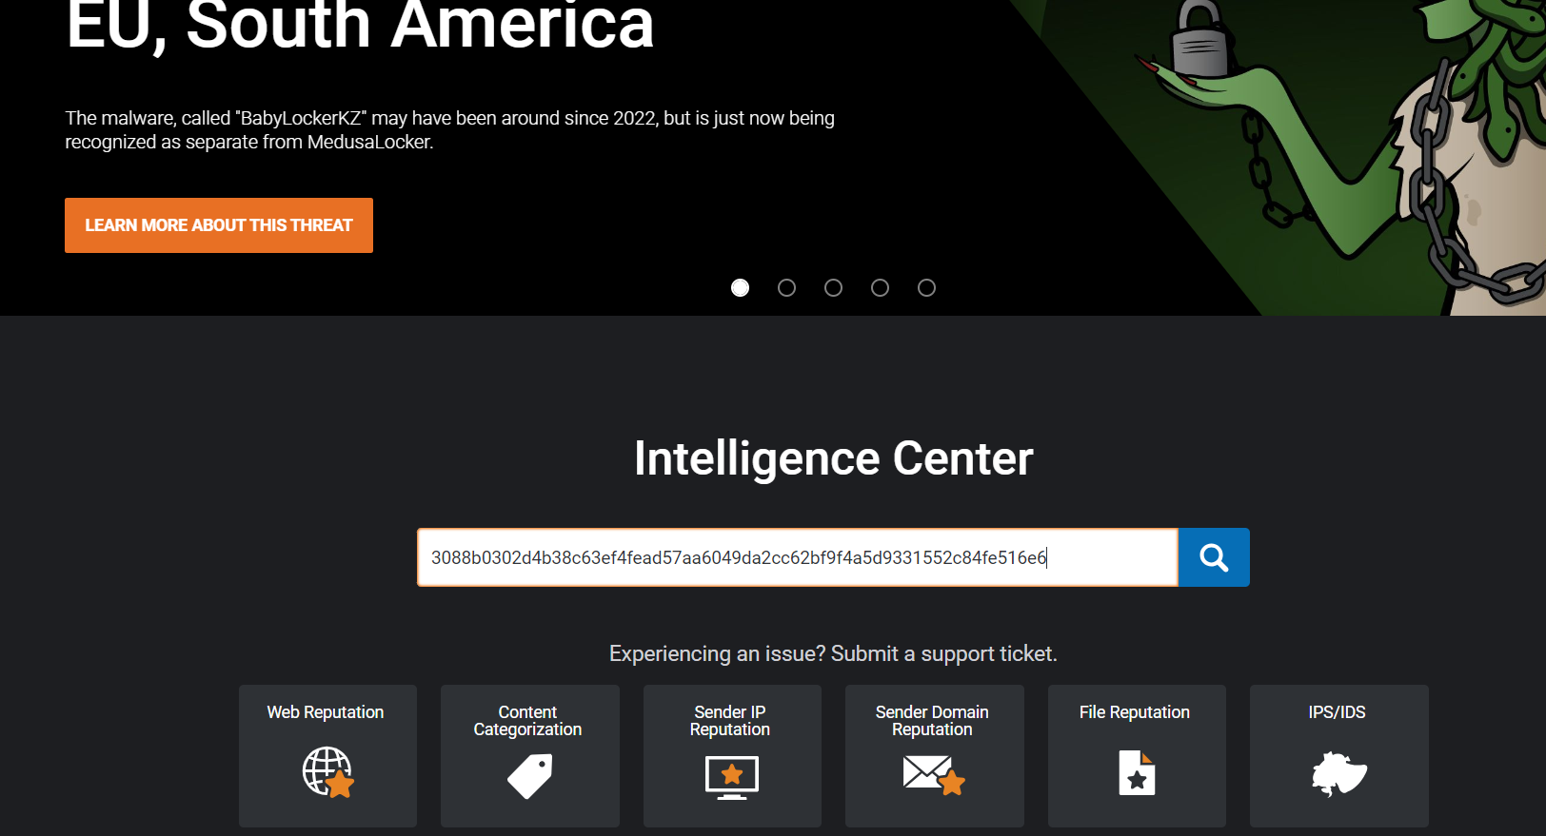
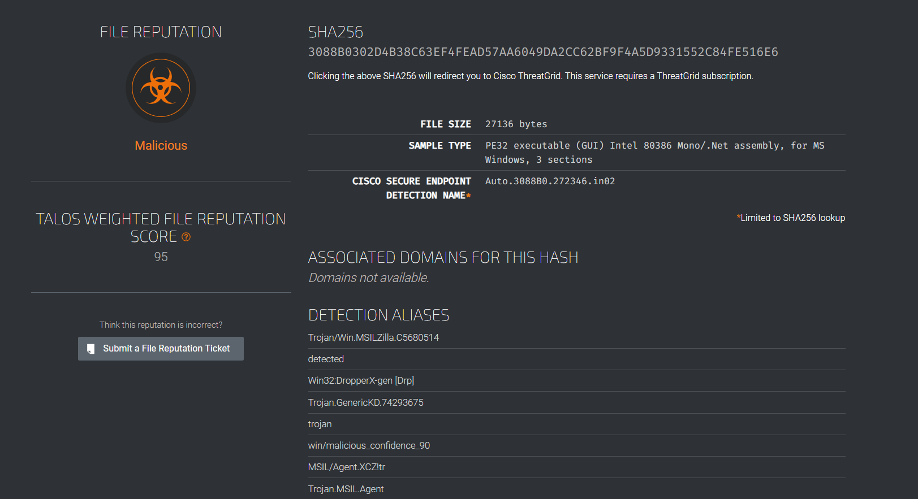
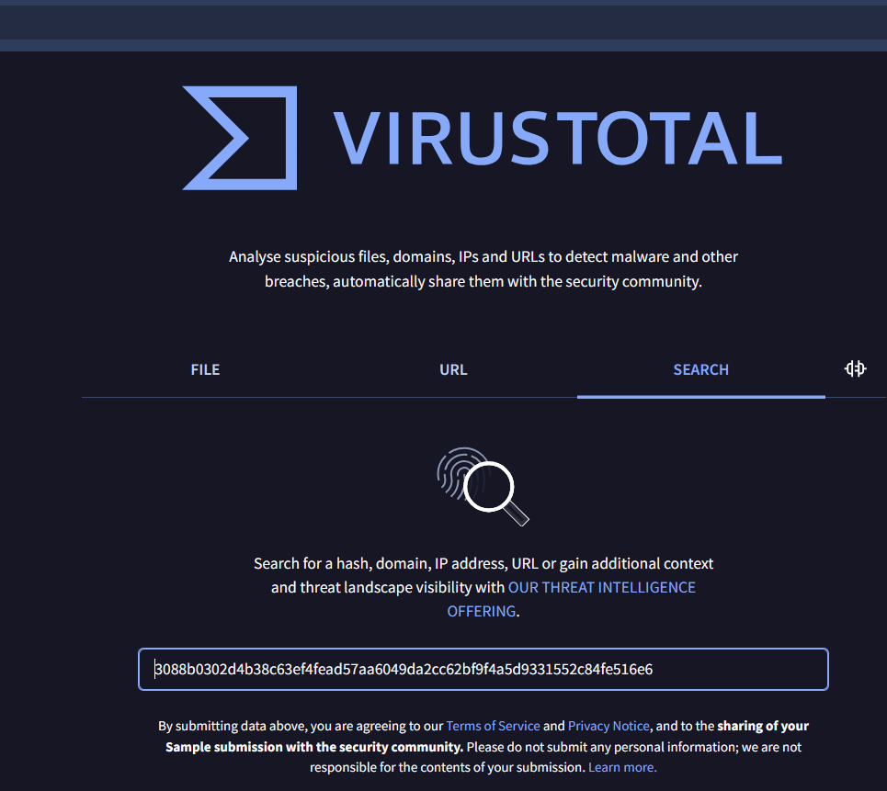
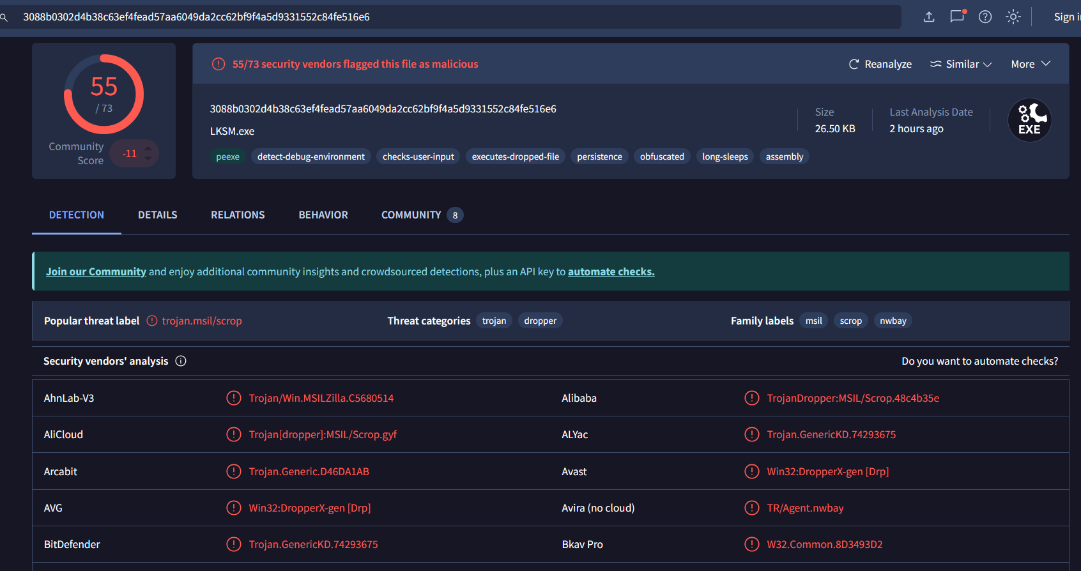
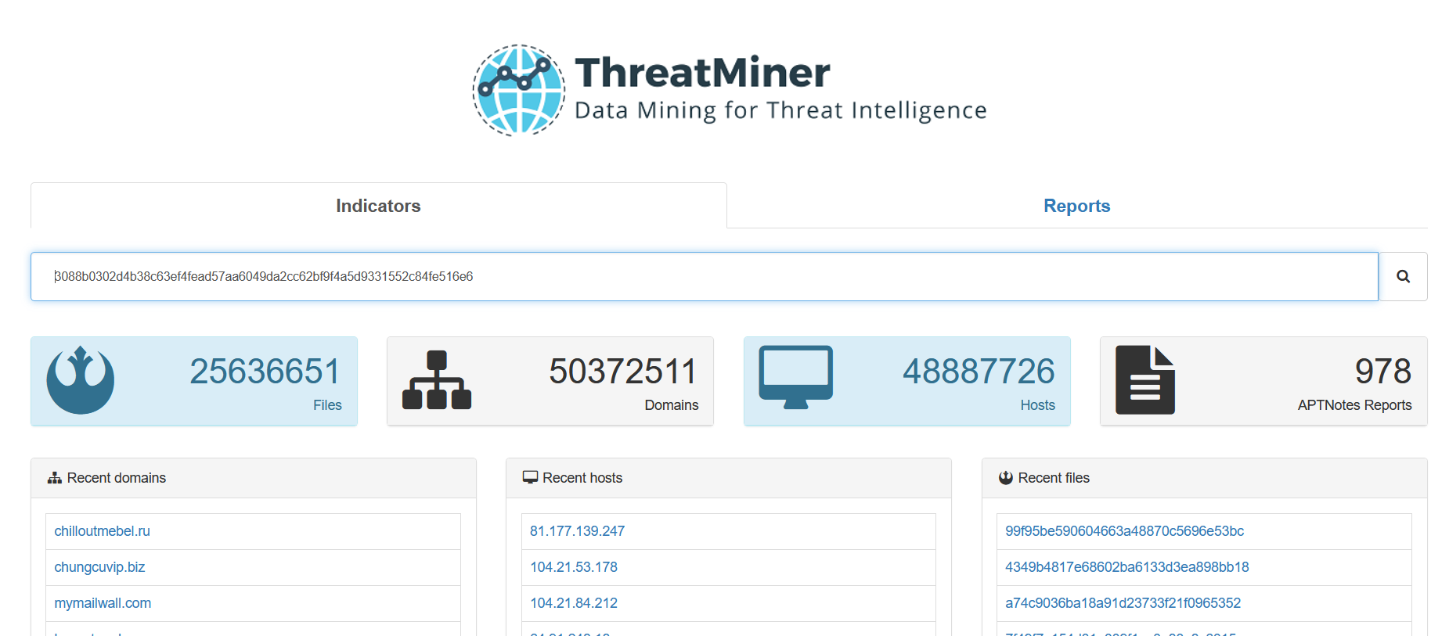
On threatminer we will find the google analysis of the provided hash.
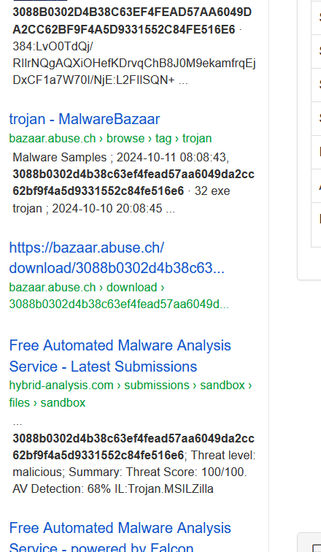
Hybrid analysis for hash
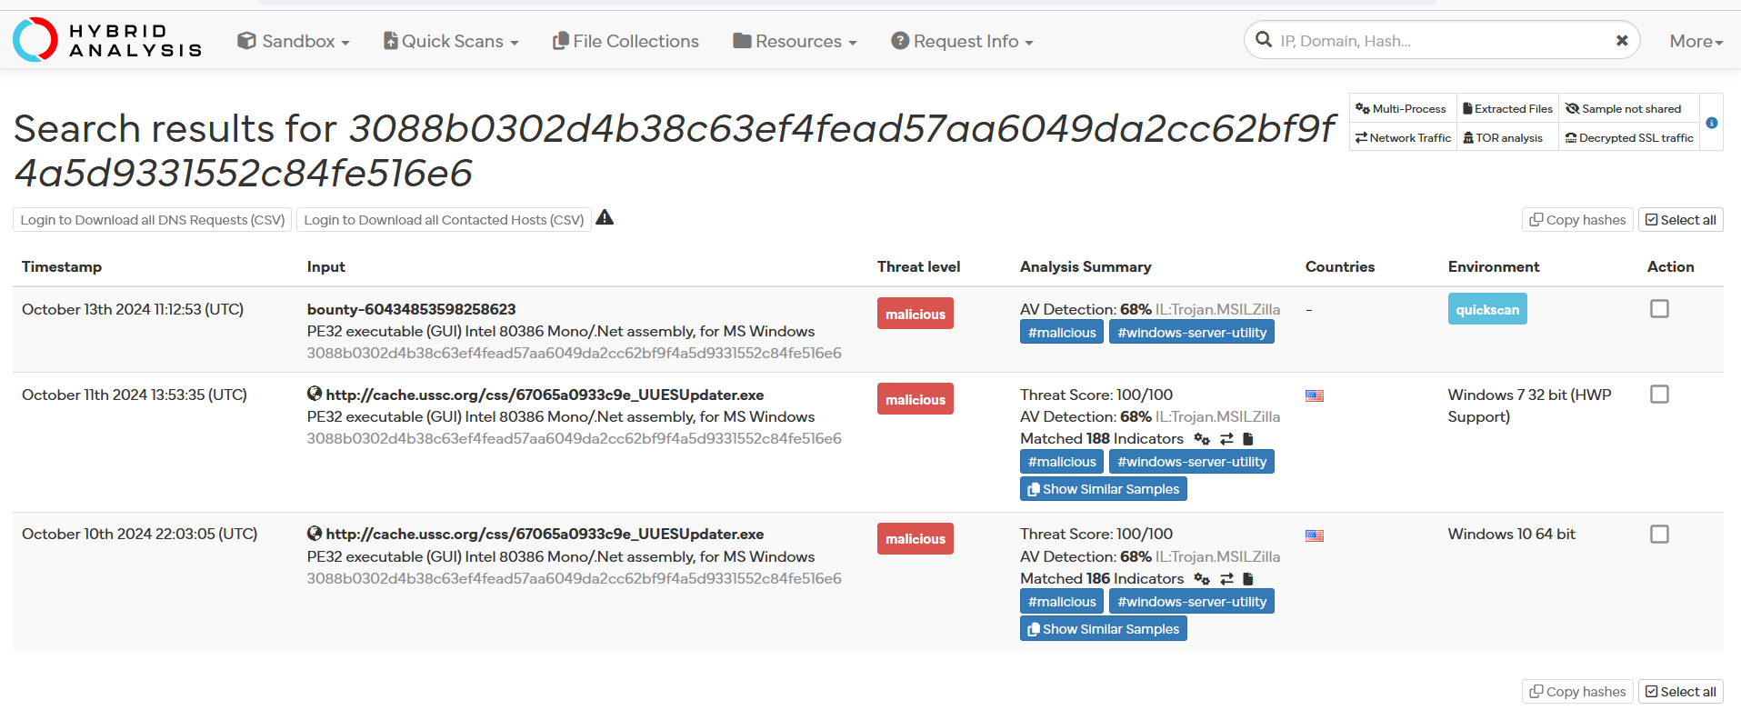
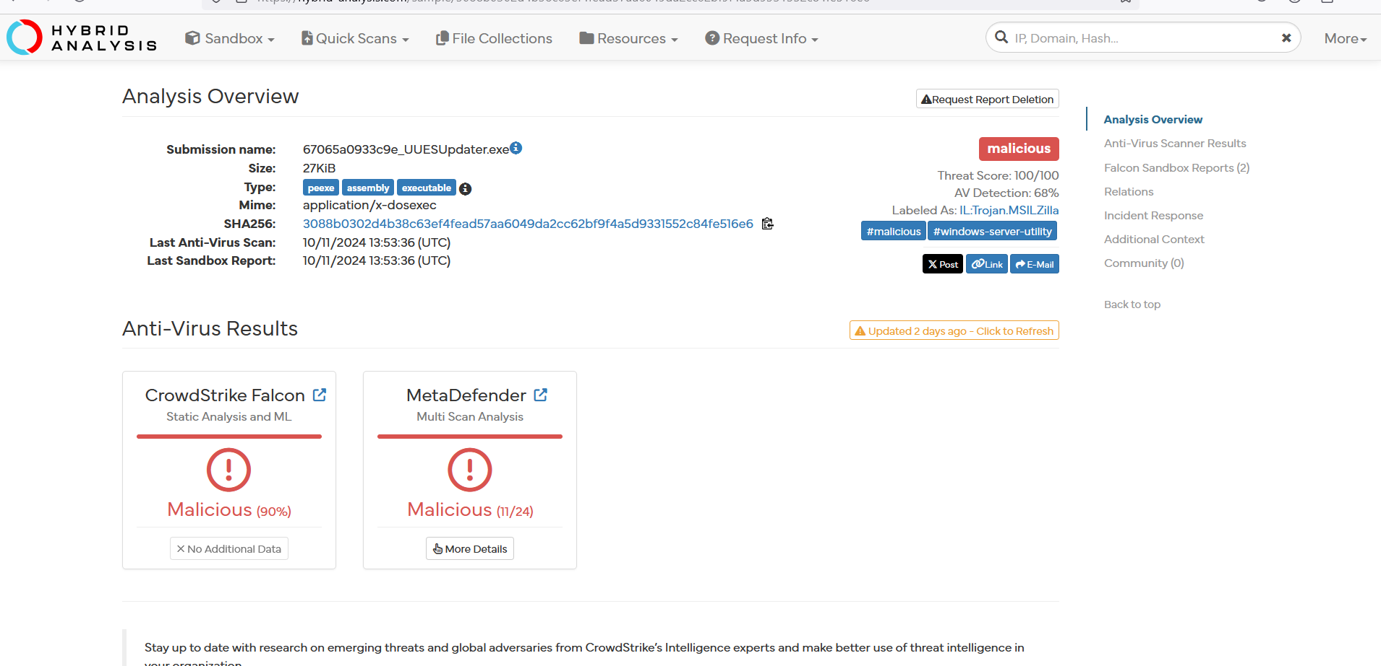
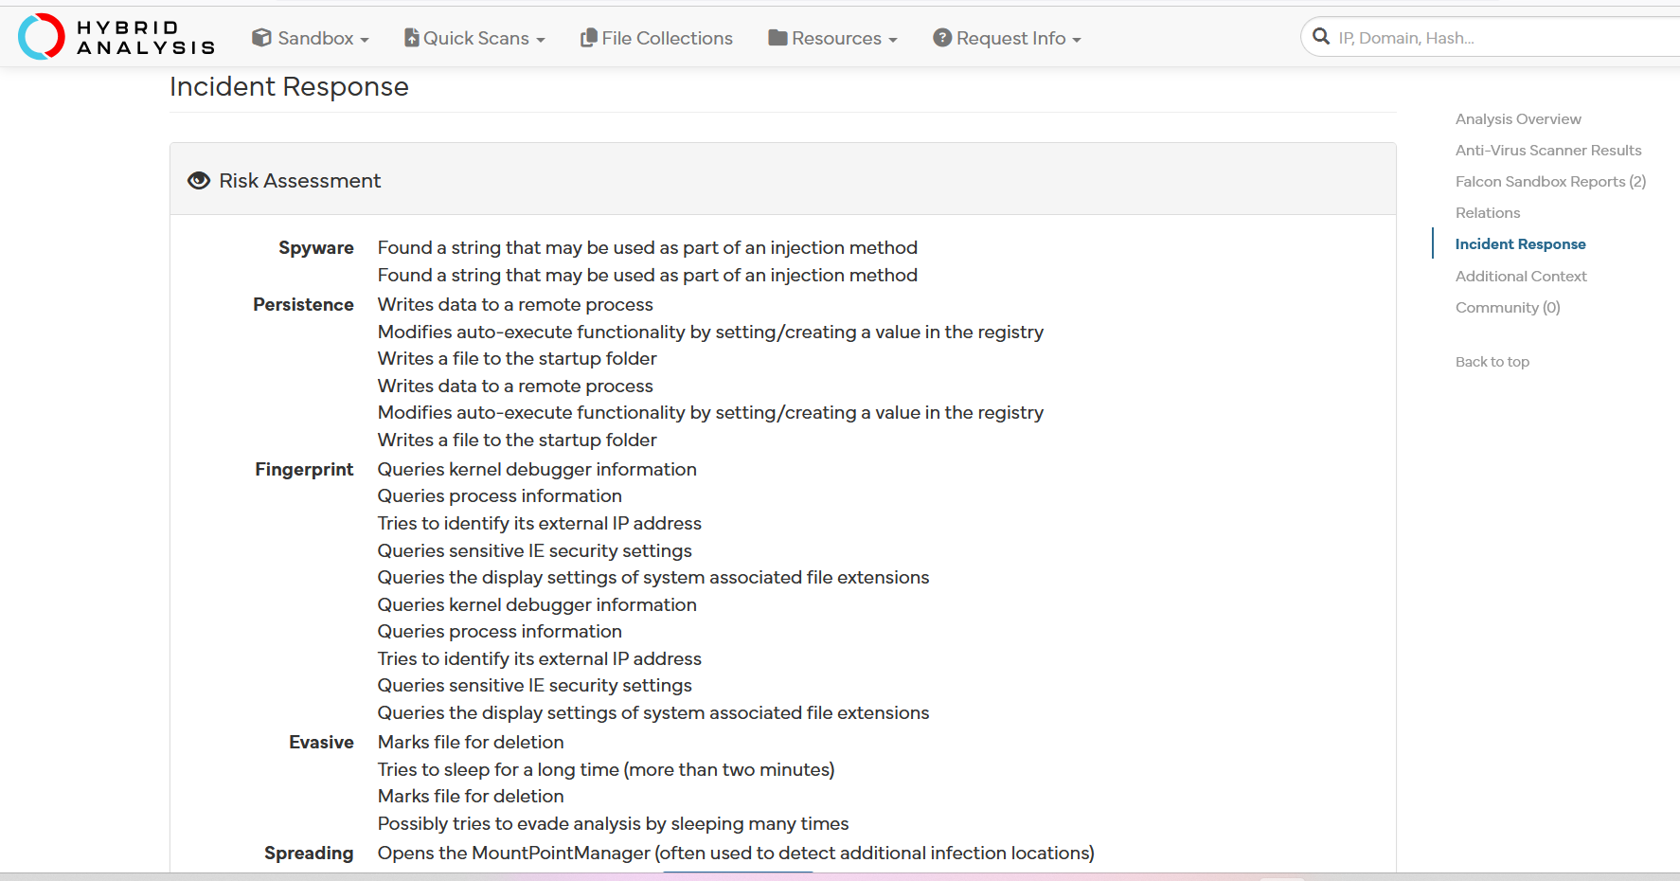
On same website we can find the TTPs, from MITRE from view details.
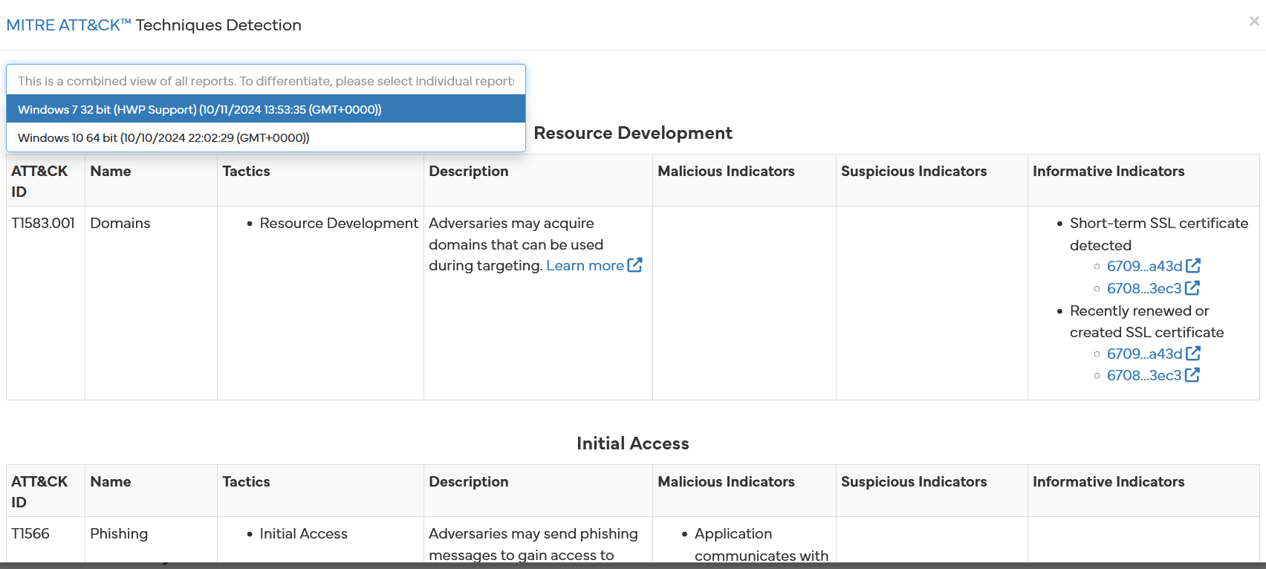
Considering, all the data mentioned above we can detect the threat level of hashes and their spread.

Q.2) Investigate suspicious HTTP requests using a packet capture tool (e.g., Wireshark) and
determine if they are linked to any known cyber threats.
Solution:

Slip 13:
Q.1) Investigate known ransomware groups using a threat intelligence platform and identify
common TTPs used by these groups.
Solution:
Here, we consider a known platform MITTRE ATT&CK.
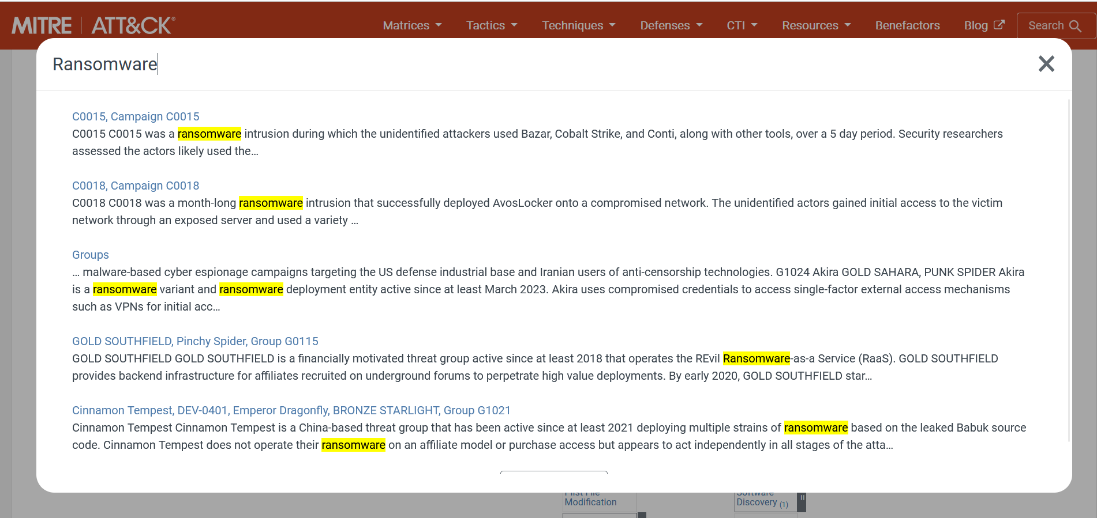
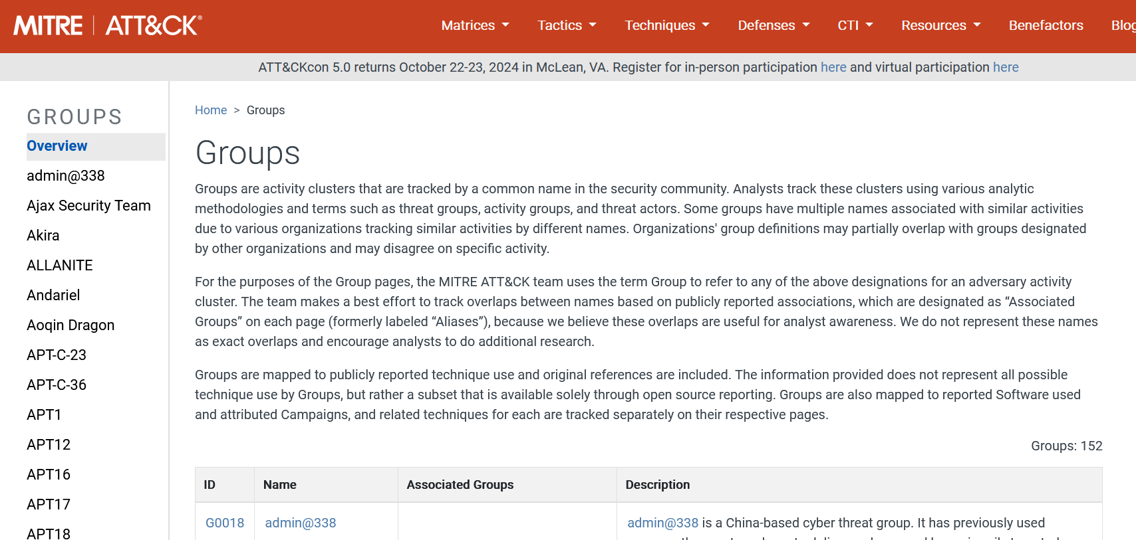
By observing the groups Common TTPs will have the following info:
Common TTPs for Ransomware Attacks:
- Initial Access:
  - Compromised Credentials: Many groups, such as Akira and APT18, use compromised credentials to gain access to networks, often leveraging single-factor authentication mechanisms like VPNs.
  - Phishing Campaigns: Groups like APT19 employ phishing attacks to trick victims into providing access, often leading to malware installation.
- Lateral Movement:
  - Use of Publicly Available Tools: Groups such as Akira utilize common tools and techniques for lateral movement within compromised networks. This can include tools like PsExec or RDP.
  - Remote Access Trojans (RATs): Groups such as admin@338 leverage publicly available RATs (e.g., PoisonIvy) for maintaining access and moving laterally.
- Data Exfiltration:
  - Double Extortion: Groups like Akira engage in "double extortion" tactics where data is exfiltrated prior to encryption. This increases pressure on victims to pay ransoms, as they risk public exposure of sensitive information.
  - Targeting Sensitive Data: Many ransomware groups focus on sensitive or high-value data to maximize impact and ransom demands.
- Encryption of Files:
  - Ransomware Deployment: Groups like Akira actively deploy ransomware to encrypt files on victim systems, making data inaccessible until a ransom is paid.
  - Custom Ransomware Development: Some groups create or modify existing ransomware to suit their operational needs, as seen with Akira's links to Conti malware.
- Communication and Negotiation:
  - Dedicated Ransomware Payment Portals: Many groups establish dedicated portals or communication channels for ransom negotiation, making it easier for victims to communicate and pay ransoms.

Q.2) Perform a reverse IP lookup on a malicious domain and correlate the results with other
known malicious infrastructures.
Solution:
Select a malicious domain and for reverse IP lookup we can consider the following tools
Online Tools:
- ViewDNS.info
- IPinfo.io
Malicious Domain: www.redcap.work
Using threatcrowd we can find the IP associated with the domain.

For reverse IP lookup:
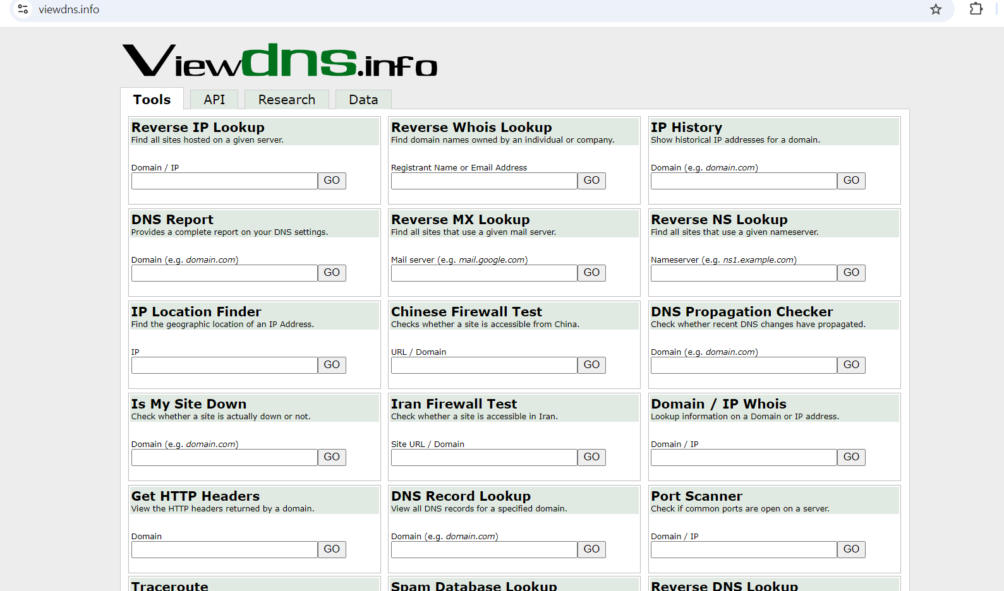
Here, we get the associated domains with the IP addresses, and by searching for the domains and IPs we can use various platforms such as Virustotal, AalienVault, shodan, whois and collect the associated data of it such as, registrar, area, country etc. and relate it with the malware bazaar and threatfox database.

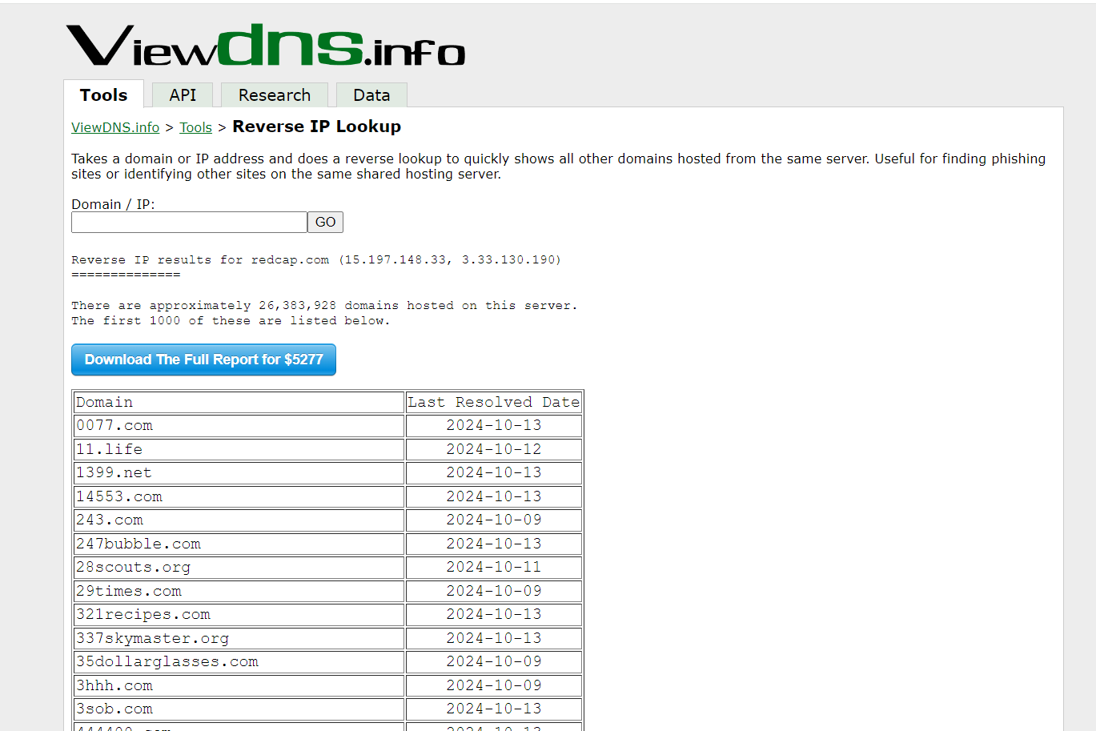
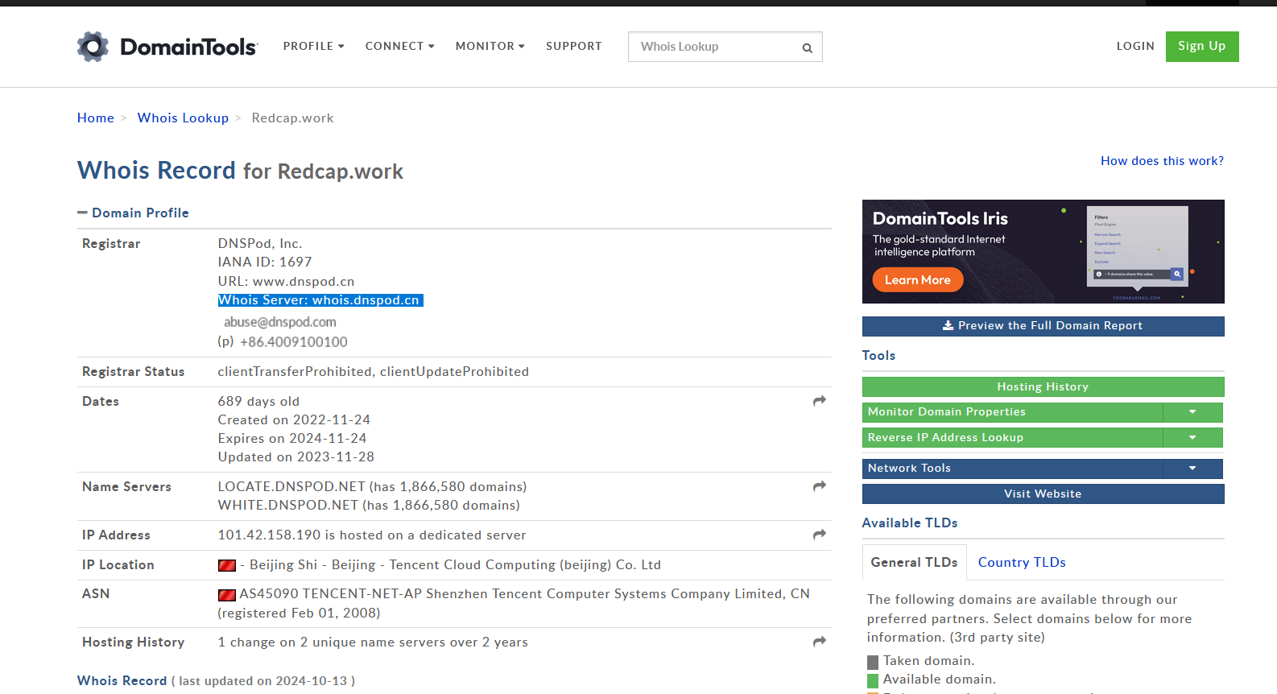
Like the 337skymaster.org is one of the associated domain to the IP we have considered. Following is the Whois report for it.
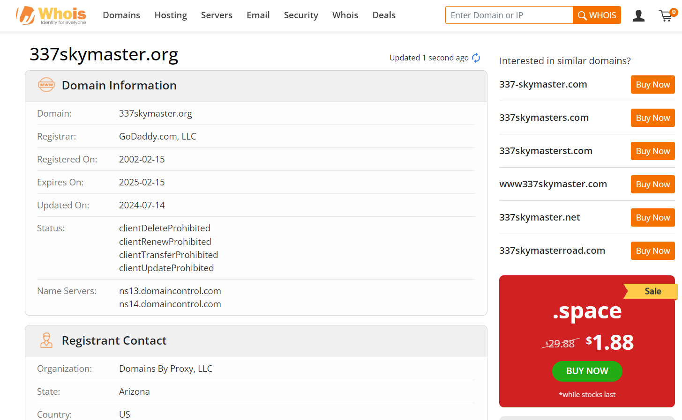
Threat miner will give us details about associated Domains.
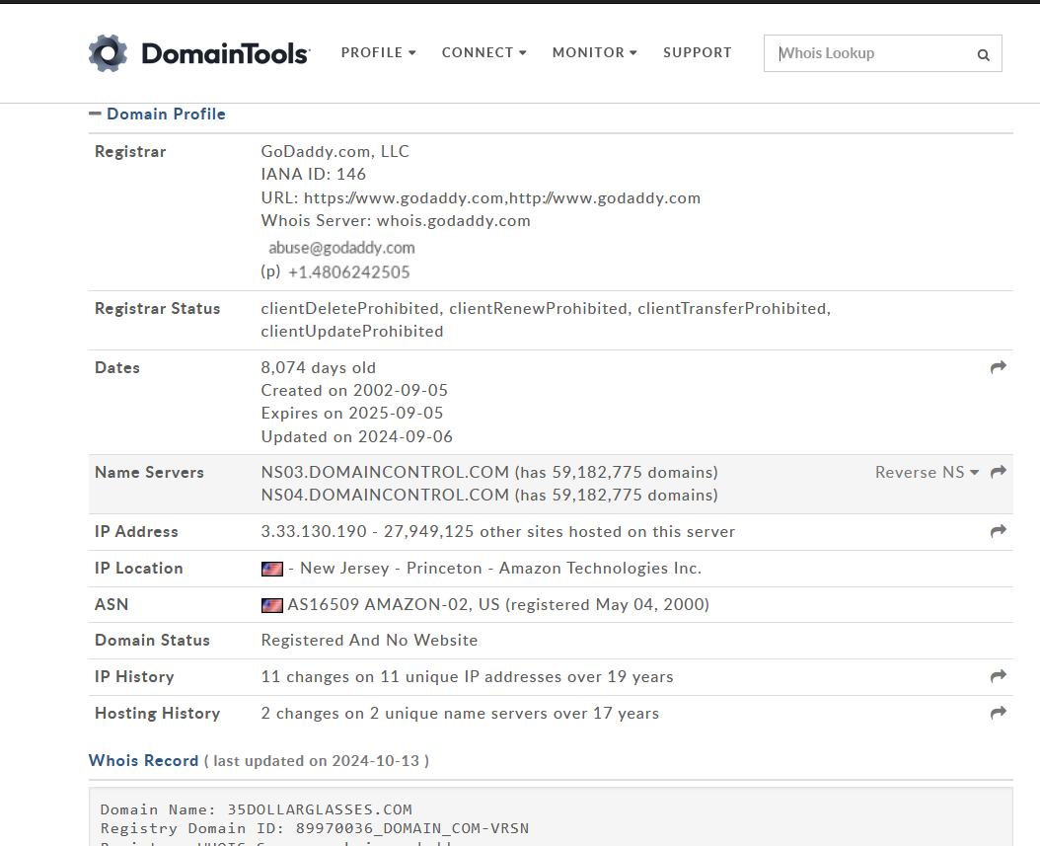
Slip 14:
Q.1) Use a threat intelligence platform to gather intelligence on a data breach and analyze the
data types targeted by the attackers.
Solution:
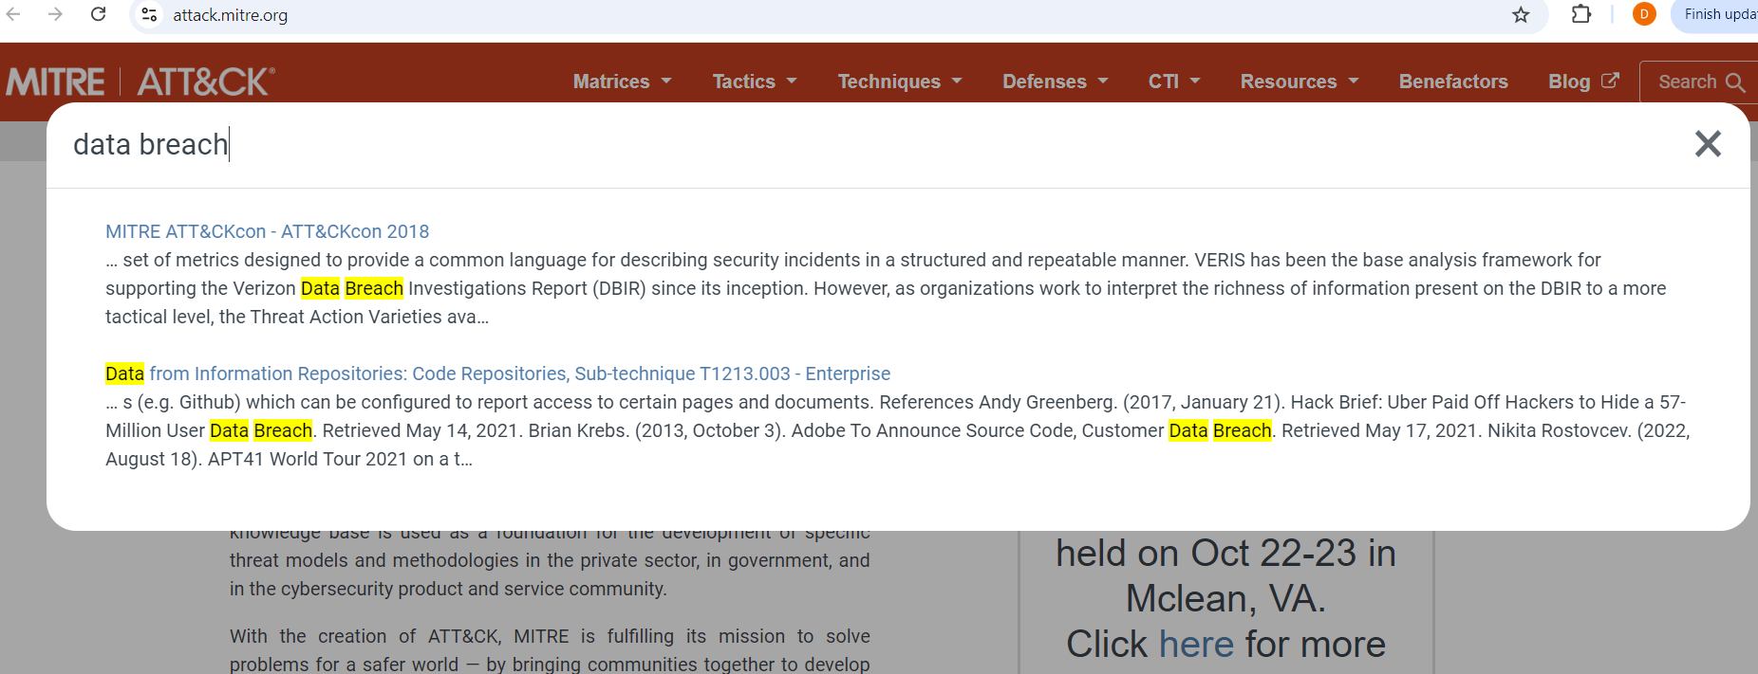
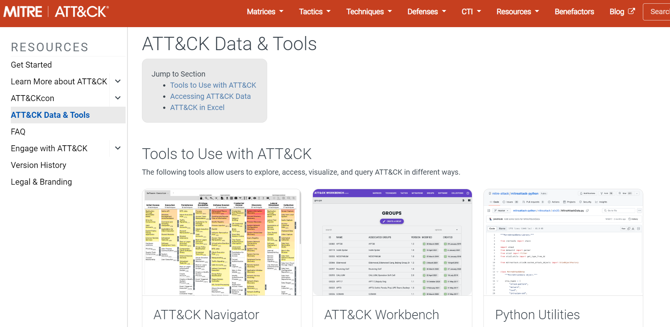
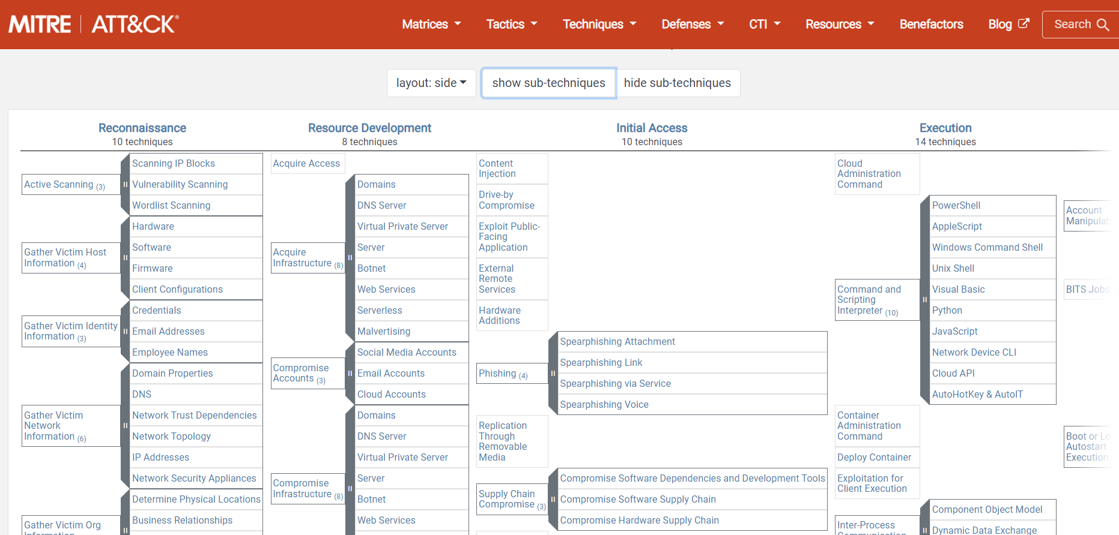
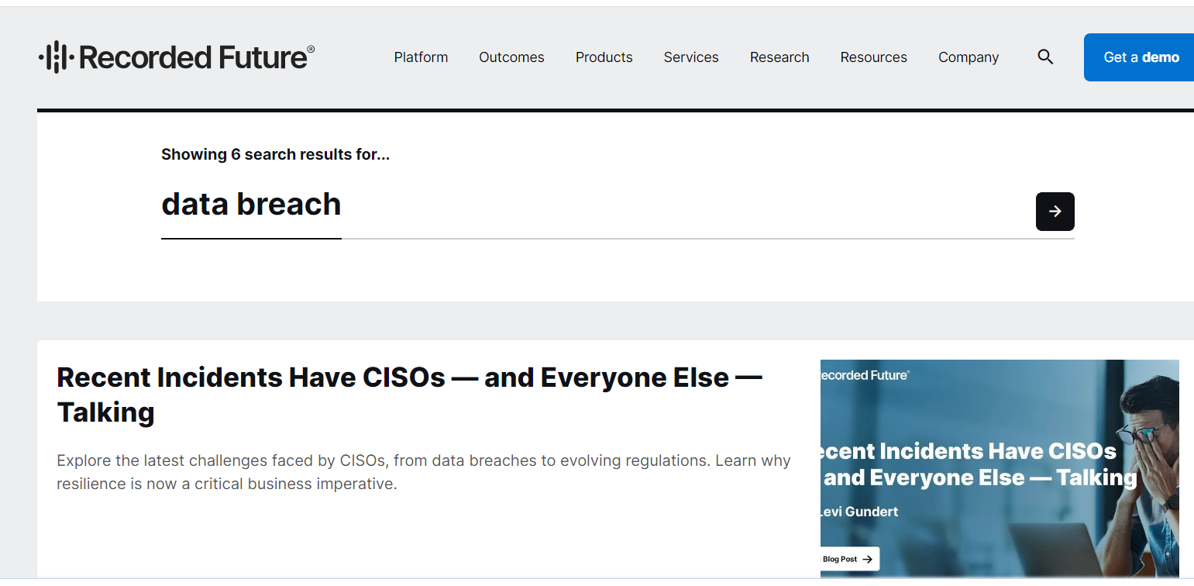
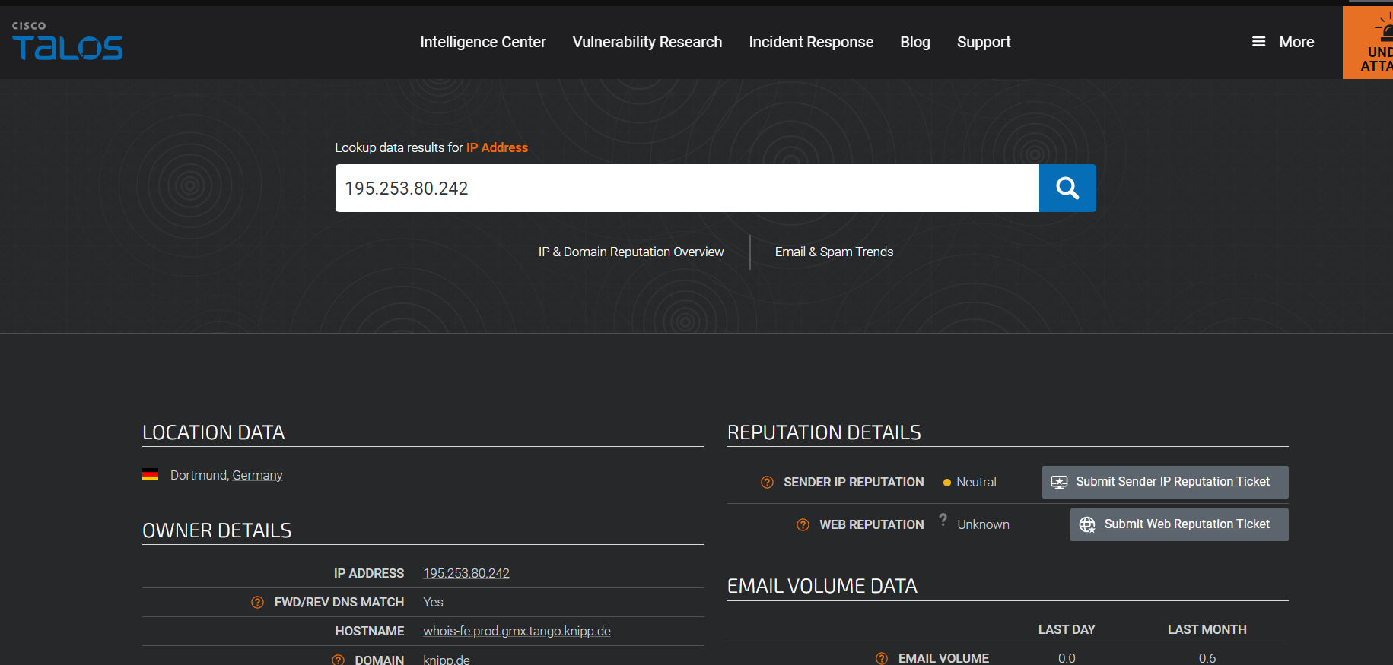
By observing all the above info, common data types used are:
Personal Identifiable Information (PII): Social Security numbers, birth dates, addresses.
Credit card numbers (approximately 209,000).
Driver’s license numbers (approximately 18,000).
PII: Names, email addresses, birth dates.
Security questions and answers.
Passwords (hashed, but some were outdated).

Q.2) Analyze SSL certificates of suspicious websites to identify signs of fraud or illegitimacy.
Solution:
For SSL certificate of the website we will use the shodan website.
Here the signs of fraud will be,
Issuer: CN=\x001\x000\x00_\x000\x00_\x002\x004\x00_\x001\x006 (Legitimate user define proper name of issuer)
Validity
Not Before: Jul 19 04:00:47 2024 GMT (A long term validity period of the certificate can also be a sign of fraud)
Not After : Jan 18 04:00:47 2025 GMT
Subject: CN=\x001\x000\x00_\x000\x00_\x002\x004\x00_\x001\x006 (Use of escape sequences for most of the time)

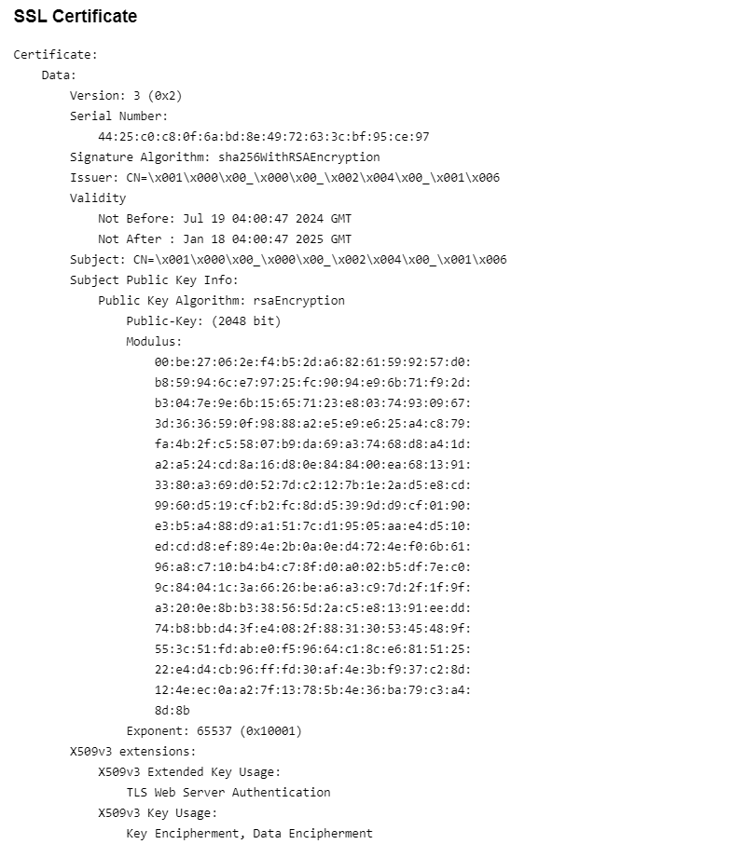
Also we can view the certificate and website details on: Netcraft
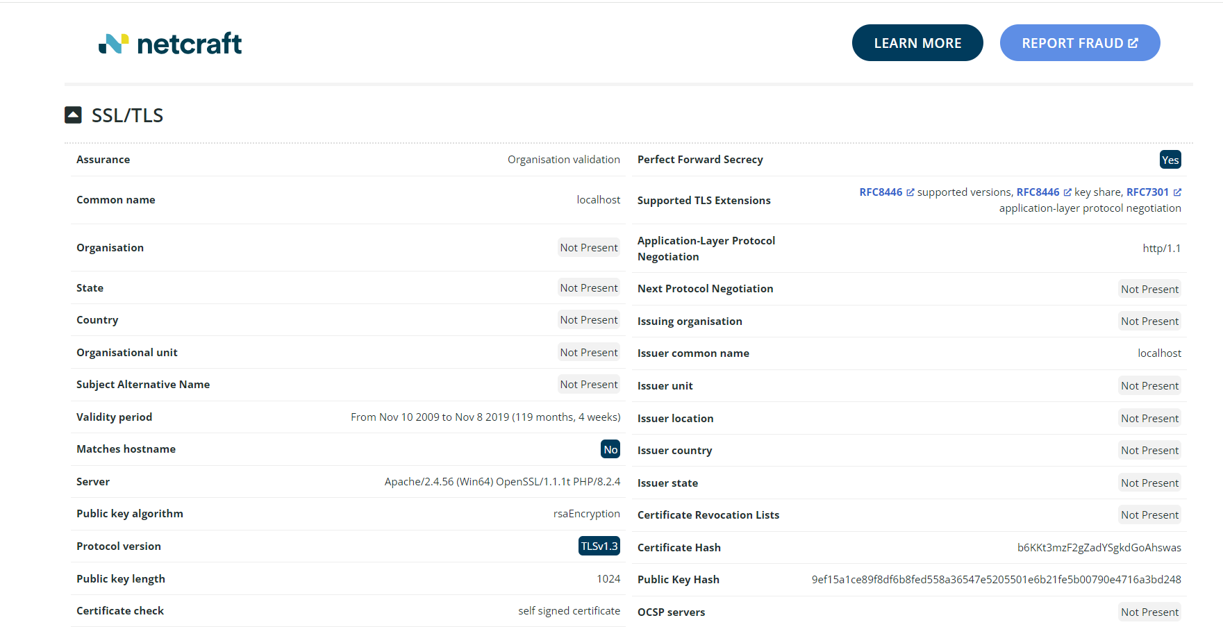
A legitimate SSL certificate will be like
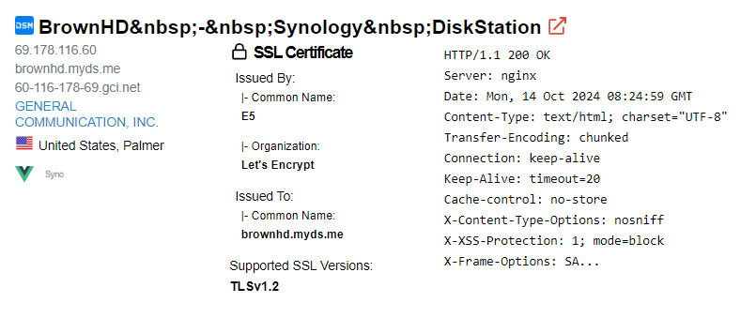

Slip 15:
Q.1) Perform a correlation analysis of multiple threat intelligence sources to identify a
coordinated cyber-attack campaign.
Solution:
Incomplete

Q.2) Use OSINT to track the activities of a known threat actor across various social media and
underground forums.
Solution:
For threat actors:
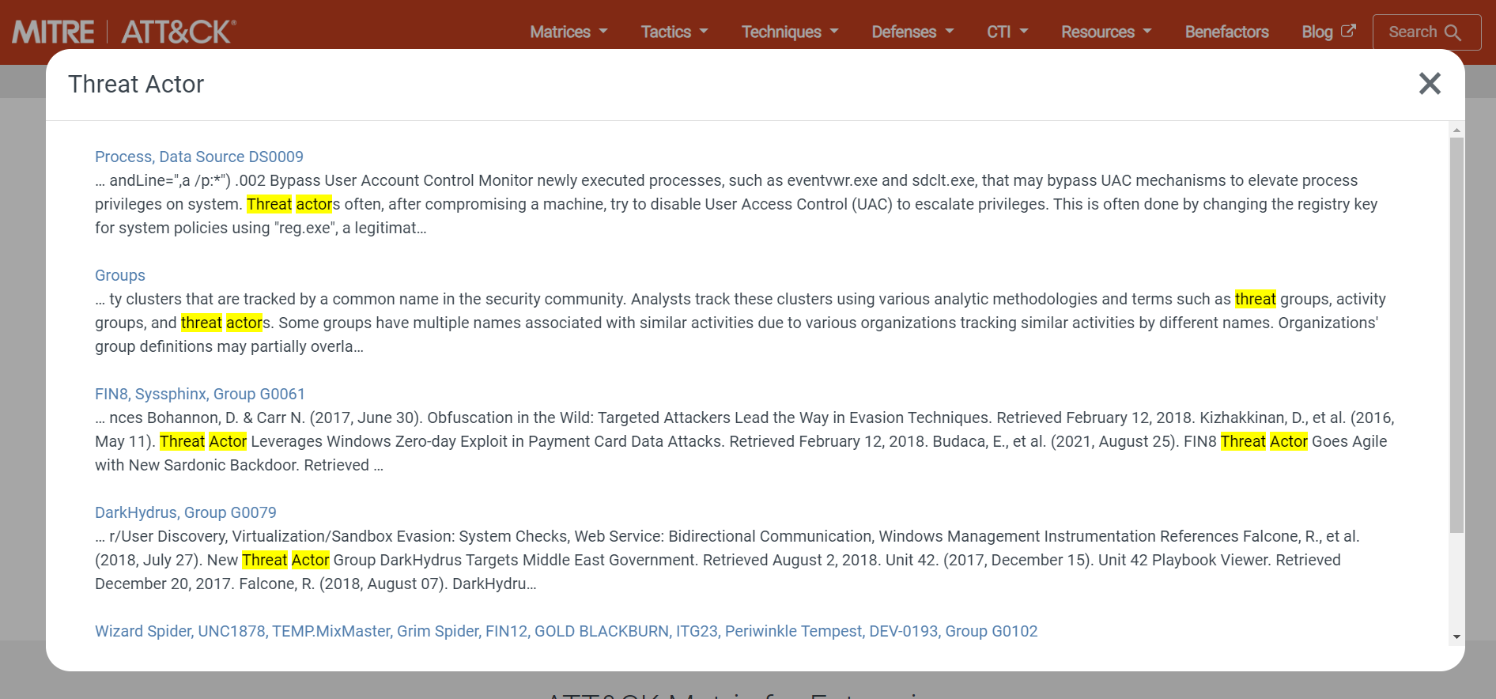
From the website we have chosen a threat actor TA505 on this threat actor we will perform OSINT.

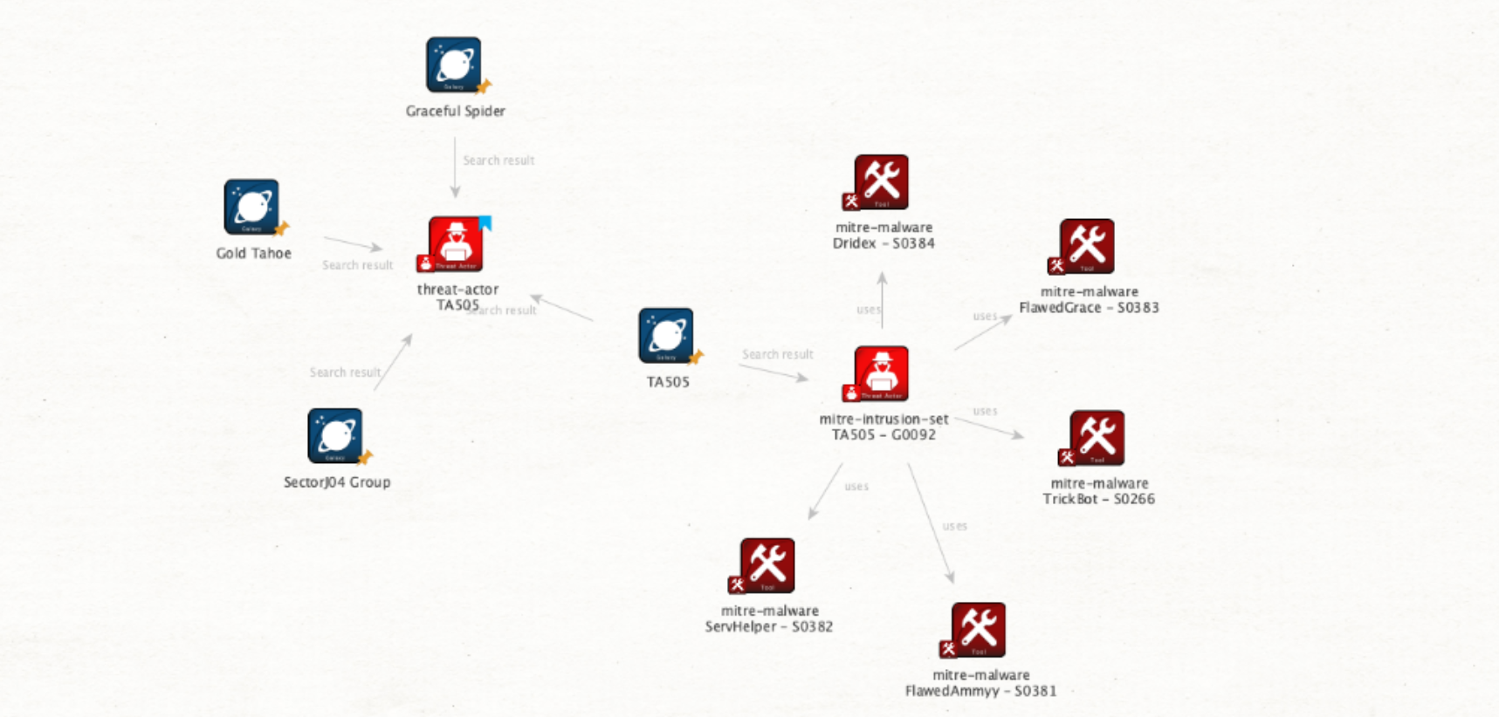

Hashes related to TA505 which can be seen through the hybrid analysis on maltego.
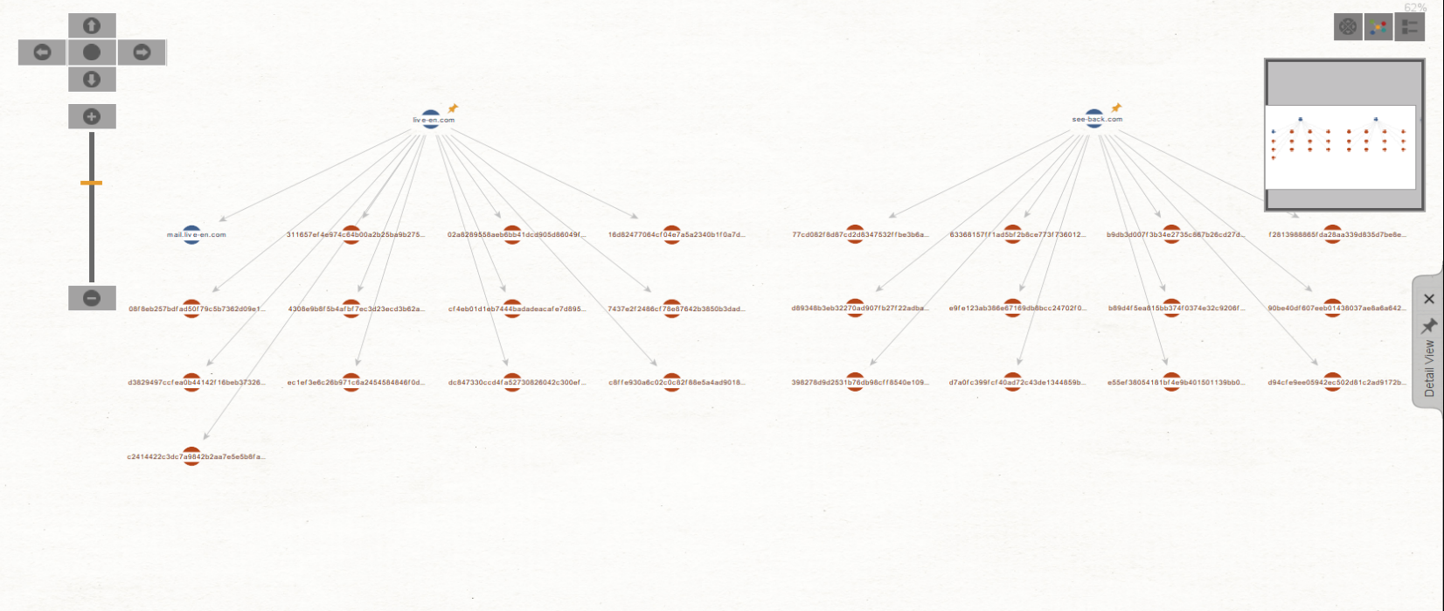

We can search for these hashes on CTI platforms for more information
Virustotal:

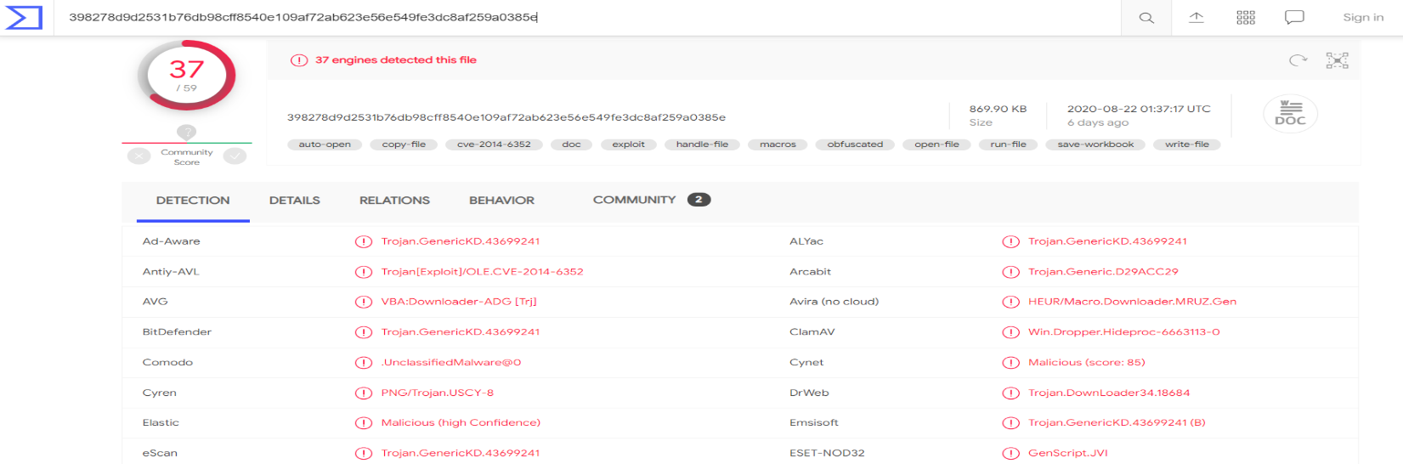
Talos Intelligence platform:

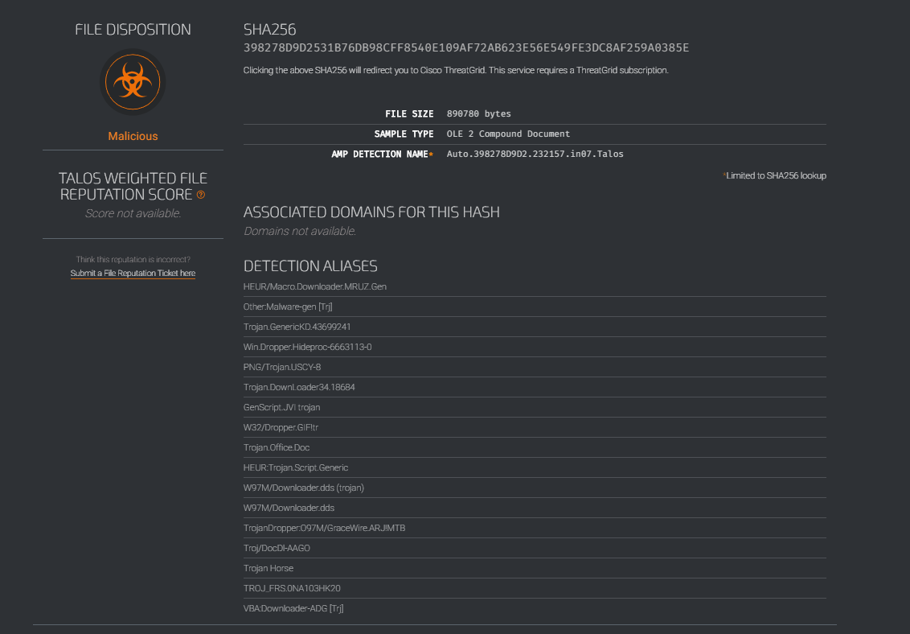

Slip 16:
Q.1) Use a Threat Intelligence Platform to identify emerging threats and analyze how they are
evolving in the cyber landscape.
Solution:
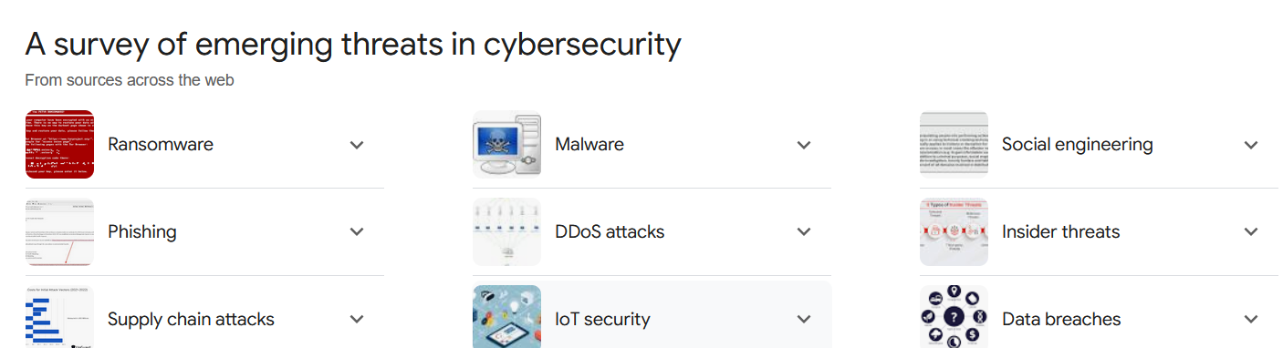
ThreatConnect

AlienVault OTX:
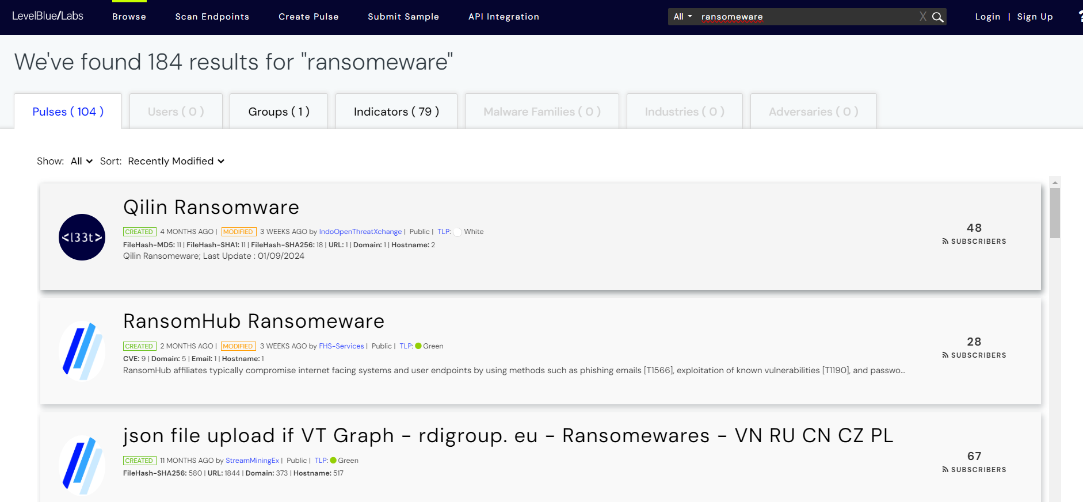
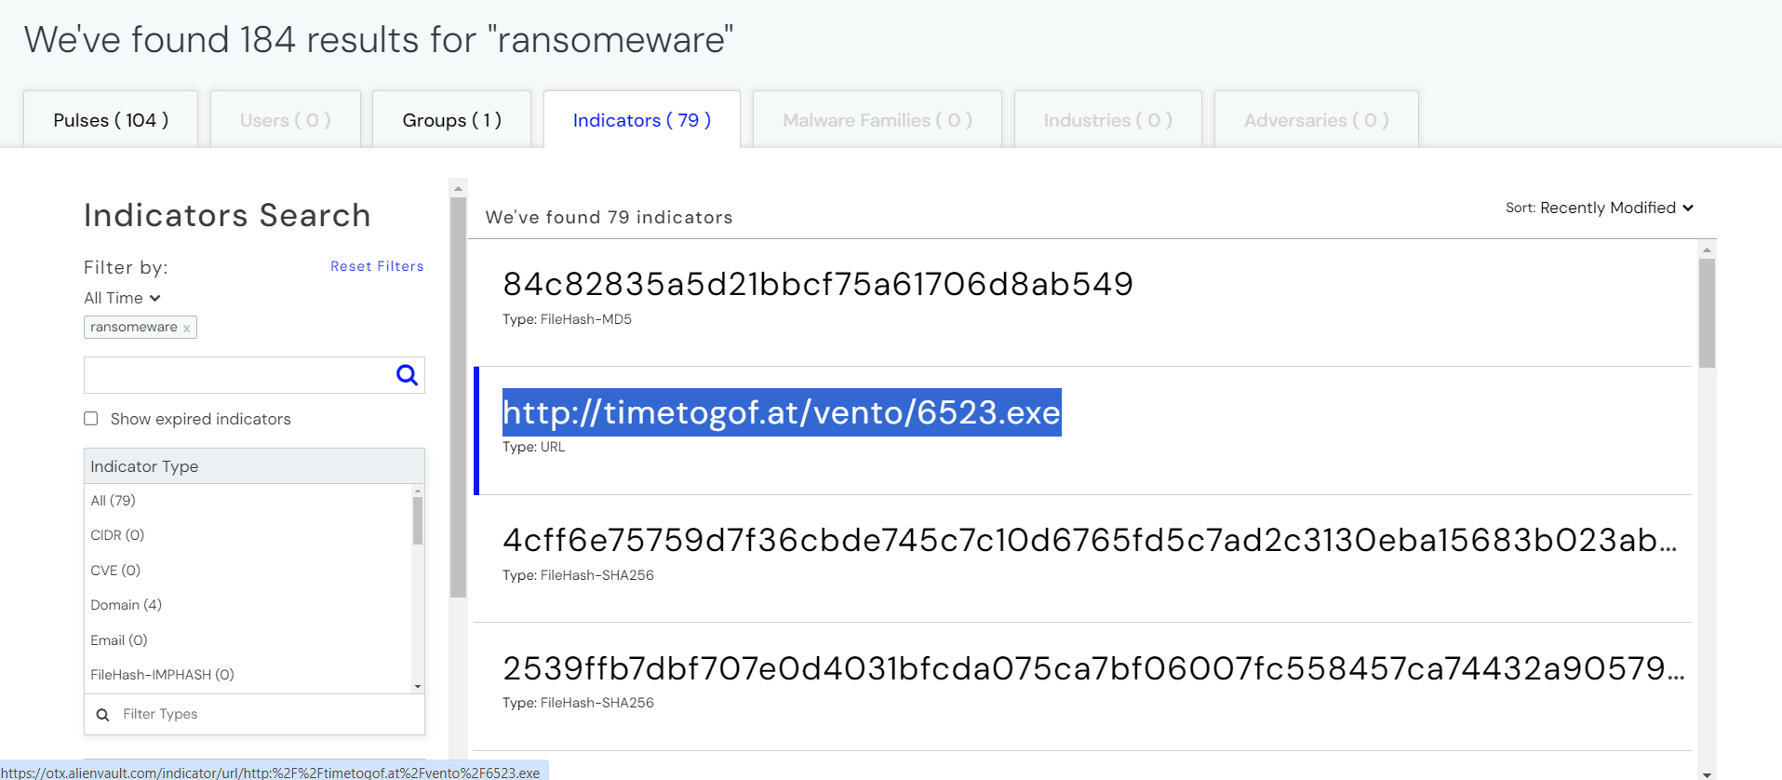
Virustotal:
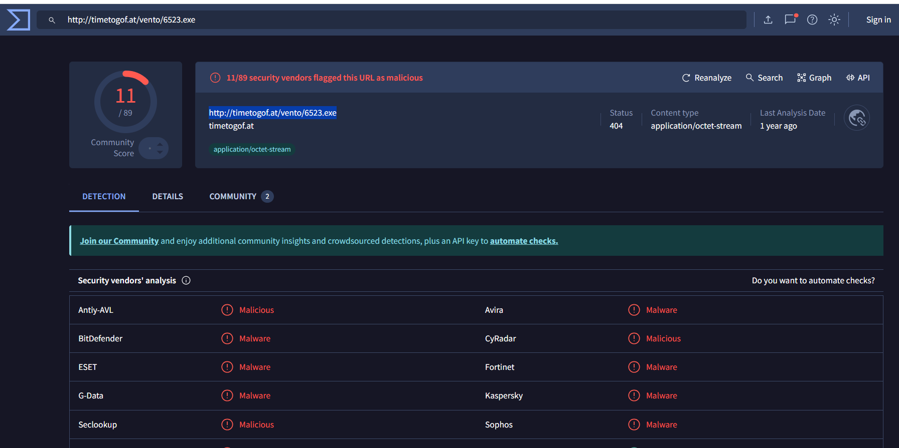
Fortinet report of analysis:
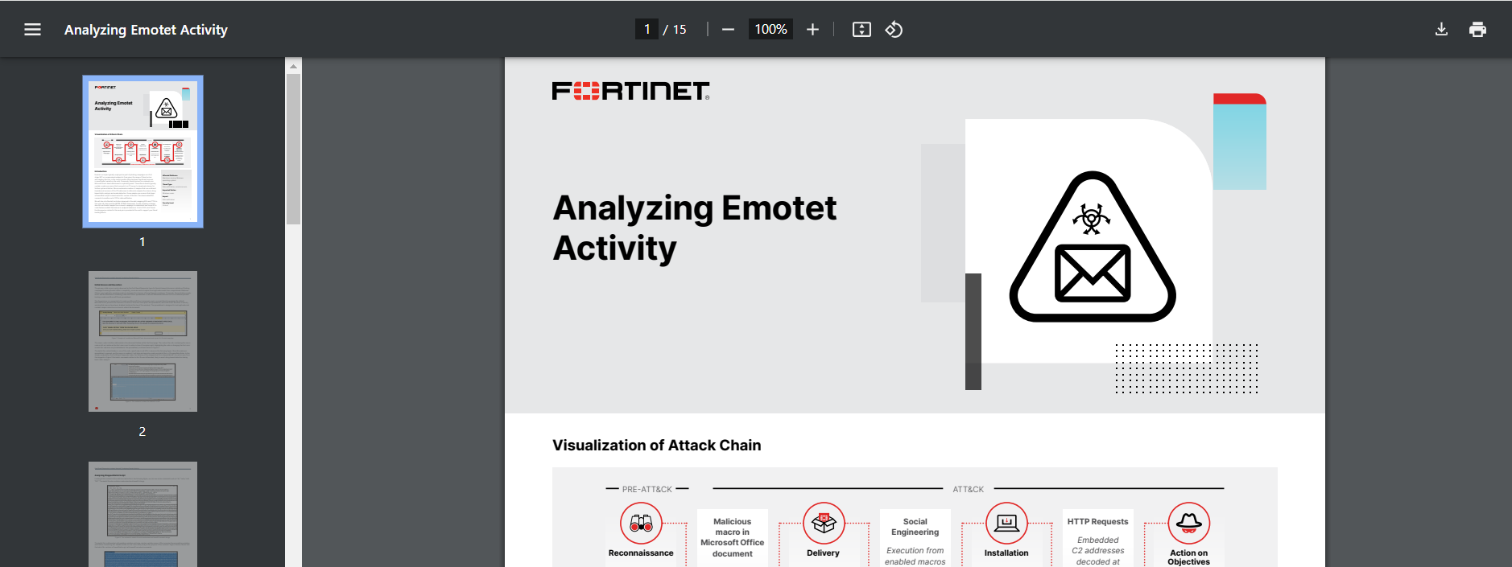

Q.2) Perform a passive reconnaissance using domain and IP reputation tools to gather
intelligence on a suspicious website.
Solution:
Malicious domain to investigate: scratgyy.biz
ThreatConnect for IP associated with it.
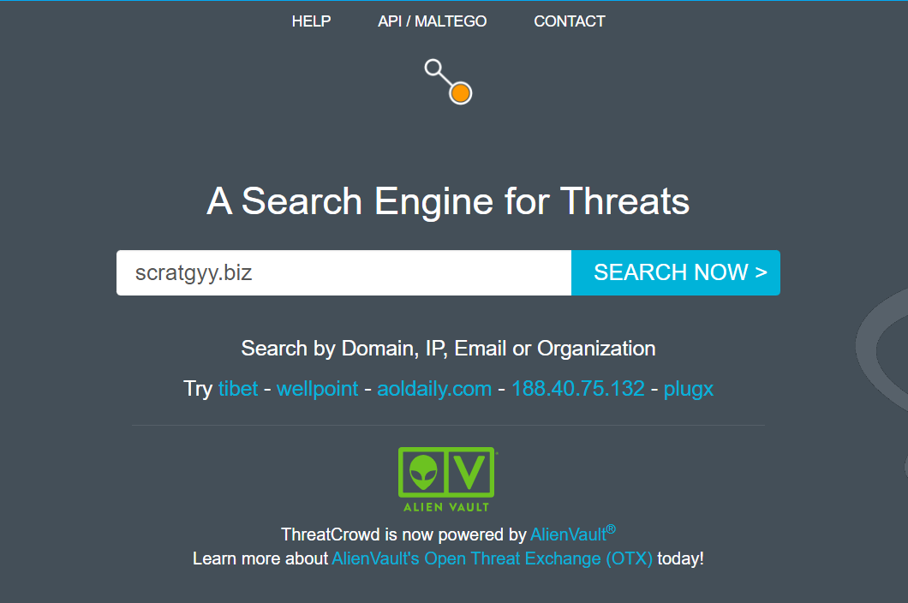
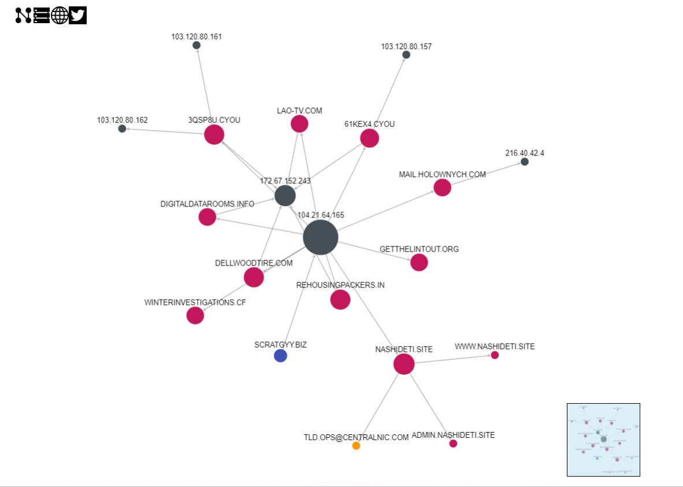
For IP reputation check we will use TIP e.g. Virustotal, AbuseIPDB, CriminalIP etc.

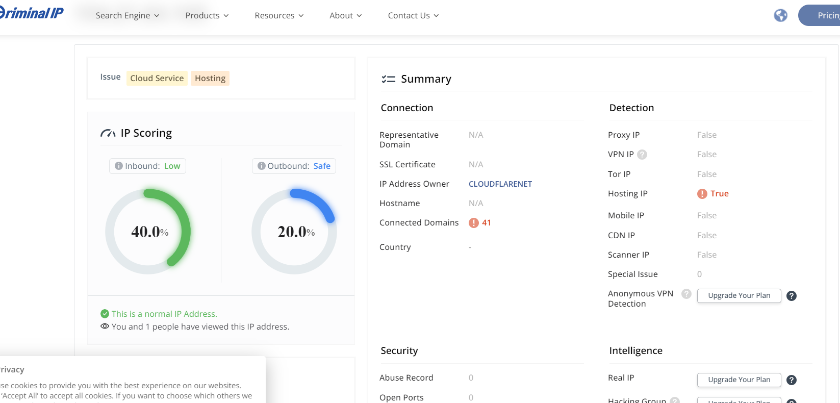

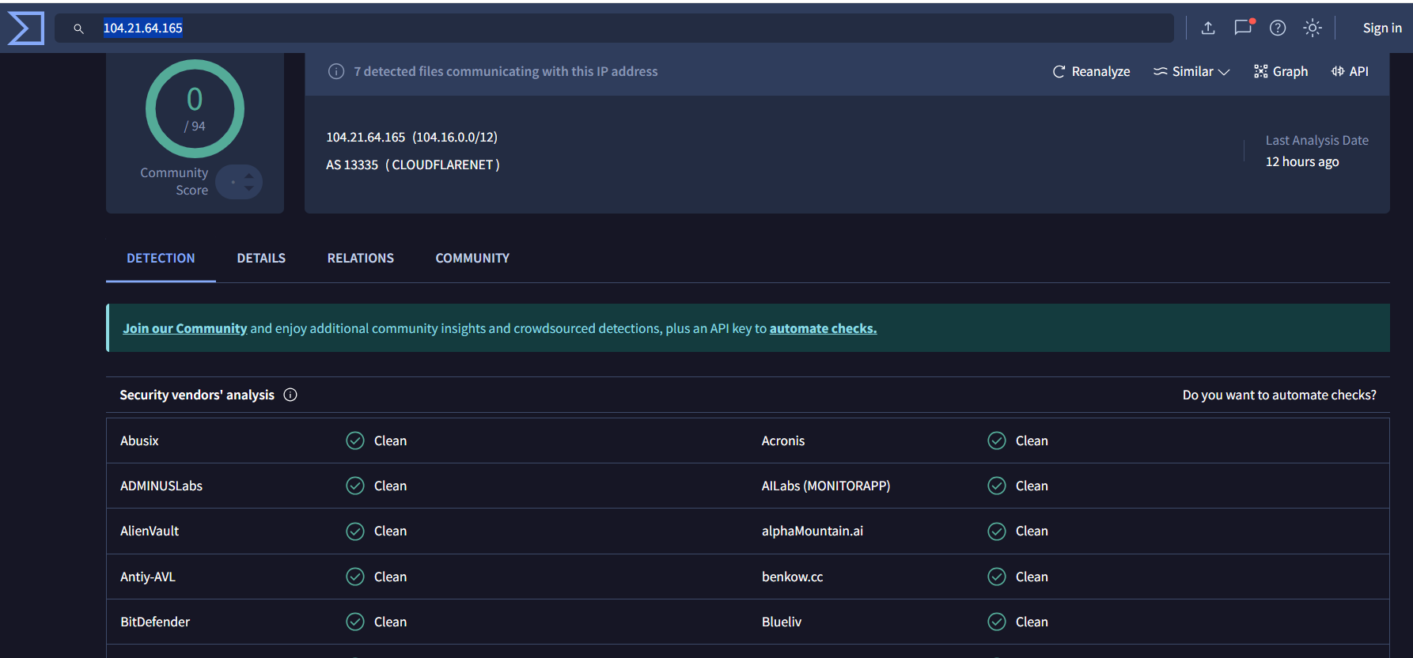

Slip 17:
Q.1) Analyze a phishing kit using cyber threat intelligence tools to uncover the threat actor’s
infrastructure and methods.
Solution:

Q.2) Perform threat intelligence gathering on a dark web marketplace and identify any illicit
activity related to cyber-attacks.
Solution:

- Legal and reputable tools like DarkOwl, Recorded Future, or Flashpoint allow organizations to monitor dark web marketplaces for any illicit activities, including cyber-attacks.

Slip 18:

Q.1) Investigate a large-scale DDoS attack using threat intelligence tools and identify the botnet
behind the attack.
Solution:
We can find the DDOS attack database on threatfox website. By searching malware:DDOS
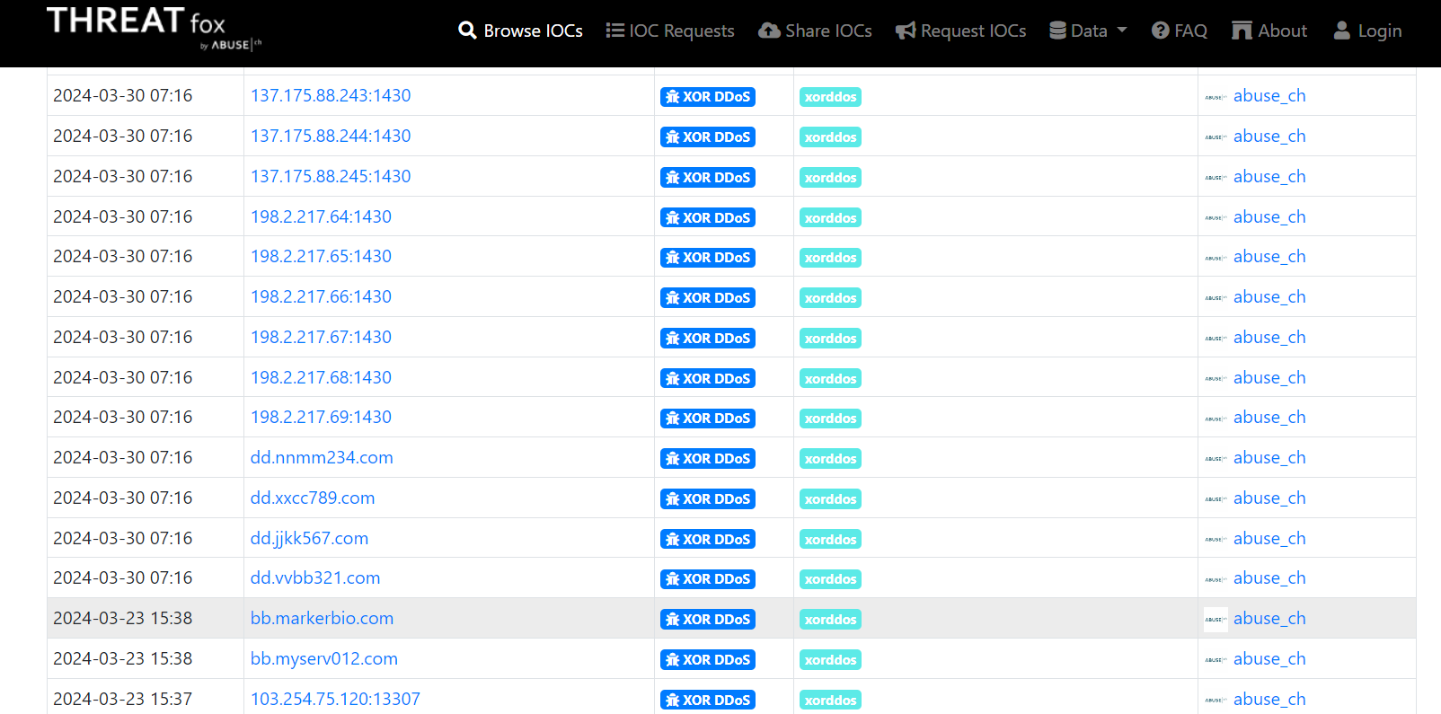

Using AlienVaultOTX:

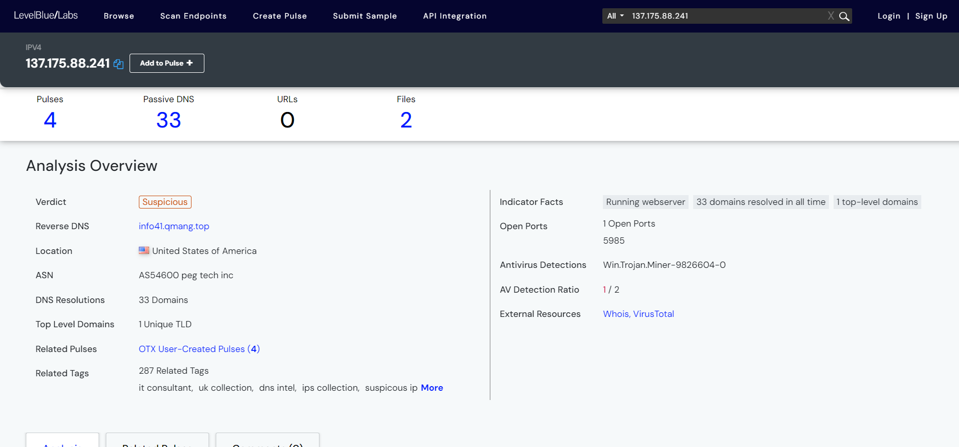

Q.2) Perform IP reputation analysis to investigate whether certain IPs are associated with known
DDoS attack campaigns.
Solution:
