Email Analyzer Report

Spam Scorel :- SpamAssassin2.10

Sender address From :- mssecurity-noreply@microsoft.com

And to :- choonapoodi@gmail.com

Sub. :- New recommendation available for Default Directory

Headers :-

authentication-results

mx.google.com; arc=pass (i=1); spf=pass (google.com: domain of mssecurity-noreply@microsoft.com designates 2a01:111:f403:2414::70a as permitted sender) smtp.mailfrom=MSSecurity-noreply@microsoft.com; dmarc=pass (p=REJECT sp=REJECT dis=NONE) header.from=microsoft.com

Pass or fail (spa) Pass

Authentication results :-
arc=pass
spf=pass
dmarc=pass

Deliver to Address should be same as sender :- choonapoodi@gmail.com

Return path :- MSSecurity-noreply@microsoft.com

Count of url :- 4

Attachment :- yes
(File name part-000
Size 4.3 kb
MIME type PNG image data, 206 x 44, 8-bit/color RGBA, non-interlaced
SHA256 ce7b8581fa1acfca82e0fa4d24b2b786e467fc863420e6eef50a05238947adb2)

Count of Domen :- 3

Find IP from tools 184.84.169.167

Identify Email as (Clean, Spam, Malicious) :- Clean
Check email through email hunter tool or any other
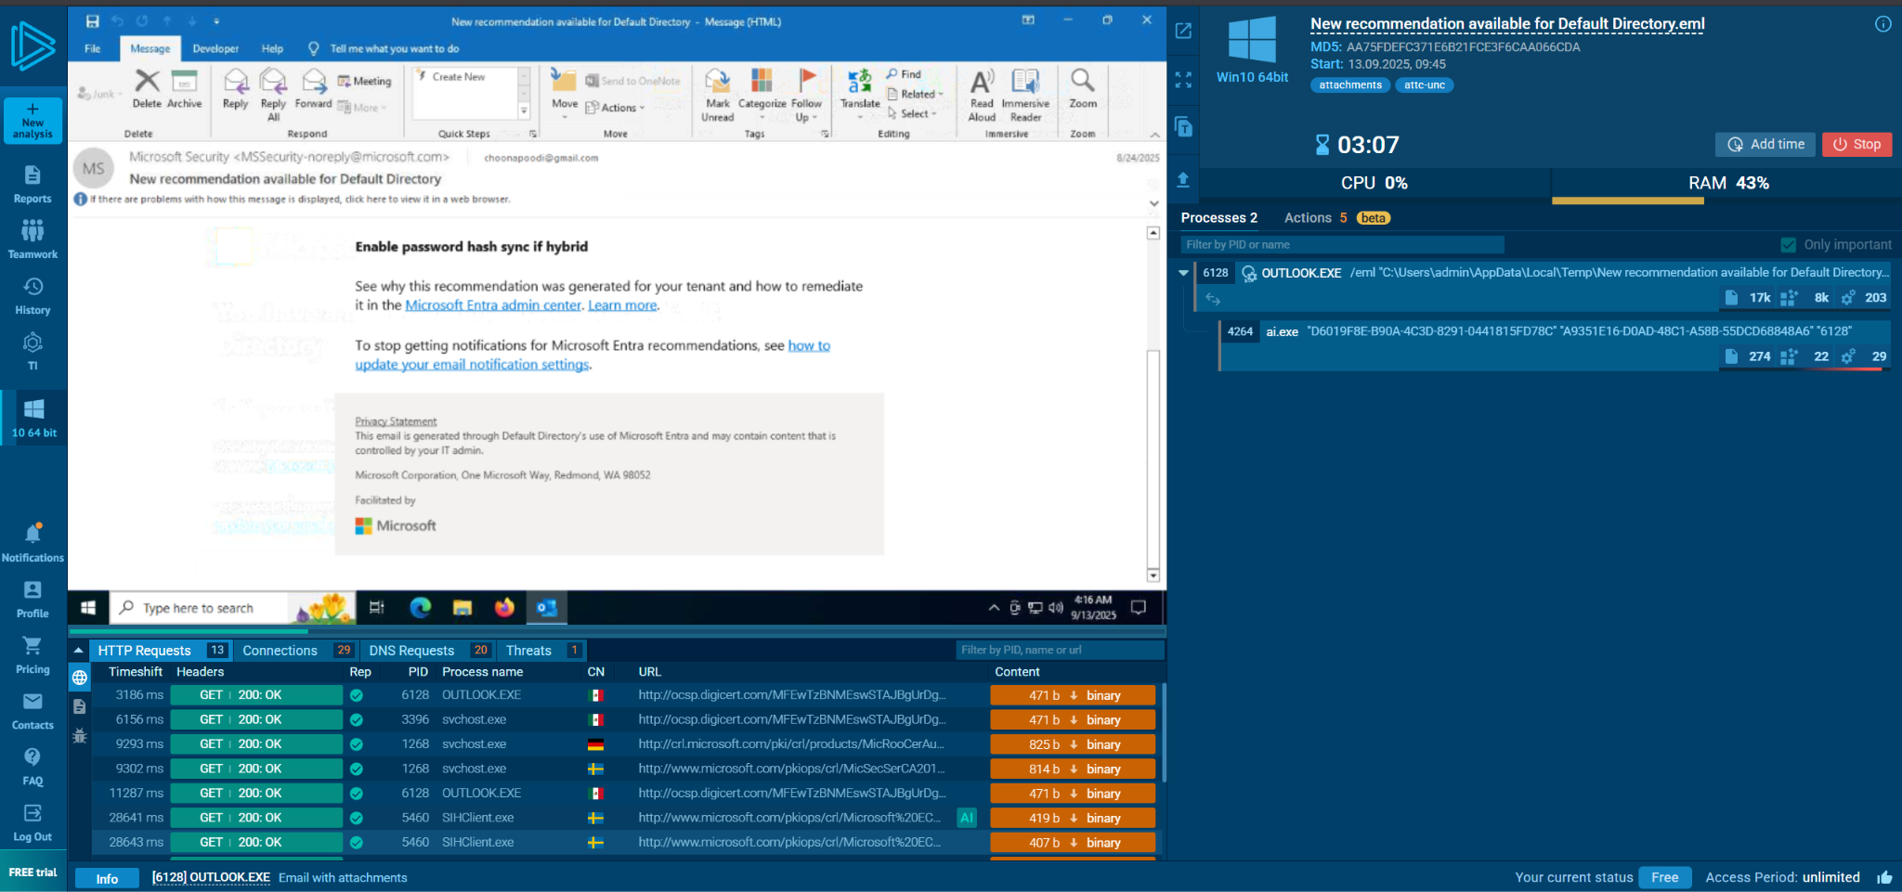

Conclusion :-
The investigation shows that the email is safe: no malware, no dangerous links, and it truly came from the official sender. You don’t need to worry about this message, but always double-check if such recovery emails match your recent activity.

