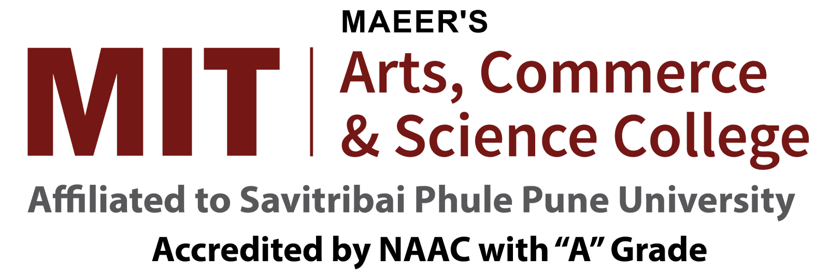
School of Computer Science & Application
Department of Design, Analytics and Cyber Security
T. Y. BSc Cyber and Digital Science
Academic Year 2025–2026
Information Security policy and Audit
Student Name-
Roll No- Class/ Div –
Information Systems (IS) Auditing Standards
Abstract
This case study looks at how Information Systems (IS) auditing standards can ensure the security, efficiency, and regulatory compliance of a multinational corporation's IT infrastructure. The study focuses on "TechGlobal," a financial services organization, and covers the process of conducting IS audits in accordance with important standards such as ISACA's IS Audit and Assurance Standards, ISO/IEC 27001:2013, and the NIST Cybersecurity Framework. It examines the audit process from planning to follow-up, highlighting the significance of a risk-based strategy, effective evidence gathering, and compliance with different regulatory requirements. The research also discusses problems such as increasing cyber threats, compliance with various standards, and resource limits, emphasizing the importance of IS audits in ensuring organizational stability and security.
Key words
IS Auditing, Information Technology (IT) Infrastructure, Regulatory Compliance, Risk Assessment, Audit Charter, Audit Evidence, ISO/IEC 27001, NIST Cybersecurity Framework, Audit Planning, Fieldwork, Audit Reporting, Control Weaknesses, Follow-up, Cybersecurity, Data Protection, Access Control, Incident Response, Compliance Standards, Resource Constraints, Tech Global
Introduction
Information Systems (IS) auditing is the practice of assessing the controls in an organization's IT infrastructure. The purpose is to guarantee that information systems are efficient, secure, and comply with applicable rules and regulations. IS auditing standards offer auditors with a framework for effectively assessing these controls. These requirements ensure that the audit process is consistent, of high quality, and reliable.

Background
Consider the international company "TechGlobal," which operates in the financial services sector. TechGlobal offers an advanced IT infrastructure that includes cloud services, data centers, and various kinds of financial applications. Given the sensitive nature of its operations, the company is subject to severe legal regulations, such as the General Data
Protection Regulation (GDPR), Sarbanes-Oxley Act (SOX), and Payment Card Industry Data Security Standard (PCI DSS).
Scenario
TechGlobal's internal audit department is in charge of conducting regular IS audits to verify compliance with regulatory standards and internal rules. The Chief Information Officer (CIO) has expressed worry about the effectiveness of present audit processes, particularly in light of the growing cyber security scenario. The board of directors has asked for a thorough examination of the IS audit process and adherence to relevant standards.
Objectives
• Assess the effectiveness of IT controls in place to protect sensitive customer data. • Ensure the accuracy and integrity of financial data processed by IT systems. • Evaluate compliance with relevant regulatory requirements and industry standards. • Identify areas of improvement in IT governance, risk management, and control processes.
IS Auditing Standards
• ISACA's COBIT Framework: To assess IT governance and management practices. • ISO/IEC 27001: To evaluate the information security management system (ISMS) in place.
• NIST SP 800-53: To assess the controls related to cybersecurity.
• PCI-DSS: To ensure compliance with standards for handling payment card information.
Audit Process
Step 1: Planning
The audit team starts by analyzing TechGlobal's IT environment and identifying potential risks. This includes examining previous audit reports, comprehending regulatory requirements, and interviewing important parties. The team creates an audit plan based on a risk assessment, with a focus on data security, access control, and incident response.
Step 2: Fieldwork.
During the fieldwork phase, auditors collect evidence using a variety of approaches, including:
Interviews with IT personnel to better understand security practices. Observation of processes, such as user access management.
Controls can be tested by checking access records or simulating a data breach. Reviewing rules, processes, and system settings.
Step 3: Reporting.
Following the fieldwork, the audit team creates a report outlining the results, including any control flaws, non-compliance with standards, and recommendations for improvement. The audit committee reviews the report, which is then shared with all key stakeholders, including the CIO and board of directors.
Step 4: Follow up.
The final stage is to follow up on the audit recommendations. The audit team oversees the implementation of remedial actions to ensure that detected concerns are resolved in a timely way.
1. ISO/IEC 27001: To evaluate the information security management system (ISMS) in place.
2. NIST SP 800-53: To assess the controls related to cybersecurity.
3. PCI-DSS: To ensure compliance with standards for handling payment card information.
The audit was divided into three main phases:
4. Planning and Scoping:
o Identify critical systems, processes, and data assets.
o Define the audit scope, considering the bank’s operational and regulatory environment.
o Develop an audit plan, including timelines and resource allocation. 5. Execution:
o Perform a detailed review of IT controls, focusing on access management, data encryption, incident response, and network security.
o Conduct interviews with IT staff and review documentation related to IT policies and procedures.
o Test the effectiveness of controls by simulating potential cyber-attacks and analyzing system logs.
o Review compliance with industry-specific standards like PCI-DSS, focusing on the security of payment processing systems.
6. Reporting and Recommendations:
o Document findings, highlighting both strengths and weaknesses in the current IT control environment.
o Provide actionable recommendations to address identified vulnerabilities, such as implementing multi-factor authentication, enhancing encryption protocols, and improving staff training on cybersecurity.
o Prioritize recommendations based on the potential impact on the bank’s operations and compliance requirements.
Key Findings
• Strengths:
o Strong data encryption practices were in place, reducing the risk of unauthorized access to sensitive data.
o Effective network security controls, including firewalls and intrusion detection systems, were identified.
o The bank had a robust incident response plan, which was regularly updated and tested.
• Weaknesses:
o Access controls were found to be weak, with instances of shared accounts and inadequate password policies.
o Some IT policies were outdated and did not reflect current best practices or regulatory requirements.
o Employee awareness of cybersecurity risks was low, increasing the likelihood of phishing attacks and other social engineering tactics.
Conclusion
IS auditing standards are essential for ensuring that information systems operate securely, efficiently, and in compliance with relevant regulations. For TechGlobal, adherence to these standards is crucial for managing IT risks, safeguarding sensitive data, and maintaining regulatory compliance. The audit process, guided by these standards, enables the organization to identify and mitigate potential threats, ultimately contributing to the overall stability and security of the business.
References
• ISACA: IS Audit Standards, COBIT Framework
• ISO/IEC 27001: Information Security Management Systems
• (2002) NIST: Cybersecurity Framework
• SOX: U.S. Regulatory Act
• GDPR: EU Data Protection Regulation
• PCI DSS: Payment Card Security Standards
• IT Governance Institute: IT Control Objectives for SOX
• Tipton & Krause (2008): Info Security Management Handbook
• Anderson (2016): Risk Management Framework

Date of Submission Sign of Instructor

