Assignment 6 Ram capture

Step 1: Download Magnet Ram Capture from their official site after filling the informations
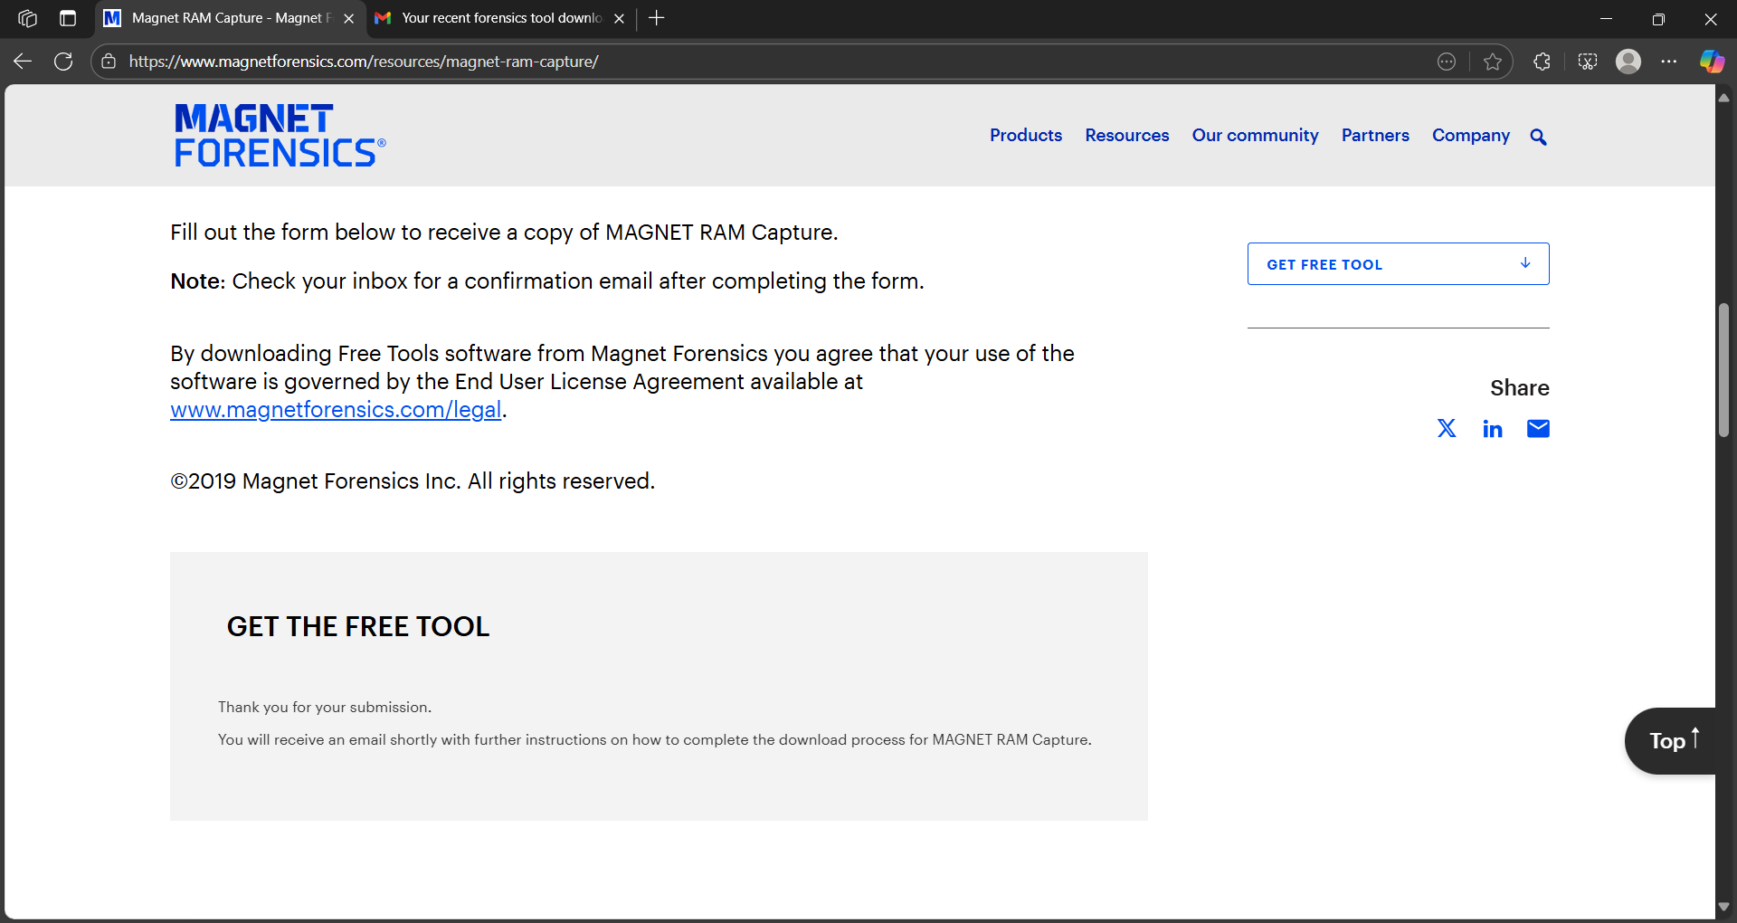

Step 2: Run “MRCv120.exe”

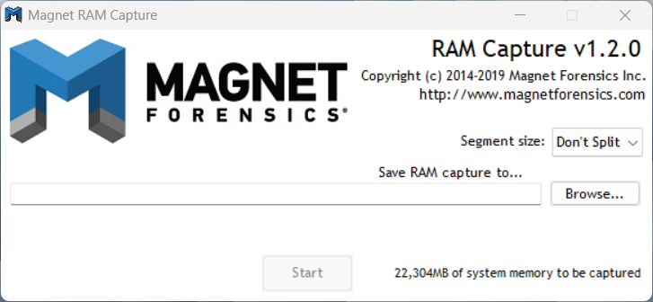

Step 3: Provide the destination to store the Ram captured image and click start 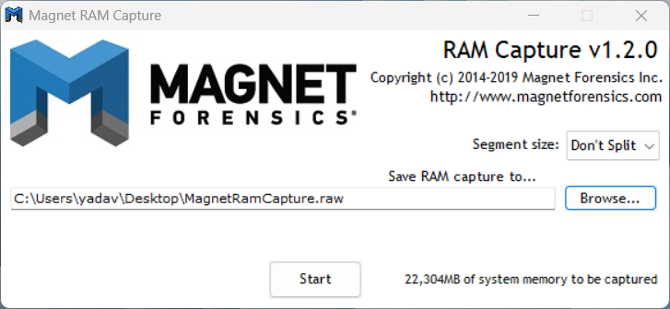

Step 4: For Analysis purpose Download Volatility 3 From it’s Github and do installation after reading instructions from the provided ReadMe file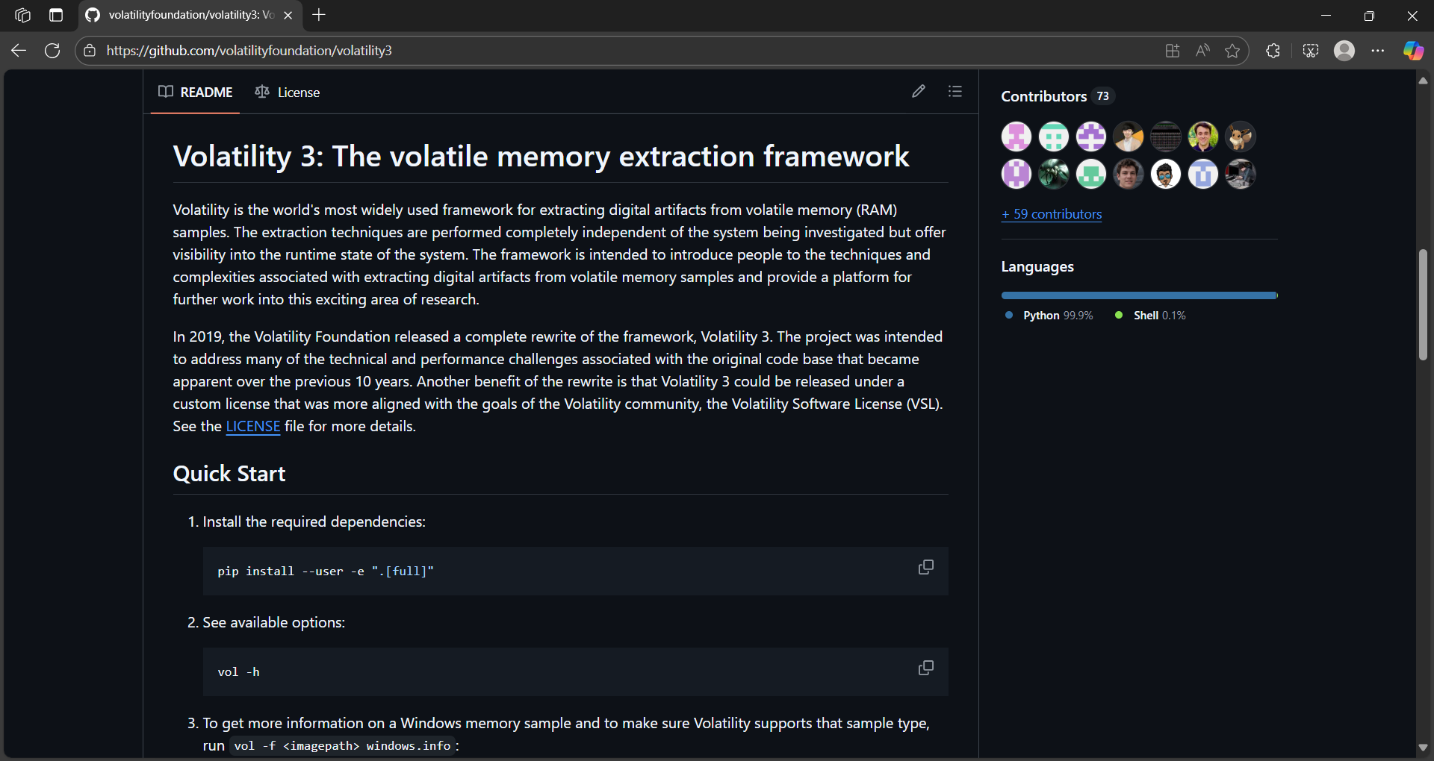

Step 5: Store both files in same directory for ease of access 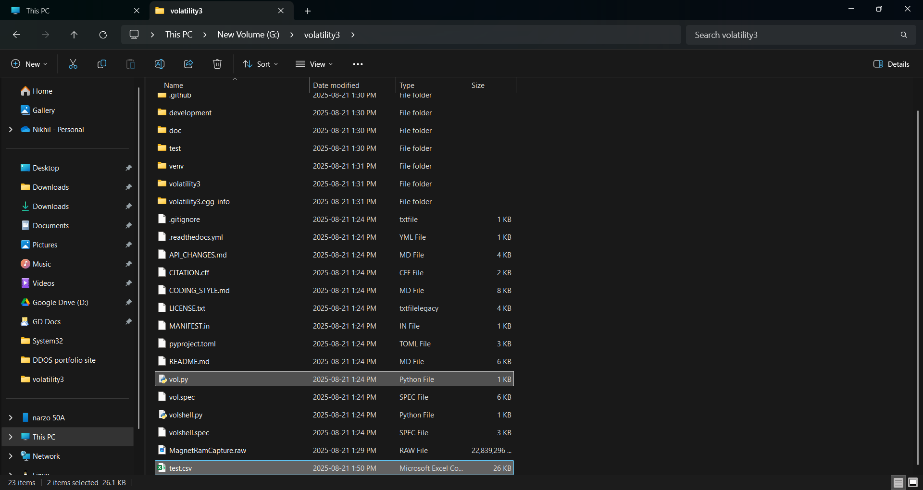

Step 6: Run cmd in format to use Volatility tools (in example windows info is searched) 