Assignment 7 ADB

To download adb tool: https://developer.android.com/tools/releases/platform-tools
enable developer option: Go to "Settings"/ Tap "About phone" or "About device"/ Tap "Software information"/ Tap "Build number" seven times/
enable USB Debugging option from phone / Navigated to key directories: Downloads\platform-tools-latest-windows\platform-tools /

Step 1: #adb devices (to Verify Connection)

Step 2: #adb shell (you can start a remote command-line session on your Android device from your computer)
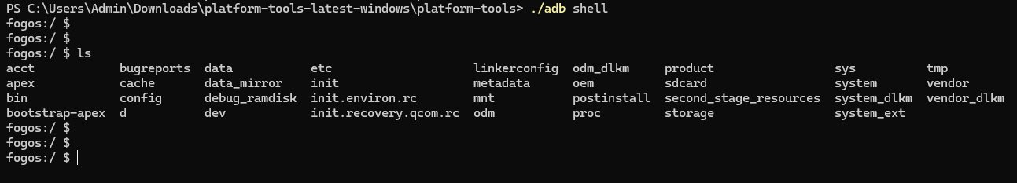

Step 3: For developers or those troubleshooting their device, the #adb logcat command displays the device log in real-time. This log provides insights into what’s happening behind the scenes.
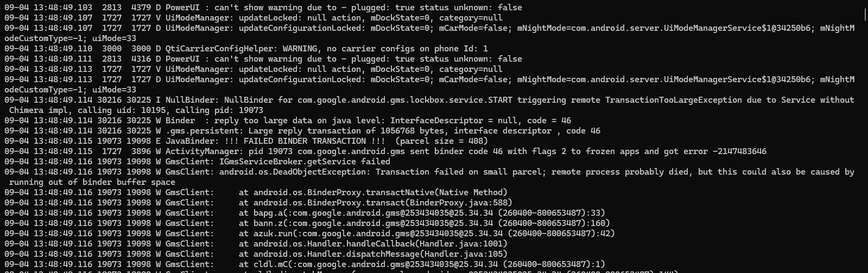
Step 4: #adb backup -apk -shared -all -f my_android_backup.ab
🔹 -apk
Backs up the installed apps' APK files (but not their data unless the app allows it).
Handy if you want to reinstall apps without downloading them again.
🔹 -shared
Includes files stored on the shared storage of your device (like pictures, downloads, music).
🔹 -all
Backs up all installed applications. & Doesn’t require you to list individual packages.
🔹 -f my_android_backup.ab
Specifies the name of the backup file to create: my_android_backup.ab.
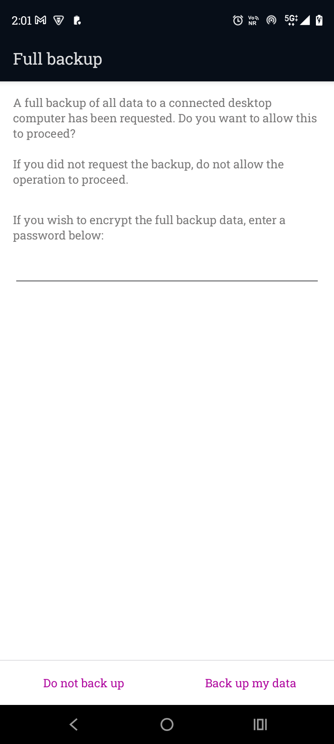

Step 5: #adb pull <remote_path> <local_path>: Copies files or directories from the Android device to the local computer. This is crucial for extracting evidence such as call logs, SMS messages, contacts, application data, and user files.

Step 6: #adb push <local_path> <remote_path>: Copies files or directories from the local computer to the Android device. While less common in forensic extraction, it can be used in certain scenarios like pushing forensic tools or scripts onto the device.

