Mobile Data Extraction using EaseUS Data Recovery Wizard Pro

Tool Used: EaseUS Data Recovery Wizard Pro

EaseUS Data Recovery Wizard Pro is a professional data recovery software designed to recover deleted, formatted, or lost data from PCs, laptops, hard drives, USB drives, memory cards, and other storage devices. In the context of mobile forensics, it can be used to extract data from mounted mobile storage devices.

Step 1: Open EaseUS Data Recovery Wizard Pro.
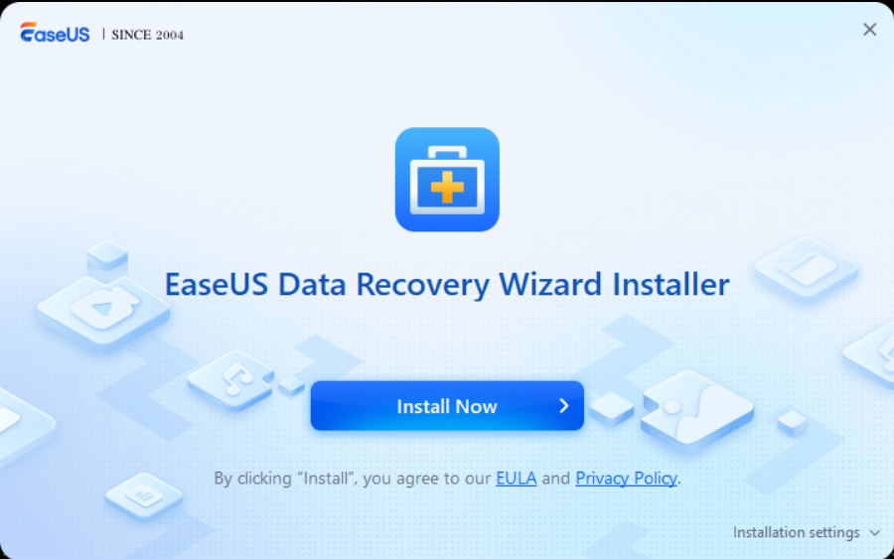

Step 2: Connect the mobile device via USB and select it from the interface.
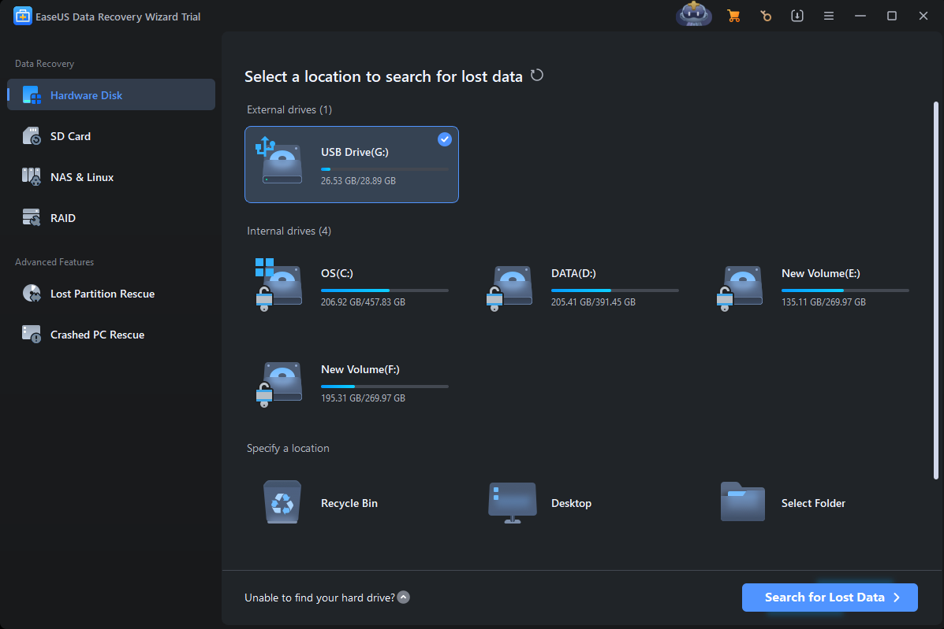

Step 3: Start scanning the selected device.
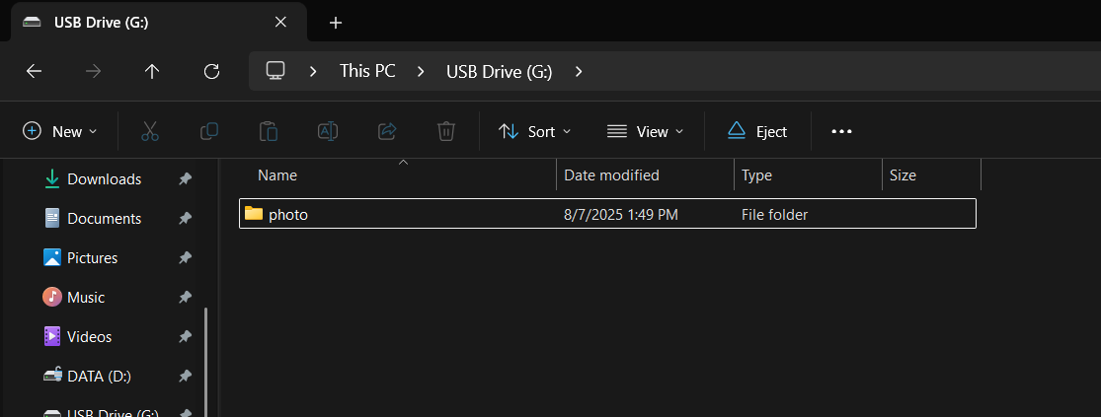

Step 4: The scanning process begins; wait for it to complete.
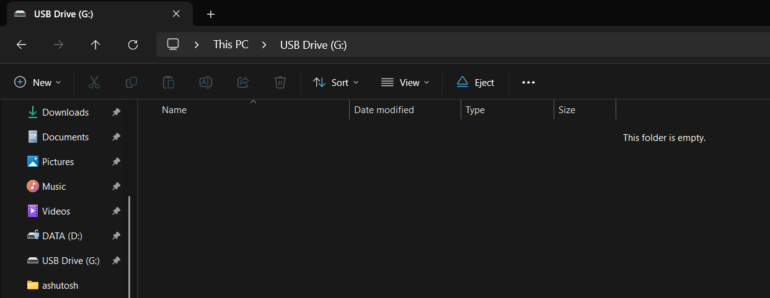

Step 5: Once the scan is complete, browse the recovered files.
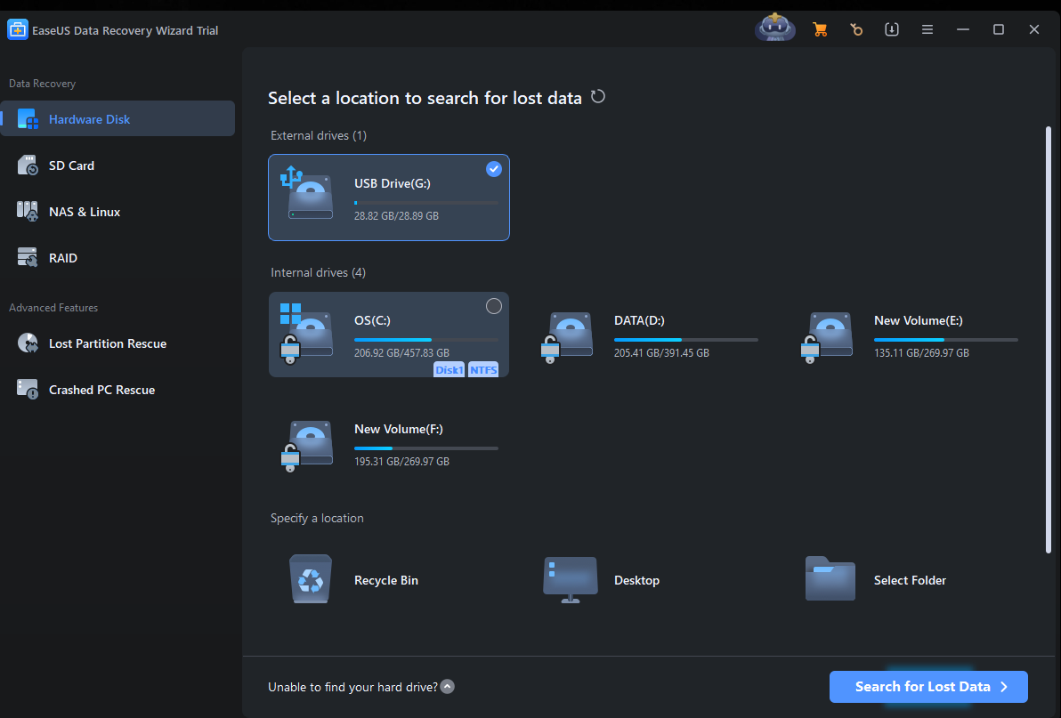

Step 6: Preview the recovered data, including photos, messages, and more.
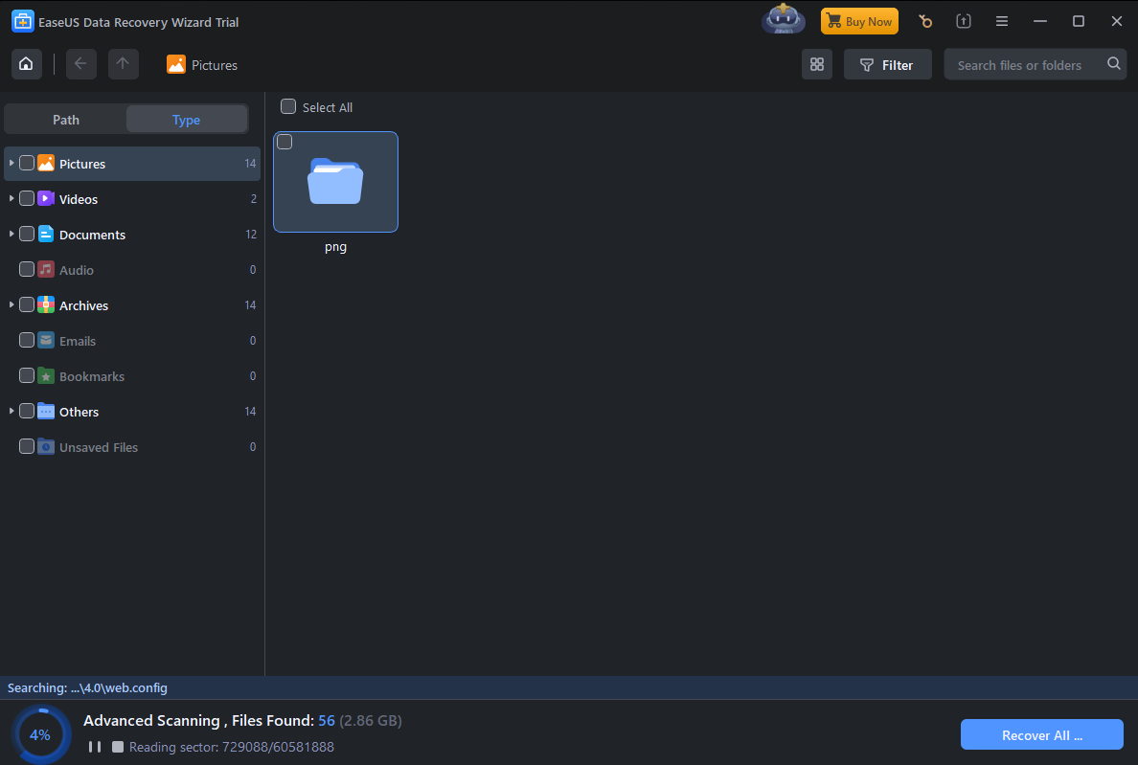

Step 7: Select the files you want to recover and click on the 'Recover' button.
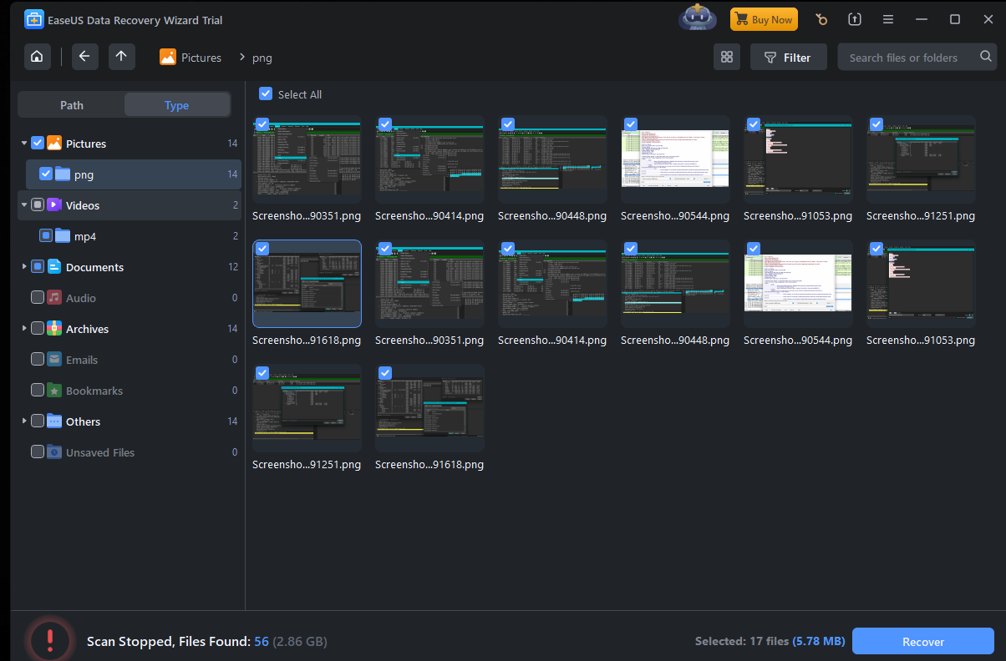

Step 8: Choose the location to save the recovered data.
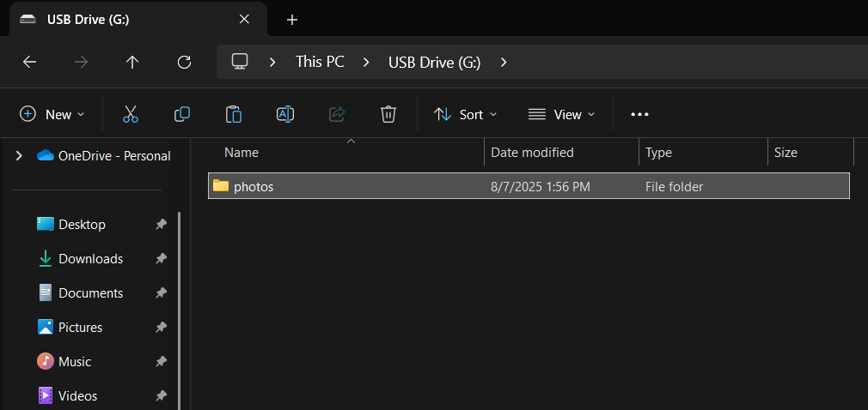

Step 9: Confirm that the data has been successfully recovered and saved.
