Extraction of Digital Evidence using FTK Imager

Objective:
To extract and preserve data from a logical drive using FTK Imager and retrieve mobile data (phonebook, call logs, calendar, messages, media, etc.) using Oxygen Forensics Suite for forensic analysis.

Introduction:
Digital Forensics is a vital part of cybersecurity and criminal investigations. It focuses on the recovery, analysis, and preservation of data from digital devices in a way that ensures its integrity and authenticity. In this practical, we explore how forensic imaging and logical mobile data extraction are performed using industry-recognized tools like FTK Imager and Oxygen Forensics Suite.

Resources Used:
• FTK Imager v3.1.2.0 (AccessData)
• Autospy
• Oxygen Forensics Suite (If available)
• USB Flash Drive (Label: “NOT_VIRUS”)
• Windows Operating System (64-bit)
• System with administrator privileges

Tool Overview:

FTK Imager:
FTK Imager (Forensic Toolkit Imager) is a lightweight yet powerful forensic acquisition tool used for creating forensic images. It enables investigators to acquire complete images of drives, files, or folders, preview contents without modification, generate hash values for data integrity, and save images in multiple formats including RAW (dd), E01, AFF, and SMART.
Autopsy:
Autopsy is an open-source digital forensics platform used for analyzing hard drives, smartphones, and other digital media. It provides a user-friendly graphical interface for The Sleuth Kit (TSK) and supports various forensic functions including file recovery, timeline analysis, keyword searching, hash matching, and email and web artifact extraction. Autopsy is widely used in law enforcement, incident response, and academic research for conducting in-depth forensic investigations on Windows, Linux, and macOS systems.

Oxygen Forensics Suite:
Oxygen Forensics Suite is a comprehensive mobile forensic tool used to extract and analyze data from mobile devices. It can acquire logical, file system, and physical extractions from Android and iOS devices. It supports data such as contacts, call logs, messages, calendar entries, images, videos, and application data. This tool is widely used by law enforcement and forensic professionals.

Procedure (FTK Imager):

Step 1: Launch FTK Imager
Open the FTK Imager application. Go to File > Create Disk Image.
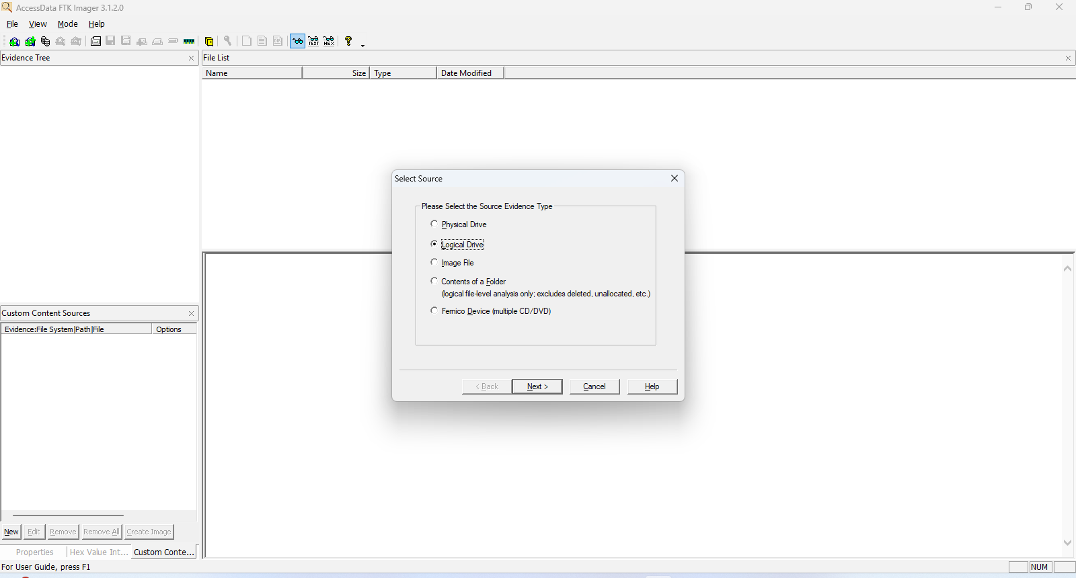

Step 2: Select Source Evidence Type
Choose Logical Drive from the list of source types. Click Next.


Step 3: Select Logical Drive
From the drop-down, select the USB drive (F:\ - NOT_VIRUS [FAT32]). Click Finish.
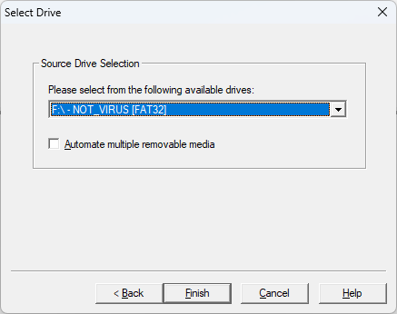

Step 4: Choose Destination Image Type
Select Raw (dd) format for compatibility and integrity. Click Next.
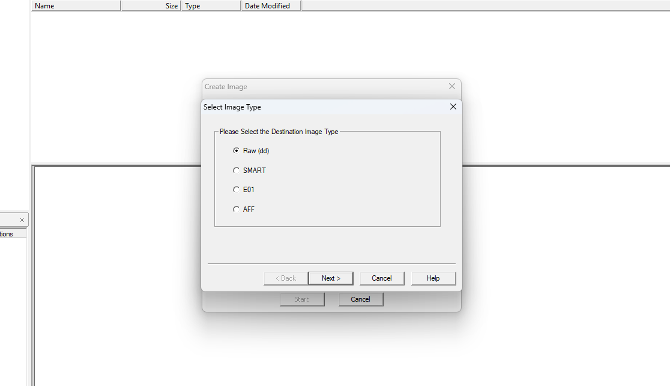

Step 5: Provide Evidence Information
Fill in the following details:
- Case Number: 001
- Evidence Number: TTR2323
- Unique Description: nothing
- Examiner: Jhon Devid
- Notes: Evidence
Click Next.
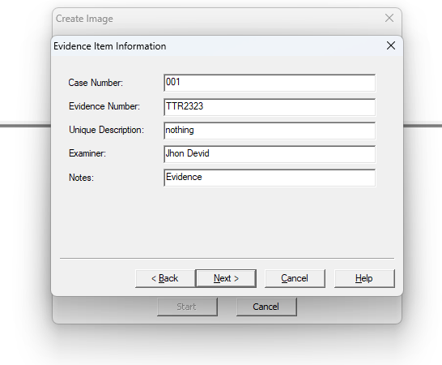

Step 6: Set Image Destination
Specify the destination folder (e.g., C:\evidence files) and file name (Take_It). Set fragment size to 1500 MB and compression level to 0 (no compression). Click Finish.
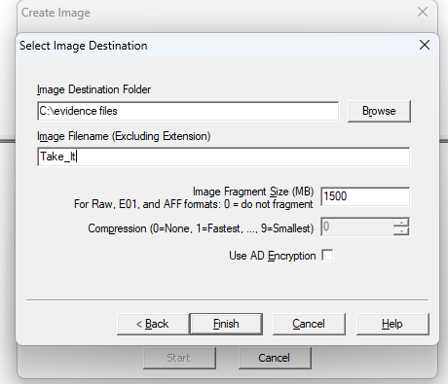

Step 7: Image Creation
Ensure the options for verifying the image and precalculating progress statistics are checked. Click Start to begin imaging.
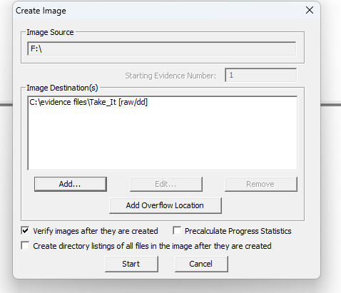

Step 8: Image Creation In Progress
The imaging process begins. The application displays elapsed time and estimated time left.
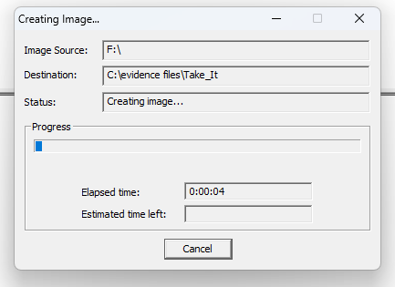

Step 9: Verifying the Image
After imaging, FTK Imager verifies the image file against the original source using MD5 and SHA1 hash values.
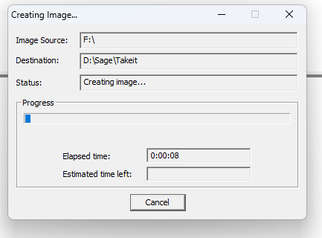

Step 10: Completion
The image is successfully created. Hash values match, confirming the data has not been altered.
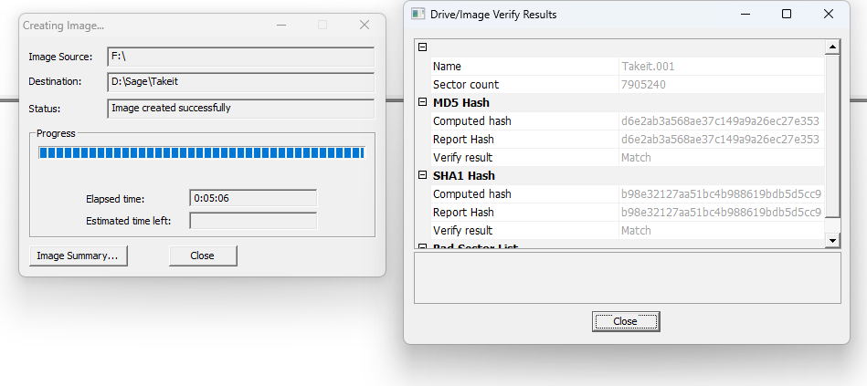

Conclusion:
The FTK Imager tool was effectively used to create a bit-by-bit forensic image of a logical drive. The process included setting evidence details, selecting image types and formats, specifying the destination path, and verifying image integrity using hash values. This ensured the digital evidence was acquired without any modification. This type of forensic imaging is critical in maintaining the chain of custody and ensuring that the data can be used in court or further analysis.

