Case Study: Data Recovery Using Wondershare Recoverit

Title:
Recovery of Deleted Files from D: Drive Using Wondershare Recoverit

1. Introduction
Data loss can occur due to accidental deletion, formatting, partition loss, or system crashes. In this case study, Wondershare Recoverit was used to recover deleted files from the D: drive, specifically from a folder named “New folder delete”.
The objective of this case study was to:
- Scan the D: drive for deleted files
- Locate files from a specific deleted folder
- Preview and recover selected files safely

2. Tool Used
- Software: Wondershare Recoverit
- Platform: Windows
- Recovery Type: Deleted Folder Recovery from Local Drive

Step-by-Step Recovery Process

Step 1: Launching Wondershare Recoverit
After installing and opening Wondershare Recoverit, the main dashboard appeared with multiple recovery options such as:
- Hard Drives and Locations
- SD Card Recovery
- File Repair
- Other Tools
The system displayed available drives including:
- Windows (C:)
- Data (D:)
- Lost Partitions
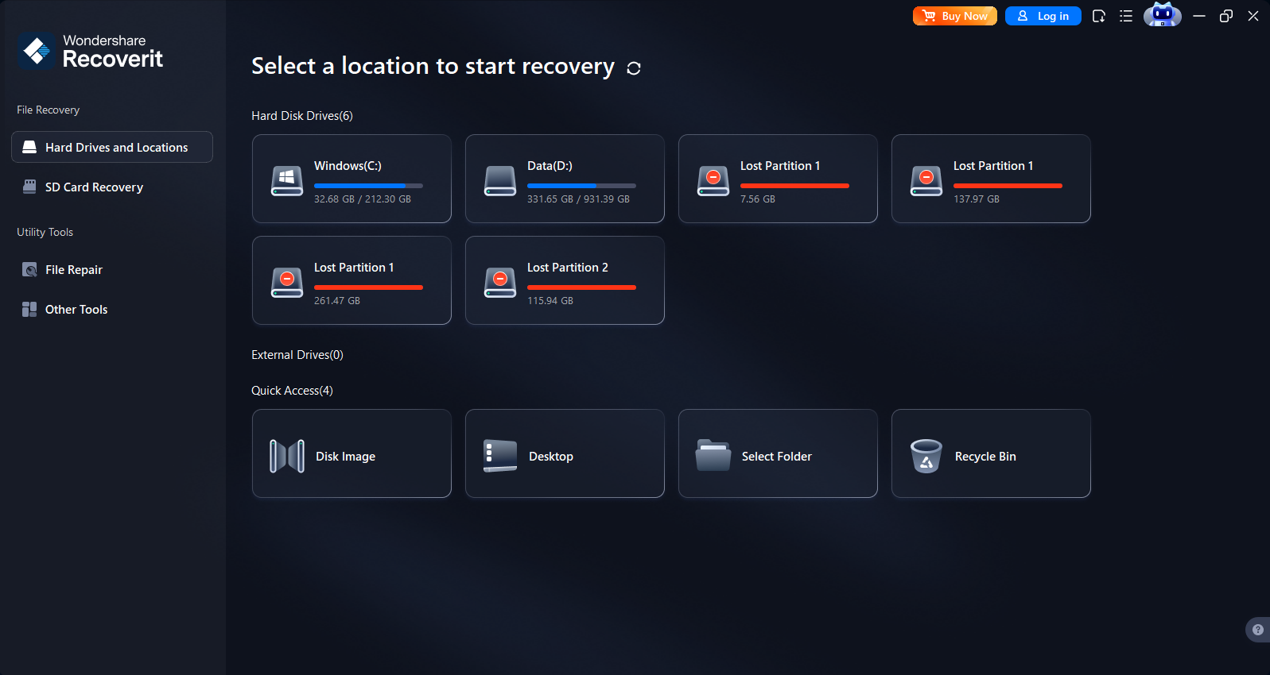This screen allows the user to select the storage location where data loss occurred.

Step 2: Selecting the Target Drive
Since the deleted folder was located in the D: drive, the following steps were performed:
- Clicked on Data (D:)
- Chose the option Select Folder
- Navigated to the specific folder location
A directory window opened showing multiple folders.
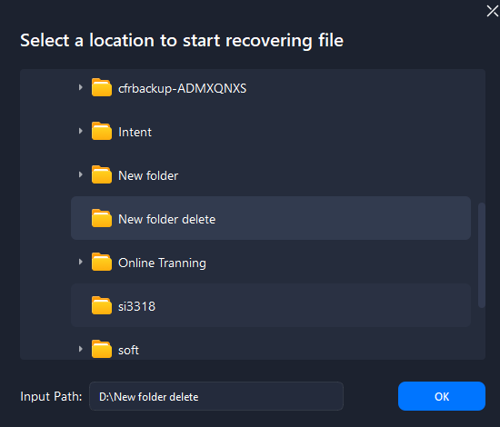
From the list, the folder “New folder delete” was selected.
The input path displayed:
D:\New folder delete
Then clicked OK to start scanning.

Step 3: Scanning Process
After selecting the folder, Recoverit automatically began scanning.
Recoverit performed:
- Quick Scan (for recently deleted files)
- Deep Scan (sector-by-sector analysis for permanently deleted files)
During scanning, files were categorized based on:
- File Type
- File Location
- File Size
- Date Modified
- File Status

Step 4: Viewing Scan Results
After the scanning process completed, Recoverit displayed recoverable files.
The interface showed:
- File location panel on the left
- Recovered file previews in the center
- Filtering options at the top
Recovered files included:
- .doc files
- .xls files
- .csv files
- .html files
- .log files
- System and temporary files
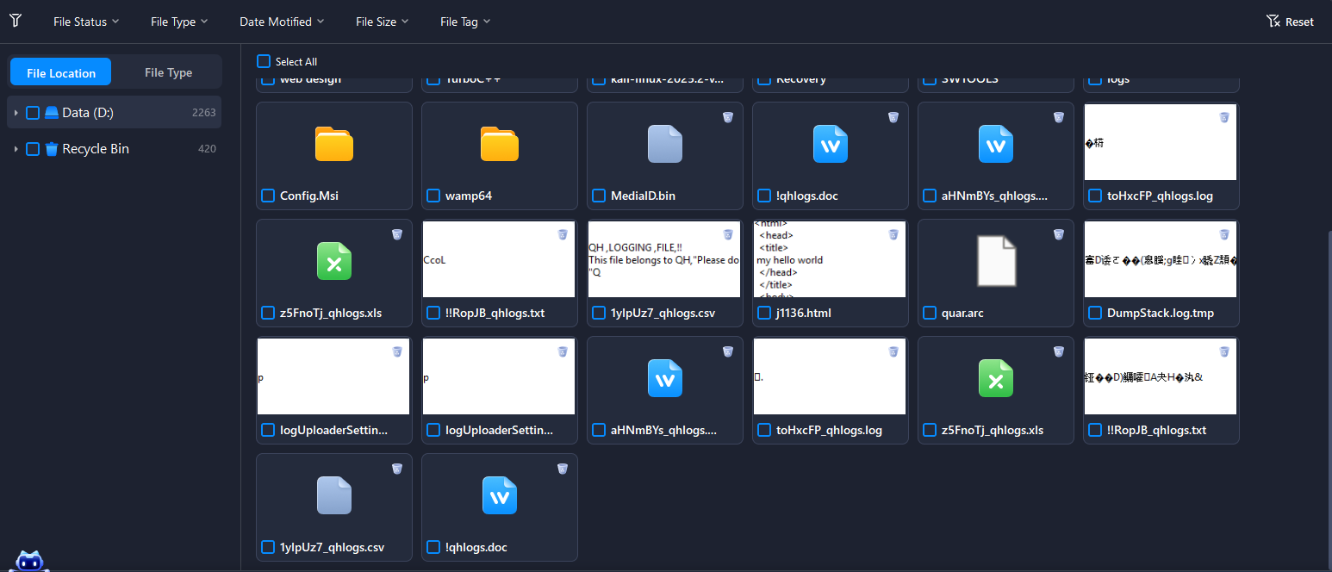The software also provided:
- Preview option
- Select All option
- Individual file selection
- File filtering

Step 5: Previewing Files
Before recovery, files were previewed to verify integrity.
Examples seen in preview:
- HTML file showing sample code
- CSV logging files
- Word documents
- Excel spreadsheets
This ensured that only required files were selected for recovery.

Step 6: Recovering Files
To recover files:
- Selected the required files using checkboxes.
- Clicked on the Recover button.
- Chose a different storage location (Important: Not D: drive to avoid overwriting).
- Confirmed recovery.
The files were successfully restored to the selected safe location.

Features of Recoverit Observed in This Case Study
✔ User-friendly graphical interface
✔ Quick and Deep scan modes
✔ File preview before recovery
✔ Folder-level recovery
✔ File filtering and sorting options
✔ Support for multiple file formats

Precautions Taken
- Recovery files were saved to a different drive to avoid overwriting.
- The affected drive was not used during recovery.
- Only necessary files were recovered.

Results
- The deleted folder data from D:\New folder delete was successfully scanned.
- Multiple file types were identified.
- Selected files were restored successfully.
- File integrity was maintained after recovery.

1. How did you use Recoverit to analyze the Android image, and what options does it provide for file recovery?
To analyze the Android image, I used Wondershare Recoverit Data Recovery software. First, I connected the Android device (or mounted its extracted storage image) to my computer. Recoverit automatically detected the storage media, including internal storage or SD card.
I selected the target storage location and initiated a Deep Scan. Recoverit performed a sector-by-sector scan to identify deleted, lost, or inaccessible files. During the scanning process, it categorized the recovered data into file types such as images, videos, documents, audio files, and other formats.
Recoverit provides the following options for file recovery:
- Quick Scan – For recently deleted files.
- Deep Scan – For permanently deleted or formatted data.
- File Type Filtering – Allows filtering results by file format (e.g., JPG, MP4, DOCX).
- Preview Feature – Enables previewing recoverable files before restoration.
- Selective Recovery – Users can choose specific files to restore instead of recovering everything.
- External Device Recovery – Supports SD cards and external drives used with Android devices.
After reviewing the scan results, I selected the required files and recovered them to a different storage location to prevent overwriting.

2. What specific techniques did you employ to recover deleted SMS messages on your Android device?
To recover deleted SMS messages, I used the following approach with Recoverit:
- Device Connection / SD Card Extraction – Since SMS data is stored in the device’s internal database, I first checked if SMS backups or exported message files were available. If messages were backed up to external storage, Recoverit scanned that storage.
- Deep Scan Mode – I enabled Deep Scan to search for deleted database files (such as .db or .sqlite files) where SMS messages are typically stored.
- File Signature Analysis – Recoverit uses signature-based scanning to identify deleted files even when file system metadata is missing.
- Recovery of Backup Files – If SMS backup files (e.g., XML backup files created by SMS backup apps) were found, I recovered those files and restored messages using an appropriate SMS restore application.
- Preview and Selective Recovery – I previewed recoverable files before restoring them to ensure the correct data was retrieved.
This method helped retrieve deleted SMS data, provided the storage sectors had not been overwritten.

3. Describe the steps you followed to recover contacts using your Google account.
To recover contacts using my Google account, I followed these steps:
- Logged into Google Contacts
I signed in to my Google account via contacts.google.com.
- Accessed the “Trash” or “Undo Changes” Option
  - Checked the Trash section to restore recently deleted contacts.
  - Used the Undo Changes feature to restore contacts to a previous date (within the allowed recovery period, usually up to 30 days).
- Restored Contacts
Selected the contacts to restore and confirmed the recovery.
- Synchronized the Device
  - Went to Settings → Accounts → Google → Sync Contacts
  - Enabled synchronization to update the restored contacts on the Android device.
- Verification
Opened the Contacts app on the Android device to confirm that the recovered contacts were successfully restored.

Conclusion
This case study demonstrates that Wondershare Recoverit is an effective and reliable tool for recovering deleted data from local drives. Its deep scanning technology, preview functionality, and organized interface make it suitable for both beginners and professionals.
Using Recoverit, the deleted folder and its contents were successfully analyzed, scanned, previewed, and restored without data corruption.

