Digital Forensics Case Study

Mobile Evidence Imaging using AccessData FTK Imager 3.1.2.0

# Case Overview
Case Title: Acquisition of Mobile Evidence using FTK Imager
Tool Used: Access Data FTK Imager 3.1.2.0
Evidence Type: Mobile evidence folder (logical acquisition)
Examiner: John David
Objective: To forensically acquire mobile evidence in a forensically sound manner while maintaining data integrity using cryptographic hash verification.

# Background
In this case, a folder containing mobile evidence was provided for forensic acquisition. Since the evidence already existed as data on a storage drive, a logical image (AD1 format) was created instead of a physical device acquisition. FTK Imager was used to ensure integrity, verification, and proper documentation of the evidence.

# Tools & Environment
- Operating System: Windows
- Forensic Tool: AccessData FTK Imager 3.1.2.0
- Source Path: D:\New folder\Evidences\Mobile_Evidence
- Output Path: D:\New folder\Evidences\Mobile_Evidence output
- Image Format: AD1 (AccessData Logical Image)

# Step-by-Step Evidence Acquisition Process

Step 1: Launch FTK Imager
The examiner opens AccessData FTK Imager 3.1.2.0. From the top menu, the File option is selected.
Figure 1: FTK Imager main interface with File menu open.
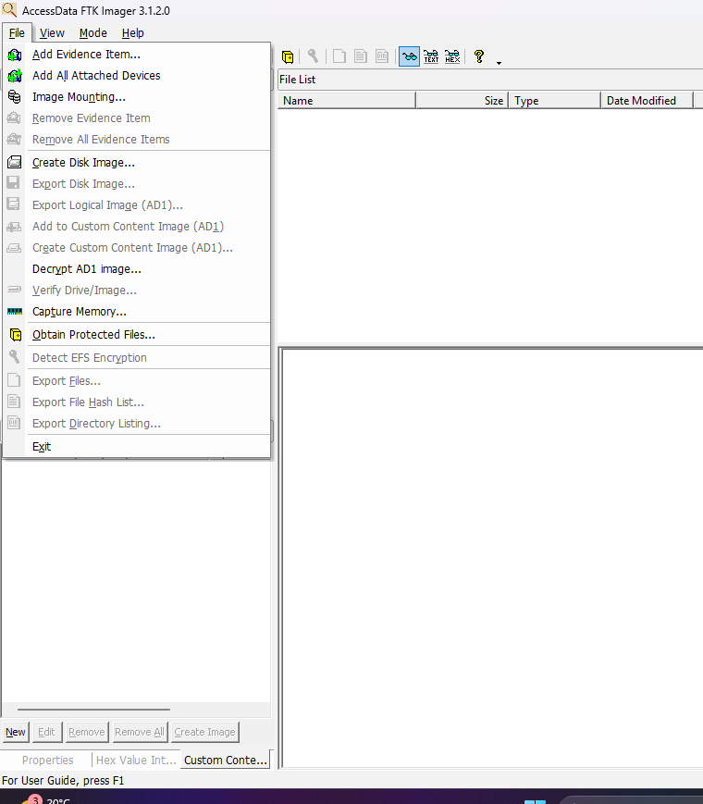

Step 2: Create Disk Image
From the File menu, Create Disk Image is selected to begin the acquisition process.

Step 3: Select Source Evidence Type
The source evidence type is chosen as Contents of a Folder, suitable for logical file-level analysis.
Reason: The evidence is already extracted and stored as a folder.
Figure 2: Source Evidence Type selection window.
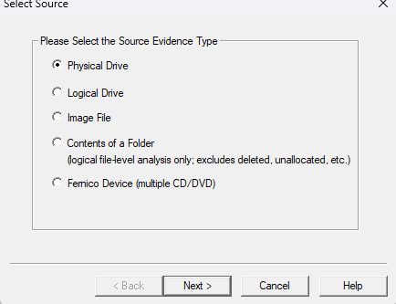

Step 4: Select Evidence Source Path
The examiner browses and selects the folder:
D:\New folder\Evidences\Mobile_Evidence
This folder contains the mobile evidence to be acquired.
Figure 3: Evidence Source Selection window showing the folder path.
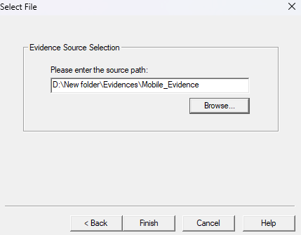

Step 5: Configure Image Creation
The Create Image window appears showing the selected source. The examiner clicks Add to define the image destination.
Figure 4: Create Image window before adding destination.
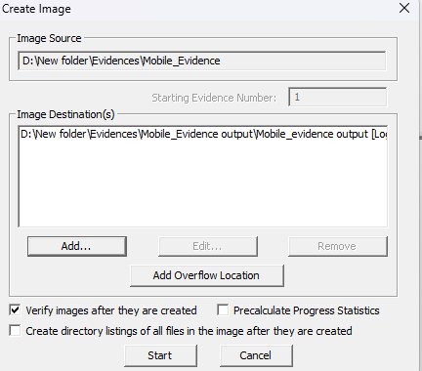
Step 6: Select Image Destination and Settings
The destination folder and image filename are configured:
- Image Name: Mobile_evidence output
- Fragment Size: 1500 MB
- Compression Level: 6
- Encryption: Enabled
- Filter by File Owner: Enabled
Figure 5: Image destination and configuration window.
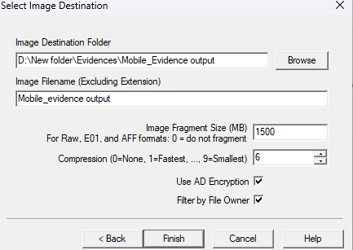

Step 7: Select File Owner
Only files owned by the selected user are included:
- User Selected: Jhon Devid
This ensures scoped acquisition based on ownership.
Figure 6: File Owner selection window.
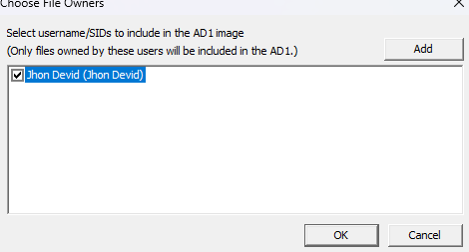
Step 8: Start Imaging Process
After reviewing settings, the examiner clicks Start. FTK Imager begins creating the AD1 image.

Step 9: Hash Verification
Upon completion, FTK Imager automatically verifies the image using:
- MD5 Hash
- SHA1 Hash
Both computed and reported hashes match, confirming data integrity.
Figure 7: Drive/Image Verify Results window showing hash match.
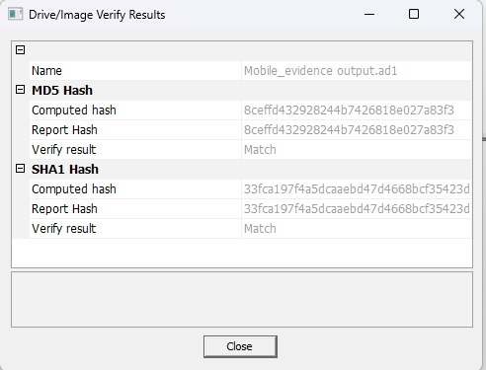
# Image Creation Confirmation
The status displays Image created successfully, indicating successful acquisition.
Figure 8: Image creation success message.
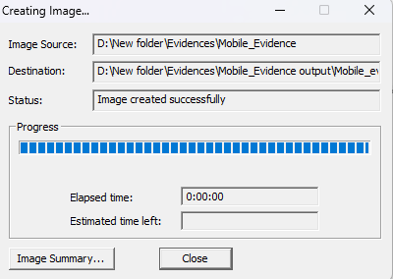
# Image Summary Review
The examiner reviews the image summary which includes:
- Tool version
- Case number
- Evidence number
- Examiner name
- Hash values
- Acquisition start and finish time
Figure 9: Image Summary window.
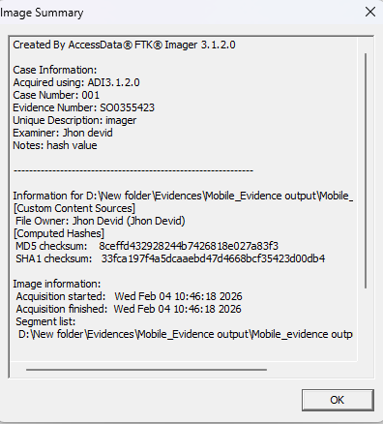
# Hash Values Recorded
- MD5: 8ceffd432928244b7426818e027a83f3
- SHA1: 33fca197f4a5dcaebd47d4668bcf35423d00db4
These hashes ensure the integrity and authenticity of the acquired evidence.

# Conclusion:
This case study demonstrates a proper logical acquisition of mobile evidence using AccessData FTK Imager. All forensic best practices were followed, including controlled acquisition, verification using cryptographic hashes, and proper documentation. The resulting AD1 image is forensically sound and suitable for further analysis or legal proceedings.

# Key Learning Outcomes
- Understanding logical evidence acquisition
- Proper use of FTK Imager for folder-based evidence
- Importance of hash verification
- Maintaining forensic integrity and documentation

