Assignment No. 6
Multimedia Forensics

Introduction

Multimedia Forensics is the sub-discipline of digital forensics focused on analyzing digital media (images, audio, video) to determine its origin, integrity, and authenticity. The goal is to detect manipulation or forgery, which is critical for legal, journalistic, and security purposes.

Core Concepts

Integrity and Authenticity: Integrity means the media is unaltered; authenticity means it genuinely represents the event captured.
Source Identification: Linking media to a specific capture device (camera/phone) by analyzing unique hardware artifacts, such as Photo Response Non-Uniformity (PRNU) or lens distortion.

Tampering Detection:
  - Image Forgery: Detecting splicing, copy-move operations, and resampling (scaling/rotation) by looking for inconsistencies in noise, lighting, or compression artifacts.
  - Audio Forgery: Identifying discontinuities in the spectrum or inconsistent background noise (cut-and-paste).
  - Video Forgery: Checking for inconsistencies between frames (inter-consistency) and detecting advanced synthetic media (Deepfakes).

Forensic Methodology (The Digital Autopsy)
A structured, multi-phase process ensures reliable findings:
Install Autopsy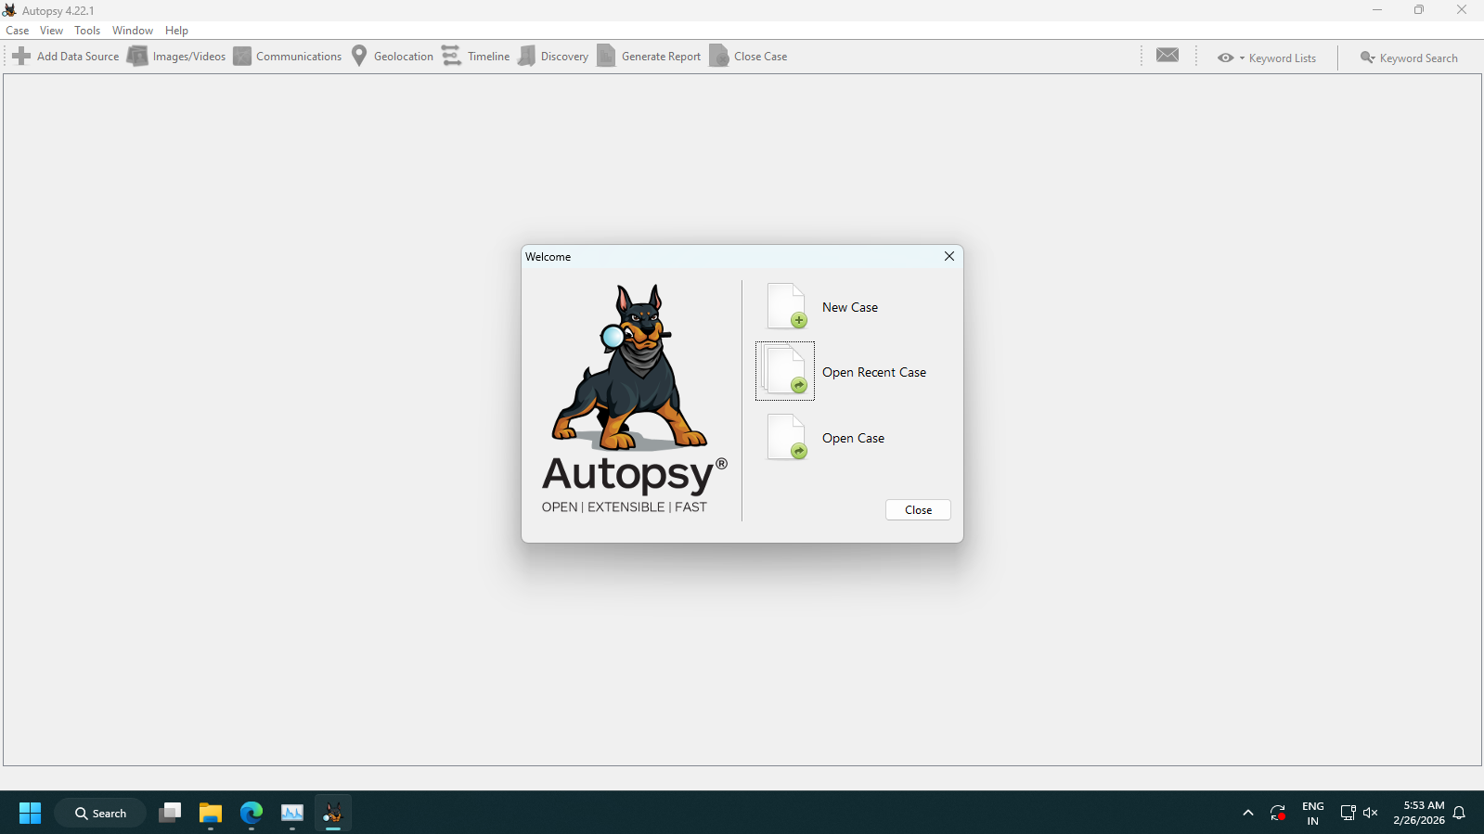

Step 1: Acquisition and Preservation (The Collection Phase)

Goal: Secure the original media evidence and ensure its integrity for the entire investigation.

Steps:
- Secure the media and create a bit-for-bit forensic copy.
- Calculate a cryptographic hash (e.g., SHA-256) of the original file.
- Document the Chain of Custody (who handled the evidence, when, and why).
(Conceptual Screenshot/Visualization: A secure drive image being generated with a hash value)
Output | Description
Original File Hash: 8b1a3c7d... | The unique digital fingerprint of the evidence before analysis.
Forensic Image Created | A perfect, unalterable copy of the original file.
Step 2: Initial Triage and Metadata Examination (The External Examination)

Goal: Analyze external file data for immediate signs of inconsistency or alteration.

Steps:
- Analyze file format and structure.
- Extract EXIF/Metadata (capture time, device model, software used) and flag immediate inconsistencies (e.g., mismatched file extensions, unreasonable timestamps, "Software Used: Adobe Photoshop" on an image claiming to be straight from a camera).
(Conceptual Screenshot/Visualization: Metadata Viewer)
Field | Value | Observation
Date/Time Original | 2026:02:26 10:00:00 | Consistent
Make/Model | Canon EOS R6 | Consistent
Software Used | Picasa 3.0 | Flagged: Indicates the image was opened/saved by editing software.
Step 3: Authentication and Integrity Assessment (The Internal Examination - Analysis)

Goal: Apply sophisticated forensic techniques to detect and localize specific manipulations.

Steps:
- Source Identification: Apply PRNU analysis (Photo Response Non-Uniformity) to fingerprint the camera that took the photo. (If the image was allegedly taken by Camera A, but the PRNU matches Camera B, forgery is indicated.)
- Manipulation Detection:
  - Analyze compression artifacts (Look for double JPEG compression or inconsistent quality factors).
  - Detect geometric resampling (Scaling or rotation leaves periodic traces in the frequency domain).
  - Use specialized algorithms to localize forged areas (e.g., identifying boundaries in splicing or finding duplicated blocks in copy-move).
- Deepfake Analysis: Check frame-to-frame consistency, motion cues, and temporal synchronization for advanced synthetic media.
(Conceptual Screenshot/Visualization: Forgery Detection Map)
Image | Description
 | Error Level Analysis (ELA) Map: The highlighted red area shows a region (the inserted cat) that was saved with a different JPEG compression quality/level than the rest of the image, indicating splicing/forgery.
Step 4: Reporting and Conclusion (The Report Generation)

Goal: Document the findings clearly, concisely, and in a format suitable for legal or official review.

Steps:
- Document all methods and tools used (e.g., "Used J-PhotoMetric Tool v4.2 for PRNU Analysis").
- Clearly state whether evidence of manipulation was found, providing technical details (e.g., "Evidence of copy-move forgery found at coordinates 450x300").
- Provide a final conclusion on the media's authenticity, prepared for legal presentation.
(Conceptual Screenshot/Visualization: Summary Report)
Section | Finding | Conclusion
Integrity Check | SHA-256 Hash matches forensic copy. | Integrity maintained.
Metadata Check | Software used field altered from "Camera Default" to "Adobe Photoshop." | Inconsistent.
Manipulation Detection | Strong evidence of inconsistent compression and geometric resampling detected in the top-right quadrant (ELA Score: 85/100). | Verdict: Forgery/Manipulation Detected.
Conclusion

Multimedia Forensics is an essential, evolving field dedicated to combating digital disinformation. Continuous development of robust detection tools is crucial to maintain trust in digital evidence.

