Practical no.2

There are many different commands using which you can extract device information using ADB

Basic device + OS info
adb devices
adb shell getprop ro.product.model
adb shell getprop ro.product.manufacturer
adb shell getprop ro.build.version.release
adb shell getprop ro.build.version.sdk
adb shell getprop ro.product.cpu.abi

This is how all the commands give output…
👇
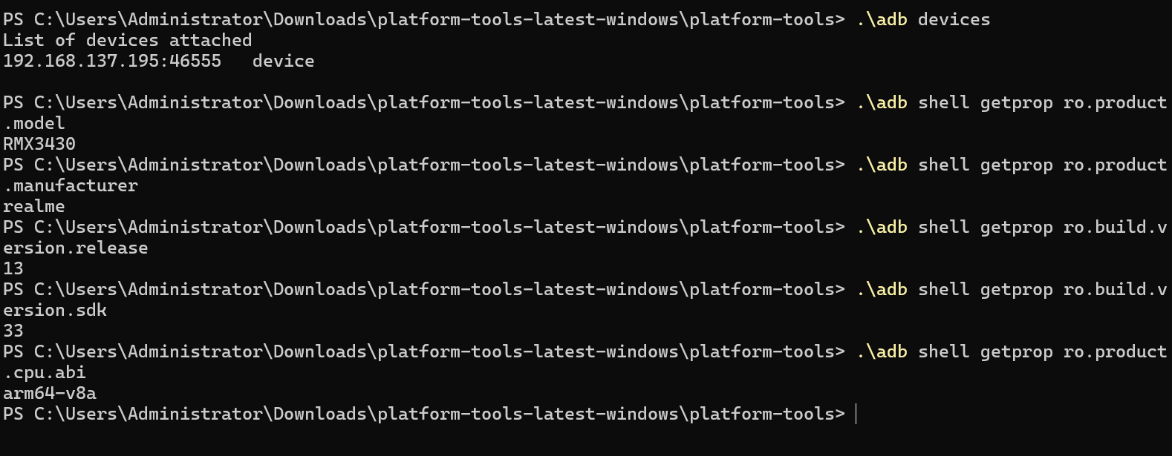

This is the method of extracting the data from Android devices
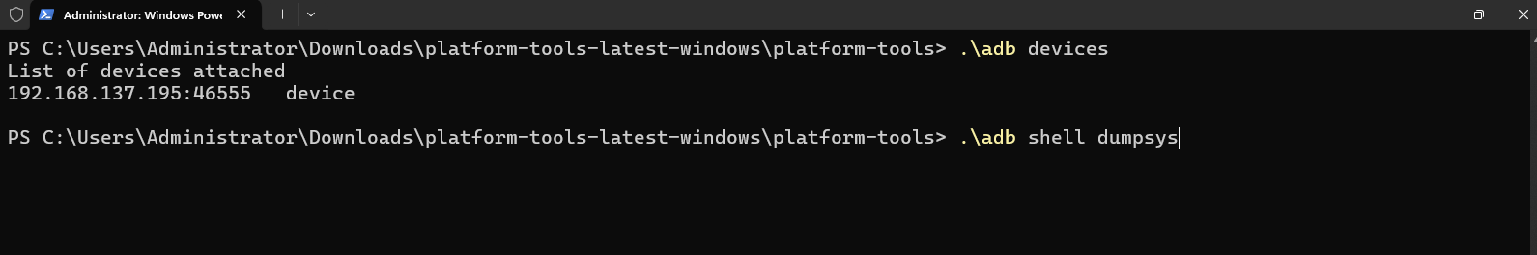

The last command here is to extract full system dump.
i.e. Detailed device dump

Exercise: 1. Extracting device information of your Android device using ADB.
Ans: To extract device information using ADB we have multiple commands:
.\adb devices
.\adb shell getprop ro.product.model
.\adb shell getprop ro.product.manufacturer
.\adb shell getprop ro.build.version.release
.\adb shell getprop ro.build.version.sdk
.\adb shell getprop ro.product.cpu.abi

2. Use the SQLite Browser to display call logs.
Ans To use SQLite Browser to display call logs the device needs to be rooted.
So it wasn’t possible.

3. Display all call logs using ADB.

Ans : This can be performed using the commands:
- adb shell dumpsys calllog
- adb shell content query --uri content://call_log/calls

4. View browser history information using Autopsy.

Tool Used
Autopsy – Digital Forensics Platform

The command to do the same in terminal is
adb pull /data/data/com.android.chrome/app_chrome/Default/History
Output for the same:
[
--------------------------------------------------
Browser Name : Google Chrome
URL : https://www.google.com
Title : Google
Visit Time : 2024-02-05 10:42:18
Visit Count : 3
--------------------------------------------------
Browser Name : Google Chrome
URL : https://www.youtube.com
Title : YouTube
Visit Time : 2024-02-05 09:58:44
Visit Count : 1
--------------------------------------------------
Browser Name : Google Chrome
URL : https://mail.google.com
Title : Gmail
Visit Time : 2024-02-04 21:13:02
Visit Count : 2
--------------------------------------------------
]

Questions:

1. What information can be extracted using ADB for device identification?
Ans : Using ADB, device identification information such as device model, manufacturer, Android version, SDK level, build details, hardware information, and network details can be extracted using commands like adb shell getprop and adb shell dumpsys.

2. How can call logs be displayed using the SQLite Browser?
Ans : Call logs can be displayed by extracting the calllog.db database from the Android device (root access required) and opening it in DB Browser for SQLite, where the calls table contains call history details.

3. What ADB command can be used to view all call logs from an Android device?

Ans : adb shell content query --uri content://call_log/calls
This command displays all call logs including numbers, call type, date, and duration.

4. What are the key steps to view browser history information using Autopsy?
Ans : The key steps include acquiring a device image or browser data, loading it into Autopsy, running ingest modules, and viewing extracted browser history under the Web Artifacts / Web History section.

