**A PROJECT REPORT**

**ON**

**Intelligent Tutoring System**

**M.E. (Software Engineering)**

**(2017-2019)**



**Submitted by:**

Kartik Jaitly (801731004)

Pankaj Yadav (801731008)

**Submitted to:**

Mrs. Harkiran Kaur

Department of Computer Science and Engineering

Thapar University

Patiala, Punjab

**ACKNOWLEDGEMENT**

The satisfaction that accompanies that the successful completion of any task would be incomplete without the mention of people whose ceaseless cooperation made it possible, whose constant guidance and encouragement crown all efforts with success.

We are grateful to our mentor Mrs. Harkiran Kaur for her guidance, inspiration and constructive suggestions that help us in the implementation and completion of this project.

Lastly we would like to thank all those who helped us in any way in our project.

Thanking You

(Pankaj Yadav

Kartik Jaitly)

**ABSTRACT**

“Intelligent Tutoring System” is a software developed for students for learning. This software is very interactive and attractive which will increase the interest of the student. Tutoring System will also generate quiz based on the content provided and then do the analysis based on the response of the student. This system will analyse the incorrect response and write the alternative approach to the answer. The system will also display the marks scored by the student in a particular subject/quiz. This system will store the study material and quiz in a database. The solution and alternative approach to an answer is also present in the database.

**LIST OF FIGURES**

4.1 DFD for ITS 11

4.2 ER Diagram for ITS 12

4.3 Use Case for ITS 12

**Contents**

ACKNOWLEDGEMENT i

ABSTRACT ii

LIST OF FIGURES iii

TABLE OF CONTENTS iv

**Table of Contents**

1. Introduction 1

1.1 Purpose 1

1.2 Project Scope 1

1.3 Definitions, Acronyms and Abbreviations 2

1.4 References 3

1.5 Overview 3

2. Overall Description 4

2.1 Product Perspective 4

2.1.1 System Interfaces 4

2.1.2 Product Functions 5

2.1.3 User Characteristics 5

2.1.4 Constraints 6

2.1.5 Assumptions and Dependencies 6

3. Specific Requirements 6

3.1 External Interface Requirements ………..………………………………..........6

3.2 Functional Requirements………………….….………………………………...7

3.2.1 Quiz 7

3.2.2 Study Material 7

3.3 Logical Database Requirements……………………………………………….8

3.3.1 Types of Information 8

3.3.2 Frequency of use 8

3.3.3 Accessing Capabilities 8

3.3.4 Data Entities and their relationships……………………………………….8

3.3.5 Integrity Constraints………………………………………………………..8

3.4 Software System Attributes 8

3.4.1 Reliability 8

3.4.2 Availability 9

3.3.3 Maintainability 9

3.3.4 Usability 9

3.3.5 Scalability 9

4. System Design 9

4.1 Feasibility Study 9

4.1.1 Financial Feasibility 10

4.1.2 Technology Feasibility 10

4.1.3 Schedule Feasibility 10

4.1.4 Legal Feasibility 10

Appendix 13

# 1. Introduction

An **Intelligent Tutoring System** (ITS) comes as a result of the application of the artificial intelligence in the field of education. The concept of ITS is briefly introduced in this article. The modules and structures in the ITS is also detailed.

An intelligent tutoring system (ITS) is any computer system that provides direct customized instruction or feedback to students. The theory of learning by doing is implemented by the ITS. a range of different technologies maybe employed by the ITS to achieve its functionality.

## 1.1 Purpose

## An intelligent tutoring system (ITS) is a computer system that aims to provide immediate and customized instruction or feedback to learners, usually without requiring intervention from a human teacher. ITSs have the common goal of enabling learning in a meaningful and effective manner by using a variety of computing technologies. There are many examples of ITSs being used in both formal education and professional settings in which they have demonstrated their capabilities and limitations. There is a close relationship between intelligent tutoring, cognitive learning theories and design; and there is ongoing research to improve the effectiveness of ITS. An ITS typically aims to replicate the demonstrated benefits of one-to-one, personalized tutoring, in contexts where students would otherwise have access to one-to-many instruction from a single teacher (e.g., classroom lectures), or no teacher at all (e.g., online homework). ITSs are often designed with the goal of providing access to high quality education to each and every student.

## 1.2 Project Scope

The aim of this project is to design and develop an intelligent tutoring system that provides an interactive way of learning for the kids. This system can also conduct various assessment programs and respond according to the assessment.

This portal will benefit new learners and teachers. This System will be specified only for kids. Students can search for topics related to their subjects within specific area. Similarly, teachers can add new content on this System with specific information for subjects. This System will maintain the database of Subject as well as the questions.

## 1.3 Definitions, Acronyms and Abbreviations

* **Stakeholders**

*“Stakeholder is any person who has an interest in an existing or proposed information system. Stakeholders may include both technical and nontechnical workers they may also include both internal and external workers.”*

* **SRS (Software Requirements Specification)**

*“SRS is a complete description of the behavior of the system to be developed. It includes a set of functional requirements that describe all of the interactions that the users will have with the software. In addition to functional requirement, the SRS also contains nonfunctional (or supplementary) requirements.”*

* **DBMS (Database Management System)**

*“DBMS is a sophisticated software package that controls and manages the access to the databases*.

* **Netbeans**

“*NetBeans is a* [*software development*](https://en.wikipedia.org/wiki/Software_development)[*platform*](https://en.wikipedia.org/wiki/Platform_(computing)) *written in* [*Java*](https://en.wikipedia.org/wiki/Java_(programming_language))*. The NetBeans Platform allows applications to be developed from a set of modular* [*software components*](https://en.wikipedia.org/wiki/Software_component) *called modules. Applications based on the NetBeans Platform, including the NetBeans* [*integrated development environment*](https://en.wikipedia.org/wiki/Integrated_development_environment) *(IDE) that can be extended by* [*third party developers*](https://en.wikipedia.org/wiki/Third_party_developer)*”.*

* **MySQL**

*“MySQL is a multithreaded, multi-user SQL database management system (DBMS) which has, according to MySQL AB, more than 10 million installations. MySQL is owned and sponsored by a single for-profit firm, the Swedish company MySQL AB.”*.

**Software**

* *“Software is a set of instructions that cause a computer to perform one or more tasks. The set of instructions is often called a program or, if the set is particularly large and complex, a system.”* [5].
* **Hardware**

*“A computer and the associated physical equipment directly involved in the performance of data-processing or communications functions.”* [5].

* **UPS**

UPS stands for Uninterruptible Power Supply; it is used as battery backup system for the electronic equipment.

* **Wamp Server**

Wamp Server refers to a [software stack](https://en.wikipedia.org/wiki/Solution_stack) for the [Microsoft Windows](https://en.wikipedia.org/wiki/Microsoft_Windows) operating system, created by Romain Bourdon and consisting of the [Apache web server](https://en.wikipedia.org/wiki/Apache_HTTP_Server), [OpenSSL](https://en.wikipedia.org/wiki/OpenSSL) for SSL support, [MySQL](https://en.wikipedia.org/wiki/MySQL) database and [PHP](https://en.wikipedia.org/wiki/PHP) programming language.

## 1.4 References

1. Wikipedia website URL:http://en.wikipedia.org
2. Answers website URL:http://www.answers.co

## 1.5 Overview

The following sections of this specification document will give general description related to the product under discussion. It will provide information about the specific requirements including detailed functional, nonfunctional and logical database requirements. The rest of the document is organized as follows:

1. The general factors that affect the product under discussion, product interfaces, constraints, assumptions and dependencies will be described under the heading “Overall Description”.
2. In the next section which is named as “Specific Requirements“, detailed functional requirements, design constraints and product attributes will be discussed.

# 2. Overall Description

This section of the specification document will provide the background of the specific requirements which are defined in detail later in this document and makes them easier to understand.

## 2.1 Product Perspective

The software which is to be developed will work independently and is not to be integrated into any other larger system/software. A DBMS will be running behind the scene on which the software that is to be developed will be running as Desktop application to manage the database of subject and questions, further details are provided later in this document.

### 2.1.1 System Interfaces

##### 2.1.1.1 Software Interfaces

Netbeans and DBMS will be required for this software to run. MySQL is used as a DBMS. Operating system running will be Windows 2010 or lower.

On the Client Site, any browsers like Internet Explorer or Firefox would be fine to access the web application. The basic purpose of the browser would be to request a web page from Web Server. On client side operating system should be Windows 2000, Windows XP, Windows Vista or Linux.

##### 2.1.1.2 Communications Interfaces

As Job Portal is an Intranet based system, therefore it will require some standard networking protocols for communication. These protocols are usually installed automatically by the operating system running on the server or the client.

Few of these protocols are:

**TCP/IP:** It is a protocol used to communicate data all around the Internet/Intranet.

**HTTP (Hyper Text Transfer Protocol):** It is a protocol used by the WWW(World Wide Web) service to make communication possible between a web server and a Web browser.

**SMTP (Simple Mail Transfer Protocol):** It is a de facto standard for e-mail transmissions across the Internet.

##### 2.1.1.3 Memory

**Primary Memory:**

The minimum proposed RAM for running the application is 512MB and recommended is 1GB. The minimum proposed RAM for the DBMS is 64MB and recommended is 128MB or more.

**Secondary Memory:**

Proposed hard disk required for Web Server installation is 100MB to 120MB and for DBMS installation 95MB to 270MB. Additional data storage will be required for Databases, also the size the Databases may increase after each year according to the requirements, maintaining the backup will also take space.

### 2.1.2 Product Functions

The main functions of a product are listed below:

1. Students can learn anywhere from this system.
2. It provides an interactive way of learning.
3. Students can learn according to their subjects.
4. Students can be assessed based on quiz.

### 2.1.3 User Characteristics

The main users accessing the system are students. The students can interact with the system to gain information about different subjects. The students can also take part in the quiz. The score of the quiz would be recorded and the maximum score would be displayed on the system.

### 2.1.4 Constraints

The followings constrains are present in this System:

1. Everyone is allowed to access the system.
2. No one has the right to change the information on the system.
3. A student can access the system any time.
4. No one can maintain and manage this system except the developer of the system.

### 2.1.5 Assumptions and Dependencies

The assumptions and dependencies for this system are:

***Software on client end:***

The software needed on the client end is netbeans and MySql. If a client doesn’t have the required software he/she can’t get benefit from this tutoring system.

***User based:***

As this software, work on the computer the user must know how to operate a computer.

**3. Specific Requirements**

In this section the specific requirements will be stated that are required to satisfy users so that they should be incorporated in the software product.

**3.1 External Interface Requirements**

The following list presents the external interface requirements:

• The product requires medium graphics usage with just a keypad and mouse for taking the user input.

• The product does not require usage of sound or animation. The hardware and operating system requires a screen resolution not more than 320 x 240 pixels (owing to the small form factor).

• Sound is not an essential feature but it can be considered for future variants

## 3.2 Functional requirements

The functional requirements for intelligent tutoring system are explained below:

### 3.2.1 Quiz

The student is allowed to participate in the quiz.

The student will open the intelligent tutoring system and click on quiz to participate in quiz. He/She can choose from different subjects such as:

* Maths
* English
* Month
* Week

Student will be assessed on the basis of his/her answers. The intelligent tutoring system will check whether the answer is right or wrong. Also, the intelligent tutoring system will provide answers as well as alternate way to understand the question.

The Score will be generated on the basis of answers given by the students.

**3.2.2** **Study Material**

The student can search for various subjects and choose any subject for learning. The intelligent tutoring system provides interactive way for learning. Subjects available in the system are:

* English
* Hindi
* Maths
* Days of Week
* Month

## 3.3 Logical Database Requirements

The database requirements will be elaborated in the design phase. In this document only general information related to the database requirements are given below:

### 3.3.1 Types of Information

The basic information stored in the databases will be in the form of tables containing information about all the employees and employers.

### 3.3.2 Frequency of Use

The DBMS will be used frequently 24hours in a day.

### 3.3.3 Accessing Capabilities

Every one is allowed to see the jobs posted on the job portal. But only those people can apply for job that has login account on this portal. Similarly, only those companies are allowed to post jobs that have login account on this portal.

### 3.3.4 Data Entities and their relationships

The Entities and the relations among them will be designed in the design phase.

### 3.3.5 Integrity Constraints

Data will be stored in the DBMS in compatible formats data will be logically connected. The Database Administrator will define various records integrity constraints.

## 3.4 Software System Attributes

The nonfunctional attributes of the system are described below:

### 3.4.1 Reliability

The system should be reliable. This software should not crash frequently.

### 3.4.2 Availability

The system shall be available to all users 24/7.

### 3.4.3 Maintainability

The intelligent tutoring system will be designed in such a way that it can be maintained in future.

### 3.4.4 Usability

User interface is not much of concern because only the basic information is required to use this portal. E-mail Alerts will be sent to users who will subscribe to it so that they can remain up to date with the system.

### 3.4.5 Scalability

The system scope is limited only for students so scalability in software scope is not a big issue.

**4. System Design**

**4.1 Feasibility Study:**

Feasibility study is the test of proposed system in the light of its workability, meeting user requirements, effective use of resources and the cost effectiveness. The main goal of feasibility study is not to solve the problem but to achieve the scope. In the process of feasibility study, cost and benefits are estimated with greater accuracy to find the return on investment. There are different types of feasibility, which are as follows:-

**4.1.1 Financial Feasibility:**

Financial Feasibility is the most frequently used method for evaluating the effectiveness of a new system more commonly known as cost/benefit analysis. Net beans, Wamp and SQL database are easily available on internet.

**4.1.2 Technology Feasibility:**

The technical feasibility in the proposed system deals with the technology used in the system. It deals with the hardware and software used in the system whether they are of latest technology or not. It happens that after a system is prepared a new technology arises and the user wants the system based on that technology. This system use java virtual machine platform, NetBeans as front end and Wamp Server as backend or database.

**4.1.3 Schedule Feasibility**

Schedule feasibility is defined as the probability of a project to be completed within its scheduled time. Time and Schedule Feasibility: It checks whether the proposed system can be built in given time or not? It checks the parameters urgency of project against available resources. This project “Intelligent Tutoring System “completes the time duration of 3 months against its proposed functionality and thus is fulfils the criteria of time and schedule feasibility.

**4.1.4 Legal feasibility**

Determines whether the proposed system conflicts with legal requirements, e.g., a data processing system must comply with the local data protection regulations and if the proposed venture is acceptable in accordance to the laws of the land. This project “Intelligent Tutoring System” does not violate any terms and conditions of the used. No pirated software is used during the development of this System.

**4.2 Data Flow Diagram**

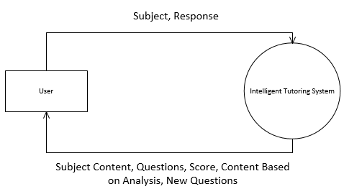

Figure 1 DFD Level 0 Intelligent Tutoring System

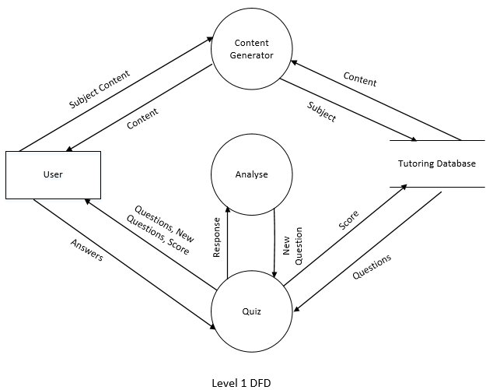

Figure 2 DFD Level 1 Intelligent Tutoring System

4.2 ER Diagram

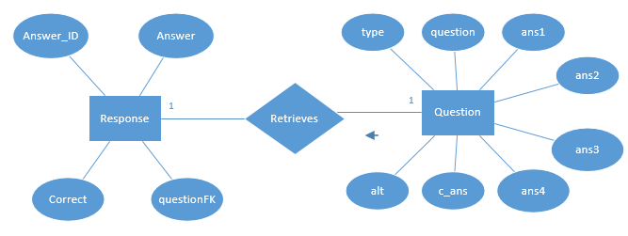

Figure 3 ER Diagram

4.3 Use Case Diagram

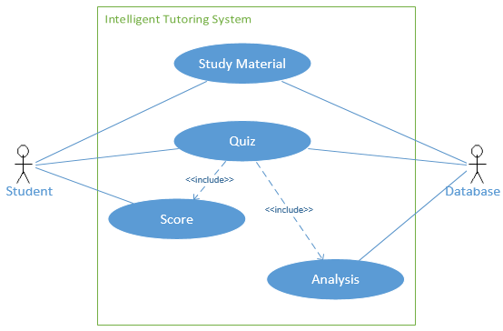

Figure 4 Use Case Diagram

**4.4 Class Diagram**

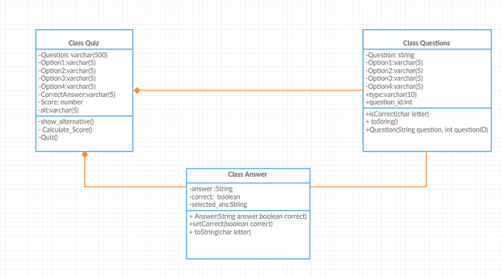

Figure 5 Class Diagram of Tutoring System

**Appendix**

Screenshots:

Home Page

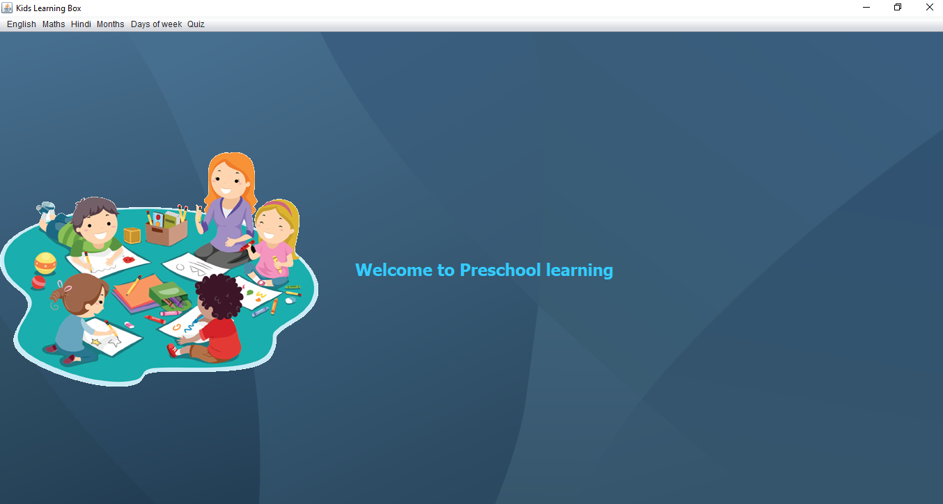

Menu Buttons

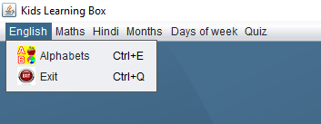

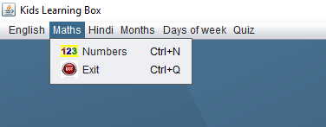

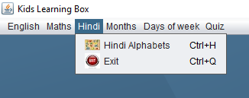

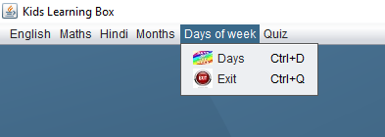

Quiz Page

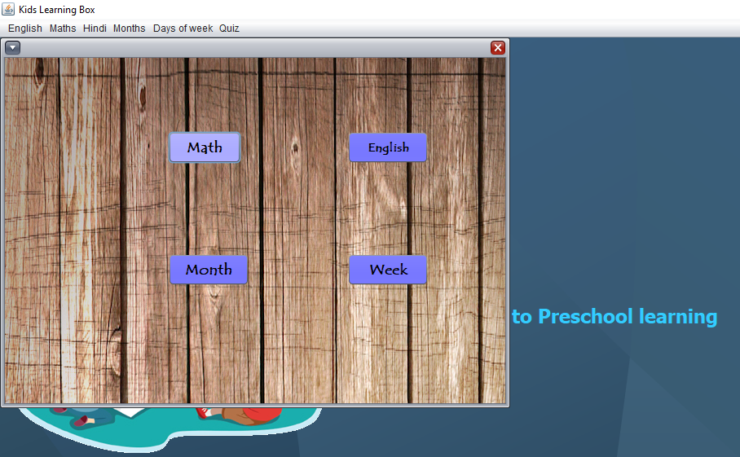

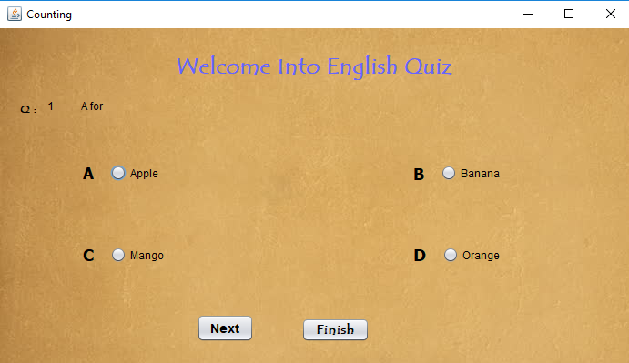

Score Page

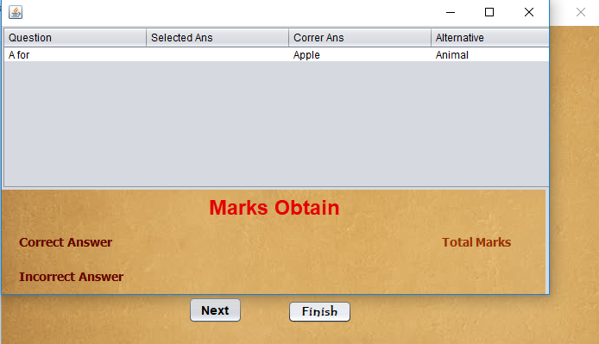

**Project Timeline**

**Gantt Chart:**

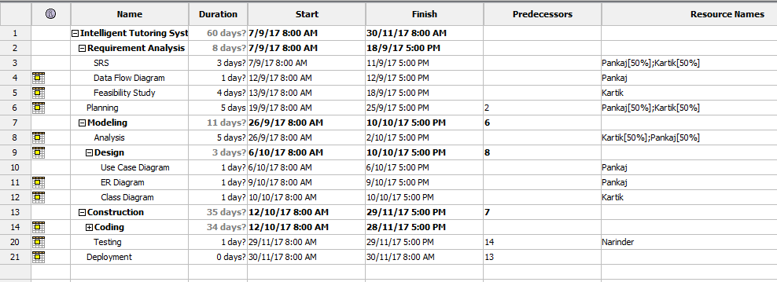

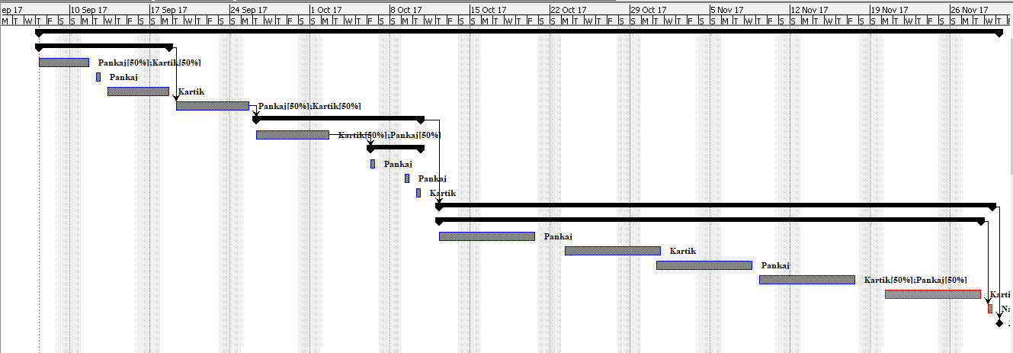

**WBS:**

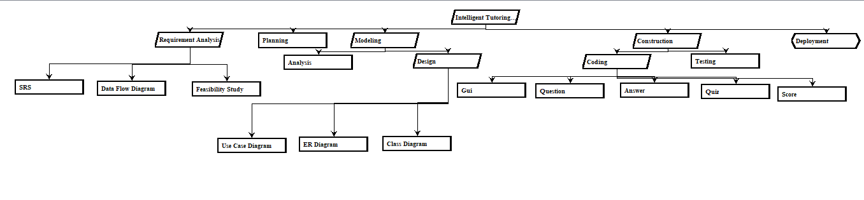

**Network Diagram:**

