**Prerequisite: Google Chrome Version 87**

1. Download this setup and place it inside any of your directory

<https://1drv.ms/u/s!As3hIp7JgHiNhEcVE72NxvrmKpwk?e=D4zaHW>

1. Extract it, as this is compressed folder.
2. After extracting, find **userInfo.json** file and open this in notepad

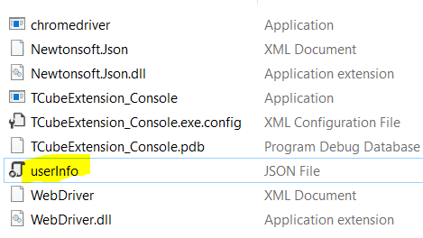

1. Add your TCube Email, password and save it.

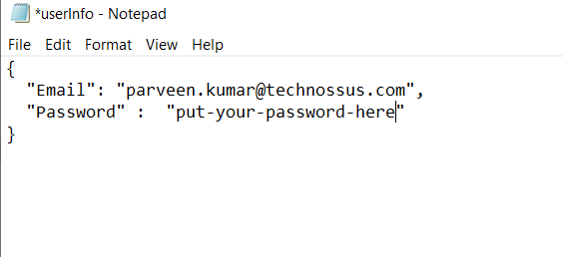

**NOTE**: Make sure you are adding right credentials

1. Click on windows Icon of your computer and search for “Task Schedular”

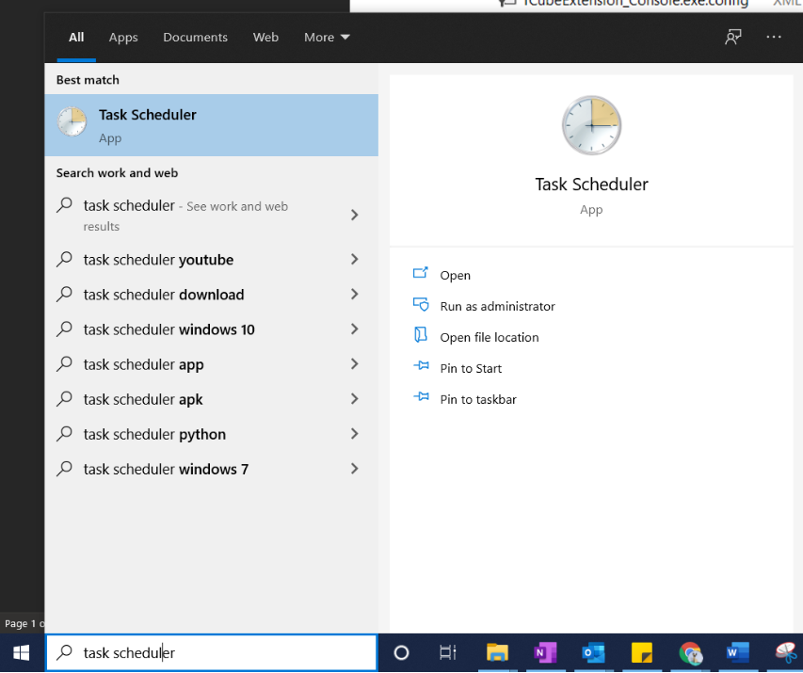

1. Click on Task Scheduler Icon, it will open a new window for you

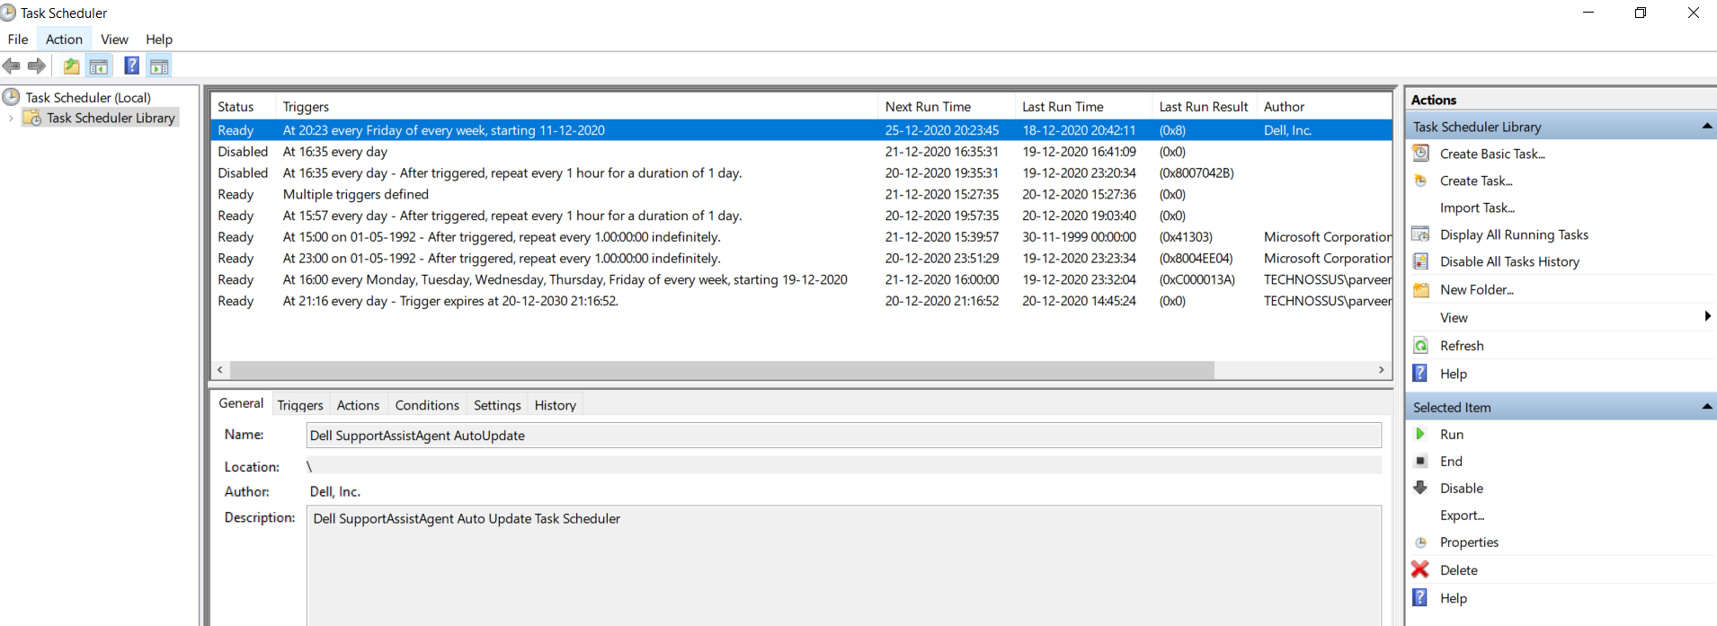

1. On the Left hand side, click over “**Create Task**”

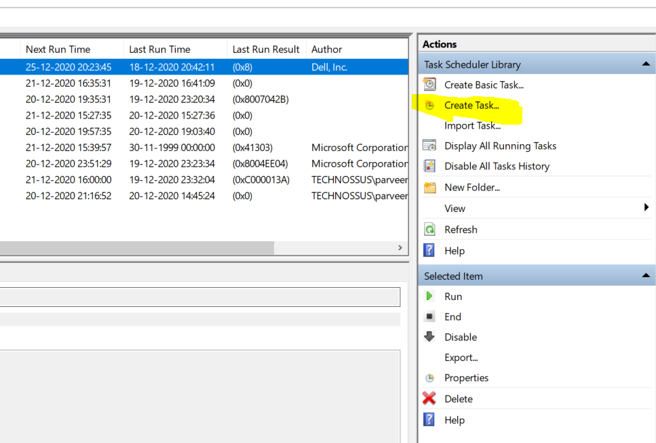

1. You will get a new Popup window, add the General info under General Tab

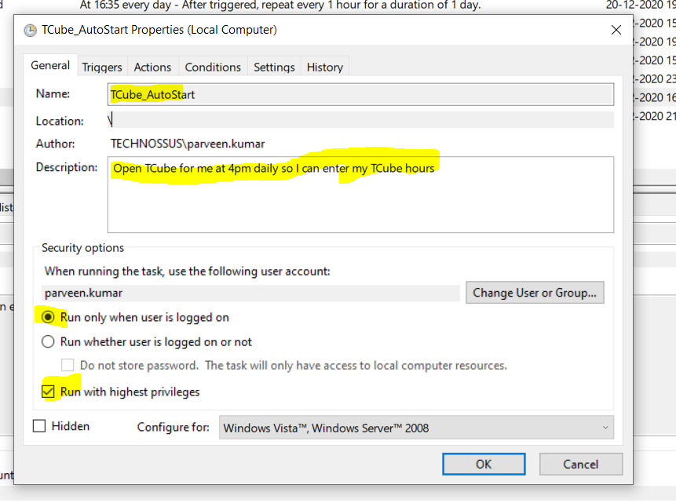

1. Now click over “Triggers” Tab right after General and click on “New” on the bottom

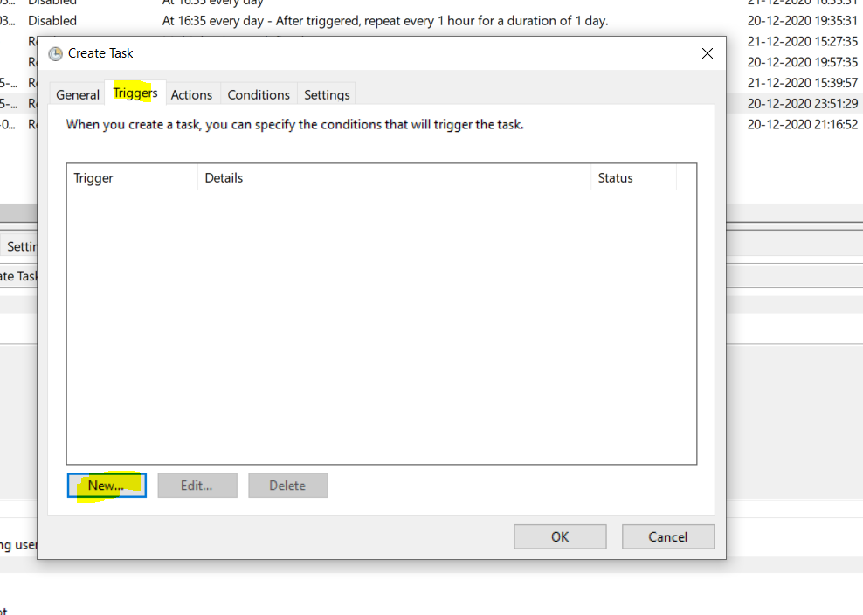

1. You will get another Popup, make sure you have added all the info as highlighted in the screenshot

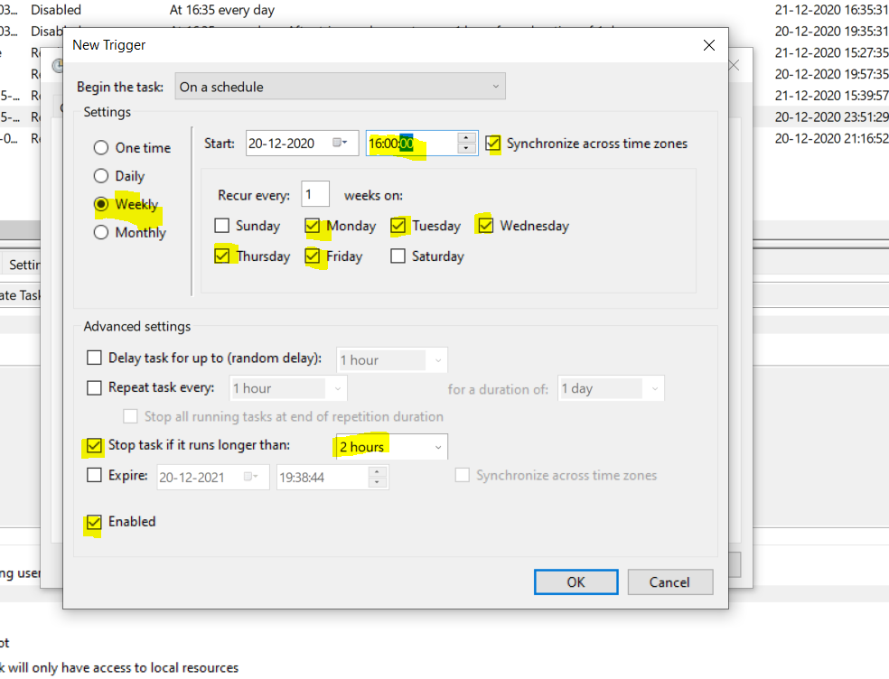

NOTE: My system Time format is 24 hrs so I have added 16:00:00, you can set it according to your system time format

1. Press OK button on the bottom of the popup
2. After this click on next Tab “Actions”
3. Click on ”New”

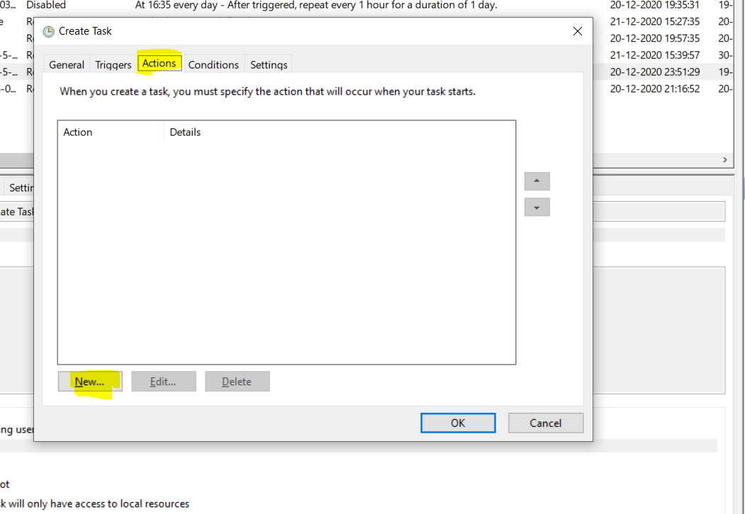

1. Browse for folder that you extracted in 2nd step

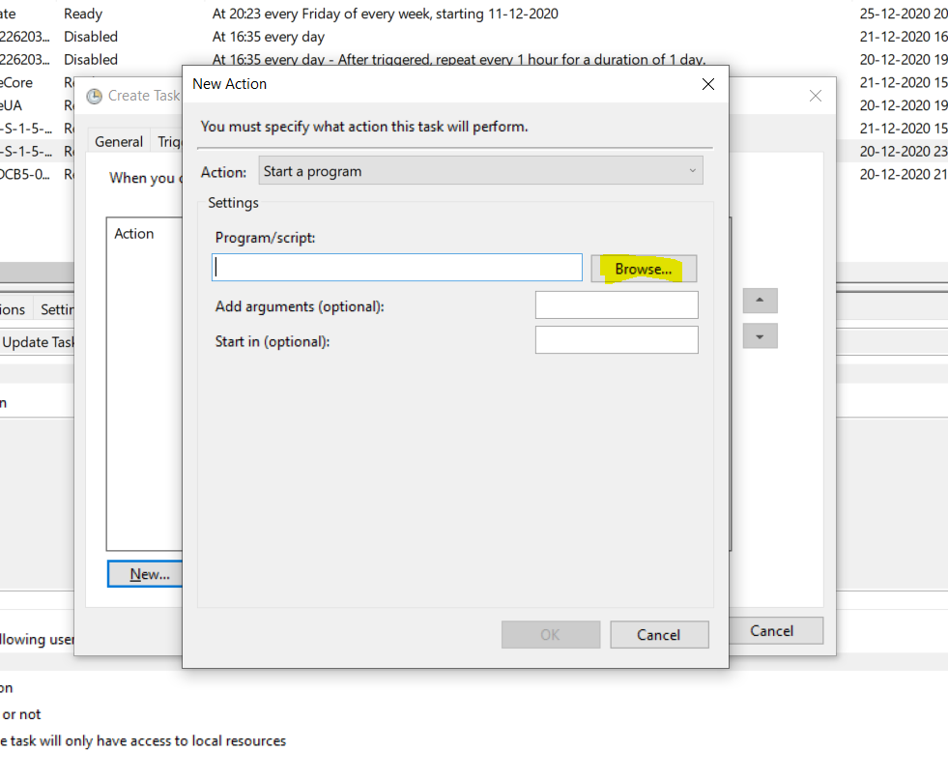

1. Choose “TCubeExtension_Console” and click on “Open”

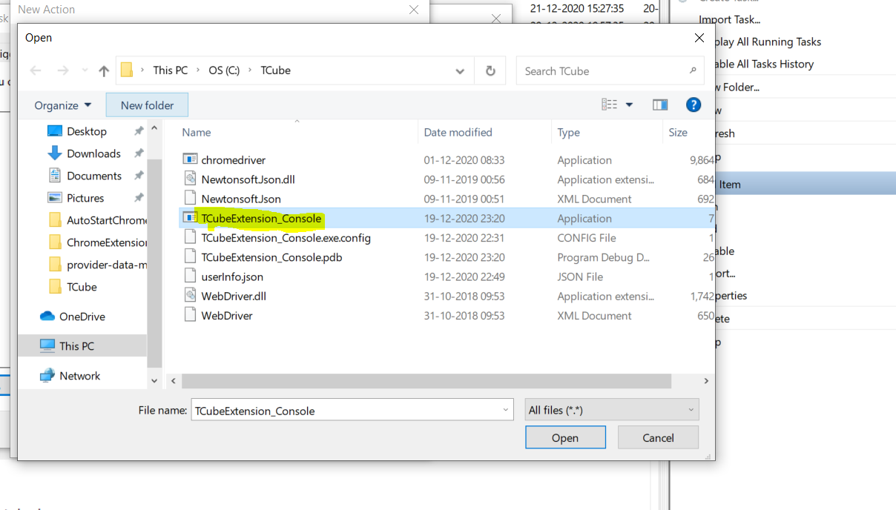

1. After this you will see Action is added

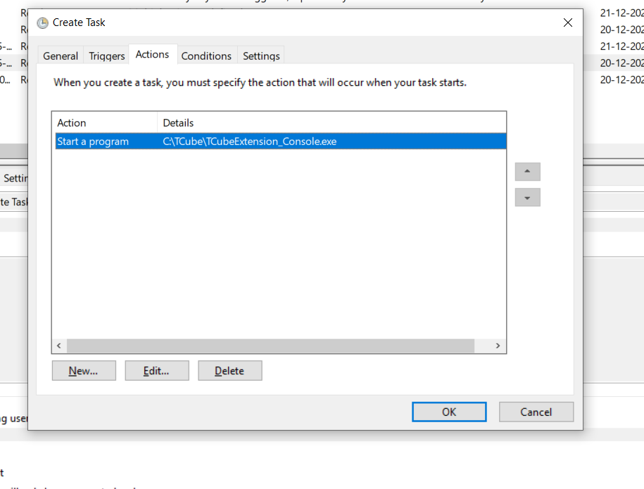

1. Next Click on Last Tab “Settings” and configure the highlighted settings

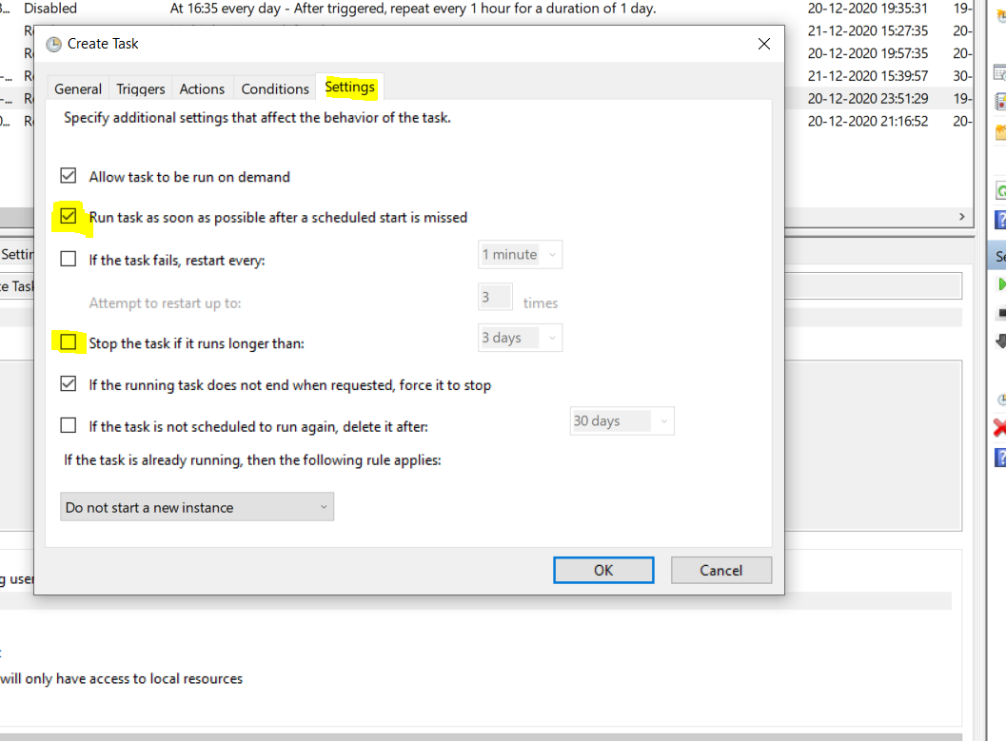

1. Click on “Ok”
2. After all this step completed you would be able to see your Task schedular

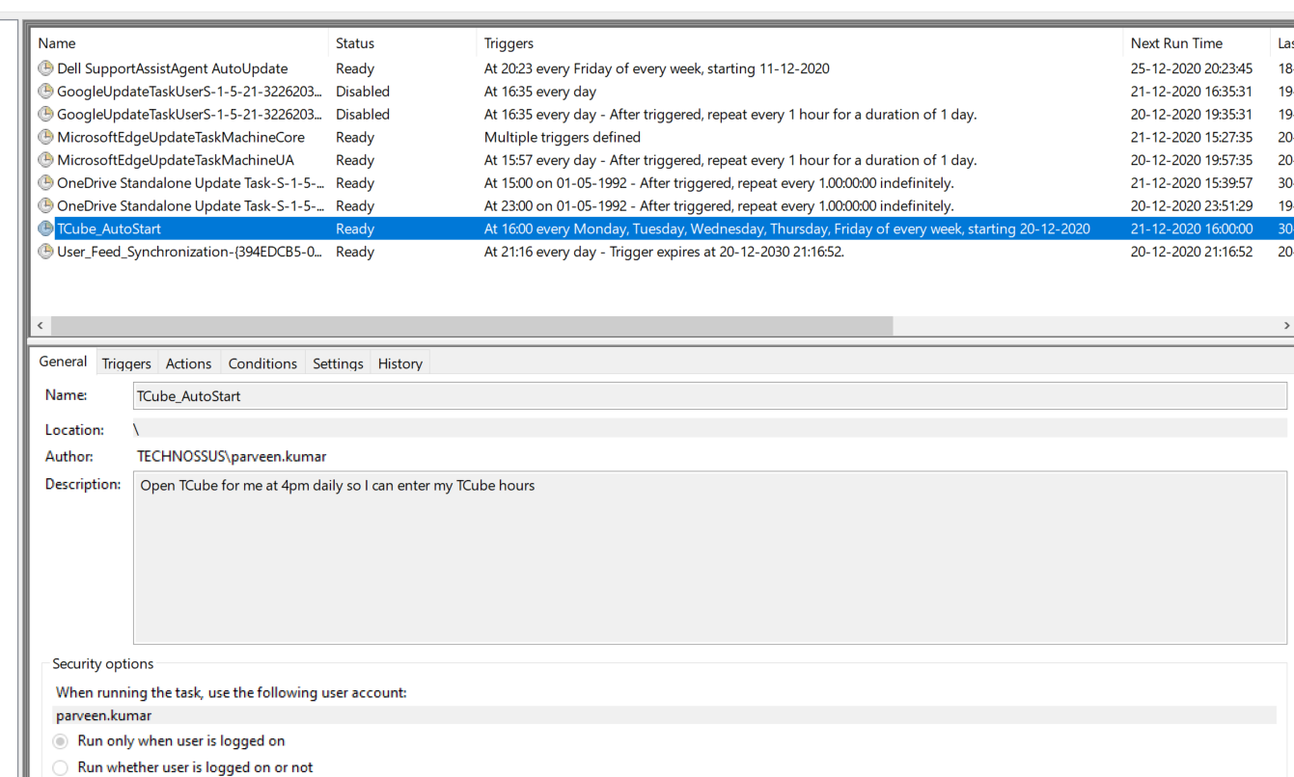

1. Hurray, All done!!!

**Wanted to Test?**

In case you wanted to test it, you can right click on Task and hit the “Run” button. You will have your TCube account open without any user interaction.

