**VISVESVARAYA TECHNOLOGICAL UNIVERSITY BELAGAVI**



Project Synopsis on

**SELF CHECKOUT**

Submitted by

|  |  |
| --- | --- |
| **Pratik Shelake** | **2JR20CS057** |
| **Shreejit Sankannavar** | **2JR20CS085** |
| **Yuvraj Jadhav** | **2JR20CS110** |
| **Sakshi Yadav** | **2JR21CS416** |

In partial fulfillment of the requirement for the award of the

**Bachelor of Engineering**

**In**

**Computer Science & Engineering**

Under the Guidance of

**Prof. Srinidhi Kulkarni**

Assistant Professor

**Subject Code: 18CSP77**



**Jain College of Engineering & Research,Belagavi**

**Department of Computer Science & Engineering Academic Year 2023 - 2024**

# 

**ABSTRACT**

In the ever-evolving landscape of retail, customer experience and convenience have become paramount. This abstract presents a cutting-edge solution designed to revolutionize the traditional retail checkout process – the Self-Checkout App. This innovative mobile application aims to empower customers with a seamless, efficient, and personalized shopping experience, ultimately transforming the way transactions are conducted in retail stores. The Self-Checkout App leverages the ubiquity of smartphones to provide customers with a user-friendly interface that guides them through the entire shopping journey. From scanning products and adding them to the virtual cart to secure payment processing, the app streamlines the checkout process, reducing wait times and enhancing overall customer satisfaction. Through the integration of state-of-the-art technology such as barcode scanning, RFID, and secure payment gateways, the app ensures accuracy, speed, and security in every transaction.

**CHAPTER 1**

**INTRODUCTION**

In the current competitive business world where more customers go online to purchase and with the arrival of numerous apps and devices to make shopping easy and quick, retailers need to evolve to catch up with customer expectations and bring convenience to their in-store shopping experience. Customers always choose the most convenient way to shop, and retailers that follow customers’ preferences and introduce them in their store can boost their sales. For customers, one of the most common complaints in retail shops is the length of the queue at the checkout lines. Shorter perceived waiting times improve the customer experience, customer loyalty, and market share. Setting up physical retail concepts that utilise technology like self-checkout solutions helps create a modest customer experience. Through solutions that reduce cost, complexity, and downtime in a secure but accessible manner, mobile technology also plays a significant role in reducing many of the challenges of a seamless customer experience. Retailers need to develop past conventional mobile technology management to capitalise on new customer expectations quickly and efficiently. Newer generations of self-checkout systems use mobile devices provided by retailers. Those are picked up by the customer after the identification process needed for seamless payment. During the shopping, the customers can self-scan the products and pay for their baskets before leaving. However, the high investment required to provide the devices, as well as their subsequent maintenance costs, limit this approach. Hence, a self-checkout mobile application that allows customers to scan goods with their own phones as they pick them up in the store is a powerful, effective, and affordable choice. The customers save a lot of time as they can pay on the spot using the application and leave the store with a swipe of the receipt as they exit the store, with zero waiting time before they leave.

**CHAPTER 2**

**LITERATURE SURVEY**

**[1] Vrushaket Pravin Chaudhari, Smart Self-Checkout System for Supermarkets, Proc of IEEE, 16 June 2023**

This paper deals with the implementation of self checkout software application, which is a 100%digital approach to offline shopping and aims to reduce the overall time required for shopping. This approach is implemented via bar code technology, real-time database and payment gateway. This software application aims to reduce time spent in shopping along with providing better security, self-pickup option and new wish list concept. This application skims through the barcodes of the products already present on each and every product and the user can exclusively select multiple products, finally bill will be generated which will be displayed to the user along with various payment options. The study concludes that the overall time for the basic work of super markets is minimized.

1. **Narendra Kumar Nagam, Smart Phone Self Checkout Payments in Super bazaar, Proc ICIIP, Nov 2020 .**

With the increasing super bazaar purchases by the customers in cities there is a problem of bottleneck for billing the customers at peak times, to solve this problem we propose a secure way for billing the purchased goods by the customer with their Smartphone's. There are other self checkouts that are present such as `Amazon go', `Perpule 1Pay', and self checkout terminals, some of the solutions uses RFID tags, these solutions are costlier and difficult to implement in countries such as India. `Amazon go' uses computer vision, Deep learning algorithms, Sensor Fusion, Our solution is a combination of Smartphone QR Code scanner app and secure website for billing the products. Users are provided with two options to pay their bill either to pay the bill online or to pay by cash.

1. **Fachrurrozi Maulana, Self-Checkout System Using RFID (Radio Frequency Identification) Technology, Proc of IEEE, 24 November 2021**

RFID (Radio Frequency Identification) is a combination of radio frequency technology and microchip technology, and as an alternative to barcodes microchipped in tags to store and transmit detailed information about tagged items. The number of RFID applications in everyday life is due to the convenience it provides, one of which is the self-checkout system. In this literature review, the authors have analyzed various techniques that can be used to implement RFID in a self-checkout system through methodological and model analysis. The purpose of this study is to explore various possible applications of RFID technology in a self-checkout system.

1. **Chasandra Puspitasari, The Implementation of Augumented Reality as a smart self service cashier in the pandemic era, Proc of IEEE, 24 November 2021**

Considering the recent booming of cashier-less checkout technology and the future trend of increasing self-service and contactless conditions due to Covid-19, it is necessary to find an alternative checkout concept suitable for local retail conditions. Using augmented reality, the aim of this study is to compare the proposed method with the conventional method of cashier checkout using barcode scanner. The method used in this study is marker-based tracking, where the marker is an image file which will be uploaded to Vuforia SDK Kit. The result of the proposed method for AR-Mart as a smart cashier is faster, more accurate and can reduces the duration for cashier checkout significantly.

1. **Kirti Wankhede, Just Walk-Out Technology and its Challenges: A Case of Amazon Go, Proc of IEEE, 03 January 2019**

The current research looks at the work of new technology called “Amazon Go”. The Shopping experiences are becoming more revolutionary, first there was the introduction of the supermarkets shelves, then came the barcode scanners, then arrived the self-checkout lines and then the online shopping. With this revolution in shopping Amazon comes with a complete new kind of shopping style with just Walk-out technology. The present research involves about the technology used in Amazon go store, how it is implemented and the details about how it actually works. This paper further discusses about the challenges that can be faced on implementing this new technology and suggestions to overcome these challenges.

**CHAPTER 3**

**PROBLEM DEFINITION**

In the current retail landscape, traditional checkout processes are facing challenges that hinder optimal customer satisfaction and operational efficiency. Long queues, cumbersome transactions, and limited flexibility in payment options are just a few of the pain points that contribute to a less-than-ideal shopping experience. This problem definition outlines the key issues faced by both customers and retailers, highlighting the need for a trans formative solution – a Self-Checkout App.

**CHAPTER 4**

**OBJECTIVES**

1. **Improve Customer Experience:**
   * Streamline the checkout process to significantly reduce wait times, providing customers with a faster and more convenient shopping experience.
   * Enhance user satisfaction by offering a user-friendly interface that accommodates a wide range of technological proficiencies.
2. **Increase Payment Flexibility:**
   * Integrate diverse payment options, including digital wallets, credit/debit cards, and mobile payments, to cater to the varied preferences of modern consumers.
   * Ensure a secure and seamless payment experience for customers, promoting trust and confidence in the self-checkout system.
3. **Offer Real-Time Customer Support:**

- Implement a customer support feature within the Self-Checkout App to address any issues or queries users may encounter during their shopping experience

- Provide real-time assistance through chat or helpline functionalities to enhance customer satisfaction and resolve concerns promptly.

1. **Enhance Data Security and Privacy:**

- Implement encryption protocols and secure authentication methods to safeguard customer data and privacy.

- Comply with data protection regulations to build trust among users and protect the integrity of sensitive information throughout the self-checkout process.

**CHAPTER 5**

**METHODOLOGY**

**Flowchart**

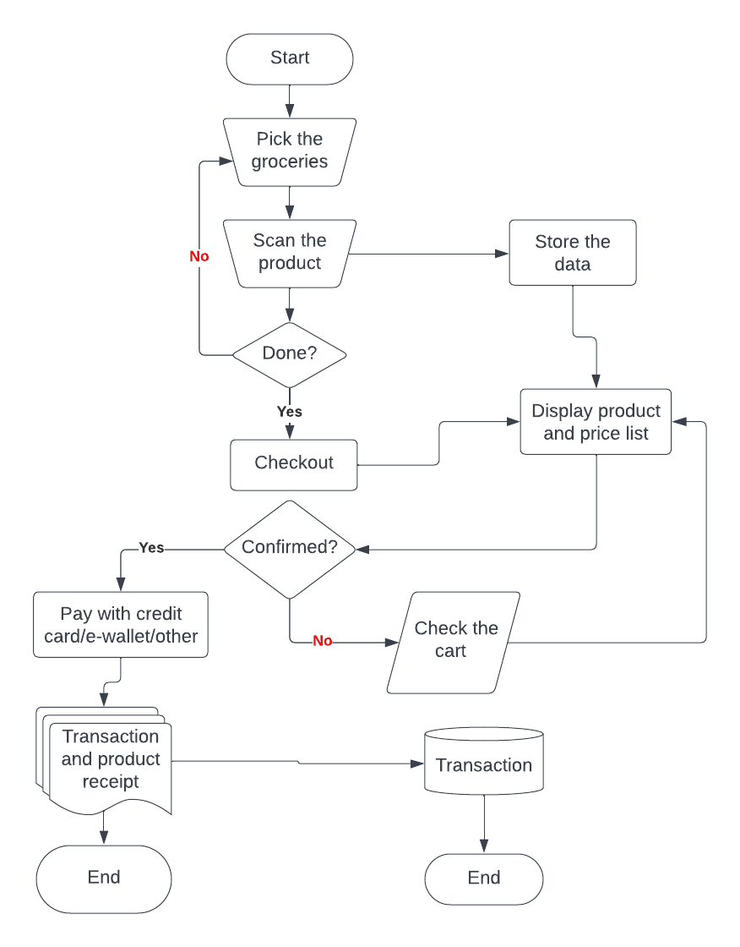

**Introduction**

A mobile self-checkout application is a mobile payment system that allows a customer conveniently buy and complete the payment for products without the need to go through the cashier checkout point. This is achieved by using the mobile self-checkout application to scan the barcodes of products and adding them to the virtual shopping cart on the application and subsequently checkout after successfully making the payment.

**Frontend**

**1. User Authentication**

1. Login/Registration : Implement a secure login and registration system for users.

**2. Product Display**

1. Product Listings : Display products with relevant information, including name, price, and possibly images.
2. Search and Filter: Implement features to search for products and filter them based on categories or other criteria.

**3. Shopping Cart**

1. Cart Management : Allow users to view, edit, and remove items from their shopping cart.
2. Quantity Adjustment : Implement controls to adjust the quantity of items in the cart.
3. **Payment Interface**
4. Payment Options : Display various payment methods available (credit card, digital wallets, etc.).
5. Form Inputs : Collect necessary information for payment, such as card details or account information.
6. Payment Confirmation : Provide a confirmation screen after processing the payment.

**Backend**

**1.Database Management**

1. User Database : Maintain user profiles, authentication details, and order histories.
2. Transaction Database : Record details of completed transactions, including items purchased, payment status, and timestamps.

**Technology Used**

1. **(i) Java in android studio :**

Java is the primary programming language for Android development. Android applications are typically written in Java, and the code is executed by the Java Virtual Machine (JVM) on the Android device.

**Role in Android Studio:**

- Activity and Application Logic: Java is used to define the behavior of activities (screens) and the overall application logic.

- Event Handling: Java is responsible for handling user input events, such as button clicks or touch events.

- Backend Integration: Java is often used to interact with databases, web services, and other backend systems.

**(ii)** **XML in Android Studio:**

XML (eXtensible Markup Language) is a markup language that defines a set of rules for encoding documents in a format that is both human-readable and machine-readable.

**Role in Android Studio:**

- Layout Definition: XML is commonly used in Android for defining the layout and structure of user interfaces. Each screen (activity) in an Android app is associated with an XML layout file.

- Resources: XML is used to define various resources like strings, colors, dimensions, and more in a structured way. These resources can be easily managed and localized.

- Manifest File: The AndroidManifest.xml file, written in XML, is a crucial configuration file that declares essential information about the app, such as its components, permissions, and hardware requirements.

1. **MySQL Database :**

MySQL is an open-source relational database management system (RDBMS) that provides a scalable, high-performance, and reliable platform for efficiently managing and organizing large sets of data. Developed by MySQL AB, which is now a part of Oracle Corporation, MySQL is one of the most popular database systems and is commonly used in web development, particularly with PHP.

1. **(i) ZXing (Zebra Crossing) for Barcode Scanner :**

ZXing, also known as Zebra Crossing, is an open-source barcode image processing library. It provides functionality to decode barcodes from various formats such as QR codes, Data Matrix, UPC, EAN, and more. ZXing is written in Java and has implementations for various programming languages.

**(ii) ZXing Android Embedded library :**

The ZXing Android Embedded library is a specific version of ZXing designed for use in Android applications. It allows developers to easily integrate barcode scanning functionality into their Android apps, enabling users to scan and decode barcodes using the device's camera.

key features and aspects of the ZXing Android Embedded library :

- Barcode Formats: ZXing supports a wide range of barcode formats, including QR Code, Data Matrix, UPC-A, UPC-E, EAN-8, EAN-13, Code 39, Code 128 and more.

- Integration with Android Camera: The library provides classes and methods to interact with the Android device's camera for capturing barcode images. It includes components for previewing the camera feed and processing the captured frames for barcode recognition.

- Ease of Use: Integrating ZXing into an Android application is relatively straightforward. The library provides a set of APIs and UI components that developers can use to quickly add barcode scanning capabilities to their apps.

- ZXing Intent Integration: Besides using the library directly in the code, ZXing also provides an Intent-based integration approach. Developers can launch the ZXing barcode scanner app (if installed) using an Intent, simplifying the integration process for scenarios where the ZXing app is preferred for barcode scanning.

**CONCLUSION**

In conclusion, the development and implementation of the Self Checkout App have marked a significant stride towards enhancing user convenience and efficiency in the retail sector. This project aimed to streamline the checkout process, empowering users to navigate through their shopping experience with autonomy and ease.The project's success lies not only in its technological advancements but also in its potential to drive operational efficiency, reduce waiting times, and ultimately improve customer satisfaction. As we embrace the era of digitization and customer-centric solutions, the Self Checkout App stands as a testament to the power of innovation in reshaping the retail landscape.

**REFERENCES**

1. Vrushaket Pravin Chaudhari, Smart Self-Checkout System for Supermarkets, Proc of IEEE, 16 June 2023 https://ieeexplore.ieee.org/document/10150048
2. Narendra Kumar Nagam, Smart Phone Self Checkout Payments in Super bazaar, Proc of ICIIP, Nov 2020 .
3. Fachrurrozi Maulana, Self-Checkout System Using RFID (Radio Frequency Identification) Technology, Proc of IEEE, 24 November 2021, <https://ieeexplore.ieee.org/document/9609762>
4. Chasandra Puspitasari, The Implementation of Augmented Reality as a Smart Self-Service Cashier in the Pandemic Era, Proc of IEEE, 24 November 2021 , <https://ieeexplore.ieee.org/document/9609740>
5. Kirti Wankhede, Just Walk-Out Technology and its Challenges: A Case of Amazon Go, Proc of IEEE, 03 January 2019 , https://ieeexplore.ieee.org/document/8597403
6. S.Beck, Adrian. 2022. Global Study on Self-checkout in Retail. Online. 13 March 2022. ECR. <https://www.ecrloss.com/research/global-study-on-selfcheckout-in-retail/.>
7. Beck, Adrian. 2022. Self-checkout in Retail: Measuring the Impact on Loss. Online. 1 March 2022. ECR. <https://www.ecrloss.com/research/globalstudy-on-self-checkout-in-retail/.>
8. Mathur, Vrinda. 2022. Barcode Technology: Meaning and Types analytic steps. Online. 20 September 2022. analyticSteps. https://www.analyticssteps.com/blogs/barcode-technology-meaning-and-types. Accessed 28 December 2022.
9. McCue, Ian. 2022. Barcodes Defined-How they Work, Benefits and Uses. Online. 5 September 2022. ORACLE NETSUITE. <https://www.netsuite.com/portal/resource/articles/inventorymanagement/barcode.shtml>.
10. Jain, Preeti. Barcode Technology – What is Barcode?. Online. ENGINEERS GARAGE. https://www.engineersgarage.com/barcodetechnology-what-isbarcode/#:~:text=It%20basically%20encodes%20alphanumeric% 20characters,als o%20reducing%20error%20and%20time. Accessed 15 December 2022.
11. McCue, Ian. 2022. Barcodes Defined-How they Work, Benefits and Uses. Online. 5 September 2022.ORACLENETSUITE.[https://www.netsuite.com/portal/resource/articles/inventorymanagement/barcode.shtml.](https://www.netsuite.com/portal/resource/articles/inventorymanagement/barcode.shtml)
12. Jain, Preeti. Barcode Technology – What is Barcode?. Online. ENGINEERS GARAGE. <https://www.engineersgarage.com/barcodetechnology>, Accessed 15 December 2022.