# csy1018-assign1(Report)

BSc Computing

CSY 1018 Web Development

Title:- Web Development Design

Project

9th April 2017

Csy 1018 Contents

Introduction……………………………………………………………….3

Sketches……………………………………………………………………..

-sketche home page

-sketche cv page

-sketche bio page

-sketche contact page

Final Designe………………………………………………………………

-This is my home page

- This is my cv page

-This is my bio. Page

-This is my contact page

E

Introduction

Now, I am going to make my portfolio, before starting and visit different

Portfolio to know more about and how could design website. From their

I got different idea and information which can help me to develop

Website like font-size, about html, css, how to put image etc. I make my

website by using html, css and different things are put myself to make

different which helps us to sow my own. Different website I visit but

some of them are better which I like very much there each part header,

body ,div , footer etc. Some of them are:-

.http://kellyedmunds.co.uk/

.

Sketches

Sketches Homepage

I want my homepage simple which helps the user to run the website.

I will also add background image at hole body part. If click at home

Than the next slide will be open and also over upon the background

Image. I was put short information about myself. Their will also image

Of paper work of homepage at the bottom which clearly show What

Was in the homepage contains.

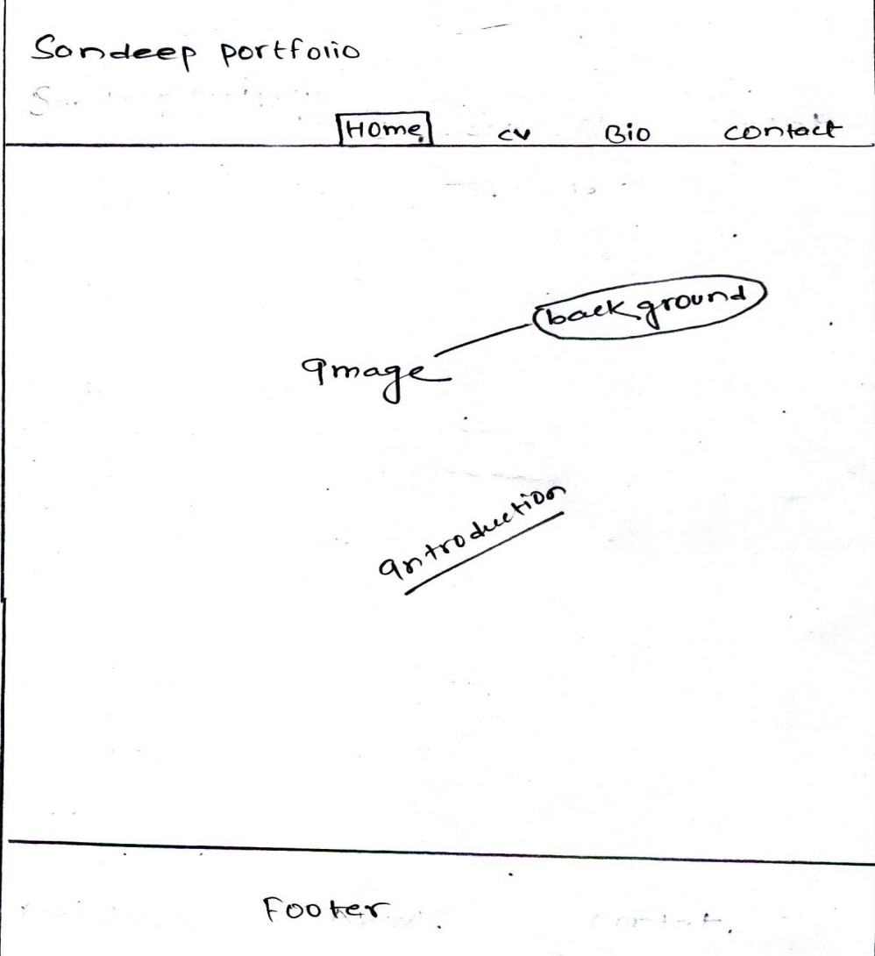

Sketches CV page.

For my CV page I include only greenlight color at background and also

Put my own image at the center of body part. In the bold letter title and

Also put my CV context at the buttom of the part with introduction and

Navigation bar will same to the homepage. This saction contain about

My activity, information and many more.

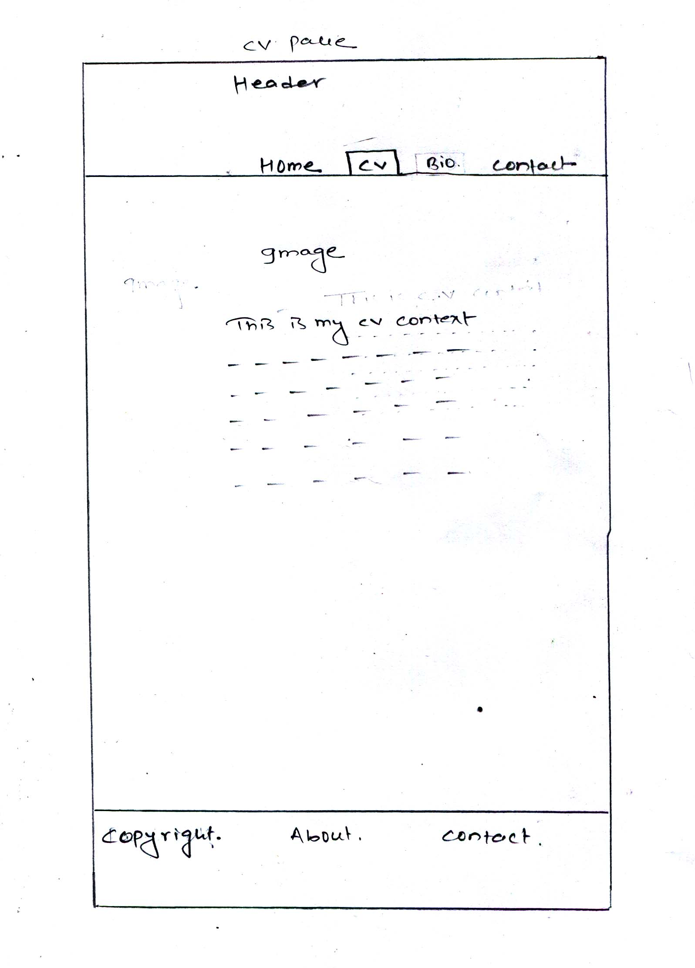 Sketches Bio.

This page will be the same design as the portfolio. It also contain

Another image but the background color are same like Cv green

Light color and bold in context but at the buttom Bio.data about

Myself and at the footer part contain link Facebook. , Link in. and

Contact. The sketch page at the buttom of the page…

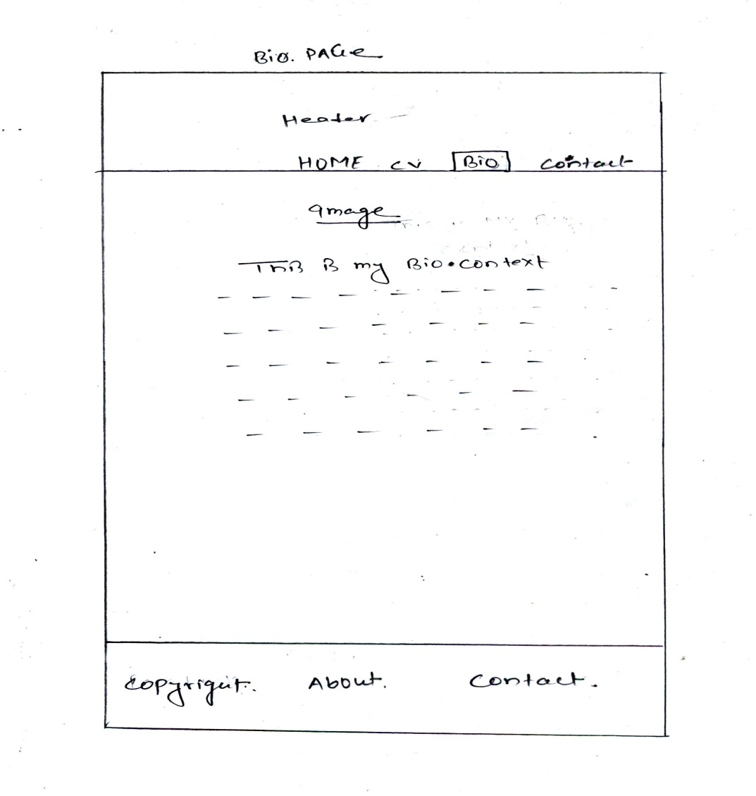

Sketches contact

Contact page will be nice and simple. In this page portfolio, back

Ground color and footer with there link same. At the center of the

Page it contain another image and at the buttom of the image it

Contain “This is my contact context” and it mention some contact address but “stay connected with us” context carried different social network link like Facebook. Linkin. And Twiter.

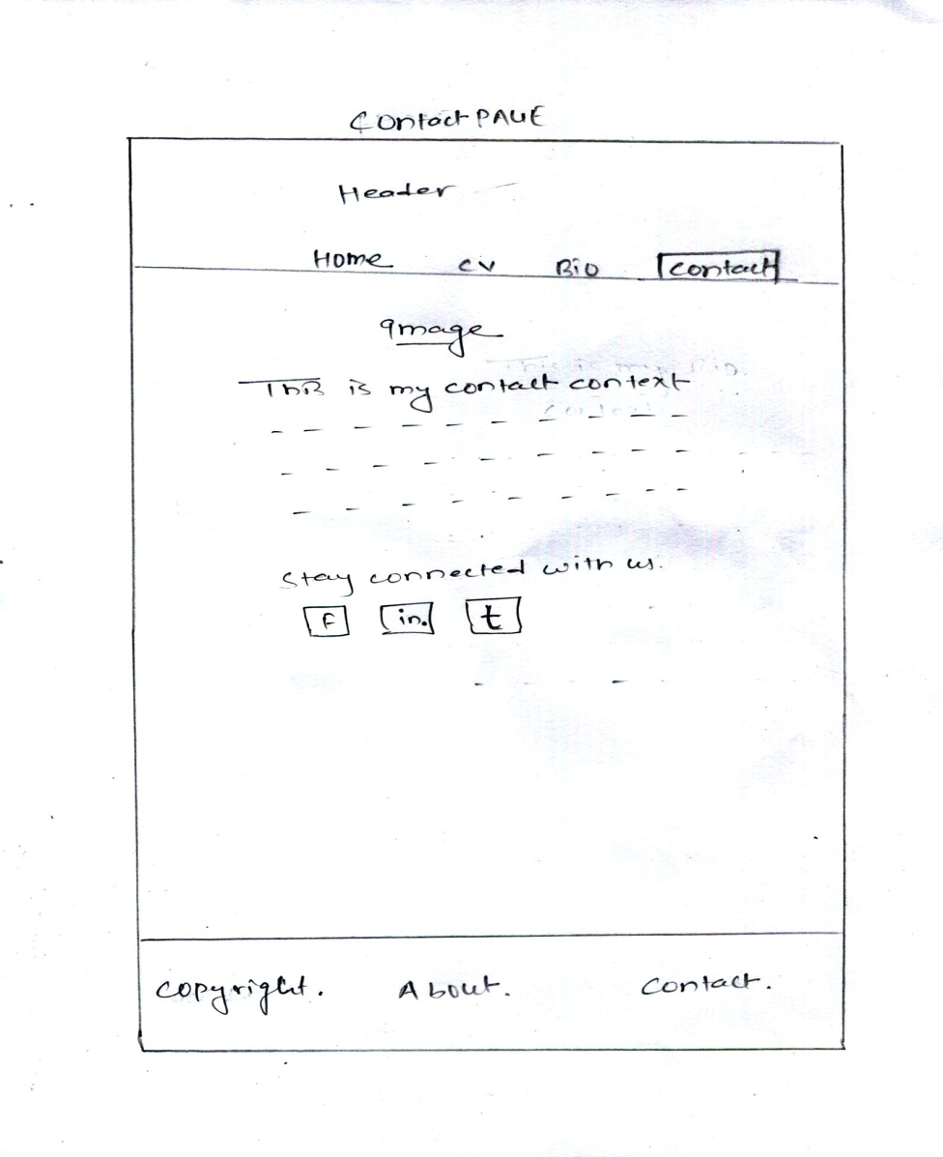

Final Design

Home Page: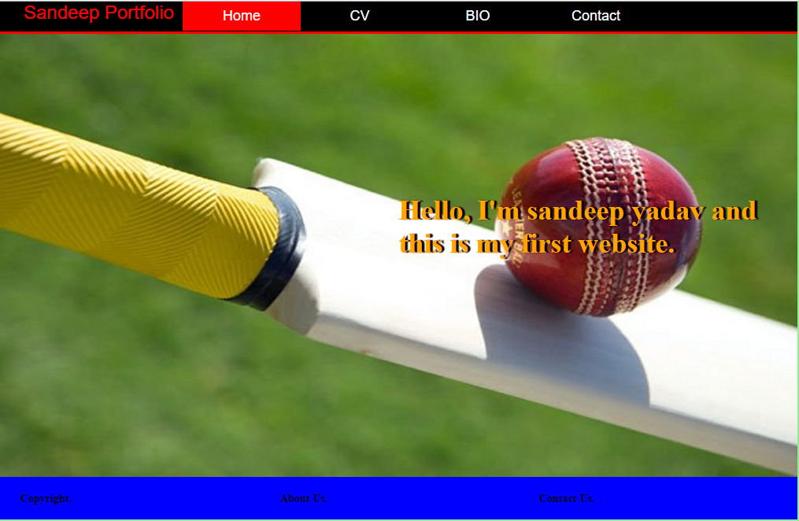

CV Page:

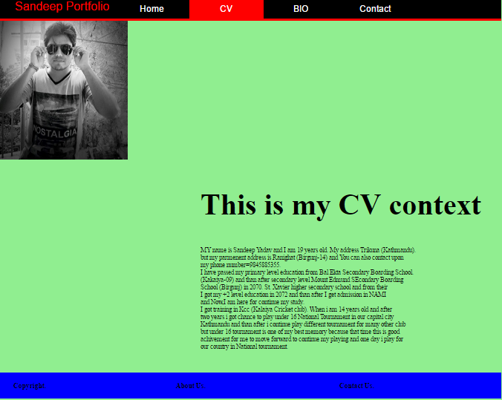

Bio Page:

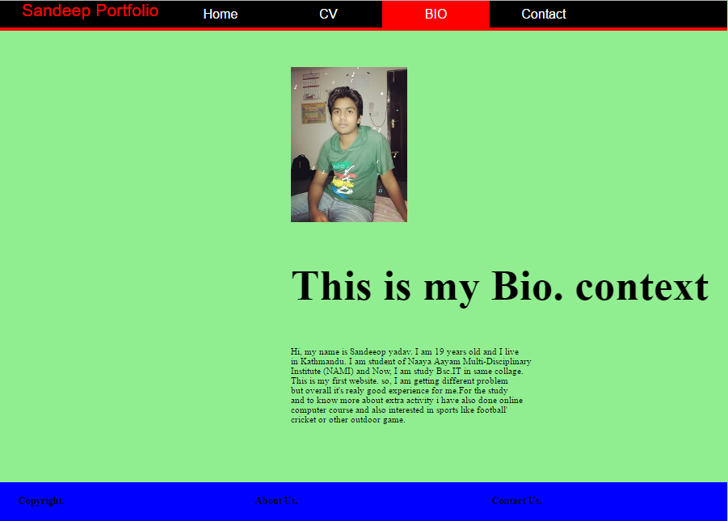

Contact Page:

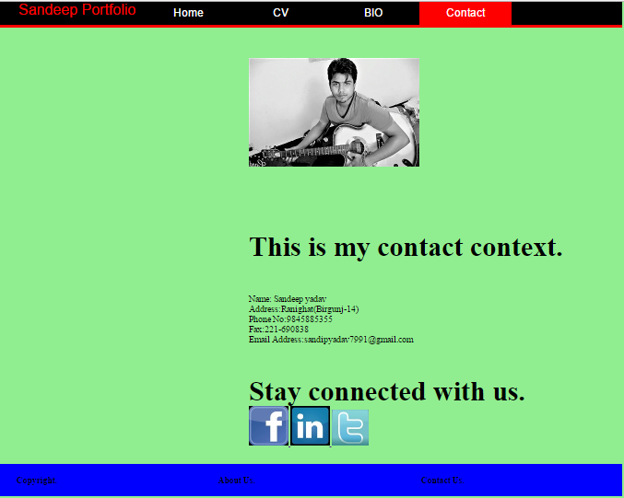

Evidence how I have used Models of good practice

Page load speed:

We know that the importance of internet . The speed of internet faster we know

very well. I have make my website and check my website upload fast and it is

good practice. I have tested my website on pingdom.com and the tested image

are below.

Visual Appear:

When I have making my website than I have looking different other website

Like Marwell zoo. , corchester zoo. etc. Find what was popular, most visually

To other. I have tried to make my website common and simple without any

Crazy graphics and unappealing colour. I have also take help of my class

Friends and also group descrision. From treir I have got different idea like

How to creating cesign which appeals to the most people.

Navigation:

Last of the important models of good practice in the navigation system. Which

You can see. Also making perfect endless of directories and navigation buttons,

Once top of your website will allow to return back easily at the buttom part of

Your website. Website flow the key getting perfect navigation.

Progression of website

This is