EMPLOYEE SALARY
MANAGEMENT SYSTEM
Final Detailed Technical Project Report
Python Phase 3 - Level 2 Practical Project
Prepared by | Shraddha Yadav
Project type | Menu-driven Python payroll application
Language | Python 3.x - standard library only
Primary file | employee_salary_system.py
Report date | 18 August 2026
A complete design, implementation, verification and evaluation record

Executive Summary
This report documents the completed Employee Salary Management System, a terminal-based Python application developed for the practical assessment scenario of a mid-sized UK company replacing an unreliable spreadsheet payroll process. The HR manager is the intended end user. The program therefore focuses on clear menu navigation, readable output, reliable calculations and defensive handling of incorrect input rather than on advanced technical features that are outside the scope of the brief.
The finished program implements all eight mandatory modules: Add Employee, View All Employees, Search Employee, Calculate Salary, Salary Analysis, Department Analysis, Update Employee and Delete Employee. A ninth menu option exits the program. The menu is placed inside a loop so the application continues running after each task until the user explicitly chooses to leave.
The employee data store is one in-memory list containing one dictionary per employee. Each dictionary stores the seven required fields: Employee ID, Employee Name, Department, Basic Salary, Allowance, Bonus and Deduction. Gross and net salary are deliberately not stored. They are calculated whenever needed using one shared function, which prevents stale values after an update and ensures that the same formula is used across every module.
The solution was verified against the ten supplied starter records and the assessment self-check values. The company-wide analysis returns a highest net salary of £70,000, a lowest net salary of £26,700, an average net salary of £46,020, three employees strictly above £50,000, one employee strictly below £30,000 and total annual net payroll of £460,200. Department totals and averages also match the expected reference values. A dedicated verification run completed 38 checks successfully, including invalid menu choices, duplicate IDs, non-numeric and negative salary input, case-insensitive searching, missing employees, missing departments, updates, deletion confirmation and empty-list safety.
Project verification status
The current employee_salary_system.py compiled successfully and all 38 verification checks passed on 18 August 2026. The checks exercise both normal operations and the error conditions that are explicitly assessed.

Contents
- 1. Project Background and Problem Definition
- 2. Objectives, Scope and Success Criteria
- 3. Requirements Analysis and Traceability
- 4. Data Model and Data-Structure Design
- 5. Salary Calculation Design
- 6. Program Architecture and Control Flow
- 7. Detailed Implementation of Shared Functions
- 8. Detailed Implementation of Modules 1-8
- 9. Input Validation and Error Handling
- 10. Salary Analysis Algorithms and Verified Results
- 11. Department Analysis Algorithms and Verified Results
- 12. Output Formatting and User Experience
- 13. Testing Strategy and Detailed Test Record
- 14. Code Quality, Maintainability and Assessment Alignment
- 15. Challenges, Decisions and Resolutions
- 16. Limitations and Future Development
- 17. Final Evaluation and Conclusion
- Appendices A-F

1. Project Background and Problem Definition

1.1 Business scenario
The assessment scenario describes a company that currently manages payroll information in a spreadsheet edited by several people. That approach creates operational problems: totals can stop reconciling, records can be overwritten, and management questions such as the average salary in a department require manual spreadsheet work. The requested replacement is a small Python application that keeps employee information in one controlled data structure during the run and answers common payroll questions directly from that data.
The HR manager is the target user. This is important because the quality of the project is not measured only by whether calculations are mathematically correct. The program must also be understandable to a non-programmer. Each feature therefore gives a clear heading, uses descriptive prompts, formats currency as pounds sterling and provides confirmation or error messages instead of failing silently.

1.2 Technical problem
The technical problem is to combine record storage, CRUD-style employee operations, salary calculations, collection analysis, validation and a persistent menu loop into one coherent Python file while staying inside the constraints of Python 3.x and the standard library. The solution must not rely on pandas, NumPy, tabulate, a database, files as the primary data store or a graphical interface.

1.3 Core design question
The most important design question is how to keep every module operating on the same current data while avoiding duplicated calculation logic. I solved this by passing one shared employee list to each module and by centralising the gross/net arithmetic in calculate_salary(). This means that Add, View, Search, Calculate, Analysis, Update and Delete all operate on the same records and derive salary figures in the same way.

2. Objectives, Scope and Success Criteria

2.1 Project objectives
1. Create a terminal-based Python program with a numbered menu that remains active until option 9 is selected.
2. Implement all eight mandatory employee/payroll modules as separate functions.
3. Store all employee records in one in-memory collection using the seven required fields.
4. Calculate gross and net salary consistently from the four salary components whenever a salary is displayed or analysed.
5. Provide reliable employee lookup, updating and deletion without corrupting the shared data.
6. Calculate company-wide and department-wide salary statistics from current records rather than using hard-coded answers.
7. Validate numeric input, menu choices, duplicate IDs, empty text and missing lookups so common mistakes do not terminate the program.
8. Present output in a form that an HR manager can read quickly, including aligned tables and salary breakdowns.
9. Verify the program against the supplied starter dataset, the supplied self-check values and additional edge cases.

2.2 In-scope functionality
- Employee creation, viewing, searching, salary calculation, analysis, updating and deletion.
- Annual gross salary = Basic Salary + Allowance + Bonus.
- Annual net salary = Gross Salary - Deduction.
- Company-wide highest, lowest, average, threshold counts and total annual net payroll.
- Department employee count, total net salary, average net salary, highest net salary and lowest net salary.
- In-memory starter records and in-memory changes during one execution.
- Console-based interaction and readable messages.

2.3 Deliberate exclusions
The project does not calculate PAYE income tax, National Insurance or real statutory payroll deductions. The single Deduction field is treated exactly as the assessment defines it. The project also does not persist changes after the program exits, because files and databases are outside the required data-storage model. Authentication, user roles, PDF payslips, export features and a graphical interface are possible future extensions but are not part of the submitted core solution.
Important interpretation used throughout the project
Every analysis figure is based on net salary, not gross salary. The threshold questions use strict comparisons: more than £50,000 means > 50000 and less than £30,000 means < 30000. An employee on exactly £50,000 is not counted as being above £50,000.

3. Requirements Analysis and Traceability
The following matrix links the major assessment requirements to the implementation and the verification approach. This provides a direct audit trail from the brief to the finished source code.
ID | Assessment requirement | Implementation | Verification
R1 | Menu exposes eight modules plus Exit | display_main_menu(), main() | Menu run; invalid choice; option 9 exit
R2 | Program continues until explicit exit | main() while True loop | Menu returns after module; exits only on 9
R3 | Seven fields stored per employee | get_starter_employees(), add_employee() | Schema check across all 10 records
R4 | Employee ID must be unique | find_employee_by_id() in add_employee() | Duplicate E101 rejected before E111 accepted
R5 | Salary inputs must be numeric | prompt_non_negative_number() | Text value rejected and prompt repeated
R6 | Negative salary values rejected | prompt_non_negative_number() | Negative values rejected in Add and Update
R7 | Gross/net calculated, not stored | calculate_salary() | Formula check for E101 and update recalculation
R8 | View All aligned table with required columns | view_all_employees() | 10-record table inspection
R9 | Search by ID or name; name case-insensitive | search_employee(), find_*() | lower-case Charlotte Bennett search passes
R10 | Salary breakdown for one employee | calculate_salary_module() | E104 payslip-style output
R11 | Six company salary analysis questions | salary_analysis() | All supplied self-check values matched
R12 | Strict > £50k and < £30k boundaries | generator expressions in salary_analysis() | E107 exactly £50k excluded
R13 | Department analysis with five measures | department_analysis() | All five departments matched reference
R14 | Department matching case-insensitive | casefold() comparison | Input "it" matches IT
R15 | Update one permitted field only | update_employee() | Bonus-only update verified
R16 | Employee ID must not be editable | Update menu excludes ID | Function inspection and update test
R17 | Delete only after confirmation | delete_employee() | N cancels; invalid retries; Y removes
R18 | Missing/empty cases handled | early checks in relevant modules | Missing IDs, Legal dept, empty list
R19 | Python 3.x standard library only | import math only | Source inspection and successful compile
R20 | Separate functions; meaningful names/comments | 19 named functions + docstrings | Source review
R21 | No hard-coded analysis answers | max/min/sum/count calculations | Results change from current list

This traceability matrix also shows why the project uses several small helper functions. Validation, lookup, formatting and salary calculation are cross-cutting concerns used by more than one module. Centralising them reduces repeated code and makes the behaviour easier to verify.

4. Data Model and Data-Structure Design

4.1 Selected data structure: list of dictionaries
I chose a list of dictionaries because it maps naturally to the problem. The outer list represents the full workforce. Each inner dictionary represents one employee and uses meaningful field names. This is more readable than a list of positional lists because employee["bonus"] explains what the value means, whereas employee[5] would require the programmer to remember a column position.
Representative employee record
employee = {
"employee_id": "E101",
"name": "James Whitfield",
"department": "Sales",
"basic_salary": 35000.0,
"allowance": 5000.0,
"bonus": 3000.0,
"deduction": 2000.0,
}

Dictionary key | Type | Purpose | Validation / use | Example
employee_id | Text | Unique employee key | Non-empty; unique on Add; normalised to upper case | E101
name | Text | Full employee name | Non-empty; searchable without case sensitivity | James Whitfield
department | Text | Department membership | Non-empty; compared case-insensitively for analysis | Sales
basic_salary | Number | Annual base salary | Finite numeric value >= 0 | 35000
allowance | Number | Annual allowance amount | Finite numeric value >= 0 | 5000
bonus | Number | Annual bonus amount | Finite numeric value >= 0 | 3000
deduction | Number | Annual deduction amount | Finite numeric value >= 0 | 2000

4.2 Why gross and net salary are not stored
Gross salary and net salary are derived values. Storing them would duplicate information that can already be calculated from basic salary, allowance, bonus and deduction. Duplication creates a consistency risk. For example, if E103 has a bonus of £4,000 and a stored net salary of £57,000, then the user changes the bonus to £4,500, the stored net salary would become wrong unless every update path remembered to change it as well. The final design avoids that problem completely by recalculating salary from the current components whenever it is requested.

4.3 Shared mutable collection
The main() function creates the employee list once at program startup and passes the same list to each module. Lists and dictionaries are mutable objects in Python, so add_employee(), update_employee() and delete_employee() can modify the current data in place. When control returns to the menu, later modules immediately see those changes. This is exactly the behaviour required for an in-memory management system.

4.4 Starter dataset
The program launches with the ten supplied assessment records so that analysis can be demonstrated immediately. get_starter_employees() returns a fresh list each time it is called. Returning a fresh collection is useful for repeatable testing because one test can update or delete a record without contaminating the starting state of the next test.

5. Salary Calculation Design

5.1 Authoritative formulas
Salary formulas
Gross Salary = Basic Salary + Allowance + Bonus
Net Salary = Gross Salary - Deduction

The calculation is implemented once in calculate_salary(employee). The function accepts one employee dictionary, reads the four salary components and returns a two-item tuple containing gross salary and net salary. Every feature that needs a salary calls this function rather than repeating the arithmetic.
Actual implementation of calculate_salary()
def calculate_salary(employee):
"""Calculate gross and net salary from the four stored salary components."""
gross_salary = employee["basic_salary"] + employee["allowance"] + employee["bonus"]
net_salary = gross_salary - employee["deduction"]
return gross_salary, net_salary

5.2 Worked example: E101 James Whitfield
Component | Amount | Calculation / origin
Basic Salary | £35,000 | Stored field
Allowance | £5,000 | Stored field
Bonus | £3,000 | Stored field
Gross Salary | £43,000 | 35,000 + 5,000 + 3,000
Deduction | £2,000 | Stored field
Net Salary | £41,000 | 43,000 - 2,000

5.3 Currency formatting
format_currency() converts numeric results into readable pound values with thousands separators. Whole numbers display without unnecessary decimal places, while non-integer values display to two decimal places. This keeps the output suitable for an HR user while still allowing decimal inputs if required.
Actual implementation of format_currency()
def format_currency(amount):
"""Format a salary amount as pounds sterling for readable console output."""
if float(amount).is_integer():
return f"£{amount:,.0f}"
return f"£{amount:,.2f}"

6. Program Architecture and Control Flow

6.1 Functional decomposition
Function | Role | Responsibility
get_starter_employees() | Data initialisation | Returns the ten starter records
calculate_salary() | Business logic | Returns gross and net salary
format_currency() | Presentation helper | Formats numbers as pounds
prompt_non_empty() | Validation helper | Rejects blank text
prompt_non_negative_number() | Validation helper | Validates finite numbers >= 0
prompt_menu_choice() | Validation helper | Restricts a choice to permitted values
find_employee_by_id() | Lookup helper | Case-insensitive ID lookup
find_employee_by_name() | Lookup helper | Case-insensitive full-name lookup
display_employee_record() | Presentation helper | Prints all fields plus calculated salaries
add_employee() | Module 1 | Creates a validated record
view_all_employees() | Module 2 | Displays aligned employee table
search_employee() | Module 3 | Searches by ID or name
calculate_salary_module() | Module 4 | Shows one salary breakdown
salary_analysis() | Module 5 | Calculates workforce statistics
department_analysis() | Module 6 | Calculates department statistics
update_employee() | Module 7 | Changes one permitted field
delete_employee() | Module 8 | Deletes after confirmation
display_main_menu() | Navigation | Prints options 1-9
main() | Controller | Owns the shared list and menu loop

6.2 Main menu loop
The main controller follows a simple cycle: initialise the shared employee list, display the menu, validate the selected option, dispatch to one module, then return to the menu. The loop ends only when the user chooses option 9. Invalid choices never reach a module because prompt_menu_choice() repeats until a valid option is entered.
Actual implementation of main()
def main():
"""Run the main menu loop continuously until the user explicitly chooses option 9."""
employees = get_starter_employees()
while True:
display_main_menu()
choice = prompt_menu_choice("Enter your choice (1-9): ", set("123456789"))
if choice == "1":
add_employee(employees)
elif choice == "2":
view_all_employees(employees)
elif choice == "3":
search_employee(employees)
elif choice == "4":
calculate_salary_module(employees)
elif choice == "5":
salary_analysis(employees)
elif choice == "6":
department_analysis(employees)
elif choice == "7":
update_employee(employees)
elif choice == "8":
delete_employee(employees)
else:
print("\nThank you for using the Employee Salary Management System. Goodbye!")
break
if __name__ == "__main__":
main()

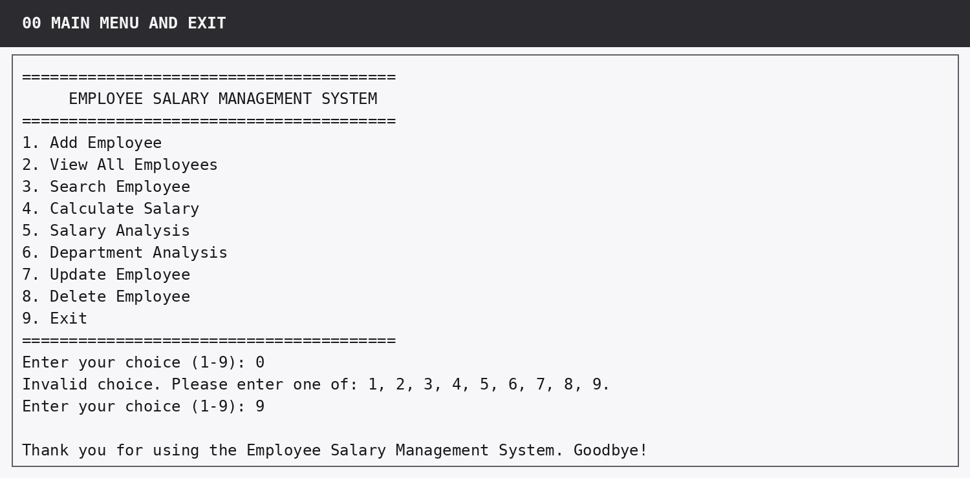
Figure 1. Main menu, invalid option handling and controlled exit.

7. Detailed Implementation of Shared Functions

7.1 get_starter_employees()
This function isolates the supplied test data from the main control logic. It returns a new list rather than exposing a single module-level list. This design keeps startup predictable and makes tests repeatable. Each starter dictionary contains exactly the seven assessed fields and no stored gross/net values.

7.2 prompt_non_empty()
Text input is stripped before validation. A blank value or a string containing spaces only is rejected. The function uses a while True retry loop and returns only when it has a usable value. This prevents empty IDs, names and departments from entering the data structure.
Blank-text validation helper
def prompt_non_empty(prompt_text):
"""Keep asking until the user enters text containing at least one character."""
while True:
value = input(prompt_text).strip()
if value:
return value
print("Input cannot be blank. Please try again.")

7.3 prompt_non_negative_number()
Numeric validation is one of the most important robustness features because Basic Salary, Allowance, Bonus and Deduction are entered by the user. The helper removes commas so values such as 45,000 are acceptable, then attempts float conversion inside try/except. It rejects text that cannot be converted, rejects NaN or infinity using math.isfinite(), and rejects values below zero. The loop repeats until a valid finite number of zero or more is entered.
Numeric validation helper
def prompt_non_negative_number(prompt_text, field_name):
"""Accept a finite numeric value of zero or more, retrying invalid input."""
while True:
raw_value = input(prompt_text).strip().replace(",", "")
try:
value = float(raw_value)
except ValueError:
print(f"Invalid entry. {field_name} must be a number. Please try again.")
continue
if not math.isfinite(value):
print(f"Invalid entry. {field_name} must be a finite number. Please try again.")
continue
if value < 0:
print(f"Invalid entry. {field_name} cannot be negative. Please try again.")
continue
return value

7.4 prompt_menu_choice()
This helper takes a prompt and a set of permitted values. It is reused by the main menu, the Search sub-menu and the Update sub-menu. Reusing one helper gives consistent behaviour across the program and prevents invalid choices from reaching later logic.

7.5 Lookup helpers
find_employee_by_id() and find_employee_by_name() normalise both the user input and stored value using casefold(). casefold() is more robust for case-insensitive comparisons than a simple exact comparison. Both functions return the matching dictionary or None, which gives the calling module a simple and predictable success/failure contract.
Employee lookup helpers
def find_employee_by_id(employees, employee_id):
"""Find an employee by ID without treating upper/lower case as different."""
target = employee_id.strip().casefold()
for employee in employees:
if employee["employee_id"].casefold() == target:
return employee
return None
def find_employee_by_name(employees, employee_name):
"""Find an employee by full name using a case-insensitive comparison."""
target = employee_name.strip().casefold()
for employee in employees:
if employee["name"].casefold() == target:
return employee
return None

7.6 display_employee_record()
This presentation helper is shared by Search, Update and Delete. It calculates fresh gross/net salary, then prints all stored fields in a consistent labelled format. Using one display function avoids subtle differences between modules and makes before/after comparisons easy to read.

8. Detailed Implementation of Modules 1-8

8.1 Module 1 - Add Employee
Purpose: Create a new employee only after all seven fields pass validation.

Processing sequence
1. Prompt for a non-empty Employee ID and convert it to upper case.
2. Search the current list for that ID. If found, display a duplicate-ID message and ask again.
3. Collect name and department using non-empty text validation.
4. Collect all four salary fields using the shared numeric validator.
5. Construct one dictionary with exactly the seven stored fields.
6. Append the dictionary to the shared list.
7. Calculate gross and net salary immediately and display a success confirmation.

Design discussion
The duplicate check happens before the rest of the record is accepted. A failed numeric input does not abandon the module; it repeats the specific salary prompt. This matches the requirement that one wrong keypress must not crash the program.
Implementation excerpt: add_employee()
def add_employee(employees):
"""Module 1: validate seven fields and add one new employee to the shared list."""
print("\n--- ADD NEW EMPLOYEE ---")
while True:
employee_id = prompt_non_empty("Employee ID : ").upper()
if find_employee_by_id(employees, employee_id) is None:
break
print(f"Employee ID {employee_id} already exists. Please enter a unique ID.")
name = prompt_non_empty("Employee Name : ")
department = prompt_non_empty("Department : ")
basic_salary = prompt_non_negative_number("Basic Salary : ", "Basic Salary")
allowance = prompt_non_negative_number("Allowance : ", "Allowance")
bonus = prompt_non_negative_number("Bonus : ", "Bonus")
deduction = prompt_non_negative_number("Deduction : ", "Deduction")
employee = {
"employee_id": employee_id,
"name": name,
"department": department,
"basic_salary": basic_salary,
"allowance": allowance,
"bonus": bonus,
"deduction": deduction,
}
employees.append(employee)
gross_salary, net_salary = calculate_salary(employee)
print(f"\nEmployee {employee_id} added successfully.")
print(f"Gross Salary: {format_currency(gross_salary)} | Net Salary: {format_currency(net_salary)}")

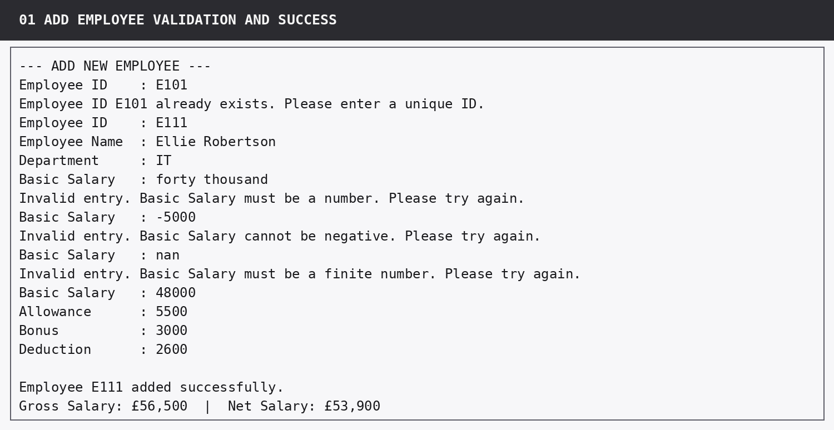
Figure 2. Add Employee showing duplicate, text, negative and non-finite validation before successful creation.

8.2 Module 2 - View All Employees
Purpose: Display every employee in one aligned console table.

Processing sequence
1. Check whether the list is empty and return with a clear message if so.
2. Calculate gross and net salary for each current employee.
3. Convert salary amounts into formatted currency strings.
4. Calculate each column width from the header and current row contents.
5. Print the header, separator and all rows using f-string alignment.

Design discussion
Column widths are dynamic rather than manually fixed. If a newly added employee has a longer name or department, the table expands instead of losing alignment.
Key implementation excerpt: view_all_employees()
def view_all_employees(employees):
"""Module 2: display every employee in one dynamically aligned console table."""
print("\n--- ALL EMPLOYEES ---")
if not employees:
print("No employees are currently stored.")
return
rows = []
for employee in employees:
gross_salary, net_salary = calculate_salary(employee)
rows.append(
(
employee["employee_id"],
employee["name"],
employee["department"],
format_currency(employee["basic_salary"]),
format_currency(gross_salary),
format_currency(net_salary),
)
)
id_width = max(len("ID"), max(len(row[0]) for row in rows)) + 2
name_width = max(len("NAME"), max(len(row[1]) for row in rows)) + 2
department_width = max(len("DEPARTMENT"), max(len(row[2]) for row in rows)) + 2
basic_width = max(len("BASIC"), max(len(row[3]) for row in rows)) + 2
gross_width = max(len("GROSS"), max(len(row[4]) for row in rows)) + 2
net_width = max(len("NET"), max(len(row[5]) for row in rows)) + 2
...

8.3 Module 3 - Search Employee
Purpose: Find an employee by either Employee ID or full Employee Name.

Processing sequence
1. Reject the operation early if the employee list is empty.
2. Offer a two-option search menu and validate the choice.
3. Collect a non-empty search value.
4. Call the matching lookup helper.
5. If no record is found, print an explicit not-found message.
6. If a record is found, display all seven stored fields plus gross and net salary.

Design discussion
The name search is case-insensitive. For example, entering "charlotte bennett" successfully finds "Charlotte Bennett".
Implementation excerpt: search_employee()
def search_employee(employees):
"""Module 3: search by employee ID or full employee name and show the record."""
print("\n--- SEARCH EMPLOYEE ---")
if not employees:
print("No employees are currently stored, so there is nothing to search.")
return
print("1. Search by Employee ID")
print("2. Search by Employee Name")
choice = prompt_menu_choice("Choose search type (1-2): ", {"1", "2"})
if choice == "1":
search_value = prompt_non_empty("Enter Employee ID: ")
employee = find_employee_by_id(employees, search_value)
else:
search_value = prompt_non_empty("Enter Employee Name: ")
employee = find_employee_by_name(employees, search_value)
if employee is None:
print(f"No employee matched '{search_value}'.")
return
display_employee_record(employee, "SEARCH RESULT")

8.4 Module 4 - Calculate Salary
Purpose: Display a readable salary breakdown for one selected employee.

Processing sequence
1. Check for an empty list.
2. Request Employee ID and perform case-insensitive lookup.
3. Handle a missing ID without an exception.
4. Calculate gross and net salary through calculate_salary().
5. Print basic salary, allowance, bonus, gross salary, deduction and net salary in a payslip-style block.

Design discussion
The module deliberately shows the full calculation path rather than only the final net value so the HR user can understand how the result was produced.
Implementation excerpt: calculate_salary_module()
def calculate_salary_module(employees):
"""Module 4: show a payslip-style salary calculation for one selected employee."""
print("\n--- CALCULATE SALARY ---")
if not employees:
print("No employees are currently stored.")
return
employee_id = prompt_non_empty("Enter Employee ID: ")
employee = find_employee_by_id(employees, employee_id)
if employee is None:
print(f"Employee ID {employee_id} was not found.")
return
gross_salary, net_salary = calculate_salary(employee)
print("\n========================================")
print(" SALARY BREAKDOWN")
print("========================================")
print(f"Employee : {employee['name']} ({employee['employee_id']})")
print(f"Department : {employee['department']}")
print("----------------------------------------")
print(f"Basic Salary : {format_currency(employee['basic_salary']):>14}")
print(f"Allowance : {format_currency(employee['allowance']):>14}")
print(f"Bonus : {format_currency(employee['bonus']):>14}")
print("----------------------------------------")
print(f"Gross Salary : {format_currency(gross_salary):>14}")
print(f"Deduction : {format_currency(employee['deduction']):>14}")
print("----------------------------------------")
print(f"Net Salary : {format_currency(net_salary):>14}")
print("========================================")

8.5 Module 5 - Salary Analysis
Purpose: Answer all six required questions for the whole workforce using net salary.

Processing sequence
1. Build temporary (employee, net salary) pairs from the current records.
2. Use max() to identify the highest net salary.
3. Use min() to identify the lowest net salary.
4. Use sum() for total annual payroll.
5. Divide total payroll by employee count for the average.
6. Count net salaries > 50000 and < 30000 using strict comparisons.
7. Format and display all six results.

Design discussion
No result is typed into the source code as an answer. The figures are derived from the current list every time, so they change correctly after Add, Update or Delete operations.
Key implementation excerpt: salary_analysis()
def salary_analysis(employees):
"""Module 5: calculate the six required company-wide statistics using net salary."""
print("\n========== SALARY ANALYSIS ==========")
if not employees:
print("No employees are currently stored, so salary analysis cannot be calculated.")
print("=====================================")
return
salary_rows = []
for employee in employees:
_, net_salary = calculate_salary(employee)
salary_rows.append((employee, net_salary))
highest_employee, highest_net = max(salary_rows, key=lambda row: row[1])
lowest_employee, lowest_net = min(salary_rows, key=lambda row: row[1])
total_payroll = sum(net_salary for _, net_salary in salary_rows)
average_net = total_payroll / len(salary_rows)
more_than_50000 = sum(1 for _, net_salary in salary_rows if net_salary > 50000)
less_than_30000 = sum(1 for _, net_salary in salary_rows if net_salary < 30000)
print(f"Total Employees : {len(employees)}")
print(
"Highest Net Salary : "
f"{highest_employee['name']} ({highest_employee['employee_id']}) - {format_currency(highest_net)}"
)
print(
"Lowest Net Salary : "
f"{lowest_employee['name']} ({lowest_employee['employee_id']}) - {format_currency(lowest_net)}"
...

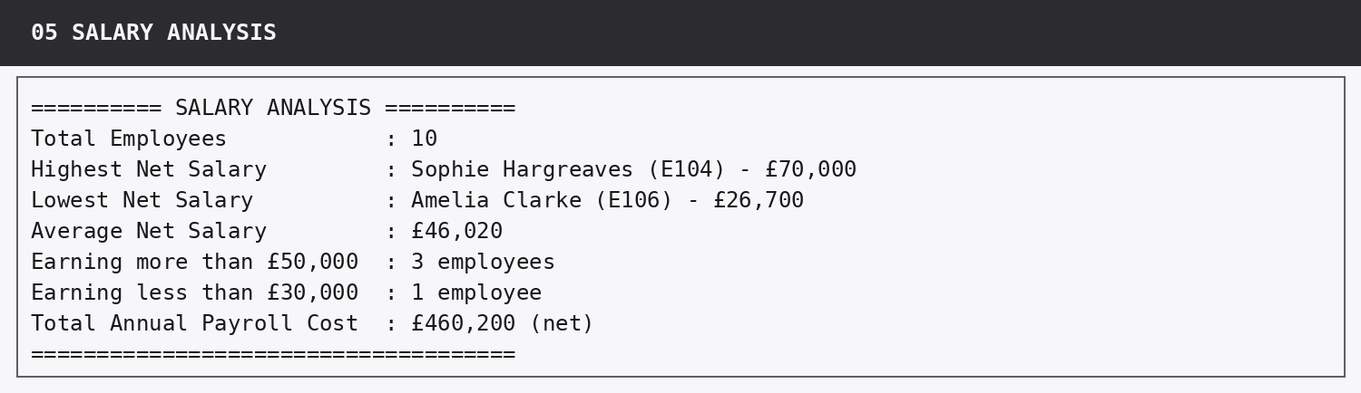
Figure 3. Company-wide salary analysis produced from the starter data.

8.6 Module 6 - Department Analysis
Purpose: Filter the workforce to one department and calculate five required measures.

Processing sequence
1. Check for an empty workforce.
2. Collect a department name and compare it with casefold().
3. Build a list of matching employee dictionaries.
4. If no matches exist, print a message before any division occurs.
5. Calculate net salary for matching employees.
6. Calculate employee count, total, average, highest and lowest net salary.
7. Display the selected department using the stored capitalisation.

Design discussion
Checking for zero matches before calculating the average prevents division-by-zero errors. A search for "it" and "IT" returns the same department.
Key implementation excerpt: department_analysis()
def department_analysis(employees):
"""Module 6: calculate the required net-salary statistics for one department."""
print("\n--- DEPARTMENT ANALYSIS ---")
if not employees:
print("No employees are currently stored, so department analysis cannot be calculated.")
return
department_name = prompt_non_empty("Enter department name: ")
matching_employees = [
employee
for employee in employees
if employee["department"].casefold() == department_name.casefold()
]
if not matching_employees:
print(f"No employees were found in the '{department_name}' department.")
return
salary_rows = []
for employee in matching_employees:
_, net_salary = calculate_salary(employee)
salary_rows.append((employee, net_salary))
total_salary = sum(net_salary for _, net_salary in salary_rows)
average_salary = total_salary / len(salary_rows)
highest_employee, highest_salary = max(salary_rows, key=lambda row: row[1])
lowest_employee, lowest_salary = min(salary_rows, key=lambda row: row[1])
display_name = matching_employees[0]["department"]
...

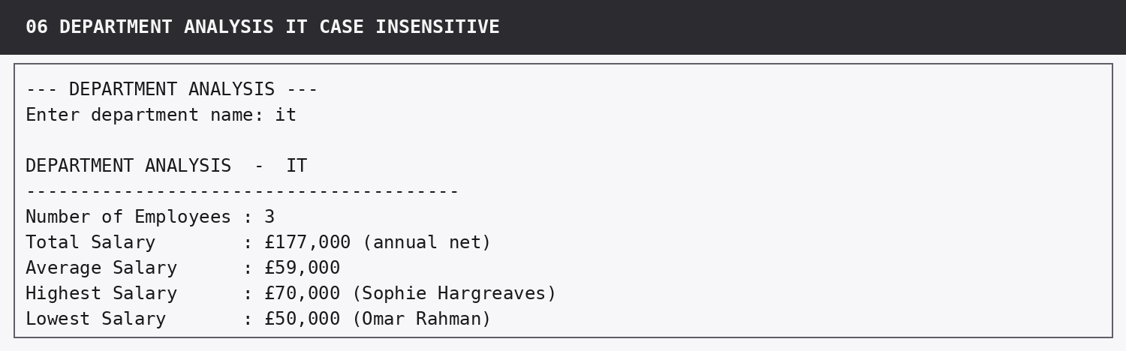
Figure 4. Department Analysis for IT using lower-case input.

8.7 Module 7 - Update Employee
Purpose: Change one permitted field for an existing employee while keeping Employee ID fixed.

Processing sequence
1. Locate the record by ID.
2. Display the complete record before the change.
3. Offer only Department, Basic Salary, Allowance, Bonus and Deduction as editable fields.
4. Validate the selected update option.
5. Apply non-empty text validation to Department or numeric validation to salary fields.
6. Display success confirmation.
7. Display the record again so recalculated gross/net salary is visible.

Design discussion
Only one field is changed in each call. The user is not forced to re-enter unchanged data, and Employee ID cannot be edited because it is the stable key used to identify the record.
Key implementation excerpt: update_employee()
def update_employee(employees):
"""Module 7: locate an employee by ID and update exactly one permitted field."""
employee_id = prompt_non_empty("Enter Employee ID to update: ")
employee = find_employee_by_id(employees, employee_id)
if employee is None:
print(f"Employee ID {employee_id} was not found.")
return
display_employee_record(employee, "RECORD BEFORE UPDATE")
choice = prompt_menu_choice("Enter choice (1-5): ", {"1", "2", "3", "4", "5"})
if choice == "1":
employee["department"] = prompt_non_empty("New Department: ")
elif choice == "2":
employee["basic_salary"] = prompt_non_negative_number("New Basic Salary: ", "Basic Salary")
elif choice == "3":
employee["allowance"] = prompt_non_negative_number("New Allowance: ", "Allowance")
elif choice == "4":
employee["bonus"] = prompt_non_negative_number("New Bonus: ", "Bonus")
else:
employee["deduction"] = prompt_non_negative_number("New Deduction: ", "Deduction")
print("\nEmployee updated successfully.")
display_employee_record(employee, "RECORD AFTER UPDATE")

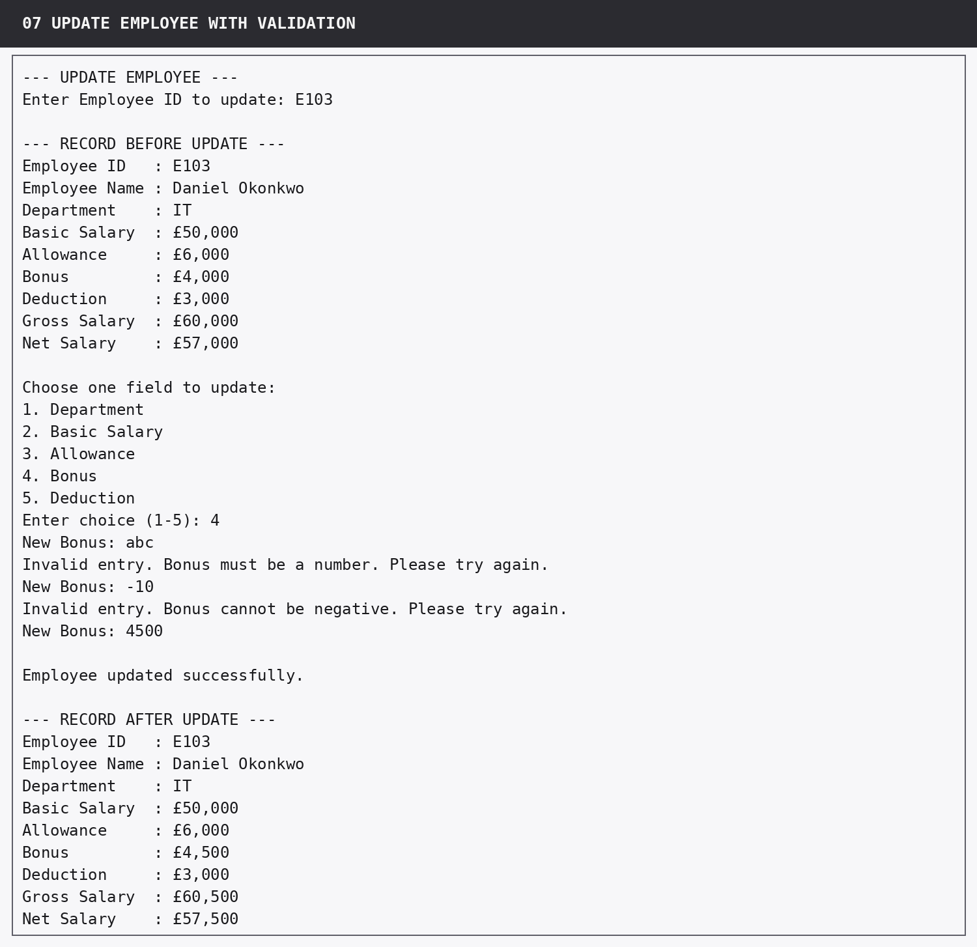
Figure 5. Update Employee with invalid values rejected and net salary recalculated.

8.8 Module 8 - Delete Employee
Purpose: Remove a selected employee only after a deliberate confirmation.

Processing sequence
1. Check for an empty list.
2. Locate the employee by ID.
3. If the ID does not exist, report that nothing was deleted.
4. Display the exact record that would be removed.
5. Accept Y/Yes to confirm or N/No to cancel.
6. Reject any other confirmation and ask again.
7. Remove the employee only after positive confirmation and print a success message.

Design discussion
Displaying the record before deletion reduces the chance of deleting the wrong employee. Cancellation returns safely without modifying the list.
Implementation excerpt: delete_employee()
def delete_employee(employees):
"""Module 8: locate by ID, show the record, confirm, then safely delete it."""
print("\n--- DELETE EMPLOYEE ---")
if not employees:
print("No employees are currently stored, so there is nothing to delete.")
return
employee_id = prompt_non_empty("Enter Employee ID to delete: ")
employee = find_employee_by_id(employees, employee_id)
if employee is None:
print(f"Employee ID {employee_id} was not found. Nothing was deleted.")
return
display_employee_record(employee, "RECORD TO DELETE")
while True:
confirmation = input("\nConfirm deletion (Y/N): ").strip().casefold()
if confirmation in {"y", "yes"}:
employees.remove(employee)
print(f"Employee {employee['employee_id']} - {employee['name']} deleted successfully.")
return
if confirmation in {"n", "no"}:
print("Deletion cancelled. No record was removed.")
return
print("Invalid response. Please enter Y or N.")

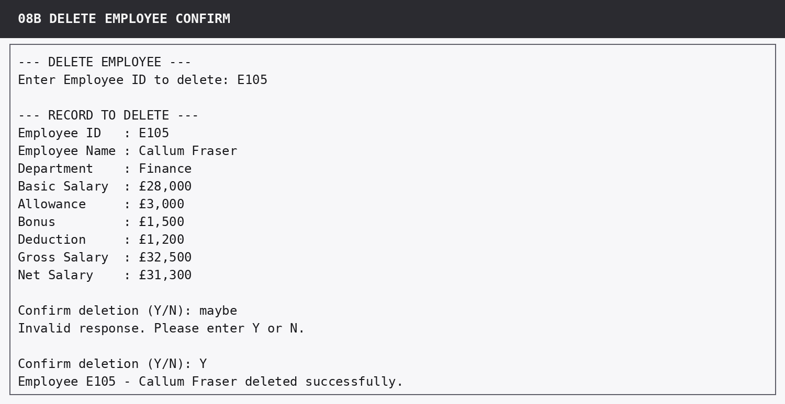
Figure 6. Delete Employee validation and confirmed deletion.

9. Input Validation and Error Handling
The assessment gives significant marks for robustness. The design therefore treats validation as part of the normal control flow rather than as an afterthought. Most invalid values are handled by retry loops; lookup failures are handled by clear messages and early returns. This keeps the user inside the program and prevents accidental state changes.
Input / condition | Detection | Program response | Crash?
Main menu: 0, 10, text | Not in valid choice set | Print valid choices and retry | No
Blank ID/name/department | strip() produces empty string | Print message and retry | No
Duplicate Employee ID | ID lookup already returns a record | Reject and ask for a unique ID | No
Salary entered as text | float() raises ValueError | Print field-specific message and retry | No
Negative salary | value < 0 | Reject and retry | No
NaN / infinity | math.isfinite(value) is false | Reject and retry | No
Employee ID not found | Lookup returns None | Print not-found message and return | No
Unknown department | Filtered list is empty | Print no-employees message and return | No
Empty workforce | employees evaluates false | Print module-specific message and return | No
Delete: "maybe" | Not Y/Yes/N/No | Print prompt guidance and retry | No
Delete: N/No | Valid cancellation | Do not remove record | No

9.1 Why early returns are used
Several modules begin with an empty-list check or stop after a failed lookup. Returning early keeps the successful path easier to read and guarantees that later operations receive valid data. For example, department_analysis() returns before dividing when no department matches, and delete_employee() returns before confirmation when the requested ID does not exist.

9.2 Handling non-finite numbers
A value such as NaN is syntactically accepted by Python float conversion but is not a sensible salary. The final numeric validator uses math.isfinite() to reject NaN and positive/negative infinity. This is stricter than the minimum text/negative validation and prevents unusual numeric values from contaminating totals, comparisons and averages.
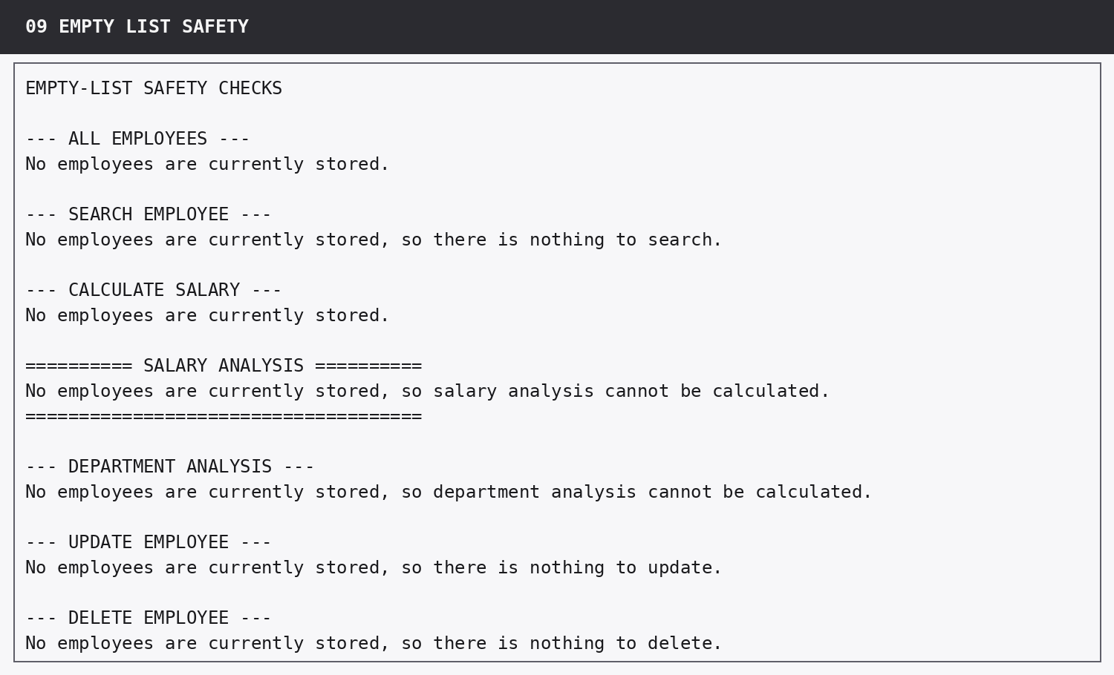
Figure 7. Empty-list safety checks across all affected modules.

10. Salary Analysis Algorithms and Verified Results

10.1 Temporary salary rows
salary_analysis() first creates a temporary collection of (employee, net_salary) pairs. Keeping the employee object beside the salary value allows max() and min() to return both the winning amount and the person associated with it. The temporary rows are calculated from current data and are discarded when the function ends.

10.2 Highest and lowest salary
max(salary_rows, key=lambda row: row[1]) selects the pair whose second item is the largest net salary. min() performs the equivalent operation for the smallest value. This avoids manually maintaining tracking variables and directly expresses the intended operation.

10.3 Total and average payroll
The total annual payroll cost is the sum of all net salaries. Average net salary is the total divided by the number of employees. The function checks for an empty list before creating these calculations, so the divisor is always at least one.

10.4 Threshold counts and the £50,000 boundary
The threshold logic is intentionally strict. The code counts one item for each net salary > 50000 and one item for each net salary < 30000. E107 Omar Rahman has a net salary of exactly £50,000; because the question asks for employees earning more than £50,000, E107 is not included. This produces a count of 3 rather than 4.
Measure | Employee(s) | Program result | Reference check
Highest net salary | Sophie Hargreaves (E104) | £70,000 | Matches
Lowest net salary | Amelia Clarke (E106) | £26,700 | Matches
Average net salary | Company average | £46,020 | Matches
Net salary > £50,000 | E103, E104, E109 | 3 employees | Matches
Net salary < £30,000 | E106 | 1 employee | Matches
Total annual payroll (net) | All 10 employees | £460,200 | Matches

10.5 Independent manual arithmetic check
ID | Net salary
E101 | £41,000
E102 | £46,000
E103 | £57,000
E104 | £70,000
E105 | £31,300
E106 | £26,700
E107 | £50,000
E108 | £34,000
E109 | £62,000
E110 | £42,200

Summing these ten net salaries gives £460,200. Dividing £460,200 by 10 gives £46,020. The maximum is £70,000 and the minimum is £26,700. Values strictly above £50,000 are £57,000, £70,000 and £62,000; the value exactly equal to £50,000 is excluded. The only value below £30,000 is £26,700.

11. Department Analysis Algorithms and Verified Results

11.1 Filtering approach
The department module uses a list comprehension to select only employees whose stored department matches the typed department after casefold(). This produces a temporary department-specific list. Every statistic is then calculated from that list, so no hard-coded department names or figures are required.

11.2 Calculated measures
- Number of employees = len(matching_employees).
- Total annual salary = sum of the matching employees' net salaries.
- Average salary = department total / department employee count.
- Highest salary = max() over the department salary rows.
- Lowest salary = min() over the department salary rows.
Department | Employees | Total net | Average | Highest | Lowest
IT | 3 | £177,000 | £59,000 | £70,000 | £50,000
HR | 2 | £80,000 | £40,000 | £46,000 | £34,000
Sales | 2 | £67,700 | £33,850 | £41,000 | £26,700
Finance | 2 | £73,500 | £36,750 | £42,200 | £31,300
Operations | 1 | £62,000 | £62,000 | £62,000 | £62,000

All five department rows match the supplied expected results. Operations contains one employee, so its total, average, highest and lowest are all £62,000. This is a useful edge case because the highest and lowest calculations must still work when only one value exists.

12. Output Formatting and User Experience

12.1 Menu clarity
The main menu uses the same numbering as the assessment modules. This reduces cognitive load because the user can select a feature directly by number. The title and separator lines visually distinguish navigation from module output.

12.2 Table alignment
View All Employees dynamically calculates column widths from the current data. Text columns are left-aligned and monetary columns are right-aligned. This makes values easier to scan vertically and prevents a long name or department entered later from breaking the table layout.
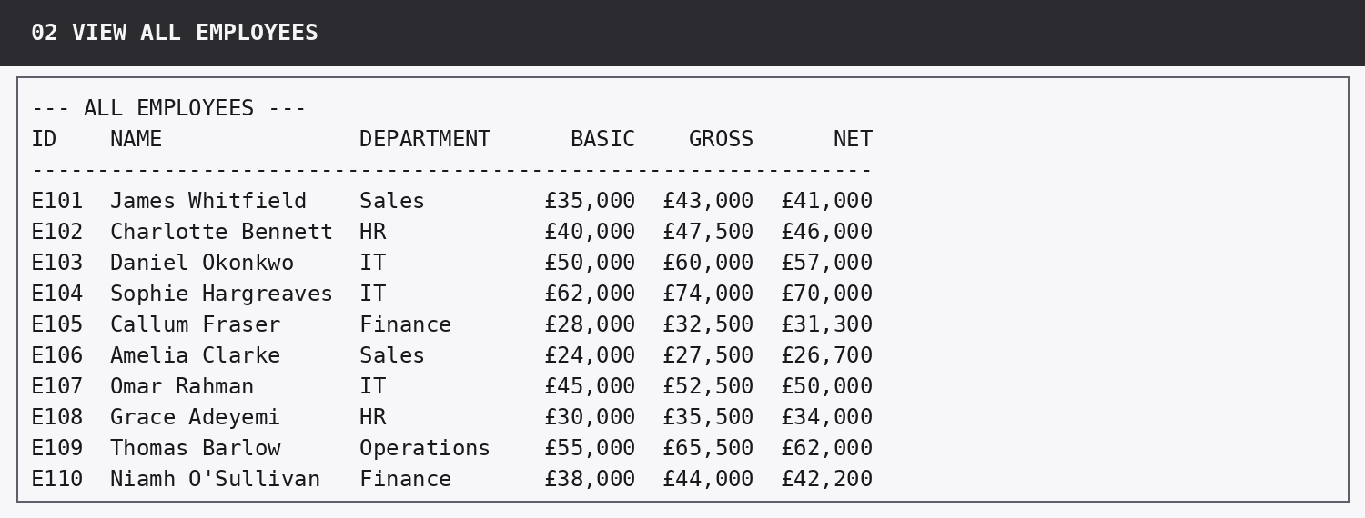
Figure 8. Aligned View All Employees table with calculated gross and net salary.

12.3 Salary breakdown
Calculate Salary presents a small payslip-style block rather than one long sentence. Basic salary, allowance and bonus appear before gross salary; deduction appears between gross and net. This ordering mirrors the calculation and allows the user to verify each component.
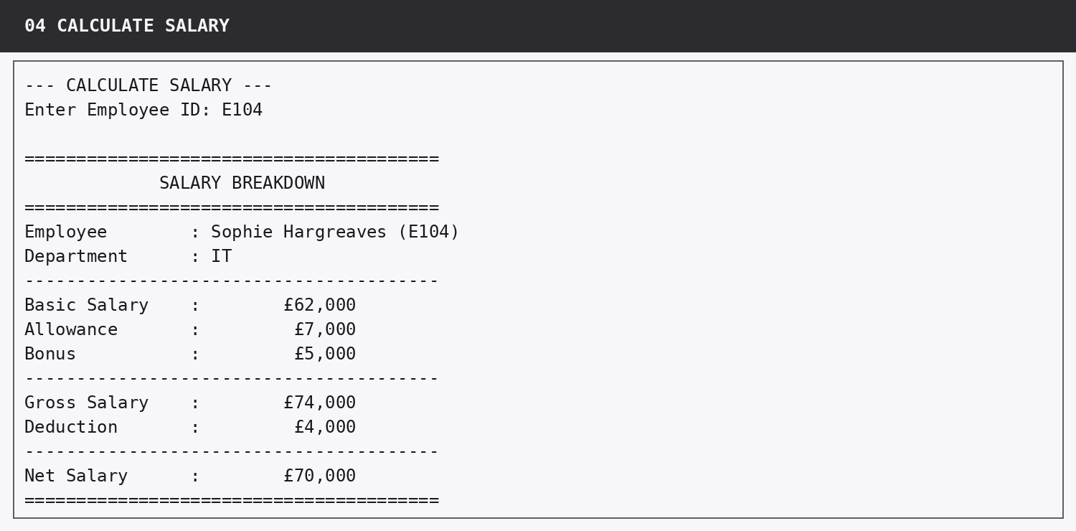
Figure 9. Payslip-style calculation for E104 Sophie Hargreaves.

12.4 Clear state-change feedback
Add, Update and Delete all confirm what happened. Update prints the record before and after the change, so the user can see which value changed and how the salary was recalculated. Delete shows the record before asking for confirmation and distinguishes successful deletion from cancellation. These messages reduce uncertainty in operations that alter data.

13. Testing Strategy and Detailed Test Record

13.1 Testing approach
Testing was carried out at three complementary levels. First, deterministic arithmetic checks verified individual salary formulas and the supplied analysis figures. Second, module-level tests supplied controlled input sequences to the actual functions and inspected output or list state. Third, captured console runs demonstrated the complete user-facing behaviour, including errors and confirmations. This combination checks both internal correctness and what the end user actually sees.

13.2 Verification environment
Item | Verification detail
Program | employee_salary_system.py
Runtime | Python 3.x
External packages used by runtime | None
Compilation check | python -m py_compile employee_salary_system.py - passed
Verification checks | 38 passed, 0 failed
Starter records | 10
Departments covered | IT, HR, Sales, Finance, Operations

13.3 Detailed test cases
ID | Area | Input / action | Expected | Actual | Result
T01 | Startup data | Launch fresh data | 10 records loaded | 10 records | PASS
T02 | Record schema | Inspect starter dictionaries | Exactly 7 required keys | 7 keys each | PASS
T03 | Unique starter IDs | Check IDs | No duplicates | All unique | PASS
T04 | ID lookup | Search e101 | Find E101 | Found | PASS
T05 | Name lookup | Search charlotte bennett | Find Charlotte Bennett | Found | PASS
T06 | Formula E101 | 35k + 5k + 3k - 2k | Gross 43k; net 41k | Matched | PASS
T07 | Main menu invalid | Enter 0 | Reject and retry | Rejected | PASS
T08 | Main menu exit | Enter 9 | Exit cleanly | Exited | PASS
T09 | Add duplicate | Enter E101 | Reject duplicate | Rejected | PASS
T10 | Add text salary | Enter "forty thousand" | Reject and retry | Rejected | PASS
T11 | Add negative salary | Enter -5000 | Reject and retry | Rejected | PASS
T12 | Add non-finite | Enter nan | Reject and retry | Rejected | PASS
T13 | Add valid record | Enter E111 data | Append one record | Added | PASS
T14 | Add salary confirm | E111 salary components | Gross £56,500; net £53,900 | Matched | PASS
T15 | View All | Use 10 starters | Required columns + 10 rows | Displayed | PASS
T16 | View All empty | Use [] | Clear empty message | Displayed | PASS
T17 | Search name case | charlotte bennett | Return complete E102 record | Displayed | PASS
T18 | Search missing | E999 | Clear not-found message | Displayed | PASS
T19 | Calculate salary | E104 | Full breakdown; net £70,000 | Matched | PASS
T20 | Calculate missing | E999 | Not-found message | Displayed | PASS
T21 | Salary highest | Starter data | E104 £70,000 | Matched | PASS
T22 | Salary lowest | Starter data | E106 £26,700 | Matched | PASS
T23 | Salary average | Starter data | £46,020 | Matched | PASS
T24 | Above £50k | Starter data | 3 employees | Matched | PASS
T25 | Below £30k | Starter data | 1 employee | Matched | PASS
T26 | Payroll total | Starter data | £460,200 | Matched | PASS
T27 | Department IT lower-case | Enter it | 3; £177k; £59k; £70k; £50k | Matched | PASS
T28 | Department HR | Enter HR | 2; £80k; £40k; £46k; £34k | Matched | PASS
T29 | Department Sales | Enter Sales | 2; £67.7k; £33.85k; £41k; £26.7k | Matched | PASS
T30 | Department Finance | Enter Finance | 2; £73.5k; £36.75k; £42.2k; £31.3k | Matched | PASS
T31 | Department Operations | Enter Operations | 1; all £62k | Matched | PASS
T32 | Unknown department | Enter Legal | Clear no-employee message | Displayed | PASS
T33 | Update validation | E103 bonus abc then -10 | Reject both and retry | Rejected | PASS
T34 | Update one field | E103 bonus to 4500 | Only bonus changes | Matched | PASS
T35 | Update recalc | E103 after bonus change | Gross £60,500; net £57,500 | Matched | PASS
T36 | Delete cancel | E105 then N | Record remains | Remained | PASS
T37 | Delete confirm | E105, maybe, then Y | Retry invalid then remove | Removed | PASS
T38 | Empty-list safety | Run affected modules on [] | No exception; clear messages | Matched | PASS

13.4 Overall test outcome
Final test outcome
38 verification checks passed and no check failed. The current program also passed Python compilation. The test evidence covers all eight functional modules, the two analysis modules, input validation, missing-record handling, empty lists, menu flow and state-changing operations.

13.5 Why the tests are meaningful
The tests are not limited to the happy path. They intentionally exercise the failure modes highlighted by the assessment: invalid menu input, duplicate IDs, non-numeric salary values, negative values, a name with different capitalisation, IDs that do not exist, a department with no employees, an exact £50,000 boundary salary, deletion from an empty list and invalid confirmation text. Passing these cases demonstrates that error handling is part of the implementation rather than being represented only in documentation.

14. Code Quality, Maintainability and Assessment Alignment

14.1 Function-based structure
The final source contains 19 named functions. Each mandatory module has its own function, while repeated concerns are moved into helpers. This satisfies the requirement to avoid one monolithic block and makes individual behaviours easier to test and explain.

14.2 Single source of truth for salary logic
calculate_salary() is the only place where the gross and net formulas are defined. This is a deliberate maintainability decision. If the simplified salary rule ever changed, one function would need updating rather than several modules.

14.3 Meaningful naming and documentation
Names such as find_employee_by_id, prompt_non_negative_number and department_analysis describe intent directly. Every function includes a concise docstring explaining its responsibility. The code avoids cryptic variable names for core business data and keeps salary component keys explicit.

14.4 No hard-coded analysis answers
The program contains the supplied starter records, which the brief permits, but it does not contain the expected analysis results as values to print. Highest, lowest, average, threshold counts, payroll totals and department statistics are all computed from the current list. This distinction is important: test data is initial data, while an answer such as £46,020 must be the result of the algorithm.

14.5 Complexity and suitability
The current dataset is small, so linear scans are appropriate and easy to understand. Employee lookup is O(n), View All is O(n), Salary Analysis is O(n), and Department Analysis is O(n) for filtering plus O(k) for the matched department. For a ten-record teaching dataset this is efficient and significantly clearer than introducing indexing structures that are not required by the assessment.
Assessment area | Evidence in this project | Status
Core features - 30 marks | All eight modules reachable and functioning | Addressed
Analysis correctness - 20 marks | Company and department figures plus boundary case match | Addressed
Code quality - 15 marks | Functions, helpers, meaningful names, shared logic | Addressed
Validation/error handling - 10 marks | Invalid input, duplicate, missing, empty cases handled | Addressed
Output/user experience - 10 marks | Aligned table, clear prompts, payslip, confirmations | Addressed
Test evidence - 10 marks | Captured runs and 38 verification checks | Addressed
Report/documentation - 5 marks | Design, implementation, testing and decisions documented here | Addressed

15. Challenges, Decisions and Resolutions
Challenge | Risk | Decision / resolution | Outcome
Consistent salary arithmetic | Repeating formulas in multiple modules would risk mismatched outputs. | Created calculate_salary() and called it everywhere a salary is needed. | One tested source of truth; updates cannot leave stored totals stale.
£50,000 boundary | Using >= would incorrectly include E107 and produce 4 employees. | Used net_salary > 50000 exactly as the wording requires. | Verified count is 3.
Robust numeric input | float(input()) alone would terminate on text and accept NaN. | Created a reusable retry helper with try/except, finite check and negative check. | Invalid values are rejected without leaving the module.
Readable View All output | Fixed spacing could break when future data contains longer text. | Calculated column widths from headers and current rows. | Table remains aligned as data changes.
Safe updates | Storing net salary would require synchronising derived values after every change. | Store only components and calculate gross/net on demand. | After-update values are always current.
Safe deletion | Deleting immediately after ID entry risks removing the wrong record. | Display the target and require Y/Yes confirmation; N/No cancels. | No deletion occurs without explicit confirmation.
Empty collection operations | Analysis or deletion on [] could produce exceptions. | Added early list checks in every affected module. | Clear user messages; no crash or division by zero.
Case-sensitive user input | HR users may type names/departments with different capitalisation. | Used casefold() for ID, name and department comparison. | Search and department analysis are forgiving without altering stored presentation.

15.1 Design decisions I would keep
The strongest decisions in this project are the central salary function, the shared validation helpers, the use of a list of dictionaries and the rule of calculating derived salaries only when required. These choices keep the program understandable while directly preventing common consistency and error-handling problems.

15.2 Decisions that are intentionally simple
The linear search approach and in-memory storage are simple by design. For a production payroll system with thousands of records they would be replaced by persistent storage and indexed queries, but doing that here would add complexity that is explicitly outside the assessment and would make the core Python learning outcomes less visible.

16. Limitations and Future Development

16.1 Current limitations
Limitation | Impact
No persistence | Changes made during a session are lost after exit because the data lives in memory.
Simplified deduction model | The program does not represent real UK payroll tax, National Insurance or multiple deduction categories.
No authentication | Any user who can run the program can add, update or delete records.
No audit trail | Changes are not timestamped and previous salary values are not retained.
Full-name search only | Name searching is case-insensitive but expects the full stored name rather than partial/fuzzy matching.
Single-process console interface | The system is designed for one terminal user, not concurrent HR staff.
No export/report file | Results are displayed in the terminal rather than exported to CSV, PDF or another format.

16.2 Prioritised future improvements
1. Add persistent storage, initially CSV or JSON for a simple extension and later a relational database for multi-user use.
2. Separate data access, business logic and user-interface layers so the same calculations can support a future web or desktop interface.
3. Add authentication, role-based permissions and an audit log for salary changes and deletion events.
4. Replace the single deduction amount with configurable payroll rules only if the business specification requires real payroll processing.
5. Add partial name search and controlled department choices to reduce typing errors.
6. Provide export functions for payroll summaries and printable employee salary statements.
7. Retain the current verification suite as a regression test set and extend it whenever new features are introduced.

16.3 What should not be changed without a requirement
A future version should not introduce complexity simply because it is technically possible. The current project is successful because each design choice answers a stated requirement. For example, replacing a readable list of dictionaries with a complex class hierarchy would only be worthwhile if new requirements made encapsulation, validation rules or polymorphic employee types necessary.

17. Final Evaluation and Conclusion
The completed Employee Salary Management System satisfies the functional and technical requirements of the assessment. All eight modules are available from a persistent numbered menu; employee data is stored in one shared in-memory collection; every employee record contains the required seven fields; gross and net salary are calculated through one shared function; and company/department analysis is derived dynamically from the current data.
The program has also been designed around the failure cases emphasised in the brief. Duplicate employee IDs are rejected. Salary fields reject text, negative values and non-finite numbers. Searches and department matching are case-insensitive. Missing employees and departments return clear messages. Empty lists do not cause analysis or deletion crashes. Update preserves Employee ID and recalculates salary after a changed component. Delete requires confirmation before state is changed.
Verification against the ten starter records produced all expected salary and department figures, including the strict £50,000 boundary case. The final verification run completed 38 checks with no failures and the source file passed compilation. The result is a complete, understandable and testable Python application that directly addresses the HR scenario without adding features outside the defined scope.
Final project status
Implementation complete. All eight required modules are present. Supplied self-check values match. 38 verification checks pass. Source compiles successfully. Detailed execution evidence is available in the separate Output Evidence document.

Appendix A - Starter Dataset and Calculated Salaries
ID | Name | Dept. | Basic | Allow. | Bonus | Deduct. | Gross | Net
E101 | James Whitfield | Sales | £35,000 | £5,000 | £3,000 | £2,000 | £43,000 | £41,000
E102 | Charlotte Bennett | HR | £40,000 | £4,000 | £3,500 | £1,500 | £47,500 | £46,000
E103 | Daniel Okonkwo | IT | £50,000 | £6,000 | £4,000 | £3,000 | £60,000 | £57,000
E104 | Sophie Hargreaves | IT | £62,000 | £7,000 | £5,000 | £4,000 | £74,000 | £70,000
E105 | Callum Fraser | Finance | £28,000 | £3,000 | £1,500 | £1,200 | £32,500 | £31,300
E106 | Amelia Clarke | Sales | £24,000 | £2,500 | £1,000 | £800 | £27,500 | £26,700
E107 | Omar Rahman | IT | £45,000 | £5,000 | £2,500 | £2,500 | £52,500 | £50,000
E108 | Grace Adeyemi | HR | £30,000 | £3,500 | £2,000 | £1,500 | £35,500 | £34,000
E109 | Thomas Barlow | Operations | £55,000 | £6,000 | £4,500 | £3,500 | £65,500 | £62,000
E110 | Niamh O'Sullivan | Finance | £38,000 | £4,000 | £2,000 | £1,800 | £44,000 | £42,200

Gross and net columns are shown here for verification only. The program does not store them inside the employee dictionaries; they are calculated when needed.

Appendix B - User Menu and Normal Operating Sequence
Main menu
========================================
EMPLOYEE SALARY MANAGEMENT SYSTEM
========================================
1. Add Employee
2. View All Employees
3. Search Employee
4. Calculate Salary
5. Salary Analysis
6. Department Analysis
7. Update Employee
8. Delete Employee
9. Exit
========================================

A normal user session starts with the ten starter records, performs any number of options 1-8, and returns to this menu after each operation. Option 9 exits. Changes made by Add, Update or Delete are visible to later operations in the same session because every module receives the same list object.

Appendix C - Complete Verification Pass List
01. PASS - Starter dataset contains exactly 10 employees
02. PASS - Every starter record contains exactly the seven required stored fields
03. PASS - Starter employee IDs are unique
04. PASS - Employee ID lookup is case-insensitive
05. PASS - Employee name lookup is case-insensitive
06. PASS - Gross and net salary formulas are correct for E101
07. PASS - Salary analysis contains expected result £70,000
08. PASS - Salary analysis contains expected result £26,700
09. PASS - Salary analysis contains expected result £46,020
10. PASS - Salary analysis contains expected result 3 employees
11. PASS - Salary analysis contains expected result 1 employee
12. PASS - Salary analysis contains expected result £460,200
13. PASS - IT department analysis matches the supplied self-check figures
14. PASS - HR department analysis matches the supplied self-check figures
15. PASS - Sales department analysis matches the supplied self-check figures
16. PASS - Finance department analysis matches the supplied self-check figures
17. PASS - Operations department analysis matches the supplied self-check figures
18. PASS - Add Employee appends a valid employee after validation retries
19. PASS - Add Employee rejects duplicate, text, negative and non-finite numeric input
20. PASS - Add Employee confirms calculated gross and net salary
21. PASS - View All Employees displays all required aligned columns
22. PASS - View All Employees handles an empty list
23. PASS - Search Employee returns the complete case-insensitive name match with calculated salaries
24. PASS - Search Employee reports a missing employee clearly
25. PASS - Calculate Salary displays the full payslip-style breakdown
26. PASS - Calculate Salary handles a missing employee ID
27. PASS - Department Analysis handles a department with no employees
28. PASS - Department Analysis handles an empty list without division by zero
29. PASS - Update Employee changes only the selected field after validation retries
30. PASS - Update Employee shows before/after records and recalculated net salary
31. PASS - Update Employee handles a missing ID
32. PASS - Delete Employee supports cancellation without removing the record
33. PASS - Delete Employee validates confirmation and removes the confirmed record
34. PASS - Delete Employee gives clear confirmation messages
35. PASS - Delete Employee handles a missing ID
36. PASS - Delete Employee handles an empty list
37. PASS - Salary Analysis handles an empty list
38. PASS - Main menu rejects invalid input and exits only on option 9

Appendix D - Source Function Map
Source range | Function | Purpose
Lines 14-28 | get_starter_employees() | Starter data
Lines 30-35 | calculate_salary() | Salary formulas
Lines 37-42 | format_currency() | Currency display
Lines 44-51 | prompt_non_empty() | Text validation
Lines 53-72 | prompt_non_negative_number() | Numeric validation
Lines 74-81 | prompt_menu_choice() | Choice validation
Lines 83-99 | find_employee_by_id/name() | Lookup
Lines 101-114 | display_employee_record() | Reusable record output
Lines 116-147 | add_employee() | Module 1
Lines 149-197 | view_all_employees() | Module 2
Lines 199-222 | search_employee() | Module 3
Lines 224-253 | calculate_salary_module() | Module 4
Lines 255-291 | salary_analysis() | Module 5
Lines 293-329 | department_analysis() | Module 6
Lines 331-366 | update_employee() | Module 7
Lines 368-392 | delete_employee() | Module 8
Lines 394-409 | display_main_menu() | Menu output
Lines 411-438 | main() | Controller loop

Appendix E - End-to-End Example Walkthrough
The following sequence shows how the shared in-memory state behaves across modules rather than treating each feature as an isolated demonstration.
Step | Action | Expected state / behaviour
1 | Launch program | 10 starter employees exist.
2 | Choose Add Employee | Enter E111 Ellie Robertson, IT, 48000/5500/3000/2600.
3 | Add confirmation | Gross £56,500 and net £53,900 are calculated; list now contains 11 records.
4 | Choose Search Employee | Search E111 and confirm the newly added record is present.
5 | Choose Update Employee | Change E111 bonus from £3,000 to £3,500; gross/net are recalculated from the current fields.
6 | Choose Department Analysis | IT now includes E111, so the result is recalculated from the changed current list rather than the original reference table.
7 | Choose Delete Employee | Select E111, verify the displayed record and confirm Y.
8 | Choose Search Employee | Search E111 again; the program reports no match.
9 | Choose Exit | Program ends cleanly. In-memory changes are discarded when the process ends.

