PYTHON - PHASE 3, LEVEL 2

Employee Salary Management System
Detailed Output Evidence and Test Record

Prepared by | Shraddha Yadav
Project | Employee Salary Management System
Document | Output evidence
Date | 18 August 2026

Assessment-ready documentation for the menu-driven Python payroll application.

Document Map
1. Evidence Summary
2. Environment and Test Method
3. Requirement Traceability
4. Starter Data Verification
5. Module 1 - Add
6. Module 2 - View All
7. Module 3 - Search
8. Module 4 - Calculate Salary
9. Module 5 - Salary Analysis
10. Module 6 - Department Analysis
11. Module 7 - Update
12. Module 8 - Delete
13. Validation and Empty-List Tests
14. Automated QA Summary
15. Final Verification

1. Evidence Summary
This document records actual output produced by the final employee_salary_system.py program. The screenshots are based on captured console output from the final code and show both normal use and error-handling behaviour. The evidence covers every required module, company salary analysis, department analysis, invalid input, missing records and empty-list handling.
Final status
All eight modules are implemented and reachable. The supplied company-wide and department analysis figures match the reference results. The final automated QA run completed with every check passing.

2. Environment and Test Method
Item | Value
Student | Shraddha Yadav
Program | employee_salary_system.py
Language | Python 3.x
Libraries | Python standard library only (math)
Data store | One in-memory list of employee dictionaries
Starting records | 10 supplied employees
Salary basis for analysis | Net salary
Evidence date | 18 August 2026

For repeatable evidence, the final program was imported and its production functions were run with scripted keyboard inputs. The input wrapper echoed each supplied answer beside the program prompt, so the captured output shows exactly what was entered and what the program returned. State-changing modules were executed against fresh copies of the supplied dataset unless a sequence required the same list.

3. Requirement Traceability
ID | Requirement | Evidence | Status
R1 | All eight modules reachable from menu | Evidence Sections 5-12 | Pass
R2 | Menu loops; invalid choice handled; option 9 exits | Section 4 screenshot | Pass
R3 | Seven stored fields per employee | Section 4 dataset table | Pass
R4 | Gross/net calculated, not stored | Sections 4, 8, 9, 11 | Pass
R5 | Duplicate ID rejected | Module 1 evidence | Pass
R6 | Numeric text/negative values rejected | Module 1 and Module 7 evidence | Pass
R7 | Name and department case-insensitive | Modules 3 and 6 evidence | Pass
R8 | Missing records handled | Search/Department evidence plus QA table | Pass
R9 | Salary analysis matches self-check | Module 5 evidence | Pass
R10 | Department analysis matches self-check | Module 6 and department table | Pass
R11 | Empty lists do not crash | Section 13 | Pass
R12 | Output readable and aligned | Module 2 and salary block | Pass

4. Starter Data and Baseline Verification
The program starts with the ten records supplied in the assessment. The table below shows the stored salary components and the gross/net values calculated by the final salary function. Gross and net are shown here for evidence only; they are not stored in the employee dictionaries.
ID | Name | Dept. | Basic | Allow. | Bonus | Deduct. | Gross | Net
E101 | James Whitfield | Sales | £35,000 | £5,000 | £3,000 | £2,000 | £43,000 | £41,000
E102 | Charlotte Bennett | HR | £40,000 | £4,000 | £3,500 | £1,500 | £47,500 | £46,000
E103 | Daniel Okonkwo | IT | £50,000 | £6,000 | £4,000 | £3,000 | £60,000 | £57,000
E104 | Sophie Hargreaves | IT | £62,000 | £7,000 | £5,000 | £4,000 | £74,000 | £70,000
E105 | Callum Fraser | Finance | £28,000 | £3,000 | £1,500 | £1,200 | £32,500 | £31,300
E106 | Amelia Clarke | Sales | £24,000 | £2,500 | £1,000 | £800 | £27,500 | £26,700
E107 | Omar Rahman | IT | £45,000 | £5,000 | £2,500 | £2,500 | £52,500 | £50,000
E108 | Grace Adeyemi | HR | £30,000 | £3,500 | £2,000 | £1,500 | £35,500 | £34,000
E109 | Thomas Barlow | Operations | £55,000 | £6,000 | £4,500 | £3,500 | £65,500 | £62,000
E110 | Niamh O'Sullivan | Finance | £38,000 | £4,000 | £2,000 | £1,800 | £44,000 | £42,200

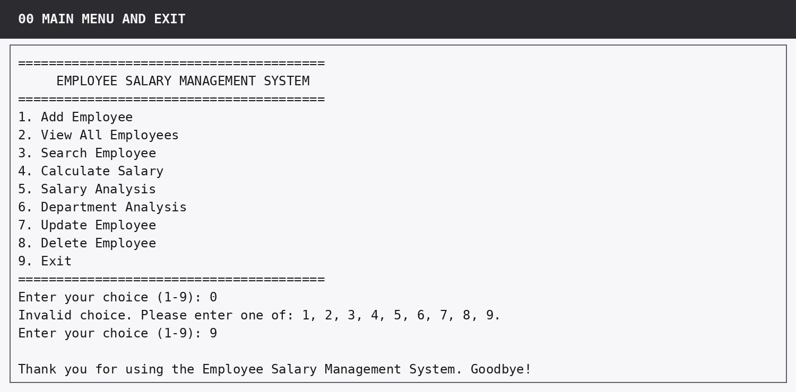
Figure 1. Main menu: invalid choice 0 is rejected; option 9 exits cleanly.

5. Module 1 - Add Employee
The demonstration intentionally enters a duplicate ID, text in a numeric field, a negative value and NaN before entering valid data. The program remains running, retries each invalid value, adds E111 and confirms gross salary £56,500 and net salary £53,900.
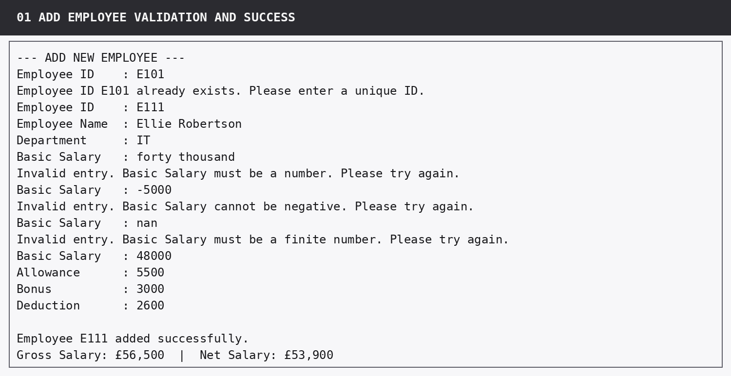
5. Module 1 - Add Employee - captured console output.

Acceptance checks
- Duplicate E101 is rejected before the record is created.
- Non-numeric, negative and non-finite salary values are rejected with retry messages.
- All seven fields are collected.
- The new record is appended and gross/net confirmation is calculated rather than hard-coded.

6. Module 2 - View All Employees
The complete ten-record workforce is printed in one table. The required columns are ID, Name, Department, Basic, Gross and Net. Column widths are derived from current data so values remain aligned.
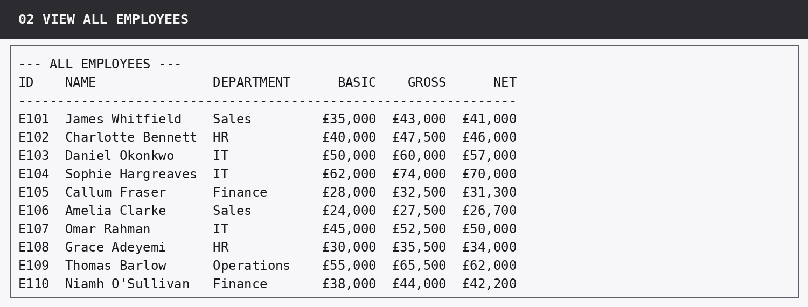
6. Module 2 - View All Employees - captured console output.

Acceptance checks
- Every starter record E101-E110 is visible.
- Gross and net salaries are calculated for each row.
- The table uses formatted widths instead of manually typed spaces.

7. Module 3 - Search Employee
The user selects name search and enters “charlotte bennett” in lower case. The program finds Charlotte Bennett and prints the full record with calculated gross and net salary.
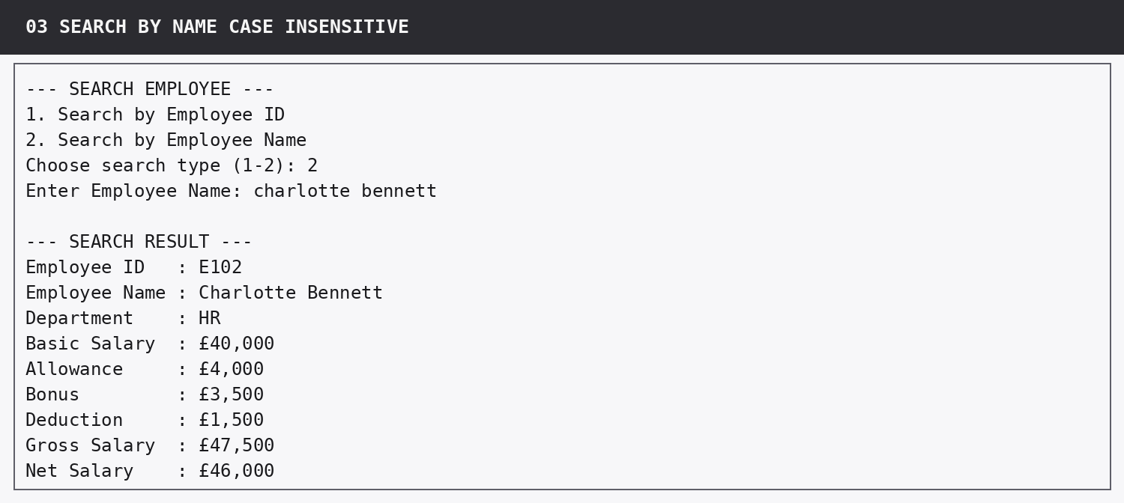
7. Module 3 - Search Employee - captured console output.

Acceptance checks
- The user chooses search method.
- Name matching is case-insensitive.
- Full stored record plus gross/net is displayed.

8. Module 4 - Calculate Salary
E104 is selected and the program prints a payslip-style salary breakdown. The output shows the salary components in a readable sequence and finishes with the £70,000 net salary.
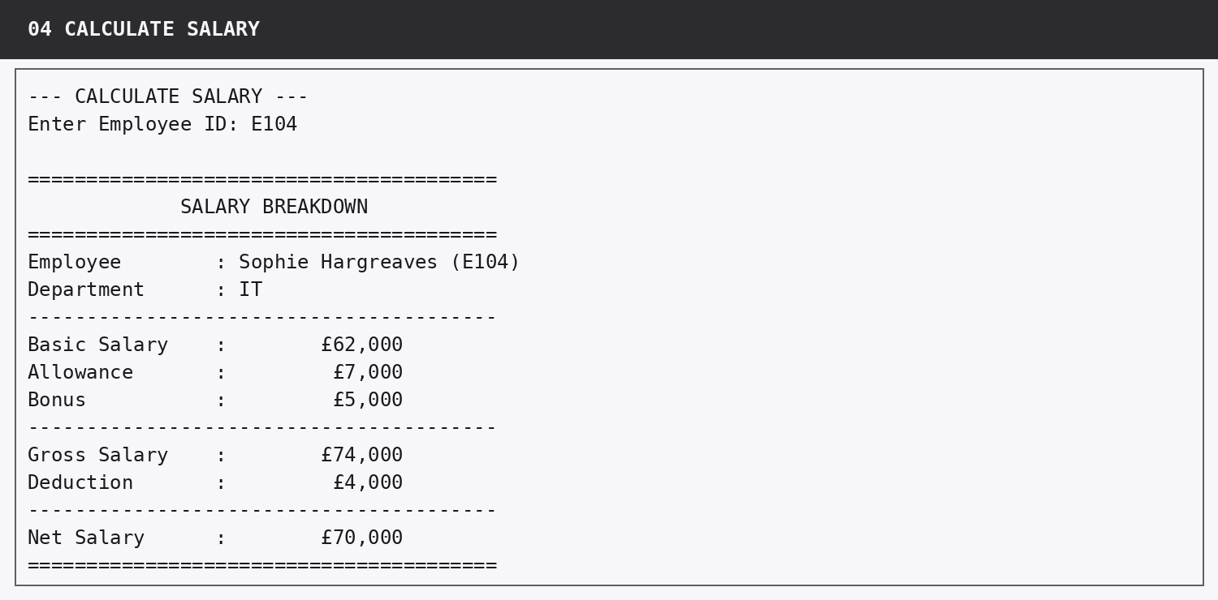
8. Module 4 - Calculate Salary - captured console output.

Acceptance checks
- Employee is selected by ID.
- Basic salary, allowance, bonus, gross, deduction and net are visible.
- Output is a formatted block rather than one long line.

9. Module 5 - Salary Analysis
The salary-analysis module runs against the original ten starter records and produces all six required company-wide results. The strict boundary logic excludes E107 from the “more than £50,000” count because E107 is exactly £50,000 net.
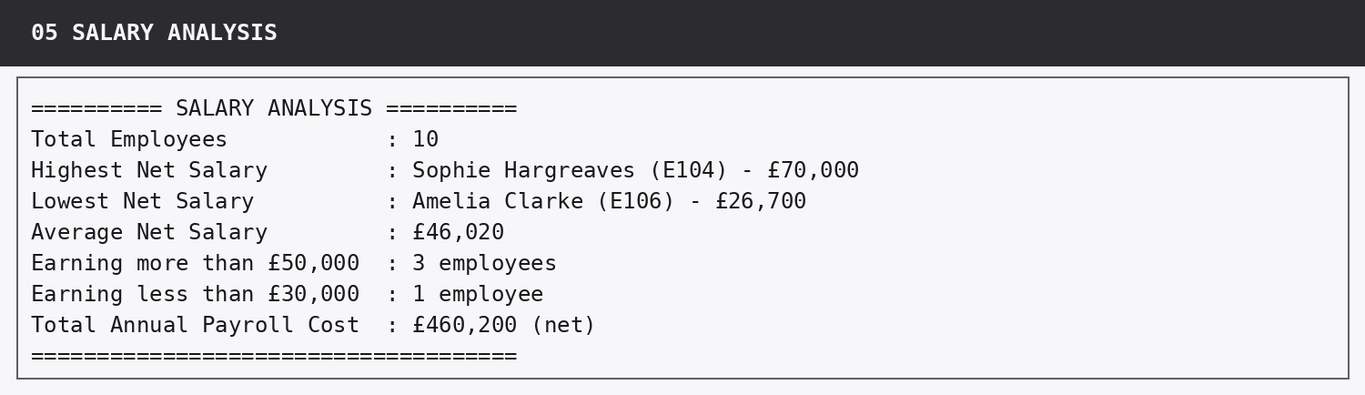
9. Module 5 - Salary Analysis - captured console output.

Acceptance checks
- Highest net salary: £70,000 (E104).
- Lowest net salary: £26,700 (E106).
- Average net salary: £46,020.
- More than £50,000: 3 employees.
- Less than £30,000: 1 employee.
- Total annual net payroll: £460,200.

10. Module 6 - Department Analysis
The user enters the department as lower-case “it”. The program matches the stored IT department and reports the required five net-salary statistics.
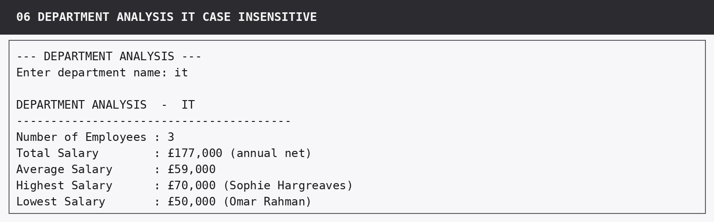
10. Module 6 - Department Analysis - captured console output.

Acceptance checks
- Case-insensitive department match succeeds.
- Employee count: 3.
- Total: £177,000.
- Average: £59,000.
- Highest: £70,000.
- Lowest: £50,000.

11. Module 7 - Update Employee
E103 is selected and the complete before-record is shown. Bonus is chosen as the one field to update. Invalid text and a negative value are rejected before £4,500 is accepted. The after-record shows the new bonus and the recalculated net salary of £57,500.
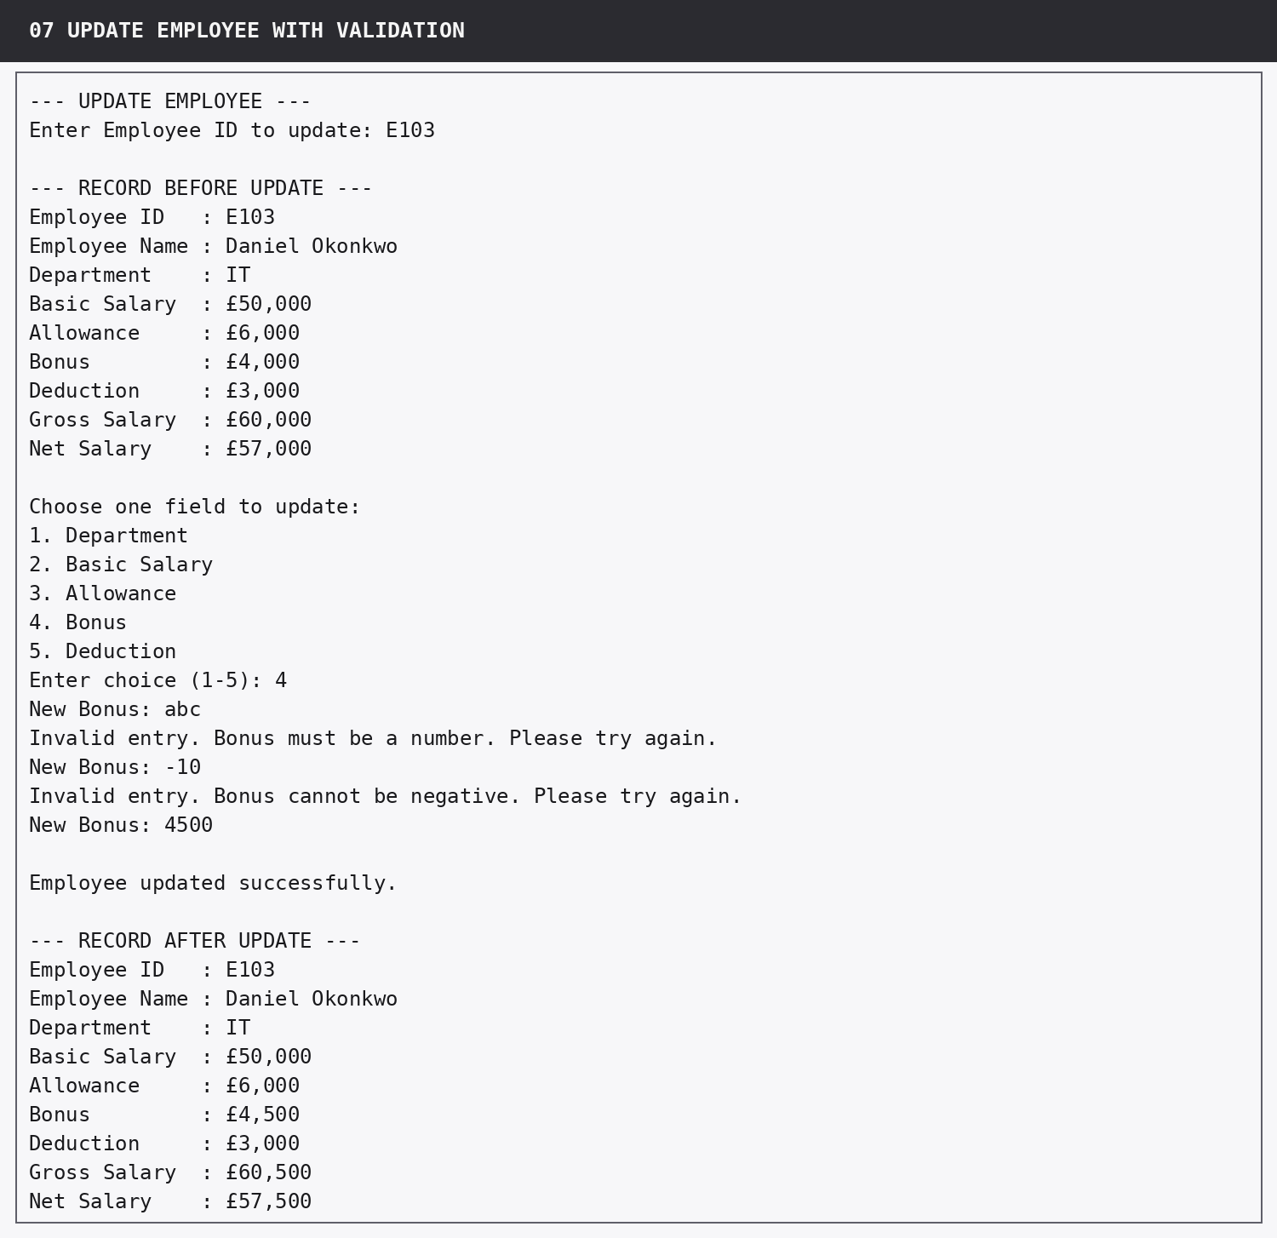
11. Module 7 - Update Employee - captured console output.

Acceptance checks
- Employee ID is used to locate the record and is not offered for editing.
- Only one permitted field is changed.
- Numeric validation remains active during updates.
- Before and after records are shown with recalculated salary.

12. Module 8 - Delete Employee
E105 is displayed before deletion. The invalid confirmation “maybe” is rejected; Y is then accepted and the program confirms that the employee was deleted.
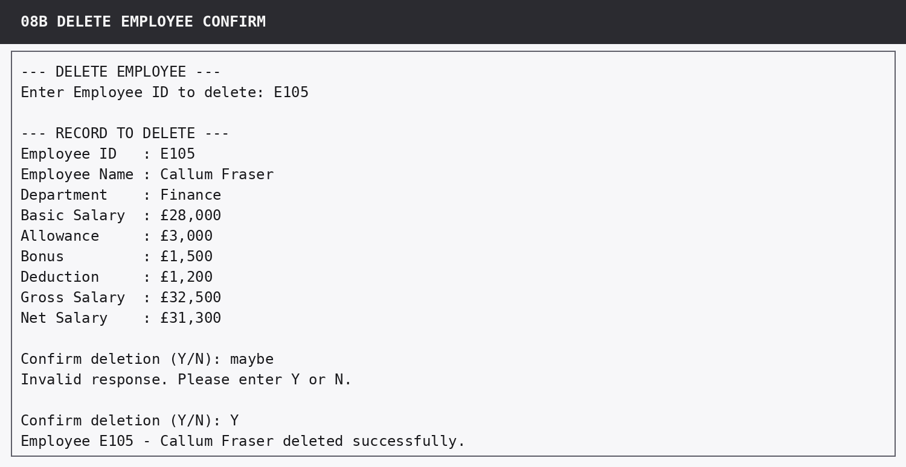
12. Module 8 - Delete Employee - captured console output.

Acceptance checks
- Record is displayed before removal.
- Deletion requires explicit confirmation.
- Invalid confirmation input is retried.
- A successful deletion message identifies the removed employee.

13. Additional Error and Edge-Case Evidence

13.1 Search for a missing employee
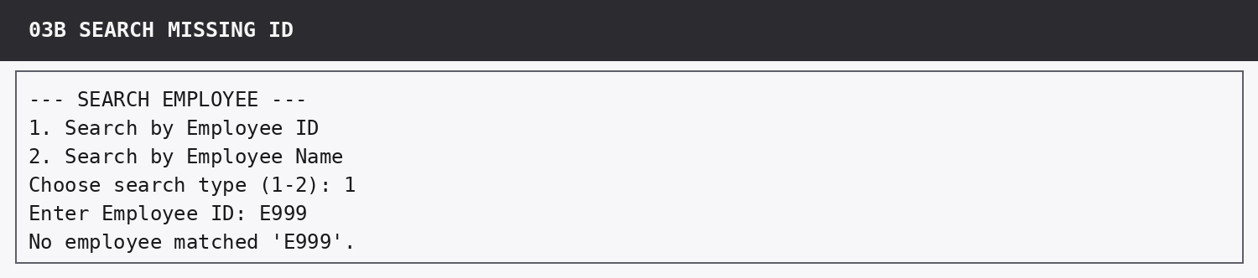
Figure: Search returns a clear message for E999.

13.2 Department with no employees
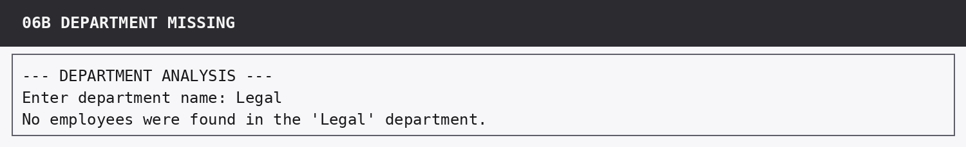
Figure: Unknown department “Legal” is handled without calculation or crash.

13.3 Delete cancellation
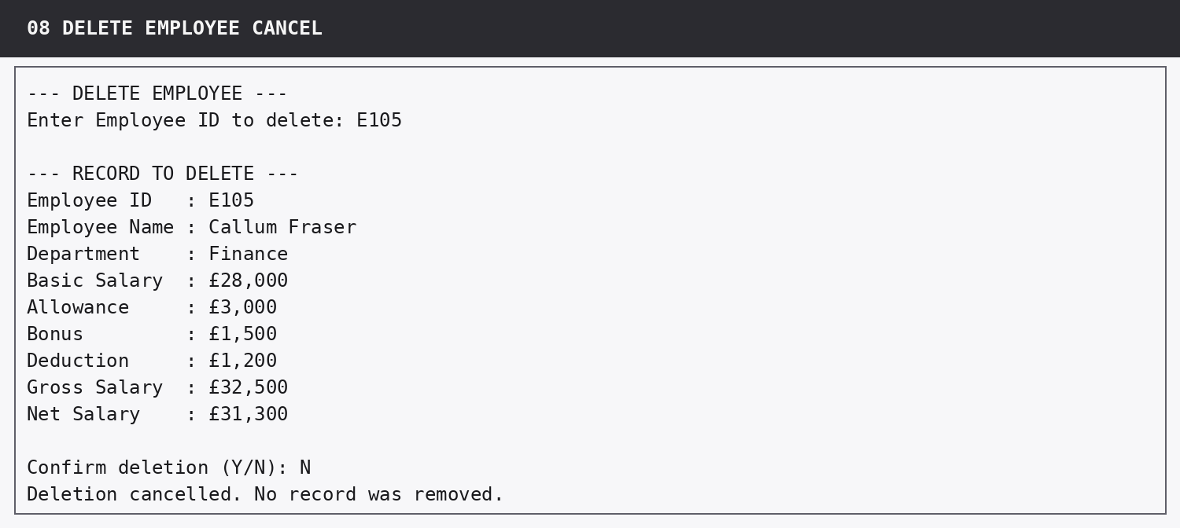
Figure: N cancels deletion and no record is removed.

13.4 Empty-list safety
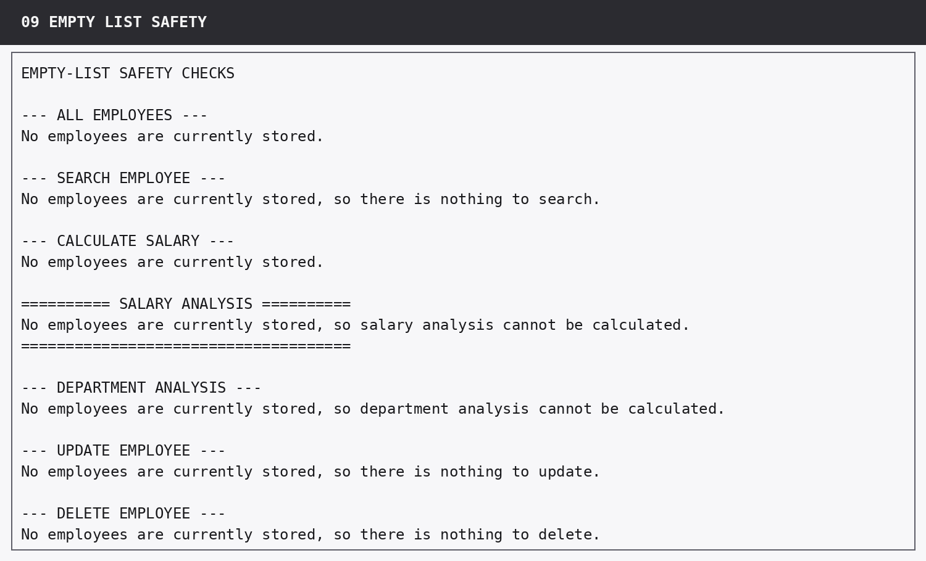
Figure: All affected modules return clear messages when the employee list is empty.

14. Full Department Self-Check
The program was also executed once for every department in the supplied starter data. The results below are taken from the final program and agree with the expected analysis table.
Department | Employees | Total net | Average | Highest | Lowest | Status
IT | 3 | £177,000 | £59,000 | £70,000 | £50,000 | Pass
HR | 2 | £80,000 | £40,000 | £46,000 | £34,000 | Pass
Sales | 2 | £67,700 | £33,850 | £41,000 | £26,700 | Pass
Finance | 2 | £73,500 | £36,750 | £42,200 | £31,300 | Pass
Operations | 1 | £62,000 | £62,000 | £62,000 | £62,000 | Pass

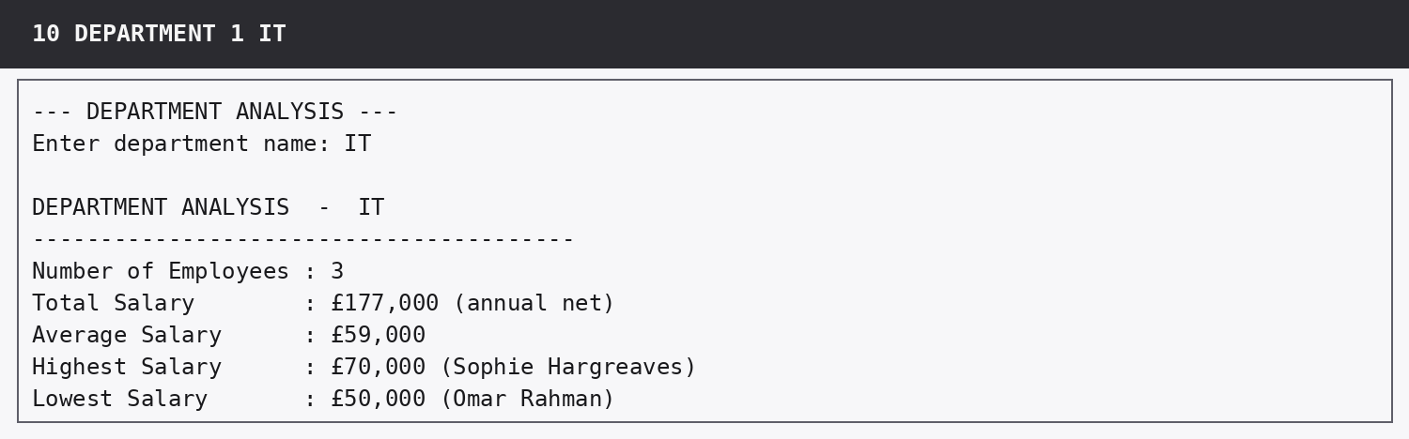
IT output
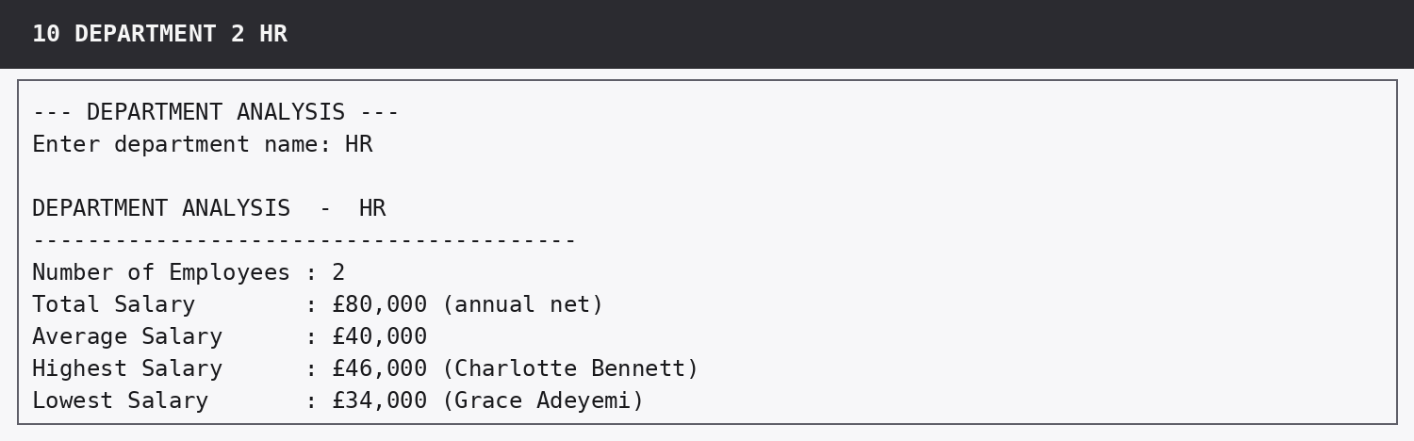
HR output
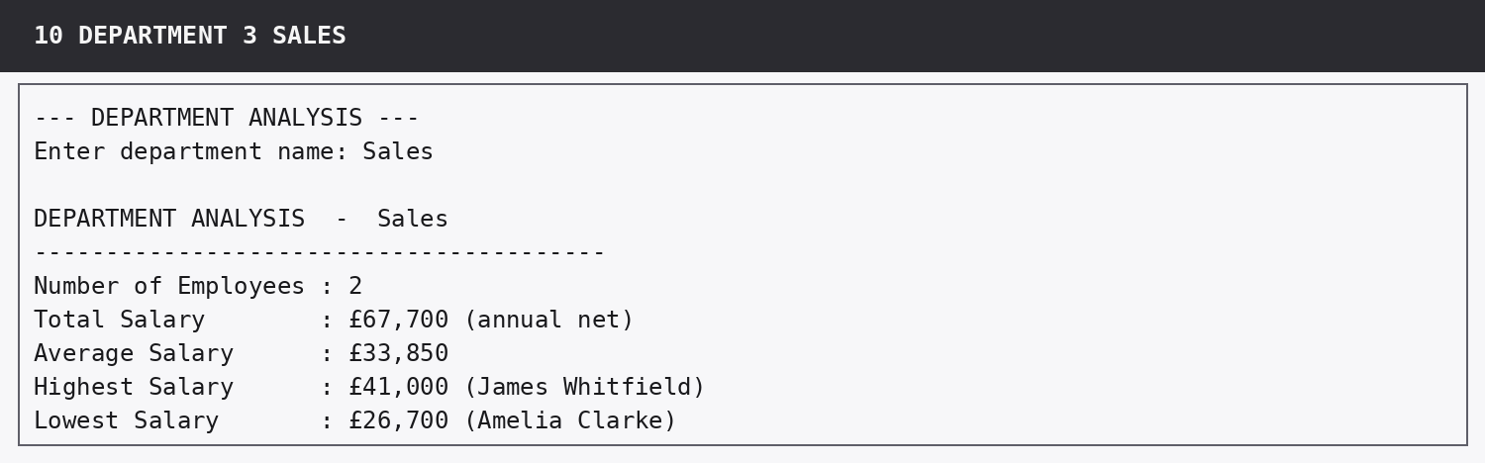
Sales output
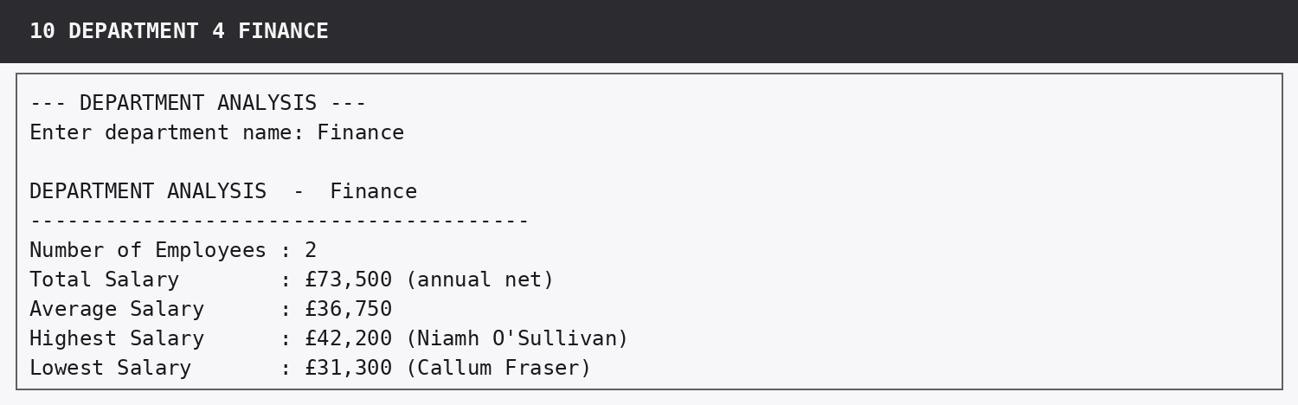
Finance output
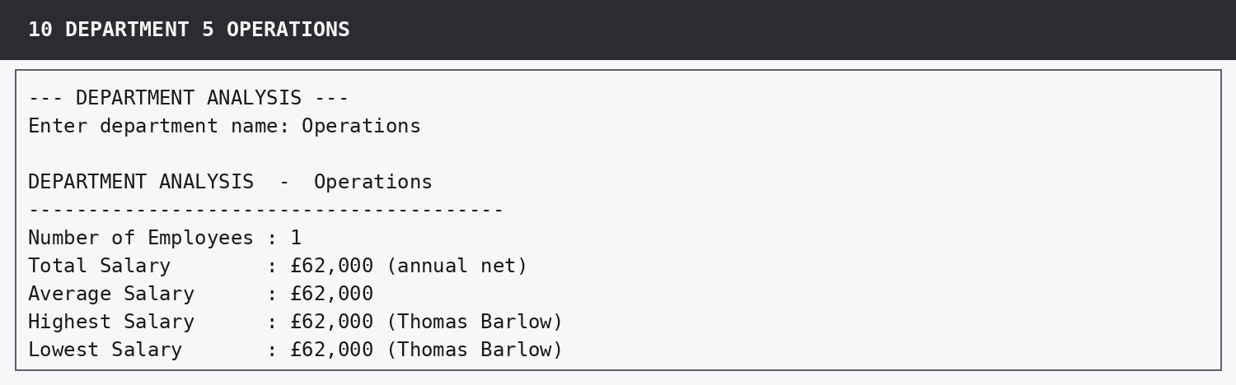
Operations output

15. Automated QA Summary
The final QA script completed 38 individual assertions. Each assertion passed. The tests cover starter-data integrity, salary formulas, company and department results, every module, validation, missing records, update/delete state changes, empty-list safety and menu behaviour.
# | Automated check | Result
1 | Starter dataset contains exactly 10 employees | Pass
2 | Every starter record contains exactly the seven required stored fields | Pass
3 | Starter employee IDs are unique | Pass
4 | Employee ID lookup is case-insensitive | Pass
5 | Employee name lookup is case-insensitive | Pass
6 | Gross and net salary formulas are correct for E101 | Pass
7 | Salary analysis contains expected result £70,000 | Pass
8 | Salary analysis contains expected result £26,700 | Pass
9 | Salary analysis contains expected result £46,020 | Pass
10 | Salary analysis contains expected result 3 employees | Pass
11 | Salary analysis contains expected result 1 employee | Pass
12 | Salary analysis contains expected result £460,200 | Pass
13 | IT department analysis matches the supplied self-check figures | Pass
14 | HR department analysis matches the supplied self-check figures | Pass
15 | Sales department analysis matches the supplied self-check figures | Pass
16 | Finance department analysis matches the supplied self-check figures | Pass
17 | Operations department analysis matches the supplied self-check figures | Pass
18 | Add Employee appends a valid employee after validation retries | Pass
19 | Add Employee rejects duplicate, text, negative and non-finite numeric input | Pass
20 | Add Employee confirms calculated gross and net salary | Pass
21 | View All Employees displays all required aligned columns | Pass
22 | View All Employees handles an empty list | Pass
23 | Search Employee returns the complete case-insensitive name match with calculated salaries | Pass
24 | Search Employee reports a missing employee clearly | Pass
25 | Calculate Salary displays the full payslip-style breakdown | Pass
26 | Calculate Salary handles a missing employee ID | Pass
27 | Department Analysis handles a department with no employees | Pass
28 | Department Analysis handles an empty list without division by zero | Pass
29 | Update Employee changes only the selected field after validation retries | Pass
30 | Update Employee shows before/after records and recalculated net salary | Pass
31 | Update Employee handles a missing ID | Pass
32 | Delete Employee supports cancellation without removing the record | Pass
33 | Delete Employee validates confirmation and removes the confirmed record | Pass
34 | Delete Employee gives clear confirmation messages | Pass
35 | Delete Employee handles a missing ID | Pass
36 | Delete Employee handles an empty list | Pass
37 | Salary Analysis handles an empty list | Pass
38 | Main menu rejects invalid input and exits only on option 9 | Pass

Final verification
The code compiles successfully, all automated checks pass, the company analysis matches every supplied self-check figure, all five department result rows match, and the evidence above demonstrates each required module.

