BABU BANARASI DAS
UNIVERSITY
2026-2027


SCHOOL OF COMPUTER APPLICATION
No SQL Project On
Student Database Using MongoDB
Submitted to:  Mr. Harendra Singh  Department: BCA DS & AI  Date : 6 /10 /2026 | Submitted by:  Name: Sonam Yadav  Class: BCA DS & AI  Section: 26  Roll no : 1250258455  Subjectt: NoSQL Project

ACKNOWLEDGEMENT
I would like to sincerely thank my teacher, Mr. Harendra Singh, for giving me the opportunity to complete this project on NoSQL and MongoDB. This project helped me understand how student information can be stored and managed in a NoSQL database. Through this practical work, I learned how to create a database and collection, insert student records, read data and apply different conditions such as greater than, less than and equal to. I also learned how to update, delete, sort and count documents in MongoDB. I am thankful for the guidance, support and valuable instructions provided during the completion of this project. I would also like to thank my university and everyone who supported me in completing this work. This project has improved my practical knowledge of NoSQL and MongoDB operations.

50 STUDENT DATA USED IN THE PROJECT
ID | Name | Age | Course | Marks | City
1 | Aarav | 19 | BCA | 57 | Kannauj
2 | Aditi | 20 | BSc | 64 | Kanpur
3 | Akash | 21 | BBA | 71 | Delhi
4 | Ananya | 22 | BCA | 78 | Agra
5 | Arjun | 18 | BCA | 85 | Lucknow
6 | Bhavna | 19 | BCA | 92 | Kannauj
7 | Chetan | 20 | BSc | 99 | Kanpur
8 | Deepak | 21 | BBA | 55 | Delhi
9 | Diya | 22 | BCA | 62 | Agra
10 | Esha | 18 | BCA | 69 | Lucknow
11 | Farhan | 19 | BCA | 76 | Kannauj
12 | Gauri | 20 | BSc | 83 | Kanpur
13 | Harsh | 21 | BBA | 90 | Delhi
14 | Isha | 22 | BCA | 97 | Agra
15 | Jatin | 18 | BCA | 53 | Lucknow
16 | Kajal | 19 | BCA | 60 | Kannauj
17 | Karan | 20 | BSc | 67 | Kanpur
18 | Kavya | 21 | BBA | 74 | Delhi
19 | Laksh | 22 | BCA | 81 | Agra
20 | Meera | 18 | BCA | 88 | Lucknow
21 | Naman | 19 | BCA | 95 | Kannauj
22 | Neha | 20 | BSc | 51 | Kanpur
23 | Om | 21 | BBA | 58 | Delhi
24 | Pooja | 22 | BCA | 65 | Agra
25 | Pranav | 18 | BCA | 72 | Lucknow
26 | Priya | 19 | BCA | 79 | Kannauj
27 | Rahul | 20 | BSc | 86 | Kanpur
28 | Riya | 21 | BBA | 93 | Delhi
29 | Rohan | 22 | BCA | 100 | Agra
30 | Sakshi | 18 | BCA | 56 | Lucknow
31 | Sameer | 19 | BCA | 63 | Kannauj
32 | Sanya | 20 | BSc | 70 | Kanpur
33 | Shivam | 21 | BBA | 77 | Delhi
34 | Shruti | 22 | BCA | 84 | Agra
35 | Siddharth | 18 | BCA | 91 | Lucknow
36 | Simran | 19 | BCA | 98 | Kannauj
37 | Tanmay | 20 | BSc | 54 | Kanpur
38 | Tanya | 21 | BBA | 61 | Delhi
39 | Uday | 22 | BCA | 68 | Agra
40 | Vansh | 18 | BCA | 75 | Lucknow
41 | Varun | 19 | BCA | 82 | Kannauj
42 | Ved | 20 | BSc | 89 | Kanpur
43 | Vikas | 21 | BBA | 96 | Delhi
44 | Yash | 22 | BCA | 52 | Agra
45 | Yashi | 18 | BCA | 59 | Lucknow
46 | Zoya | 19 | BCA | 66 | Kannauj
47 | Abhay | 20 | BSc | 73 | Kanpur
48 | Anjali | 21 | BBA | 80 | Delhi
49 | Dev | 22 | BCA | 87 | Agra
50 | Muskan | 18 | BCA | 94 | Lucknow

1. Create Database and Collection

Operation / Formula
use StudentDB
db.createCollection("students")

Step-by-Step Procedure
Step 1: Select the StudentDB database using the use command.
Step 2: Create a collection named students.
Step 3: Check the output to confirm that the collection is created.

Explanation
This operation selects the StudentDB database and creates the students collection. The collection is used to store student documents in MongoDB.

Output
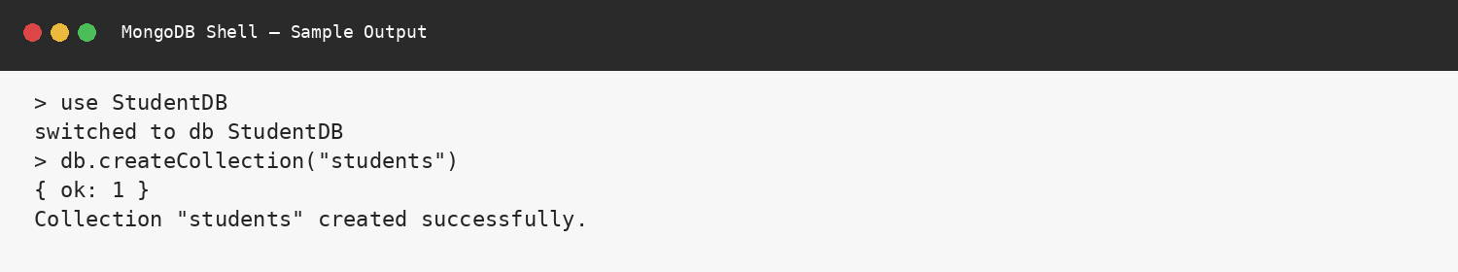

2. Insert 50 Students Data

Operation / Formula
db.students.insertMany([
{ _id:1, name:"Aarav", age:19, course:"BCA", marks:57, city:"Lucknow" },
{ _id:2, name:"Aditi", age:20, course:"BCA", marks:64, city:"Kannauj" },
// ... 48 more student documents ...
])

Step-by-Step Procedure
Step 1: Prepare the student documents with ID, name, age, course, marks and city.
Step 2: Use insertMany() to insert multiple documents.
Step 3: Check insertedCount to confirm that 50 records were inserted.

Explanation
The insertMany() operation is used to insert multiple student documents at the same time. In this project, 50 student records are inserted with details such as ID, name, age, course, marks and city.

Output
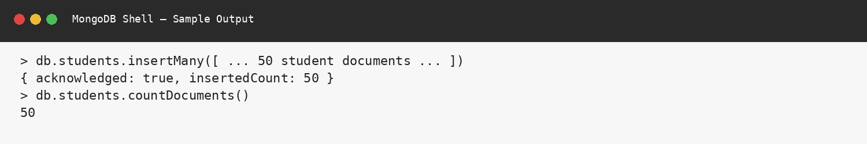

3. Display / Read Student Data

Operation / Formula
db.students.find(
{},
{ _id:1, name:1, marks:1 }
).limit(5)

Step-by-Step Procedure
Step 1: Use find() to search the students collection.
Step 2: Select the fields to display using projection.
Step 3: Use limit(5) to display only five records.

Explanation
The find() operation is used to read student records from the collection. Projection is used to display only the required fields, and limit(5) displays five records.

Output
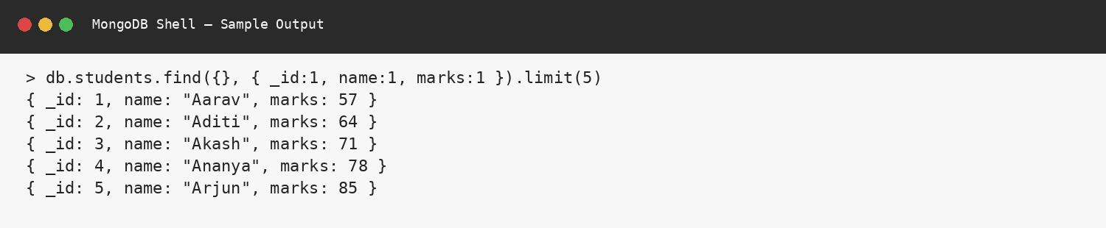

4. Greater Than ($gt)

Operation / Formula
db.students.find(
{ marks: { $gt: 80 } },
{ name:1, marks:1, _id:0 }
)

Step-by-Step Procedure
Step 1: Choose the marks field.
Step 2: Use the $gt operator.
Step 3: Give 80 as the comparison value.
Step 4: MongoDB displays students having marks greater than 80.

Explanation
The $gt operator means greater than. It is used to find students whose marks are greater than 80.

Output
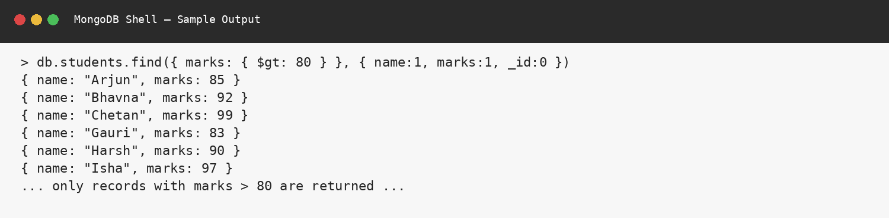

5. Less Than ($lt)

Operation / Formula
db.students.find(
{ marks: { $lt: 60 } },
{ name:1, marks:1, _id:0 }
)

Step-by-Step Procedure
Step 1: Choose the marks field.
Step 2: Use the $lt operator.
Step 3: Give 60 as the comparison value.
Step 4: MongoDB displays students having marks less than 60.

Explanation
The $lt operator means less than. It is used to find students whose marks are less than 60.

Output
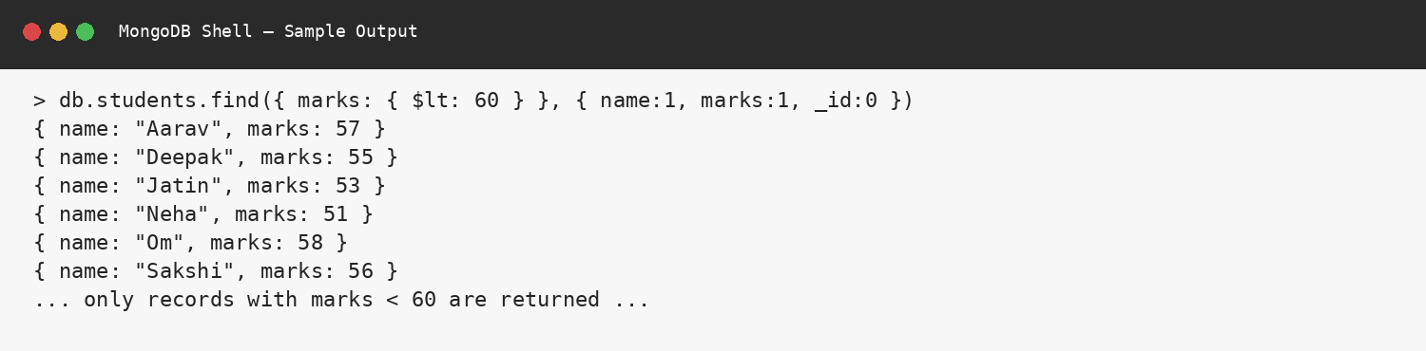

6. Equal To ($eq)

Operation / Formula
db.students.find(
{ marks: { $eq: 71 } },
{ name:1, marks:1, _id:0 }
)

Step-by-Step Procedure
Step 1: Choose the marks field.
Step 2: Use the $eq operator.
Step 3: Give 71 as the value.
Step 4: MongoDB displays students whose marks are exactly 71.

Explanation
The $eq operator means equal to. It is used to find students whose marks are exactly equal to 71.

Output
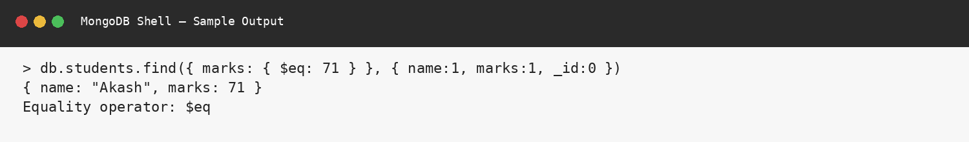

7. Update Student Data

Operation / Formula
db.students.updateOne(
{ _id: 1 },
{ $set: { marks: 95 } }
)

Step-by-Step Procedure
Step 1: Select the student using _id: 1.
Step 2: Use updateOne().
Step 3: Use $set to change the marks.
Step 4: Check the output to confirm the document was modified.

Explanation
The updateOne() operation changes data in one matching document. Here, the $set operator changes the marks of the student having _id 1 to 95.

Output
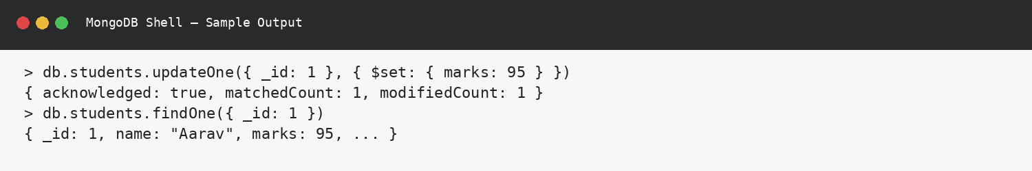

8. Delete Student Data

Operation / Formula
db.students.deleteOne(
{ _id: 50 }
)

Step-by-Step Procedure
Step 1: Select the student using _id: 50.
Step 2: Use deleteOne().
Step 3: Run the command.
Step 4: deletedCount: 1 confirms that one document was deleted.

Explanation
The deleteOne() operation removes one matching document from the collection. Here, the student having _id 50 is deleted.

Output
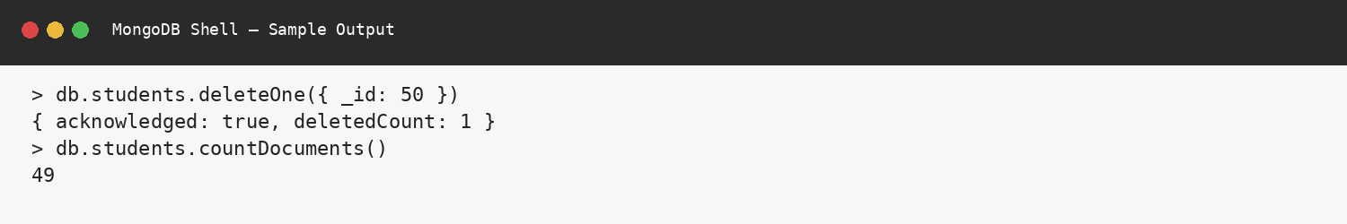

9. Sort Student Data

Operation / Formula
db.students.find(
{},
{ name:1, marks:1, _id:0 }
).sort({ marks: -1 }).limit(5)

Step-by-Step Procedure
Step 1: Select the students collection.
Step 2: Select name and marks fields.
Step 3: Use sort({ marks: -1 }) for descending order.
Step 4: Use limit(5) to show the top five students.

Explanation
The sort() operation arranges student records according to marks. The value -1 arranges the marks from highest to lowest, and limit(5) shows the top five students.

Output
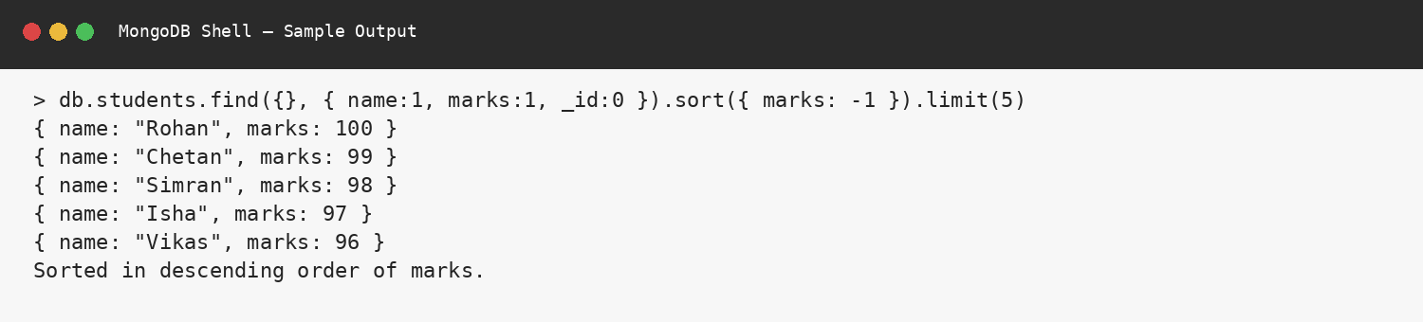

10. Count Documents

Operation / Formula
db.students.countDocuments(
{ marks: { $gte: 60 } }
)

db.students.countDocuments(
{ course: "BCA" }
)

Step-by-Step Procedure
Step 1: Use countDocuments().
Step 2: Give the required condition.
Step 3: MongoDB counts the documents matching the condition.

Explanation
The countDocuments() operation counts documents that satisfy a given condition. Here, it is used to count students according to marks and course.

Output
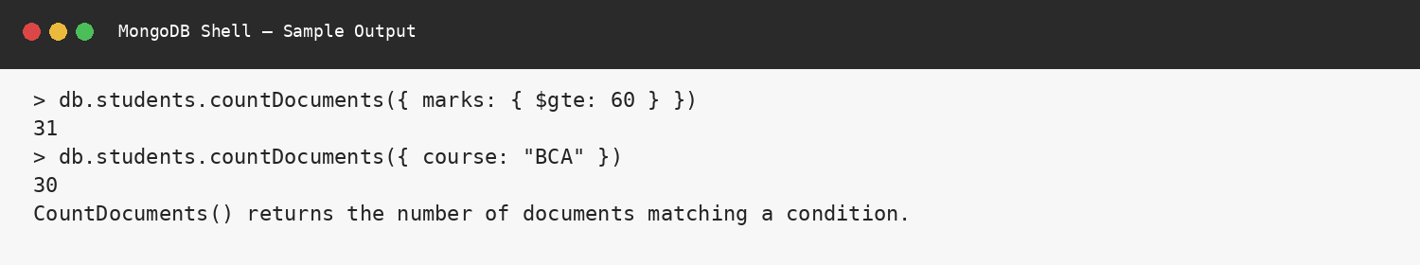

CONCLUSION
This project helped me understand the basic practical operations of NoSQL using MongoDB. I created a student collection and worked with 50 student records. I performed insert, read, comparison, update, delete, sorting and counting operations step by step. The project shows that MongoDB provides a simple and flexible way to manage student data.

