*Bird Strikes Data Visualization*

***Wireframe Documentation***

Homepage

Dashboard 1:

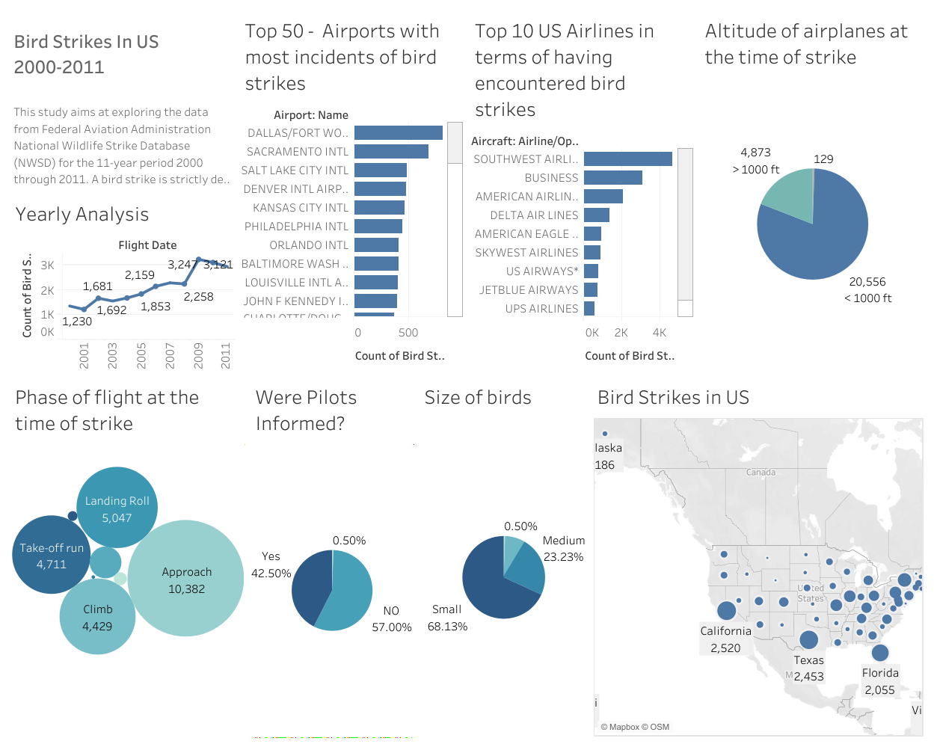

As per the problem statement, we have divided analysis into following sections: -

1:Visuals Depicting the Number of Bird Strikes:

1.1 Yearly Analysis:

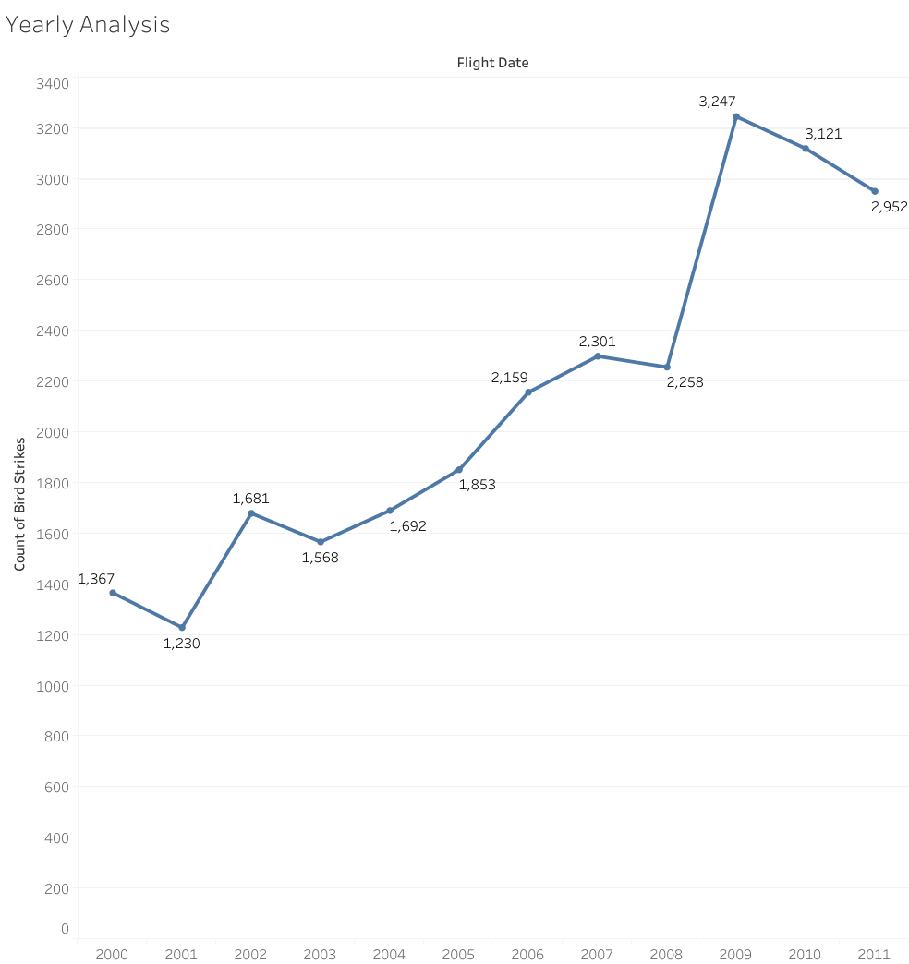

1.2 Bird Strikes in US:

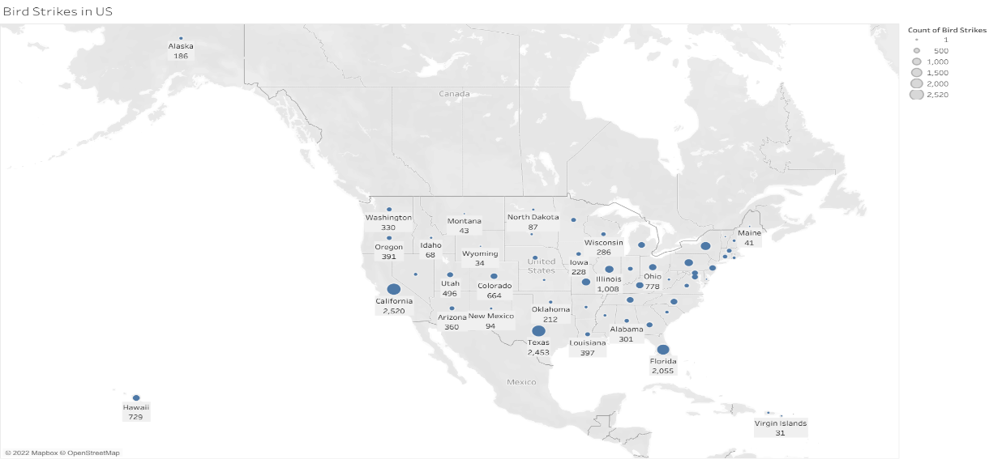

1.3 Top 10 US Airlines in terms of having encountered bird strikes:

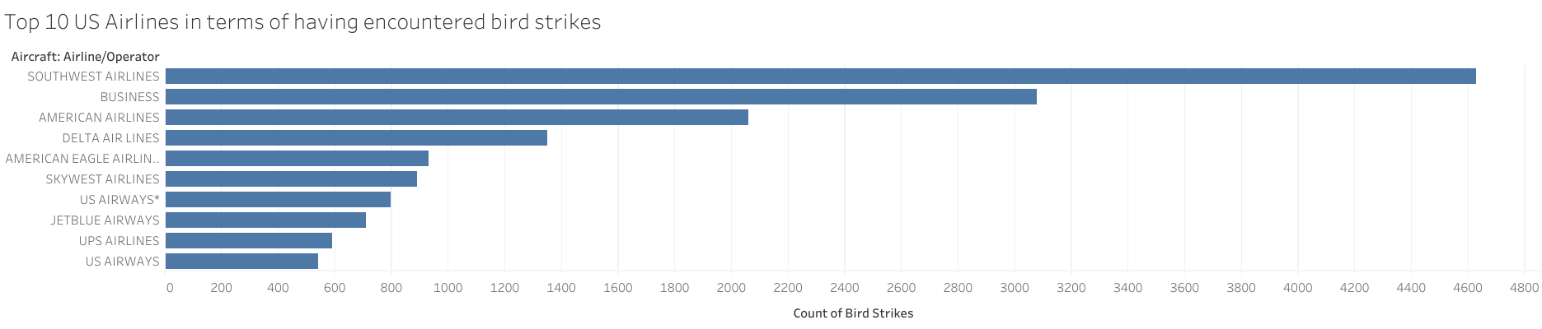

1.4 Top 50 Airports with most incidents of bird strikes:

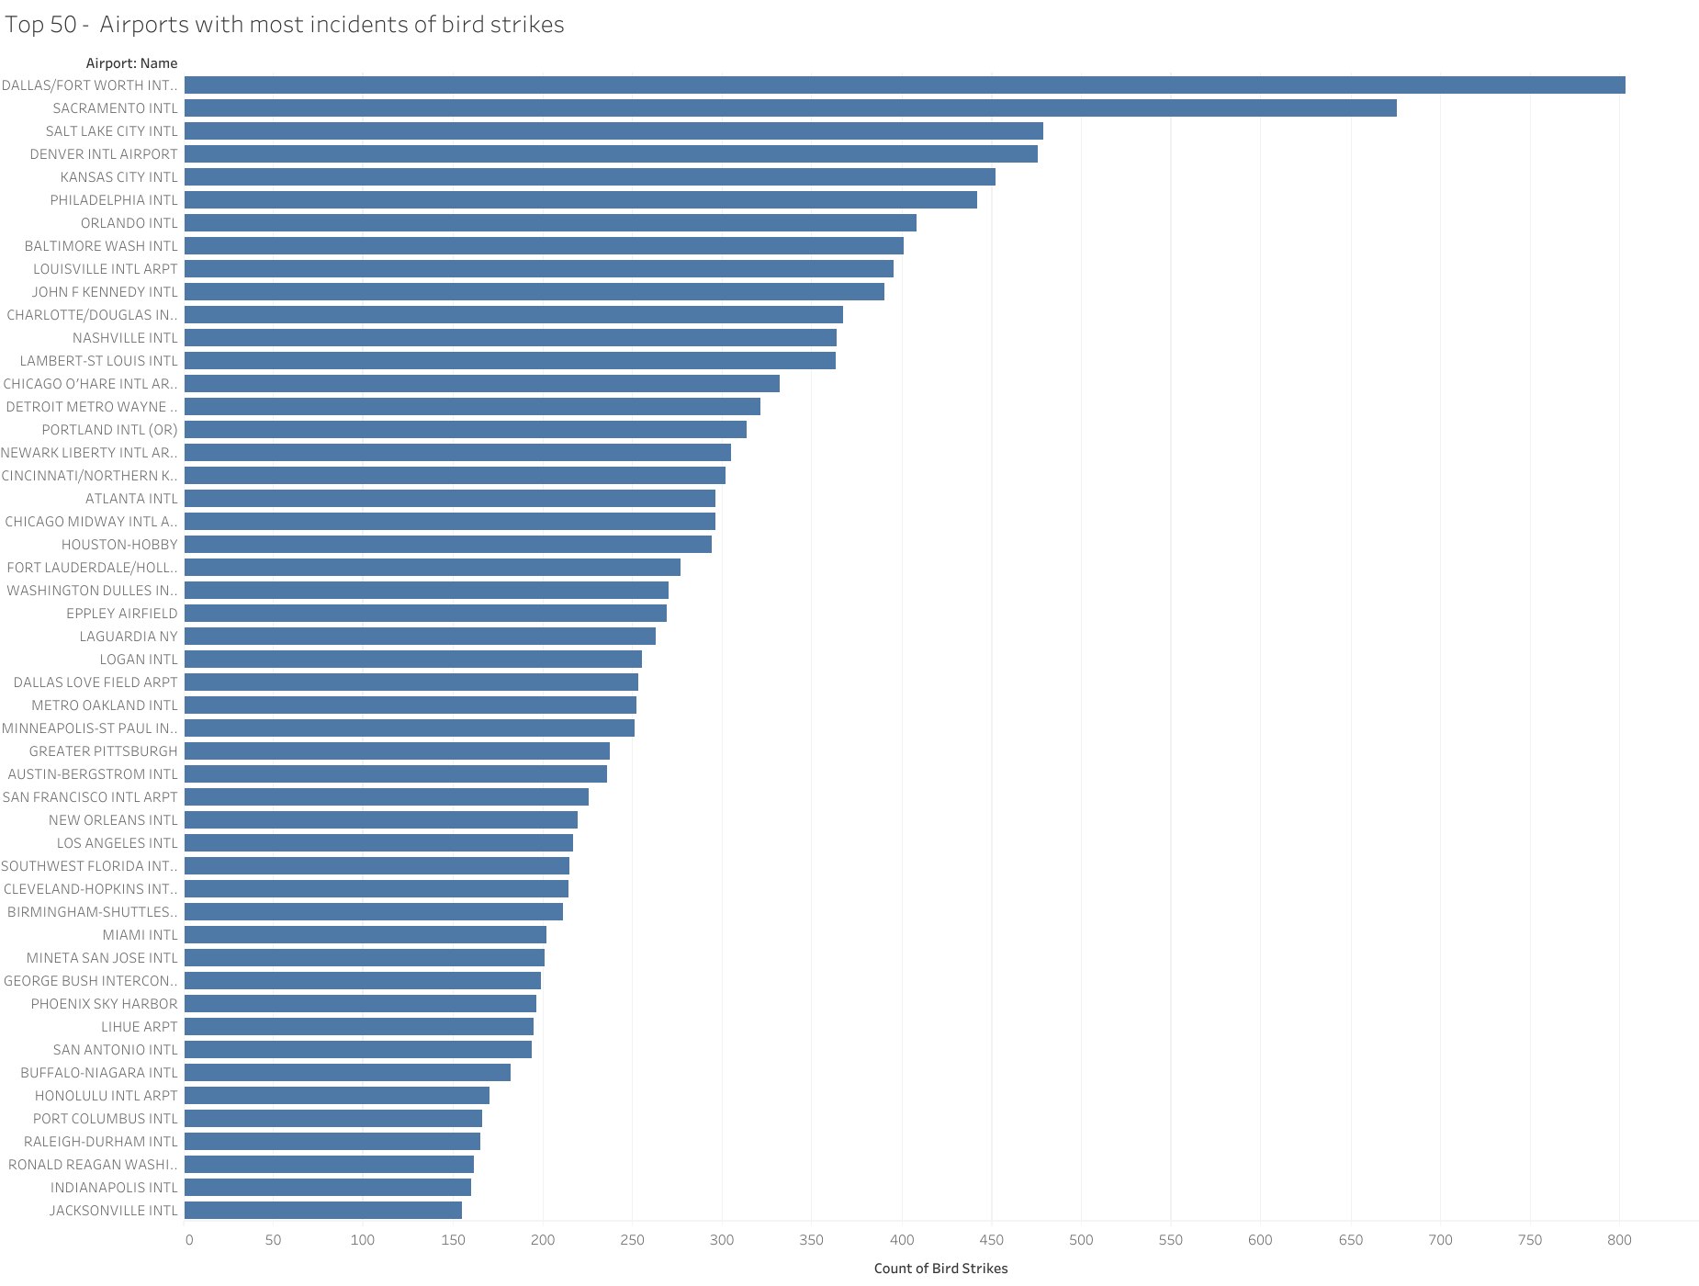

2. Yearly Cost Incurred due to Bird Strikes:

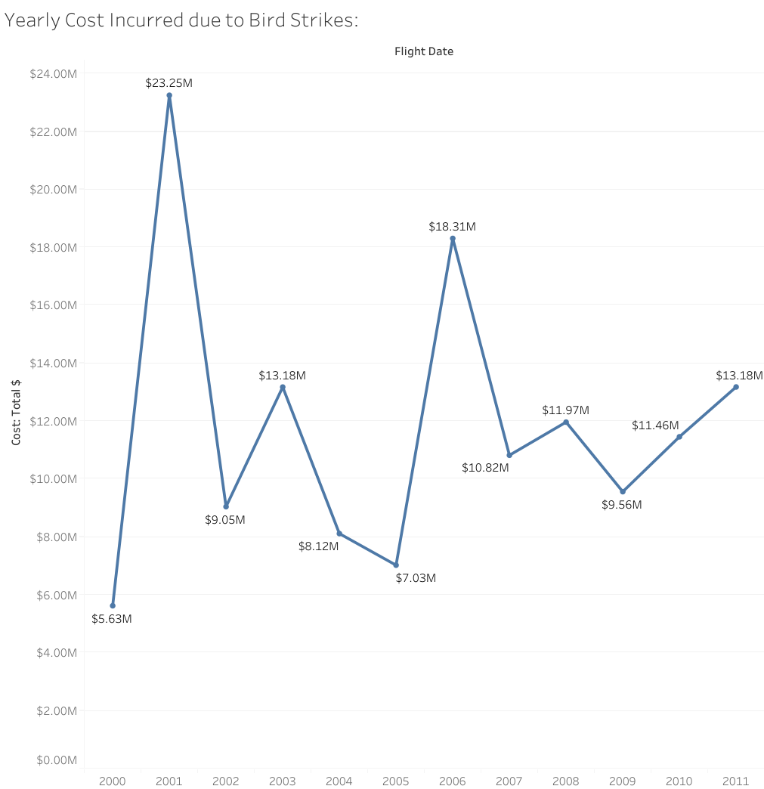

3. When do most bird strikes occur?

3.1 Altitude of airplanes at the time of strike:

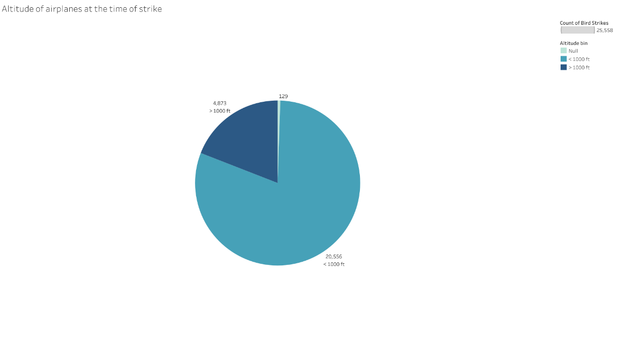

3.2 Phase of flight at the time of strike:

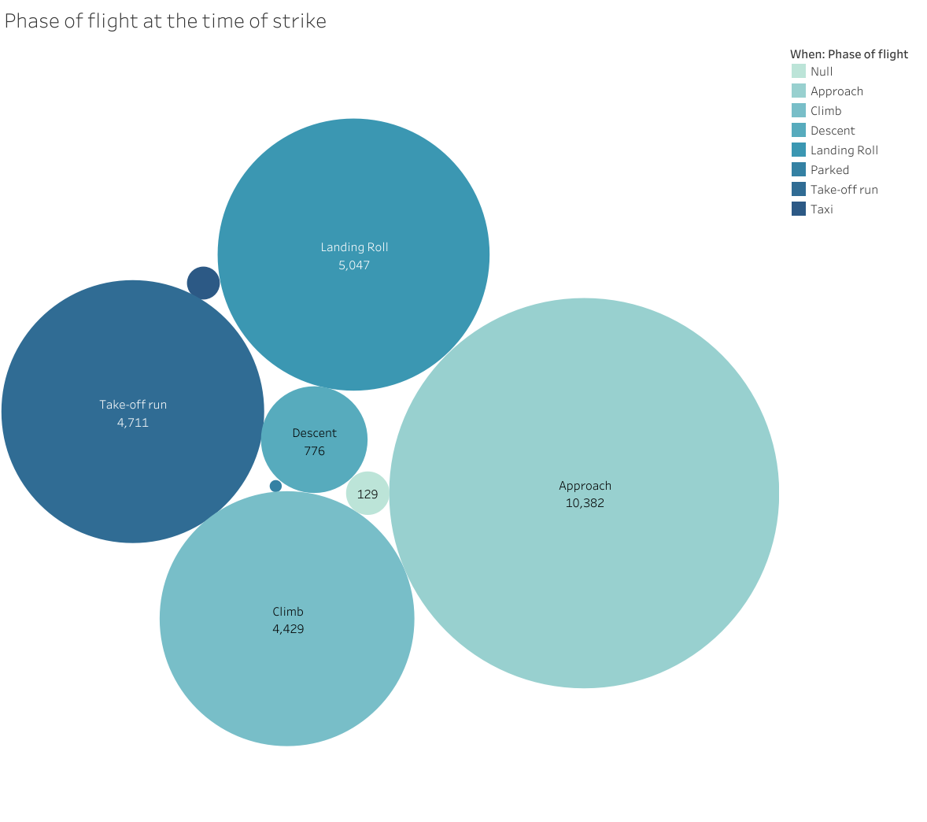

3.3 Average Altitude of the airplanes in different phases at the time of strike:

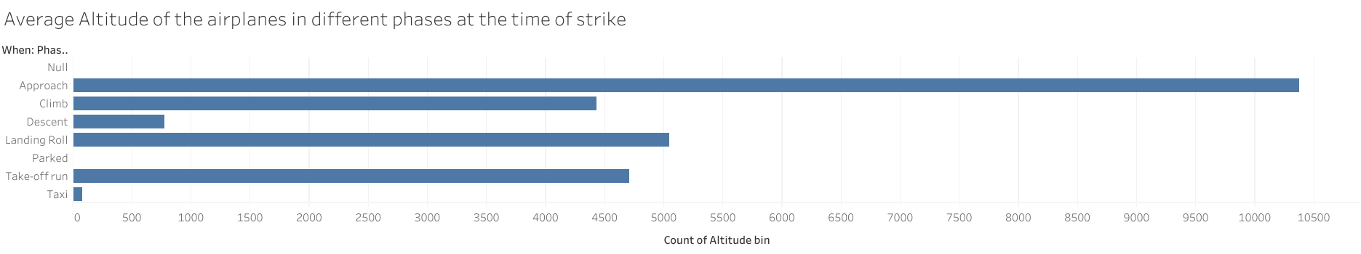

1. **In Dashboard 2, we tried to show Effects of bird Strikes:**

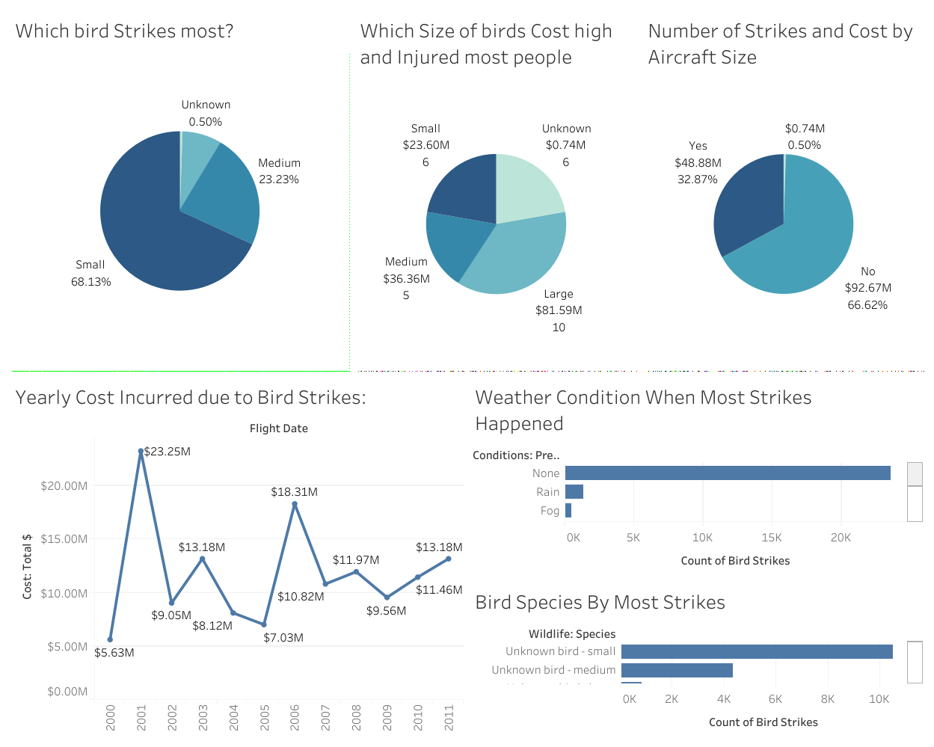

2.1 In Which Month, Most Bird Strikes Occurs?

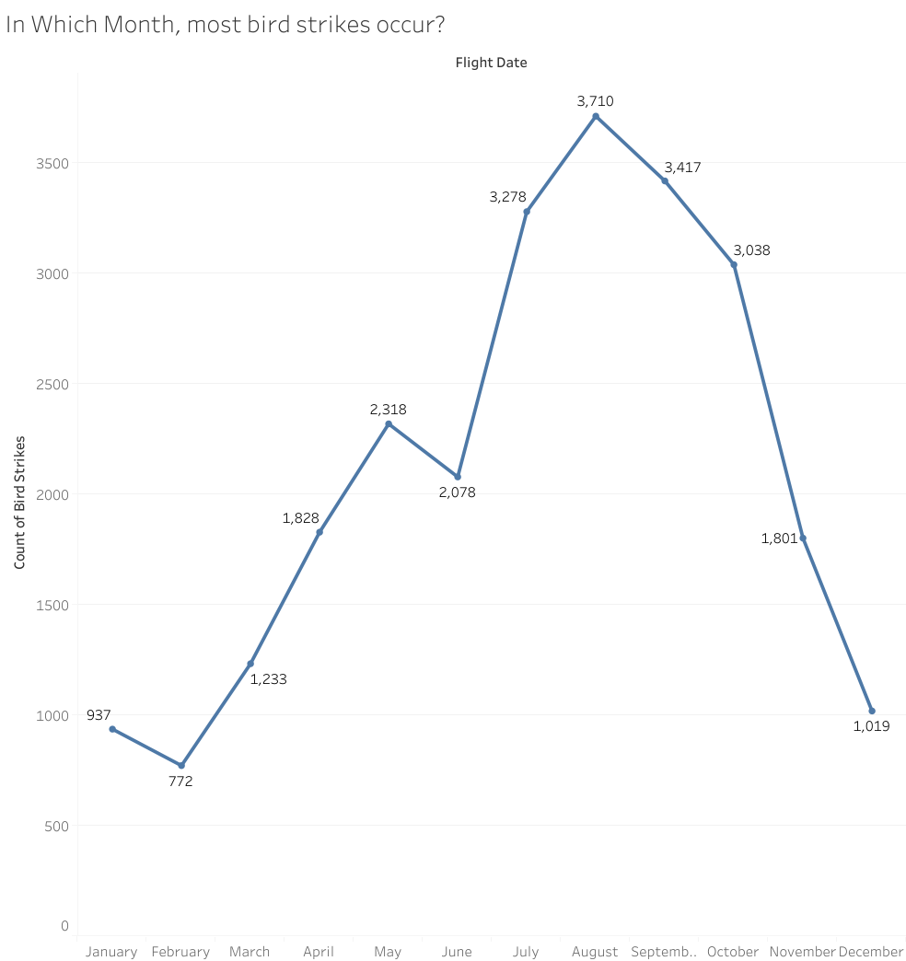

2.2 Prior Warning and Effect of Strike Relation:

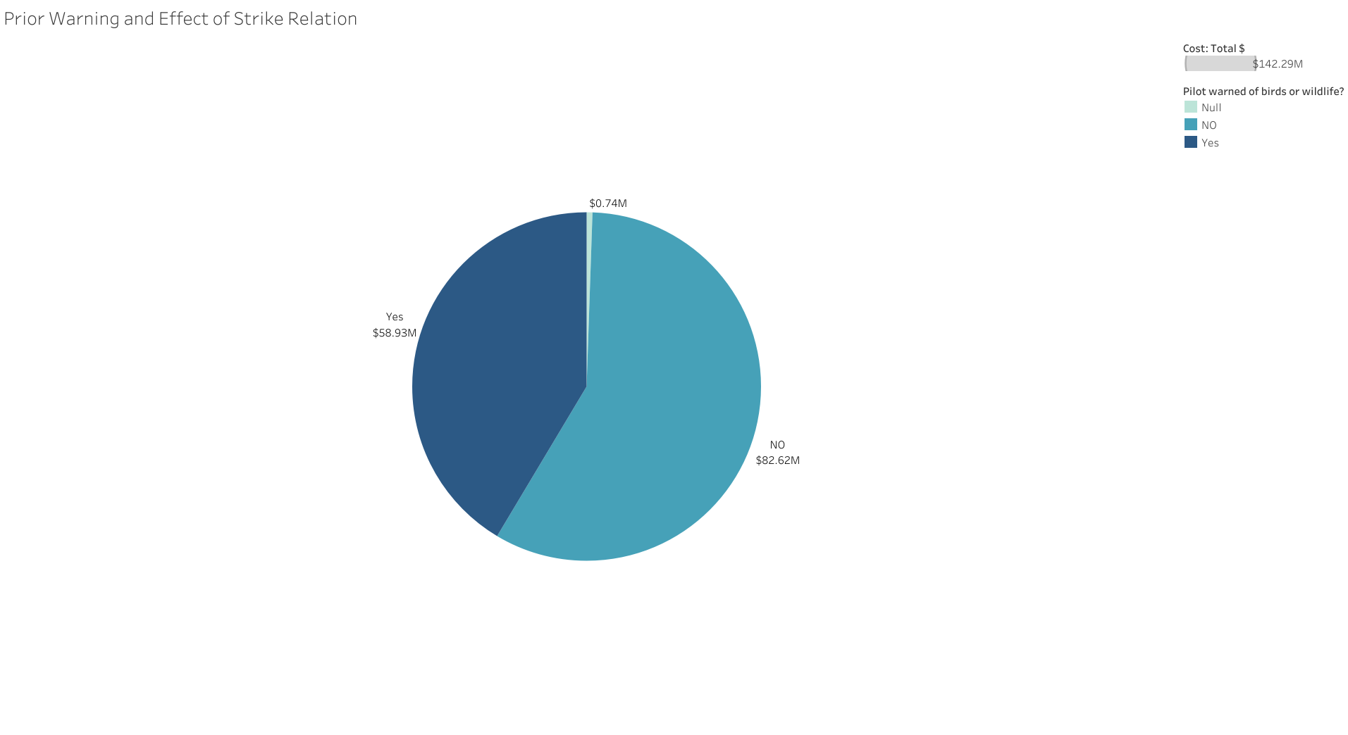

2.3 Weather Condition:

