SIMATS ENGINEERING
ASSESSMENT TOOL 1: Experiments

COURSE NAME: Cloud Computing and
Big Data Analytics
COURSE CODE: CSA1596

COURSE OUTCOME COVERED
CO3: Implement cloud-based solutions using cloud storage, web APIs, and platform services for real-world applications. (BL3)
Assessment Tool Weightage: 40%

Dave's Taxonomy: Precision (Level 3) Question Count: 4
Total Marks: 40

Duration : 60 Minutes

Code of Conduct
I YADDALA KUSHAL KUAMR(192524068)(Name / Reg No) certify that this submission is my original work and that I have adhered to the guidelines specified for this assessment.
I understand that any violation of academic integrity rules will result in disciplinary action. Signature of the student: YADDALA KUSHAL KUMAR(192524068)

Experiments Rubric
Criteria | Weightage | Level 4 - Exemplary | Level 3 - Proficient | Level 2 - Developing | Level 1 - Beginning
Experimental Design | 25% | Design is  systematic and technically strong | Mostly correct design | Basic design with gaps | Poorly designed activity
Use of Tools / Platforms | 20% | Appropriate and effective use of cloud tools | Good tool usage with minor issues | Limited tool usage | Incorrect or missing tool usage
Application of Concepts | 20% | Concepts are applied accurately to practical tasks | Mostly accurate application | Partial application | Weak application
Analysis and Output | 20% | Strong analysis and meaningful outcome interpretation | Good analysis with minor gaps | Basic analysis | Little or no analysis
Documentation | 15% | Clear, structured, and complete documentation | Mostly complete documentation | Partially complete | Poor documentation

Total Marks Award

Experiment 1: Create a simple cloud software application for Hospital information system for SIMATS Hospital using any Cloud Service Provider to demonstrate SaaS with fields of patient name, age, address, phone, email, Attender name, attender phone, doctor name, diseases, etc.
Aim
To create a simple cloud-based Hospital Information System for SIMATS Hospital using a Cloud Service Provider to demonstrate Software as a Service (SaaS).
Procedure
- Select a Cloud Service Provider such as Zoho Creator.
- Create an account and log in to the cloud application platform.
- Create a new application named SIMATS Hospital Information System.
- Create a patient information form.
- Add fields such as:
  - Patient Name
  - Age
  - Address
  - Phone
  - Email
  - Attender Name
  - Attender Phone
  - Doctor Name
  - Diseases
  - Patient ID
  - Admission Date
- Configure the form and save the application.
- Enter sample patient details and submit the form.
- View and manage the stored patient information through the cloud application.
- Access the application through a web browser to demonstrate SaaS functionality.

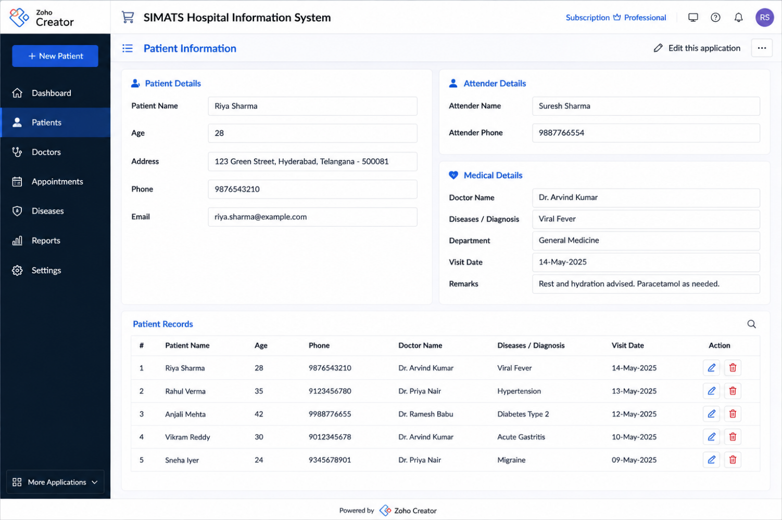
Result
A simple cloud-based Hospital Information System was successfully created using a Cloud Service Provider. Patient details were stored and managed through the SaaS application.

Experiment 2: Create a simple cloud software application for online super market using any Cloud Service Provider to demonstrate SaaS with the template of customer name, address, phone, email, items, quantity etc. with the item classification form.

Aim
To create a simple cloud-based Online Supermarket application using a Cloud Service Provider to demonstrate Software as a Service (SaaS).
Procedure
- Select a Cloud Service Provider such as Zoho Creator.
- Log in to the cloud application platform.
- Create a new application named Online Supermarket.
- Create a customer information form.
- Add fields such as:
  - Customer Name
  - Address
  - Phone
  - Email
  - Item Name
  - Quantity
  - Price
  - Total Amount
  - Order Date
- Create an Item Classification form with categories such as:
  - Fruits
  - Vegetables
  - Groceries
  - Beverages
  - Dairy Products
  - Household Items
- Configure the forms and establish the required fields.
- Enter sample customer and item details.
- Submit and view the order information.
- Access the application through a web browser to demonstrate SaaS.

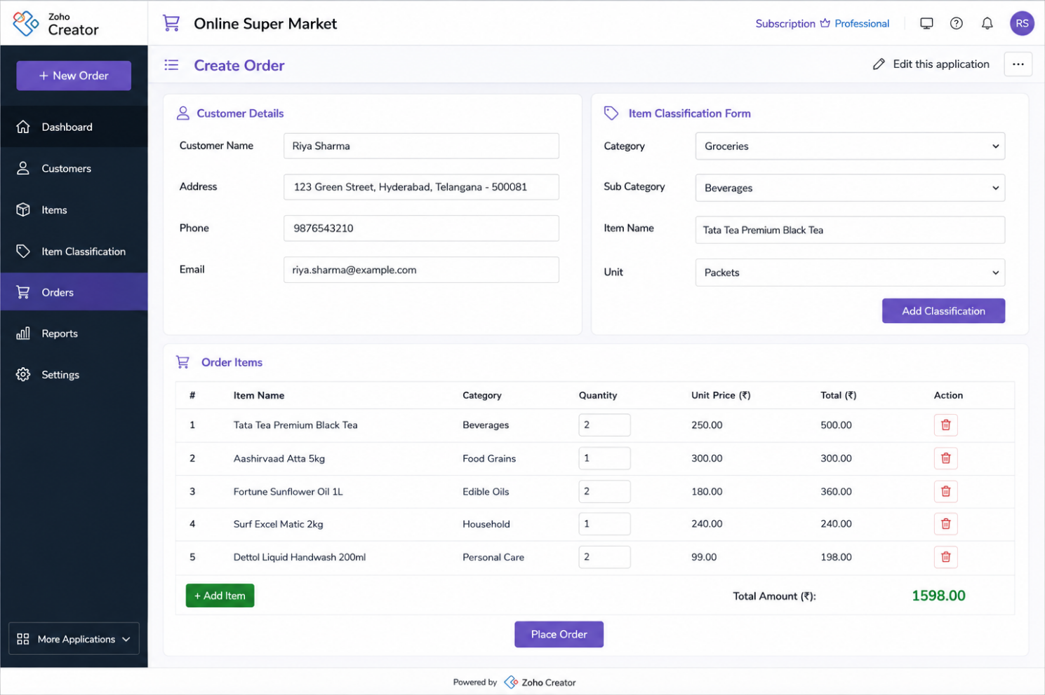
Result
A simple cloud-based Online Supermarket application was successfully created using a Cloud Service Provider. Customer orders and item classifications were stored and managed through the SaaS application.

Experiment 3: Demonstrate virtualization by Installing Type-2 Hypervisor in your device, create and configure VM image with a Host Operating system (Either Windows/Linux). Create a Virtual Machine with 3 CPU, 10GB RAM and 10GB storage disk using a Type 2 Virtualization Software.

Aim
To demonstrate virtualization by installing a Type-2 Hypervisor and creating and configuring a Virtual Machine with 3 CPUs, 10 GB RAM, and 10 GB storage using a host operating system.
Procedure
- Install a Type-2 Hypervisor such as Oracle VirtualBox or VMware Workstation on the host computer.
- Launch the virtualization software.
- Create a new Virtual Machine and provide a suitable name.
- Select the required guest operating system, such as Windows or Linux.
- Allocate 3 CPU cores to the Virtual Machine.
- Allocate 10 GB RAM to the Virtual Machine.
- Create a virtual hard disk with 10 GB storage.
- Select the required virtual disk type and complete the VM configuration.
- Attach the guest operating system ISO image to the VM.
- Start the Virtual Machine and install the guest operating system.
- Verify the allocated CPU, RAM, and storage resources.
- Run the guest operating system successfully inside the Virtual Machine.


Result
A Type-2 Hypervisor was successfully installed, and a Virtual Machine was created with 3 CPUs, 10 GB RAM, and 10 GB storage. The guest operating system was successfully installed and executed on the host system.

Experiment 4: Demonstrate virtualization by Installing Type-2 Hypervisor in your device, create and configure VM image with a Host Operating system (Either Windows/Linux). Create a Snapshot of a VM and Test it by loading the Previous Version/Cloned VM.
Aim
To demonstrate virtualization by creating a snapshot of a Virtual Machine using a Type-2 Hypervisor and testing the previous version or cloned VM by restoring the saved snapshot.
Procedure
- Install and open a Type-2 Hypervisor such as Oracle VirtualBox or VMware Workstation.
- Create or select an existing Virtual Machine with a Windows or Linux guest operating system.
- Start the Virtual Machine and make some changes to the guest operating system.
- Shut down or pause the VM if required by the virtualization software.
- Open the Snapshot option in the Type-2 Hypervisor.
- Create a snapshot and provide a suitable name such as Initial Version.
- Restart the Virtual Machine and make additional changes.
- Verify that the VM has changed from the original state.
- Restore the previously created snapshot.
- Start the VM and verify that the previous configuration and system state have been recovered.
- Alternatively, create a clone of the VM and start the cloned VM.
- Compare the original/previous version with the modified VM.

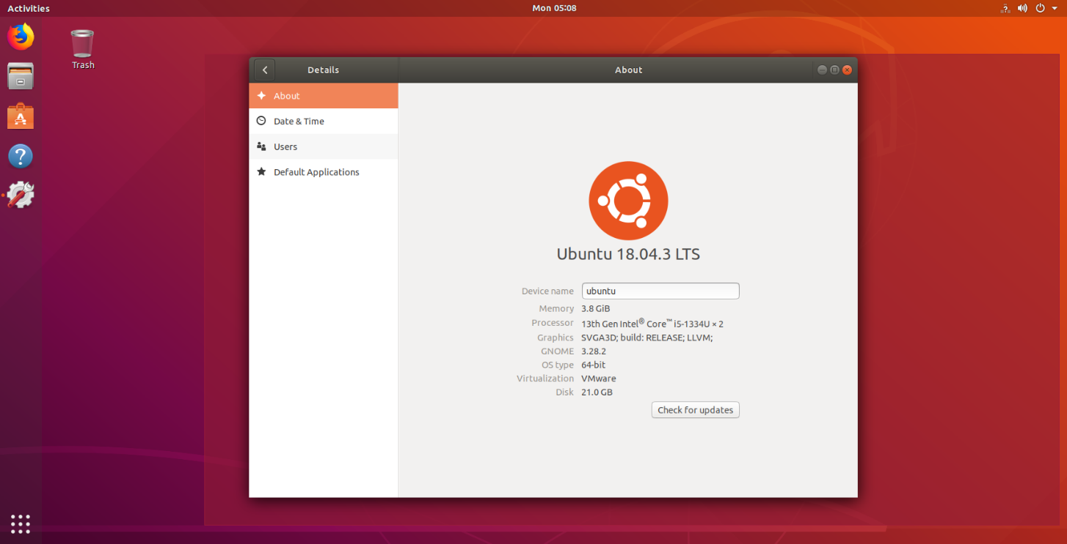
Result
A snapshot of the Virtual Machine was successfully created using the Type-2 Hypervisor. The previous VM state was successfully restored, demonstrating how snapshots and cloned VMs can be used for backup, recovery, and testing.

