
Agricultural Products Direct to Customers: An Online Farm-to-Consumer Marketing System
A CAPSTONE PROJECT REPORT

Submitted in the partial fulfilment for the Course of
CSA0820-Python Programming for Scientific Computing
to the award of the degree of
BACHELOR OF ENGINEERING
IN
B TECH ARTIFICAL INTELLENGENCE
Submitted by
YADDALA KUSHAL KUMAR (192524068)
PULLAREDDIGARI KIRAN(192525201)
Under the Supervision of
Dr Vijayaragavan P & Dr Aruna

SIMATS ENGINEERING
Saveetha Institute of Medical and Technical Sciences
Chennai-602105



SIMATS ENGINEERING
Saveetha Institute of Medical and Technical Sciences
Chennai-602105

DECLARATION

We, YADDALA KUSHAL KUMAR (192524068), PULLAREDDIGARI KIRAN
(192525201) of the AI&DS, Saveetha Institute of Medical and Technical Sciences, Saveetha University, Chennai, hereby declare that the Capstone Project Work entitled “Agricultural Products Direct to Customers: An Online Farm-to-Consumer Marketing System” the result of our own bonafide efforts. To the best of our knowledge, the work presented herein is original, accurate, and has been carried out in accordance with principles of engineering ethics.

Place:
Date:

Signature of the Students with Names
YADDALA KUSHAL KUMAR (192524068)
PULLAREDDIGARI KIRAN(192525201)
SIMATS ENGINEERING
Saveetha Institute of Medical and Technical Sciences
Chennai-602105

BONAFIDE CERTIFICATE
This is to certify that the Capstone Project entitled “Agricultural Products Direct to Customers: An Online Farm-to-Consumer Marketing System ” has been carried out by YADDALA KUSHAL KUMAR (192524068), PULLAREDDIGARI KIRAN(192525201)
under the supervision of Dr Vijayaragavan P and is submitted in partial fulfilment of the requirements for the current semester of the B.Tech AI program at Saveetha Institute of Medical and Technical Sciences, Chennai.

SIGNATURE SIGNATURE
DR.Anusya S Dr Vijayaragavan P
Program Director Associative Professor
Department of computational data science Department of Next gen AI
Saveetha School of Engineering Saveetha School of Engineering
SIMATS SIMATS

Submitted for the Project work Viva-Voce held on __________________________________ .

INTERNAL EXAMINER EXTERNAL EXAMINER
ACKNOWLEDGEMENT

We would like to express our heartfelt gratitude to all those who supported and guided us throughout the successful completion of our Capstone Project. We are deeply thankful to our respected Founder and Chancellor, Dr. N.M. Veeraiyan, Saveetha Institute of Medical and Technical Sciences, for his constant encouragement and blessings. We also express our sincere thanks to our Pro-Chancellor, Dr. Deepak Nallaswamy Veeraiyan, and our Vice-Chancellor, Dr. S. Suresh Kumar, for their visionary leadership and moral support during the course of this project.

We are truly grateful to our Director, Dr.Anusya S, SIMATS Engineering, for providing us with the necessary resources and a motivating academic environment. Our special thanks to our Principal, Dr. B. Ramesh for granting us access to the institute’s facilities and encouraging us throughout the process. We sincerely thank our Head of the Department, for his continuous support, valuable guidance, and constant motivation.

We are especially indebted to our guide, Dr Vijayaragavan P for his creative suggestions, consistent feedback, and unwavering support during each stage of the project. We also express our gratitude to the Project Coordinators, Review Panel Members (Internal and External), and the entire faculty team for their constructive feedback and valuable inputs that helped improve the quality of our work. Finally, we thank all faculty members, lab technicians, our parents, and friends for their continuous encouragement and support.

Signature With Student Name
YADDALA KUSHAL KUMAR (192524068)
PULLAREDDIGARI KIRAN(192525201)

Abstract
Agriculture is a vital sector that contributes significantly to economic growth and food security. However, many farmers face challenges in marketing their products due to the involvement of multiple intermediaries, which often reduces their profits and increases the prices paid by consumers. To address these issues, this project proposes an Agricultural Products Direct to Customers: An Online Farm-to-Consumer Marketing System that enables farmers to sell their products directly to consumers through a web-based platform.
The primary objective of the system is to establish a direct connection between farmers and customers, eliminating unnecessary middlemen and improving transparency in agricultural transactions. The platform allows farmers to register, upload product information, manage inventory, and process customer orders efficiently. Customers can browse available products, compare prices, place orders, and access fresh agricultural products conveniently from their homes. An administrative module is also included to manage users, products, and overall system activities.
The system was developed using modern web technologies, including HTML, CSS, JavaScript, PHP, and MySQL, following the Software Development Life Cycle (SDLC) methodology. Various stages such as requirement analysis, system design, implementation, testing, and evaluation were carried out to ensure the development of a reliable and user-friendly application.
The results of the project demonstrate that the system effectively improves communication between farmers and consumers while providing a convenient online marketplace for agricultural products. The platform enhances market accessibility, reduces dependency on intermediaries, increases farmers' profitability, and offers consumers access to fresh products at competitive prices. Furthermore, the project highlights the potential of information technology in transforming traditional agricultural marketing practices and promoting sustainable agricultural development.
Keywords: Agriculture, E-Commerce, Farm-to-Consumer Marketing, Online Marketplace, Farmers, Customers, Web-Based System, Agricultural Products.

TABLE OF CONTENTS
Chapter / Section | Title | Page No.
Chapter 1 | Introduction | 8
1.1 | Background Information | 8
1.2 | Project Objectives | 8
1.3 | Significance of the Project | 8
1.4 | Scope of the Project | 9
1.5 | Methodology Overview | 9
Chapter 2 | Problem Identification and Analysis | 10
2.1 | Description of the Problem | 10
2.2 | Evidence of the Problem | 10
2.3 | Stakeholders | 11
2.4 | Supporting Data and Research | 11
Chapter 3 | Solution Design and Implementation | 12
3.1 | Development and Design Process | 12
3.2 | Tools and Technologies Used | 12
3.3 | Solution Overview | 12
3.4 | Engineering Standards Applied | 13
3.5 | Solution Justification | 13
Chapter 4 | Results and Recommendations | 14
4.1 | Evaluation of Results | 14
4.2 | Challenges Encountered | 14
4.3 | Possible Improvements | 15
4.4 | Recommendations | 15
Chapter 5 | Reflection on Learning and Personal Development | 16
5.1 | Key Learning Outcomes | 16
5.1.1 | Academic Knowledge | 16
5.1.2 | Technical Skills | 16
5.1.3 | Problem-Solving and Critical Thinking | 16
5.2 | Challenges Encountered and Overcome | 17
5.2.1 | Personal and Professional Growth | 17
5.2.2 | Collaboration and Communication | 17
5.3 | Application of Engineering Standards | 18
5.4 | Insights into the Industry | 19
5.5 | Conclusion of Personal Development | 20
Chapter 6 | Conclusion | 21
— | References | 22
— | Appendices | 23

Chapter 1
Introduction
1.1 Background Information
Agriculture is one of the most important sectors that supports the economy and provides food for the growing population. Farmers play a significant role in producing fruits, vegetables, grains, and other agricultural products that are essential for daily life. However, many farmers face challenges in selling their products directly to consumers because traditional agricultural marketing systems involve several intermediaries such as wholesalers, distributors, and retailers. These intermediaries often increase the final market price while reducing the profit earned by farmers.
With the rapid growth of information technology and internet-based services, online marketing platforms have become an effective way to connect producers and consumers directly. E-commerce solutions have transformed many industries by simplifying buying and selling processes and improving accessibility for users. In the agricultural sector, a farm-to-consumer marketing system can help bridge the gap between farmers and customers by providing a digital marketplace where products can be displayed, ordered, and delivered efficiently.
The Agricultural Products Direct to Customers: An Online Farm-to-Consumer Marketing System is designed to provide farmers with an online platform where they can market their products directly to consumers. The system helps eliminate unnecessary intermediaries, improve transparency in pricing, and create a more efficient supply chain. Customers can purchase fresh agricultural products conveniently while farmers can increase their earnings through direct sales.
1.2 Project Objectives
The main objective of this project is to develop a web-based platform that allows farmers to sell agricultural products directly to consumers without relying heavily on intermediaries. The system aims to improve communication between farmers and customers while ensuring a smooth and secure purchasing experience.
The specific objectives of the project are to create a user-friendly online marketplace where farmers can register and manage their product listings. The system aims to provide customers with easy access to a variety of agricultural products and enable them to place orders conveniently from any location. Another objective is to improve the profitability of farmers by reducing marketing costs and providing direct access to consumers. The project also seeks to enhance transparency in product pricing and improve overall efficiency in agricultural product distribution.
1.3 Significance of the Project
This project is significant because it addresses the common challenges faced by both farmers and consumers in the traditional agricultural supply chain. Farmers often struggle to find reliable markets for their products and receive lower profits due to the involvement of multiple intermediaries. By providing a direct marketing platform, farmers can gain better control over pricing and sales.
Consumers benefit from access to fresh agricultural products at reasonable prices while having the opportunity to purchase directly from producers. The system also promotes transparency by allowing customers to view product information, pricing details, and availability before making a purchase.
From a broader perspective, the project supports the digital transformation of agriculture by encouraging the adoption of technology in farming and marketing activities. It contributes to rural development, improves market accessibility, and promotes sustainable agricultural practices by reducing inefficiencies in the supply chain.
1.4 Scope of the Project
The scope of the project includes the development of a web-based platform that facilitates direct transactions between farmers and consumers. The system allows farmers to register, create profiles, upload product details, update inventory information, and manage customer orders. Customers can create accounts, browse products, search for specific items, add products to a shopping cart, and place orders through the platform.
The system includes an administrative module that enables administrators to monitor users, manage product listings, and oversee platform operations. Basic order management and transaction recording functionalities are incorporated to ensure smooth system operation.
The project does not include advanced logistics management, real-time GPS tracking of deliveries, international shipping services, or artificial intelligence-based forecasting mechanisms. These features may be considered for future enhancements.

1.5 Methodology Overview
The project follows the Software Development Life Cycle (SDLC) methodology to ensure systematic development and implementation. The first phase involves gathering and analyzing requirements from farmers and consumers to understand their needs and expectations. During the design phase, system architecture, database structures, user interfaces, and workflow diagrams are developed.
The implementation phase focuses on coding and integrating system modules using appropriate programming languages and development tools. Comprehensive testing is conducted to identify and correct errors while ensuring that the system functions according to requirements. Finally, the system is deployed and evaluated to determine its effectiveness in addressing the identified problems.

Chapter 2:
Problem Identification and Analysis
2.1 Description of the Problem
Traditional agricultural marketing systems often involve several intermediaries between farmers and consumers. As products move through different stages of distribution, the final selling price increases while the share of revenue received by farmers decreases. This situation creates financial challenges for farmers and limits their ability to maximize profits from their hard work.
Consumers also face difficulties because they may not always have access to fresh products at reasonable prices. The lack of direct communication between farmers and customers reduces transparency and makes it difficult for consumers to understand product origins and quality standards.
Additionally, many small-scale farmers lack access to modern marketing channels and digital technologies, limiting their ability to compete effectively in larger markets. These challenges highlight the need for an innovative solution that can improve market access and simplify agricultural transactions.
2.2 Evidence of the Problem
Research studies and market observations indicate that farmers often receive only a small percentage of the final retail price of agricultural products. The involvement of multiple intermediaries increases operational costs and reduces overall efficiency in the supply chain.
Many consumers prefer purchasing fresh agricultural products directly from producers but lack convenient platforms that facilitate such transactions. Surveys and reports on agricultural marketing have shown increasing demand for online purchasing options and greater transparency in food sourcing.
The rapid growth of e-commerce and digital technologies demonstrates that online platforms can effectively address these challenges by connecting producers and consumers more efficiently.

2.3 Stakeholders
The primary stakeholders of the project include farmers who use the platform to market and sell their products directly to consumers. Customers are another important stakeholder group because they use the platform to browse and purchase agricultural products conveniently.
Administrators play a critical role in managing the platform, monitoring transactions, and ensuring system security. Delivery personnel or logistics providers may also be involved in transporting products from farms to customers. Government agencies and agricultural organizations may benefit indirectly from improved agricultural marketing practices and increased economic activity within rural communities.
2.4 Supporting Data and Research
Several studies have shown that direct-to-consumer marketing systems can significantly improve farmer income and customer satisfaction. Research indicates that reducing the number of intermediaries increases transparency, improves product traceability, and creates stronger relationships between producers and consumers.
Studies on e-commerce adoption in agriculture have demonstrated that digital platforms enhance market access and provide farmers with opportunities to reach a broader customer base. These findings support the development of an online farm-to-consumer marketing system as an effective solution to existing challenges in agricultural marketing.

Chapter 3:
Solution Design and Implementation
3.1 Development and Design Process
The development process began with requirement gathering and analysis to understand the needs of farmers, customers, and administrators. Information was collected through discussions, observations, and reviews of existing agricultural marketing systems.
The design phase involved creating system architecture diagrams, database models, user interface layouts, and process flow diagrams. These designs served as a blueprint for system development and ensured that all requirements were addressed effectively.
During implementation, the various modules of the system were developed and integrated. The development process focused on creating a secure, reliable, and user-friendly platform that supports efficient product management and transaction processing.
Testing activities were conducted to evaluate functionality, usability, performance, and security. Identified issues were resolved to ensure that the system met quality standards before deployment.
3.2 Tools and Technologies Used
The project utilized modern web development technologies to ensure effective system performance. HTML, CSS, and JavaScript were used for designing attractive and responsive user interfaces. PHP was employed as the server-side programming language to manage application logic and process user requests.
MySQL was used as the database management system to store user information, product details, order records, and transaction data. Development and testing activities were carried out using tools such as Visual Studio Code and XAMPP. Version control mechanisms were used to manage source code and facilitate systematic development.
3.3 Solution Overview
The proposed system functions as an online marketplace where farmers can register and showcase their agricultural products to potential customers. Farmers can upload product descriptions, images, prices, and available quantities. Customers can browse product categories, search for specific items, compare options, and place orders through the platform.
The system automatically records transactions and maintains order histories. Administrators can oversee system activities, manage users, monitor product listings, and ensure compliance with platform policies. The overall solution aims to create an efficient, transparent, and user-friendly environment for agricultural commerce.
3.4 Engineering Standards Applied
The project was developed according to established software engineering principles and standards. Structured development methodologies were followed to ensure systematic planning, implementation, testing, and maintenance. Database normalization techniques were applied to improve data consistency and reduce redundancy.
User interface design standards were considered to enhance usability and accessibility. Security measures such as authentication and data validation were implemented to protect user information and prevent unauthorized access. Quality assurance procedures were performed throughout development to ensure reliability and performance.
3.5 Solution Justification
The proposed solution effectively addresses the identified challenges by creating a direct communication channel between farmers and consumers. The online platform eliminates unnecessary intermediaries and allows farmers to retain a larger share of profits from product sales.
The system provides customers with convenient access to fresh agricultural products while improving transparency regarding pricing and product availability. The use of digital technologies enhances operational efficiency and supports the modernization of agricultural marketing practices.

Chapter 4:
Results and Recommendations
4.1 Evaluation of Results
The developed system successfully achieved its primary objectives by providing a functional online marketplace for agricultural products. Farmers were able to manage product listings efficiently, while customers could browse and purchase products through a user-friendly interface.
Testing results indicated that the system performed effectively in handling user registrations, product management, order processing, and administrative functions. Feedback from users suggested that the platform improved convenience and accessibility for both farmers and consumers.
4.2 Challenges Encountered
Several challenges were encountered during the project development process. Gathering accurate requirements from different stakeholders required significant time and effort. Designing a database structure capable of handling various system functions presented technical difficulties.
Ensuring compatibility across different devices and browsers required extensive testing and adjustments. Additional challenges included debugging software errors, optimizing system performance, and maintaining data security throughout development.
4.3 Possible Improvements
Future enhancements may include the integration of secure online payment gateways to facilitate electronic transactions. Mobile application development could improve accessibility and user engagement. Real-time delivery tracking features could enhance customer satisfaction and order monitoring.
Advanced analytics and reporting tools may help farmers make informed business decisions. Artificial intelligence technologies could be incorporated to provide personalized product recommendations and demand forecasting capabilities.

4.4 Recommendations
It is recommended that the system undergo regular maintenance and updates to ensure continued reliability and security. Additional training and support should be provided to farmers who may have limited experience with digital technologies.
The platform should be expanded to include more farmers, product categories, and geographical regions. Future development efforts should focus on integrating advanced features that further enhance user experience and operational efficiency.

Chapter 5:
Reflection on Learning and Personal Development
5.1 Key Learning Outcomes
The development of the Agricultural Products Direct to Customers: An Online Farm-to-Consumer Marketing System provided valuable learning experiences in both academic and practical aspects of software development. This project offered an opportunity to apply theoretical concepts learned throughout the academic program to solve a real-world problem faced by farmers and consumers. Through the development process, various technical, analytical, and interpersonal skills were strengthened, contributing significantly to personal and professional growth.
5.1.1 Academic Knowledge
This project enhanced understanding of software engineering principles, system analysis and design methodologies, database management systems, and web development technologies. It provided practical experience in applying concepts such as requirement gathering, system modeling, database normalization, and software testing. The project also increased knowledge about agricultural marketing systems and the role of digital technologies in improving business operations and customer engagement.
The development process demonstrated how information systems can be used to solve real-world challenges by improving communication, reducing operational costs, and increasing efficiency. Through extensive research and implementation activities, a deeper understanding of e-commerce systems and online transaction management was achieved.
5.1.2 Technical Skills
The project significantly improved technical skills related to web application development. Practical experience was gained in designing user interfaces using HTML, CSS, and JavaScript while implementing server-side functionalities using PHP. Knowledge of database design and management was strengthened through the creation and maintenance of MySQL databases.
The project also enhanced skills in debugging, troubleshooting, testing, and system integration. Working with development tools and managing different software components improved confidence in handling complex technical tasks. Additionally, the experience provided insight into software deployment procedures and maintenance practices that are essential in professional software development environments.
5.1.3 Problem-Solving and Critical Thinking
Developing the system required identifying challenges, analyzing possible solutions, and making informed decisions throughout the project lifecycle. Various obstacles encountered during development demanded logical thinking and systematic problem-solving approaches. Critical thinking skills were applied when evaluating system requirements, selecting technologies, designing databases, and optimizing application performance.
The project encouraged continuous learning and adaptation as new challenges emerged during implementation. Through research, experimentation, and testing, effective solutions were developed to overcome technical and operational issues. This experience strengthened the ability to analyze problems from multiple perspectives and implement appropriate solutions efficiently.
5.2 Challenges Encountered and Overcome
The project development process involved several challenges that required persistence, adaptability, and effective planning. These challenges provided valuable opportunities for learning and personal growth while contributing to the successful completion of the project.
5.2.1 Personal and Professional Growth
Managing the project from planning to implementation required strong commitment, discipline, and time management. Balancing academic responsibilities with project development activities was sometimes difficult, requiring careful scheduling and prioritization of tasks.
The experience improved self-confidence in handling technical projects and strengthened the ability to work independently. Exposure to real-world problem-solving situations encouraged greater responsibility and accountability for project outcomes. Through continuous effort and determination, obstacles were successfully addressed, resulting in significant personal and professional development.
The project also fostered a growth mindset by emphasizing the importance of continuous learning and improvement. Each challenge presented an opportunity to acquire new knowledge and refine existing skills, contributing to overall professional readiness.

5.2.2 Collaboration and Communication
Although technical development was a major focus, effective communication and collaboration were equally important throughout the project. Interactions with supervisors, peers, and potential users helped clarify requirements and improve system design decisions.
The project enhanced communication skills by requiring the preparation of documentation, presentations, and progress reports. Feedback received from stakeholders was carefully analyzed and incorporated into system improvements. The ability to explain technical concepts in a clear and understandable manner improved significantly during the project.
Collaborative discussions and knowledge sharing contributed to better decision-making and problem-solving. These experiences emphasized the importance of teamwork and effective communication in achieving project success.
5.3 Application of Engineering Standards
Engineering standards played a critical role in ensuring the quality, reliability, and maintainability of the developed system. Throughout the project, software engineering principles were applied to guide planning, design, implementation, testing, and evaluation activities.
Structured methodologies were followed to ensure systematic development and proper documentation. Database design standards were applied to maintain data integrity and minimize redundancy. User interface design principles were considered to improve usability and accessibility for different types of users.
Software testing procedures were conducted to verify system functionality and identify potential defects before deployment. Security considerations such as user authentication, data validation, and access control mechanisms were implemented to protect sensitive information. By following engineering standards, the project achieved a higher level of quality and professionalism.
The application of these standards also demonstrated the importance of adopting best practices in software development to create reliable and scalable solutions capable of meeting user requirements effectively.

5.4 Insights into the Industry
The project provided valuable insights into both the agricultural and information technology industries. It highlighted the growing importance of digital transformation in agriculture and demonstrated how technology can improve traditional business processes.
One important insight gained was the increasing demand for online platforms that connect producers directly with consumers. The project revealed that many farmers face marketing challenges that can be addressed through accessible and affordable digital solutions. Similarly, consumers are increasingly seeking convenient ways to purchase fresh products while supporting local producers.
The experience also provided an understanding of current trends in e-commerce, online marketplaces, and customer relationship management. It emphasized the importance of user-centered design, data security, and system reliability in modern software applications.
Furthermore, the project illustrated how technological innovation can contribute to economic development, sustainability, and improved quality of life. These insights have broadened perspectives regarding future career opportunities and the potential impact of technology on society.

5.5 Conclusion of Personal Development
The completion of this capstone project represents a significant milestone in academic and professional development. The experience provided opportunities to apply theoretical knowledge, develop technical expertise, and strengthen problem-solving abilities in a practical setting.
The project enhanced confidence in managing complex tasks, working with technology, and delivering solutions that address real-world challenges. Valuable lessons were learned regarding project planning, teamwork, communication, and continuous improvement. These experiences have prepared the developer for future professional responsibilities and provided a strong foundation for career growth in the field of information technology and software engineering. Overall, the project has been a rewarding learning journey that contributed significantly to personal development, technical competence, and professional readiness.
CHAPTER 6
OUTPUT

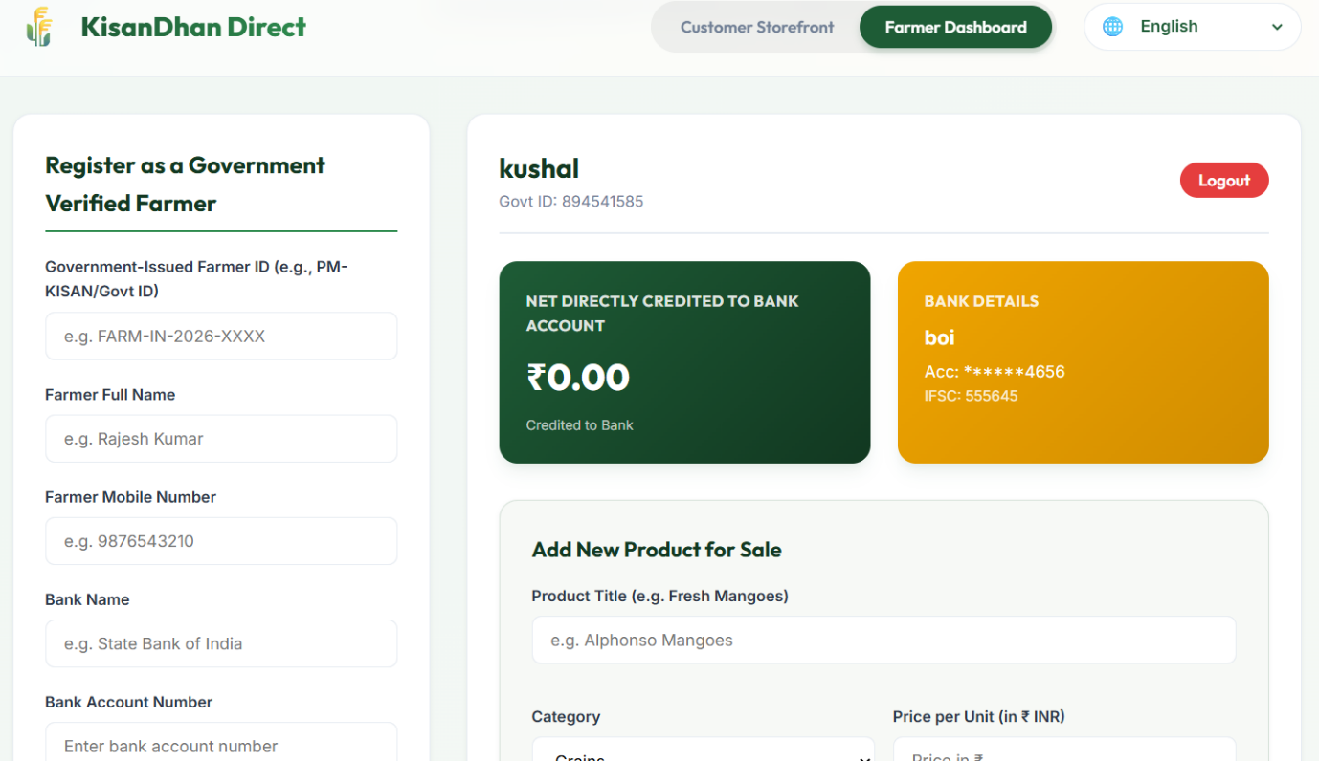

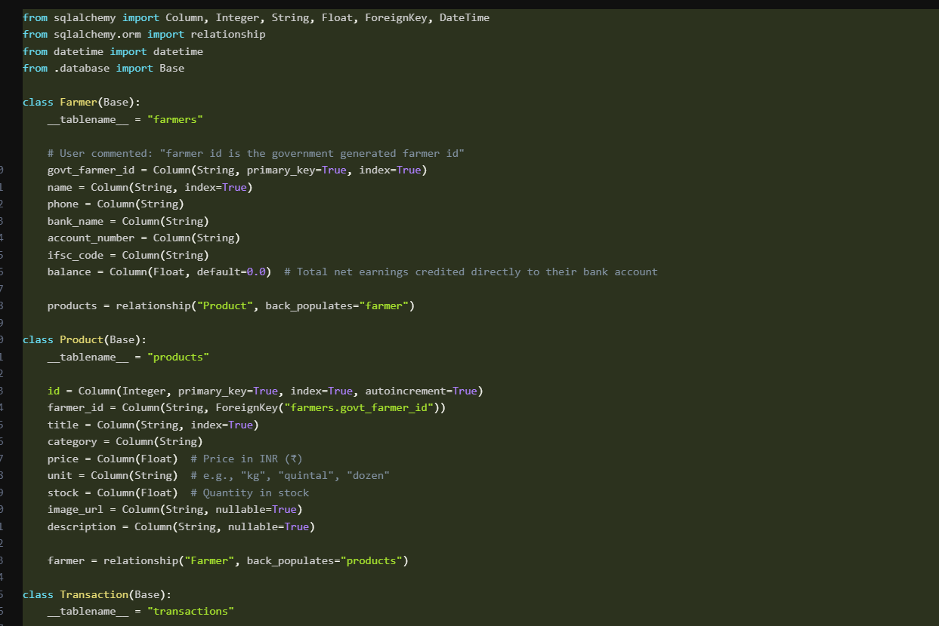

Chapter 7
Conclusion
The Agricultural Products Direct to Customers: An Online Farm-to-Consumer Marketing System was developed to address the challenges associated with traditional agricultural marketing practices. The project focused on creating a digital platform that enables farmers to market and sell their products directly to consumers without relying heavily on intermediaries. By leveraging web-based technologies, the system provides a convenient and efficient solution that benefits both producers and consumers.
The project successfully achieved its objectives by developing a functional platform that supports user registration, product management, order processing, and administrative control. Farmers can now showcase their products to a wider audience, while consumers can conveniently access fresh agricultural products from trusted sources. The system promotes transparency, improves communication, and enhances overall efficiency within the agricultural supply chain.
The implementation of this project demonstrated the potential of information technology in transforming traditional agricultural practices and supporting economic development. Through direct marketing opportunities, farmers can increase profitability while customers benefit from improved product quality and competitive pricing. The project also highlighted the importance of adopting innovative solutions to address evolving market demands and technological advancements.
Although the system achieved its primary goals, opportunities remain for future enhancements such as mobile application development, online payment integration, advanced analytics, and real-time delivery tracking. These improvements can further increase functionality, user satisfaction, and overall system effectiveness.
In conclusion, the Agricultural Products Direct to Customers: An Online Farm-to-Consumer Marketing System serves as an effective solution for modern agricultural marketing challenges. The project demonstrates how digital technologies can strengthen connections between farmers and consumers, promote sustainable business practices, and contribute to the growth of the agricultural sector. The successful completion of this project reflects the practical application of software engineering principles and highlights the positive impact that technology can have on society.

References
- Pressman, R. S. (2019). Software Engineering: A Practitioner's Approach. McGraw-Hill Education.
- Laudon, K. C., & Laudon, J. P. (2021). Management Information Systems: Managing the Digital Firm. Pearson Education.
- Sommerville, I. (2016). Software Engineering. Pearson Education.
- Elmasri, R., & Navathe, S. B. (2017). Fundamentals of Database Systems. Pearson Education.
- Food and Agriculture Organization (FAO). (2023). Digital Agriculture and Rural Development Reports.
- World Bank. (2022). Agriculture and Food Sector Development Reports.
- OECD. (2021). The Digital Transformation of Agriculture.
- Various research journals related to E-Commerce Systems, Agricultural Marketing, and Digital Business Platforms.

Appendices
Appendix A: System Screenshots
This appendix contains screenshots of the major system interfaces including the home page, user registration page, login page, farmer dashboard, product listing page, shopping cart page, order management page, and administrator dashboard.
Appendix B: Database Design
This appendix contains the Entity Relationship Diagram (ERD), database schema, table structures, primary keys, foreign keys, and relationships used in the system.
Appendix C: System Flowcharts and Diagrams
This appendix includes use case diagrams, data flow diagrams, activity diagrams, and system architecture diagrams that illustrate the operation of the proposed system.
Appendix D: Source Code Samples
This appendix presents selected source code modules related to user authentication, product management, database connectivity, and order processing functions.
Appendix E: Testing Results
This appendix contains test cases, expected outputs, actual outputs, error reports, bug fixes, and user acceptance testing results that verify system performance and functionality.
Appendix F: User Manual
This appendix provides step-by-step instructions for farmers, customers, and administrators on how to use the system effectively, including registration procedures, product management, order placement, and account maintenance activities.

