NEWS PORTAL WEB APPLICATION
SYSTEM

A PROJECT REPORT
Submitted By

Jabi Raj B (Reg.No: 220021090322)

in partial fulfillment for the award of the degree of

BACHELOR OF COMPUTER APPLICATIONS


N.S.S. COLLEGE, RAJAKUMARI
KULAPPARACHAL PO - 685619 IDUKKI (Dist.)
KERALA

Affiliated to

MAHATMA GANDHI UNIVERSITY, KOTTAYAM

MARCH 2025

N.S.S. COLLEGE, RAJAKUMARI
KULAPPARACHAL P.O. - 685619 IDUKKI (Dist.), KERALA


DEPARTMENT OF COMPUTER APPLICATIONS

CERTIFICATE

This is to certify that this project report entitled “News Portal Web Application” submitted in partial fulfillment of the requirements for the degree of Bachelor of Computer Applications of Mahatma Gandhi University is a bonafide record of project work done by Jabi Raj B, (Reg. No: 220021090322) under my guidance and supervision.

Head of the department | Guide
Dr. Shyam Kumar K. Associate Professor,  Department of Computer Applications, NSS College, Rajakumari | Bijukumar S P  Assistant Professor,  Department of Computer Applications,  NSS College, Rajakumari
External Examiner

DECLARATION

I, Jabi Raj B (220021090322), S6 B.C.A., hereby declare that this project report entitled “News Portal Web Application” is a bonafide record of project work done by me in partial fulfillment of the requirements for the Degree of Bachelor of Computer Applications, under the guidance of Mr. Bijukumar S P, Assistant Professor, Department of Computer Applications, NSS College Rajakumari..

I further declare that no part of it has been formed as the basis for the award of any degree, diploma or any other similar title of any university or institution.

RAJAKUMARY
Jabi Raj B
(220021090322)
ACKNOWLEDGEMENT

“Gratitude is not only the greatest of virtues, but the parent of all others.”

I would like to express my sincere gratitude to all those who supported me throughout the duration of this project.

First and foremost, I express my deep thanks to Dr. Praveen N., Principal, NSS College Rajakumari, for his constant support and encouragement.

I am especially grateful to Dr. Shyam Kumar K., Associate Professor and Head of Department of Computer Applications, for his valuable guidance and support throughout this journey.

A heartfelt thanks to my project guide Mr. Bijukumar S P, Assistant Professor, for his continuous mentoring, technical expertise, and constructive feedback which played a vital role in the successful completion of this project.

I would also like to acknowledge all the faculty members of the Department of Computer Applications for their support and encouragement.

Lastly, I thank my family, friends, and well-wishers who stood by me with moral support and motivation throughout.

Jabi Raj B
(220021090322)
ABSTRACT

The News Portal Web Application is a dynamic, content-driven system designed to facilitate the creation, management, and display of news articles in a user-friendly environment. This project aims to digitize traditional media publishing workflows by empowering administrators to easily upload and manage breaking news, category-based articles, and editorial content.

The application features a secure admin panel for content curation, a public-facing interface for readers, and structured category management to segment news by topic such as politics, sports, entertainment, and technology. The Django-based backend ensures fast and reliable data management, while the front end provides a clean, responsive UI using HTML, CSS, and Bootstrap.

By automating and digitizing the process of news distribution, this project enhances media management efficiency, allows real-time updates, and ensures consistent content delivery across platforms. The project is scalable and designed to meet future integration needs with features like search functionality, featured news, and user engagement metrics.

This system serves as a modern solution for aspiring journalists, editors, and readers, and sets the foundation for digital transformation in the field of news media.

TABLE OF CONTENTS

CHAPTER | Page

1. INTRODUCTION | 1
1.2 About the Project | 2
1.3 About the Organization | 3

2. SYSTEM ANALYSIS | 4
2.1. Existing System | 5
2.2. Drawbacks of Existing System | 6
2.3. Proposed System | 7
2.4. Advantages of Proposed System | 8

3.FEASIBILITY STUDY | 9
3.1 Economic Feasibility | 10
3.2 Technical Feasibility | 11
3.3 Behavioral Feasibility | 12

4.SYSTEM DESIGN | 13
4.1. Modules Design | 15
4.2 Data Flow Diagram for the project and Explanation | 16
4.3 Database Design | 28
4.4 Table Design | 29
4.5 Normalization Principles used | 33

5.HARDWARE AND SOFTWARE SELECTION | 35
5.1. Front-End | 36
5.2. Back-End | 36

5.3. Hardware Specification | 36

6.CODING | 46
6.1 Input Forms Design | 47
6.2 Selected Code | 4
6.3 Output Reports Design | 60

7.SYSTEM TESTING AND IMPLEMENTATION | 66
7.1. System Testing | 67
7.2. Implementation | 68

8.CONCLUSION | 85
APPENDIX | 89
BIBLIOGRAPHY | 92

LIST OF TABLES

 | Table | Page
1. | Customuser….………………………………………………………………… | 29
2. | Category……………………………………………………………………........ | 30
3. | Subcatagory……..……………………………………………………………… | 30
4. | News…..…………………………………………………………………………… | 31
5. | Page……………………………………………………………………………… | 31
6. | Comment…………………………………………………………………………… | 32

LIST OF FIGURES

 | Table | Page
1. | F.4.1 Context level DFD | 23
2. | F.4.2 First-level DFD | 24
    - Level 2 DFD for Artwork Management …………………………………………………25
    - ER Diagram… …………………………………………………………………...26
F.A1. Login Page ……………………………………………………………………....64
  - 2. Admin dashboard….……………………………………………………………………79

INTRODUCTION

ABOUT THE PROJECT

The News Portal Web Application is a dynamic, database-driven content management system tailored for publishing and managing news articles online. In the era of instant digital news delivery, this system offers a centralized platform for administrators to publish real-time updates, categorize news items, and manage editorial content efficiently.

This project replaces the traditional manual and static HTML-based approaches to online publishing. By using Django, a high-level Python web framework, the system handles backend logic, secure user authentication, and efficient database interaction seamlessly. The portal is designed to be scalable, mobile-responsive, and intuitive, providing an enhanced experience for both content managers and readers.

Key functionalities of the system include:

- Secure admin login

- News category management

- Article posting with images

- Automatic publication timestamps

- Article editing and deletion

- Dynamic homepage with latest and featured news

The application aims to provide a modern, easy-to-navigate news portal that can support both editorial teams and the general public with timely, organized, and visually appealing news content.

ABOUT THE ORGANIZATION

The News Portal Web Application is more than just a digital news platform—it is a manifestation of my passion for technology and my vision for a smarter, faster, and more reliable way of delivering news to the public. In a world where information flows faster than ever, I recognized the need for a structured and dynamic content management system that empowers publishers and informs readers in real-time.

With this initiative, I’ve built a comprehensive, Django-based web application that simplifies the tasks of news publishing, article management, and front-end display. The system replaces traditional, error-prone methods with a centralized, secure, and highly efficient platform. Through intuitive design and category-based content segmentation, it ensures that both editors and readers have a seamless experience.

My commitment goes beyond just building a functioning platform—I aim to establish a modern, scalable foundation for future innovation in digital journalism. This system allows publishers to focus on delivering quality news without being bogged down by technical complexities. Through this project, I am creating a professional-grade content delivery platform that reflects the future of online publishing and elevates the way news is shared with the world.

SYSTEM ANALYSIS

EXISTING SYSTEM

Traditional news publishing systems are either fully manual or based on static web pages. These platforms require direct HTML editing or CMS platforms with limited customization. Content updates require technical knowledge, slowing down the publishing process and increasing dependency on developers.

Manual management of news categories, no dynamic update capabilities, and lack of real-time user interactivity are major drawbacks of existing systems. In many cases, smaller news organizations rely on third-party platforms or social media for distribution, which compromises content control and data ownership.

DRAWBACKS OF EXISTING SYSTEM

        - Lack of Automation

Manual HTML coding or using basic CMS results in inefficient content management.
No real-time publishing workflows or dynamic backend

  - Limited Access Control

Traditional sites don’t support role-based access. Only one editor/admin can update content.

  - No Structured Categorization

Articles are often not grouped by type (e.g., Politics, Sports, etc.), making it hard for readers to find relevant content.

  - No Search/Filter Functions

Readers can’t search or filter articles. This reduces user engagement and retention.

2.2 PROPOSED SYSTEM

The proposed News Portal Web Application is a fully dynamic and database-integrated system built using Python Django framework. It provides a responsive front end, secure admin panel, and organized content flow.
The system allows:

- Easy article posting with title, description, date, category, and image
- Dynamic categorization for better readability
- Admin authentication for secure backend access
- Automatic timestamping and ordering of latest news
- Clean layout for readers to navigate news articles easily
- Future scalability to include features like user comments, search, or trending tags

The News Portal Web Application is developed to automate and streamline the process of publishing, organizing, and displaying news articles in a structured, user-friendly format. The system aims to eliminate the inefficiencies and limitations of traditional web publishing by introducing a responsive, secure, and easy-to-manage content management system.

Administrators can securely log in and perform all necessary tasks such as article posting, category creation, media upload, and editing. Once an article is submitted, it is automatically categorized and made available on the public-facing site for users to read. Each article is timestamped, and images are displayed along with the content to enhance visual engagement.

The application also ensures better content visibility through structured layouts and improved article discoverability by organizing news items under relevant topics like politics, sports, technology, and entertainment. Admins can easily access the dashboard to monitor and update articles without requiring technical coding skills.

Furthermore, the proposed system ensures mobile responsiveness, enabling users to access the news portal across different devices. As the application is built using Django, it also supports scalability and can be extended in the future to include search, comments, user registrations, and analytics features.

2.4 ADVANTAGES OF PROPOSED SYSTEM

The News Portal Web Application introduces a new level of efficiency and reliability in managing news content online. By automating article publication and category management, the system reduces dependency on manual operations and eliminates the need for frequent developer intervention.

The secure login mechanism ensures that only authorized users can access the dashboard and manage content, providing a safe environment for editorial work. The structured and categorized layout of the portal enhances readability, allowing users to quickly find and engage with content of interest.

Additionally, the use of modern web technologies ensures fast loading times, responsive design, and scalability. Articles can be easily updated or removed, and images can be uploaded to enrich content visually. Overall, the system simplifies administrative tasks, improves reader experience, and sets a strong foundation for future expansion and enhancements.

FEASIBILITY STUDY

ECONOMIC FEASIBILITY

The News Portal Web Application demonstrates high economic feasibility due to its use of open-source technologies and minimal hardware requirements. The system utilizes the Python Django framework, which is free and community-supported, eliminating licensing or platform costs.

- Additional cost-saving measures include:

- Use of lightweight front-end frameworks like Bootstrap
- No external database licensing (relies on SQLite or MySQL as per project setup)
- Runs efficiently on existing systems without the need for additional infrastructure

- Long-term operational costs are significantly reduced due to:
- Easy content management via admin panel (no developer needed)
- Faster publishing = less manual labor
- Low server requirements = economical hosting

This makes the project not only budget-friendly for academic use, but also scalable for small-to-medium media outlets.

3.2 TECHNICAL FEASIBILITY

The News Portal Web Application is highly feasible from a technical perspective. It utilizes robust, scalable, and widely adopted open-source technologies that are well-supported in both the developer community and industry. The backend of the application is developed using Django, a high-level Python web framework known for its clean architecture and built-in security features. Django supports rapid application development and ensures modular and maintainable code, making it an ideal choice for content-heavy systems like a news portal.

The front-end interface is crafted using standard web technologies including HTML5, CSS3, and Bootstrap. These technologies ensure cross-platform compatibility and responsive design, which allows the application to adapt to different screen sizes, including desktops, tablets, and mobile devices. The use of Bootstrap not only enhances the visual appeal of the portal but also speeds up the development process by providing a set of pre-built UI components.

Database handling is managed through SQLite in development and is compatible with more advanced systems like MySQL or PostgreSQL in production. Django’s built-in ORM (Object Relational Mapping) simplifies database interactions, enabling secure and efficient data operations without writing complex SQL queries. The database structure supports content categorization, image storage paths, and timestamps, ensuring smooth retrieval and display of news articles on the front end.

Deployment of the project is straightforward. It can be hosted on a local server for academic testing or on cloud platforms such as Heroku or PythonAnywhere for live demonstration. The system does not require any high-end hardware or commercial licenses, making it suitable for environments with limited resources. Overall, the technology stack is stable, secure, and flexible enough to support future enhancements such as search features, user comments, and analytics dashboards.

3.3 BEHAVIOR FEASIBILITY

The success of any application depends significantly on how easily its intended users can adopt and use it. In this project, special attention was given to the behavior and expectations of both administrators and general users. The News Portal Web Application has been designed with simplicity and accessibility as top priorities, making it highly feasible in terms of user behavior and acceptance.
Administrators who manage the content require minimal training, as the admin panel is organized, clear, and intuitive. Common operations like adding a new article, categorizing content, or uploading media files are guided through straightforward forms and interfaces. All backend actions are accompanied by feedback messages, ensuring that users understand whether an operation was successful or if an error occurred. This significantly reduces the learning curve, even for users without prior technical experience.
On the reader’s side, the application provides a pleasant browsing experience through a responsive layout and clean typography. Articles are grouped under categories such as politics, sports, entertainment, and technology, helping users quickly navigate to the content that interests them. The homepage displays the latest news in an organized format, ensuring that fresh content is always easily visible.

SYSTEM DESIGN

The News Portal Web Application is designed to replace outdated and static methods of online news publishing with a structured, interactive, and easily manageable platform. It focuses on improving the content management workflow for administrators while delivering a better user experience for readers. By combining modern web development frameworks with a relational database, the system ensures real-time article publication, efficient categorization, and secure administrative control.

This comprehensive platform introduces automation to the news publishing workflow. It includes features such as user authentication, dynamic content display, real-time article updates, media management, and responsive front-end design. By removing the manual intervention required in traditional systems, the project provides a smooth and efficient environment for content delivery.

The main features of the News Portal Web Application are described below:

Article Management System

The system allows administrators to add, edit, and delete news articles through a user-friendly dashboard. Each article includes a title, body content, image, category, and publication timestamp. Articles are automatically displayed on the front end under their respective categories without requiring code changes.

Category-Based Organization

To improve readability and navigation, the application enables the creation and management of categories such as Politics, Technology, Sports, and Entertainment. Each article is linked to a category, allowing users to filter and view content based on their interests.

Secure Admin Access

Only authorized users can access the admin panel through a secure login system. This prevents unauthorized changes and maintains the integrity of the published content. Passwords are encrypted and stored securely in the database.

Responsive Front-End Interface

- The application is designed using HTML, CSS, and Bootstrap to ensure compatibility across various devices. Whether accessed from a desktop or mobile phone, the layout adjusts to provide a seamless viewing experience.

Image Upload and Media Handling

The system supports image uploads for each article. Uploaded media files are stored in a dedicated directory and linked to their corresponding articles, enhancing the visual appeal of the content displayed

Real-Time Content Updates

As soon as an article is submitted or updated, changes are reflected instantly on the front-end site. Readers can view the most recent news without delays, ensuring that the platform remains up-to-date at all times.

4.1MODULES DESIGN
The News Portal Web Application is organized into five key modules:

Admin Authentication Module
o Ensures secure login access to the admin dashboard.
o Validates credentials against the database before granting access.
o Restricts unauthorized users from modifying or publishing content.

Category Management Module
o Enables the creation, updating, and deletion of news categories.
o Helps organize articles into structured topics such as Politics, Sports, and Technology.
o Ensures a clean and navigable interface for readers based on category filters.

Article Management Module
o Allows admins to create, edit, or delete articles.
o Associates each article with a title, content, image, and category.
o Stores article data in the database and publishes it instantly on the site.

Front-End Display Module
o Retrieves and displays published articles to readers.
o Dynamically groups articles by category for organized reading.
o Ensures responsiveness across devices including desktops and mobiles.

Media Handling Module
o Supports image uploads during article creation.
o Stores images in a designated directory linked to article records.
o Enhances the visual presentation of content through embedded media.

The News Portal Web Application replaces traditional static publishing systems with a dynamic and responsive platform. It introduces automation in content management, offers real-time publishing capabilities, and delivers a seamless experience to both administrators and readers. This modular structure improves workflow efficiency, promotes scalability, and ensures reliable operation across multiple environments.

4.2 DATA FLOW DIAGRAM FOR THE PROJECT AND EXPLANATION

A A Data Flow Diagram (DFD) is a graphical tool used to describe and analyze the movement of data through a system. It is a fundamental part of system design that illustrates how data flows between different entities, processes, and data stores. The News Portal Web Application uses DFDs to map out the transformation of data from input (admin article posting and category management) to output (categorized article display on the user interface). These diagrams help in understanding the functional and logical structure of the application.

There are two main types of DFDs used in system development. Logical DFDs describe the data flow in a way that is independent of hardware, platforms, or actual implementation. These diagrams focus on how information is processed and how data is transformed from input to output. Physical DFDs, on the other hand, show how the system will be implemented. They include database interactions, user interfaces, and other physical aspects such as servers, files, and systems.

A complete DFD representation of the News Portal Web Application includes multiple levels, each developed using standard notations such as Yourdon, Gane, and Sarson. Each element in a DFD is labeled clearly, and each process is assigned a unique number to help identify it throughout the diagrams.

- Levels of Data Flow Diagrams
Context Diagram (Level 0 DFD):
This is a high-level overview of the entire News Portal system. It treats the system as a single process that interacts with two external entities: the Administrator and the Reader. The Administrator submits data such as categories, articles, and images, while the Reader accesses published articles via the front-end interface.

- Level 1 DFD:
This diagram breaks down the system into its core modules, providing a detailed view of processes like Admin Authentication, Category Management, Article Management, and Front-End Display. These processes interact with internal data stores such as the Admin Table, Category Table, and Article Table. Admins log in to access features, manage categories, and upload articles, while users view categorized news content.

These diagrams go further in detail, illustrating sub-processes within each module. For instance, the Article Management module includes article data input, content validation, image upload, category assignment, and database storage. Similarly, the login module includes admin credential input, password encryption, database verification, and session creation.

Key Components of the News Portal Web Application DFD
- Administrator

- Logs in securely to access the dashboard

- Adds, updates, or deletes news articles

- Manages category creation and structure

- Uploads images to enhance visual presentation

2. Reader (Public User)

- Accesses the portal to read published articles

- Navigates content using categories

- Views the latest posts organized by timestamp

3. Core Processes in the System

- Admin Authentication: Validates user login credentials

- Category Management: Manages topics under which articles are grouped

- Article Management: Accepts input, validates data, uploads images, and stores articles

- Content Display: Retrieves and renders categorized articles dynamically on the front end

4. Database (Data Stores)

- Admin Table: Stores admin login credentials

- Category Table: Maintains category names and creation dates

- Article Table: Contains article titles, content, images, categories, and timestamps

Importance of DFD in System Development
DFDs serve as the starting point for detailed system planning and modular design. By dividing the News Portal Web Application into clear and manageable components, the diagrams help both developers and stakeholders understand system workflows before actual implementation begins. The approach ensures that every process is well-documented, and the movement of data is thoroughly analyzed
The concept of modular design, as introduced by Larry Constantine, plays a key role in building scalable systems. Through DFDs, the News Portal Web Application is separated into functional modules that simplify development, testing, and maintenance. These diagrams provide a solid foundation for identifying potential issues, streamlining operations, and ensuring that system requirements are accurately met.
A well-structured DFD, often referred to as a "Bubble Chart", visually explains the journey of data from the admin's input to the reader's interface. It clarifies how information is captured, transformed, stored, and displayed — ensuring the smooth operation of the entire publishing process.

- Basic Data Flow Diagram Symbols

A direct line represents a flow of data
Circles stands for process that converts data into information. A process represents transformation where incoming data flows are changed into
outgoing data flows.
Source is represented by a square. A source is a person or part of an organization which enters or receives information from the system, but is considered to be outside the contest of data flow model.
An open-ended rectangle represents a data store

- CONSTRUCTING A DFD

When designing Data Flow Diagrams (DFDs) for the News Portal Web Application, several best practices must be followed to ensure clarity, consistency, and accuracy. These guidelines help effectively represent how data flows between system components, ensuring a proper understanding of how information moves through the platform from input to output.

1. Naming and Numbering of Processes
• Each process should be named and numbered in a consistent manner for easy tracking.

• Process names must clearly indicate their function, such as "Post Article," "Manage Categories," or "Display News."

• When expanding a process into a lower-level DFD, hierarchical numbering should be used (e.g., Process 2.0 in Level 0 DFD becomes 2.1, 2.2, etc., in Level 1).

2. Direction of Data Flow
• Data should traditionally flow from left to right and top to bottom for ease of understanding.

• External sources such as "Administrator" or "Reader" are typically placed on the left, while data outputs like "Published Articles" are placed on the right.

• If data flows back to the source, this can be indicated using:

o A return flow line to the source

o A repeated instance of the source entity marked with a small diagonal line for differentiation

3. Hierarchical Numbering for Process Explosion
• When a higher-level process is broken down into multiple sub-processes, numbering should be done hierarchically.
Example:
Level 0 DFD – Process 1.0: Manage Articles
Level 1 DFD –
1.1 – Receive Article Input
1.2 – Upload Image
1.3 – Assign Category
1.4 – Store Article in Database

4. Naming Conventions
• All data stores and external entities must be written in uppercase (e.g., ARTICLE TABLE, CATEGORY TABLE).

• Process names and data flow names must use capitalized word format (e.g., "Add Article", "Retrieve Categories").

5. Data Store Representation
• Each data store should include all necessary data elements that flow into or out of it.

• All data fields should be clearly defined to prevent redundancy or interface confusion.

• For example, the ARTICLE TABLE must contain:
o Article ID
o Title
o Content
o Image Path
o Category ID
o Publication Timestamp

6. Identifying Missing Data and Redundancies
• User feedback and testing should be used to verify that all necessary data flows are represented.

• Unused processes or repeated flows should be removed to keep the system efficient and streamlined.

By following these standards, the DFDs for the News Portal Web Application will provide a structured and readable representation of how information flows between the system's core components. This results in smoother implementation and better understanding of system functionalities.

- SALIENT FEATURES OF DFDs
The following are important characteristics of Data Flow Diagrams:

1. No Control Loops or Decision Structures
• DFDs only show the flow of data between different entities and processes.

• Conditional structures like if-else or loops are not represented in DFDs. These are part of process-level logic, not data movement.

2. No Time Component
• DFDs do not represent when a process occurs (daily, weekly, etc.).

• They only represent the transformation and flow of data, not the schedule or timing of processes.

3. No Sequential Flow Representation
• DFDs do not show the order in which processes occur.

• The purpose is to show how data is transferred and handled, not the chronological sequence of operations.

- RULES GOVERNING THE DFDs
To ensure correct structure and interpretation, the following rules must be followed while creating DFDs:

1. Process Rules
• Each process must have both input and output. A process cannot function with only one.

• A process with only inputs is called a sink and is considered a final data destination.

• Process names should always be labeled using verb phrases such as "Add Article" or "Verify Login."

2. Data Store Rules
• Data cannot flow directly from one data store to another without a process in between.
• External data sources cannot write directly to a data store — the data must pass through a system process.

• Data store names should be clear and written in noun phrases (e.g., ARTICLE DATABASE, ADMIN TABLE).

3. Source or Sink Rules
• Data should not move directly between a source and a sink without passing through a process.

• Sources and sinks should be labeled with meaningful nouns like "Administrator" or "Reader."

4. Data Flow Rules
• Data flow arrows should always indicate a single direction unless an explicit "read-before-update" condition exists.

• A data flow cannot return directly to the same process it originated from. It must be passed through another process first.

• When data flows from a data store, it implies that data is being retrieved for processing or display.

By strictly adhering to these rules, the DFDs developed for the News Portal Web Application will offer a clear, efficient, and well-documented foundation for design, development, and implementation

CONTEXT LEVEL DFD

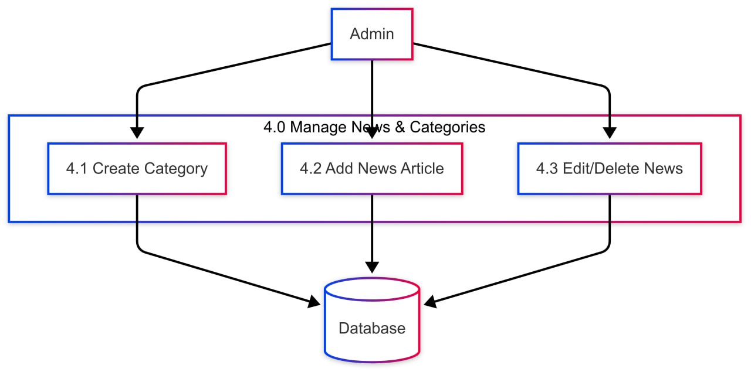

LEVEL-1 DFD

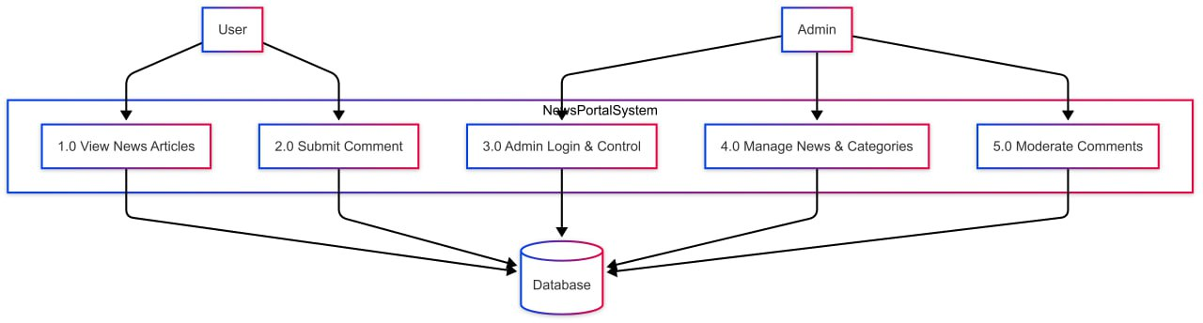

LEVEL -2 DFD

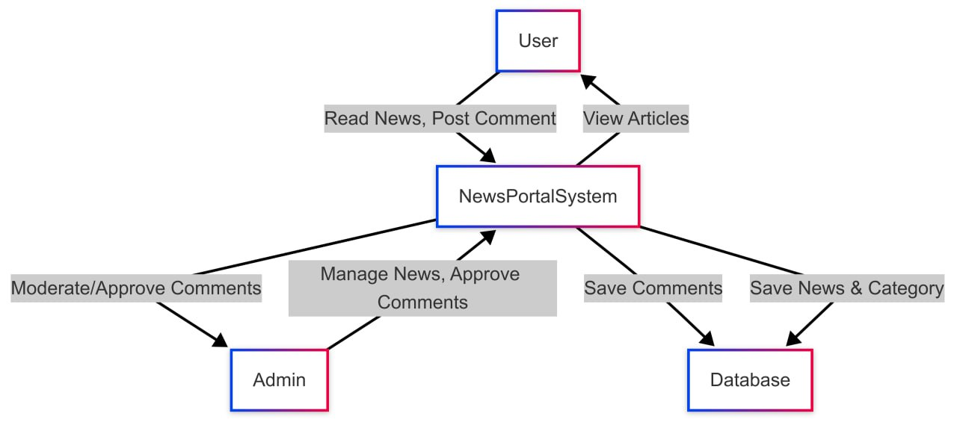

E R DIAGRAM

ER Diagram (Entity relationship diagram) is a visual representation of data that describes data is related to each other. E R Diagrams are used to represent between entity sets.
The following Symbols are used in E-R diagram,

ENTITY

An entity can be any object, place, and person. In ER-diagram an entity is represented using rectangles.

RELATIONSHIP

A relationship describes relations between entities. Relationship is represented using diamonds

ATTRIBUTE

A attribute describes a property or characteristic of an entity. An attribute represented using oval shaped box (ellipse) and are connected to entities or relationship by lines

ER-DIAGRAM OF News Portal Web Application

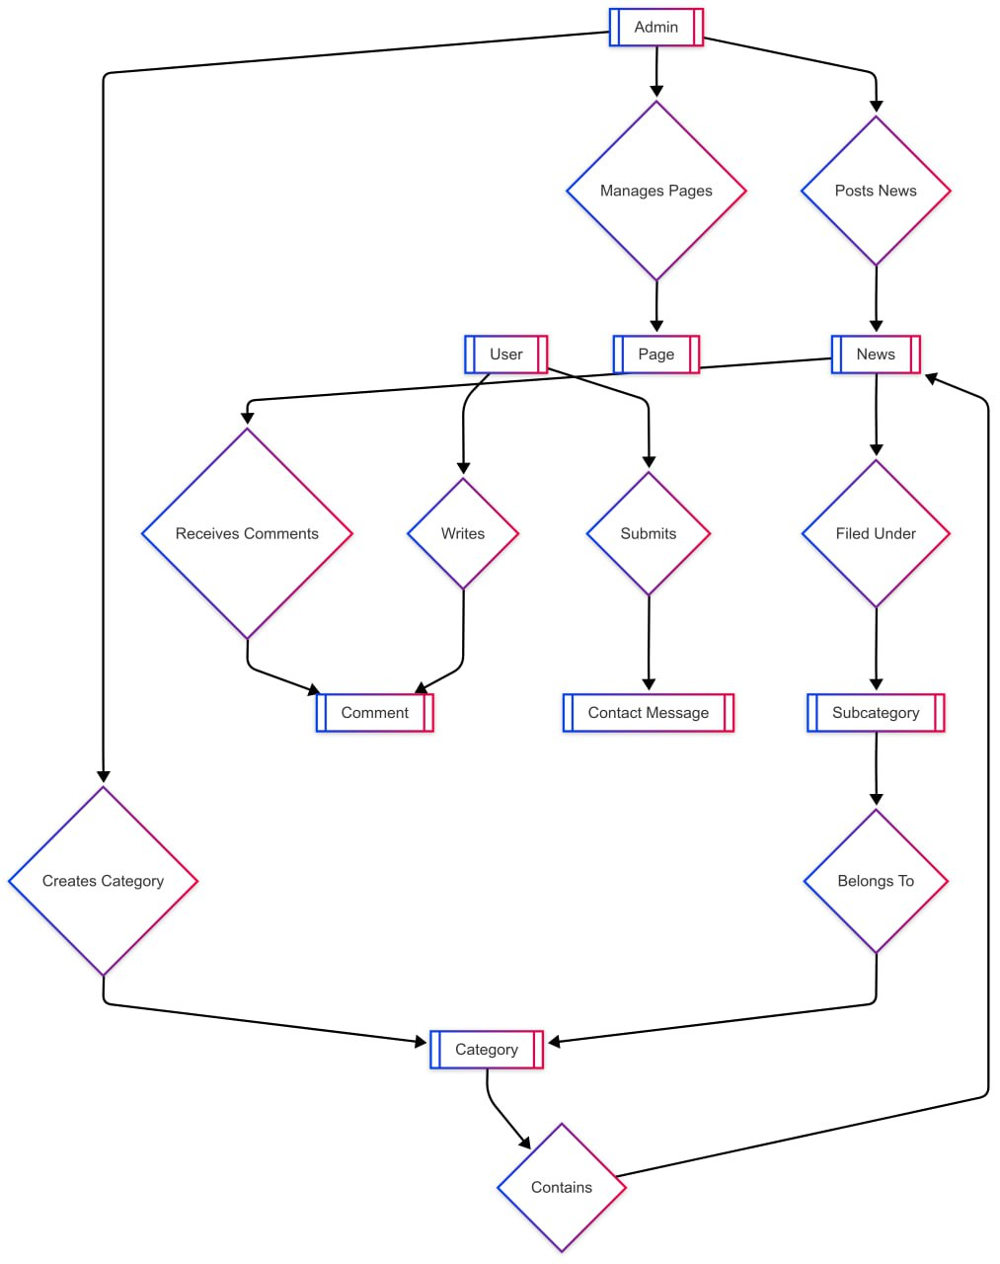

4.3 DATABASE DESIGN
Database design is a critical aspect of system development, as the efficiency, reliability, and scalability of the system depend on how well the database is structured. The goal of the News Portal Web Application is to manage article records, category grouping, administrator access, and content delivery in an optimized and secure manner.

A well-structured database enhances data retrieval speed, reduces redundancy, and improves performance. To achieve this, a relational database model is used, ensuring logical structuring and efficient handling of interrelated data. The database design process involves identifying the required entities, defining their attributes, and establishing relationships between them.

Key Principles of Database Design
• Data should be stored with minimal redundancy to enhance efficiency.
• All users should have controlled access to relevant data, ensuring data integrity and security.
• The system should support quick modifications to accommodate changes easily.
• Data should be consistently formatted to facilitate seamless retrieval and reporting.

Relational Database Approach
The relational database model is chosen for this system due to its robustness, scalability, and ability to enforce data integrity. It organizes data into structured tables, where:
• Each record (row) represents a unique entry, ensuring organized data storage.
• Each field (column) stores specific attributes, allowing quick searches and filtering.
• Primary keys uniquely identify records, preventing duplication and enforcing integrity.
• Foreign keys establish relationships between different entities, ensuring seamless data referencing.

General Objectives of the Database
The News Portal Web Application is designed to meet the following objectives:
• Eliminate traditional static HTML-based content creation and enable dynamic publishing.
• Ensure accurate classification of articles using category linking.
• Enable secure and role-based admin access.
• Allow easy incorporation of updates and modifications to news content.
• Ensure fast and reliable article retrieval for display on the front end.
• Lower the overall cost of data handling through open-source DBMS platforms.
• Improve data consistency and remove duplicate or outdated content manually posted.
• Provide a structured and scalable data model for future expansion such as user feedback, comments, and search filters.

- Role of Database Management System (DBMS)
A Database Management System (DBMS) is used to separate the definition of data from application programs, promoting data independence. This ensures:
• Efficient file structuring for optimal data access and management.
• Multiple modules (article, category, admin login) can interact with the same database without conflict.
• High-level security measures prevent unauthorized access and ensure secure storage.
• Data integrity constraints ensure accurate handling of inputs, updates, and deletions.
• Automated query execution supports real-time publishing and display of news items.

- Importance of Data Directory
A data directory is crucial for defining major system elements, ensuring:
• Logical grouping of data to minimize duplication.
• Efficient access control mechanisms for backend admin functionalities.
• Consistency in data format across article and category modules.
• Optimized storage management for improved system performance and expansion readiness.

The entire system depends on the accurate maintenance and organization of data. By utilizing a well-defined relational model, the News Portal Web Application ensures a structured, scalable, and high-performance approach to managing content and delivering news efficiently to users.

TABLE DESIGN

Table is a collection of data. These data are saved in row and column. The data of each row are different units. Hence, rows are called RECORDS and column of each row is called FIELDS. Some of the major task in computer system is to and manage data. Data stored in table.
- CustomUsers Table

FIELD | DATA TYPE | CONSTRAINT | DESCRIPTION
Id | INT | Primary key | Uniqe user id
username | Varchar(150) | uniqe | User name for login
password | Varchar(255) | Not null | Encrypted user password
User_type | Char(50) | Choices(1,2) | Type of user(admin,subadmin)
Profile_pic | Image fileld |  | Profile pictue path

- Category Table

FIELD | DATA TYPE | CONSTRAINT | DESCRIPTION
id | INT | Primary Key | Unique ID for each category
Catname | VARCHAR  (200) | Not Null | Name of the category
catdes | TEXT | optional | Description of the category
Created_at | DATETIME | Auto Add | Timestamp of creation
Updated_at | DATETIME | Auto Upadate | Timestamp of last update
FIELD | DATA TYPE | CONSTRAINT | DESCRIPTION
id | INT | Primary key | Unique ID for each  subcategory
Cat_id | Foreign key | Category ID | Linkes subcategory to a parent category
subcatname | VARCHAR (200) | Not Null | Name of subcategory
created_at | DATETIME | Auto add | Timestamp of creation
updated_at | DATETIME | Auto Update | Timestamp of last udate

- Subcategory Table

- News Table

FIELD | DATA TYPE | CONSTRAINT | DESCRIPTION
id | INT | Primary key | Unique ID for the article
Cat_id | Foregin key | Category ID | Links article to category
Subcategory_id | Foregin key | Subcategory ID | Links article to subcategory
posttitle | TEXT | Optational | Headline of the news post
postdeatils | TEXT | Optational | Body content of the article
status | VARCHAR (50) |  | Publication status of the article
postimage | imageField |  | Path to uploaded image
Postedby | VARCHAR (50) |  | Name of admin who created the post
Posted_date | DATETIME | Auto Add | Timestamp of publication
Upadated_at | DATETIME | Auto update | Timestamp of Last update
Updatedby | VARCHAR (50) |  | Name of user who last udated the post

- Page Table

FIELD | DATA TYPE | CONSTRAINT | DESCRIPTION
id | INT(11) | Primary key(not null) | Unique Id for the page
pagetitle | VARCHAR (255) | Not null | Title of the page
address | VARCHAR(255) | Not null | address
Aboutus | TEXT | Not null | About us content
email | FIELD | Not null | Contact email
mobileno | INT | Default=0 | Phone number
Created_at | DATETIME | Auto add | Timestamp of creation
Updated_at | DATETIME | Auto update | Timestamp of last update

Comment Table

FIELD | DATA TYPE | CONSTRAINT | DESCRIPTION
Id | Int(11) | Primary key | Unique comment id
News_id | FOREIGN KEY | News ID | Reference the article the comment belongs to
Comment | TEXT | Not null | The commetextnt
Name | VARCHAR(255) | Not null | Name of the commenter
Email | VARCHAR(255) | Not null | Email of the commenter
Status | VARCHAR(255) | Optional | Approval status of moderation info
Posted_date | DATETIME | Auto add | Time the comment was posted
Updated_at | DATETIME | Auto update | Time the comment was last modified

NORMALIZATION

One of the major tasks in designing a relational database is normalization. The process of normalization ensures that there will not be problems in updating the database and the operation of the various relations will not lead to inconsistent and incorrect data.

Normalization is the process of organizing data in a database. This includes creating tables and establishing relationships between those tables according to rules designed both to protect data and to make the database more flexible by eliminating two main issues: redundancy and inconsistent dependency.

Redundant data wastes disk space and creates maintenance problems. If data exists in more than one place and needs to be updated, the update must be made in all those locations exactly the same way. Otherwise, inconsistencies may occur that lead to confusion, inaccurate reporting, or data corruption.

There are a few rules for database normalization. Each rule is called a “normal form.” If the first rule is observed, the database is said to be in the “first normal form.” If three rules are observed, the database is considered to be in the “third normal form.”

FIRST NORMAL FORM

First normal form eliminates repeating groups in individual tables. In this system, all repeating groups are removed from the database. Each table contains fields that can be uniquely identified with a primary key. For example, in the News Portal Web Application, article titles, categories, comment entries, and static pages are each stored in separate, structured tables. This separation ensures a clear structure and eliminates data duplication. Hence, the News Portal Web Application database conforms to the rules of the first normal form.
SECOND NORMAL FORM

A relation is in 2NF if it is already in 1NF and all non-key attributes are functionally dependent on the entire primary key. In this project, the system satisfies the conditions of the second normal form. For instance, each news article in the News table is linked to its category and subcategory using foreign keys, and all article-related information like title, content, image, and timestamps are dependent on the unique article ID. Similarly, comments are linked to articles using a foreign key reference, and all other comment data is fully dependent on the primary key of the comment table.

THIRD NORMAL FORM

Third normal form is achieved when all attributes in a table are not only functionally dependent on the primary key, but also independent of other non-key attributes. This means eliminating fields that do not depend on the key. In the News Portal Web Application, transitive dependencies are eliminated by separating data across multiple tables. For example, the Category and Subcategory names are stored in their respective tables and not duplicated in the News table. Instead, they are linked using foreign key relationships. This ensures that updates to a category or subcategory are automatically reflected across the system without affecting article integrity.

During the normalization process, all relations are first evaluated against first normal form, followed by second and finally third normal form. To conform to second and third normal forms, each non-key field must provide information about the entire key and not about other fields. Thus, normalization creates a database in which there is minimal redundancy of data and maximum consistency across all operations.

HARDWARE AND SOFTWARE SELECTION

SOFTWARE SPECIFICATION

Front End Design : HTML, CSS, Bootstrap, Django Templates
Styling : Bootstrap, Custom CSS
Client-Side Scripting : JavaScript
Back End Framework : Django (Python)
Database : SQLite3
Web Server : Django Development Server (WSGI)

HARDWARE SPECIFICATION

An important matter in building an application is selecting hardware and software. The hardware drives the software to facilitate solutions. Factors like cost performance etc are taken into consideration during the purchase of the hardware component for any computerized system.
Hardware requirements needs for the system

Processor | : | Intel Core i3 or higher
Ram | : | 4 GB or more
Hard disk | ; | 250 GB or more
5.1 FRONT END

The front end is the interface between the users and the back end of the application. It is responsible for displaying content and managing user interaction. In web development, the front end is often referred to as the client-side, where users can interact with forms, navigate pages, and view content dynamically generated by the server.

In this project, the front end was developed using HTML5 for markup structure, CSS3 for styling, and Bootstrap for responsive design. The integration of Django Templates allowed seamless communication between the front end and back-end data. The UI was designed to be clean and mobile-responsive, ensuring a smooth reading experience across devices.

These technologies work together to provide a flexible and scalable user interface. They allow the site to adapt to varying screen sizes and provide administrators the ability to dynamically update content from the backend.
5.1.2. DJANGO TEMPLATES:-

INTRODUCTION

Django Templates are an essential part of the Django web framework. They act as a powerful templating engine that bridges the gap between the back-end logic and the front-end interface. Django Templates allow developers to embed Python-like expressions into HTML, enabling dynamic content rendering directly in web pages.

Unlike static HTML pages, Django Templates enable dynamic insertion of variables, conditional rendering of content, and iteration over datasets. This allows for real-time data-driven websites that are both functional and interactive without writing extensive JavaScript.

Django Templates follow a clean and readable syntax using template tags (like {% %} for logic and {{ }} for variables), making it easy to use even for front-end developers with limited Python experience.

KEY FEATURES OF DJANGO TEMPLATES

1.Template Inheritance
Django supports parent-child template structure using {% block %} and {% extends %} tags. This allows reusable layouts such as headers, footers, and navigation bars across multiple pages.

- Variable Output and Context Integration
Data from views can be passed into templates as a "context," allowing dynamic display of database content like article titles, categories, or recent news.

- Filters and Tags
Templates support built-in filters to format text, dates, and numbers, as well as custom-defined filters for advanced formatting. Tags like {% for %}, {% if %}, and {% include %} help manage logic directly in HTML.

- Safe from Injection Attacks
Django templates automatically escape output, preventing XSS (Cross-Site Scripting) vulnerabilities. This makes it secure by default when displaying user-submitted data.

- Separation of Logic and Presentation
Django encourages clean separation between logic (in views and models) and presentation (in templates), making the codebase easier to maintain and scale.

- Modular and Reusable
Templates can be organized in directories and reused across the site. For example, base.html may include shared layout while home.html, news_detail.html, and category.html can inherit it.

- REASONS FOR USING DJANGO TEMPLATES

- Built-In Framework Support
Django Templates are fully integrated with the Django framework, eliminating the need for external engines or additional configuration.

- Rapid Development
Developers can build complete page layouts with live data in minimal time. Changes in backend data are reflected instantly through template rendering.

- Simplified Content Management
Admins can update content like titles, pages, and news articles without touching the template files, as data comes directly from the database.

- Flexible and Extensible
Developers can create custom template tags and filters to handle project-specific formatting or functions, increasing adaptability.

- SEO-Friendly Structure
Django Templates produce clean and structured HTML output, which is essential for better indexing by search engines and improved visibility.

- Community Support and Documentation
Django has excellent documentation and a large community. Template-related resources, troubleshooting, and examples are readily available.

5.1.2.JAVASCRIPT INTRODUCTION
JavaScript (JS) is a dynamic computer programming language. It is most commonly used as part of web browsers, whose implementations allow client-side scripts to interact with the user, control the browser, communicate asynchronously, and alter the document content that is displayed. It is also being used in server-side network programming (with Node.js), game development and the creation of desktop and mobile applications.
JavaScript is a prototype-based scripting language with dynamic typing and has first-class functions. Its syntax was influenced by C. JavaScript copies many names and naming conventions from Java, but the two languages are otherwise unrelated and have very different semantics. The key design principles within JavaScript are taken from the Self and Scheme programming languages. It is a multi-paradigm language, supporting object-oriented, imperative, and functional programming styles.
The application of JavaScript in use outside of web pages—for example, in PDF documents, site specific browsers, and desktop widgets—is also significant. Newer and faster JavaScript VMs and platforms built upon them (notably Node.js) have also increased the popularity of JavaScript for server-side web applications. On the client side, JavaScript was traditionally implemented as an interpreted language but just-in-time compilation is now performed by recent (post-2012) browsers. JavaScript was formalized in the ECMA Script language standard and is primarily used as part of a web browser (client-side JavaScript). This enables programmatic access to objects within a host environment.
JavaScript is the most popular programming language in the world.

It is the language for HTML, for the Web, for computers, servers, laptops, tablets, smart phones, and more.
You can use JavaScript to:

- Change HTML elements

- Delete HTML elements

- Create new HTML elements

- Copy and clone HTML elements

5.1.3 BOOTSTRAP

Bootstrap is a popular and powerful open-source front-end framework that simplifies and accelerates the process of web development. Originally created by Twitter, Bootstrap has evolved into a widely adopted toolkit for building responsive and visually appealing websites and web applications. It is based on HTML, CSS, and JavaScript, providing developers with a robust set of tools, components, and styles to create consistent and modern user interfaces.
Key Features of Bootstrap:

- Responsive Design: One of the standout features of Bootstrap is its built-in responsiveness. It offers a mobile-first approach, ensuring that websites and applications look and function well on a variety of devices and screen sizes. This is achieved through a responsive grid system and predefined classes.
- Pre-designed Components: Bootstrap provides a rich library of pre-designed UI components such as buttons, forms, navigation bars, modals, and more. These components can be easily customized and integrated into projects, saving developers time and effort.
- Extensive Documentation: Bootstrap comes with thorough and well-organized documentation. This documentation serves as a comprehensive guide for developers, offering detailed explanations, examples, and code snippets for each component and feature. It makes learning and implementing Bootstrap straightforward.
- Customization: While Bootstrap provides a set of default styles and components, it is highly customizable. Developers can leverage Sass variables and mixins to tailor the framework to suit specific design requirements. This flexibility allows for the creation of unique and branded user interfaces.
- Community Support: Bootstrap has a large and active community of developers, designers, and contributors. This community actively engages in discussions, provides support through forums, and contributes to the continuous improvement of the framework. The community- driven nature of Bootstrap ensures ongoing updates and enhancements.

- Cross-Browser Compatibility: Bootstrap is designed to be compatible with various web browsers, ensuring consistent performance and appearance across platforms. This eliminates the need for extensive browser-specific styling and debugging.
- JavaScript Plugins: Bootstrap includes a variety of JavaScript plugins that enhance the functionality of web pages. Examples include carousels, modals, tooltips, and form validation. These plugins are easily integrable, and their behavior is customizable.
- Versatility: Bootstrap can be used for a wide range of projects, from simple websites to complex web applications. Its versatility makes it suitable for developers working on diverse projects with varying design and functionality requirements.
In Bootstrap is a versatile, responsive, and customizable framework that empowers developers to create modern and visually appealing web applications efficiently. Its extensive features and supportive community contribute to its widespread adoption in the web development industry.

BACK END

INTRODUCTION

Django is a powerful and secure high-level Python web framework that enables rapid development of dynamic and scalable web applications. It follows the Model-View-Template (MVT) architectural pattern and promotes clean design and reusable code. Django is known for its simplicity, robustness, and ability to scale for both small and large-scale projects.

In the News Portal Web Application, Django serves as the backbone of the backend system. It manages user authentication, content creation, article categorization, comment handling, and page routing. One of Django’s greatest strengths is its built-in admin panel, which allows site administrators to manage content efficiently without requiring direct database access.

The Django framework seamlessly integrates with databases like SQLite3, PostgreSQL, and MySQL, allowing developers to choose the best database for their project's size and needs. It comes bundled with an Object-Relational Mapper (ORM), which allows developers to interact with the database using Python classes instead of raw SQL queries.

Django’s architecture ensures secure session management, CSRF protection, role-based access control, and form validation, making it a reliable solution for data-driven applications. Its compatibility with Python and wide support for third-party packages makes Django a go-to choice for building full-featured web platforms.

In the News Portal Web Application, Django handles all the backend operations, from user logins to news publishing, comment moderation, and page rendering — making it the ideal framework for developing content-heavy, secure, and scalable portals.

5.2.1 SQLITE3
SQLite3 is a lightweight, open-source relational database management system used by default in Django projects during development. It is a self-contained, serverless database engine that stores the entire database as a single file on disk. It is designed for simplicity, ease of use, and quick setup, making it perfect for development and testing environments.

SQLite3 supports full SQL capabilities, including queries, joins, transactions, and constraints like primary keys and foreign keys. Despite its small footprint, SQLite3 offers remarkable reliability and performance for small to medium-sized applications.

Unlike server-based databases, SQLite does not require any configuration or server software. It reads and writes directly to disk, which makes it an ideal solution for local testing, prototyping, or applications with moderate data load requirements.

SQLite3 is cross-platform compatible and works on Windows, macOS, Linux, and even mobile platforms like Android and iOS. It is widely used in embedded systems, standalone desktop applications, and web apps that do not require a full-scale database server.

SERVICES

SQLite3 offers a range of database features and capabilities that enhance the backend efficiency of the News Portal Web Application:
- ​Relational database management system (RDBMS)

SQLite3 operates as a relational database that stores data in structured tables. It supports indexing, normalization, and SQL syntax for managing data relations and performing efficient queries. The system ensures data integrity through relational constraints, enforcing consistency between categories, news articles, and user comments.

- ​Data security and access control

SQLite3 provides data protection through file-based access control, allowing only authenticated users or system services to access the database file. In combination with Django’s built-in security features like password hashing, CSRF protection, and form validation, data security is robust and reliable for local and internal use.

- ​Scalability and performance optimization

While SQLite3 is designed for lighter workloads, it is capable of handling thousands of records with fast read/write speeds. It supports transaction processing, query optimization, and on-disk caching. For production-grade scaling, the system can easily migrate to other Django-compatible databases such as PostgreSQL or MySQL without changing the application logic, thanks to Django ORM.

SQLite3 continues to be a preferred option for development due to its minimal setup, performance for moderate datasets, and seamless integration with the Django framework. In the News Portal Web Application, it allows developers to build, test, and manage the entire system efficiently, while remaining open to future upgrades to more powerful databases if required.

HARDWARE SPECIFICATION

An important matter in building an application is selecting hardware and software. The hardware drives the software to facilitate solutions. Factors like cost performance etc are taken into consideration during the purchase of the hardware component for any computerized system.
Hardware requirements needs for the system:

Processor : Intel Core i3 1.80 GHz or more

Ram : 4 GB or more

Hard disk : 250 GB

CODING

INPUT FORM DESIGN

Input design is the process of converting user-oriented inputs into a computer-based format. In this system, users and administrators interact primarily through web forms. These are designed to collect and validate data before being submitted to the backend for processing.

The input forms of the News Portal Web Application are developed using Django forms and ReactJS components. Each form includes user-friendly labels, placeholders, validation checks, and contextual error messages to enhance usability.

The major approaches to input design include menu-driven navigation, intuitive prompts, dropdowns, file inputs, and responsive layouts. Error feedback is displayed immediately upon incorrect input, reducing user frustration.

Features of the Input Forms:

User Friendly: Each input form is clean and easy to understand, with proper spacing and labeling.

Menu Driven: Admins can select actions like “Add News”, “Edit Category”, or “View Comments” using sidebars or navbars.

Interactive Layout: Forms adapt to screen size and provide live feedback using dynamic elements powered by JavaScript.

Validation: Forms are validated both on the client-side (React) and the server-side (Django) to ensure accurate and secure input.

- SELECTED CODE
- Html code(index.html)

{% extends 'base1.html' %}
{% block content %}
{% load static %}
<div class="trending-area fix pt-30 gray-bg">
<div class="container">
<div class="trending-main">
<div class="row">
<div class="col-lg-8">
<!-- Trending Top -->
<div class="slider-active">
<!-- Single -->
{% for i in postnews %}
<div class="single-slider">
<div class="trending-top mb-30">
<div class="trend-top-img">
<img src="{{i.postimage.url}}" alt="">
<div class="trend-top-cap">
<span class="bgr" data-animation="fadeInUp" data-delay=".2s" data-duration="1000ms">{{i.cat_id.catname}}</span>
<h2><a href="{% url 'view_single_news' i.id %}" data-animation="fadeInUp" data-delay=".4s" data-duration="1000ms">{{i.posttitle}}</a></h2>
<p data-animation="fadeInUp" data-delay=".6s" data-duration="1000ms">{{i.posted_date}}</p>
</div>
</div>
</div>
</div>{% endfor %}
<!-- Single -->

</div>
</div>
<!-- Right content -->
<div class="col-lg-4">
<!-- Trending Top -->
<div class="row">
{% for i in postnews %}
<div class="col-lg-12 col-md-6 col-sm-6">
<div class="trending-top mb-30">
<div class="trend-top-img">
<img src="{{i.postimage.url}}" alt="">
<div class="trend-top-cap trend-top-cap2">
<span class="bgb">{{i.cat_id.catname}}</span>
<h2><a href="{% url 'view_single_news' i.id %}">{{i.posttitle}}</a></h2>
<p>{{i.posted_date}}</p>
</div>
</div>
</div>
</div>{% endfor %}

</div>
</div>
</div>
</div>
</div>
</div>
<!-- Trending Area End -->
<!-- Whats New Start -->
<section class="whats-news-area pt-50 pb-20 gray-bg">
<div class="container">
<div class="row">
<div class="col-lg-8">
<div class="whats-news-wrapper">
<!-- Heading & Nav Button -->
<div class="row justify-content-between align-items-end mb-15">
<div class="col-xl-4">
<div class="section-tittle mb-30">
<h3>News</h3>
</div>
</div>
<div class="col-xl-8 col-md-9">
<div class="properties__button">
<!--Nav Button -->
<nav>
<div class="nav nav-tabs" id="nav-tab" role="tablist">
{% for i in category %}
<a class="nav-item nav-link active" href="{% url 'category_detail' id=i.id %}" role="tab" aria-controls="nav-home" aria-selected="true">{{i.catname}}</a>{% endfor %}
</div>
</nav>
<!--End Nav Button -->
</div>
</div>
</div>
<!-- Tab content -->
<div class="row">
<div class="col-12">
<!-- Nav Card -->
<div class="tab-content" id="nav-tabContent">
<!-- card one -->
<div class="tab-pane fade show active" id="nav-home" role="tabpanel" aria-labelledby="nav-home-tab">
<div class="row">
<!-- Left Details Caption -->

<!-- Right single caption -->
<div class="col-xl-8 col-lg-12">
<div class="row">
<!-- single -->
{% for i in postnews1 %}
<div class="col-xl-12 col-lg-6 col-md-6 col-sm-10">
<div class="whats-right-single mb-20">
<div class="whats-right-img">
<img src="{{i.postimage.url}}" alt="" width="200" height="200">
</div>
<div class="whats-right-cap">
<span class="colorb">{{i.cat_id.catname}}</span>
<h4><a href="{% url 'view_single_news' i.id %}">{{i.posttitle}}.</a></h4>
<p>{{i.posted_date}}</p>
</div>
</div>
</div>{% endfor %}
</div>
</div>
</div>
</div>
<!-- Card two -->
</div>
<!-- End Nav Card -->
</div>
</div>
</div>
<!-- Banner -->

</div>
<div class="col-lg-4">
<!-- Flow Socail -->

<!-- Most Recent Area -->
<div class="most-recent-area">
<!-- Section Tittle -->
<div class="small-tittle mb-20">
<h4>Most Recent</h4>
</div>
<!-- Details -->
{% for i in recentnews %}
<div class="most-recent mb-40">
<div class="most-recent-img">
<img src="{{i.postimage.url}}" alt="">
<div class="most-recent-cap">
<span class="bgbeg">{{i.cat_id.catname}}</span>
<h4><a href="{% url 'view_single_news' i.id %}">{{i.posttitle}}.</a></h4>
<p>{{i.posted_date}}</p>
</div>
</div>
</div>{% endfor %}
<!-- Single -->
</div>
</div>
</div>
</div>
</section>
<!-- Whats New End -->
<!-- Weekly2-News start -->
<div class="weekly2-news-area pt-50 pb-30 gray-bg">
<div class="container">
<div class="weekly2-wrapper">
<div class="row">
<!-- Banner -->

<div class="col-lg-12">
<div class="slider-wrapper">
<!-- section Tittle -->
<div class="row">
<div class="col-lg-12">
<div class="small-tittle mb-30">
<h4>Most Popular</h4>
</div>
</div>
</div>
<!-- Slider -->
<div class="row">
<div class="col-lg-12">
<div class="weekly2-news-active d-flex">
<!-- Single -->
{% for i in recentnews %}
<div class="weekly2-single">
<div class="weekly2-img">
<img src="{{i.postimage.url}}" alt="">
</div>
<div class="weekly2-caption">
<h4><a href="{% url 'view_single_news' i.id %}">{{i.posttitle}}</a></h4>
<p>{{i.posted_date}}</p>
</div>
</div> {% endfor %}
<!-- Single -->

</div>
</div>
</div>
</div>
</div>
</div>
</div>
</div>
</div>
<!-- End Weekly-News -->
<!-- Recent Articles start -->

<!--Recent Articles End -->
<!-- Weekly3-News start -->
<div class="weekly3-news-area pt-80 pb-130">
<div class="container">
<div class="weekly3-wrapper">
<div class="row">
<div class="col-lg-12">
<div class="slider-wrapper">
<!-- Slider -->
<div class="row">
<div class="col-lg-12">
<div class="weekly3-news-active dot-style d-flex">
{% for i in recentnews %}
<div class="weekly3-single">
<div class="weekly3-img">
<img src="{{i.postimage.url}}" alt="" width="300" height="200">
</div>
<div class="weekly3-caption">
<h4><a href="{% url 'view_single_news' i.id %}">{{i.posttitle}}</a></h4>
<p>{{i.posted_date}}</p>
</div>
</div> {% endfor %}
</div>
</div>
</div>
</div>
</div>
</div>
</div>
</div>
</div>
<!-- End Weekly-News -->
<!-- banner-last Start -->

{% endblock %}

- PYTHON CODE (views.py)

from django.contrib.auth import authenticate, login,logout
from django.shortcuts import render, redirect
from django.contrib import messages
from django.conf import settings
from datetime import timedelta
from django.contrib.auth.decorators import login_required
from newsapp.models import CustomUser,News,Category,Page,Comments,Subcategory
from django.contrib.auth import get_user_model
from django.db import IntegrityError
from django.core.paginator import Paginator, EmptyPage, PageNotAnInteger
import random
from django.utils import timezone
from django.db.models import Q
from django.shortcuts import render, get_object_or_404
from django.db.models import Count
User = get_user_model()

def BASE(request):
return render(request,'base.html')

def BASE1(request):
return render(request,'base1.html')

def INDEX(request):
postnews = News.objects.order_by('-posted_date')[:3]
postnews1 = News.objects.all()[:4]
category = Category.objects.all()[:4]
recentnews = News.objects.order_by('-posted_date')[:5]

context ={
'postnews':postnews,
'category': category,
'recentnews':recentnews,
'postnews1':postnews1
}

return render(request,'index.html',context)

def ABOUTUS(request):
first_page = Page.objects.first()
context = {
"page": first_page,
}
return render(request, 'aboutus.html', context)

def CONTACTUS(request):
first_page = Page.objects.first()
context = {
"page": first_page,
}
return render(request, 'contactus.html', context)

def category_detail(request):
first_page = Page.objects.first()
context = {
"page": first_page,
}
return render(request, 'contactus.html', context)

def category_detail(request, id):
catid = get_object_or_404(Category, id=id)
news_list = News.objects.filter(cat_id=catid).order_by('-posted_date') # Order by published date, or any other field
paginator = Paginator(news_list, 4) # Show 5 news items per page

page_number = request.GET.get('page')
news = paginator.get_page(page_number)

return render(request, 'categorywise_newsdetail.html', {'catid': catid, 'news': news})

def VIEW_SINGLENEWS(request, id):
sinnews = get_object_or_404(News, id=id)
recentnews = News.objects.order_by('-posted_date')[:4]
category_counts = Category.objects.annotate(news_count=Count('news'))
comments_list = Comments.objects.filter(news_id=sinnews, status='Approved')

if request.method == "POST":
# Create the comment object
comment_obj = Comments(
news_id=sinnews,
comment=request.POST['comment'],
name=request.POST['name'],
email=request.POST['email'],
)
comment_obj.save()
return redirect('thank_you')

context = {
"sinnews": sinnews,
'recentnews': recentnews,
'category_counts': category_counts,
'comments_list':comments_list,
}
return render(request, 'single-news-details.html', context)

def THANKYOU(request):
return render(request, 'thankyou.html')

def DASHBOARD(request):
category_count = Category.objects.all().count
subcategory_count = Subcategory.objects.all().count
news_count = News.objects.all().count
subadmin_count = CustomUser.objects.filter(user_type=2).count

context = {'category_count':category_count,
'subcategory_count': subcategory_count,
'news_count':news_count,
'subadmin_count':subadmin_count,

}
return render(request,'dashboard.html',context)

def LOGIN(request):
return render(request,'login.html')
def doLogin(request):
if request.method == 'POST':
username = request.POST.get('username')
password = request.POST.get('password')
remember_me = request.POST.get('remember_me') # This is 'on' if checked, otherwise None

user = authenticate(request, username=username, password=password)
if user is not None:
login(request, user)

# Set session expiry based on remember_me
if remember_me:
# Remember the user for 30 days
request.session.set_expiry(2592000) # 30 days in seconds
else:
# Browser session: expire when the user closes the browser
request.session.set_expiry(0)

user_type = user.user_type
if user_type == '1':
return redirect('dashboard')
elif user_type == '2':
return redirect('dashboard')
else:
messages.error(request, 'Email or Password is not valid')
# Pass the entered username and remember_me back to the template
return render(request, 'login.html', {'username': username, 'remember_me': remember_me})
else:
# If the request method is not POST, redirect to the login page with an error message
messages.error(request, 'Invalid request method')
return redirect('login')

def doLogout(request):
logout(request)
return redirect('login')

@login_required(login_url = '/')
def ADMIN_PROFILE(request):
user = CustomUser.objects.get(id = request.user.id)
context = {
"user":user,
}
return render(request,'profile.html',context)

@login_required(login_url = '/')
def ADMIN_PROFILE_UPDATE(request):
if request.method == "POST":
profile_pic = request.FILES.get('profile_pic')
first_name = request.POST.get('first_name')
last_name = request.POST.get('last_name')
email = request.POST.get('email')
username = request.POST.get('username')
print(profile_pic)

try:
customuser = CustomUser.objects.get(id = request.user.id)
customuser.first_name = first_name
customuser.last_name = last_name

if profile_pic !=None and profile_pic != "":
customuser.profile_pic = profile_pic
customuser.save()
messages.success(request,"Your profile has been updated successfully")
return redirect('admin_profile')

except:
messages.error(request,"Your profile updation has been failed")
return render(request, 'profile.html')

login_required(login_url='/')
def CHANGE_PASSWORD(request):
context ={}
ch = User.objects.filter(id = request.user.id)

if len(ch)>0:
data = User.objects.get(id = request.user.id)
context["data"]:data
if request.method == "POST":
current = request.POST["cpwd"]
new_pas = request.POST['npwd']
user = User.objects.get(id = request.user.id)
un = user.username
check = user.check_password(current)
if check == True:
user.set_password(new_pas)
user.save()
messages.success(request,'Password Change Succeesfully!!!')
user = User.objects.get(username=un)
login(request,user)
else:
messages.success(request,'Current Password wrong!!!')
return redirect("change_password")
return render(request,'change-password.html')

def SEARCH_NEWS(request):
if request.method == "GET":
query = request.GET.get('query', '')
if query:
# Filter records where posttitle, category name, or subcategory name contains the query
searchnews = News.objects.filter(
Q(posttitle__icontains=query) |
Q(cat_id__catname__icontains=query) |
Q(subcategory_id__subcatname__icontains=query)
)
if searchnews.exists():
messages.info(request, "Search results for: " + query)
else:
messages.info(request, "No records found for: " + query)

# Set up pagination
paginator = Paginator(searchnews, 10) # Show 10 search results per page
page = request.GET.get('page', 1)

try:
searchnews_paginated = paginator.page(page)
except PageNotAnInteger:
searchnews_paginated = paginator.page(1)
except EmptyPage:
searchnews_paginated = paginator.page(paginator.num_pages)

return render(request, 'search-news.html', {
'searchnews': searchnews_paginated,
'query': query,
})
else:

return render(request, 'search-news.html', {})

The News Portal Web Application consists of several core components, each implemented through well-structured code blocks. These codes are organized in reusable views, models, templates, and frontend components.
Key operations such as data insertion, user authentication, session handling, and API calls are managed through Python (Django) and JavaScript (React/Axios). The selected code snippets represent essential parts of the system that drive its functionality.
The selected code in this project demonstrates the core working of the News Portal Web Application, with a focus on frontend display and backend logic integration. The system enables smooth content delivery to users while offering dynamic control features for administrators.

The homepage interface (index.html) is designed to showcase the latest news articles with an elegant and responsive layout. Built using HTML, CSS, and Bootstrap, the frontend emphasizes readability and user experience. Articles are displayed with featured images, brief summaries, and category labels, making navigation intuitive for end users. The layout adapts gracefully across desktops and mobile devices.

Dynamic elements such as latest news highlights, category-based filtering, and "read more" links are rendered using Django template tags. These tags fetch data directly from the database and ensure that the content is always up-to-date. News entries are looped through with context data passed from the Django view, allowing seamless rendering of multiple posts with titles, timestamps, and author names.

On the backend, the views.py file handles major server-side operations. The index() view fetches active news articles and passes them into the template for display. It also includes logic for fetching active categories and featured posts. This view communicates with Django ORM to query the database securely and efficiently.

Admin-related operations, such as adding or editing news posts, category management, and comment moderation, are handled through protected views with login-required decorators. These are connected to forms where data input is validated, saved, and redirected appropriately.

- Key backend functions include:
- Rendering the homepage with all published news posts

- Loading category-specific articles dynamically

- Managing the article detail view via slug-based routing

- Admin post creation/editing using POST requests

- Managing subcategories under each main category

- Storing submitted comments with relation to the news ID

The user interface for viewers is static in terms of layout but dynamic in its content. It supports smooth navigation between pages such as “Home,” “Categories,” “News Details,” and optionally, “About” or “Contact.” Django messages framework may also be used to display confirmation alerts or validation warnings.

From a technical standpoint, the project follows MVC principles using Django’s MVT (Model-View-Template) architecture. This separation allows frontend designers and backend developers to work independently, making the project more scalable and maintainable.

In terms of enhancement, future updates can include a search feature, pagination, news tags, image optimization, or even AJAX-based comment submission for real-time updates without page reloads.

In summary, this selected code provides a backbone to the News Portal’s dynamic content handling. It successfully demonstrates how Django manages routing, rendering, and interaction between users and the database in a secure and efficient way, forming the foundation of a reliable content management system.

OUTPUT REPORTS

The index.html and views.py files form the core of the News Portal Web Application’s content presentation and delivery mechanism. These components work together to retrieve, process, and display news articles, categories, and featured stories, offering users a seamless and dynamic reading experience.

The visual interface is composed of several distinct sections, each crafted to maximize clarity and user engagement. At the top, the homepage features a navigation bar that enables smooth transitions across sections like Home, Categories, and About. A scrolling ticker or hero banner highlights the latest headlines, drawing user attention immediately to breaking news or featured stories.

Below the header, news articles are neatly arranged using Bootstrap cards or grid layouts. Each article block includes a title, image, author name, post date, and a short excerpt. Users can click on the “Read More” button to view the full article, which routes them to a detail page powered by Django’s views.py and URL dispatcher. The content loads dynamically based on the article’s slug, ensuring unique, SEO-friendly URLs.

Categories are displayed as navigation links or sidebar elements, allowing users to filter news based on interest. When a category is selected, only relevant news posts are rendered, keeping the reading experience focused and user-centric. Subcategories are also implemented under main categories, enhancing the site’s organization and discoverability.

Behind the scenes, the views.py file serves as the communication bridge between the templates and the database. The index() function queries all active articles and categories using Django ORM. Context data is passed to the index.html template using a dictionary, which includes news posts, category listings, and other custom filters like recent posts or popular tags.

This system leverages Django’s render() function to bind server-side logic with frontend views, ensuring that all dynamic elements are rendered accurately and efficiently. By isolating business logic within views and templates, the architecture remains clean and maintainable.

In addition to rendering output, the system includes optional features such as displaying featured posts, showing article comment counts, and linking to an admin-only dashboard. These elements contribute to a robust, real-world publishing platform that mimics professional news portals.

From a UX perspective, the portal is clean and professional. The responsive design ensures that users on mobile, tablet, and desktop devices receive a consistent and polished experience. Article cards stack gracefully, font sizes adjust dynamically, and images resize to fit within the grid structure.

In terms of optimization, the templates are designed for readability and speed. Minimal external dependencies are used, and Django’s template inheritance system allows for reusable headers, footers, and base layouts. The result is faster load times and a consistent layout across all pages.

Despite its strong performance, there’s room for enhancement. Features like AJAX-based pagination, live comment updates, or lazy loading for images can further elevate performance and interactivity. Implementing advanced filtering options, author archives, or a search bar would also enrich the user experience.

In summary, the index.html and views.py integration delivers a reliable and visually appealing output mechanism for the News Portal Web Application. It ensures that all content is retrieved, rendered, and displayed efficiently — while remaining easy to navigate and maintain. With future enhancements, this system can scale into a more powerful publishing solution for content creators and institutions alike. M
Output :

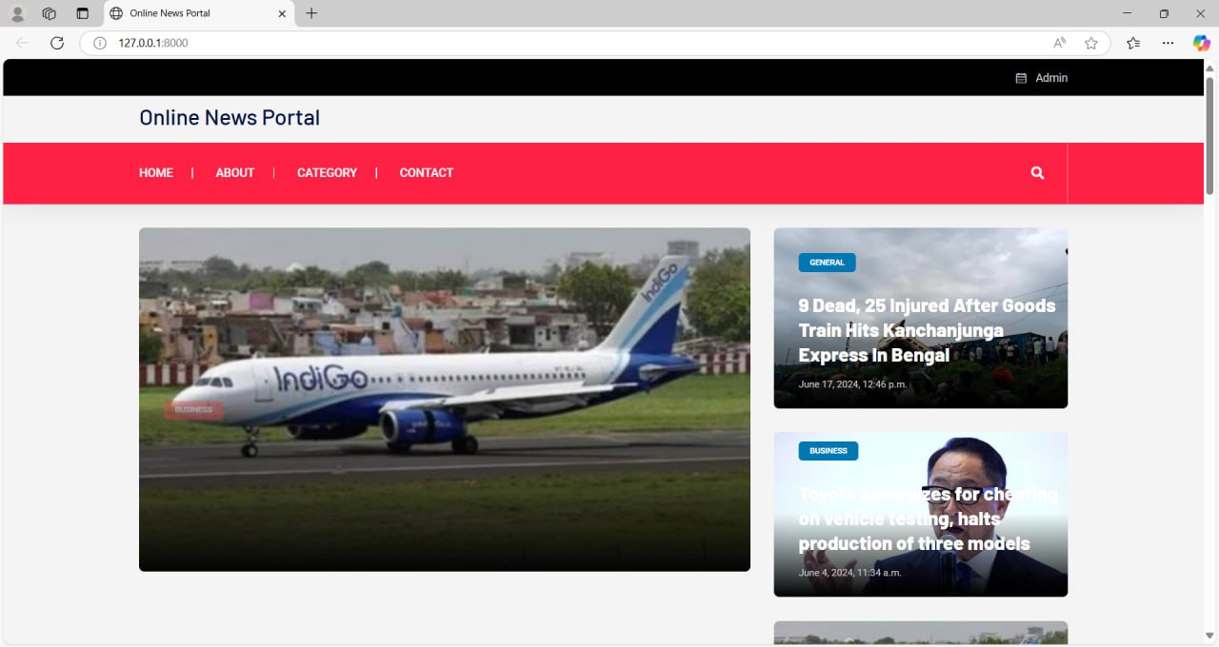

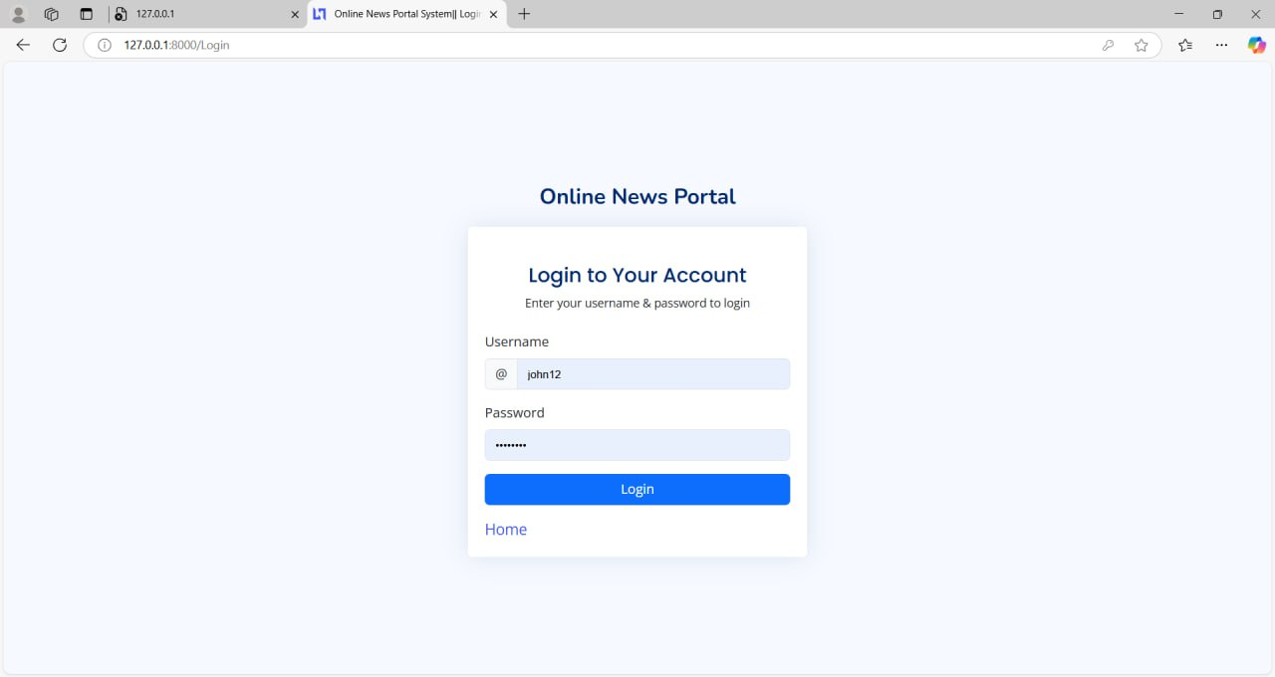

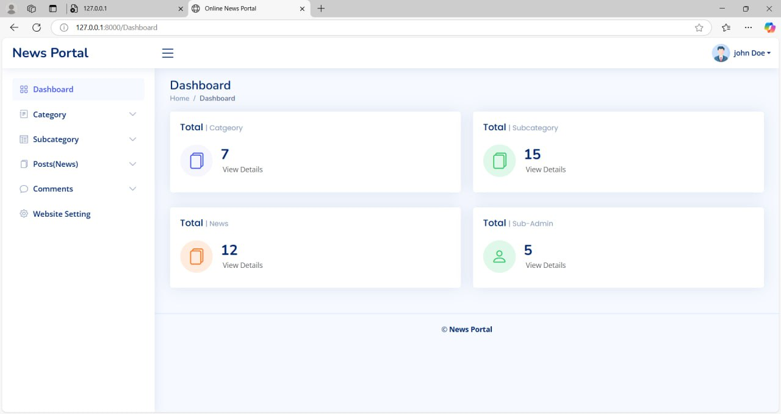

SYSTEM TESTING AND IMPLEMENTATION

SYSTEM TESTING

Software testing is a critical aspect of software quality assurance (SQA) and represents the ultimate review of specifications, design, and coding. Unlike other phases of software development, testing can be considered a destructive activity because it aims to identify errors and defects rather than build new functionality.

A well-structured software testing strategy integrates various test case design methods into a systematic plan, ensuring that the software functions as expected under different scenarios. Testing is a carefully planned and organized set of activities designed to uncover software defects, improve reliability, and ensure the software meets the required standards.

Why Should We Test?

Though software testing is resource-intensive, the cost of deploying software without thorough testing can be significantly higher. For systems where accuracy, reliability, and security are essential—such as a News Portal Web Application—the consequences of failure can include:

• Loss of news articles or media files.
• System malfunction during peak hours.
• Inaccurate publication or scheduling of content.
• Unauthorized access or content manipulation.

Early detection and correction of errors reduce overall maintenance costs and ensure smooth operation. The earlier an error is detected in the software life cycle, the lower the cost of correcting it.

Who Should Do the Testing?
- Developers and QA Engineers: While developers perform unit testing to validate individual functions, it is often difficult for them to identify defects in their own work.
- Independent Testers: Organizations typically differentiate between development and testing phases by assigning different teams to each task. Independent testing teams bring a fresh perspective and are better positioned to identify errors overlooked by developers.
- User Acceptance Testers (UAT): End-users or stakeholders can perform acceptance testing to ensure that the software meets their expectations and system requirements.

What Should We Test?

Testing should cover the system’s responses to all possible inputs, including:

- Valid Inputs: Ensuring that correct and expected data generates appropriate responses.
- Invalid Inputs:
- Testing how the system handles incorrect, unexpected, or malicious inputs.
- Boundary Values: Checking system behavior at the limits of permissible inputs.
- Error Conditions: Evaluating how the system reacts when encountering exceptions or unforeseen circumstances.

Example:

• Article Management – Verify if articles are submitted, edited, published, and deleted correctly.
• User Authentication – Ensure that only authorized users can access restricted areas.
• Comment Moderation – Check for spam protection and proper rendering.
• Content Scheduling – Ensure that posts appear exactly on scheduled dates.
• Database Integrity – Check that stored articles and user records are consistent and retrievable.
• Load Testing – Validate performance during heavy site traffic.

Challenges in Testing

Testing all possible input combinations is impractical in real-world applications due to the sheer number of possibilities. For instance:

- If the system processes multiple inputs such as student IDs, course details, and system numbers, the number of combinations increases exponentially.
- Even if one input takes 1 second to process, testing all possible combinations could take several hours or even days.

Therefore, complete testing is rarely achievable. However, a well-defined strategy that focuses on critical functionalities and potential failure points can ensure high reliability and system stability.

STRATEGIC APPROACH TO SOFTWARE TESTING

The software engineering process can be viewed as a spiral. Initially system engineering defines the role of software and leads to software requirement analysis where the information domain, functions, behavior, performance, constraints and validation criteria for software are established. Moving inward along the spiral, we come to design and finally to coding. To develop computer software we spiral in along streamlines that decrease the level of abstraction on each turn.

Unit Testing
Module Testing
Component Testing
Sub−System Testing
System Testing
Integration Testing
Acceptance Testing

UNIT TESTING

Unit testing verifies the functionality of individual modules in the News Portal Web Application by testing them independently to ensure they perform as expected. It primarily follows a white-box approach, focusing on internal logic, structure, and flow rather than just input-output behavior.
- Key Modules Tested
- User Authentication ModuleValidates login credentials for admin and users, ensuring secure access and proper session management.
- Encrypts passwords and prevents unauthorized entry through error handling and session expiry control.

- News Publishing ModuleVerifies that only authenticated users can publish news with valid data inputs.
- Ensures data validation and proper tagging or categorization of news entries.

- Commenting and Feedback ModuleEnsures that registered users can leave comments, and spam inputs are filtered out.
- Validates the link between a comment and the related article for consistency.

- Admin Dashboard ModuleTests various administrative controls including content approval, analytics display, and category management.
- Confirms that only admins can perform sensitive actions and access restricted data.

- Category and Tag Management ModuleChecks the correct association and deletion of tags or categories.
- Ensures that changes reflect across related content without breaking functionality.

- Database Interaction ModuleValidates CRUD operations across all models such as articles, users, and comments.
- Ensures relationships and foreign key constraints are respected during operations.

Parallel Testing Strategy

In some cases, unit testing for multiple modules may be conducted in parallel to optimize time and resources. Parallel testing ensures that dependent modules can be verified simultaneously without waiting for one module to be completed.

By thoroughly validating each module independently, unit testing forms a solid foundation for higher levels of testing such as integration testing and system testing.

WHITE BOX TESTING

White box testing is a software testing technique that examines the internal structure, logic, and code implementation of a system. Also known as clear-box or glass-box testing, it ensures that all logical paths, decision points, and loops are tested. In the News Portal Web Application, white box testing was conducted to verify that each module functions as intended, covering all possible execution paths to ensure accurate system behavior.

The primary objective of white box testing is to exercise all independent paths, validate logical decisions, and test loop boundaries to avoid unexpected outcomes. It also ensures that internal data structures are handled correctly, preserving data integrity during processing. This approach guarantees that all conditions are evaluated and that both valid and invalid scenarios are addressed.

White box testing was applied to critical modules, including user authentication, attendance recording, system allocation, admin functionalities, and the complaint-response system. Each module

was tested to validate login procedures, barcode scanning accuracy, system allocation logic, and complaint handling processes. Boundary conditions and potential edge cases were also tested to identify possible errors.

The results of white box testing confirmed that all modules handled data correctly, logical decisions worked as expected, and control flows were executed without errors. This comprehensive testing approach ensured that the system operates smoothly, minimizing the risk of runtime failures and enhancing overall reliability.

BASIC PATH TESTING

Basic path testing is a structural testing technique used to ensure that all possible execution paths through a program are tested. It uses flow graphs and Cyclomatic complexity to identify independent paths and derive test cases. This method was applied to the News Portal Web Application to verify the correctness of various modules and ensure all critical paths were executed.

The process began by analyzing the code and constructing a corresponding flow graph to represent the control flow of the application. Next, the Cyclomatic complexity (V(G)) was calculated using the following formulas:

  - V(G) = E - N + 2 (where E is the number of edges and N is the number of nodes)
  - V(G) = P + 1 (where P is the number of predicate nodes)
  - V(G) = Number of Regions (alternate method)

After determining the Cyclomatic complexity, the basis set of linearly independent paths was identified. Test cases were designed to cover these paths, ensuring that all possible branches, loops, and decision points were exercised.

By applying basic path testing, the system's key functionalities, including attendance marking, system allocation, salary management, and work order tracking, were thoroughly validated. This approach ensured that the system performed accurately under all conditions, enhancing reliability and minimizing the risk of unforeseen errors.

CONDITIONAL TESTING

Conditional testing focuses on verifying the outcomes of logical conditions and decision points in the system. Each condition in the News Portal Web Application was evaluated for both its true and false outcomes, ensuring that all possible execution paths were exercised and tested thoroughly.

The objective was to ensure that all logical branches derived from conditions were traced to their respective outcomes to uncover any potential errors. During the testing phase, test cases were designed to cover all possible combinations of conditions, allowing validation of different decision paths.

By testing conditions comprehensively, the system’s behavior was verified under multiple scenarios, such as valid and invalid login credentials, news article submission workflows, comment moderation, and admin approval or rejection actions. This approach ensured that all decision points operated correctly and produced the expected outcomes, enhancing the overall reliability and robustness of the system.

LOOP TESTING

Loop testing was conducted to ensure that all the loops within the News Portal Web Application performed correctly under different conditions. This phase involved rigorous evaluation of all loop structures to verify their behavior at various limits..

The following steps were followed:
• All loops were tested at their lower limit, upper limit, and just beyond these limits to check boundary conditions.
• Loops were intentionally skipped at least once to evaluate system behavior in edge cases.
• For nested loops, the innermost loops were tested first, followed by outer loops to ensure comprehensive coverage.
• In the case of concatenated loops, dependent loop values were set using the corresponding connected loop.
• Any unstructured loops were resolved into nested or concatenated loops and tested accordingly.

Each module was separately tested by the development team, and all possible inputs were validated to ensure loop stability and correctness in different scenarios, such as user comment listing, pagination handling, admin article review cycles, and tag-based filtering.

INTEGRATION TESTING

Integration testing was conducted to ensure seamless interaction between different modules within the News Portal Web Application. While unit testing focused on verifying individual modules, integration testing targeted the interfaces between these modules to identify potential mismatches and inconsistencies
This phase primarily validated:

• Parameter Matching: Ensuring that parameters passed between modules aligned in terms of data type, valid ranges, and expected values.
• Data Consistency: Checking that data exchanged between modules remained accurate and coherent across different operations.
• Functional Interaction: Detecting any functional conflicts that might arise when modules were combined, especially during article publication, comment moderation, and user login or registration.

Simulating real-world scenarios, the system’s functionality was assessed under various conditions to evaluate how modules behaved in collaboration. This approach guaranteed that data flowed correctly across modules and that the system operated reliably and efficiently in real-time usage.

SYSTEM TESTING

System testing was conducted to evaluate the overall functionality and performance of the News Portal Web Application. Unlike unit and integration testing, which focus on isolated components and their interactions, system testing assessed the system from a user’s perspective, verifying that it met functional requirements and provided a seamless user experience.

The primary goal was to ensure that the system operated correctly under different scenarios and adhered to the user’s expectations rather than merely meeting technical specifications. System testing focused on the following critical attributes:

  - Usability: Verified whether the system interface was intuitive, user-friendly, and predictable for students, administrators, and faculty.
  - Security: Ensured that sensitive data, including student records, attendance, and system allocation, was accessible only to authorized users.
  - Compatibility: Tested the system’s compatibility with existing databases, hardware, and other relevant software components.
  - Dependability: Assessed the system’s ability to handle errors, ensuring smooth recovery and minimal downtime in case of unexpected failures.
  - Documentation: Verified that system documentation, including user manuals and technical guidelines, was accurate, comprehensive, and easy to understand.

System testing provided a final assurance that the system was ready for deployment, demonstrating that it met operational expectations and ensured smooth and reliable performance.

VALIDATION TESTING

Validation testing was conducted to assess the software as a complete product, ensuring that it met the functional requirements and quality standards defined by the user. This phase was carried out after successful completion of unit and integration testing, ensuring that all individual modules and their interactions worked correctly.

Various approaches, including alpha, beta, and acceptance testing, were employed to involve the customer during the testing process. These tests allowed real-world scenarios and user feedback to be incorporated into the final assessment.

The IEEE Standard 1059-1993, titled “IEEE Guide for Software Verification and Validation,” was used as a reference to guide the planning and documentation of validation tasks. This standard provided a structured approach to ensure that all aspects of the system were thoroughly evaluated and documented.

Validation testing improved the overall quality of News Portal Web Application by verifying its functional capabilities and ensuring that quality attributes such as performance, reliability, and user satisfaction were met.

IMPLEMENTATION

Implementation is the process of transforming the newly designed system into an operational one. This phase involves creating computer-compatible files, training operating staff, and installing necessary hardware while ensuring minimal disruption to the organization’s ongoing operations. Proper implementation is essential to ensure the success of the system and to gain user confidence in its effectiveness.
User training plays a critical role in reducing resistance to change and ensuring the smooth transition to the new system. Training aids such as user-friendly manuals, a data dictionary, job performance aids, and help screens guide users through the new system and provide a solid foundation for operating it. Effective training equips the operating staff with the skills and knowledge needed to manage the system effectively.
Maintenance is an ongoing process after implementation to address minor enhancements, bug fixes, and adapt to changes in the user’s environment. It ensures that the system continues to operate efficiently and meets the evolving needs of the organization.

Types of Implementation:

- Implementation of a computer system to replace a manual system: This involves digitizing a previously manual process, which improves speed and accuracy.
- Implementation of a new computer system to replace an existing one: A new system is introduced to enhance functionality and replace outdated or inefficient systems.
- Implementation of a modified application to replace an existing one: An updated version of the application is installed to improve performance or introduce new features.

Key Activities in Implementation Include:

  - Planning: Developing a timeline and deciding on methods for system conversion.

  - System Testing: Ensuring that all modules and processes work effectively.

  - Changeover Methods: Designing methods to transition smoothly from the old system to the new one.
  - Staff Training: Providing comprehensive training to the operating staff.

Successful implementation transforms a theoretical system design into a fully functional News Portal Web Application, enhancing the efficiency and accuracy of lab attendance processes.

TRAINING

Training is an essential phase in the implementation of a computer-based information system. The primary objective of training is to familiarize users with the concepts of the system and ensure that they can efficiently use it. Proper training reduces errors, improves user confidence, and ensures smooth operation of the system.

Training Focuses on Two Main Aspects:

  - User Capabilities: Understanding the user's proficiency level and customizing the training accordingly.
  - Name of the System Being Installed: Providing in-depth knowledge about the features and functionality of the new system.

Different Training for Operators and End Users:

  - Operators Training: Operators need to understand the system at a deeper level, including system architecture, data management, and error handling.
  - End-User Training: End users are trained primarily on performing transactions, accessing records, and utilizing system functions effectively.

Types of Training Provided:

- Brainstorming Sessions: Interactive sessions where users are encouraged to ask questions, clarify doubts, and discuss possible challenges.
- Seminars: Structured presentations covering the system’s functionalities, key processes, and operational guidelines.
- Computer Awareness Training: Basic training to ensure that users are familiar with the system interface, navigation, and transaction handling.

Effective training ensures that both operators and end users can utilize the News Portal Web Application to its full potential, minimizing errors and increasing overall system efficiency.

BRAIN STORMING SECTION

Brainstorming Session is an effective fact-finding technique used during the training process. It involves an open discussion where participants actively exchange ideas and share their perspectives about the system. Through these sessions, users can unknowingly become familiar with various system concepts and functionalities.
Purpose of Brainstorming Sessions:

  - Knowledge Sharing: Encourages participants to express their thoughts and ask questions about the system.
  - Clarification of Concepts: Helps uncover gaps in understanding and provides an opportunity to clarify system operations.
  - Identification of Potential Challenges: Allows users to raise concerns or highlight areas that may require additional attention.
Brainstorming sessions create a collaborative environment where users develop a deeper understanding of the News Portal Web Application, enhancing their confidence and readiness to operate the system effectively.

SEMINARS

Seminars play a vital role in the training process by emphasizing the various features and functionalities of the system. These sessions cover essential aspects such as input and output procedures, report generation, and the overall operation of the system.
Key Objectives of Seminars:

  - Understanding System Features: Provides a detailed overview of the system’s capabilities and usage.
  - Input and Output Procedures: Educates users on how to enter data and interpret system- generated reports.

  - Practical Workshops (if necessary): After the seminar, a hands-on workshop can be conducted to ensure the operational staff gains practical control over the system.

Computer Awareness Training (Technical training)

Computer Awareness Training focuses on educating users about the technical aspects of the system environment in which the software operates. It covers both the hardware and software components essential for the system’s proper functioning.
Scope of Technical Training:

  - System Environment: Understanding the hardware and operating system where the application runs.
  - Software Dependencies: Familiarizing users with the supporting software environments aiding system functionality.
  - Error Handling and Troubleshooting: Teaching basic troubleshooting methods for common errors.
This training ensures that users are technically equipped to manage the system effectively and respond appropriately to any system-related challenges.

CONVERSION

Conversion is the process of transitioning from the old system to the new system. It is a critical phase where the new system is introduced and gradually replaces the existing one. Several methods of conversion can be used, each with its own advantages and disadvantages.

Types of Conversion Methods:

- Parallel Conversion

  - In this method, both the existing system and the new system run simultaneously for a certain period.
  - Advantages:

    - Provides a fallback option if the new system fails.

    - Allows for a comparison of results between the two systems, ensuring accuracy.
  - Disadvantages:

    - Increases overhead due to the need for maintaining both systems.

Direct Cutover Conversion

  - The old system is completely replaced by the new system at a specific point in time.

  - Advantages:

    - Quick and cost-effective.

  - Disadvantages:

    - High risk, as no fallback option is available if the new system encounters issues.

Phase-in Method

  - The new system is introduced in stages, gradually replacing components of the old system.
  - Advantages:

    - Reduces risk by allowing for incremental changes.

  - Disadvantages:

    - May take longer to fully implement the new system.

Pilot Approach

  - The new system is first implemented in a small part of the organization, and after successful evaluation, it is rolled out to the entire organization.
  - Advantages:

    - Low-risk approach with room for evaluation and adjustments.

  - Disadvantages:

    - Time-consuming due to the need for extended evaluation before full implementation.
Choosing the appropriate conversion method depends on the complexity of the system, organizational requirements, and acceptable risk levels.

PHASE IN METHOD

The phase-in method is applied when it is impractical to implement the new system across the entire organization simultaneously. This method supports a gradual and staged approach to system conversion, allowing different components of the system to be implemented in phases. In the context of the News Portal Web Application the phase-in method would involve introducing the system module by module or for specific batches of students before extending it to the entire user base.
With this approach:

- Initially, attendance marking and system allocation may be implemented for a limited group of students or a single semester.
- Once the initial phase is successfully tested and feedback is gathered, additional groups or modules can be integrated gradually.
- Admins will monitor system performance, address any identified issues, and ensure that the new system meets the operational requirements.
This method allows for continuous improvement by identifying potential challenges during each phase and making adjustments before full-scale implementation. The success of the initial phase will guide decisions regarding the rollout of subsequent phases. Though the phase-in method may extend the overall transition timeline, it minimizes the risks associated with a sudden system-wide change and ensures a smoother adoption process.

PILOT APPROACH

The pilot approach involves deploying a working version of the News Portal Web Application in a limited environment before rolling it out organization-wide. In this approach:
- The system is initially launched for a specific group, such as a department or editorial team, to evaluate performance under real-use conditions.

- Admin users monitor all system operations such as article publishing, comment moderation, and user registration functionalities, while collecting direct feedback from the initial testers.

- If the system performs effectively and meets all functional and usability expectations, it is then rolled out to the rest of the departments or user base, either in full or in stages

- If the system meets the expected standards and performs effectively, it is then rolled out to the rest of the organization, either all at once or in phases.

Post-Implementation Review

A post-implementation review is conducted once the News Portal Web Application has been fully deployed. This stage is critical to verify that the system aligns with the original objectives and user expectations. The review includes:
- Auditing the application’s performance, including page load times, publishing workflows, and user engagement metrics.

- Verifying whether features like category browsing, search filtering, admin controls, and reader interaction behave as expected.

- Collecting structured feedback from editors, writers, readers, and admin users to identify bugs, gaps, or additional needs.

Based on this analysis, necessary improvements and optimizations are applied to ensure that the portal continues to deliver accurate, fast, and reliable news content, with a stable backend for ongoing maintenance and future expansion.

SYSTEM MAINTENANCE

System maintenance involves performing all activities after the installation of the News Portal Web Application to ensure its continued smooth operation. The process includes:
- Understanding the Existing Software: Thorough knowledge of the system to assess its functionality and behavior.
- Analyzing the Impact of Changes: Evaluating the effects of adding new features or making modifications.
- Testing for Satisfaction: Ensuring that any changes made do not introduce new errors and that the system continues to meet user requirements.
Types of Maintenance:

- Corrective Maintenance: Fixing bugs and errors that may arise after deployment.

- Adaptive Maintenance: Modifying the system to adapt to changes in the environment or requirements.
- Perfective Maintenance: Enhancing system performance or functionality to meet evolving user needs

the system relies on a database, maintenance may involve adding new features, modifying existing forms, or expanding the database to accommodate changing requirements. The maintenance process also identifies and corrects any undetected errors that might have persisted despite thorough testing.

CONCLUSION

CONCLUTION

The Online News Portal Website is a transformative platform for delivering news content efficiently and engagingly. By automating critical processes such as content publishing, user interaction tracking, and analytics generation, this system minimizes manual effort, reduces errors, and enhances operational efficiency. The platform ensures seamless integration between news delivery, user engagement, and data analytics, creating a streamlined experience for administrators, editors, and readers alike.

The Admin Module

The Admin Module is the backbone of the news portal, providing administrators with a centralized interface to manage content, monitor user interactions, and maintain accurate records. Through this module, admins can publish articles in real time, categorize news by topics, and ensure that content is relevant and accessible to the target audience. The module empowers administrators to moderate comments, manage user subscriptions, and make data-driven decisions to optimize content delivery. This level of control ensures content accuracy and prevents duplication, reducing the complexity of managing a dynamic news platform.

The Reader Module

The Reader Module offers a seamless experience for users to access news articles and engage with content effortlessly. Readers can browse news by category, search for specific topics, or receive personalized recommendations based on their reading history. The module ensures quick access to breaking news, feature stories, and multimedia content, enhancing user satisfaction. By allowing readers to comment, share articles, and view their interaction history, the module fosters transparency, accountability, and community engagement.

Content Publishing and Categorization

The platform excels in efficient content publishing and categorization. With automated publishing tools, news articles are uploaded instantly, ensuring that readers have access to up-to-date information in real time. Simultaneously, the system dynamically categorizes articles based on topics, tags, or trending keywords, ensuring that no two articles overlap in focus unnecessarily. This eliminates confusion and enhances content discoverability, allowing readers to find relevant news quickly. The automation of these processes increases efficiency and enables admins to focus on curating high-quality content.

Content Management Module

The Content Management Module is a critical component of the platform, ensuring that articles are published and organized based on a robust algorithm that optimizes visibility and engagement. This module considers factors such as article type, audience preferences, and trending topics to ensure that readers have access to relevant content without delays. The dynamic nature of the system ensures that if an article requires updates or corrections, changes are implemented seamlessly without disrupting the reader experience. This enhances the overall user experience and ensures smooth platform operations.

Report Generation and Data Analytics

The Analytics Module provides administrators with detailed insights into reader behavior, content performance, and platform activity. The ability to generate real-time reports allows admins to analyze trends, identify popular topics, and optimize content strategies. These reports enable data-driven decision-making, offering valuable information about reader demographics, article engagement, and potential areas for improvement. By offering customizable analytics dashboards, the system caters to diverse reporting needs, ensuring that admins have the necessary data to enhance overall platform efficiency.

Error Reduction and Data Integrity

By automating content publishing and user interaction tracking, the platform eliminates errors commonly associated with manual processes. Duplicate articles, incorrect categorizations, and inconsistencies are minimized, ensuring data integrity and maintaining an accurate record of content and user activity. The system’s built-in validation checks further ensure that errors are detected and corrected promptly, preventing potential discrepancies in the database and delivering a reliable experience for both administrators and readers.

Future Enhancements and Potential Upgrades

Future enhancements to the system could include the integration of advanced analytics tools to provide deeper insights into news trends, system utilization, and user behavior. The addition of AI-powered predictive analytics could enable the system to anticipate system demands, optimize resource allocation, and further enhance overall efficiency. Moreover, integrating a notification system to alert people and administrators about important updates or system changes can improve communication and engagement.

Long-Term Benefits and Impact

The successful implementation of the News Portal Web Application has delivered significant long-term benefits to the organization. By automating attendance tracking, system allocation, and reporting, the system ensures:
- Improved Accuracy: Elimination of manual errors and inconsistencies.

- Increased Efficiency: Faster and more streamlined processes.

- Enhanced Transparency: Real-time access to news and records.

- Better Resource Utilization: Optimal system allocation and reduced downtime.

As the organization continues to grow and evolve, the system will remain a vital asset in maintaining smooth lab operations, enhancing the student experience, and enabling administrators to manage resources more effectively.
The News Portal Web Application has proven to be an indispensable tool for managing news portal and system allocation efficiently. By automating key processes and minimizing human intervention, the system has greatly enhanced operational accuracy, reduced administrative workload, and improved student satisfaction. With its scalable architecture and ability to adapt to future requirements, the system positions the organization for continued success. As the system evolves with future enhancements and integrations, it will continue to serve as a cornerstone of efficient and error-free lab management, ensuring that the organization remains well-equipped to handle its growing needs effectively.

APPENDIX

SCREENSHOTS

HOME PAGE

SUB ADMIN

LOGIN FORM

BIBLIOGRAPHY

BIBLIOGRAPHY

WEB PREFERENCES

- Wikipedia

- YouTube

- Chat GPTs

- https://www.w3schools.com/

- https://themes.getbootstrap.com/

