Secure and Role-Aware Explainable Occupant Tracking in Multi-Building Indoor Smart Spaces
Project report submitted in partial fulfilment of the requirements for the award of the degree of
BACHELOR OF TECHNOLOGY
in
COMPUTER SCIENCE AND ENGINEERING
Submitted by
Ajith Ashok AM.U4.U4CSE23204
Arjun Rajesh AM.U4.U4CSE23208
D Aditya Kiran AM.U4.U4CSE23215
Yadhu Vipin Madhilakath Madathil AM.U4.U4CSE23270
Under the guidance of
Dr. Lakshmi Mohan
[Guide designation]

AMRITA SCHOOL OF COMPUTING
AMRITA VISHWA VIDYAPEETHAM
AMRITAPURI CAMPUS
KOLLAM 690525
NOVEMBER 2026

DEPARTMENT OF COMPUTER SCIENCE AND ENGINEERING
Amrita School of Computing, Amritapuri Campus
BONAFIDE CERTIFICATE
This is to certify that the project report entitled “Secure and Role-Aware Explainable Occupant Tracking in Multi-Building Indoor Smart Spaces”, submitted by Ajith Ashok (AM.U4.U4CSE23204), Arjun Rajesh (AM.U4.U4CSE23208), D Aditya Kiran (AM.U4.U4CSE23215) and Yadhu Vipin Madhilakath Madathil (AM.U4.U4CSE23270), in partial fulfilment of the requirements for the award of the degree of Bachelor of Technology in Computer Science and Engineering at Amrita Vishwa Vidyapeetham, is a bonafide record of the work carried out by them under my guidance and supervision at Amrita School of Computing, Amritapuri, during Semester 7 of the academic year 2026 - 2027.
Dr. Lakshmi Mohan | [Coordinator name]
Project Guide | Project Coordinator
Signature ____________________ | Signature ____________________

[Chairperson name]
Chairperson, CSE
Place: Amritapuri
Date: [DD Month YYYY]

DEPARTMENT OF COMPUTER SCIENCE AND ENGINEERING
Amrita School of Computing, Amritapuri Campus
DECLARATION
We, Ajith Ashok (AM.U4.U4CSE23204), Arjun Rajesh (AM.U4.U4CSE23208), D Aditya Kiran (AM.U4.U4CSE23215) and Yadhu Vipin Madhilakath Madathil (AM.U4.U4CSE23270), hereby declare that the project entitled “Secure and Role-Aware Explainable Occupant Tracking in Multi-Building Indoor Smart Spaces” is a record of our original work carried out under the guidance of Dr. Lakshmi Mohan [Guide designation], Department of Computer Science and Engineering, Amrita Vishwa Vidyapeetham, Amritapuri. To the best of our knowledge, this work has not formed the basis for the award of any degree, diploma, fellowship or similar qualification to any candidate at any university. All sources and contributions of others have been appropriately acknowledged.
Place: Amritapuri
Date: [DD Month YYYY]
Student details | Signature of the student
Ajith Ashok  AM.U4.U4CSE23204 | ____________________
Arjun Rajesh  AM.U4.U4CSE23208 | ____________________
D Aditya Kiran  AM.U4.U4CSE23215 | ____________________
Yadhu Vipin Madhilakath Madathil  AM.U4.U4CSE23270 | ____________________

Project Guide: Dr. Lakshmi Mohan
Signature of the Project Guide: ________________________

ACKNOWLEDGEMENT
We thank our guide, Dr. Lakshmi Mohan, for proposing the problem, for the Distributed State Transition System framework on which this work builds, and for guiding every review from the first literature survey to the final evaluation. Her comments on the mid-review shaped the role-based access control, the explainability and the security work reported here.
We are grateful to the Department of Computer Science and Engineering and the Amrita School of Computing, Amritapuri Campus, for the computing facilities and the review process that kept the project on schedule. We also thank the authors of the open datasets and models we used, CASIA-WebFace, the Real-World Masked Face Dataset (RMFRD) and the InsightFace models, whose public release made this evaluation possible.
Finally, we thank our team members for the shared effort across the lanes of the project: the routing and pipeline, the query, access-control and security layers, the explanation layer and the dashboard.

ABSTRACT
Multi-building campuses need to recognise and follow people across buildings, but keeping every face template in one central store concentrates sensitive biometric data, while keeping the templates apart makes it hard to find the building that knows a visitor. This project extends the Distributed State Transition System (DSTS) framework to decentralised multi-building occupant identification and tracking, with secure, role-based and explainable access to the results. Each building keeps its own gallery and publishes only a Bloom filter built from locality-sensitive-hash (LSH) codes of its occupants' face embeddings. A capture that is not recognised locally is routed to a short list of likely buildings, which verify it by angular-distance voting. A dynamic visitor database, per-state probabilistic tracking, two-layer role-based access control with a class-teacher model, sealed inter-building transfers, and explanations redacted to the caller's disclosure level complete the system. It is evaluated on 550 simulated occupants in 11 buildings (500 from CASIA-WebFace and 50 masked people from the real-world RMFRD dataset) over 11,000 events per simulated day, against a centralised search. On seed 42 the decentralised pipeline identified 91.76% of events against 92.24% for the central search while touching 10.3% of the galleries; over five random populations accuracy was 91.54% ± 0.20 (95% CI) and building-level state F1 was 0.9501. Unmasked people were identified 95.0% of the time and masked people 59.0%; synthetic-masked templates, upper-face matching and relaxed thresholds did not improve masked F1. 571 automated tests cover the policy, secure-transfer and explanation layers. The network, cameras and certificate authority are simulated, so the work demonstrates the design and its accuracy rather than a hardened deployment.
Keywords: Occupant identification and tracking; Distributed state transition system; Locality-sensitive hashing; Bloom filter; Role-based access control; Explainable queries; Masked face recognition
Table of Contents
ACKNOWLEDGEMENT i
ABSTRACT ii
Chapter 1 Introduction 1
1.1 Background and motivation 1
1.2 Objectives 2
1.3 Scope and constraints 2
1.4 Project report organization 3
Chapter 2 Problem Definition 4
2.1 Problem statement 4
2.2 Existing system and limitations 4
Chapter 3 Literature Review 6
3.1 Review scope and selection 6
3.2 Descriptive review of literature works 6
3.3 Comparison of reviewed literature 11
Chapter 4 Requirements 13
4.1 Functional requirements 13
4.2 Non-functional requirements 13
4.3 Hardware requirements 14
4.4 Software and data requirements 14
Chapter 5 Proposed Methodology 15
5.1 Design (architecture) 15
5.2 Proposed approach and procedure 16
Chapter 6 Results and Analysis 21
6.1 Evaluation setup 21
6.2 Evaluation criteria 21
6.3 Result 22
6.4 Comparative analysis 27
6.5 Discussion and interpretation 28
6.6 Limitations 28
Chapter 7 Conclusion 30
7.1 Conclusion 30
7.2 Future work 30
References 32

List of Figures
Figure 1: System architecture: building nodes, secure communication layer, access control layer and user interface 15
Figure 2: Inter-building tracking workflow and querying / access workflow 16
Figure 3: Identification accuracy, centralised search against the decentralised pipeline (seed 42) 22
Figure 4: Outcome of the 2,200 visitor events (seed 42) 23
Figure 5: Mean over five seeds with 95% confidence intervals 23
Figure 6: Precision, recall and F1 of the tracked state at three levels 24
Figure 7: F1 of masked probes for the tested variants (offline, building 11) 25
Figure 8: Campus overview: 11 buildings and 550 occupants, with building 11 marked as the all-masked building 26
Figure 9: A Dean's query with its “Why this answer” card (rule, evidence, uncertainty, withheld) 27
Figure 10: The same page for a Teacher: the answer is reduced and the card states what was withheld 27

List of Tables
Table 1: Objectives, evaluation methods and deliverables 2
Table 2: Comparison of reviewed literature 11
Table 3: Functional requirements 13
Table 4: Non-functional requirements 13
Table 5: Software, tools and data 14
Table 6: Access model (class-teacher RBAC) 18
Table 7: Parameters used 20
Table 8: Identification accuracy and gallery touched, seed 42, 11,000 events 22
Table 9: Event-level confusion counts and scores, seed 42 22
Table 10: Results over five random populations (one simulated day, 11,000 events each) 23
Table 11: State-level scores, mean over all 11,000 states (seed 42) 24
Table 12: Masked against unmasked people (seed 42) 24
Table 13: Automated tests by area 25
Table 14: Comparison with the baseline and the approaches in the literature 27
Table 15: Objective-wise status 30

Chapter 1
Introduction

1.1 Background and motivation
Smart spaces use cameras, sensors and computing to observe who is where and to support occupant-specific services such as access, scheduling and safety [6], [7], [26]. On a university campus or a corporate estate these services span many buildings, so the system must keep identifying and following a person as they walk from one building to the next. Camera networks for indoor tracking are well studied [1]-[5], but the identity question changes when the space has several buildings: a person registered in one building is a visitor in every other, and the building that captures the face does not hold that person's reference photos.
There are two obvious designs. A centralised design keeps every person's reference embeddings in one store and searches all of them for every capture. It is simple and accurate, but it concentrates biometric data, which is the data that cannot be reissued if it leaks, and it makes one server the single point of failure and of attack. A distributed design keeps each building's reference data in that building. This respects the data's locality, but a visitor's home building is unknown, so the capturing building must either contact every other building for every unrecognised face or share reference embeddings between buildings [6]. The base paper that this project extends, the Distributed State Transition System (DSTS) of Mohan and Menon [6], resolves visitors through a central master list.
A second gap concerns the people who ask questions of the tracking data. The same data that lets a Dean find a lost visitor also lets any user follow any other person, so the system must decide who may see whom, and at what precision, and must be able to show why an answer was given. Access control for tracking queries and explanations of the answers are rarely treated together with distributed identification.
This project therefore combines three things in one system: (i) decentralised identification and tracking in which only a one-way Bloom filter leaves a building until a match is confirmed; (ii) role-based, privacy-aware querying with a two-layer policy; and (iii) explanations that justify both the access decision and the tracking evidence behind each answer.
Relevant Sustainable Development Goals. The work maps to three goals of the 2030 Agenda [27]. SDG 9 (Industry, Innovation and Infrastructure), target 9.1 on quality, reliable and resilient infrastructure: the system is a resilient, decentralised infrastructure for smart buildings with no central biometric store to lose. SDG 11 (Sustainable Cities and Communities), target 11.7 on safe and inclusive spaces: occupants of a campus can be located for safety and service while the data is protected from misuse such as stalking. SDG 16 (Peace, Justice and Strong Institutions), target 16.6 on effective, accountable and transparent institutions: every access decision is audited and every answer is explained. The intended beneficiaries are campus administrators, who get reliable tracking, and the occupants, whose biometric data stays in their own building and whose location is visible only to people with a legitimate relationship to them.

1.2 Objectives
The objectives, each linked to how it is evaluated and to its deliverable, are given in Table 1.
Table 1: Objectives, evaluation methods and deliverables
# | Objective | Evaluation method | Deliverable
1 | Extend the DSTS framework to distributed multi-building identification and tracking | Event identification precision / recall; state-level precision / recall over every state | Pipeline, building nodes, BSTS state store
2 | Provide an RBAC query interface for Dean, Teacher and Student roles | Every policy cell tested; access matrix checked against expected decisions | Two-layer policy, FastAPI server, dashboard
3 | Return explainable responses that justify the access decision and the tracking evidence | Faithfulness and no-leakage tests on every query class | Explanation model, redaction, “Why this answer” card
4 | Design LSH + Bloom-filter routing for decentralised visitor lookup | Routing recall; gallery touched per lookup; accuracy against a centralised search | Enrolment, routing and verification modules
5 | Secure the system: sealed transfers, role-based filtering, audit logging | Tamper, replay, wrong-sender and fail-closed tests; login lockout tests | secure_transfer and access_control packages
6 | Evaluate tracking precision-recall, storage / communication cost and explanation quality | TP / FP / FN / TN per cohort and level; five seeds; centralised baseline | Evaluation scripts and result tables

1.3 Scope and constraints
Intended users. Campus administrators (Deans), faculty (Teachers) and students; each sees tracking data only as their role and relationship allow. Included functions. Face-embedding based identification of registered occupants and of visitors across buildings; probabilistic zone-level tracking; thirteen query templates (Q1-Q13) and a full-trajectory query; role-based disclosure; explanations; secure inter-building exchange; a web dashboard; and a centralised baseline for comparison.
Exclusions and assumptions. The system works on face embeddings that are produced by a pretrained model; it does not train a face model and does not process live video. Cameras, the network between buildings and the certificate authority are simulated in one process. The occupant population is synthetic in its movements: 20 reference and 20 test photos per person come from public datasets, and the test photos are replayed as camera events. Zones are a fixed nine-zone layout per building. Constraints. All experiments run on a laptop CPU; every result is reproducible from a population seed.

1.4 Project report organization
Chapter 2 states the problem and the limits of existing systems. Chapter 3 reviews fourteen related works and compares them. Chapter 4 lists the functional, non-functional, hardware and software requirements. Chapter 5 presents the design and the step-by-step approach, including the algorithms and parameters. Chapter 6 describes the evaluation, reports the results with tables and figures, compares them with a centralised baseline, and discusses limitations. Chapter 7 concludes and lists future work. The references follow.

Chapter 2
Problem Definition

2.1 Problem statement
Problem. Identify and track occupants across a wide-area, multi-building indoor environment while giving secure, role-based and explainable access to where they are and have been, and justify both the access decisions and the tracking evidence behind each answer.
Stakeholders and consequences. Occupants want their biometric data and their movements protected; administrators want reliable tracking and the ability to find a visitor; faculty need to follow their own students; auditors need to know who asked what. If identification is centralised, one breach exposes everyone's biometric data. If it is distributed without routing, every unrecognised face costs a request to every building. If access is not controlled, tracking becomes a stalking tool. If answers are not explained, they cannot be trusted or audited.
Inputs and outputs. The identification input is a face embedding captured at a building, zone and time; the output is an identity (or an abstention) and an updated probability of the person being in each zone. The query input is a request from a logged-in user (role, target, time or interval, purpose); the output is the permitted answer together with its explanation, or a refusal.

2.2 Existing system and limitations
Existing indoor tracking systems use cameras, radio signals or both [1], [2], [9]. Edge-camera frameworks localise and track people accurately inside one site [1], [2], [5], and distributed trackers associate targets across cameras with consensus filtering or shared target tables [3], [4]. These systems stay within one site. They do not address how the identity of a person who is registered elsewhere is discovered, and they do not define who may query the resulting locations.
The DSTS framework [6] models a multi-building environment as states, events and transition functions and resolves visitors through a centralised master list. Bloom filters have been used to protect biometric templates [10], and a recent privacy-preserving crowd-counting system combines face features, fuzzy extractors and encrypted Bloom filters [11]. Summary Cache [13] uses Bloom filters to find the web proxy likely to hold an object. None of them combines approximate, similarity-based routing of a face to a building with role-based access control and explanations.
Gap. Four gaps remain: (i) identity discovery across separate buildings without sharing galleries; (ii) evidence that LSH with Bloom filters can route biometric visitors accurately; (iii) role-based control over tracking queries; and (iv) explanations for access decisions and tracking answers. This project addresses all four.

Chapter 3
Literature Review

3.1 Review scope and selection
Fourteen works ([1]-[6], [8], [10]-[16]) were reviewed in eleven groups (Section 3.2). The search covered indoor occupant tracking with camera and RF sensing, multi-camera association, state-transition models of smart spaces, privacy-preserving biometrics and Bloom-filter indexing, and similarity search with locality-sensitive hashing. Search keywords were: “indoor localization camera network edge”, “distributed multi-camera multi-target tracking”, “smart space state transition”, “Bloom filter biometric”, “locality sensitive hashing” and “masked face recognition dataset”. The publication period is 1970 to 2026: recent works (2020-2026) on tracking and privacy-preserving biometrics were chosen for the problem context, and foundational works on Bloom filters and hashing were included because the routing mechanism is built on them. A work was selected if it is a primary source (a journal article, conference paper or preprint), is directly relevant to tracking, identity discovery, hashing-based routing, or the models used in this project, and gives enough detail to describe its approach and evaluation. Papers [1]-[5] are the mid-review set; [6] is the base paper that this work extends.

3.2 Descriptive review of literature works

3.2.1 Group identification and localization with privacy-preserving edge cameras
Hegde et al. (2024) in “Indoor group identification and localization using privacy-preserving edge computing distributed camera network” [1] investigate how to find when and where groups form in an indoor therapeutic space of about 1,700 m². The work proposes a pipeline that takes noisy positions and orientations of people, estimated from sparsely placed multi-view edge cameras running a lightweight two-dimensional pose detector, and groups them. The study is situated in a therapeutic built environment with seven participants over 35-minute sessions in groups of two to seven. The authors assess it with precision, recall and F1 for group identification and mean absolute error for group localization. They report F1 of up to about 90% and a localization error of 1.25 m, with raw images kept off the network because the edge devices extract the features. The limitations are that the unit of identification is a group and not an individual, and that the study covers one space; it says nothing about identifying a person who is registered elsewhere.

3.2.2 Indoor localization and multi-person tracking with sparse edge cameras
Kwon et al. (2023) in “A feasibility study on indoor localization and multiperson tracking using sparsely distributed camera network with edge computing” [2] ask whether people can be localized and tracked over a large indoor site with few, low-cost cameras. They deploy 39 edge camera units, each running pose estimation on a Google Coral accelerator, in a therapeutic space of roughly 1,700 m², and track people from the pose output. The evaluation reports localization error, multiple-object tracking accuracy, tracking precision, identity switches and body-orientation error, with an average localization error of about 1.4 m and a tracking accuracy of about 88.6%. The framework tracks anonymous people inside one site and does not attempt cross-building identity discovery, access control or explanations.

3.2.3 Distributed multi-camera multi-target association
Yang et al. (2022) in “Distributed multi-camera multi-target association for real-time tracking” [3] address real-time association of targets across cameras without a central server. They propose a target-management module in which cameras share a data structure of target labels and appearance information so that detections in different views can be matched, without camera calibration. The evaluation uses several multi-camera benchmarks and an own mobile-camera dataset and reports multi-camera tracking accuracy, IDF1, false positives, false negatives and identity switches. The work improves association, but it keeps no probabilistic state of who is in which building and does not identify where a visitor comes from.

3.2.4 Distributed multi-target tracking in camera networks
Casao et al. (2021) in “Distributed multi-target tracking in camera networks” [4] study tracking of several people with a network of cameras that exchange information only with neighbours. Their approach combines a distributed-consensus Kalman filter with a re-identification network and a distributed tracker manager that handles cross-camera association. They compare against centralised trackers on public multi-camera datasets using tracking accuracy, IDF1-type scores and bandwidth, and report better accuracy and lower bandwidth than the centralised methods they compare with. The gap is that the system tracks within one camera network and has no model of buildings, registered occupants and visitors.

3.2.5 Real-time multi-person multi-camera tracking at the edge
Gaikwad and Karmakar (2021) in “Smart surveillance system for real-time multi-person multi-camera tracking at the edge” [5] build an end-to-end pipeline of detection, tracking and re-identification that runs on an NVIDIA Jetson TX2 edge device. It is evaluated on the authors' own multi-camera campus recordings, collected over a full day, and reports an IDF1 score of 90.97, about 30 frames per second and a re-identification latency of roughly 90 ms. The pipeline shows that edge tracking and re-identification are practical, but it has no formal multi-building state or query model and no decentralised handling of visitors.

3.2.6 Modelling large-scale camera networks: the DSTS framework
Mohan and Menon (2020) in “Modelling large scale camera networks for identification and tracking: an abstract framework” [6] model identification and tracking in a wide-area camera network as a distributed state transition system. A state records the probability that each occupant is in each zone, an event is a recognition at a zone, and a transition function updates the state when an event occurs; each building has a building-level state transition system (BSTS). Registered occupants are recognised against their own building's database, and visitors are resolved through a centralised master list. The framework is abstract and the visitor step is the part this project replaces: the central list concentrates biometric data and every visitor lookup depends on it. The model of states, events and transitions builds on earlier work on the three Rs of cyber-physical spaces [7].

3.2.7 Face recognition and tracking for security surveillance
Nair et al. (2021) in “Face recognition and tracking for security surveillance” [8] investigate identifying and following faces across surveillance cameras, including cameras with non-overlapping views. The work combines face detection and recognition with tracking so that a person recognised in one camera can be followed into the next. It shows that face recognition is a practical identity cue for tracking, which is the assumption this project relies on. As a surveillance system it is not designed around separate per-building galleries, cross-building identity discovery or role-based querying.

3.2.8 Bloom filters for iris biometrics
Rathgeb et al. (2014) in “On application of Bloom filters to iris biometrics” [10] investigate how Bloom filters can hold iris templates. Representing the template as a Bloom filter makes comparison alignment-free and one-way, so that the stored template protects the biometric while still allowing identification, and the structure supports faster searches than a linear scan of templates. The work establishes that Bloom filters are a usable representation for biometric data. It targets iris codes, not face embeddings, and it protects a single database rather than routing a query among many databases.

3.2.9 Privacy-preserving face-based crowd monitoring
Marzani et al. (2026) in “Head count: privacy-preserving face-based crowd monitoring” [11] address counting individuals across locations without revealing their faces. They combine face features, fuzzy extractors and homomorphically encrypted Bloom filters so that the same person seen in different places is counted once while the underlying biometric stays hidden. This is the closest related work to using Bloom filters for cross-location face matching. Its purpose is counting, not identification and tracking of named occupants, and it has no role-based query layer; this project uses LSH codes and per-building Bloom filters to route a capture towards the building that holds the reference.

3.2.10 Space/time trade-offs in hash coding
Bloom (1970) in “Space/time trade-offs in hash coding with allowable errors” [12] introduces the Bloom filter: a bit array and several hash functions that answer “probably in the set” or “definitely not in the set”, with a controllable false-positive rate and no false negatives. The analysis trades a small error probability for a large saving in space. This is the property the project depends on: each building can publish a compact, one-way summary of its occupants. The filter answers exact membership only, which is why locality-sensitive hashing is needed to make nearby embeddings collide.

3.2.11 Summary Cache: Bloom filters for wide-area cache sharing
Fan et al. (2000) in “Summary Cache: a scalable wide-area web cache sharing protocol” [13] study how web proxies can share cache contents without flooding each other with queries. Each proxy keeps a Bloom-filter summary of the objects held by its peers and contacts only the peers whose summaries match, which sharply reduces inter-proxy messages at a small cost in false hits. The evaluation is on trace-driven simulations of proxy traffic. The same idea of summaries that tell where an item probably lives is applied here to faces, but a face capture never matches exactly, so the summaries must be built from similarity-preserving codes.

3.2.12 Similarity-preserving hashing: SimHash and multi-probe LSH
Charikar (2002) in “Similarity estimation techniques from rounding algorithms” [14] shows that random-hyperplane hashing maps vectors to bits so that the probability of two vectors agreeing on a bit grows with the angle between them, which makes binary codes preserve angular similarity. Lv et al. (2007) in “Multi-probe LSH: efficient indexing for high-dimensional similarity search” [15] improve recall without more hash tables by also probing the buckets that differ from the query in the least confident bits. Kirsch and Mitzenmacher (2006) show that Bloom-filter positions can be derived by double hashing with no loss in asymptotic false-positive rate [16]. These three works supply the encoding, multi-probe lookup and hashing used in this project. They are generic indexing techniques and say nothing about biometric privacy or access control.

3.3 Comparison of reviewed literature
Table 2 compares the reviewed works on the attributes used above; the gap that follows from the comparison is stated below it.
Gap. None of the surveyed works routes a face from a building that does not know it to the building that does, using compact similarity-preserving summaries, and none combines this with role-based access to the tracking data and with explanations of the answers. That combination is the contribution of this project.
Table 2: Comparison of reviewed literature
Work | Problem or objective | Approach and contribution | Study context | Evaluation criteria | Key findings | Limitations and gap
[1] Hegde et al., 2024 | Find when and where groups form indoors | Pose + clustering on edge cameras | One therapeutic space, 7 people, 35 min | Precision, recall, F1, MAE | F1 up to ~90%, MAE 1.25 m | Groups, not individuals; one site
[2] Kwon et al., 2023 | Localize and track people with few cameras | 39 edge units with pose estimation | ~1,700 m² therapeutic space | Localization error, MOTA, MOTP, ID switches | ~1.4 m error, MOTA ~88.6% | Anonymous tracking in one site
[3] Yang et al., 2022 | Distributed multi-target association | Shared label and appearance table, no calibration | Benchmarks + own mobile-camera set | MOTA, IDF1, FP/FN, ID switches | Real-time association without a server | No building-level state or visitor origin
[4] Casao et al., 2021 | Distributed multi-target tracking | Consensus Kalman filter + re-ID + tracker manager | Public multi-camera datasets | MOTA/IDF1-type, bandwidth | Better than centralised in accuracy and bandwidth | One camera network; no occupants or visitors
[5] Gaikwad and Karmakar, 2021 | Edge multi-person multi-camera tracking | Detection + tracking + re-ID on Jetson TX2 | Own campus recordings, one day | IDF1, FPS, re-ID latency | IDF1 90.97, ~30 FPS, ~90 ms | No multi-building state / query model
[6] Mohan and Menon, 2020 | Model camera-network identification and tracking | Abstract DSTS: states, events, transitions | Abstract framework | Analytical | Formal model with building-level BSTS | Visitors via a central master list
[8] Nair et al., 2021 | Face recognition and tracking | Recognition + tracking across cameras | Surveillance cameras | Recognition and tracking quality | Face is a workable identity cue | Single common reference store; no access control
[10] Rathgeb et al., 2014 | Protect iris templates | Bloom-filter templates | Iris databases | Comparison and speed | Alignment-free, one-way templates | Iris, not face; one database, no routing
[11] Marzani et al., 2026 | Privacy-preserving crowd counting | Face features + fuzzy extractor + encrypted Bloom filters | Multi-location counting | Counting accuracy, privacy | Counts people without revealing faces | Counts, does not identify; no roles
[12], [16] Bloom 1970; Kirsch and Mitzenmacher 2006 | Compact set membership | Bit array + hash functions; double hashing | Theory | False-positive rate, space | No false negatives; tunable error | Exact membership only
[13] Fan et al., 2000 | Share web caches cheaply | Bloom-filter summaries of peers | Proxy traces | Messages, hit ratio | Far fewer inter-proxy messages | Exact keys, not similar faces
[14], [15] Charikar 2002; Lv et al. 2007 | Similarity-preserving hashing | Random hyperplanes; multi-probe lookup | Theory, similarity search | Recall, tables needed | Angle-preserving codes; fewer tables | Generic; no privacy or access control

Chapter 4
Requirements

4.1 Functional requirements
Table 3: Functional requirements
ID | Requirement | Actor | Acceptance criterion
FR1 | Recognise a registered occupant against the building's own gallery | Camera event | Accepted when at least 12 of 20 references agree within 80.43°
FR2 | Route an unrecognised capture to likely buildings using Bloom filters, then verify | Building node | A shortlist of at most 5 buildings; only they receive the capture
FR3 | Update the person's zone probabilities after each identified event | System | Nine rows per event summing to 1
FR4 | Remember visitors for a day and promote frequent visitors | System | Repeat sightings need no routing; promotion after 3 entries in 7 days or 8 in 30
FR5 | Open and close a visit pointer at the home building | System | Pointer minted at arrival, closed at departure; no biometrics stored
FR6 | Answer 13 query types and a full trajectory query | Dean, Teacher, Student | Answer consistent with the stored events
FR7 | Apply a two-layer policy before any answer | Query service | Every denied request returns a reason code and no data
FR8 | Return an explanation with each answer, redacted to the caller's level | Query service | Explanation never shows more than the answer
FR9 | Seal every cross-building message | Building node | Tampered, replayed or mis-addressed messages are dropped
FR10 | Show the campus, zones, queries and security log on a dashboard | All roles | Content filtered by the caller's role
FR11 | Compare with a centralised search and report TP / FP / FN / TN | Evaluator | Metrics per cohort, per state level and per seed

4.2 Non-functional requirements
Table 4: Non-functional requirements
Quality | Requirement | Measure
Accuracy | Decentralised identification close to a centralised search | Overall accuracy within 1 point; visitor F1 reported
Communication cost | Touch a small part of the galleries per lookup | Gallery touched per lookup (central = 100%)
Privacy | No gallery, id or embedding in a published filter; no plaintext biometric between buildings | Filter contents inspected; sealed-transfer tests
Security | Fail closed; resist tampering, replay, impersonation, brute force | Attack tests; lockout after 5 failures in 60 s
Explainability | Explanations faithful to the answer and free of leakage | Per query class: a yes, a no and an empty case
Reproducibility | Every result regenerable from a seed | Seeded populations; five seeds with 95% CI
Performance | Run on a laptop CPU | 11,000 events in about 8 minutes
Usability | One web page for all roles | Dashboard with role-filtered views

4.3 Hardware requirements
A laptop-class machine is sufficient: Intel CPU, 16 GB of memory recommended, and no GPU. All face-model inference is done once, offline, on the CPU; the experiments then work on stored 512-dimensional embeddings. No cameras or dedicated edge devices are required because camera events are replayed from the datasets.

4.4 Software and data requirements
Table 5: Software, tools and data
Item | Details
Operating system / language | Windows 11; Python 3.12 in a virtual environment
Numerical and data | NumPy, pandas, matplotlib; ONNX Runtime and OpenCV for the one-off embedding extraction
Face models | InsightFace buffalo_l: SCRFD detector (det_10g) [18] and ArcFace recogniser (w600k_r50) [17], 512-d output
Routing and state | Random-hyperplane LSH [14], Bloom filter [12], vote-based verifier, SQLite state stores (written from scratch)
Security and API | cryptography (X25519, HKDF, AES-GCM, Ed25519), HMAC tokens, FastAPI and uvicorn, Prometheus client
Front end | Static HTML / JavaScript dashboard served by the API (no build step)
Testing | pytest with 571 automated tests
Main dataset | CASIA-WebFace [19]: 500 identities, 20 reference + 20 test photos each (20,000 embeddings), 10 buildings of 50 people
Masked dataset | RMFRD [20]: 50 identities as an 11th building; 20 unmasked references + 20 masked probes each
Access conditions | Both datasets are public research datasets; RMFRD's page states no licence beyond a request to cite it

Dataset partitioning. For each person, the 20 reference photos enrol them in their building and are never used as events; the 20 test photos are the camera events, so no photo is used for both. Buildings are formed by a seeded random permutation of the 500 people into 10 buildings of 50; the 50 masked people always form the 11th building and are not shuffled by the seed.

Chapter 5
Proposed Methodology

5.1 Design (architecture)
The environment is a set of buildings. Each building node owns its registered occupants' gallery, a state store with a registered and a visitor database, and a visitor lifecycle manager. A secure communication layer connects the nodes; an access control layer sits between the users and the data; and a query service applies the policy and builds the response with its explanation. Figure 1 shows the architecture and Figure 2 the two main workflows.
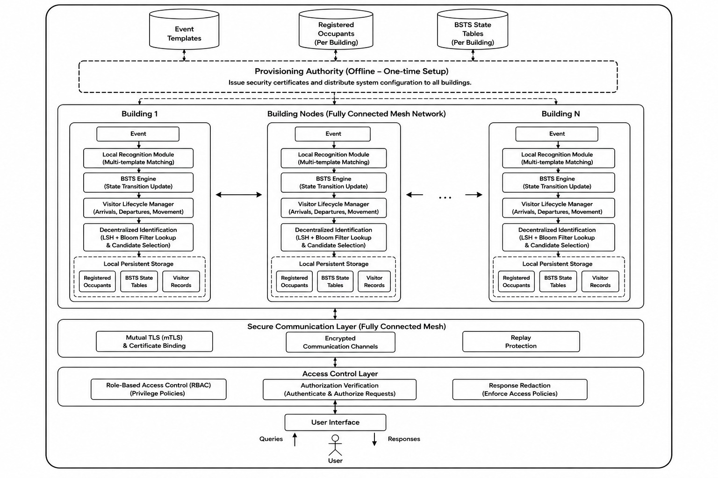
Figure 1: System architecture: building nodes, secure communication layer, access control layer and user interface
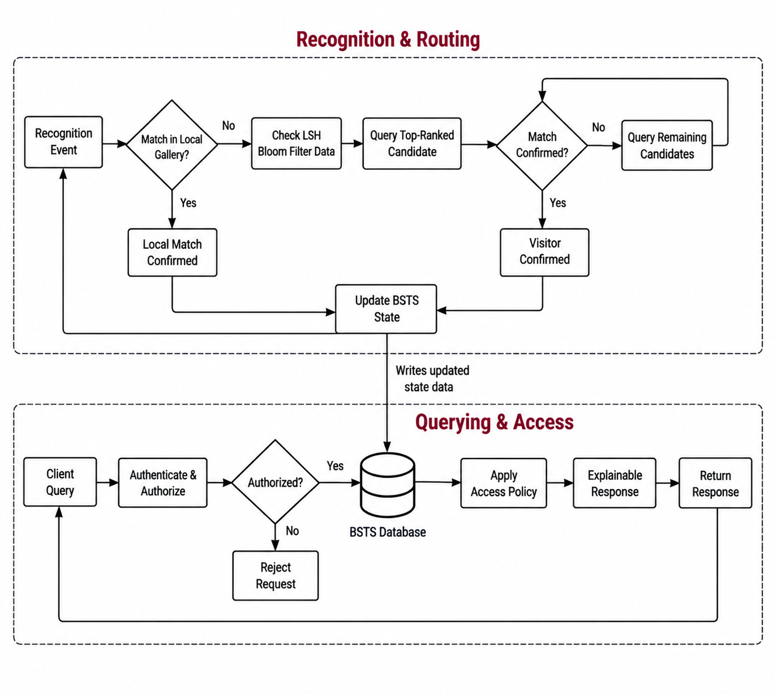
Figure 2: Inter-building tracking workflow and querying / access workflow
Novelty. On the technical side, (a) each building publishes only a Bloom filter of LSH codes, so a capture can rank buildings without any gallery leaving them, and (b) only the shortlisted buildings verify the face. On the application side, (c) a two-layer, class-teacher access policy with graded disclosure, (d) an explanation that is built from the same events as the answer and redacted to the caller's level, and (e) sealed inter-building transfers with certificate-bound keys.

5.2 Proposed approach and procedure

5.2.1 Embedding preprocessing and enrolment
Faces are detected and aligned with SCRFD [18] and embedded with an ArcFace model [17] (512 dimensions). A raw embedding is normalised, centred with the mean of the reference embeddings, and normalised again:
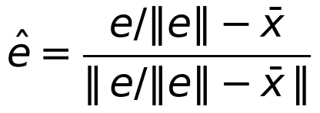 (1)
The R = 20 preprocessed references of an occupant u are averaged into a unit-norm centroid:
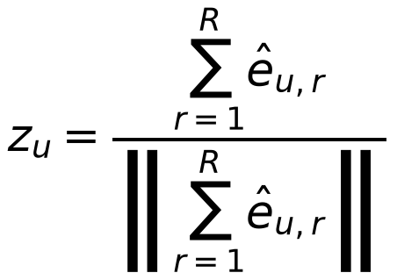 (2)

5.2.2 LSH codes and the Bloom filter
Random hyperplanes (one Gaussian vector w for each slot l and bit k, drawn once and shared by all buildings) define L = 122 slots of K = 11 bits [14]. The bit h is the side of the hyperplane on which the embedding lies, and the K bits of slot l form an integer code c_l:
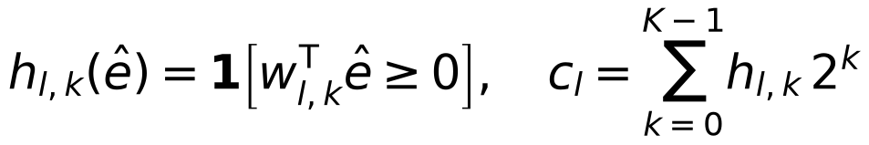 (3)
Each occupant's centroid yields L items, the item for slot l being l times 2 to the power K, plus c_l, so a code counts as a match only in the same slot. The items of all occupants of a building are inserted into a Bloom filter [12] sized for 50 occupants at a target false-positive rate of 0.01. Only the packed bits and a few scalars are published, about 10 KB per building: no ids, embeddings or centroids.

5.2.3 Local recognition, routing and verification
A capture is first compared with the capturing building's own gallery. For every candidate occupant the angle between the capture and each of the 20 references is computed, and a reference votes if its angle is at most 80.43°. The winner is the occupant with most votes (ties broken by the smallest single angle); it is accepted only with at least 12 votes.
If the local check does not accept, the capture is hashed in all L slots. As well as the exact code, the 3 least confident bits of each slot are flipped to give extra probes [15]. Each peer's filter is tested; a building's score is the number of distinct slots that matched, on a 0 to L scale, and the top 5 buildings form the shortlist. They are contacted in rank order over the sealed channel and verify the capture with the same vote rule against their own occupants; the first confirmation ends the search. If no one confirms, the capture is not identified (abstain).

5.2.4 Tracking: probabilities and state
For an identified event with candidate distances d_i to each candidate occupant i, the occupant probabilities follow Definition 3.3 of the DSTS framework [6]: with σ the population standard deviation of the distances,
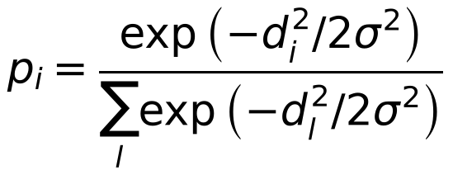 (4)
(uniform over ties when σ = 0). The Bloom score, vote counts and ground truth never enter this probability. The building state store keeps, for each occupant, a probability over the nine zones (z1 Entrance, z2 Mail room, z3 Office, z4 Lounge, z5 Conference, z6 Classroom, z7 Cafeteria, z8 Exit, and zT, the transition zone to the outdoors) and updates it from each event; movement between buildings must pass through zT. The event is stored in the building that observed it: registered occupants in the registered database and visitors in the visitor database.

5.2.5 Dynamic visitor database and visit pointers
A visitor is remembered in three layers. Presence lists who is inside and in which zone, until they leave or the day ends. The day cache keeps the visitor's 20 references for one simulated day, so that later sightings the same day are matched locally without routing. The entry history and permanent pool record every arrival; when earlier entries already satisfy a rule (default: 3 entries in 7 days, or 8 in 30) the next entry stores the visitor's embeddings permanently. A transition-zone rule keeps a visitor who is waiting in zT out of other people's probability updates until they are seen outside zT. A visit pointer (occupant id, current building, entry and exit times, no biometrics) is minted at the home building when the visitor arrives and closed at departure, so a location query follows the pointer instead of asking all buildings.

5.2.6 Role-based access control
Every query passes two layers before execution. Layer 1 authenticates the principal and applies the building scope. Layer 2 is the persona policy, which returns a disclosure level for the pair (caller, target) and the purpose and time of the query. The levels are L0 none, L1 presence, L2 current sector with the time rounded to the hour, L3 exact current zone, and L4 full historical track. Table 6 states the access model.
Table 6: Access model (class-teacher RBAC)
Role | May follow | Disclosure | Cannot see
Dean (1 per building) | Teachers and students of their own campus (any building they are in), and other Deans | L4 for own campus; coarse for other Deans | Other campuses' teachers and students; visitors
Teacher (10 per building) | Only the students on their class roster, in any building | L4 for roster students | Unassigned students, peer teachers, the Dean
Student (39 per building) | Themselves in full; the teachers assigned to them | L4 self, L3 assigned teachers | Peer students, other teachers, the Dean

Building-level queries (Q1, Q2) return aggregates to everyone in their own building and the list of people only to a Dean; zone queries (Q10, Q12, Q13) filter each listed occupant through the same policy; students cannot run zone queries. The thirteen templates are: Q1 did anyone stay after T; Q2 were there more visitors than registered occupants at T; Q3 did O leave before T; Q4 did O enter between t1 and t2; Q5 did O visit all zones; Q6 where was O at T; Q7 how many zones did O visit in an interval; Q8 when did O first visit zone z; Q9 how long did O spend there; Q10 who was in zone z at T; Q11 where was O during an interval; Q12 who was in zone z during an interval; Q13 who ever visited zone z; plus TRACK, the full trajectory.

5.2.7 Explainable responses
Each query builds an explanation from the same filtered event list that it used to compute the answer, never by recomputing afterwards. The explanation holds the decision rule in one sentence, the evidence events with their roles (decisive, last before t, carry-in state, zone visit), what was looked for and not found, uncertainty flags, what redaction withheld, and the visit pointer if one answered the query. Flags come from the identification provenance stored with every identified event (votes, routing rank, Bloom margin, whether the vote winner was also the nearest candidate): low votes (fewer than 16), vote winner not nearest, verified by a lower-ranked building, narrow routing margin (below 5), stale observation (older than 60 minutes) and pointer-based. The identity probability is not used as a confidence signal because it is close to 1 for most misidentifications too. Before leaving the service the explanation is redacted to the caller's disclosure level.

5.2.8 Secure inter-building exchange
Every message between buildings is sealed. The sender generates an ephemeral X25519 key [23], derives a symmetric key with HKDF-SHA256 [22], encrypts with AES-GCM [25] using the whole header as associated data, and signs the header, nonce and ciphertext with Ed25519 [24]. Replies are bound to their request. A campus certificate authority issues node certificates that bind both the signing key and the key-agreement key; expiry, revocation, subject and pinning are checked. A replay guard accepts a message only within a 300-second window and once per nonce, and runs after the signature check so the timestamp is authenticated. Any failed step yields no reply and nothing is admitted (fail closed). The API issues HMAC-signed tokens that expire after one hour, derives a separate login credential for each occupant from a master secret, locks out a client after 5 failures in 60 seconds, and replaces the WebSocket token in the URL with a single-use ticket.

5.2.9 The masked building
To study masked faces, 50 more people from RMFRD [20] form an 11th building. The 50 people with the most real masked photos are used. Each has 20 distinct real unmasked photos as the gallery and 20 masked probes: all their real masked photos up to 20 (800 of the 1,000 probes), topped up with augmented copies (flip, rotation, scale, shift, brightness, blur, noise, JPEG compression) for the 200 remaining. Photos are detected and aligned with SCRFD and embedded with the same ArcFace model. Routing and verification are unchanged: a masked probe is matched against an unmasked gallery. The masked people are not shuffled by the seed.

5.2.10 Parameters
Table 7: Parameters used
Parameter | Value
LSH bits per slot K / slots L | 11 / 122
Bloom target false-positive rate | 0.01
References per occupant R | 20
Accept angle / minimum votes | 80.43° / 12
Shortlist size / extra probes | 5 / 3
Embedding dimension | 512
Visitor promotion rule | 3 entries in 7 days or 8 entries in 30 days
Replay window / token lifetime | 300 s / 1 h
Login lockout | 5 failures in 60 s per client and occupant, or 20 in 5 min per occupant
Contract seed | 42

Chapter 6
Results and Analysis

6.1 Evaluation setup
The evaluation uses 550 occupants in 11 buildings: the 500 CASIA-WebFace people dealt into 10 buildings of 50 by a seeded permutation, and the 50 masked people in building 11. One simulated day has 11,000 events, one for each of the 11,000 test photos; 8,800 are local (the person is in their home building) and 2,200 are visitor events. The main run uses seed 42; variation is measured on five further seeds (0 to 4), each of which places the same people in different buildings and draws a different event day. The baseline is a hypothetical centralised server that holds every building's gallery and searches all of them with the same preprocessing and vote rule, without LSH or Bloom filters. Ground truth is recorded for each event and, for every state, as a full snapshot of who is in which building and zone, so that tracking can be scored at every step.

6.2 Evaluation criteria
All metrics use the one-vs-rest convention. An item has one true label and at most one predicted label out of L labels. TP: the predicted label is the true label. FP: a wrong label was predicted. FN: the true label was not predicted (a wrong prediction or an abstention). TN: every other (item, label) pair, that is items × L − TP − FP − FN. A wrong identity is therefore both an FP and an FN, and an abstention only an FN.
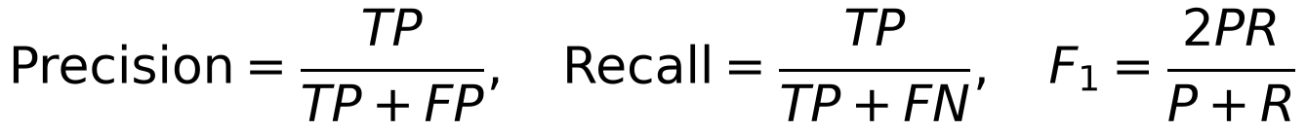 (5)
Identification accuracy is the share of events whose predicted identity is the true one. Because TN is large, accuracy computed with TN is close to 1 and is not used to compare systems. Event level: the label is the occupant id (500 + 50 labels), reported for all, local, visitor, masked and unmasked events. State level: state s_k is the campus after event k; the label is (building, zone) with 99 labels, plus building (11 labels) and zone (9 labels) alone, and every occupant the system places counts, including visitors updated by other people's events. Cost: gallery touched per lookup is the number of buildings whose gallery is searched divided by the number of buildings (the centralised server is 100%); routing recall is the share of routed visitors whose home building is in the shortlist.

6.3 Result

6.3.1 Identification: decentralised against centralised
Table 8: Identification accuracy and gallery touched, seed 42, 11,000 events
Cohort | Events | Centralised accuracy | Decentralised accuracy | Gallery touched
All events | 11,000 | 92.24% | 91.76% | 10.3%
Local | 8,800 | 92.03% | 92.31% | 9.1%
Visitor | 2,200 | 93.05% | 89.59% | 15.2%
Unmasked people | 10,000 | 95.48% | 95.04% | 10.1%
Masked people | 1,000 | 59.80% | 59.00% | 12.3%

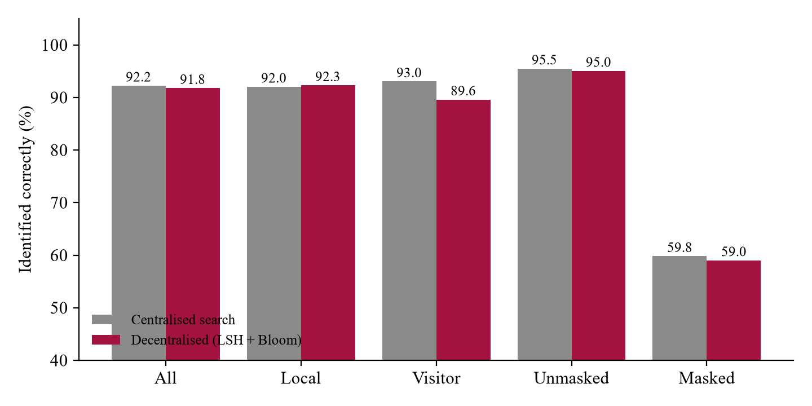
Figure 3: Identification accuracy, centralised search against the decentralised pipeline (seed 42)
Over all events the decentralised pipeline identifies 91.76% against 92.24% for the central search, a difference of 0.47 points, while each lookup touches 10.3% of the galleries. Local events are slightly better with the pipeline (92.31% against 92.03%) because a person is matched only among the 50 people of their own building, so there are fewer look-alikes to confuse them with; the central search must discriminate among 550. The visitor events lose 3.5 points (89.59% against 93.05%), the cost of routing.
Table 9: Event-level confusion counts and scores, seed 42
Cohort | TP | FP | FN | TN | Precision | Recall | F1
All | 10,094 | 217 | 906 | 6,038,783 | 0.9790 | 0.9176 | 0.9473
Local | 8,123 | 134 | 677 | 4,831,066 | 0.9838 | 0.9231 | 0.9525
Visitor | 1,971 | 83 | 229 | 1,207,717 | 0.9596 | 0.8959 | 0.9267
Unmasked | 9,504 | 147 | 496 | 5,489,853 | 0.9848 | 0.9504 | 0.9673
Masked | 590 | 70 | 410 | 548,930 | 0.8939 | 0.5900 | 0.7108

6.3.2 Routing and the visitor database
Of the 2,200 visitor events, 1,447 (65.8%) are served from the building's visitor database (the same visitor sighted again the same day) and 708 are routed. Routing recall, the share of routed visitors whose home building is in the top five, is 85.3%, with 2.08 buildings contacted per routed attempt. Visit-pointer precision is 98.6%. Figure 4 breaks the visitor events down by outcome: errors are mostly routing misses that end in an abstention, and a smaller number of cases where the right building is reached but the face still does not pass verification.
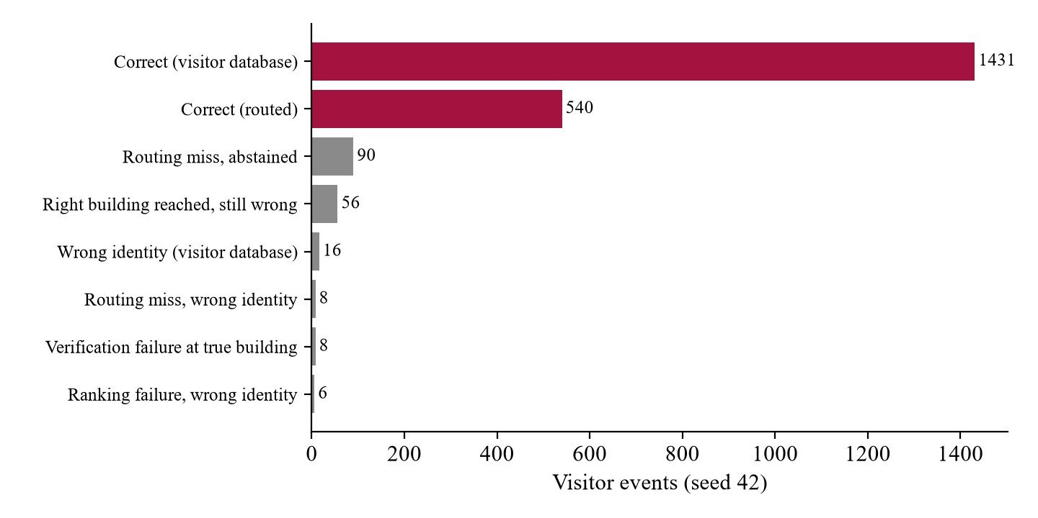
Figure 4: Outcome of the 2,200 visitor events (seed 42)

6.3.3 Stability across five random populations
Table 10: Results over five random populations (one simulated day, 11,000 events each)
Metric (mean over seeds 0-4) | Mean | Std | 95% CI (±) | Min | Max
Identification accuracy, all events | 91.54% | 0.16 | 0.20 | 91.35% | 91.76%
Identification accuracy, local | 92.02% | 0.17 | 0.21 | 91.75% | 92.18%
Identification accuracy, visitors | 89.61% | 0.56 | 0.69 | 88.86% | 90.36%
Routing recall (top 5) | 86.86% | 0.32 | 0.40 | 86.42% | 87.14%
Event F1, unmasked people | 0.9646 | 0.0018 | 0.0023 | 0.9624 | 0.9671
Event F1, masked people | 0.7106 | 0.0026 | 0.0032 | 0.7069 | 0.7131
State F1, building | 0.9501 | 0.0040 | 0.0049 | 0.9437 | 0.9533
State F1, zone | 0.9155 | 0.0021 | 0.0026 | 0.9128 | 0.9180
State F1, building + zone | 0.8957 | 0.0030 | 0.0037 | 0.8904 | 0.8976

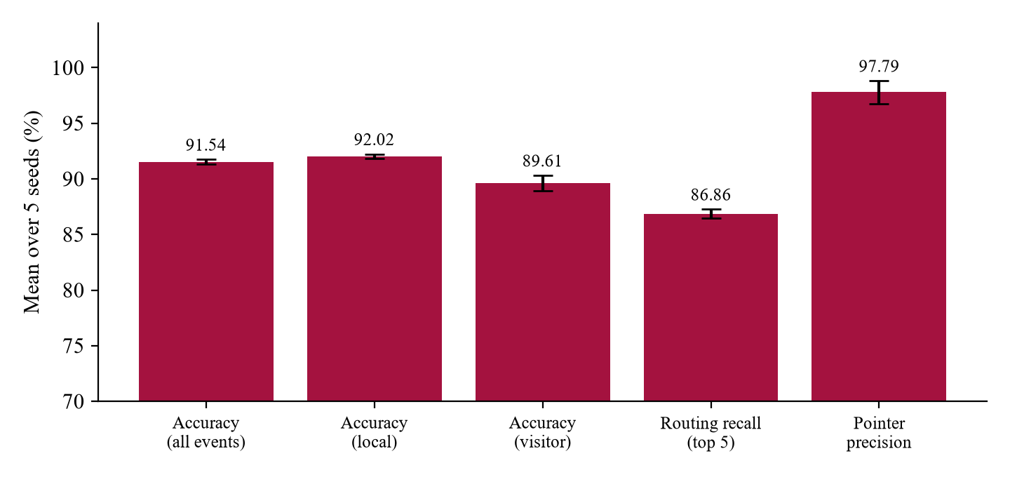
Figure 5: Mean over five seeds with 95% confidence intervals
The spread is small: overall accuracy is 91.54% with a 95% confidence interval of ±0.20 points, so the seed-42 result is representative and does not depend on one lucky assignment of people to buildings. The visitor results vary more (±0.69 points) because they rest on fewer events.

6.3.4 Tracking state
Table 11: State-level scores, mean over all 11,000 states (seed 42)
Level | Labels | Precision | Recall | F1 | Visitor recall
Building + zone | 99 | 0.902 | 0.892 | 0.897 | 0.908
Building | 11 | 0.958 | 0.947 | 0.952 | 0.937
Zone | 9 | 0.919 | 0.908 | 0.913 | 0.946

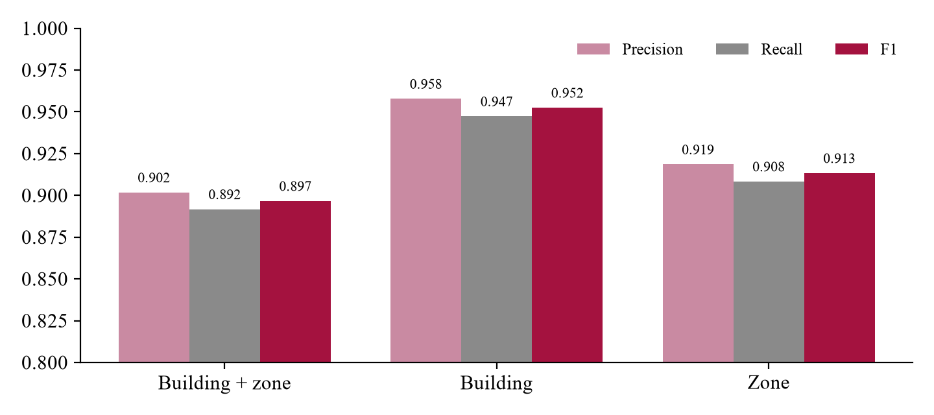
Figure 6: Precision, recall and F1 of the tracked state at three levels
Building-level state, that is knowing which building each person is in after every event, reaches an F1 of 0.952; the zone within a building and the combination are harder because the nine-zone belief is updated from one event at a time.

6.3.5 Masked people
Table 12: Masked against unmasked people (seed 42)
Group | Events | Identified correctly | Abstained | Precision | F1
Unmasked people | 10,000 | 95.04% | 349 | 0.985 | 0.967
Masked people | 1,000 | 59.00% | 340 | 0.894 | 0.711
Masked, at home | 850 | 59.41% | - | 0.895 | 0.714
Masked, visiting | 150 | 56.67% | - | 0.885 | 0.691

Masked people are identified 59.0% of the time against 95.0% for unmasked people; 340 of the 1,000 masked captures are left unidentified. When the system does answer for a masked person it is right 89.4% of the time, so the loss is mostly missed identifications rather than wrong ones. A masked probe is about 72° from its own unmasked gallery on average, close to its nearest other person, so the gallery gives little margin. Routing is also weaker for masked visitors: the right building is found less often and ranked lower.
What was tried. Three ideas were tested offline on the 1,000 masked probes against the 50-person gallery, using the real thresholds. (i) Adding ten synthetic-masked templates per person to the gallery; (ii) matching on the upper face only, by blanking the lower part of both gallery and probe; (iii) relaxing the accept angle and votes when a mask is suspected. Each mostly traded abstentions for wrong answers: relaxing the thresholds alone raised wrong identities from 7.0% to 28.4% and let strangers be accepted 31% of the time. F1 stayed at 0.72 or fell (Figure 7). Without any threshold, the nearest person is the right one only 65-70% of the time whatever the gallery, so the limit is the face model, which was not trained for masks, and the noisy web labels. Enrolling five to eight real masked photos per person gave about five points more in rank-1 accuracy.
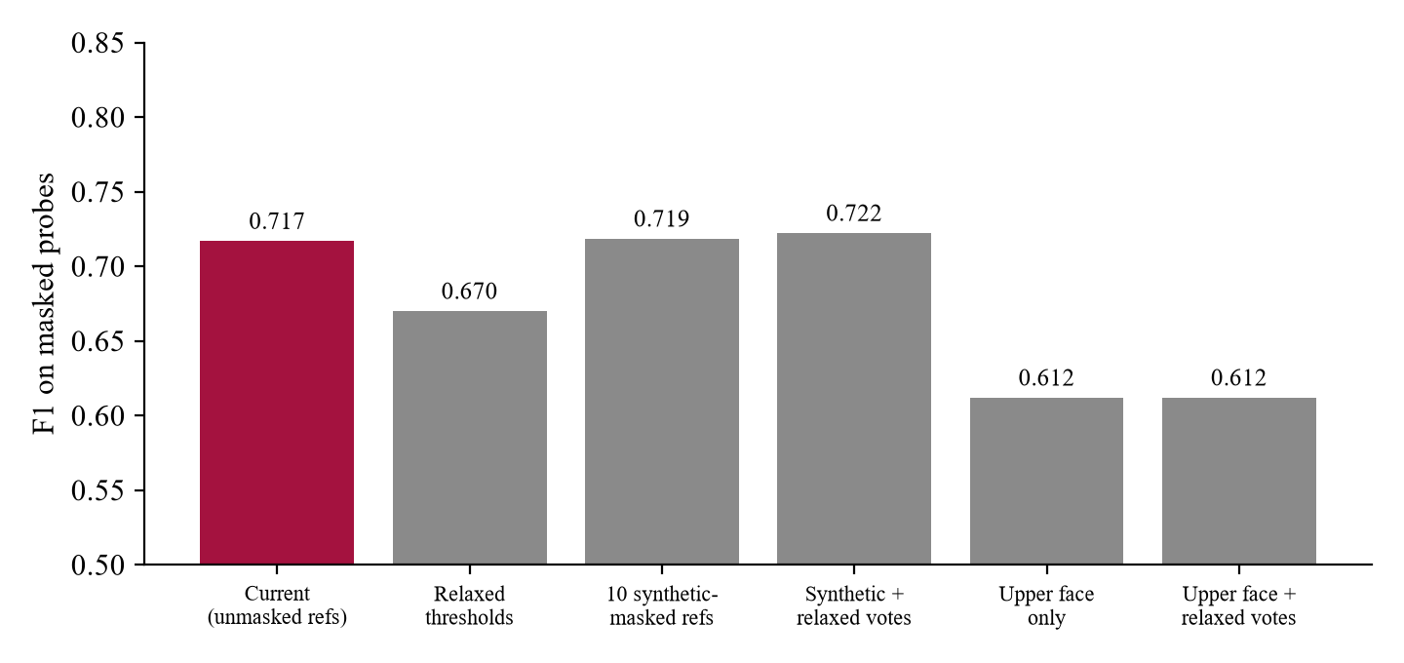
Figure 7: F1 of masked probes for the tested variants (offline, building 11)
The existing mask handler. The pipeline already contained a handler that flags a probe as masked when the spread of per-person minimum angles is large, and then loosens the angle by 4° and the votes by 25%. Measured on seed 42 it flags none of the 850 masked local events and 3,355 of the 7,950 unmasked ones (42%), because a large spread means one person stands out, not that a mask is present. With the handler switched off (DSTS_MASK_HANDLER=off), masked results are unchanged and unmasked people gain 21 correct identifications and lose 22 false accepts. The default is left on and the finding is reported as a limitation.

6.3.6 Verification of the security and policy layers
Table 13: Automated tests by area
Area | Tests | What is checked
access_control | 112 | Every policy cell, structured Layer-1 decisions, building scope, lockout, credentials, tickets, API-level RBAC attacks
secure_transfer | 61 | Sealed payloads: tampering with every header field, replay, wrong sender or recipient, revoked certificate, fail closed, strict decoding
api | 92 | Login, queries per role, caching, zone and time-frame views, dashboard adapter
queries | 184 | Query engine, multi-day normalisation, explanation faithfulness, leakage and uncertainty, CLI access rules
pipeline, population, events, evaluation | 98 | Phase 2/3/4, visitor database, seeded populations, event generation, ground truth, confusion metrics
standalone, centralised, dsts | 19 | Standalone demo, centralised baseline, state library
shared utilities | 5 | Dated timestamps, time-window arithmetic
Total | 571 | All passing on the final commit

A persona matrix tool replays 64 requests (Dean, Teacher, Student and an outsider against each query type and target type) and checks the decision, rule code and disclosure level of each. Examples: a Teacher asking for an unassigned student or for the Dean gets RULE_B_UNASSIGNED_DENIED (L0); a student asking for a peer gets RULE_C_PEER_STALKING_DENIED; a student asking for a zone listing gets RULE_C_PEER_ZONE_SURVEILLANCE_DENIED; any cross-building request gets a CROSS_BUILDING_DENIED rule; a person asking for themselves gets RULE_SELF_LOOKUP at L4.

6.3.7 The dashboard
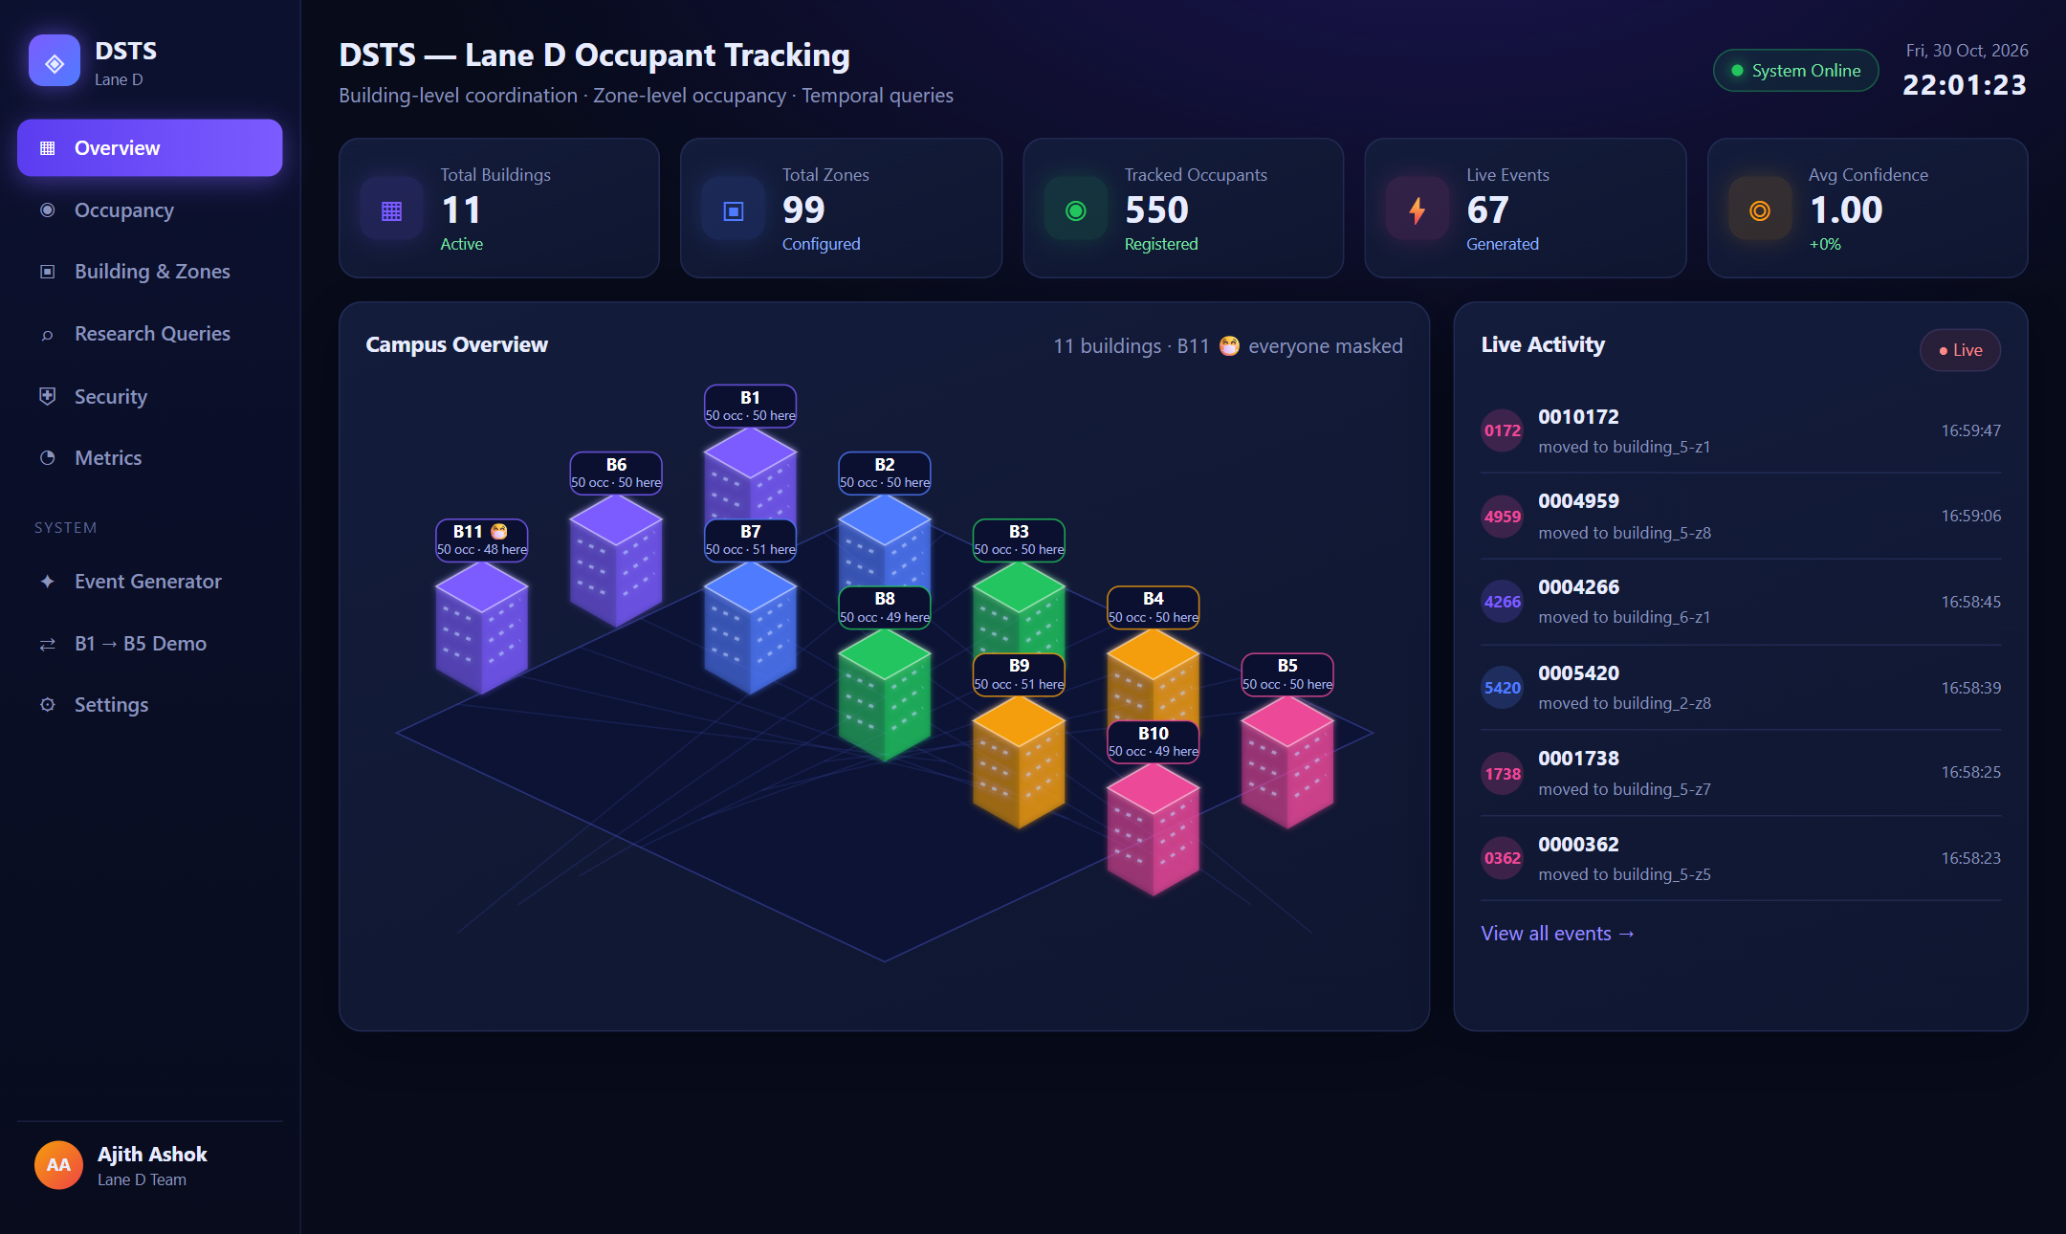
Figure 8: Campus overview: 11 buildings and 550 occupants, with building 11 marked as the all-masked building
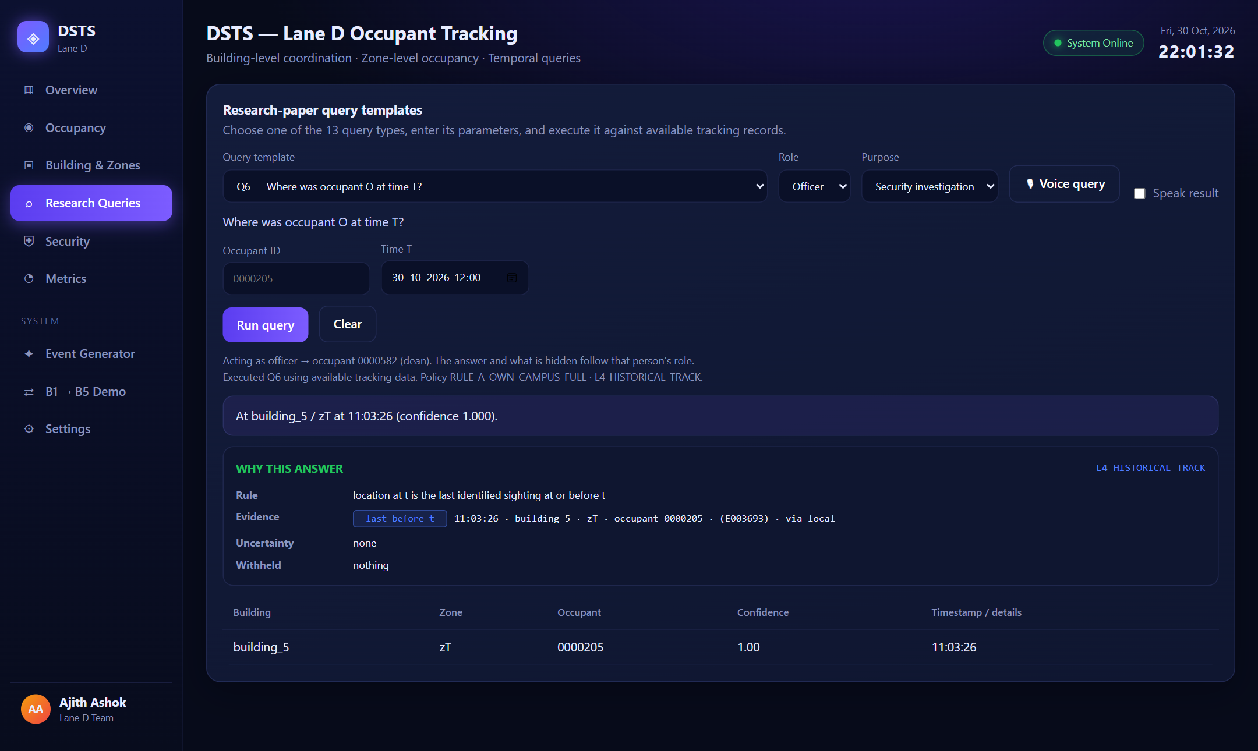
Figure 9: A Dean's query with its “Why this answer” card (rule, evidence, uncertainty, withheld)
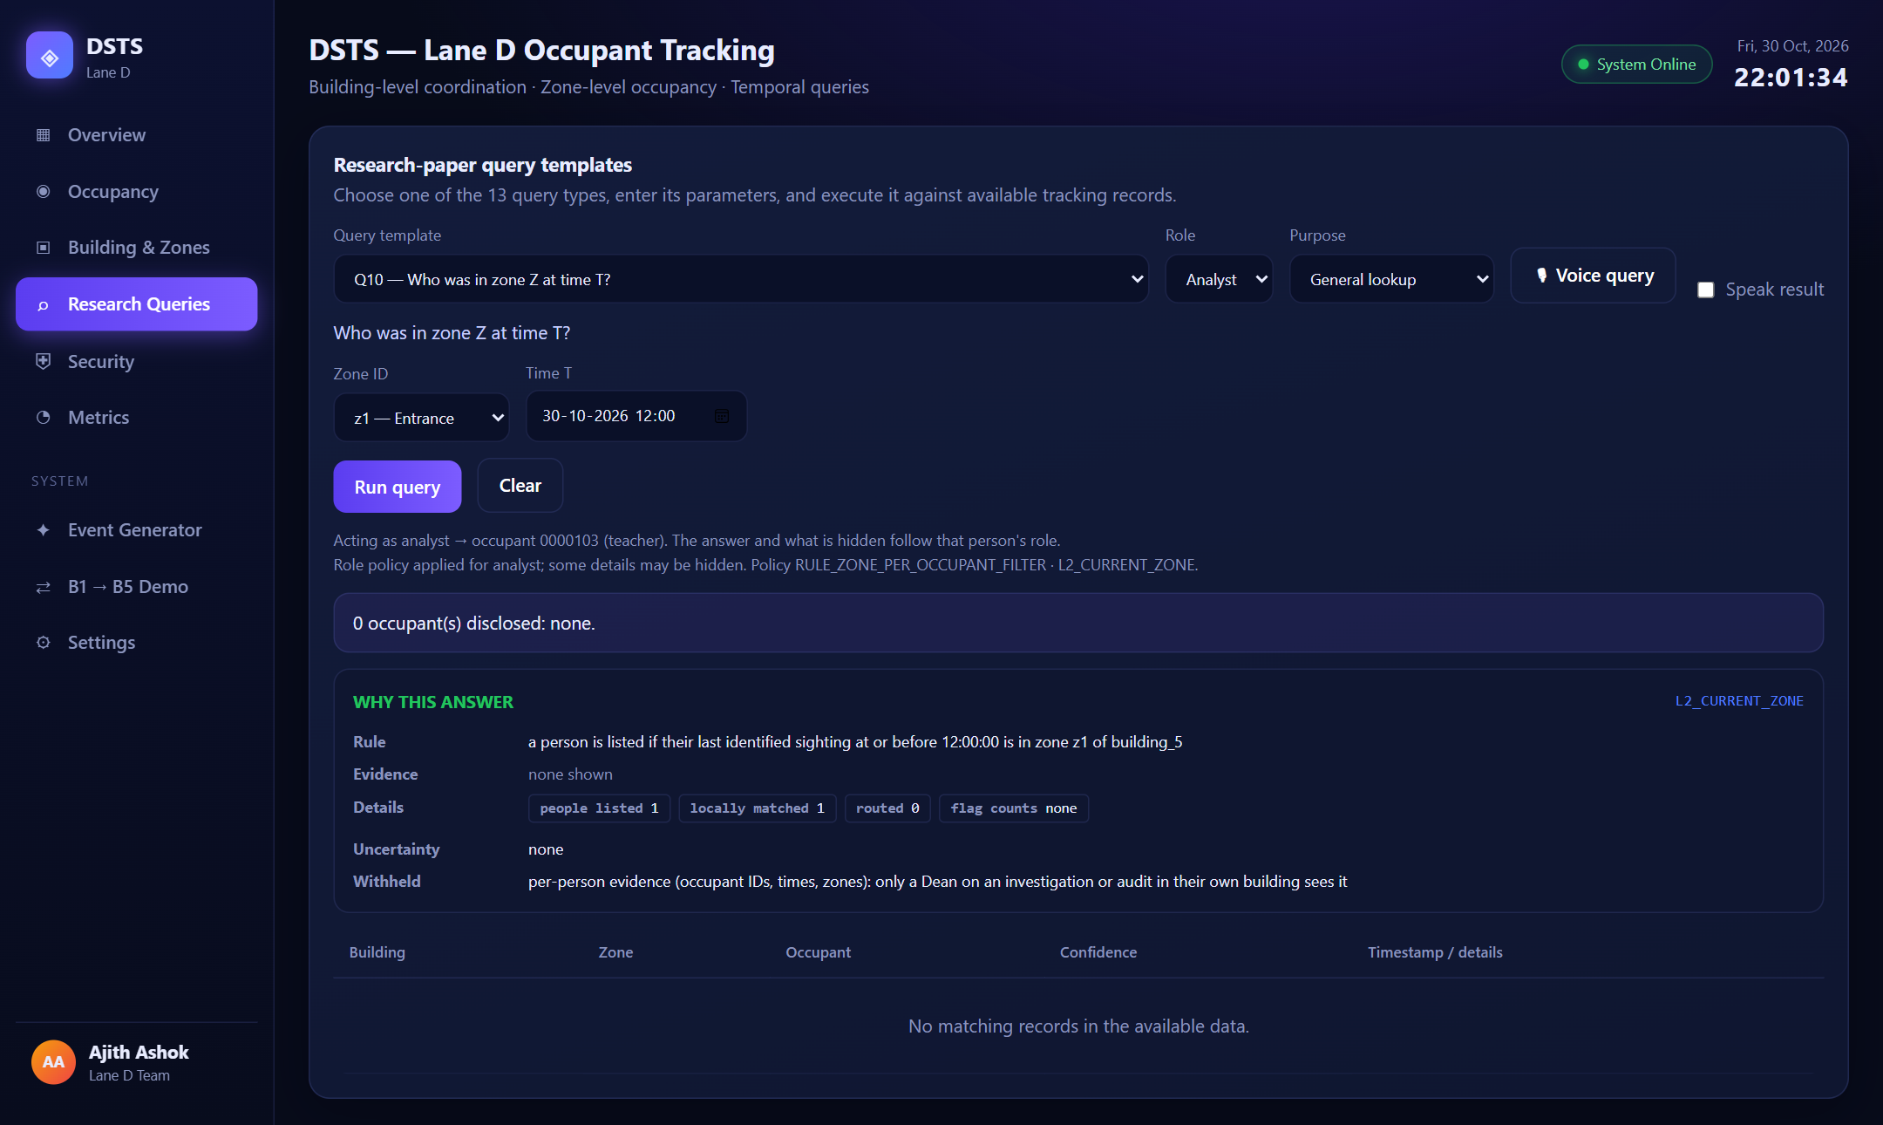
Figure 10: The same page for a Teacher: the answer is reduced and the card states what was withheld

6.4 Comparative analysis
Table 14: Comparison with the baseline and the approaches in the literature
Approach | Visitor lookup | Face data leaving a building | Result here
Centralised search over all galleries (baseline) | One global search | Galleries pooled in one store | 92.24%; 100% of the gallery searched
Decentralised LSH + Bloom routing (this work) | Rank by Bloom score, verify top 5 | Only a 10 KB Bloom filter; references move only after a confirmed match | 91.76%; 10.3% of the gallery
DSTS base paper [6] | Central master list | Master list of visitor embeddings | Not re-run; replaced by the above
Edge-camera tracking [1]-[5] | Within one site | n/a | No cross-building identity, RBAC or explanations

Other published systems [1]-[5] use different data and tasks and cannot be compared number for number; the fair comparison is the same pipeline with a central search. Routing costs 0.47 points overall and 3.5 points on visitors, in exchange for touching about a tenth of the gallery and never pooling it.

6.5 Discussion and interpretation
The results meet the objectives that can be measured. Decentralised identification is within half a point of a central search overall while touching about 10% of the galleries, so the privacy and locality gain costs little accuracy (objectives 1 and 4). Most visitor events are cheap because repeat sightings the same day come from the day cache, which is why the number of buildings contacted per visitor event is small. Tracking is reliable at building level and good at zone level (objective 1). The access model and the explanations are verified by tests rather than by accuracy figures (objectives 2, 3 and 5): every policy cell and every query class is exercised, and an explanation is checked to be faithful to its answer and to reveal no more than the answer does. The weakest result is masked identification, where the limiting factor is the face model rather than the system design.

6.6 Limitations
• The network, cameras and the face detector are simulated. Arrays are plaintext in memory before sealing and after opening, and the certificate authority is a stand-in whose signature is a message authentication code, not a real public-key infrastructure.
• The API has no TLS unless a reverse proxy adds it, no browser security headers, and no encryption of the stored embeddings and state databases. No outside penetration test or fuzzing was done; the attack tests are those the team wrote.
• Token secrets, caches and lockout counters are per process, so they would not hold across several servers; the dashboard's demo mode lets any viewer act as any role by design.
• The masked building uses web-crawled photos with some wrong labels, and 20% of the masked probes are augmented copies. Masked results are not an accuracy estimate for new people.
• A wrong identity stored in the visitor cache stays for the rest of that day, and a visitor whose departure is not identified stays “present” until the day ends.
• Only 550 people in 11 buildings were measured; larger scale is untested. The same 20 test photos per person are reused across days in multi-day runs.
• Results are from simulated movement on replayed photos, not from live video.

Chapter 7
Conclusion

7.1 Conclusion
This project built and evaluated a system that identifies and tracks occupants across buildings without pooling face data, answers queries according to the caller's role and relationship, and explains each answer. A visitor is found by routing a capture with LSH codes and per-building Bloom filters and verifying it only in the shortlisted buildings. On 11,000 events it identifies 91.8% correctly against 92.2% for a centralised search, touching 10.3% of the galleries; over five random populations the accuracy is 91.5% ± 0.2. A dynamic visitor database makes most repeat visits free of routing. A two-layer class-teacher policy, sealed transfers and redacted explanations are implemented and covered by 571 automated tests. Masked people are the hard case at 59.0%, and the evidence points to the face model, not the routing, as the limit. All six objectives are achieved in simulation; the security work is a tested design on a simulated network and not a hardened deployment.
Table 15: Objective-wise status
Objective | Planned | Status | Evidence
1 Multi-building DSTS extension | Mid review | Achieved | BSTS over 11 buildings; building-level state F1 0.9501
2 RBAC query interface | 24/9/26 | Achieved | Two layers, class-teacher model, every policy cell tested
3 Explainable responses | 26/9/26 | Achieved | Rule, evidence, flags, redaction; faithfulness tests
4 LSH + Bloom routing | Mid review | Achieved | 10.3% of gallery touched, 0.47-point accuracy cost
5 Security layer | 2/10/26 | Achieved (simulated network) | Sealed transfers, tokens, lockout, audit log
6 Evaluation | Final review | Achieved | Event and state TP/FP/FN/TN, five seeds, centralised baseline

7.2 Future work
• Masked recognition. Use a face model trained with masks, replace the angle-spread mask heuristic with a real mask detector, and enrol a few real masked photos per person (about five points of rank-1 accuracy in our tests).
• Tracking context. Prefer people known to be inside the building and fuse consecutive frames, to reduce masked errors; validate on the same seed-42 events.
• Production security. Real TLS between buildings, a real public-key infrastructure, encryption at rest, security headers, and an independent penetration test and fuzzing of the decoder and API.
• Real deployment. Live cameras and detectors, more buildings and people, and a multi-week run to test the permanent visitor pool.
• Learned routing. Compare the LSH + Bloom routing with learned or partitioned routing for distributed vector search.

References
[1] C. Hegde, H. Kwon, G. D. Clifford et al., “Indoor group identification and localization using privacy-preserving edge computing distributed camera network,” IEEE J. Indoor Seamless Position. Navig., vol. 2, pp. 51–60, 2024, doi: 10.1109/JISPIN.2024.3354248.
[2] H. Kwon et al., “A feasibility study on indoor localization and multiperson tracking using sparsely distributed camera network with edge computing,” IEEE J. Indoor Seamless Position. Navig., 2023, doi: 10.1109/JISPIN.2023.3337189.
[3] S. Yang, F. Ding, P. Li, and S. Hu, “Distributed multi-camera multi-target association for real-time tracking,” Sci. Rep., vol. 12, art. no. 11052, 2022, doi: 10.1038/s41598-022-15000-4.
[4] S. Casao, A. Naya, A. C. Murillo, and E. Montijano, “Distributed multi-target tracking in camera networks,” arXiv:2010.13701, 2021.
[5] B. Gaikwad and A. Karmakar, “Smart surveillance system for real-time multi-person multi-camera tracking at the edge,” J. Real-Time Image Process., 2021, doi: 10.1007/s11554-020-01066-8.
[6] L. Mohan and V. Menon, “Modelling large scale camera networks for identification and tracking: an abstract framework,” IET Comput. Vis., vol. 14, no. 7, pp. 426–433, 2020.
[7] V. Menon, B. Jayaraman, and V. Govindaraju, “The three Rs of cyberphysical spaces,” Computer, vol. 44, no. 9, pp. 73–79, 2011.
[8] S. P. Nair, K. A. Reddy, P. K. Alluri, and S. Lalitha, “Face recognition and tracking for security surveillance,” J. Intell. Fuzzy Syst., vol. 41, no. 5, pp. 5337–5345, 2021, doi: 10.3233/JIFS-189856.
[9] Z. Wu et al., “Learning-based tracking-before-detect for unconstrained indoor human tracking using RF signal,” IEEE Trans. Mobile Comput., vol. 24, no. 6, pp. 4777–4793, 2025, doi: 10.1109/TMC.2025.3529501.
[10] C. Rathgeb, F. Breitinger, C. Busch, and H. Baier, “On application of Bloom filters to iris biometrics,” IET Biometrics, vol. 3, no. 4, pp. 207–218, 2014.
[11] F. Marzani, T. van Ede, G. Heijenk, and M. van Steen, “Head count: privacy-preserving face-based crowd monitoring,” arXiv:2604.14250, 2026.
[12] B. H. Bloom, “Space/time trade-offs in hash coding with allowable errors,” Commun. ACM, vol. 13, no. 7, pp. 422–426, 1970.
[13] L. Fan, P. Cao, J. Almeida, and A. Z. Broder, “Summary cache: a scalable wide-area web cache sharing protocol,” IEEE/ACM Trans. Netw., vol. 8, no. 3, pp. 281–293, 2000.
[14] M. S. Charikar, “Similarity estimation techniques from rounding algorithms,” in Proc. 34th Annu. ACM Symp. Theory Comput. (STOC), 2002, pp. 380–388.
[15] Q. Lv, W. Josephson, Z. Wang, M. Charikar, and K. Li, “Multi-probe LSH: efficient indexing for high-dimensional similarity search,” in Proc. 33rd Int. Conf. Very Large Data Bases (VLDB), 2007, pp. 950–961.
[16] A. Kirsch and M. Mitzenmacher, “Less hashing, same performance: building a better Bloom filter,” in Algorithms – ESA 2006, LNCS vol. 4168, Springer, 2006, pp. 456–467.
[17] J. Deng, J. Guo, N. Xue, and S. Zafeiriou, “ArcFace: additive angular margin loss for deep face recognition,” in Proc. IEEE/CVF Conf. Comput. Vis. Pattern Recognit. (CVPR), 2019, pp. 4690–4699.
[18] J. Guo, J. Deng, A. Lattas, and S. Zafeiriou, “Sample and computation redistribution for efficient face detection,” in Proc. Int. Conf. Learn. Represent. (ICLR), 2022.
[19] D. Yi, Z. Lei, S. Liao, and S. Z. Li, “Learning face representation from scratch,” arXiv:1411.7923, 2014.
[20] Z. Wang et al., “Masked face recognition dataset and application,” arXiv:2003.09093, 2020.
[21] R. S. Sandhu, E. J. Coyne, H. L. Feinstein, and C. E. Youman, “Role-based access control models,” IEEE Computer, vol. 29, no. 2, pp. 38–47, 1996.
[22] H. Krawczyk and P. Eronen, “HMAC-based extract-and-expand key derivation function (HKDF),” RFC 5869, IETF, 2010.
[23] A. Langley, M. Hamburg, and S. Turner, “Elliptic curves for security,” RFC 7748, IETF, 2016.
[24] S. Josefsson and I. Liusvaara, “Edwards-curve digital signature algorithm (EdDSA),” RFC 8032, IETF, 2017.
[25] M. Dworkin, “Recommendation for block cipher modes of operation: Galois/Counter Mode (GCM) and GMAC,” NIST Special Publication 800-38D, 2007.
[26] M. S. S. Suresh and V. Menon, “A generic and scalable approach to maximize coverage in diverse indoor and outdoor multicamera surveillance scenarios,” IEEE Trans. Syst., Man, Cybern., Syst., vol. 53, no. 2, pp. 1172–1182, 2022.
[27] United Nations General Assembly, “Transforming our world: the 2030 Agenda for Sustainable Development,” A/RES/70/1, 2015.

