Experiment - 1

Aim: Write a program to find the factorial of a number

pseudocode :
1. Function factorial(n):
a. Initialize result = 1
b. For i from 1 to n:
i. result *= i
c. Return result
2. Input number
3. Call factorial function and print the result
Source code:

def fact(n):
if n==0 or n==1:
return 1
elif n<0:
return -1
else:
return n*fact(n-1)

n=int(input("enter number:"))
if fact(n)==-1:
print("enter postive number")
else:
f=fact(n)
print("factirial:",f)

Output:

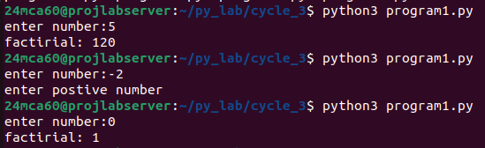

Experiment - 2

Aim: Generate Fibonacci series of N terms

pseudocode :

1. Function fibonacci(n):
a. Initialize fib_series as empty list
b. Initialize a = 0, b = 1
c. For _ from 0 to n-1:
i. Append a to fib_series
ii. Update a, b to b, a + b
d. Return fib_series
2. Input number of terms
3. Call fibonacci function and print the series

Source code:

def fibonacci(n):
fib_series = []
a, b = 0, 1
for _ in range(n):
fib_series.append(a)
a, b = b, a + b
return fib_series

terms = int(input("Enter the number of terms: "))
print(f"Fibonacci series: {fibonacci(terms)}")

Output:

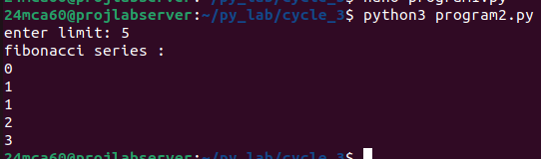

Experiment - 3

Aim: Write a program to find the sum of all items in a list. [Using for loop]

pseudocode :

1. Function sum_of_list(lst):
a. Initialize total = 0
b. For each item in lst:
i. total += item
c. Return total
2. Define a list of numbers
3. Call sum_of_list function and print the sum

Source code:

def sum_of_list(lst):
total = 0
for item in lst:
total += item
return total

numbers = [10, 20, 30, 40, 50] # Example list
print(f"total sum of elements: {sum_of_list(numbers)}")

Output:

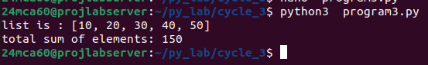

Experiment - 4

Aim: Generate a list of four digit numbers in a given range with all their digits even and
the number is a perfect square.

pseudocode :

1. Function even_perfect_squares(start, end):
a. Initialize results as empty list
b. For num from start to end:
i. If num is between 1000 and 9999 and num is even:
A. Find the square root of num
B. If square root squared is num:
a. Convert num to string
b. If all digits are even:
i. Append num to results
c. Return results
2. Input start and end range
3. Call even_perfect_squares function and print the results

Source code:

import math

start=1000
n=int(input("enter a limit(number between 1000-9999):"))

result=[]

for i in range(int(math.sqrt(start)), int(math.sqrt(n)+1)):
sq=i**2
if start<=sq<=n:
str_sq=str(sq)
if len(str_sq)==4 and all(int(digit)%2==0 for digit in str_sq):
result.append(sq)

print(result)

Output:

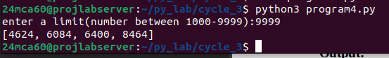

Experiment - 5

Aim: Write a program using a for loop to print the multiplication table of n, where n is
entered by the user.

pseudocode :

1. Function multiplication_table(n):
a. For i from 1 to 10:
i. Print n x i = n * i
2. Input n
3. Call multiplication_table function

Source code:

n=int(input("enter a number to print multiplication table:"))

for i in range(1,10):
print(f"{n} * {i} = {n*i}")

Output:

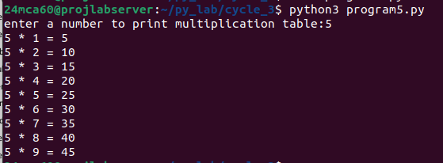

Experiment - 6

Aim: Write a program to display alternate prime numbers till N (obtain N from the user

pseudocode :
1. Function is_prime(num):
a. If num < 2:
i. Return False
b. For i from 2 to sqrt(num):
i. If num % i == 0:
A. Return False
c. Return True
2. Function alternate_primes(n):
a. Initialize count = 0
b. For num from 2 to n:
i. If is_prime(num):
A. Increment count
B. If count is odd:
a. Print num
3. Input upper limit
4. Call alternate_primes function

Source code:

def is_prime(num):
if num < 2:
return False
for i in range(2, int(num**0.5) + 1):
if num % i == 0:
return False
return True

def alternate_primes(n):
count = 0
for num in range(2, n + 1):
if is_prime(num):
count += 1
if count % 2 == 1: # Print alternate primes
print(num)

limit = int(input("enter a limit(any positive number): "))
print("alternate prime numbers:")
alternate_primes(limit)

Output:

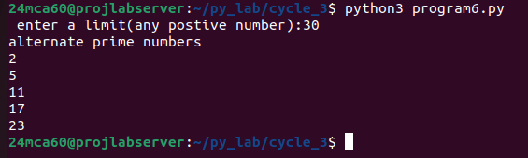

Experiment - 7

Aim: Write a program to compute and display the sum of all integers that are divisible
by 6 but not by 4, and that lie below a user-given upper limit.

pseudocode :

1. Function sum_divisible_by_6_not_4(limit):
a. Initialize total = 0
b. For i from 0 to limit-1:
i. If i % 6 == 0 and i % 4 != 0:
A. total += i
c. Return total
2. Input upper limit
3. Call sum_divisible_by_6_not_4 function and print the sum

Source code:

def sum_divisible_by_6_not_4(limit):
total = 0
for i in range(limit):
if i % 6 == 0 and i % 4 != 0:
total += i
return total

upper_limit = int(input("Enter the upper limit: "))
print(f"Sum of integers divisible by 6 but not by 4 below {upper_limit}: {sum_divisible_by_6_not_4(upper_limit)}")

Output:

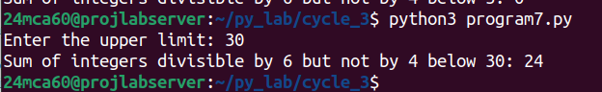

Experiment - 8

Aim: Calculate the sum of the digits of each number within a specified range (from 1 to
a user-defined upper limit). Print the sum only if it is prime.

pseudocode :

1. Function sum_of_digits(n):
a. Initialize sum = 0
b. For each digit in n:
i. sum += digit
c. Return sum
2. Function is_prime(num):
a. Check if num < 2
b. For i from 2 to sqrt(num):
i. If num % i == 0:
A. Return False
c. Return True
3. Function sum_digits_in_range(upper_limit):
a. For num from 1 to upper_limit:
i. Calculate digit_sum using sum_of_digits
ii. If digit_sum is prime:
A. Print digit_sum
4. Input upper limit
5. Call sum_digits_in_range function

Source code:

def sum_of_digits(n):
return sum(int(digit) for digit in str(n))

def is_prime(num):
if num < 2:
return False
for i in range(2, int(num**0.5) + 1):
if num % i == 0:
return False
return True

def sum_digits_in_range(upper_limit):
for num in range(1, upper_limit + 1):
digit_sum = sum_of_digits(num)
if is_prime(digit_sum):
print(f'Sum of digit {num} = {digit_sum}')

limit = int(input("Enter an upper limit: "))
sum_digits_in_range(limit)

Output:

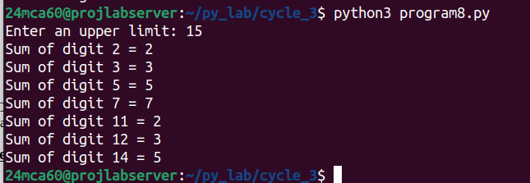

Experiment – 9

Aim: A number is input through the keyboard. Write a program to determine if it’s
palindromic.

pseudocode :

1. Function is_palindrome(num):
a. Convert num to string
b. If string is equal to reverse of string:
i. Return True
c. Return False
2. Input number
3. Call is_palindrome function and display result
Source code:

def is_palindrome(num):
return str(num) == str(num)[::-1] # [::-1] make the string in rever>

number = int(input("Enter a number: "))
if is_palindrome(number):
print(f"{number} is a palindromic number.")
else:
print(f"{number} is not a palindromic number.")

Output:

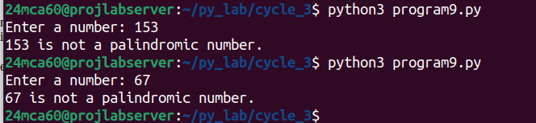

Experiment - 10

Aim: Write a program to generate all factors of a number. [use while loop]

Source code:

def factors(num):
result = []
i = 1
while i <= num:
if num % i == 0:
result.append(i)
i += 1
return result

number = int(input("Enter a number to find its factors: "))
print(f"Factors of {number}: {factors(number)}")

Output:

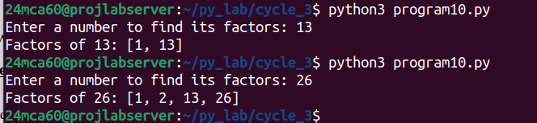

Experiment - 11

Aim: Write a program to find whether the given number is an Armstrong number or
not. [use while loop]

pseudocode :

1. Function is_armstrong(num):
a. Initialize sum_of_cubes = 0
b. Store original_num = num
c. While num > 0:
i. Extract last digit
ii. Update sum_of_cubes += digit^3
iii. Remove last digit
d. If sum_of_cubes equals original_num:
i. Return True
e. Return False
2. Input number
3. Call is_armstrong function and display result

Source code:

def is_armstrong(num):
sum_of_cubes = 0
original_num = num
while num > 0:
digit = num % 10
sum_of_cubes += digit ** 3
num //= 10
return sum_of_cubes == original_num

number = int(input("Enter a number: "))
if is_armstrong(number):
print(f"{number} is an Armstrong number.")
else:
print(f"{number} is not an Armstrong number.")

Output:

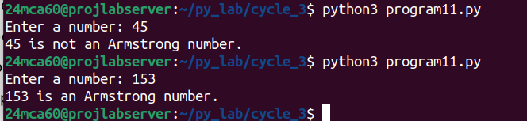

Experiment - 12

Aim: Display the given pyramid with the step number accepted from the user. Eg: N=4
1
24
369
4 8 12 16

pseudocode :

1. Function display_pyramid(n):
a. For i from 1 to n:
i. For j from 1 to i:
A. Print i * j
ii. Move to the next line
2. Input number of steps
3. Call display_pyramid function

Source code:

print("pattern :\n")
for i in range(1,4+1):
for j in range(1,i+1):
print(i*j,end=" ")
print("\n")

Output:

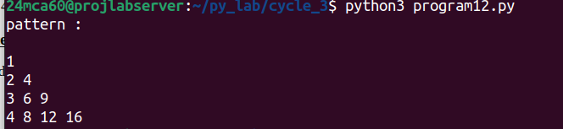

Experiment - 13

Aim: Construct following pattern using nested loop
*
**
***
****
*****
****
***
**
*

pseudocode :

1. Function display_pyramid(n):
a. For i from 1range of 1,rows+1
num_stars=1 if i<=5 else num_stars=rows-i=1
i. For j in range of num_stars:
A. Print *
ii. Move to the next line
b.go to new line
2. Call display_pyramid function

Source code:

rows=9

for i in range (1,rows+1):
if i<=5:
num_stars=i
else:
num_stars=rows-i+1

for j in range(num_stars):
print("*",end="")
print()

Output:

