Aim: Create a string from the given string where the first and last character are exchanged.
Eg: Python ⇒ nythoP

Source code:

s=list(input("enter a string: "))
s[0],s[-1]=s[-1],s[0]

print("outpust string : ",("".join(s)))

Output:

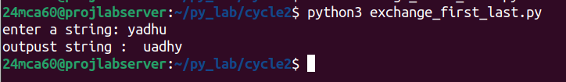

Aim: Get a string from an input string where all occurrences of the first character are
replaced with ‘$’, except the first character. [eg: onion -> oni$n]

Source code:

s=list(input("enter a string: "))
first=s[0]
for i in range(1,len(s)):
if s[i]==first:
s[i]="$"

print("".join(s))

Output:

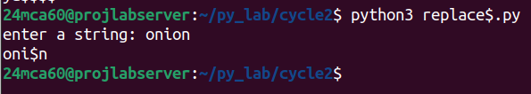

Aim: Create a single string separated with space from two strings by swapping the characterat position 1.
Eg : str1 = “Hello” str2 =”World” , then create a string str3 = “Hollo Werld” [Hint:
useslicing and concatenation ]

Source code:

s1=input("enter string1: ")
s2=input("enter string2: ")

s3=s1[:1]+s2[1]+s1[2:]+" "+s2[:1]+s1[1]+s2[2:]
print(s3)

Output:

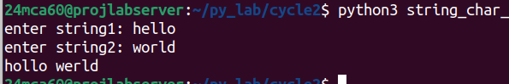

Aim: Count the number of characters (character frequency) in a string

Source code:

s=input("enter a string:")
freq_dict={}
for char in s:
if char in freq_dict:
freq_dict[char]+=1
else:
freq_dict[char]=1

print("character occurance:")
for key,value in freq_dict.items():
print(f"{key}:{value}")

Output:

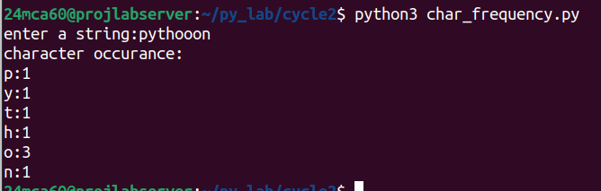

Aim: Add ‘ing’ at the end of a given string. If it already ends with ‘ing’, then add ‘ly’

Source code:

s=input("enter a string:")
if s.endswith('ing'):
print(s+"ly")
else:
print(s+"ing")

Output:

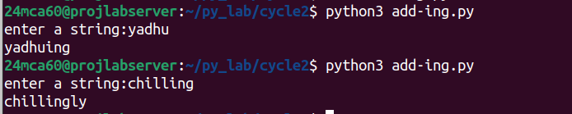

Aim: Store a list of first names. Count the occurrences of ‘a’ within the list.

Source code:

names=[]
n=int(input("enter limit:"))
for i in range(n):
el=input(f"enter name{i+1} :")
names.append(el)

print("occurances of a in names:")
for name in names:
print(f"{name}:{name.lower().count('a')}")

Output:

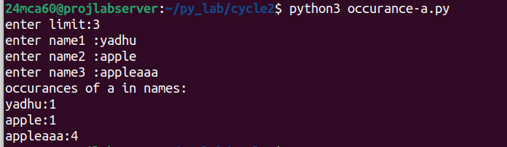

Aim: Write a python program to read two lists color-list1 and color-list2. Print out all colors from color-list1 not contained in color-list2.’

Source code:

lst1=input("enter list1 lements by space seperated :").split()
lst2=input("enter list2 lements by space seperated :").split()
print("output list :")
print(list(set(lst1)-set(lst2)))

Output:

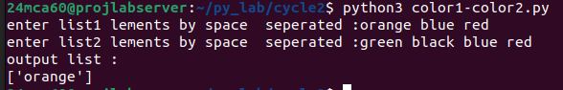

Aim: Create a list of colors from comma-separated color names entered by the user. Display first and last colors.

Source code:

lst1=input("enter list1 comma seperated:").split(",")
lst2=input("enter list2 comma seperated:").split(",")

print(f"first color of list1 :{lst1[0]}\n last color of list2 :{lst2[-1]}")

Output:

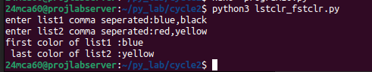

Aim: Write a program to prompt the user for a list of integers. For all values greater than
100,store ‘over’ instead

Source code:

lst=[int(num) for num in input("enter list elements(space seperated):").split()]

for i in range(len(lst)):
if lst[i] > 100:
lst[i]="over"
print(lst)

Output:

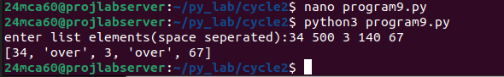

Aim: From a list of integers, create a list after removing even numbers.

Source code:

lst=[int(num) for num in input("enter a list of numbers(space seperated):").split()]
odd_list=[odd for odd in lst if odd%2!=0]

print(odd_list)

Output:

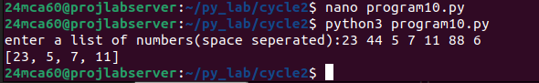

Aim: Accept a list of words and return the length of the longest word.

Source code:

lst=input("enter a list of words(space sperated):").split()
maxlength=max(len(word) for word in lst)
lword=[word for word in lst if len(word)==maxlength]

print(f"largest word word:{lword}, size:{maxlength}")

Output:

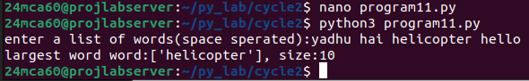

Aim: Write a program to prompt the user to enter two lists of integers and check
(a) Whether lists are of the same length.
(b) Whether the list sums to the same value.
(c) Whether any value occurs in both Lists.

Source code:

lst1=[int(num) for num in input("enter a list1 (space seperated):").split()]
lst2=[int(num) for num in input("enter a list2 (space seperated):").split()]

length=len(lst1)==len(lst2)
lsum=sum(lst1)==sum(lst2)
common=set(lst1)&set(lst2)

if length:
print("lists lengths are same")
else :
print("lists lengths are not same")

print(f"lists common elements{common}")

if lsum:
print(f"list sums are same")
else:
print("list sums are not same")

Output:

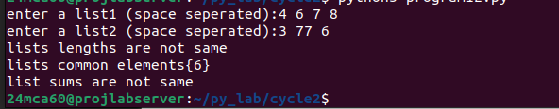

Aim: Write a Python program to count the occurrences of each word in a line of text.
Hint: use split() function and dictionary
Sample input : the quick brown fox jumps over the lazy dog
Output : {'the': 2, 'jumps': 1, 'brown': 1, 'lazy': 1, 'fox': 1, 'over': 1, 'quick': 1, 'dog.': 1}

Source code:

sentence=[word for word in input("enter a string:").lower().split()]
freq_dict={}
for word in sentence:
if word in freq_dict:
freq_dict[word]+=1
else:
freq_dict[word]=1

print("character occurance:")
for key,value in freq_dict.items():
print(f"{key}:{value}")

Output:
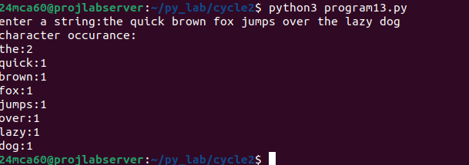

Aim: List comprehensions:
(a) Generate positive list of numbers from a given list of integers
(b) Square of N numbers
(c) Form a list of vowels selected from a given word
(d) Form a list ordinal value of each element of a word (Hint: use ord() to get
ordinal values)

Source code:

#postive nums from a list of integers
nums=[-1,-2,3,4,5,6,-10,20,-22,-50]
pos=[num for num in nums if num>0]
print("postive list elements in the list are:",pos)

#square of n numbers
n=5
sq=[i**2 for i in range(1,n+1)]
print(f"square of list elements upto {n} elements is: {sq}")

#vowels in a word
word="hello world"
vowels=[char for char in word.lower() if char in 'aeiou']
print(f"vowels in {word} are :{vowels}")

#ordinal values in list
ord=[ord(char) for char in word]
print(f"ordinal values :{ord}")

Output:
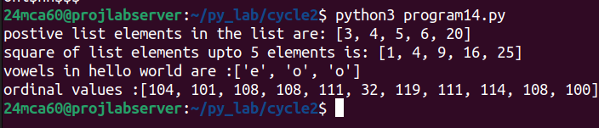

Aim: Sort dictionary in ascending and descending order

Source code:

my_dict={'apple':5,'banana':10,'orange':15}

a_sorted=dict(sorted(my_dict.items()))
d_sorted=dict(sorted(my_dict.items(),reverse=True))

print(my_dict)
print(f"ascending order sort:{a_sorted}")
print(f"descending order sort:{d_sorted}")

Output:
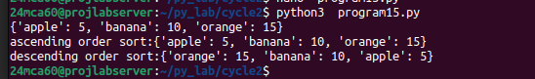

Aim: Merge two dictionaries

Source code:

dict1={'a':1,'b':2}
dict2={'c':3,'d':4}

print('dictionary combining')
print(dict1|dict2)

Output:
