Aim: Write a program to find the factorial of a number

Source code:

def fact(n):
if n==0 or n==1:
return 1
elif n<0:
return -1
else:
return n*fact(n-1)

n=int(input("enter number:"))
if fact(n)==-1:
print("enter postive number")
else:
f=fact(n)
print("factirial:",f)

Output:

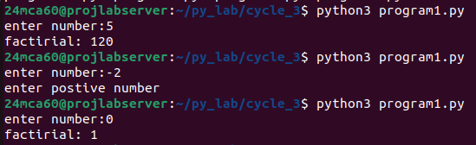

Aim: Generate Fibonacci series of N terms

Source code:

n=int(input("enter limit: "))

n1=0
n2=1
next=n1
count=1
print("fibonacci series :")
while count<=n:
print(next)
count+=1
n1,n2=n2,next
next=n1+n2

Output:

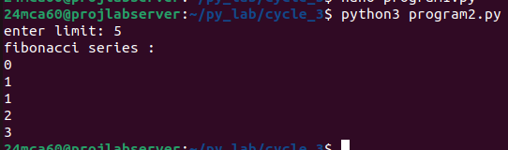

Aim: Write a program to find the sum of all items in a list. [Using for loop]

Source code:

mylist=[10,20,30,40,50]
total=0

for i in range (0,len(mylist)):
total=total+mylist[i]
print("list is :",mylist)
print("total sum of elements:",total)

Output:

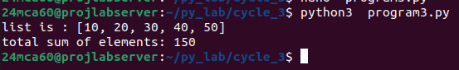

Aim: Generate a list of four digit numbers in a given range with all their digits even and
the number is a perfect square.

Source code:

mylist=[10,20,30,40,50]
total=0

for i in range (0,len(mylist)):
total=total+mylist[i]
print("list is :",mylist)
print("total sum of elements:",total)

Output:

Aim: Generate a list of four digit numbers in a given range with all their digits even and
the number is a perfect square.

Source code:

import math

start=1000
n=int(input("enter a limit(number between 1000-9999):"))

result=[]

for i in range(int(math.sqrt(start)), int(math.sqrt(n)+1)):
sq=i**2
if start<=sq<=n:
str_sq=str(sq)
if len(str_sq)==4 and all(int(digit)%2==0 for digit in str_sq):
result.append(sq)

print(result)

Output:

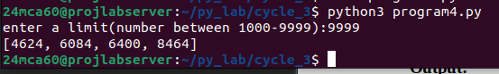

Aim: Write a program using a for loop to print the multiplication table of n, where n is
entered by the user.

Source code:

n=int(input("enter a number to print multiplication table:"))

for i in range(1,10):
print(f"{n} * {i} = {n*i}")

Output:

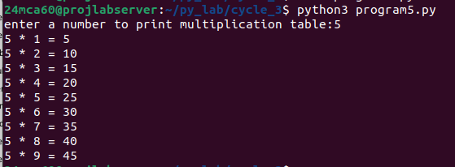

Aim: Write a program to display alternate prime numbers till N (obtain N from the user

Source code:

n=int(input(" enter a limit(any postive number):"))

def is_prime(num):
if num<2:
return False
for i in range(2,int(num**0.5)+1):
if num%i==0:
return False
return True

print("alternate prime numbers")

p_count=0
num=2
while(num<=n):
if is_prime(num):
if p_count%2==0:
print(num)
p_count+=1
num+=1

Output:

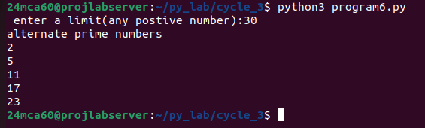

Aim: Write a program to compute and display the sum of all integers that are divisible
by 6 but not by 4, and that lie below a user-given upper limit.

Source code:

def sum_divisible_by_6_not_4(limit):
total = 0
for i in range(limit):
if i % 6 == 0 and i % 4 != 0:
total += i
return total

upper_limit = int(input("Enter the upper limit: "))
print(f"Sum of integers divisible by 6 but not by 4 below {upper_limit}: {sum_divisible_by_6_not_4(upper_limit)}")

Output:

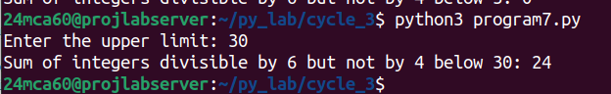

Aim: Calculate the sum of the digits of each number within a specified range (from 1 to
a user-defined upper limit). Print the sum only if it is prime.

Source code:

def sum_of_digits(n):
return sum(int(digit) for digit in str(n))

def is_prime(num):
if num < 2:
return False
for i in range(2, int(num**0.5) + 1):
if num % i == 0:
return False
return True

def sum_digits_in_range(upper_limit):
for num in range(1, upper_limit + 1):
digit_sum = sum_of_digits(num)
if is_prime(digit_sum):
print(f'Sum of digit {num} = {digit_sum}')

limit = int(input("Enter an upper limit: "))
sum_digits_in_range(limit)

Output:

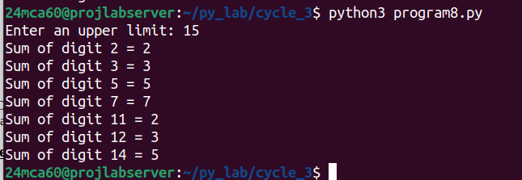

Aim: A number is input through the keyboard. Write a program to determine if it’s
palindromic.

Source code:

def is_palindrome(num):
return str(num) == str(num)[::-1] # [::-1] make the string in rever>

number = int(input("Enter a number: "))
if is_palindrome(number):
print(f"{number} is a palindromic number.")
else:
print(f"{number} is not a palindromic number.")

Output:

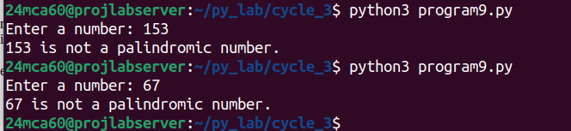

Aim: Write a program to generate all factors of a number. [use while loop]

Source code:

def factors(num):
result = []
i = 1
while i <= num:
if num % i == 0:
result.append(i)
i += 1
return result

number = int(input("Enter a number to find its factors: "))
print(f"Factors of {number}: {factors(number)}")

Output:

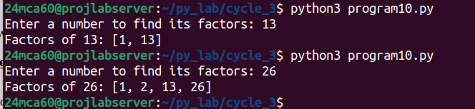

Aim: Write a program to find whether the given number is an Armstrong number or
not. [use while loop]

Source code:

def is_armstrong(num):
sum_of_cubes = 0
original_num = num
while num > 0:
digit = num % 10
sum_of_cubes += digit ** 3
num //= 10
return sum_of_cubes == original_num

number = int(input("Enter a number: "))
if is_armstrong(number):
print(f"{number} is an Armstrong number.")
else:
print(f"{number} is not an Armstrong number.")

Output:

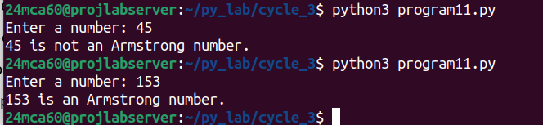

Aim: Display the given pyramid with the step number accepted from the user. Eg: N=4
1
24
369
4 8 12 16

Source code:

print("pattern :\n")
for i in range(1,4+1):
for j in range(1,i+1):
print(i*j,end=" ")
print("\n")

Output:

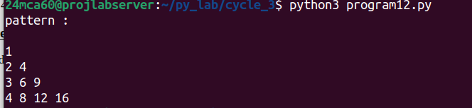

Aim: Construct following pattern using nested loop
*
**
***
****
*****
****
***
**
*

Source code:

def print_pattern():
# Upper part of the pattern
for i in range(1, 6):
print('* ' * i)

Output:

