Program:

s=list(input("enter a string: "))
s[0],s[-1]=s[-1],s[0]

print("outpust string : ",("".join(s)))

Output:

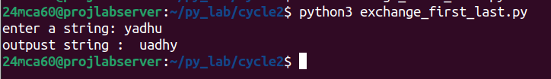

Program:

s=list(input("enter a string: "))
first=s[0]
for i in range(1,len(s)):
if s[i]==first:
s[i]="$"

print("".join(s))

Output:

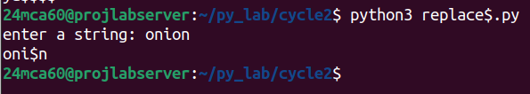

Program:

s1=input("enter string1: ")
s2=input("enter string2: ")

s3=s1[:1]+s2[1]+s1[2:]+" "+s2[:1]+s1[1]+s2[2:]
print(s3)

Output:

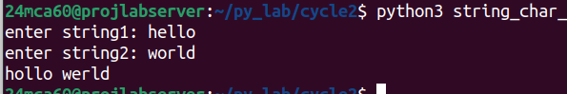

Program:

s=input("enter a string:")
freq_dict={}
for char in s:
if char in freq_dict:
freq_dict[char]+=1
else:
freq_dict[char]=1

print("character occurance:")
for key,value in freq_dict.items():
print(f"{key}:{value}")

Output:

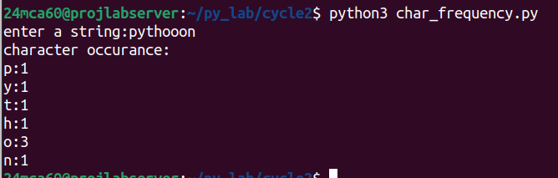

Program:

s=input("enter a string:")
if s.endswith('ing'):
print(s+"ly")
else:
print(s+"ing")

Output:

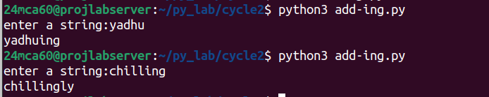

Program:

names=[]
n=int(input("enter limit:"))
for i in range(n):
el=input(f"enter name{i+1} :")
names.append(el)

print("occurances of a in names:")
for name in names:
print(f"{name}:{name.lower().count('a')}")

Output:

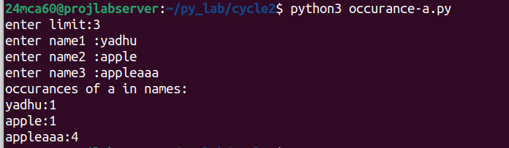

Program:

lst1=input("enter list1 lements by space seperated :").split()
lst2=input("enter list2 lements by space seperated :").split()
print("output list :")
print(list(set(lst1)-set(lst2)))

Output:

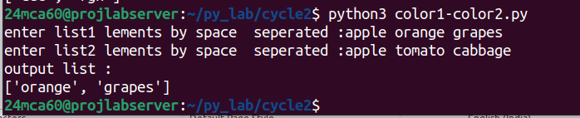

Program:

lst1=input("enter list1 comma seperated:").split(",")
lst2=input("enter list2 comma seperated:").split(",")

print(f"first color of list1 :{lst1[0]}\n last color of list2 :{lst2[-1]}")

Output:

