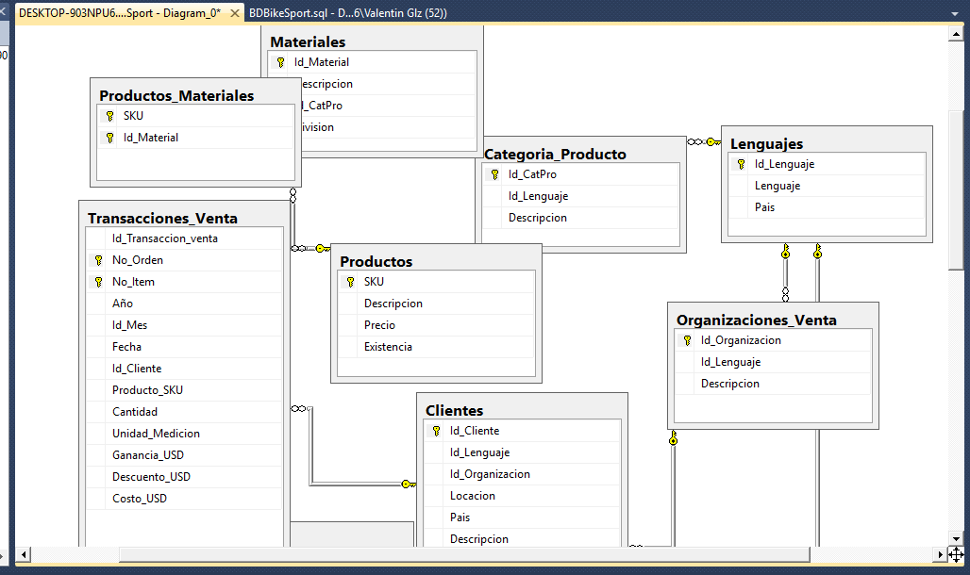

select Id_Cliente, Locacion, Pais, Descripcion

from clientes

where Pais='DE'

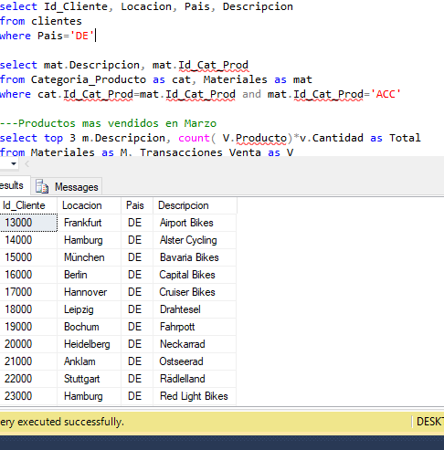

select mat.Descripcion, mat.Id_CatPro

from Categoria_Producto as cat, Materiales as mat

where cat.Id_CatPro=mat.Id_CatPro and mat.Id_CatPro='ACC'

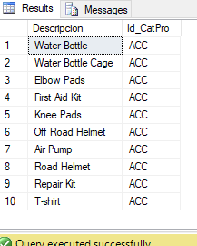

select top 3 m.Descripcion, count( V.Producto_SKU)*v.Cantidad as Total

from Materiales as M, Transacciones_Venta as V

where m.Id_Material= V.Producto_SKU and v.Id_Mes='3'

group by m.Descripcion, v.Cantidad

order by Total asc



