Retaining Wall Design & Verification Report
RT Wall Cantilever
Date: July 18, 2026
This engineering report compiles the retaining wall dimensions, material properties, applied loads, stability safety factors, bearing capacity analysis, FEM settlement profiles, and pile foundation design checks.

1. Design Inputs & Parameters

Wall Geometry
Parameter | Symbol | Value
Out-of-plane thickness | t | 1.000 m
Wall height | Hw | 3.000 m
Toe length | L_toe | 0.800 m
Heel length | L_heel | 0.800 m
Top wall thickness | b_top | 0.300 m
Bottom wall thickness | b_bot | 0.400 m
Footing thickness | h_ftg | 0.300 m

SNI Typical Geometry Verification Checklist
Parameter Name | Symbol | Value | SNI Requirement | Status
Top Wall Thickness | b_top | 0.30 m | >= 0.30 m | PASS
Base Stem Thickness | b_bot | 0.40 m | >= 0.33 m | PASS
Front Face Batter Slope | slope | 0.0333 | >= 0.0208 | PASS
Footing Width | B | 2.00 m | 1.32 ~ 2.31 m | PASS
Footing Thickness | h_ftg | 0.30 m | 0.27 ~ 0.33 m | PASS
Toe Slab Length | L_toe | 0.80 m | >= 0.67 m | PASS

Soil & Water Parameters
Parameter | Symbol | Value
Dry unit weight | γ_dry | 18.00 kN/m³
Wet unit weight | γ_wet | 20.00 kN/m³
Friction angle | φ | 45.0°
Soil cohesion | c | 10.0 kPa
Surcharge load | q | 10.00 kPa
Soil height above heel | h_soil | 3.000 m
Soil above toe | h_toe | 1.000 m
Water unit weight | γ_w | 9.81 kN/m³
Water height behind wall | Hwtr | 0.50 m
Water height in front | Hwtr_front | 0.150 m

2. Model & Geometry Diagrams

Wall Profile & Mesh Grid
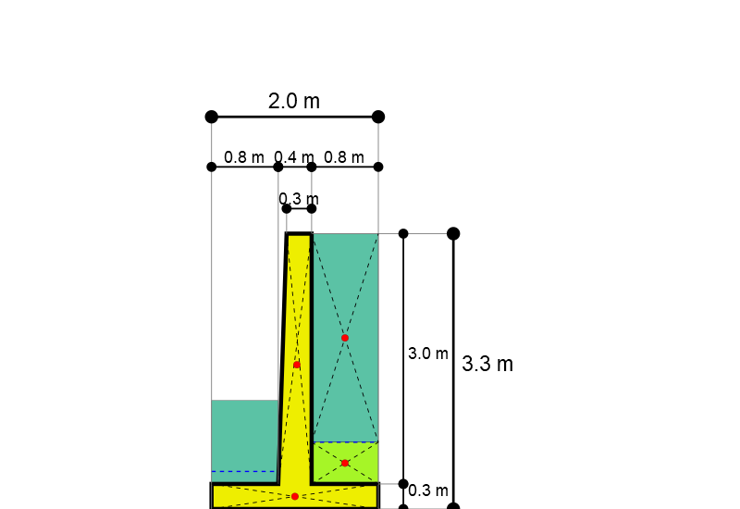

Dimensions Proportions Verification
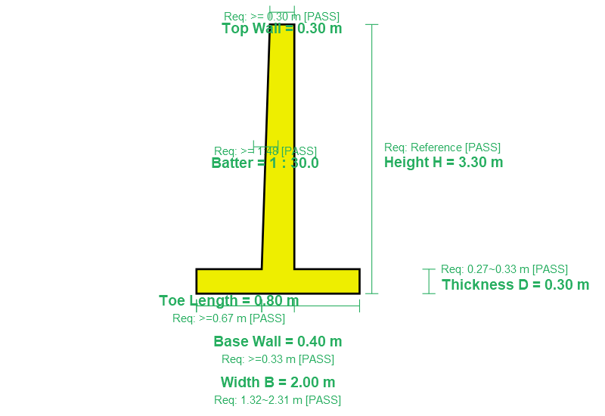

3. Applied Loads & Pressure Distributions

A. Soil Lateral Pressure (Active & Passive)
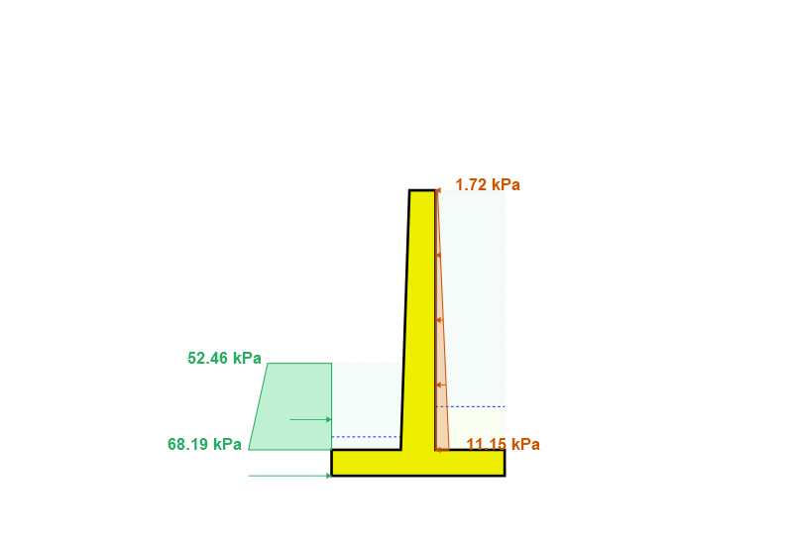
Active Earth Coefficient Equation:

Result: Ka = 0.1716
Active Pressure (Top of Stem):

Result: p_act,top = 1.72 kPa
Active Pressure (Bottom of Footing):

Result: p_act,bot = 11.15 kPa
Passive Earth Coefficient Equation:

Result: Kp = 5.8284
Passive Pressure (Bottom of Footing):

Result: p_pass,bot = 68.19 kPa (Mobilized, FS_pass = 2.0)

B. Soil Vertical Weight & Surcharge
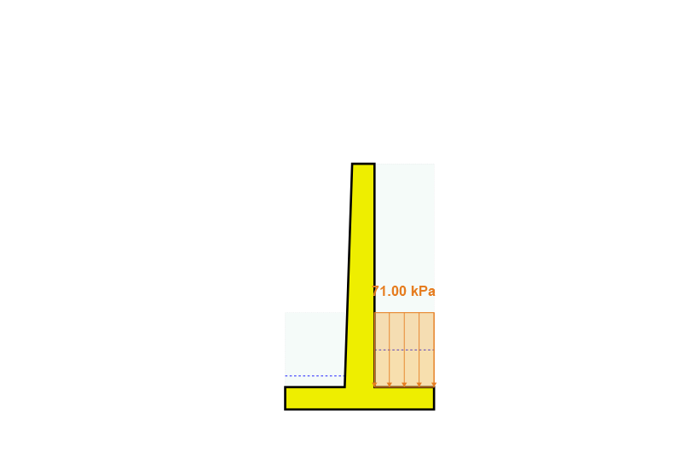
Vertical Backfill Pressure Equation:

Result: p_v,heel = 71.00 kPa

C. Hydrostatic Water Pressure
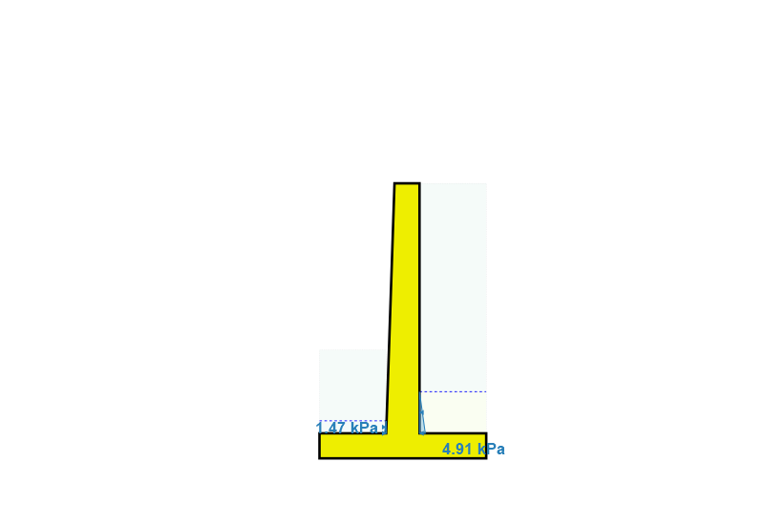
Hydrostatic Water Pressure Equation:

Result: Backwater p_w,back = 4.91 kPa, Frontwater p_w,front = 1.47 kPa

D. Uplift Water Pressure under Base
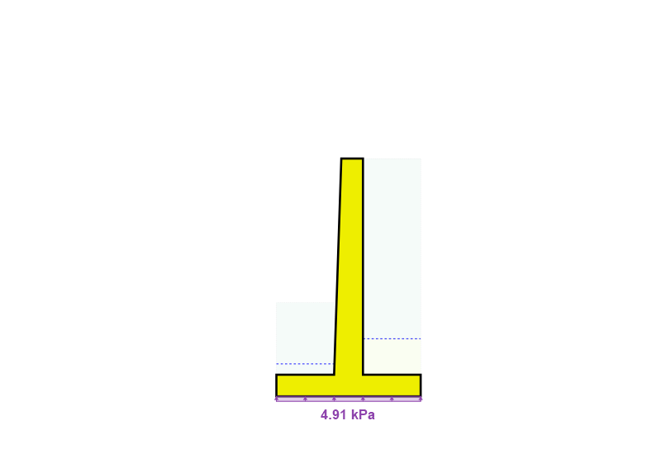
Base Uplift Pressure Equation:

Result: p_uplift = 4.91 kPa

E. Pseudo-Static Seismic Forces
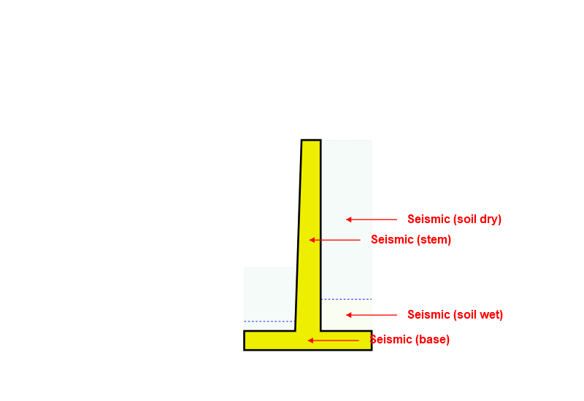

F. Total / Combined Load System
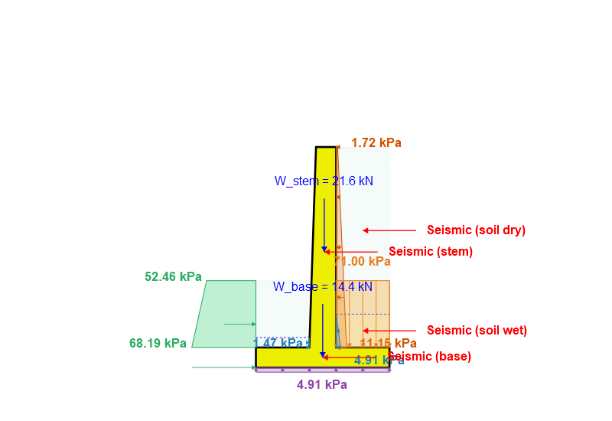

4. Stability Analysis & Verification

Stability Verification Equations
Sliding safety factor equation:

Overturning safety factor equation:

Sliding FS = 72.495 (Required >= 1.5)
Overturning FS = 4.297 (Required >= 1.5)
Global Slope Stability SSRM FS = 1.706
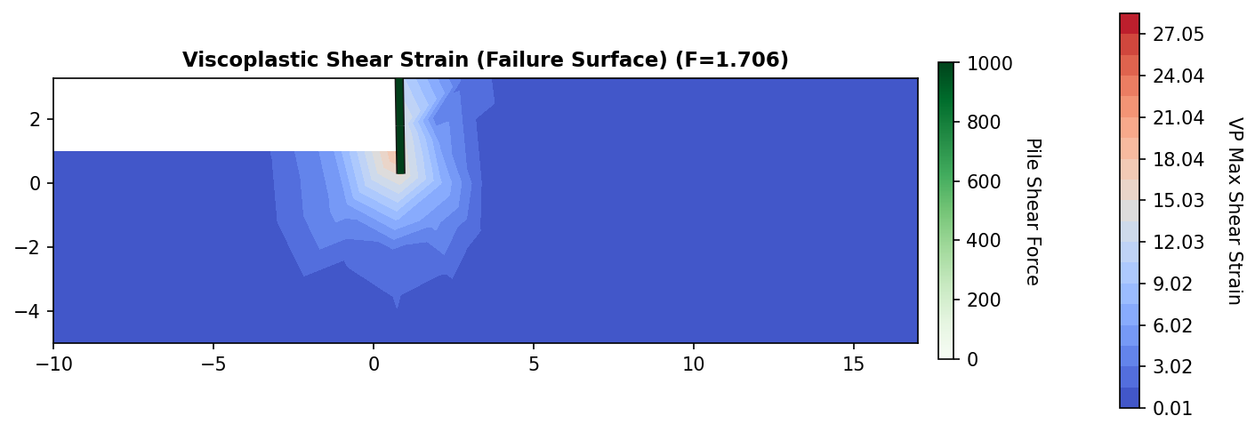

5. Bearing Capacity & Settlement

Bearing Stress & Settlement Equations
Bearing contact stress:

Bearing safety factor:

Consolidation settlement:

Ultimate bearing capacity: 4506.35 kPa
Max bearing stress: 52.98 kPa
Safety factor: 85.05 (Required >= 3.0)
Consolidation Settlement: 94.00 mm (Allowable: 153.33 mm)

6. Finite Element Settlement & Base Displacements
Toe Settlement: 23.43 mm
Heel Settlement: 18.14 mm
Differential Settlement: 41.57 mm (Allowable: 50.00 mm)

7. Finite Element Stress & Bending Moment Contours

Stem Node Bending Moment Diagram (kN·m)
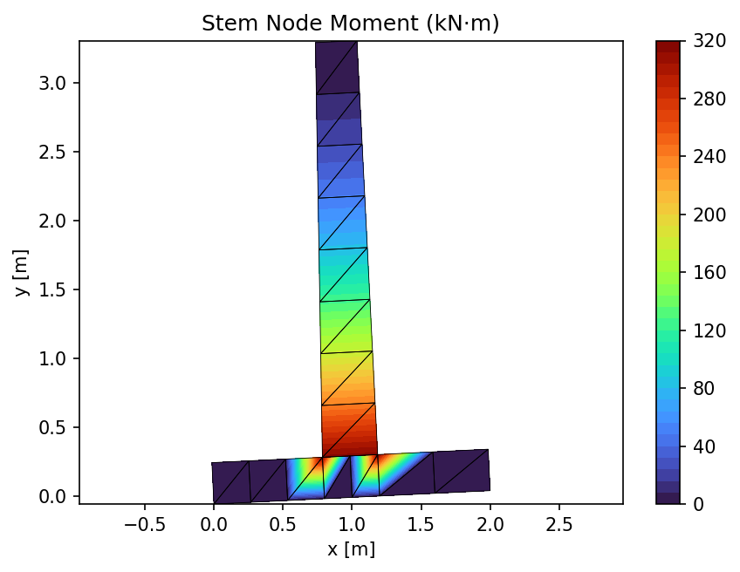

FE Stress Contour σ_xx (kN/m²)
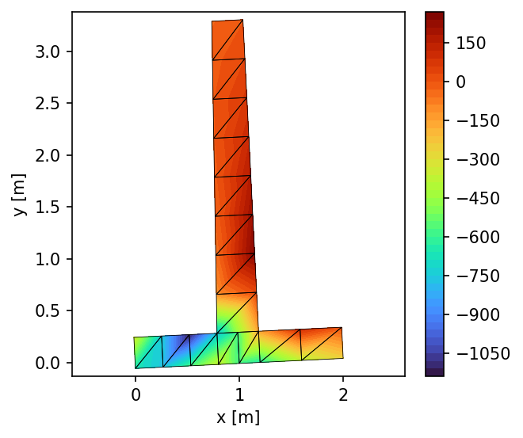

FE Stress Contour σ_yy (kN/m²)
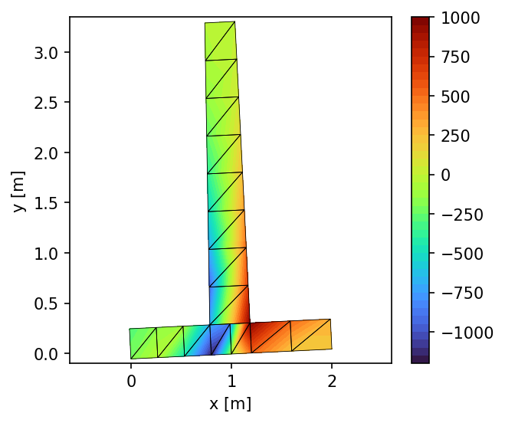

8. Pile Foundation Design & Verification

Pile Cross Section Geometry & Material Details
Parameter Name | Symbol | Value
Pile Material Type | - | Concrete
Pile Cross-section Shape | - | Circle
Pile Diameter | d_pile | 0.400 m
Concrete Cover | d_c | 50.0 mm
Main Reinforcement | - | 8 D25

Pile Cross-Section Drawing
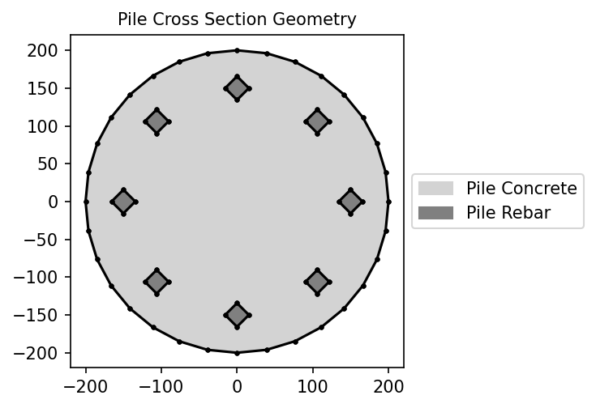

Pile Demands & Safety Factors Checklist
Toe Pile Axial demand: 36.84 kN
Toe Pile Lateral demand: 48.10 kN
Heel Pile Axial demand: 49.75 kN
Heel Pile Lateral demand: 48.10 kN

Pile Foundation Elevation Schematic
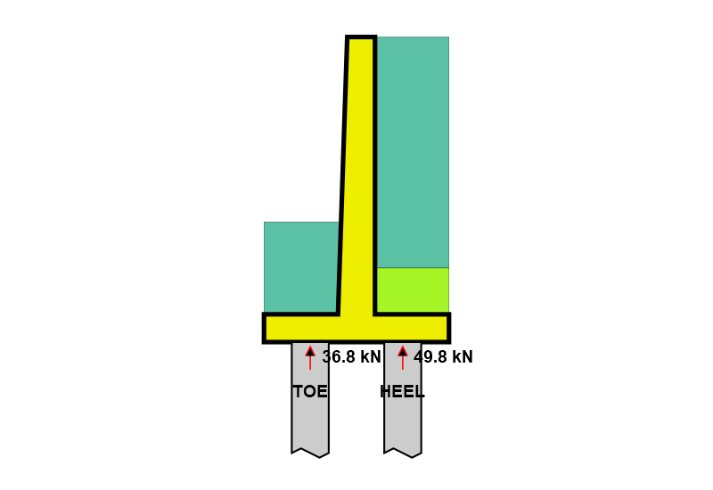

Pile Winkler Analysis Elastic Profiles
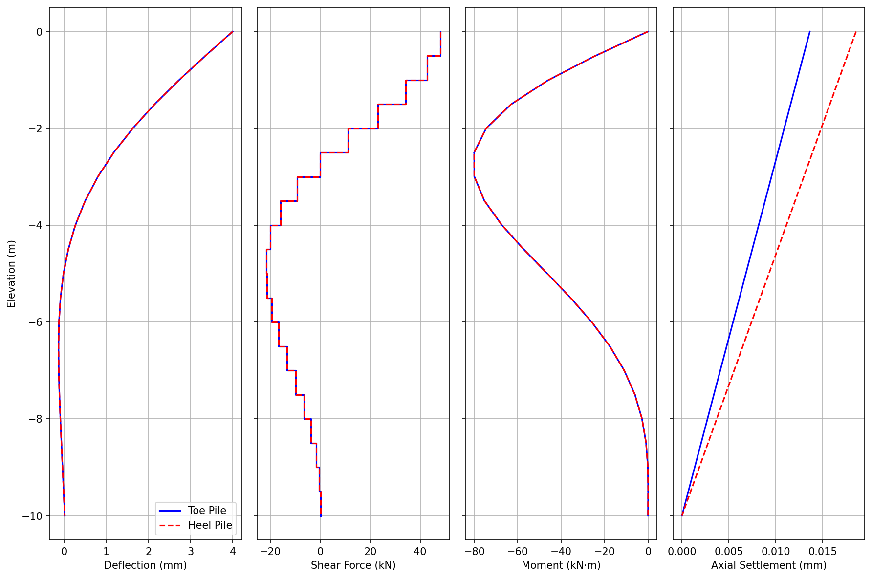

Moment-Axial Interaction Capacity Curve
