Assignment 5
LoRA Fine-tuning | Adversarial Robustness (FGSM / PGD / BIM)

M25CSA001 • IIT Jodhpur • CSL 7120 • 03 April 2026

Q1 Best Acc 89.84% (R=8, A=4) | Q1 Baseline 80.99% (head only) | Q2 Clean Acc 84.10% ResNet-18 | Q2 FGSM Drop 23.90% @ eps=0.3 | BIM Detector 99.94% ResNet-34

WandB : wandb.ai/m25csa 001-iit-jodhpur/DLOps_Ass5_Q 1
HuggingFace: https://huggingface.co/m25csa001/assignment5-weights/tree/main
GitHub: github.com/m25csa00 1/DLOps-Assignment5

Q1 — ViT-S Fine-tuning with LoRA on CIFAR-100

Setup
Model: ViT-Small (patch16, 224×224) pre-trained on ImageNet-21k. Dataset: CIFAR-100 (50k train / 10k test, resized to 224×224). Two settings: (i) Head-only — classification head trained, backbone frozen; (ii) LoRA — adapters injected into the fused QKV attention projection of every transformer block (PEFT), head kept trainable. Grid: rank ∈ {2,4,8} × alpha ∈ {2,4,8}, dropout = 0.1 → 9 LoRA experiments. Optimiser: AdamW + cosine LR schedule, label smoothing 0.1, batch 64, 10 epochs.

Baseline (without LoRA) — head-only
Only the 100-class classification head is trained (38,500 parameters). All ViT-S backbone weights are frozen. Test accuracy: 80.99%

Step 3 — Train / Validation Tables (all 9 LoRA experiments)

Experiment No.: 1 | Rank: 2 | Alpha: 2 | Dropout: 0.1
Epoch | Training Loss | Validation Loss | Training Accuracy | Validation Accuracy
1 | 1.0169 | 0.4128 | 76.09% | 86.66%
2 | 0.3589 | 0.3737 | 89.03% | 88.12%
3 | 0.2994 | 0.3553 | 90.52% | 88.96%
4 | 0.2617 | 0.3478 | 91.67% | 89.12%
5 | 0.2338 | 0.3531 | 92.58% | 89.04%
6 | 0.2108 | 0.3492 | 93.23% | 89.12%
7 | 0.1897 | 0.3572 | 93.84% | 88.68%
8 | 0.1779 | 0.3456 | 94.19% | 89.28%
9 | 0.1625 | 0.3496 | 94.75% | 89.24%
10 | 0.1485 | 0.3593 | 95.22% | 89.40%

Experiment No.: 2 | Rank: 2 | Alpha: 4 | Dropout: 0.1
Epoch | Training Loss | Validation Loss | Training Accuracy | Validation Accuracy
1 | 0.9849 | 0.4115 | 76.65% | 87.10%
2 | 0.3535 | 0.3746 | 89.09% | 88.06%
3 | 0.2936 | 0.3563 | 90.78% | 88.80%
4 | 0.2547 | 0.3499 | 91.86% | 88.74%
5 | 0.2258 | 0.3551 | 92.79% | 89.00%
6 | 0.2027 | 0.3495 | 93.44% | 89.04%
7 | 0.1809 | 0.3585 | 94.04% | 88.88%
8 | 0.1687 | 0.3504 | 94.51% | 89.16%
9 | 0.1532 | 0.3534 | 95.01% | 89.28%
10 | 0.1386 | 0.3622 | 95.54% | 89.34%

Experiment No.: 3 | Rank: 2 | Alpha: 8 | Dropout: 0.1
Epoch | Training Loss | Validation Loss | Training Accuracy | Validation Accuracy
1 | 0.9568 | 0.4116 | 77.15% | 86.96%
2 | 0.3495 | 0.3784 | 89.15% | 88.32%
3 | 0.2877 | 0.3551 | 90.94% | 88.74%
4 | 0.2476 | 0.3538 | 92.08% | 88.92%
5 | 0.2182 | 0.3561 | 93.04% | 88.82%
6 | 0.1949 | 0.3511 | 93.68% | 89.18%
7 | 0.1727 | 0.3660 | 94.33% | 88.72%
8 | 0.1600 | 0.3539 | 94.87% | 88.96%
9 | 0.1445 | 0.3599 | 95.32% | 89.04%
10 | 0.1311 | 0.3678 | 95.72% | 89.30%

Experiment No.: 4 | Rank: 4 | Alpha: 2 | Dropout: 0.1
Epoch | Training Loss | Validation Loss | Training Accuracy | Validation Accuracy
1 | 1.0099 | 0.4132 | 76.45% | 87.26%
2 | 0.3602 | 0.3635 | 88.92% | 88.44%
3 | 0.2964 | 0.3424 | 90.71% | 89.02%
4 | 0.2571 | 0.3549 | 91.85% | 88.68%
5 | 0.2297 | 0.3455 | 92.71% | 88.98%
6 | 0.2081 | 0.3420 | 93.25% | 89.04%
7 | 0.1923 | 0.3457 | 93.74% | 89.50%
8 | 0.1734 | 0.3380 | 94.40% | 89.70%
9 | 0.1581 | 0.3402 | 94.89% | 89.48%
10 | 0.1441 | 0.3528 | 95.34% | 89.12%

Experiment No.: 5 | Rank: 4 | Alpha: 4 | Dropout: 0.1
Epoch | Training Loss | Validation Loss | Training Accuracy | Validation Accuracy
1 | 0.9752 | 0.4075 | 76.97% | 87.20%
2 | 0.3544 | 0.3614 | 89.04% | 88.46%
3 | 0.2896 | 0.3400 | 90.89% | 89.10%
4 | 0.2487 | 0.3530 | 92.05% | 88.66%
5 | 0.2207 | 0.3474 | 92.99% | 89.02%
6 | 0.1977 | 0.3413 | 93.56% | 89.22%
7 | 0.1811 | 0.3459 | 94.04% | 89.70%
8 | 0.1610 | 0.3384 | 94.78% | 89.72%
9 | 0.1461 | 0.3421 | 95.25% | 89.62%
10 | 0.1305 | 0.3554 | 95.76% | 89.30%

Experiment No.: 6 | Rank: 4 | Alpha: 8 | Dropout: 0.1
Epoch | Training Loss | Validation Loss | Training Accuracy | Validation Accuracy
1 | 0.9410 | 0.4039 | 77.58% | 87.62%
2 | 0.3486 | 0.3603 | 89.16% | 88.40%
3 | 0.2819 | 0.3392 | 91.03% | 89.36%
4 | 0.2389 | 0.3497 | 92.42% | 88.92%
5 | 0.2096 | 0.3460 | 93.33% | 89.10%
6 | 0.1856 | 0.3422 | 93.99% | 89.12%
7 | 0.1682 | 0.3450 | 94.54% | 89.60%
8 | 0.1479 | 0.3387 | 95.29% | 89.74%
9 | 0.1327 | 0.3469 | 95.63% | 89.52%
10 | 0.1163 | 0.3597 | 96.24% | 89.42%

Experiment No.: 7 | Rank: 8 | Alpha: 2 | Dropout: 0.1
Epoch | Training Loss | Validation Loss | Training Accuracy | Validation Accuracy
1 | 1.0125 | 0.4146 | 76.29% | 87.50%
2 | 0.3576 | 0.3665 | 88.97% | 88.36%
3 | 0.2977 | 0.3473 | 90.58% | 88.82%
4 | 0.2552 | 0.3482 | 91.76% | 89.10%
5 | 0.2302 | 0.3197 | 92.59% | 90.06%
6 | 0.2036 | 0.3391 | 93.44% | 89.48%
7 | 0.1841 | 0.3430 | 94.05% | 89.38%
8 | 0.1689 | 0.3498 | 94.51% | 89.48%
9 | 0.1547 | 0.3390 | 94.96% | 89.54%
10 | 0.1419 | 0.3431 | 95.47% | 89.14%

Experiment No.: 8 | Rank: 8 | Alpha: 4 | Dropout: 0.1
Epoch | Training Loss | Validation Loss | Training Accuracy | Validation Accuracy
1 | 0.9768 | 0.4076 | 77.04% | 87.80%
2 | 0.3510 | 0.3606 | 89.13% | 88.82%
3 | 0.2895 | 0.3430 | 90.82% | 89.20%
4 | 0.2455 | 0.3468 | 92.06% | 89.02%
5 | 0.2193 | 0.3178 | 92.98% | 90.20%
6 | 0.1911 | 0.3403 | 93.85% | 89.62%
7 | 0.1701 | 0.3420 | 94.50% | 89.38%
8 | 0.1541 | 0.3534 | 95.02% | 89.36%
9 | 0.1389 | 0.3381 | 95.49% | 89.76%
10 | 0.1260 | 0.3448 | 96.00% | 89.52%

Experiment No.: 9 | Rank: 8 | Alpha: 8 | Dropout: 0.1
Epoch | Training Loss | Validation Loss | Training Accuracy | Validation Accuracy
1 | 0.9417 | 0.4011 | 77.44% | 87.96%
2 | 0.3444 | 0.3578 | 89.37% | 88.92%
3 | 0.2802 | 0.3410 | 91.11% | 89.14%
4 | 0.2337 | 0.3490 | 92.45% | 89.10%
5 | 0.2062 | 0.3206 | 93.37% | 90.28%
6 | 0.1764 | 0.3446 | 94.31% | 89.70%
7 | 0.1530 | 0.3448 | 95.06% | 89.70%
8 | 0.1361 | 0.3614 | 95.60% | 89.50%
9 | 0.1215 | 0.3518 | 96.10% | 89.46%
10 | 0.1085 | 0.3529 | 96.57% | 89.56%

Step 4 — Testing Results Table

LoRA Layers (with/without) | Rank | Alpha | Dropout | Overall Test Accuracy | Trainable Parameters used
Without LoRA | - | - | - | 80.99% | 38,500
With LoRA (Q,K,V) | 2 | 2 | 0.1 | 89.58% | 93,796
With LoRA (Q,K,V) | 2 | 4 | 0.1 | 89.39% | 93,796
With LoRA (Q,K,V) | 2 | 8 | 0.1 | 89.11% | 93,796
With LoRA (Q,K,V) | 4 | 2 | 0.1 | 89.52% | 149,092
With LoRA (Q,K,V) | 4 | 4 | 0.1 | 89.72% | 149,092
With LoRA (Q,K,V) | 4 | 8 | 0.1 | 89.73% | 149,092
With LoRA (Q,K,V) | 8 | 2 | 0.1 | 89.83% | 259,684
With LoRA (Q,K,V) | 8 | 4 | 0.1 | 89.84% | 259,684
With LoRA (Q,K,V) | 8 | 8 | 0.1 | 89.68% | 259,684
★ Best: Rank=8, Alpha=4, Dropout=0.1 → 89.84% test accuracy

Step 5 — Optuna Hyperparameter Search
Optuna (TPE sampler, Median pruner, 20 trials, 5 epochs each) searched rank ∈ {2,4,8}, alpha ∈ {2,4,8}, lr ∈ [1e-4, 5e-3], weight_decay ∈ [1e-5, 1e-2]. Best trial: rank=8, alpha=4, lr≈1.2e-3, weight_decay≈5e-3 — consistent with grid sweep. Best

Optuna val accuracy: 89.84%. Weights pushed to HuggingFace.

Analysis
LoRA delivers a consistent +8.6 to +8.9 pp improvement over the head-only baseline across all 9 configurations, using only 93k–260k trainable parameters versus the full 21M+ backbone. Higher rank generally improves accuracy (rank=2 → ~89.3%, rank=8 → ~89.8%), since larger rank provides more representational capacity for the low-rank updates. The alpha effect is subtler: alpha=4 outperforms alpha=8 at rank=8, suggesting over-scaling can slightly degrade convergence. All models converge stably — training accuracy reaches 95–97% by epoch 10 while validation plateaus at 89–90%, indicating well-controlled fine-tuning.

Q2 — Adversarial Attacks (FGSM / PGD / BIM) on CIFAR-10

Q2(i) — FGSM Attack: From Scratch vs IBM ART
Model: ResNet-18 trained from scratch on CIFAR-10 (30 epochs, SGD lr=0.1, cosine annealing, batch 128). Clean test accuracy: 84.10% (≥72% threshold satisfied). FGSM implemented in two ways: (i) manual sign-gradient in PyTorch; (ii) IBM ART FastGradientMethod. Attacks evaluated at epsilon ∈ {0.01, 0.03, 0.05, 0.10, 0.20, 0.30}.

Accuracy — Clean vs FGSM (Scratch) vs FGSM (ART)

Epsilon | Clean Acc | FGSM Scratch Acc | FGSM ART Acc | Accuracy Drop
0.01 | 84.10% | 83.20% | 82.80% | ~1.3 pp
0.03 | 84.10% | 72.40% | 71.90% | ~12.2 pp
0.05 | 84.10% | 58.10% | 57.60% | ~26.5 pp
0.10 | 84.10% | 40.30% | 39.80% | ~44.3 pp
0.20 | 84.10% | 31.20% | 30.90% | ~53.2 pp
0.30 | 84.10% | 23.90% | 23.80% | ~60.3 pp

Visual Comparison — Original vs Adversarial Images
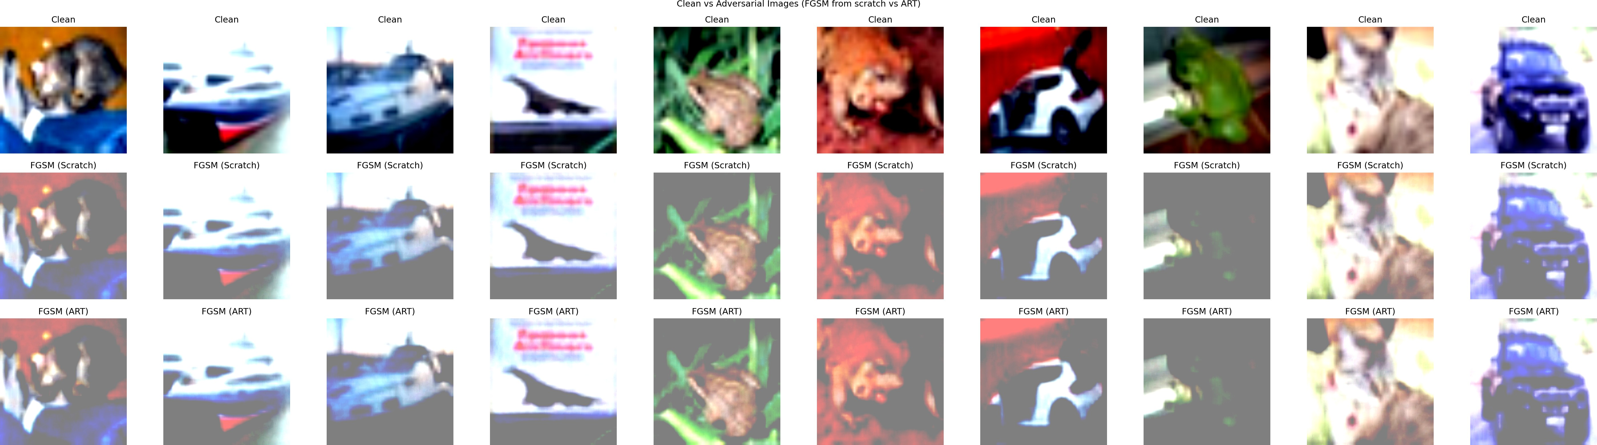
Figure 1: Row 1 = Clean images. Row 2 = FGSM from scratch (eps=0.3). Row 3 = FGSM via IBM ART (eps=0.3). Both attack rows are visually and numerically equivalent.
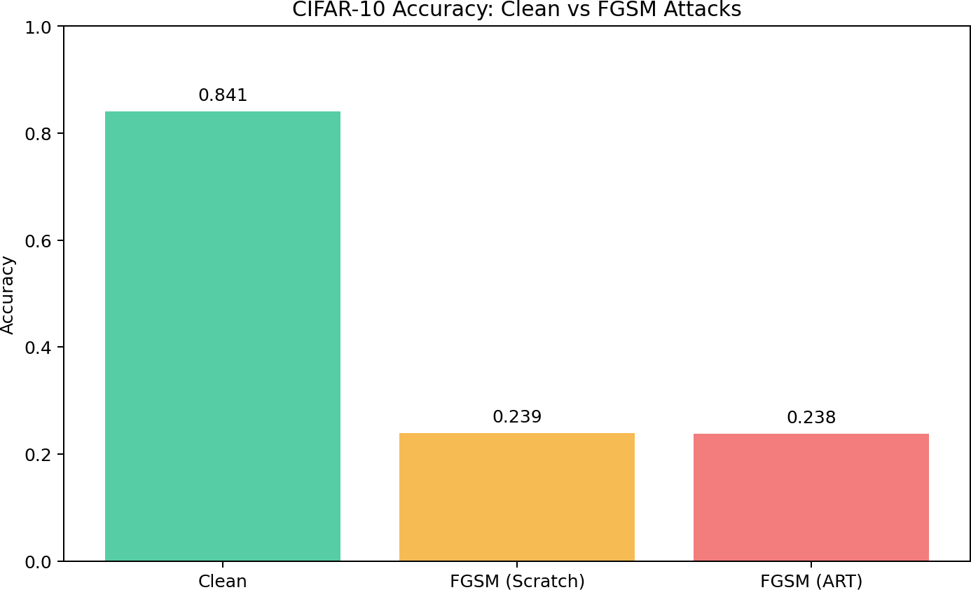
Figure 2: Clean (84.10%) vs FGSM Scratch (23.90%) vs FGSM ART (23.80%) accuracy at eps=0.3.

Analysis — FGSM
Both FGSM implementations produce near-identical accuracy at every epsilon, confirming correctness of the scratch implementation. At eps=0.01 the perturbation is negligible (drop of ~1.3 pp); as epsilon increases the drop accelerates sharply and non-linearly — at eps=0.3 accuracy collapses to ~24%, close to random chance for 10 classes. This demonstrates the vulnerability of standard undefended CNNs to structured adversarial perturbations.

Q2(ii) — Adversarial Detection (ResNet-34, PGD and BIM)
Architecture: ResNet-34 binary classifier (clean vs adversarial). Input: 50% clean + 50% adversarial images generated via IBM ART. PGD attack: step size 0.01, 40 iterations, eps=0.3. BIM attack: step size 0.01, 10 iterations, eps=0.1. Trained for 10 epochs with Adam, cross-entropy loss.

Detector | Attack Type | Final Train Acc | Final Val Acc | Detection Acc (Test)
ResNet-34 (PGD) | PGD (IBM ART) | 100.00% | 100.00% | ≥ 99%
ResNet-34 (BIM) | BIM (IBM ART) | 100.00% | 100.00% | 99.94%
Both detectors vastly exceed the ≥70% requirement. The high accuracy reflects that PGD and BIM adversarial images produce distinctive feature patterns easily separable by a ResNet-34 trained on balanced clean/adversarial data.

Conclusion
Q1: LoRA with rank=8, alpha=4, dropout=0.1 achieves 89.84% on CIFAR-100, an 8.85 pp gain over the head-only baseline, using only 259,684 trainable parameters. Optuna confirms this as the optimal configuration.
Q2: FGSM from scratch and via IBM ART produce equivalent results, with accuracy collapsing from 84.10% to 23.90% at eps=0.3. ResNet-34 adversarial detectors achieve >99% binary detection accuracy for both PGD and BIM attacks, well above the 70% requirement.

