Low Level Design Template

DMT/AD06/TMP

Project Code | Group 6
Project Name | Online Recruitment System

Prepared/Modified by | Role | Date of Preparation
Chandravati Mahule
Reviewed by | Role | Date of Review
Approved by | Role | Date of Approval
Circulation List |  | Version Number of the template:1.0
Version Number | <version No >

Table of Contents

1. Description Of The Unit 3
2. References 4
3. Dependencies / Assumptions 5
4. Class Diagrams 6
5. Sequence Diagrams 7
6. Design Components 8
6.1 List Of UI Components 8
6.2 List Of Design Classes 8
7. Re-Usable Routines/Components 9
8. Messages 10
9. Configuration Files 11
10. Crud Matrix Table 12
11. Data Mapping Matrix 13
12. Action Flow Matrix 14
13. Stored Procedures 15
14. Program Specification / Pseudo Code 16
REVISION HISTORY OF THE WORK PRODUCT 17

Description Of The Unit
Online Job Portal Comprises of three units they are as follows:
1. Admin Unit
2. Employer Unit
3. Jobseeker Unit

1. Administration Unit:
The role of Admin is divided into two task. The first task of admin is to verity the user, user can be a jobseeker or an employer. After successful verification admin will add the user into verified user list so that only verified user should access the job portal on their next login
The second task of admin is to delete those job which are greater than the last date or the expiry date.
Administration Module include:
- Admin can login
- Admin can view register member and will manage the register member in portal
- Admin can view job details
- Admin can delete the post job if its last date gets expires

2. Employer Unit:
The role of Employer is to recruit jobseeker via job portal .Employer can post job, view jobseeker details and can update job details.

Employer Module include:
- Employer can login
- Employer can update profile information
- Employer can view the posted jobs
- Employer can view jobseeker details who have applied for that particular job

3. Jobseeker Unit:
The role of Jobseeker is to search job, to apply if needed and can view the list of job applied.

Jobseeker Module include:
- Jobseeker can login
- Jobseeker can view various job of different different company
- Jobseeker can update profile information
- Jobseeker can apply for the suitable jobs

References

- Sql database by W Jason Gilmore,Apress Publication.
- http://www.w3school.com/php
- Rebecca M. Riordan: Microsoft ADO.NET
- http://webarox.com/online-job-portal-websites/

Dependencies / Assumptions

- Dependencies of Employer Module:
- Administration Module:
- On the basis of verification done by the admin, if verified then it will get added into the verified Employee list by the admin
- Before verification employer cannot access the job portal
- Jobseeker Module:
- On the basis of job applied by the jobseeker, employer will be able to view the Jobseeker’s profile who have applied for the job in “view Jobseeker application” link.

- Dependencies of Jobseeker Module:
- Administration Module:
- On the basis of verification done by the admin, if verified then it will get added into the verified Jobseeker list by the admin
- Before verification Jobseeker cannot access the job portal
- Employer Module:
- On the basis of job posted by the Employer, Jobseeker will be able to view job by using “Search Job” link and also can be apply for the same job by using ”Apply ” button

Class Diagrams

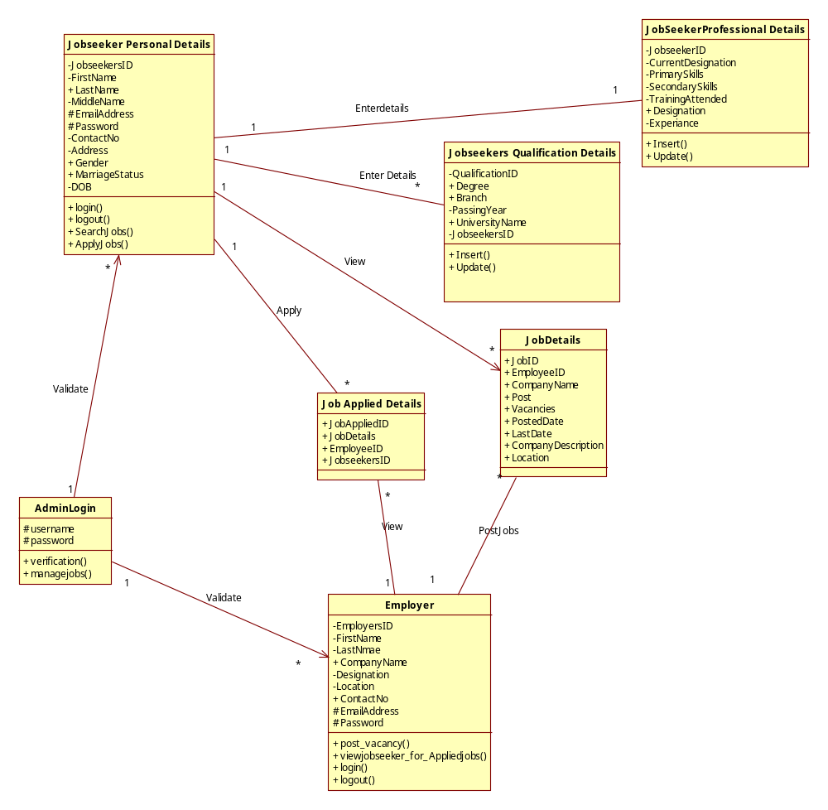

Sequence Diagrams

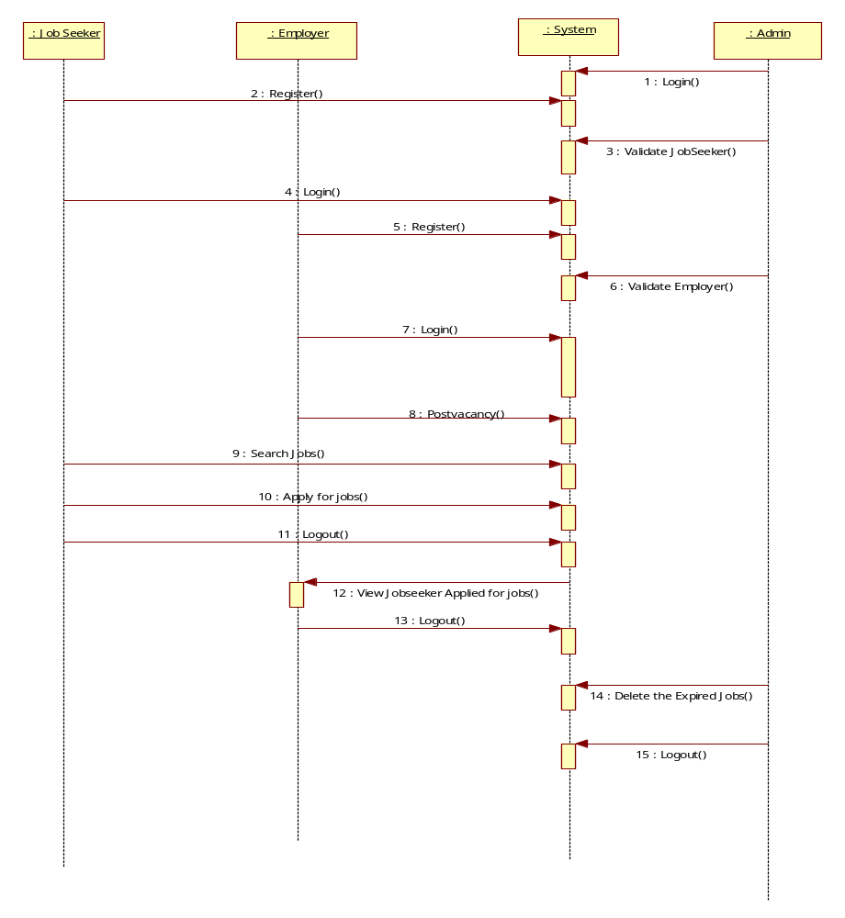

Design Components

List Of UI Components

Following are the list of components used in user interface:
- Textbox
- Dropdown List
- Radio Button List
- Button
- Label
- Image
- Hyperlinks
- Calendar

List Of Design Classes

List of classes used in job application are:
- Administrator class
- Employer class
- Jobseeker class

Re-Usable Routines/Components
<provide references to the re-usable routines, copybooks and templates used by the unit>

Messages
<describe what are relevant messages which has to be displayed in this program unit>

#. | Type | Message Text
1. | <Warning/Information/Validation/Error>

Configuration Files
<< Provide complete list of configuration files that will be required during deployment of the application. This list will comprise of all the XML files, resource files packaged within application deployment>>

File Name | Path | Description

Crud Matrix Table

# | Table Name | Create | Read | Update | Delete

Data Mapping Matrix
<identify data-mapping matrix pertinent to screen or report data items. Provide details of the base table or column, screen item name, length, calculations and validations.>

Action Flow Matrix
<identify the action flow matrix detailing all actions and triggers associated with the unit. Provide details of processing and the enabled conditions>

Stored Procedures
<describe what are Stored Procedures Pertaining to this program unit >

# | Stored Procedure Name  (with Description) | Input/Out Parameters | Type | Size
1.

Program Specification / Pseudo Code
<specify processing details of the unit >

REVISION HISTORY OF THE WORK PRODUCT
<to be maintained by projects>

# | Date | Version # | Section Changed | Details of changes made | Approved By
1
2

