OPERATING SYSTEMS LAB EXPERIMENTS

1) STUDENT NAME: YADLAPALLI CHAITHANYA
2) REG.NO: 1925260210
3) SUBJECT NAME: OPERATING SYSTEMS
4) SUBJECT CODE: CSA0402 {SLOT:B}
5) SUBMITTED TO: PRISKILLA ANGEL RANI J

LAB EXPERIMENT 3
Design a CPU scheduling program with C using First Come First Served technique with the following considerations.
a. All processes are activated at time 0.
b. Assume that no process waits on I/O devices.
AIM: To design and implement a CPU scheduling program in C using the First Come First Served (FCFS) scheduling technique, assuming that all processes arrive at time 0 and no process waits for I/O devices.
ALGORITHM:
1. Read the number of processes n.
2. Enter the burst time for each process. Since all processes are activated at time 0, the arrival time of every process is taken as 0.
3. Schedule the processes in the same order in which they are entered. FCFS is a non-preemptive scheduling algorithm.
4. Calculate the completion time (CT) of each process. For the first process, CT = Burst Time. For every next process, CT = Previous CT + Burst Time.
5. Calculate the waiting time (WT) using WT = CT − Burst Time, because all arrival times are 0.
6. Calculate the turnaround time (TAT) using TAT = CT − Arrival Time. Since arrival time is 0, TAT = CT.
7. Calculate the average waiting time and average turnaround time.
8. Display the process details and the FCFS Gantt chart.
PROGRAM:
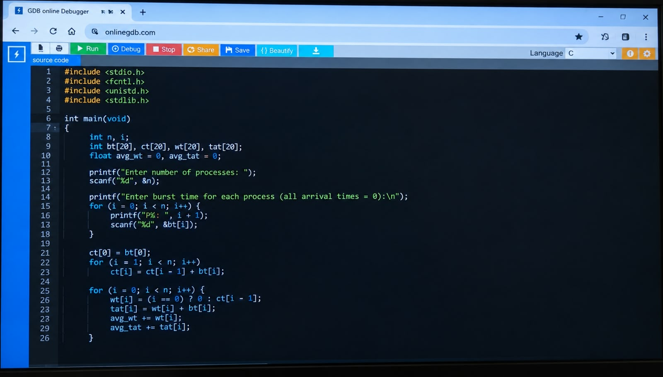

OUTPUT
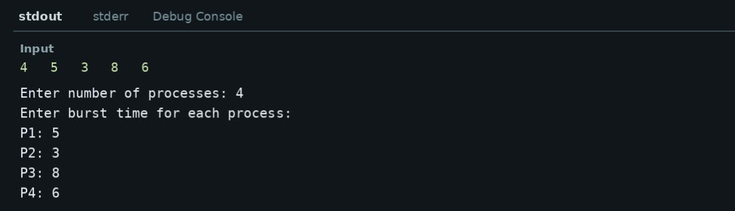
RESULT
The FCFS CPU scheduling algorithm was successfully implemented in C. The processes were executed in their arrival order, and the waiting time, turnaround time and average values were calculated successfully. The Gantt chart was obtained according to the FCFS execution sequence.

