Rysk-like DeFi App Research and Requirements

Overview
This document outlines the requirements for a DeFi application inspired by Rysk Finance. The product is centered on five strategies and a centralized Market Maker (MM) that handles pricing, execution, custody, and withdrawals.

Core Requirements

Strategy Set
The application should support five distinct financial strategies:
- Covered Call
- Cash-Secured Put
- Iron Condor
- Yield Maximizer
- Managed Volatility

Market Maker Integration
The system should use a centralized architecture with a dedicated MM.
- The MM provides RFQ pricing through an API.
- The user selects a strategy and submits a form in the frontend.
- The backend sends the request to the MM API.
- The MM returns quote data such as yield, APY, strike, and other strategy parameters.

Custody and Wallets
The custody model should be built around the MM’s Fireblocks setup.
- User funds are deposited to the MM’s Fireblocks omnibus account.
- The system uses a single Fireblocks address for pooled user deposits.
- A social login wallet should be used for user onboarding and wallet creation.
- Suitable providers include Web3Auth, Magic, Dynamic, or a similar MPC-based solution.

Lifecycle Management
The application should support strategy expiration and withdrawals.
- When a position expires, the balance becomes available for new positions.
- Withdrawal flow:
- The user submits a withdrawal request to the MM.
- The MM reviews and approves the request.
- The user claims the funds.

Research Topics

Rysk Finance Architecture
Research has focused on Rysk V1 and V1.2.
- Physical settlement is used.
- Positions are 100% collateralized.
- The RFQ engine supports options such as calls and puts.

Fireblocks API and SDK
The preferred custody model for this type of retail application is the omnibus account model.
- A single vault is used to pool assets.
- Internal ledgers track user balances.
- This model is operationally efficient for MM-centric custody.

Social Login Providers
Web3Auth and Privy were identified as strong options for mapping social identities to wallet and vault identifiers.

RFQ System
The key implementation pattern is:
- Frontend form
- Backend processing
- MM API request
- Frontend quote display

Strategy Definitions
- Covered Call (ETH/BTC)
- Hold the underlying asset and sell upside via call options.
- The MM provides the bid for the call.
- Cash-Secured Put (USDC)
- Hold stablecoins and earn yield by committing to buy at a lower price.
- The MM provides the bid for the put.
- Iron Condor
- A neutral strategy using both calls and puts.
- Best suited for sideways markets.
- Yield Maximizer (Lending + Options)
- Principal stays in Aave.
- Yield is used to buy out-of-the-money options.
- Managed Volatility (DHV)
- User funds are pooled.
- The MM dynamically hedges to target a specific delta/gamma profile.
- This reproduces the core Rysk product.

Proposed Tech Stack
Component | Recommendation | Why
Auth and Wallet | Dynamic | Native Fireblocks integration and strong social onboarding
Custody | Fireblocks Omnibus | High security, gas efficient, and MM-friendly
Frontend | Next.js + Tailwind | Fast development, SEO-friendly, and modern UI support
Backend | NestJS (Node.js) | Strong typing, modular structure, and good API integration support
Database | PostgreSQL | Reliable source of truth for the internal ledger
Blockchain | Arbitrum / Base | Low fees and strong liquidity for WETH and USDC

Implementation Roadmap

Phase 1: Integration and Onboarding
- Set up Dynamic with Fireblocks NCW.
- Integrate the MM API for basic deposit address generation.
- Build the internal ledger database to track user balances.

Phase 2: RFQ and Execution
- Implement the RFQ frontend form.
- Connect to the MM API for live quotes.
- Build the accept and lock flow from backend to MM.

Phase 3: Lifecycle and Expiration
- Automate expiration monitoring.
- Implement a roll-to-new-position feature using internal balance.

Phase 4: Withdrawals
- Implement the withdrawal request flow.
- Build the claim mechanism that triggers the MM Fireblocks outbox.

System Architecture

Workflow Overview
The system can be described as four main stages:
- Onboarding and deposit
- The user logs in through a social wallet provider.
- The wallet is created through Dynamic or a similar MPC onboarding flow.
- The user transfers funds to the MM omnibus address.
- Fireblocks confirms the deposit.
- The backend updates the internal ledger.
- RFQ and execution
- The user selects a strategy and enters a size.
- The backend requests a live quote from the MM API.
- The MM returns pricing and strategy terms.
- The frontend shows the quote with a short timer.
- If the user accepts, the backend locks the balance and sends the execution command.
- Expiration and balance update
- The MM notifies the backend when a position expires.
- The backend unlocks principal plus yield in the internal ledger.
- The app updates the user’s available balance.
- Withdrawal and claim
- The user submits a withdrawal request.
- The MM reviews and approves it.
- Funds are moved into claimable escrow.
- The app marks the withdrawal as claimable.
- The user claims the funds through the app.

Workflow Diagram
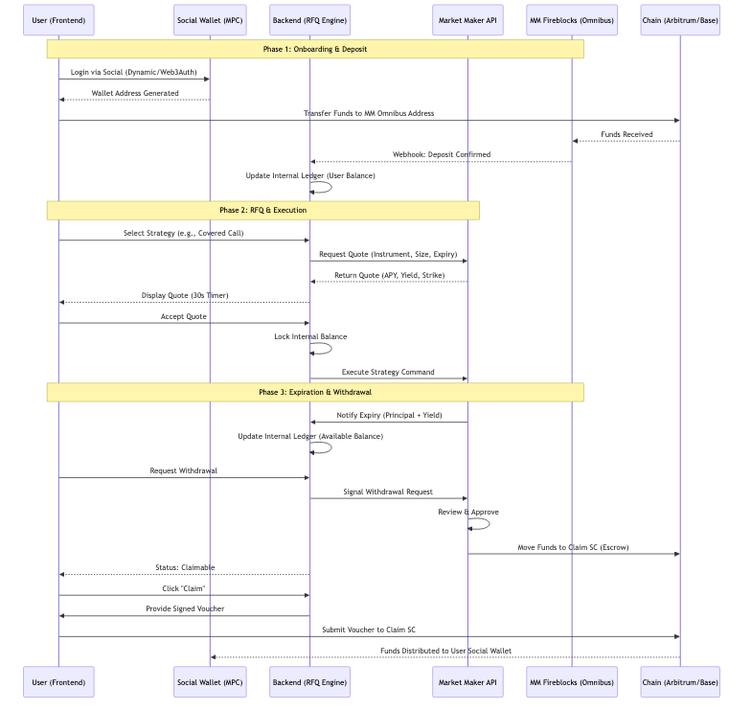

Detailed Architecture Notes

1. User Authentication and Wallet
- Recommended providers are Dynamic, Web3Auth, or Privy.
- A non-custodial MPC wallet is created during social login.
- The social wallet is the source of funds and the destination for claims.
- It is separate from the MM’s Fireblocks omnibus vault.

2. RFQ Engine
- The user selects a strategy such as an ETH covered call and enters an amount.
- The backend verifies the user’s internal balance.
- The backend calls the MM API with the quote request.
- The MM returns pricing data such as APY, yield, and strike price.
- The frontend displays the quote with a timer.
- If the user accepts, the backend locks the balance and sends the execution command.

3. Custody and Settlement
- Funds are held in the MM’s Fireblocks omnibus vault.
- The app shows a virtual balance that represents the user’s share of the pooled assets.
- Deposits are attributed to the user in the internal ledger.

4. Strategy Lifecycle and Expiration
- When a position is opened, the RFQ acceptance triggers a lock on the strategy funds.
- At expiration, the MM calculates the final value, including principal, yield, and fees.
- The backend updates the available balance.
- The user can roll the balance into a new position without on-chain movement.

5. Withdrawal and Claim Flow
- The user initiates a withdrawal request in the app.
- The MM API receives the request and performs risk checks.
- The MM approves the withdrawal.
- Funds are moved from the MM omnibus vault to an escrow wallet or to a claim smart contract.
- The user is notified that the funds are claimable.
- The user submits a claim.
- If using a claim smart contract, the backend provides a signed voucher.
- If using escrow, the backend triggers a Fireblocks transfer to the user wallet.

Recommendation
The safest and most transparent settlement model is a claim smart contract. It gives the user on-chain proof that funds are available and allows programmatic claiming rather than relying entirely on backend-controlled transfers.

