yadt 1.4 cheat sheet 0.2
http://www.yadt-project.org

concept
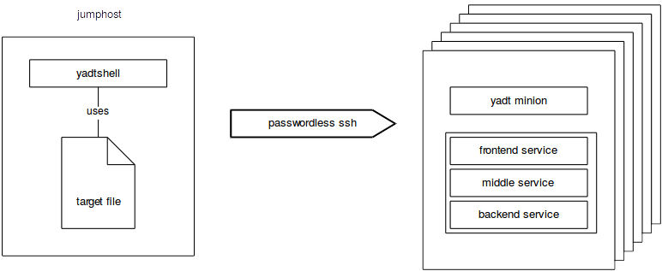
Using the yadtshell you can execute high level operations like updating a group of hosts . The only requirement is that the hosts are accessible via passwordless ssh and provide a yadt client.

Definition: Component URI
{artefact|host|service}://<hostname>[/<name>[/<version>]]
artefact://hostname/web-application/0:1.23
host://hostname
service://hostname/tomcat6
Components are always host-specific.

Brace Expansion
artefact://{hostname01|hostname03}/myapp

Range Expressions
host://hostname0[1..3]

Wildcards
service://hostname/*

yaml files
indented blocks have to start with 4 blanks. Do not use tabs. Example where blanks are marked as “␣” :
-␣frontend:
␣␣␣␣needs_services:␣[middleservice1]
␣␣␣␣is_frontservice:␣true

yadt.conf.d (directory)
The yadt minion merges all *.yaml configuration files found in /etc/yadt.conf.d
services:
frontend:
needs_services: [middleservice1]
is_frontservice: true
- middleservice1:
needs_services: [middleservice2]
The service name must be equal to the corresponding name of the service script (as found in /etc/init.d).
is_frontservice is a marker for the status overview. The status (shown in percentage) of the target will be calculated by determining how many frontservices are running.
needs_services the services that have to be running before starting this service (reverse for stopping)
The service definition may contain a component URI as string, which describes a service on another host, e.g.
- backendservice: ['service://hostname/servicename']
Please note that this notation only allows the hostname not the full qualified domain name. Yadtshell extracts the hostname from the fqdn as the string until the first dot.
Please see the Merging configuration section for more information.

target (file)
yadtshell uses a yaml file named target in the current working directory to define a yadt target (set of hosts), e.g.
hosts:
- hostname1.spam.eggs
- hostname2.spam.eggs
- hostname*.spammy.eggs
- hostname0[1..3].foo.bar
It is possible to group your hosts within a target:
hosts:
- hostname1.spam.eggs hostname2.spam.eggs
- hostname3.foo.bar hostname4.foo.bar
this will change the way the hosts will be displayed.

view (file)
If you have a lot of hosts in a target you can use a yaml-file called view to configure the rendering of the status overview.
Place the view file together with the target file in the current working directory.
info-view: [matrix, color]

matrix show status information in matrix
color display status in color
maxcols maximum number of columns
3cols use three columns

Executing yadt commands
All involved hosts have to be accessible via passwordless ssh.

1. Entering the yadtshell
Enter the yadtshell by calling
init-yadtshell
- activates autocompletion for component uris,
- allows to omit “yadtshell” when executing a yadtshell commands.
To restores your shell environment you can use CTRL + D or
deactivate

2. Using yadtshell as a command
Use the yadtshell command if you prefer to execute yadtshell commands without entering the yadtshell itself:
yadtshell [options] <command> [<component_uri> …]
-v verbose
--dryrun will print logging, but without execution
-n same as dryrun

Status Information
To retrieve the status of all services and artefacts versions from the current target use:
status
this will also perform »info«, which displays a summary of all services for each host within the current target:
info [--full]
--full shows complete information (artefacts of hosts, etc.)

To display low-level data of components (in yaml format) use
dump [uri-query0 [uri-query1 …]]
additional arguments for dump:
--attribute
--show-pending-updates
--show-current-artefacts
Example: dump info of all services.
dump service://
The output of info and dump is generated using cached data.

Hosts
To prevent others from executing commands on a host it is possible to lock the host:
lock -m "message" [--force] <host_uri> [<host_uri> ...]
afterwards commands can only be executed by you, from the current target directory on the current host.
Example: lock the host »hostname01«.
lock -m "message" host://hostname01
Example: hijacking a lock from somebody else
lock -m "message" --force host://*
Attention: when using the -m “message” option, the message should reflect the reason why you are doing what you are doing and include your name as well:
lock -m "Need this host. [Michael]" host://hostname31
To release a lock use:
unlock <host_uri> [<host_uri] ...]
Example: realase all of your locks on all target hosts.
unlock host://*

Services
If a service is currently out of order you can ignore the state of a service (e.g. assume all operations on that service are successful):
ignore -m "message" <service_uri> [<service_uri> ...]
Example: ignore all nagios checks, since the nagios server is down.
ignore -m "nagios server is down" service://*/nagios

To unignore services on host use:
unignore <service_uri> [<service_uri> ...]
To start a service, regarding its dependencies, use:
start <service_uri> [<service_uri> ...]
Example: start all services.
start service://*

To stop a service and all services depending on the service:
stop <service_uri> [<service_uri> ...]
When stopping a service all services depending on this service will be stopped as well. But starting the service will not start the services depending on the service again.

Artefacts
To install updates (if there are any) and stop/start the defined services use:
update <host_uri> [<host_uri> …] [-p <number>]
If you only want to update artefacts without restarting services use updateartefact. Take care when using this command: it is ignoring all service dependencies.
updateartefact <artefact_uri> [<artefact_uri> ...]

Merging configuration

1. Rules for merging snippets
- Dictionaries get merged (recursively).
- Lists gets concatenated.
- Scalars get overwritten (order of files matters here).

