# Machine Vision

Lab – 5 and Lab - 6

Name: Yadukrishnan

Reg. No: 21BAI1210

Lab 5:

Jupyter notebook code can be found [here](https://github.com/yadu-tv/machine-vision/blob/main/lab-5/lab-5.ipynb)

Output for Lab 5:

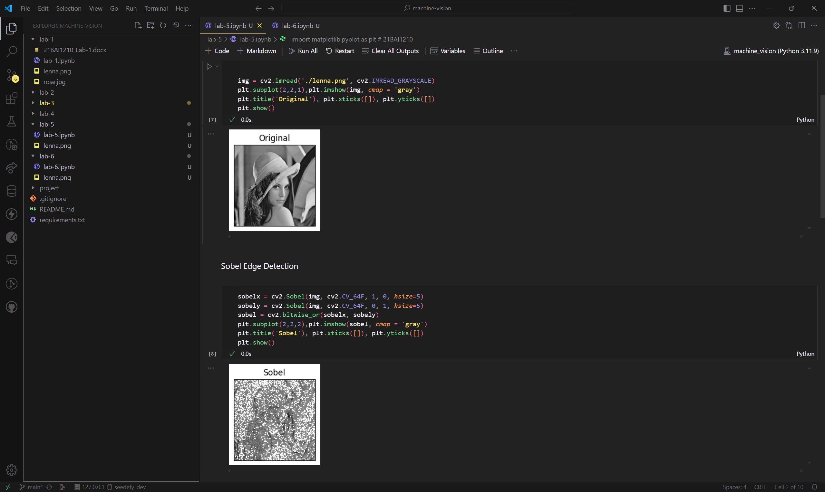

Lab 6:

Jupyter notebook code can be found [here](https://github.com/yadu-tv/machine-vision/blob/main/lab-6/lab-6.ipynb)

Output for Lab 6:

