# Machine Vision

Lab – 7 and Lab - 8

Name: Yadukrishnan

Reg. No: 21BAI1210

Lab 7:

Jupyter notebook code can be found [here](https://github.com/yadu-tv/machine-vision/blob/main/lab-7/lab-7.ipynb)

Output for Lab 7:

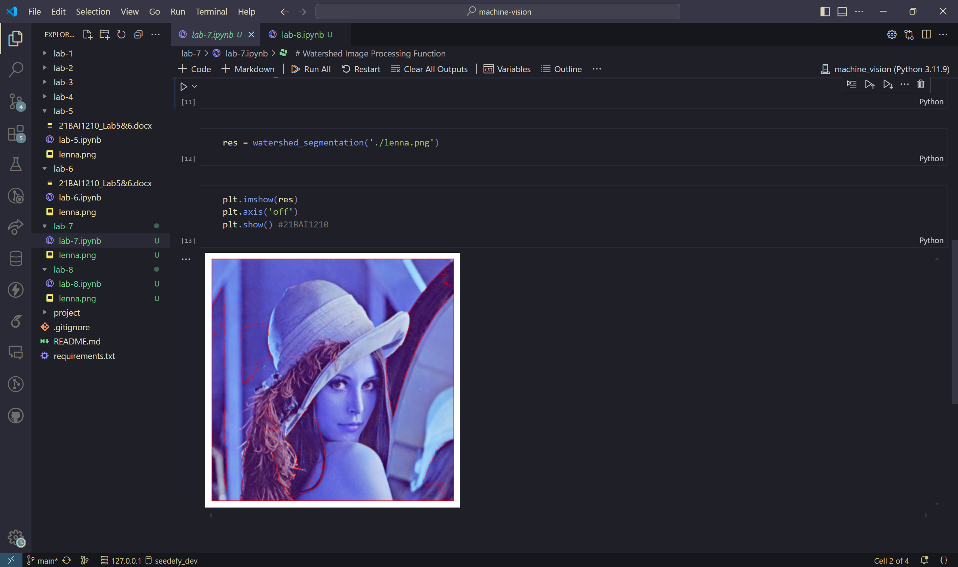

Lab 8:

Jupyter notebook code can be found [here](https://github.com/yadu-tv/machine-vision/blob/main/lab-8/lab-8.ipynb)

Output for Lab 8:

