Assignment-1.5
Name: Y.Rajiv
RollNo:2303A51357
TASK-1 AI-Generated Logic Without Modularization (String Reversal Without
Functions)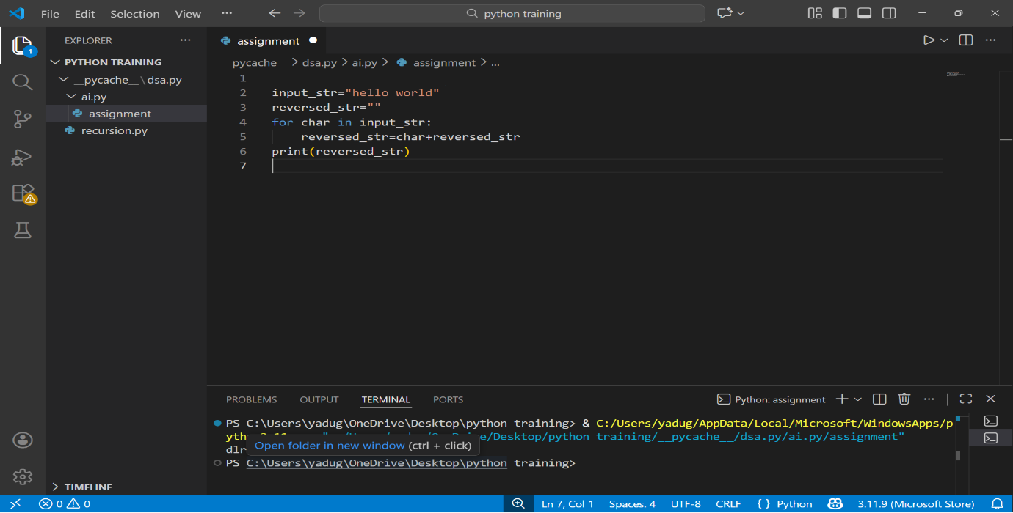
TASK-2 Efficiency & Logic Optimization (Readability Improvement)
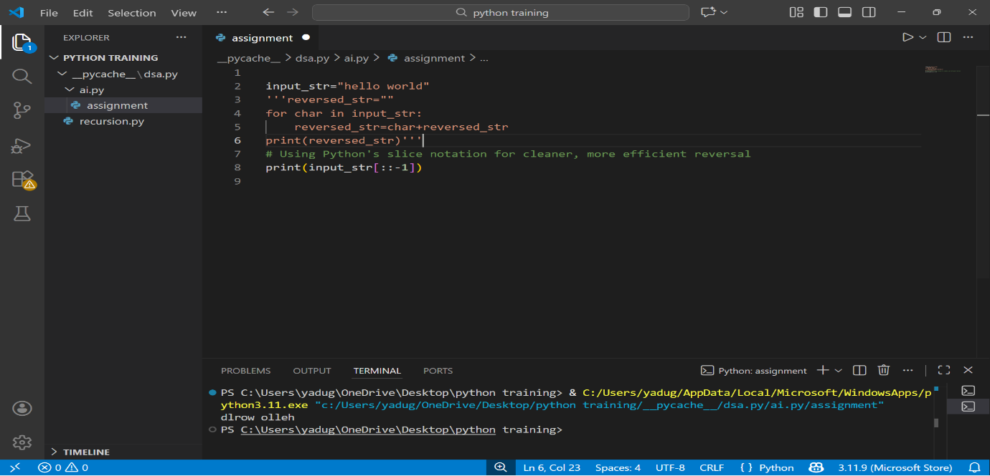
- Explaination: [::-1] tells Python:
  - Start from end
  - Move backwards
  - Step = -1
- Python internally reverses the string in one pass.
Time Complexity
- Each character is accessed once.
- No repeated copying like the loop version.
Time Complexity: O(n)
Task-3: Modular Design Using AI Assistance (String Reversal Using Functions)
Before optimization

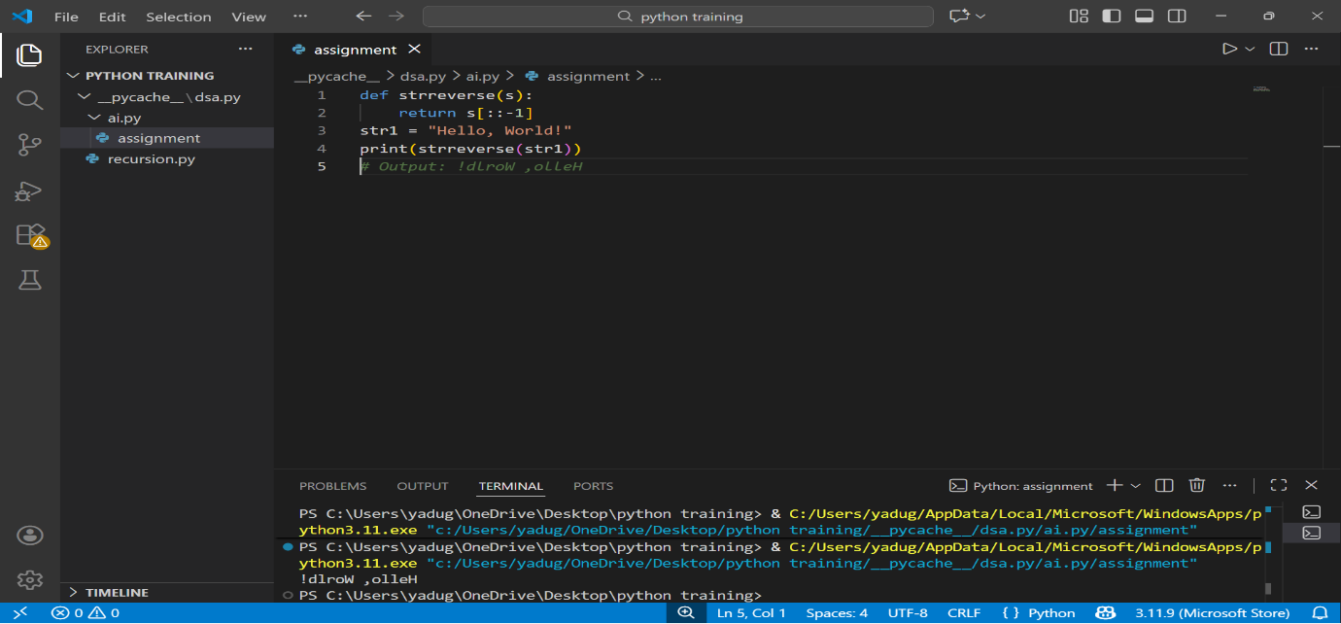
After optimization using copilot
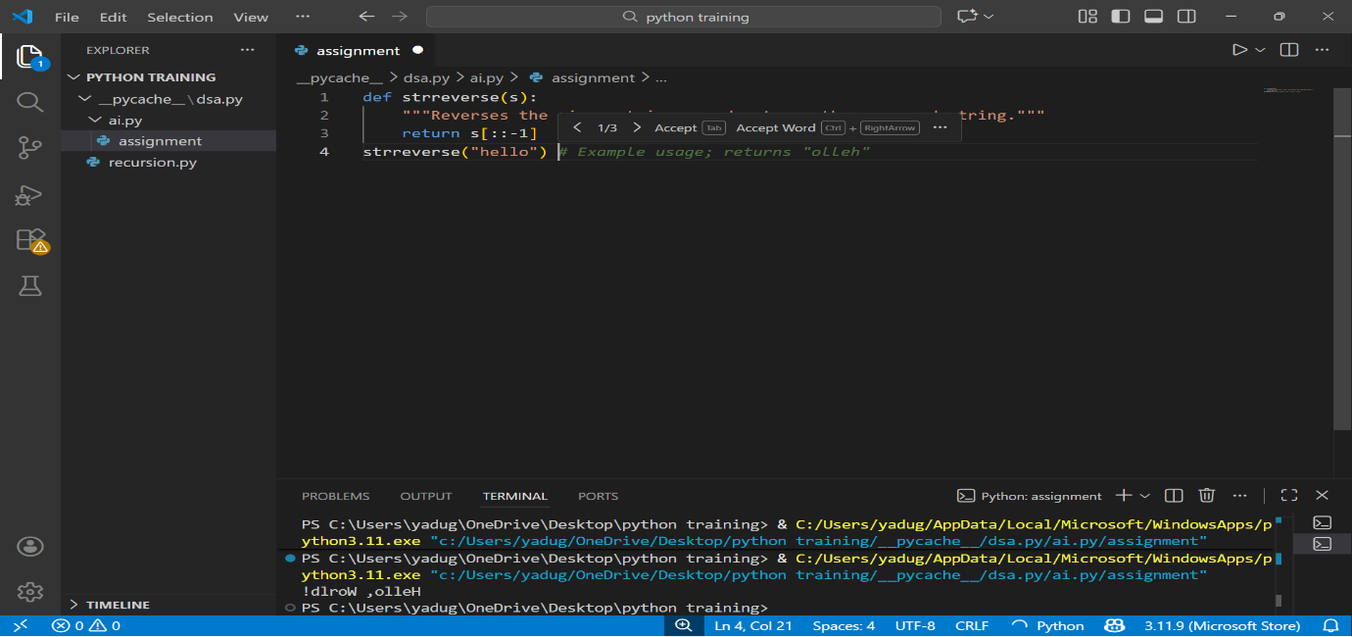
Task-4 Comparative Analysis – Procedural vs Modular Approach (With vs
Without Functions)

Criteria | Without Functions (Procedural) | With Functions (Modular)
Code Clarity | Logic mixed with execution, harder to read in large files | Clear separation of logic and execution
Reusability | Code must be rewritten for every use | Function can be reused anywhere
Debugging Ease | Bugs are harder to isolate | Easy to debug by testing the function alone
Scalability | Poor for large programs | Highly suitable for large applications
Maintenance | Changes must be made in multiple places | Changes made once in the function
Testing | Manual testing only | Supports unit testing easily
Readability | Acceptable for small scripts | Excellent for professional codebases
Copilot Assistance | Limited suggestions | Strong AI support for docstrings & logic

Task-5 AI-Generated Iterative vs Recursive Fibonacci Approaches (Different
Algorithmic Approaches to String Reversal)
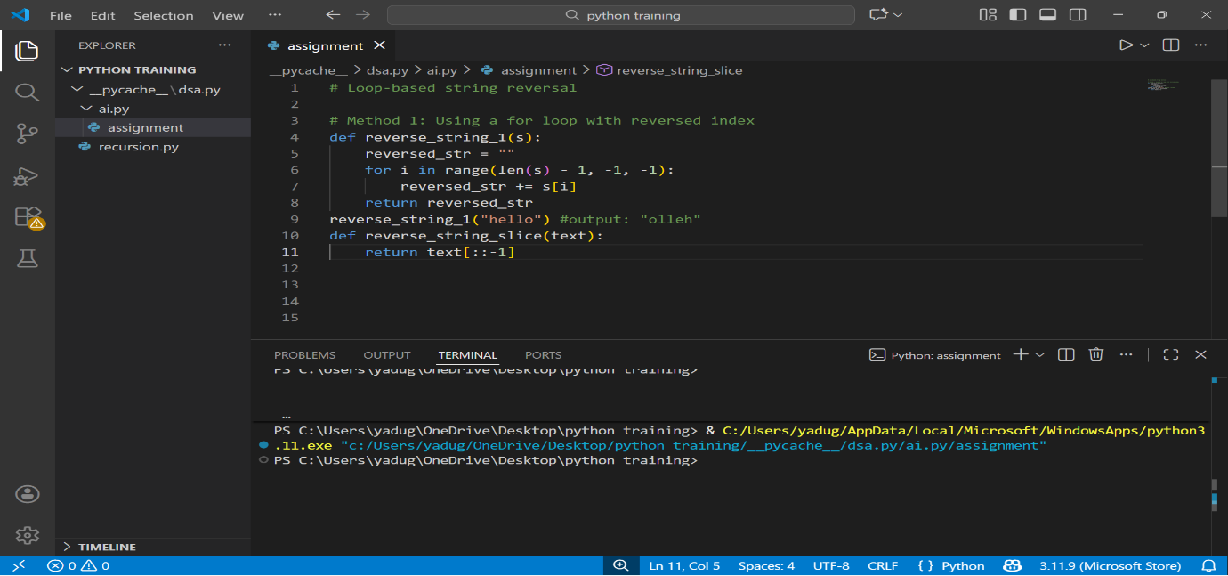
Explaination:
Both approaches correctly reverse strings.
Slicing-based reversal is superior in performance, readability, and scalability.

