**CS301: SOFTWARE ENGINEERING**

**Semester IV**

**Class Practice Sessions - 1**

**NAME : Yadukrishna PB  
ROLL NO. : 21BCS136**

**Theme :** Create new cultural destination to celebrate the heritage of India and provide a platform for emerging Talents using Digital Technology solutions

**Aim :**

· Creating doors for a first-of-its-kind, multi-disciplinary space for the Arts in cities

· Encourage Visual art space and captivating array of public art

· Bring together communities through a dynamic programming of epic theatricals , regional theatre, music , dance , spoken word etc.

· Major attraction is to provide a platform for emerging talent and showcases the vibrance of India’s heritage

· Generate source of income for the Art communities through collaborations, aggregators and accelerators investments

**Target audiences :**

· Home to Art, Artists, the audience from India and around the world.

**Assignment scope :**

1. Identify various requirements for the above program initiative that can be developed as a digital solutions

2. Use ChatGPT platform an generate code for the above requirements

a. Generate code and run the program in Goggle Colab/Jupiter Notebook/Visual Code/PyCharm

b. Perform integrated testing. Add integration testing code in the same program.

3. Modify the same program. Write APIs to access the data from the public domain and test the program for regression testing the same program

**Deliverables :**

Working Program with test scripts embedded in the same program.

**RESULTS :**

1. Requirements :

The requirements that can be developed as a digital solutions :

* Online ticketing system: An online platform that allows users to purchase tickets for events and performances at the cultural destination. This system should include payment processing, ticket generation, and seat selection functionality.
* Virtual tours: A digital platform that allows users to explore the cultural destination and its exhibits from the comfort of their own homes. This platform should include 360-degree views, audio guides, and interactive features.
* Artist management system: A digital platform that allows artists to manage their profiles, portfolios, and bookings. This system should include tools for artists to create and edit their profiles, manage their bookings, and connect with potential collaborators.
* Collaborative workspace: A digital platform that allows artists and creatives to collaborate and work on projects remotely. This platform should include tools for sharing and collaborating on files, scheduling meetings, and tracking project progress.

**2 . CODE :**

**import unittest**

**from flask import Flask, request, jsonify**

**import json**

**import subprocess**

**app = Flask(__name__)**

**login_details={}**

**art_form_options={}**

**def login():**

**while True:**

**username = input("Enter your username: ")**

**password = input("Enter your password: ")**

**if username == login_details["username"] and password == login_details["password"]:**

**print("Login successful!")**

**return True**

**else:**

**print("Invalid username or password. Please try again.")**

**# Function to display the available art forms and allow the user to choose one**

**def choose_art_form():**

**print("\nSelect an art form:")**

**print("1. Music")**

**print("2. Dance")**

**print("3. Spoken word")**

**print("4. Regional theatricals")**

**art_form = int(input("Enter a number: "))**

**if art_form == 1:**

**return view_or_buy("music")**

**elif art_form == 2:**

**return view_or_buy("dance")**

**elif art_form == 3:**

**return view_or_buy("spoken word")**

**elif art_form == 4:**

**return view_or_buy("regional theatricals")**

**else:**

**print("Invalid input. Please try again.")**

**return choose_art_form()**

**def view_or_buy(art_form_name):**

**print("\nSelect an option for", art_form_name)**

**print("1. View")**

**print("2. Buy")**

**print("3. Add new view or buy option")**

**option = int(input("Enter a number: "))**

**if option == 1:**

**return view_art_form(art_form_name)**

**elif option == 2:**

**return buy_art_form(art_form_name)**

**elif option == 3:**

**return add_option(art_form_name)**

**else:**

**print("Invalid input. Please try again.")**

**return view_or_buy(art_form_name)**

**def add_option(art_form_name):**

**option_name = input("Enter option name: ")**

**option_price = input("Enter option price: ")**

**try:**

**option_price = int(option_price)**

**except ValueError:**

**print("Invalid price. Please try again.")**

**return add_option(art_form_name)**

**art_form_options[art_form_name]['view'].append(option_name)**

**art_form_options[art_form_name]['buy'][option_name] = option_price**

**print(f"Successfully added {option_name} to {art_form_name} {view_or_buy} options.")**

**return go_back_option(art_form_name)**

**def view_art_form(art_form_name):**

**view_options = art_form_options[art_form_name]["view"]**

**if len(view_options) == 0:**

**print("No options available for", art_form_name)**

**else:**

**print("View options for", art_form_name, ":")**

**for option in view_options:**

**print("-", option)**

**return go_back_option(art_form_name)**

**def buy_art_form(art_form_name):**

**buy_options = art_form_options[art_form_name]["buy"]**

**if len(buy_options) == 0:**

**print("No options available for", art_form_name)**

**else:**

**print("Buy options for", art_form_name, ":")**

**for option in buy_options:**

**print("-", option)**

**option = input("Enter name of option to see buy price: ")**

**if option in buy_options:**

**assert buy_options[option]==art_form_options[art_form_name]["buy"][option],"inconsistent value"**

**print("Buy price for", option, "is", buy_options[option])**

**else:**

**print("Invalid input. Please try again.")**

**return buy_art_form(art_form_name)**

**return go_back_option(art_form_name)**

**def go_back_option(art_form_name):**

**print("\nEnter 1 to go back to", art_form_name)**

**print("Enter 2 to exit")**

**option = int(input("Enter a number: "))**

**if option == 1:**

**return view_or_buy(art_form_name)**

**elif option == 2:**

**return True**

**else:**

**print("Invalid input. Please try again")**

**#regression testing:**

**class TestArtForms(unittest.TestCase):**

**def test_choose_art_form(self):**

**self.assertEqual(choose_art_form(), True)**

**def test_login(self):**

**self.assertEqual(login(), True)**

**#API:**

**@app.route('/data', methods=['GET'])**

**def get_data():**

**# Get the data from the request**

**global login_details,art_form_options**

**data = request.get_json()**

**login_details=data["login"]**

**art_form_options=data["art"]**

**inpt=input("enter 1 to perform regression testing , 2 to run program , 3 to exit")**

**if(inpt=='1'):**

**unittest.main()**

**elif inpt=='2':**

**while True:**

**choice = input("Press 1 to login, 2 to exit ")**

**if choice == "1":**

**if login():**

**# integration testing:**

**assert choose_art_form() == True, "Execution error"**

**elif choice == "2":**

**print("Exiting program.")**

**break**

**else:**

**print("invalid input")**

**print("program completed")**

**else:**

**print("invalid input")**

**# Return a success message**

**return jsonify({'message': 'program execution successful'})**

**app.run(debug=True)**

**'''data to pass to http://localhost:5000/data using postman:**

**{"login":{**

**"username": "my_username",**

**"password": "my_password"**

**},"art":{**

**"music": {**

**"view": ["rock", "jazz", "blues"],**

**"buy": {**

**"rock": 10,**

**"jazz": 15,**

**"blues": 20**

**}**

**},**

**"dance": {**

**"view": ["ballet", "tap", "salsa"],**

**"buy": {**

**"ballet": 25,**

**"tap": 20,**

**"salsa": 30**

**}**

**},**

**"spoken word": {**

**"view": ["poetry", "storytelling"],**

**"buy": {**

**"poetry": 5,**

**"storytelling": 8**

**}**

**},**

**"regional theatricals": {**

**"view": ["nautanki", "jatra"],**

**"buy": {**

**"nautanki": 12,**

**"jatra": 18**

**}**

**}**

**}}**

**'''**

**3.OUTPUT :**

**Code**

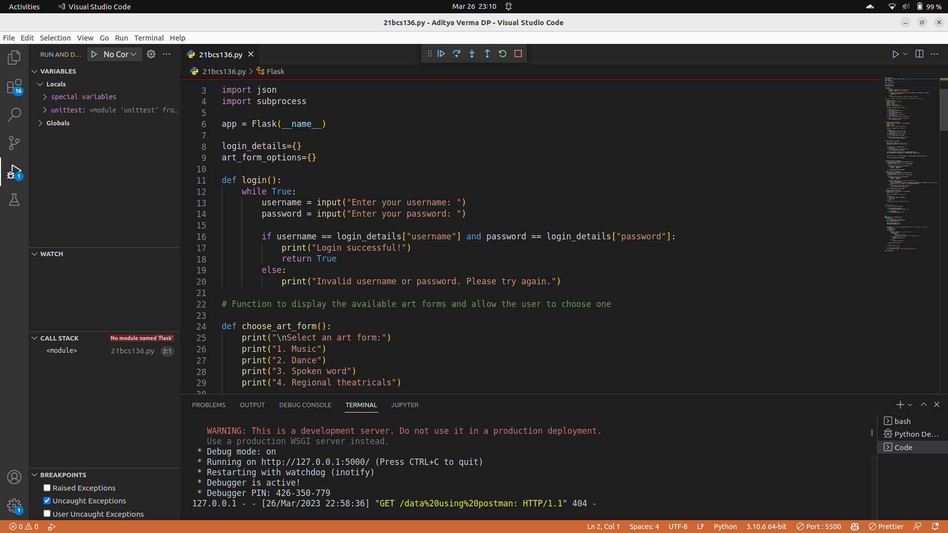

**API**



