LUMINAR
E-COMMERCE SALES &
CUSTOMER ANALYTICS
SQL PROJECT REPORT
Submitted as part of the Data Analytics Course
Institute: Luminar
Submitted by: Yadunandhanan R
Submission date: __________________

Abstract
This project uses MySQL to organize and analyze data for a simulated online store. The database includes customers, sellers, products, orders, order items, and payments. SQL queries address customer activity, order status, product performance, revenue, payment methods, and repeat purchasing. Advanced techniques include joins, aggregate functions, subqueries, common table expressions (CTEs), window functions, a view, and a stored procedure.

1. Introduction
E-commerce data can help businesses understand product performance, customer spending, sales trends, and payment-method usage. This project is part of the Data Analytics course at Luminar and uses MySQL Workbench.

2. Problem Statement
The project builds a relational database for an online store and uses SQL queries to answer business questions through filtering, sorting, aggregation, joins, and advanced techniques.

3. Objectives
- Create and use a MySQL database for e-commerce analytics.
- Organize data into six related tables.
- Use SELECT, WHERE, ORDER BY, and LIMIT.
- Use JOINs, GROUP BY, HAVING, and aggregate functions.
- Apply subqueries, CTEs, and window functions.
- Create a monthly sales view and customer-history stored procedure.
- Document database design, queries, and verified outputs.

4. Tools and Technologies
- MySQL — relational database management system.
- MySQL Workbench — used to execute SQL, inspect tables, and create the EER diagram.
- SQL — used for data retrieval and analysis.

5. Database Design
The ecommerce_project schema contains six main tables:
Table | Purpose | Analytical use
customers | Stores customer details. | Filter by city or signup date; analyze spending.
sellers | Stores seller details. | Compare seller sales performance.
products | Stores product information. | Compare price, category, and revenue.
orders | Stores order details. | Analyze date, status, and customer activity.
order_items | Stores products and quantities within orders. | Calculate units sold and product revenue.
payments | Stores payment records. | Summarize revenue and payment types.
Primary keys identify records, and relationship lines connect related tables.

Figure 1 — Entity Relationship Diagram
The diagram shows the six main tables and the monthly_sales_summary view.
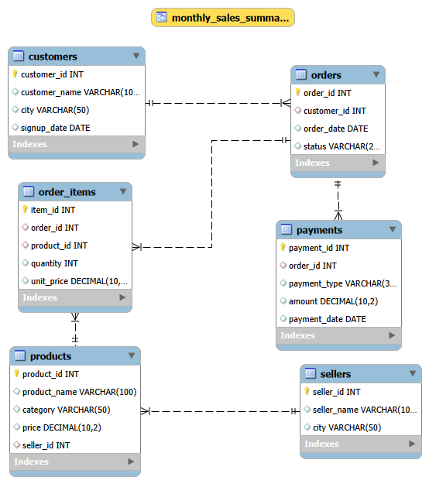

6. Methodology

Database setup
Created and selected the ecommerce_project schema in MySQL Workbench.

Table creation and data
Created six tables and used the available sample records to test relationships and queries.

Basic queries
Used filtering and sorting for customers, orders, product prices, delivery status, and signup dates.

Intermediate analysis
Used joins and aggregates for revenue, units sold, customer spending, seller revenue, order value, and payment types.

Advanced analysis
Applied subqueries, CTEs, window functions, a monthly sales view, and a customer-history stored procedure.

Validation
Executed queries and reviewed the results in MySQL Workbench.

7. Business Questions and SQL Concepts
Level | Business questions covered | SQL concepts
Beginner | Customers by city; recent orders; 10 most expensive products; delivered orders; customers who signed up in 2025. | SELECT, WHERE, ORDER BY, LIMIT, date filtering
Intermediate | Total revenue; highest-selling category; top five customers by spend; sellers above a revenue threshold; average order value by city; payment summaries. | JOIN, GROUP BY, HAVING, SUM, COUNT, AVG
Advanced | Product revenue rankings; customers spending above average; repeat customers; monthly sales view; customer order history. | Subqueries, CTEs, window functions, views, stored procedures

8. Advanced SQL Features

8.1 Window functions
RANK() or DENSE_RANK() can rank products by revenue within each category.

8.2 Common table expressions (CTEs)
A CTE introduced with WITH defines a named result set for a multi-step query.

8.3 View: monthly_sales_summary
The view provides a reusable monthly sales query. Figure 2 shows its actual output.

8.4 Stored procedure: get_customer_history
The procedure accepts a customer ID and returns that customer's order history. Figure 3 shows the call and returned rows for customer ID 1.

9. Verified Query Results — Monthly Sales Summary
The query executed successfully and returned six rows.
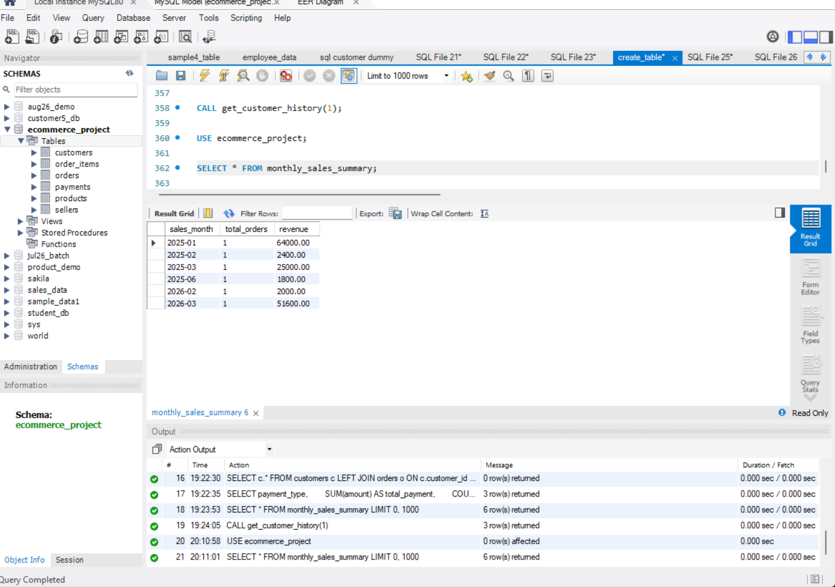
The visible monthly sales results are summarized below:
Sales month | Total orders | Revenue
2025-01 | 1 | 64,000.00
2025-02 | 1 | 2,400.00
2025-03 | 1 | 25,000.00
2025-06 | 1 | 1,800.00
2026-02 | 1 | 2,000.00
2026-03 | 1 | 51,600.00

10. Verified Query Results — Customer History
CALL get_customer_history(1); executed successfully and returned three rows. The visible output shows customer Arun and order-item details for Phone, Laptop, and Headphones.
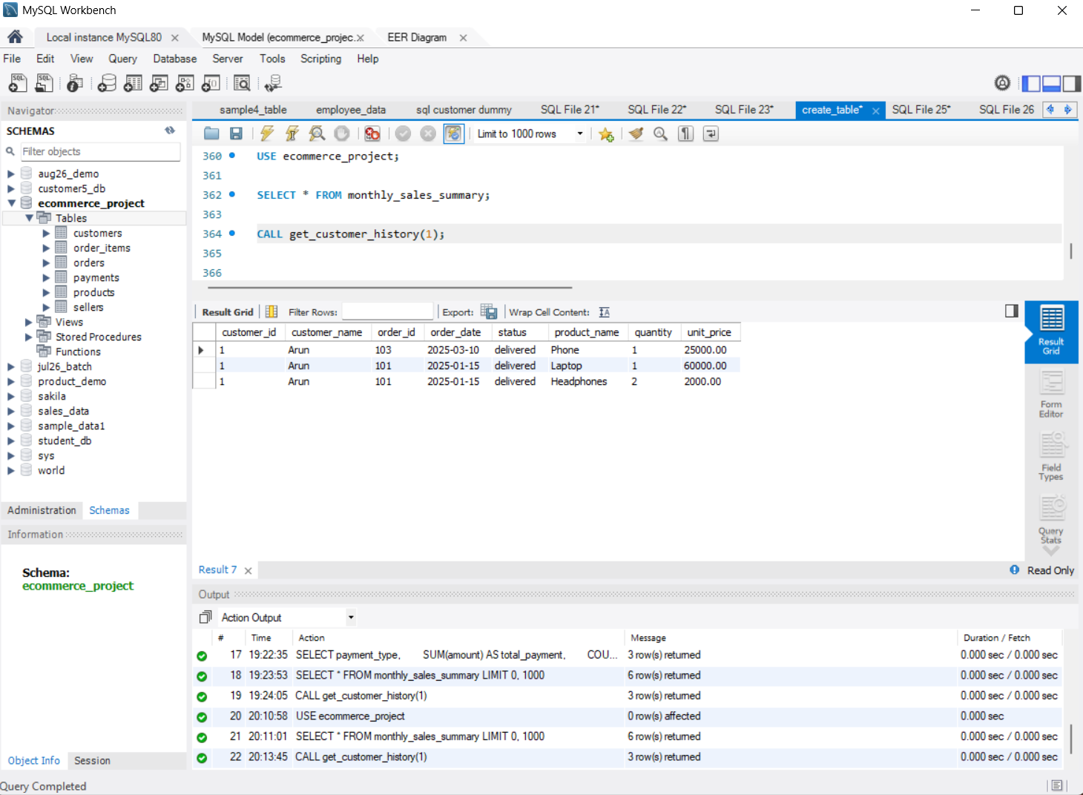

11. Verified Query Results — Payment Type
The payment summary query executed successfully and returned three payment types:
Payment type | Total payment | Payment count
UPI | 200,600.00 | 4
Card | 11,400.00 | 3
Cash | 1,800.00 | 1
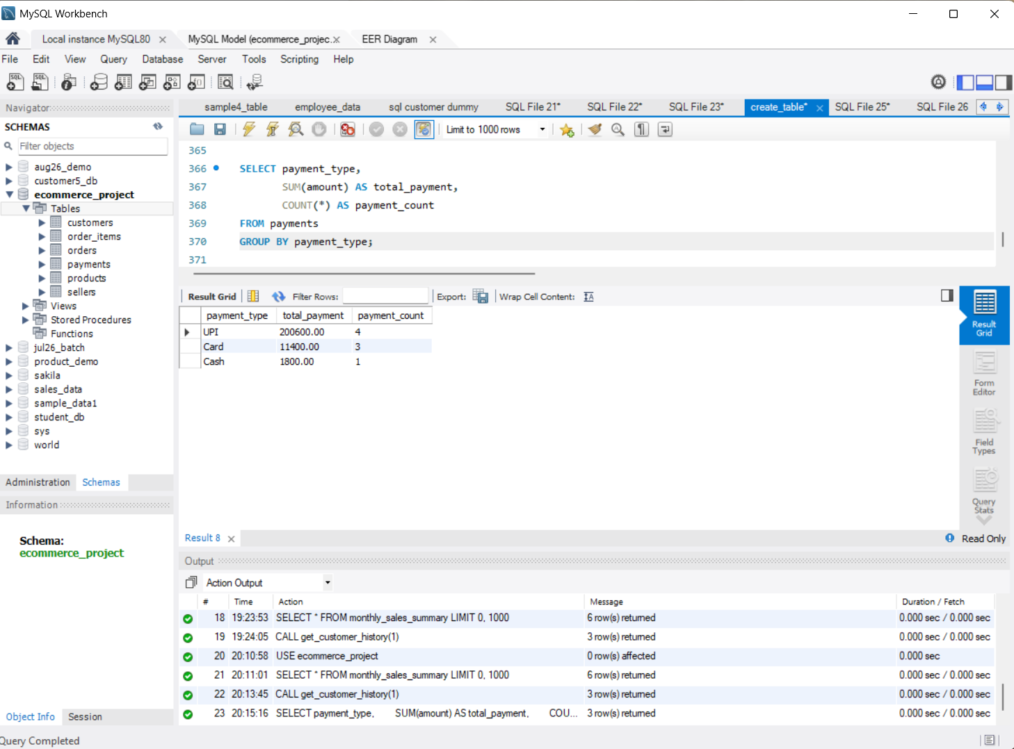

12. Key Findings
- The monthly sales view returned six rows; each displayed month has one order.
- The highest displayed monthly revenue is 64,000.00 in January 2025; the lowest is 1,800.00 in June 2025.
- UPI has the highest total payment amount in the displayed payment summary (200,600.00 across four payment records).
- The customer-history procedure returned three rows for customer ID 1 (Arun), covering Phone, Laptop, and Headphones.
These findings describe the displayed query outputs and should not be interpreted as complete business totals without checking the dataset and query definitions.

13. Skills Practiced
Relational database design, filtering, sorting, joins, aggregate functions, subqueries, CTEs, window functions, views, stored procedures, and query validation.

14. Conclusion
The project demonstrates how SQL can organize related e-commerce data and answer practical business questions. The database, SQL queries, EER diagram, and verified screenshots can form part of a Data Analytics portfolio.

15. Future Enhancements
- Connect the monthly sales view to Power BI or Tableau.
- Add records and validate data quality.
- Extend analysis with sales growth, category trends, and customer segmentation.
- Publish SQL scripts, the EER diagram, and screenshots in GitHub.

Appendix — Submission Checklist
- ☐ SQL table-creation script.
- ☐ Beginner, intermediate, and advanced queries.
- ☐ EER diagram.
- ☐ Monthly sales view screenshot.
- ☐ Customer-history procedure screenshot.
- ☐ Payment-type summary screenshot.
- ☐ Additional verified query screenshots.
- ☐ README.md with project details and data-source notes.
Before submission, credit any external dataset used. If sample data was created manually, describe it as sample/custom-built data.

