Synopsis

House Price Prediction Using Regression-Based Machine Learning Techniques

Problem Id: 5

Student Name
Ketan Agarwal, Harsh Jain, Yaduveer Yadav
University Roll number
2028742, 2028721, 2028911
Section P

- Problem Description:
The project focuses on designing a regression-based machine learning system to predict the sale price of residential houses using a structured real-estate dataset containing 25 property-related features. These features describe different aspects of a house such as its physical characteristics (area, bedrooms, bathrooms, floors, and age), location factors (distance from city center, proximity to hospitals and shopping centers), neighborhood conditions (crime rate, school rating, green space availability), and infrastructure reliability (water, electricity, and internet availability). Since house price is a continuous numerical value, regression techniques are used to estimate the relationship between these factors and the final sale price.
The main objective is to analyze the dataset using Exploratory Data Analysis (EDA), preprocess the data by handling missing values and encoding categorical variables, and then train regression models capable of accurately predicting house prices. The system is evaluated using statistical metrics such as R² score, Mean Absolute Error (MAE), and Mean Squared Error (MSE).
In real life, such predictive systems are widely used in the real-estate industry to estimate property values quickly and accurately. Real estate companies, property buyers, sellers, and investors rely on these models to make informed decisions about property pricing, investment opportunities, and market trends.
- Steps of Implementation:

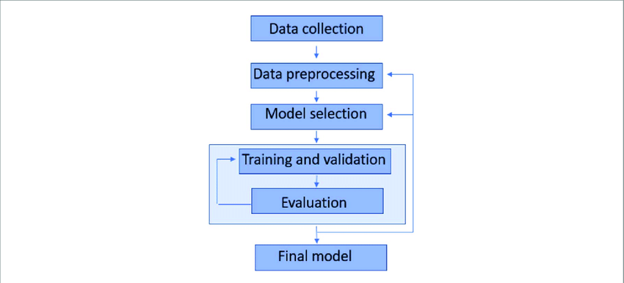
- Expected Modules/ Libraries to be used :

- 1. NumPy (numpy)
A fundamental Python library used for numerical computing and mathematical operations on arrays and matrices, which supports efficient data manipulation required in machine learning.
- 2. Pandas (pandas)
A powerful data analysis and manipulation library used to load, clean, organize, and manage structured datasets using DataFrames.
- 3. Matplotlib (matplotlib.pyplot)
A visualization library used to create graphs such as scatter plots, line plots, and residual plots for analyzing relationships between variables and model predictions.
- 4. Seaborn (seaborn)
A statistical data visualization library built on top of Matplotlib that helps generate more informative plots such as correlation heatmaps, distribution plots, and pair plots for exploratory data analysis.
- 5. Scikit-learn (sklearn)
A widely used machine learning library that provides tools for data preprocessing, regression models, model training, and evaluation metrics.
- 6. Scikit-learn Model Selection (sklearn.model_selection)
Provides utilities such as train_test_split to divide the dataset into training and testing sets for proper model evaluation.
- 7. Scikit-learn Preprocessing (sklearn.preprocessing)
Used for data preparation techniques such as feature scaling, normalization, and encoding categorical variables before training machine learning models.
- 8. Scikit-learn Metrics (sklearn.metrics)
Provides performance evaluation functions such as R² score, Mean Absolute Error (MAE), and Mean Squared Error (MSE) to measure the accuracy of regression models.
- 9. Scikit-learn Linear Model (sklearn.linear_model)
Contains regression algorithms such as Linear Regression used to predict continuous target values like house prices.
- 10. Scikit-learn Ensemble (sklearn.ensemble)
Provides ensemble learning methods such as Random Forest Regressor which combine multiple decision trees to improve prediction accuracy.

- Data Collection:
The dataset to be used was taken directly from a Kaggle online competition, the dataset was split into testing and training data by default.

- Data Preprocessing:
We handled missing values, encode cartegorical features; such as property type and normalize numerical features using feature scaling techniques.

- Model Selection:
The model to be used is Linear Regression, because it predicts continuous values like house prices by finding the relationship between input features and the target variable. It is simple, fast to train, and easy to interpret, making it a good baseline model for house price prediction.

- Training and Validation:
We had two datasets; Training and Testing, Training data is used for Training, and the Testing data is used for Validation, this helps to check whether the model is generalizing well or overfitting, it ensures that the model performs accurately on unseen data.

- Expected Evaluation metrics and Plots to be used:
To evaluate the performance of the regression models used for predicting house prices, several evaluation metrics and visualization plots will be used. These help measure how accurate the predictions are and how well the model learns the relationship between the features and the house price.

- R² Score (Coefficient of Determination) will be used to measure how well the model explains the variation in house prices. A value closer to 1 means the model predicts the data more accurately.
- Mean Absolute Error (MAE) will be used to calculate the average difference between the predicted prices and the actual prices. It gives a clear idea of how far the predictions are from the real values.

- Mean Squared Error (MSE) will also be used to measure prediction error. It squares the errors, which means larger mistakes are penalized more.

- For visualization, a Predicted vs Actual Values scatter plot will be used to compare the predicted house prices with the real prices. A Residual Plot will also be used to observe the prediction errors and check if the model is making consistent mistakes. These plots help in better understanding the model’s performance.

- Final Model:
The final model is a trained machine learning model tat gives the best performance after the training and evaluation metrics such as R² score, MAE, and MSE. The final model should be able to predict house prices based on property features.

- Required topics from the subject:

- 1. Variables and Data Types
Variables are used to store data values in a program. In this project, different data types such as integers, floats, strings, and boolean values are used to represent property features like area, number of bedrooms, and parking availability.
- 2. Conditional Statements
Conditional statements such as if, elif, and else are used to control the flow of the program based on certain conditions. They help in handling special cases during data preprocessing and validation.
- 3. Loops (Iteration)
Loops such as for and while are used to repeat a set of instructions multiple times. In this project, loops may be used for tasks such as processing data, iterating through features, or performing calculations on datasets.
- 4. Functions
Functions help organize code into reusable blocks that perform specific tasks. In this project, functions can be used for operations like data preprocessing, model training, and evaluating prediction results.
- 5. File Handling
File handling is used to read and write data from files. In this project, it is used to load the dataset (for example, CSV files) into the program for analysis and machine learning model training.
- 6. Libraries and Modules
Libraries and modules allow the use of pre-built functions and tools. In this project, libraries such as NumPy, Pandas, Matplotlib, and Scikit-learn are used for data analysis, visualization, and machine learning model development.

- Platform Required:
Jupyter Notebook

- Books and Link Sources:

- 1. Hands-On Machine Learning with Scikit-Learn, Keras, and TensorFlow – Aurélien Géron
A widely used book that explains practical machine learning concepts and implementation using Python libraries such as Scikit-learn.

- 2. Python for Data Analysis – Wes McKinney
This book focuses on data analysis using Python and explains how to use libraries like Pandas and NumPy for handling structured datasets.

- 3. Introduction to Machine Learning with Python – Andreas C. Müller and Sarah Guido
A beginner-friendly book that explains the fundamentals of machine learning and how to implement models using Scikit-learn.

- 4. Scikit-learn Official Documentation
https://scikit-learn.org
The official documentation that provides detailed explanations and examples for machine learning algorithms, preprocessing techniques, and evaluation metrics.

- 5. Pandas Official Documentation
https://pandas.pydata.org
An official resource for learning how to manipulate and analyze structured data using the Pandas library in Python.

