“Court Case System”

By

Yadwinder Singh

Level-6

Final Project

Table of Contents

Project Proposal 3

Goals and Objectives 3

Project Scope 3

Project Specifications 3

Project Deliverables 4

Resource Requirements 4

Project Tasks and Milestones 4

Project Assumptions 5

Project Report 5

Non- Functional 5

Detail Design 6

Home Page 6

News Page 6

Registration Page 7

Clients Page Admin View 7

Professional Page Admin View 7

Professional Page Client View 8

Project Testing 9

User Manual 9

Summary 9

System Configuration 9

User Access Levels 9

# 

# 

# Project Proposal

## Goals and Objectives

This project aims to implement an online web application named “Court Case Management”. In this application we are providing different kind of services. Customer can maintain the all record in Court. Because In Court there are number of cases which are very tough task for the lawyers and judges to remember these records so this software will help to the lawyers and judges. So basically this software is beneficial for lawyers and judges to maintain their cases record. This software is very user friendly software. The customer can easily manage this kind of software.

## Project Scope

The scope of this project is to implement an app named “Court Case Management” with the help of which lawyer can easily maintain his record. The duration of the project is 20 working days which is equals to 4 weeks.

## Project Specifications

* Login/Logout.
* Add, edit, delete and check details of professionals by admin
* Admin can edit, delete and check details of the clients.
* Admin can register new admins.
* Admin can edit, delete and access details of the all customer records.

## 

## Project Deliverables

The deliverables of the project are:

|  |  |
| --- | --- |
| Deliverable | Description |
| Final Report | This is the final report |
| Coding and implementation | The coding will go in this. The executable code of the project. |
| Documentation | This depicts the documentation of the project. |
| Testing | All the test details will be covered in this part. |

## Resource Requirements

The technologies used in this project are as follows:

* Asp.net MVC Framework
* 64-bit Processor and 4 GB or more RAM
* Identity framework- ASP
* Windows Operating System- 10
* Microsoft word for documentation.
* Microsoft Excel.

## Project Tasks and Milestones

The table below shows the Project Tasks and Milestones

|  |  |
| --- | --- |
| Tasks | Weeks |
| Research and analysis | 1-2 |
| Planning and first kick of meeting Project Proposal document. | 1-2 |
| Design of Database | 2-3 |
| UI design | 2-3 |
| Implementation of Identity Framework | 2-3 |
| Coding for admin and Client | 3-4 |
| Testing | 3-4 |
| Final Documentation | 3-4 |

## Project Assumptions

While doing the implementation, following assumption are made:

* One admin and client will be there to login when the app will be designed and implemented.
* Admin can only register new admin if he/she will be signing first.
* App will be open source.

# Project Report

#### Functional and Non-Functional

The functional requirements and non-functional requirements of this project are as follows:

|  |  |
| --- | --- |
| Users | Functional |
| Admin | * Manage professionals, add, edit, delete and check details. * Login/Logout * Register new data admins * Edit, delete and check details of the clients. * Edit, delete and access details of the hired professionals. |
|  |  |
| Non- Functional | |
| * Project will be compatible on all browsers and devices. * Security and fast load time of the project. * High performance and limited access for the clients. | |

## Detail Design

### Home Page

This page is the main landing page of the application. In this software there are much type of forms like Judge, Lawyer, Case, Hearing, Party, Court room, Register Login where you can add update these things.

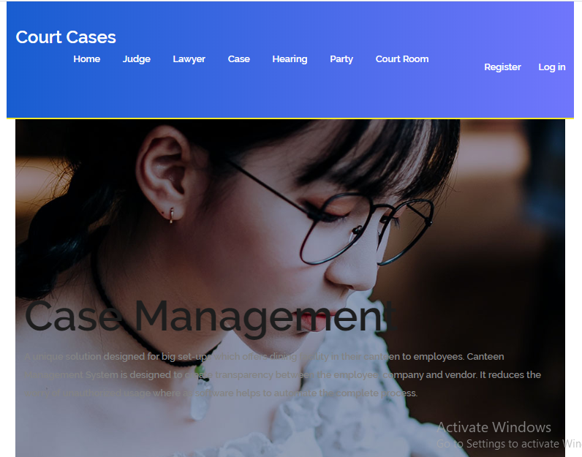

### Login Page

With the help of this page admin can login into the web application by using their credentials.

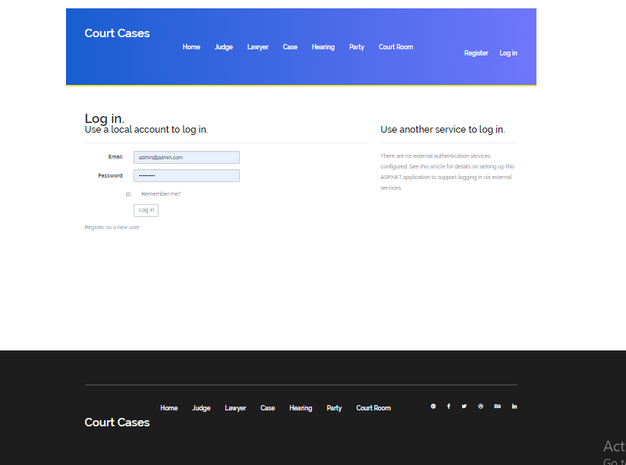

### Registration Page

With the help of this page admin can register new data.

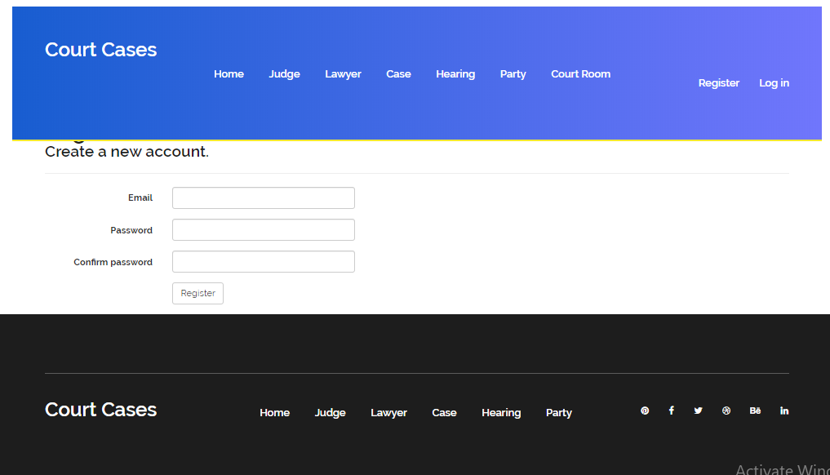

### Add record of Judge

In this page you can add the record of judges who are working in your court.

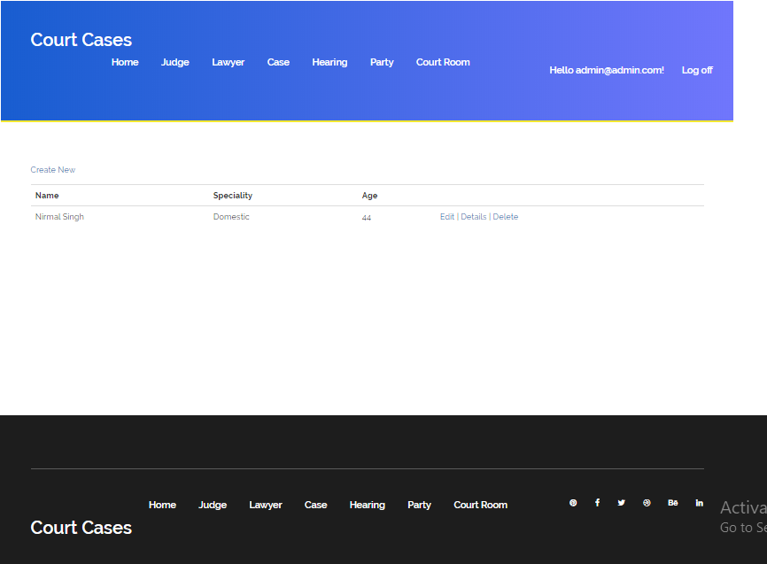

### View Judges

In this page you can view the list of judges. Here user can edit and delete the judge.

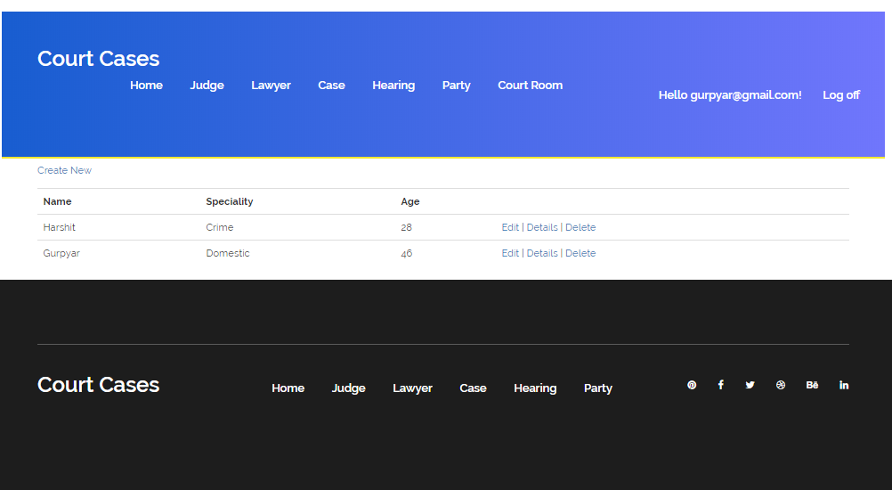

## 5. Lawyer: - Here I can show the lawyer in my website. And clicking on the create new link I can create the lawyer. Edit and delete customer are also available here.

## 6.PNG

## 

## 6. Court Room: - Here I can show the court room in my website. And clicking on the create new link I can create the court room. Edit and delete court room are also available here.

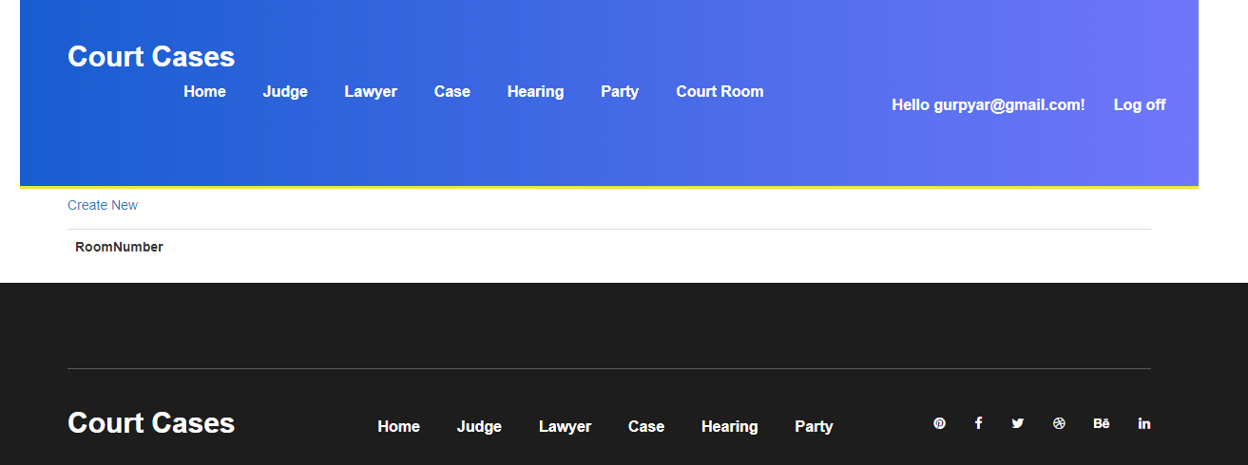

## Project Testing

Excel File Attached for Usability Testing can be found at [CourtCases.xlsx](Hire%20a%20Professional.xls)

# User Manual

This project aims to implement an online web application named “Court Case Management”. In this application we are providing different kind of services. Customer can maintain the all record in Court. Because In Court there are number of cases which are very tough task for the lawyers and judges to remember these records so this software will help to the lawyers and judges. So basically this software is beneficial for lawyers and judges to maintain their cases record. This software is very user friendly software. The customer can easily manage this kind of software.