**Installation Guide**

**Installing multiple clients on same machine.**

Since you’ll be running all the three clients on the same machine you need to follow the following steps.

Currently you are having only one copy of D_Basket folder.

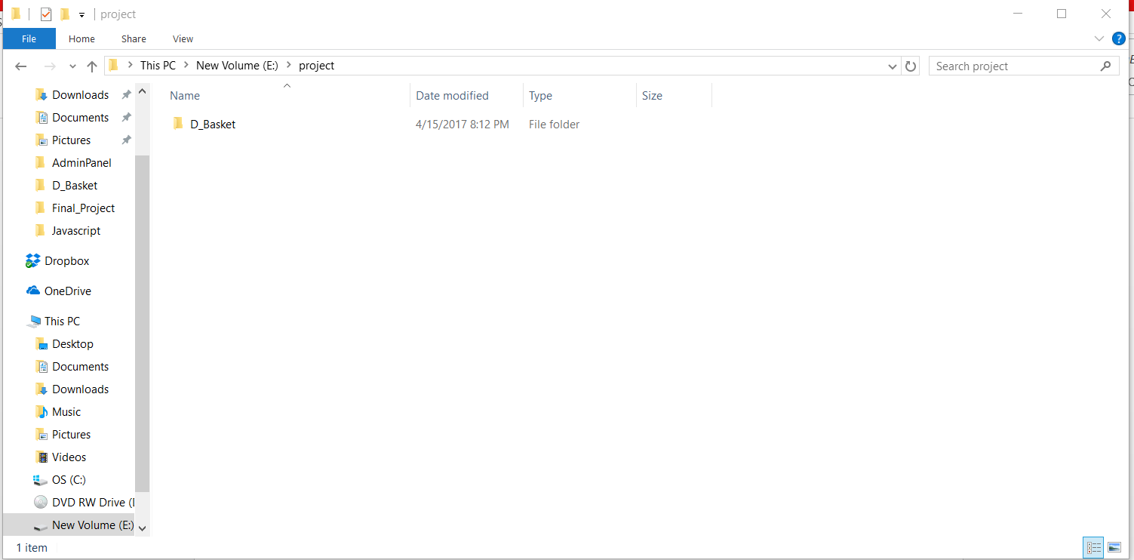

**Changed the host to point to localhost**

Since we are running the server on local machine we need to change the ip address of the host(server) in the AprioriClient.py to point to local machine.

AprioriClient.py is present in AdminPanel folder. ( D_Basket > AdminPanel > AprioriClient.py)

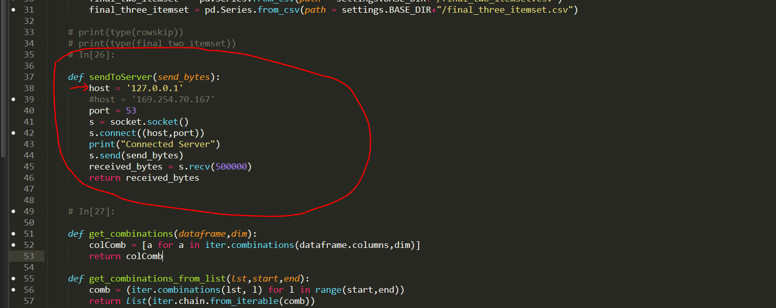

Open the AprioriClient.py in AdminPanel and make sure your host is pointing to localhost (i.e 127.0.0.1”) in the sendToServer function.  
If it is already pointing to it do nothing.

**1) Copy the D_Basket folder twice**

To create two more clients copy D_Basket folder twice and name it D_Basket2 and D_Basket 3

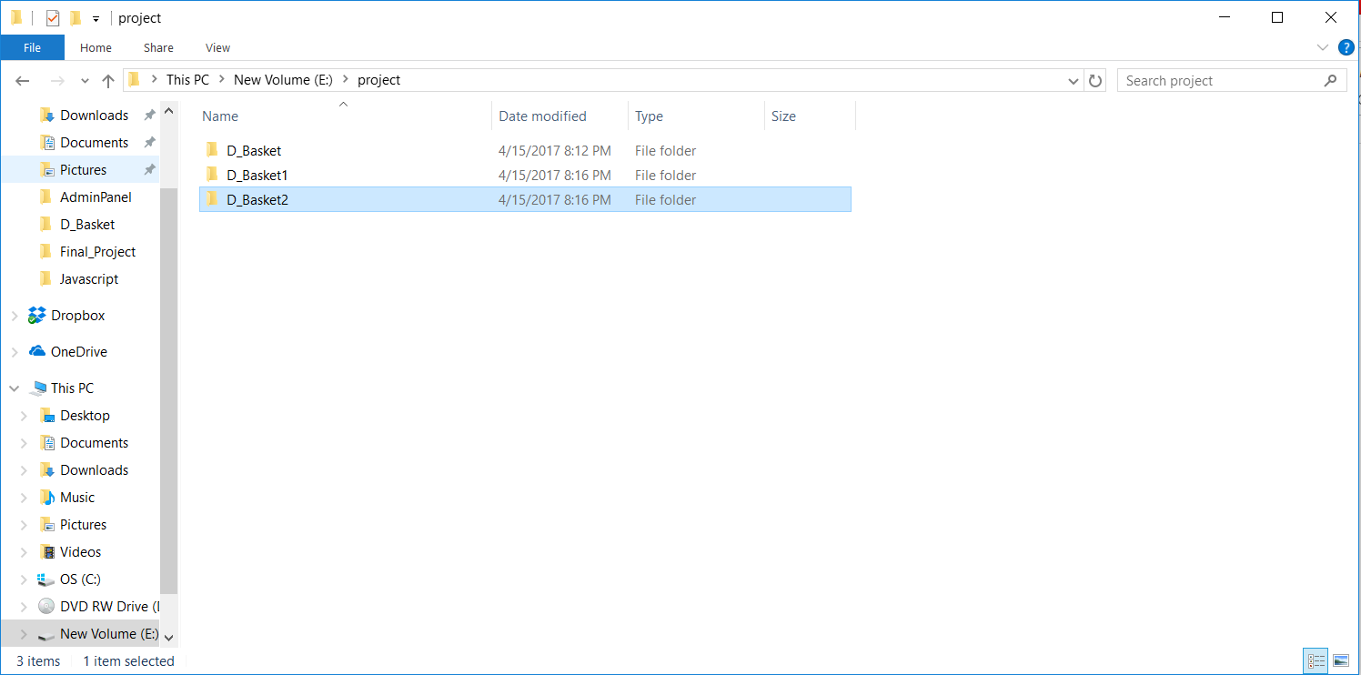

**2) Open three command prompts**

Now for each client we need 3 command prompts. So open 3 command prompts and go to D_Basket, D_Basket1 and D_Basket2 respectively.

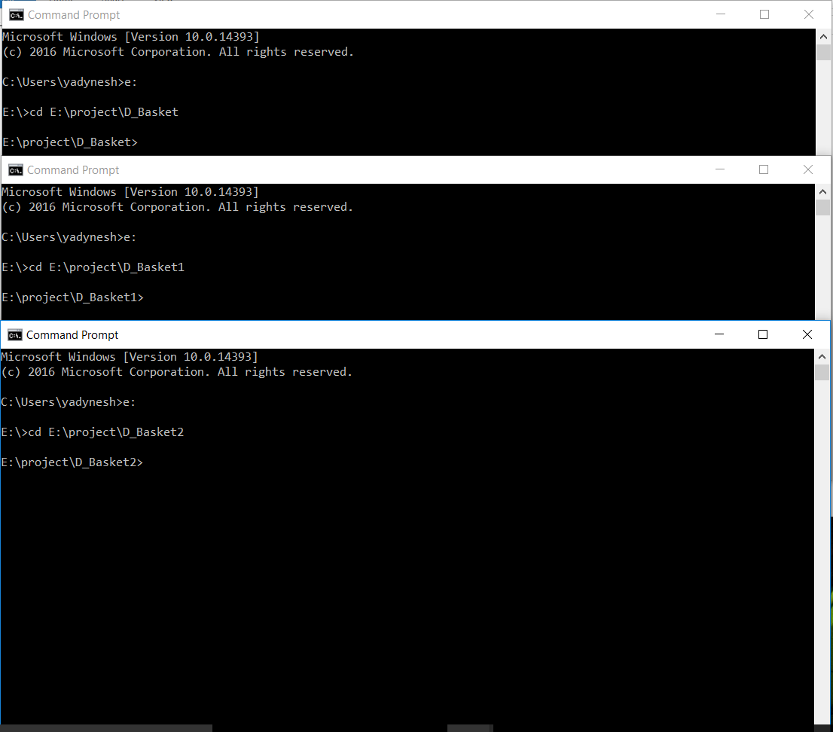

**3) Activate python environment in each client**

Now we need to activate the python environment. This environment is where all our python packages are installed.  
We have already installed the environment for you.

To activate the environment use the command - **activate <environment_name>**

**Note:** In my computer the name of the environment is finalproject but the name of the environment in your computer is Dipriori so you need to use the command - **activate Dipriori**

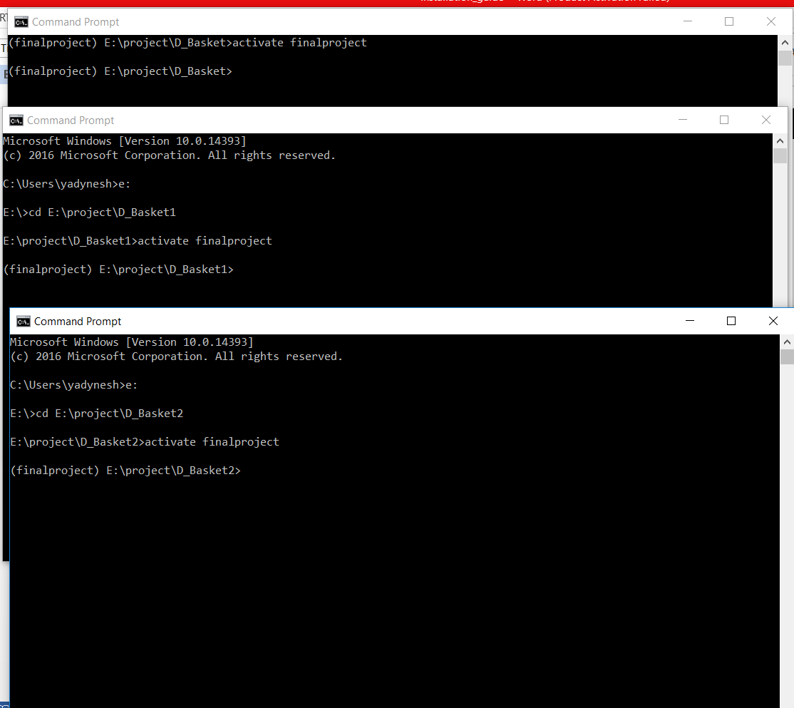

**4) Run the Django server on each of the client**

Now to run the web application we need to start the django server on each of the clients. Since we are running the 3 servers on the same machine we will use different ports for each of the servers. The command for this is –

python manage.py runserver <port_number>

The default port of django server is 8000. So if you don’t specify the port it will run port 8000 by default.

We will be running all the three django servers on 3 different ports.

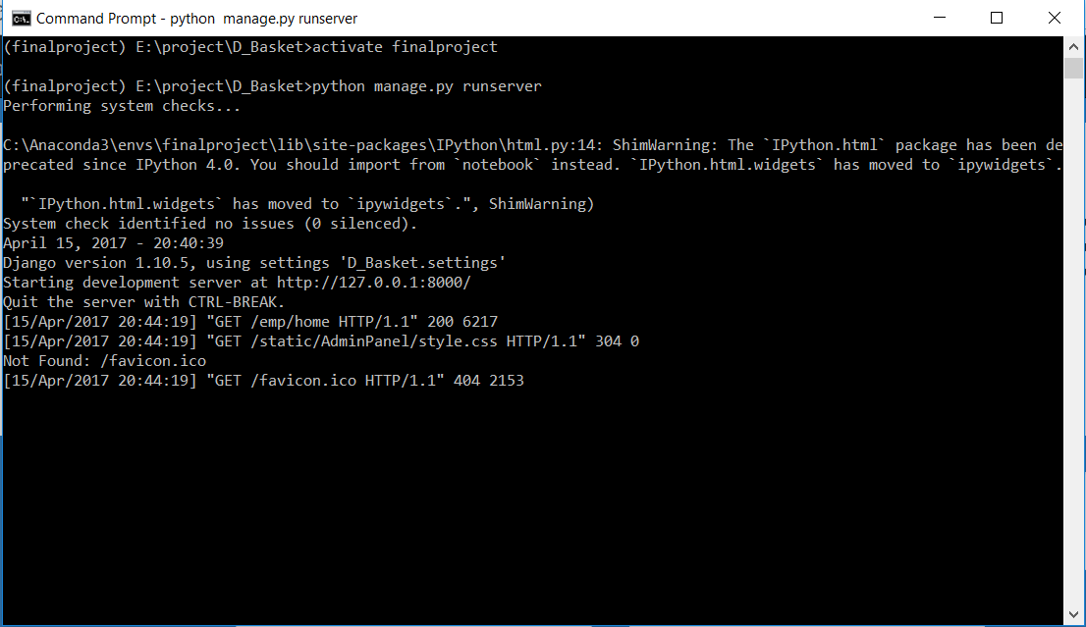

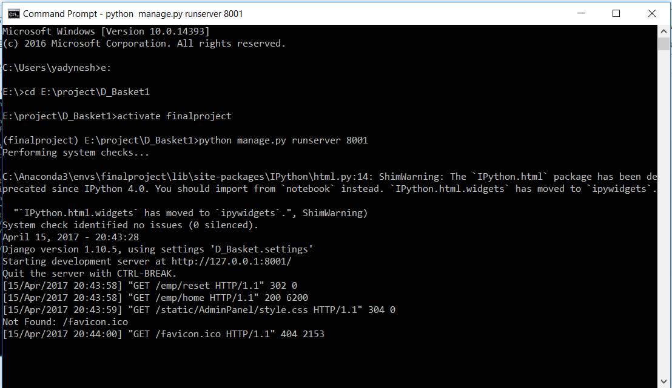

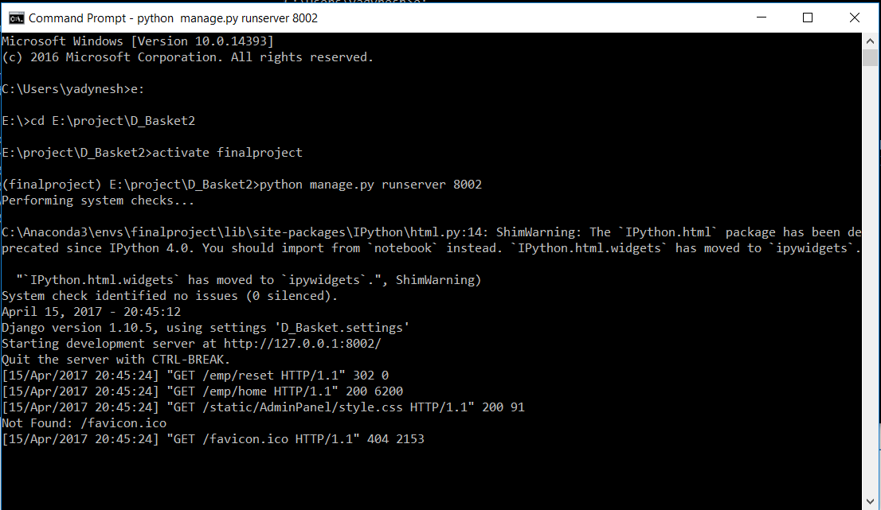

As you can see we are running D_Basket on port 8000, D_Basket2 on port 8001 and D_Basket3 on port 8002.

**4) Test if the client is working**

Now to test whether the clients are working open your browser and open 3 tabs and enter the following urls:

<http://127.0.0.1:8000/emp/home>

<http://127.0.0.1:8001/emp/home>

<http://127.0.0.1:8002/emp/home>

If you are not already logged in you need to register. Once you are registered the web application is ready to be used.

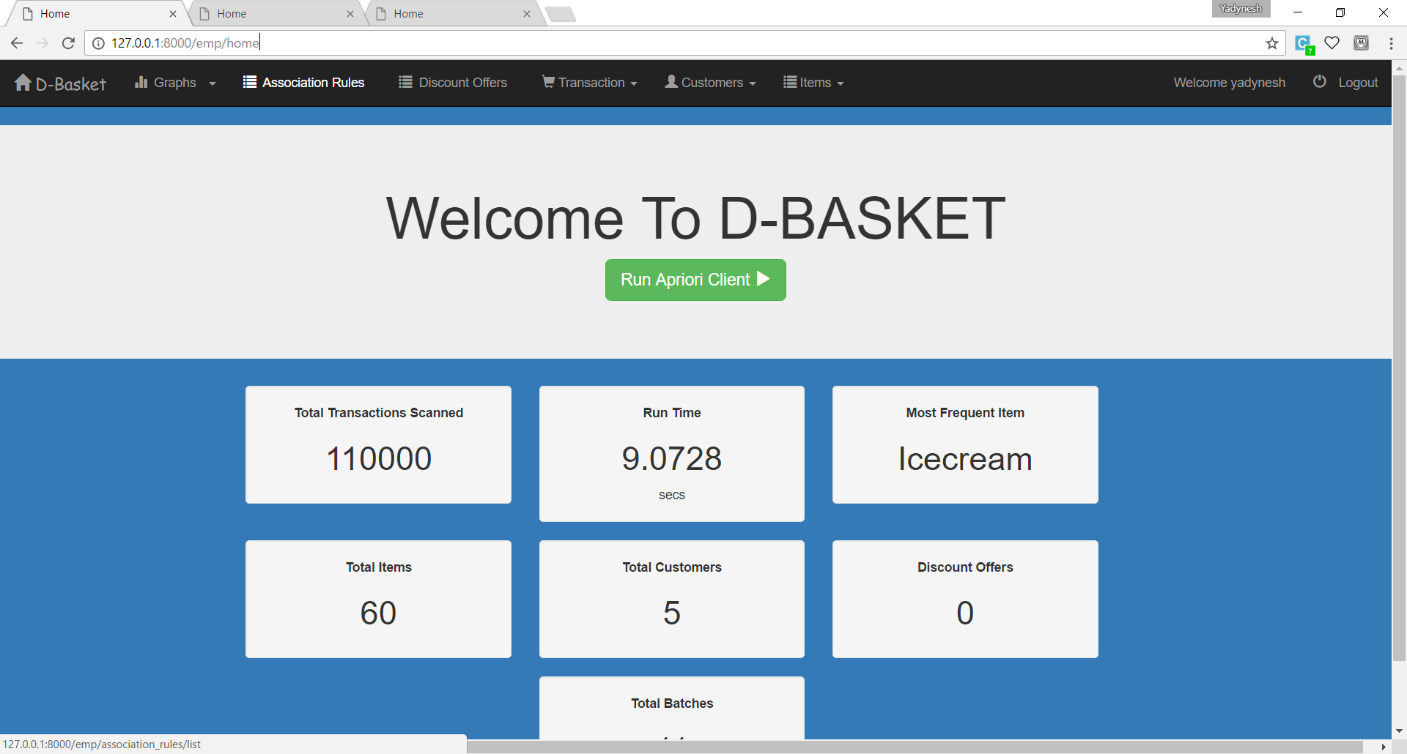

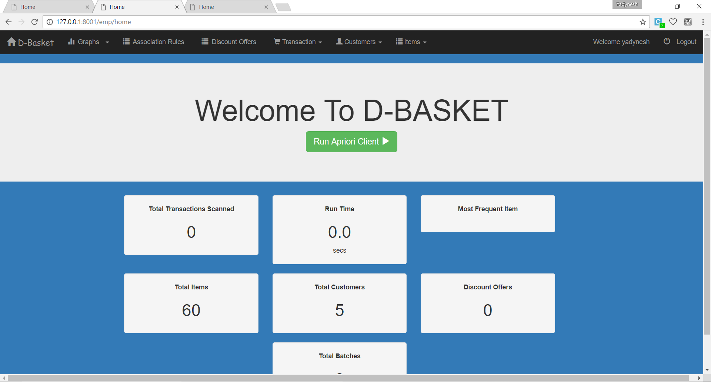

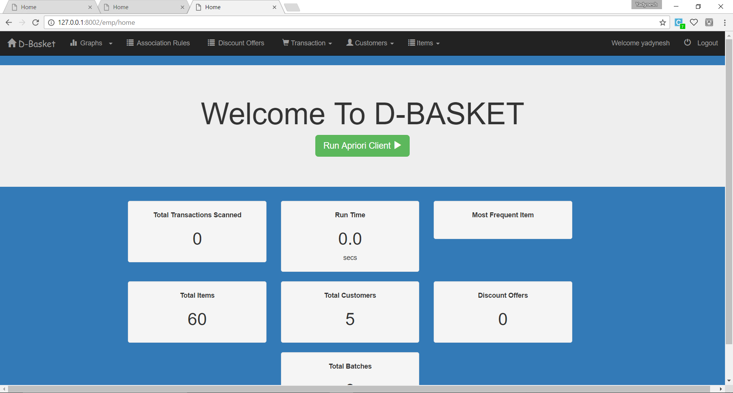

As you can see in the url all three clients are running on different ports.

**Running the server**

You will find the server code in one of the D_Basket folder named “tcpServer.py”

You can either run this file in command prompt or an IDE like spyder. We will do it in spyder

1) Open anaconda navigator

To run it in spyder IDE search for anaconda navigator and open it.

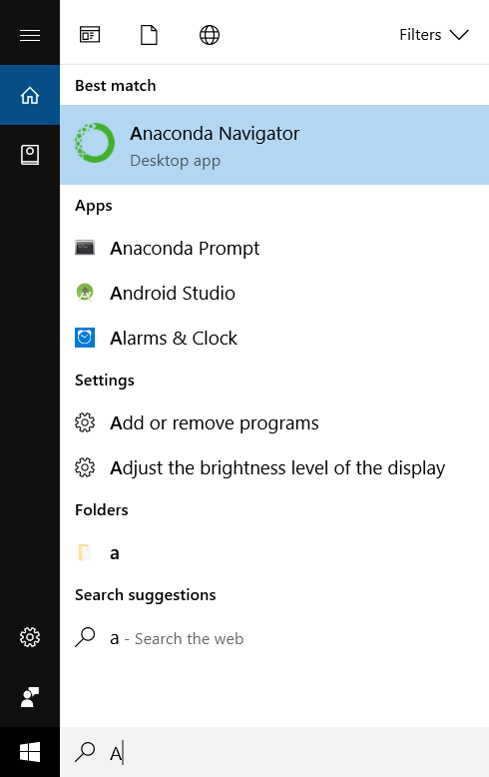

**2) Launch Spyder**

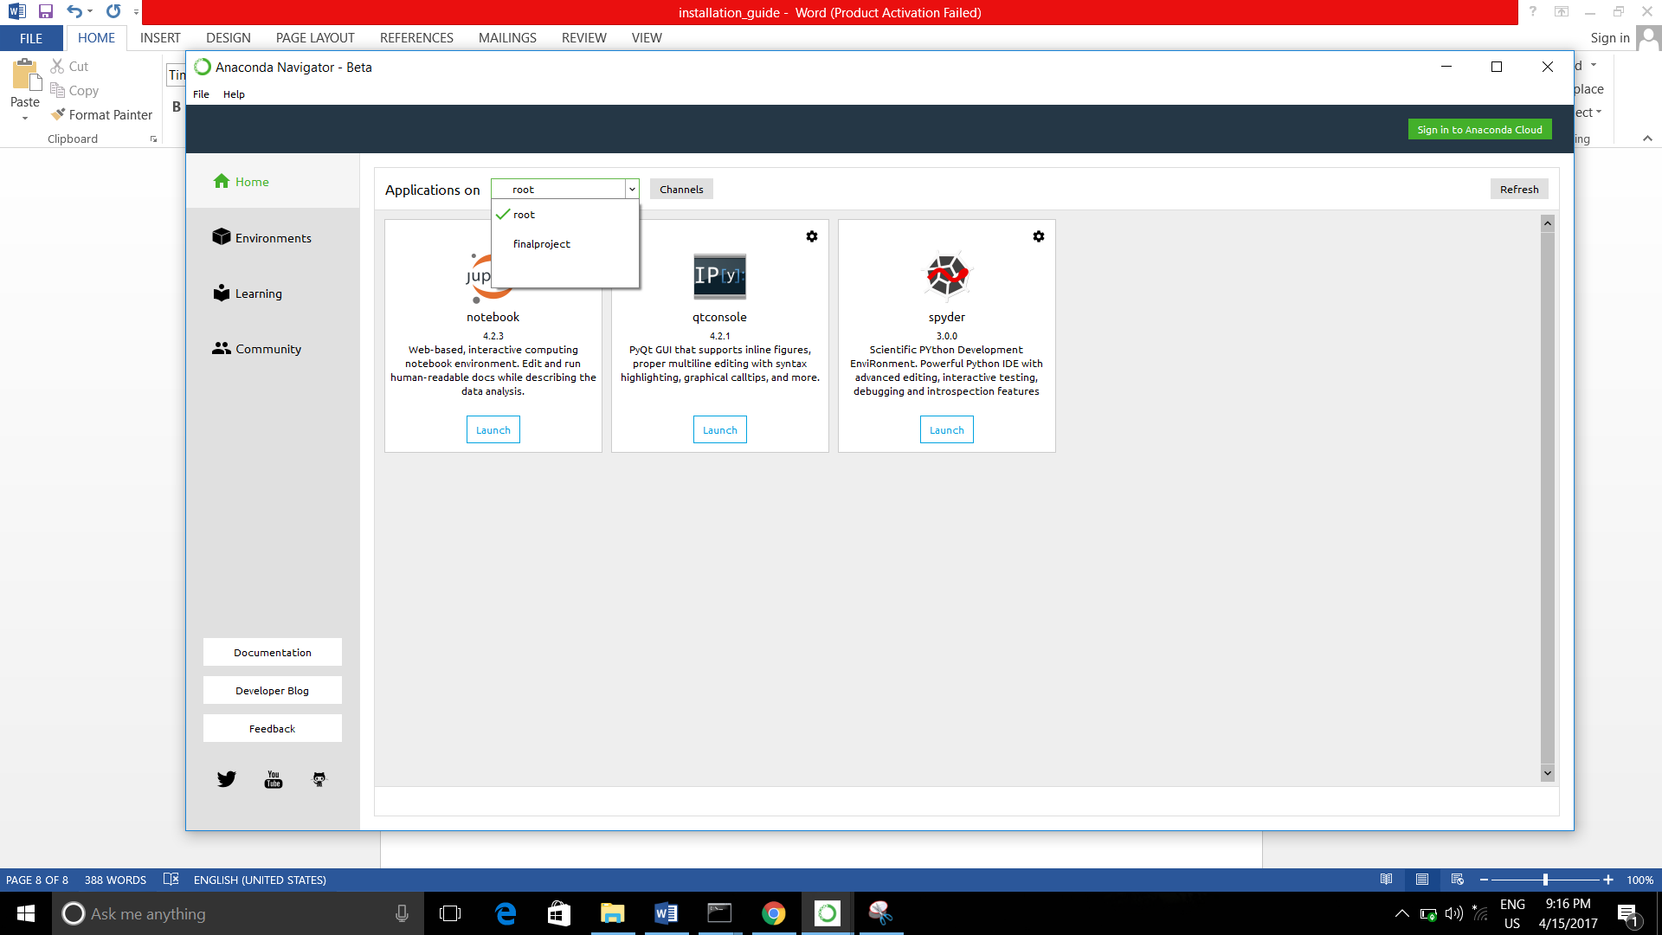

Select your environment name here i.e. **Dipriori** in your computer.

After selecting Dipriori launch spyder which is already installed.

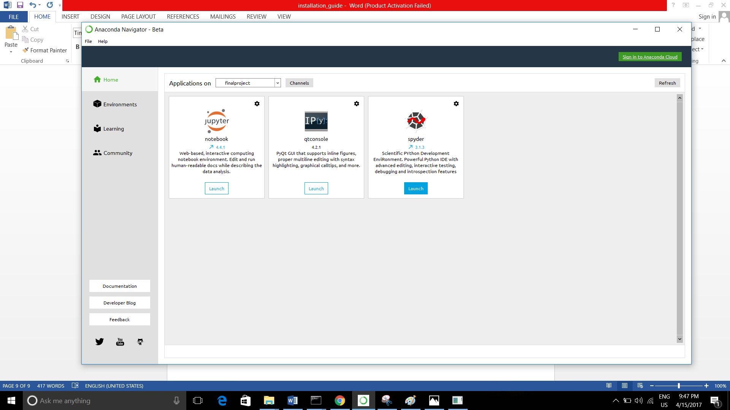

**3) Open tcpServer.py**

Now open the server file (i.e tcpServer.py) present in D_Basket folder in spyder.

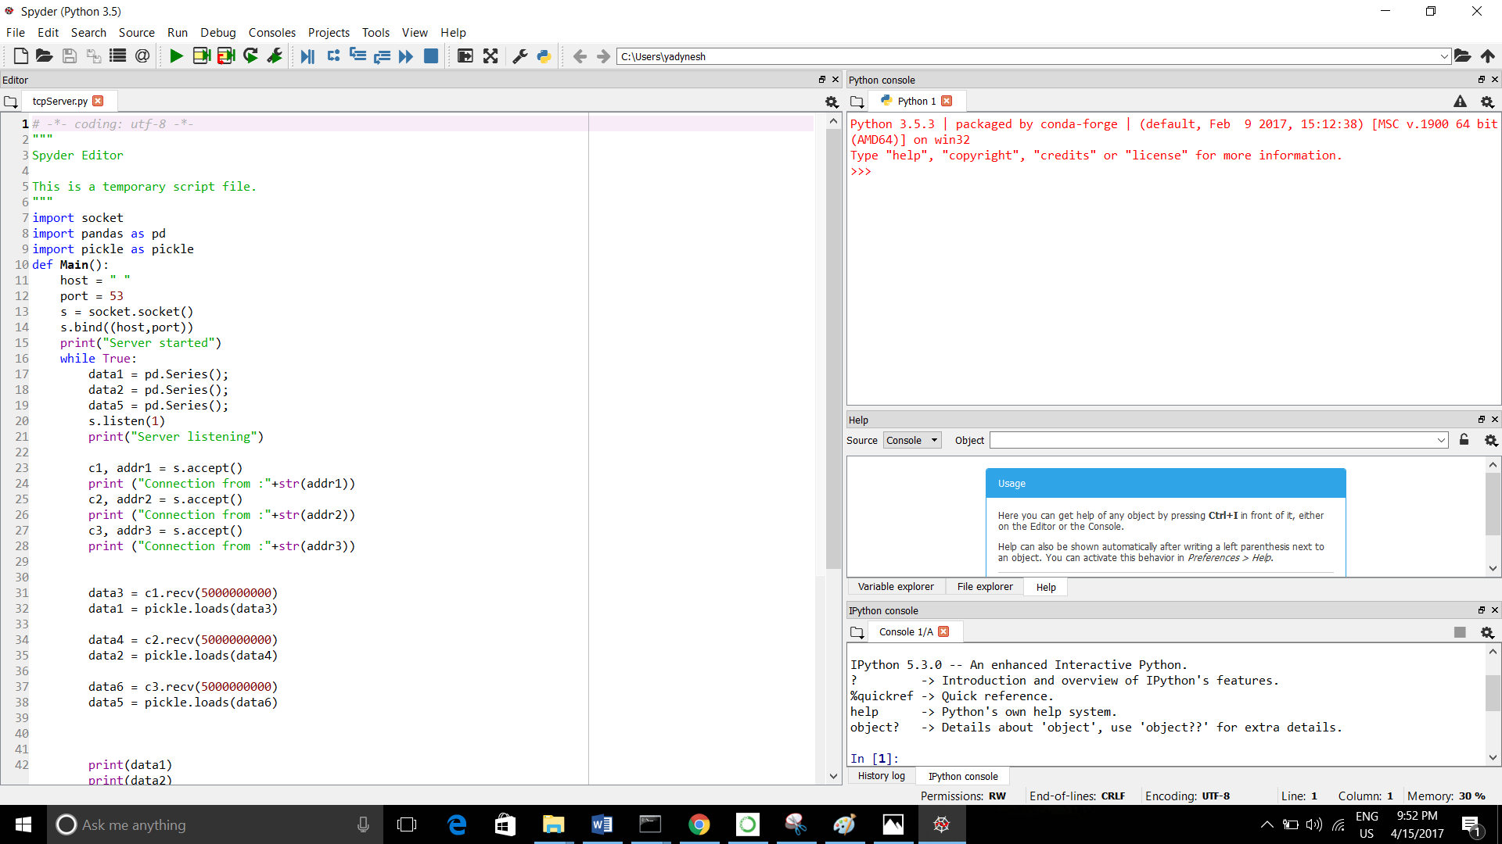

**4) Run the surver**

Click on run icon. Once the server is started you’ll get the following output on the console.

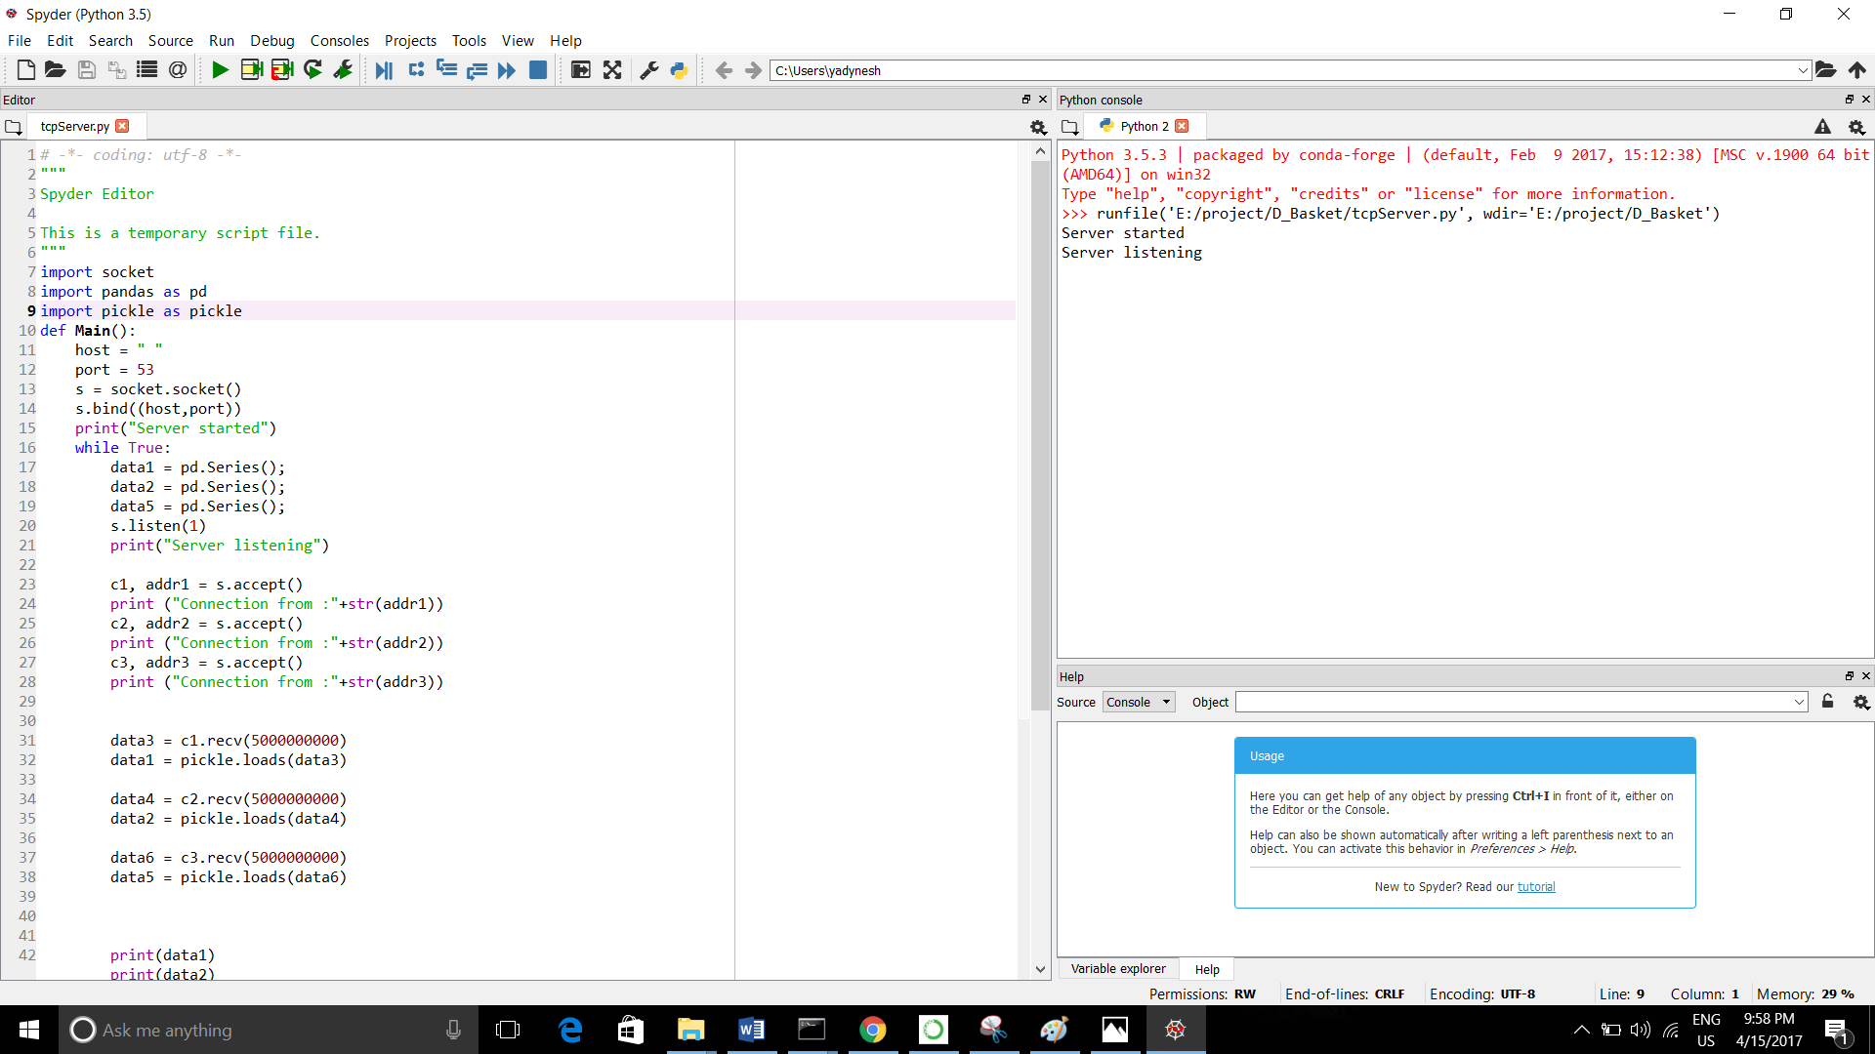

**Connect client to server**

**1) Run the first client**

Everything is setup now. All you have to do is open the web application open in one of your browser tabs and click on Run Apriori Client.

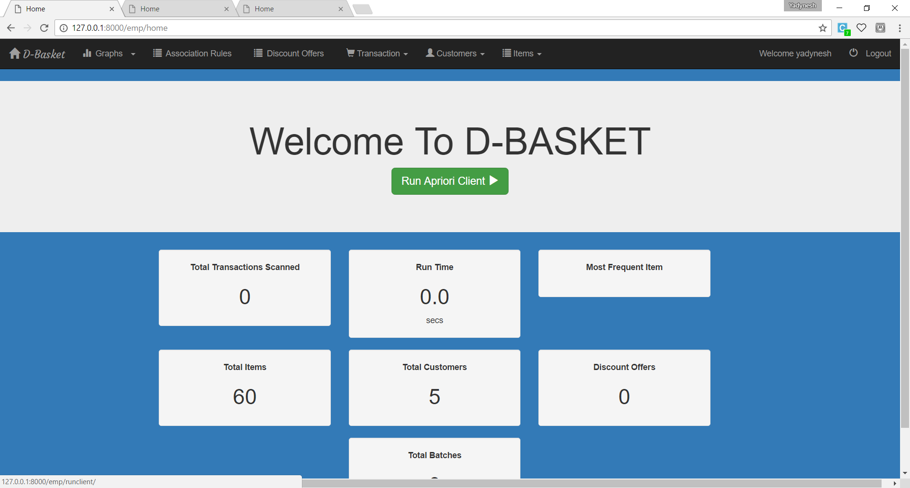

Once you click on the run client you will get a connection on the server.

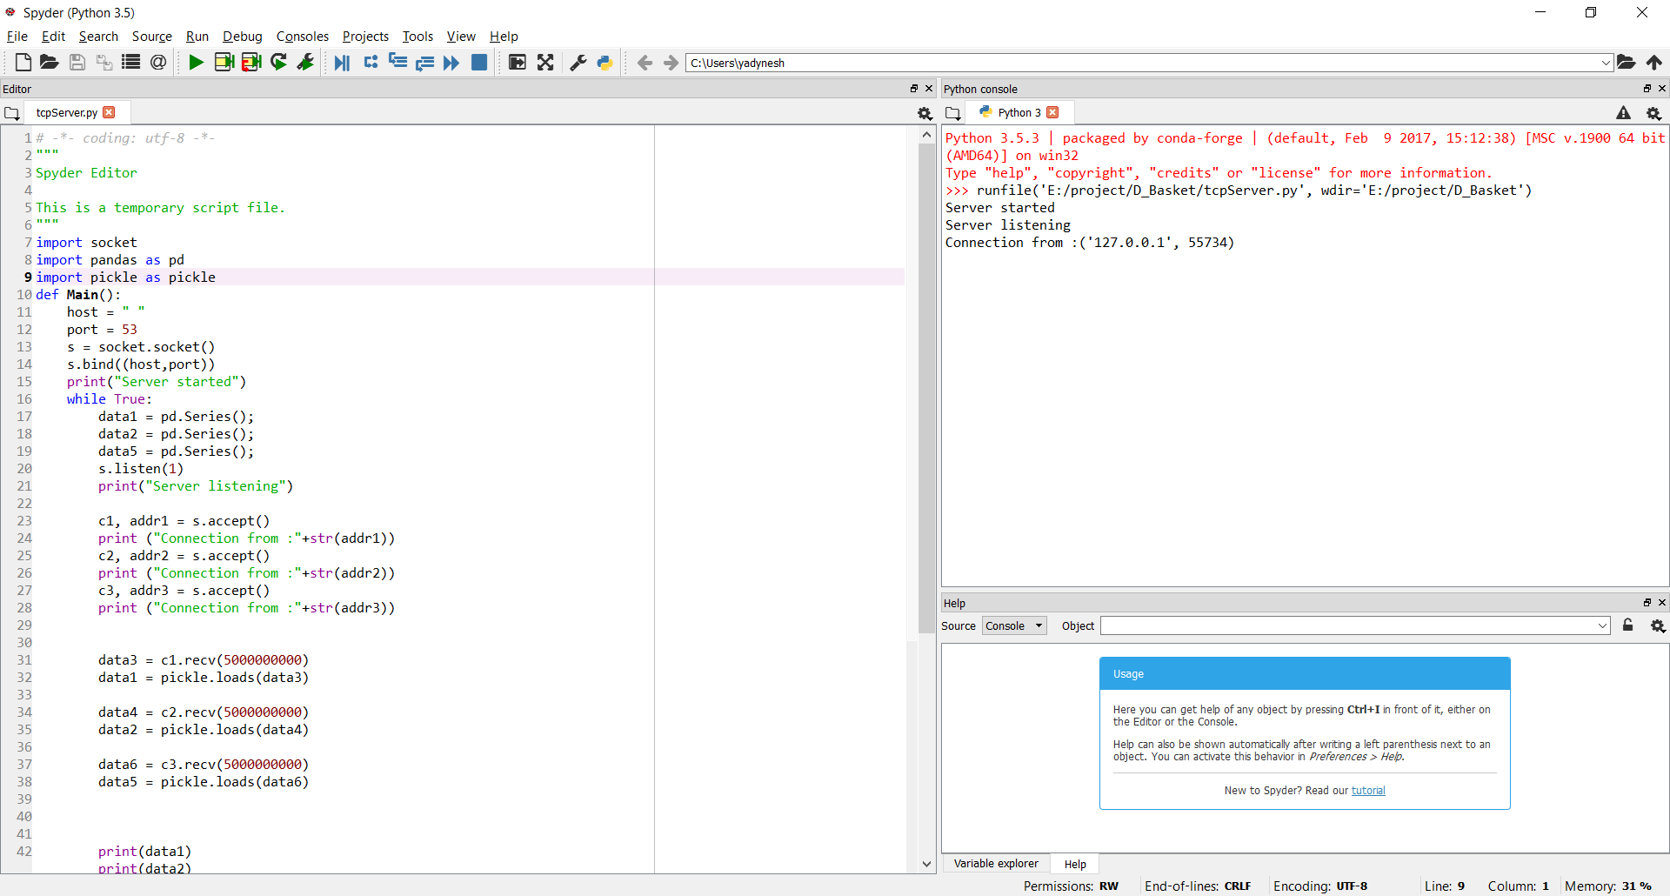

**2) Connect remaining two clients**

Open the web application running on the other two ports and click on Run Apriori Client.

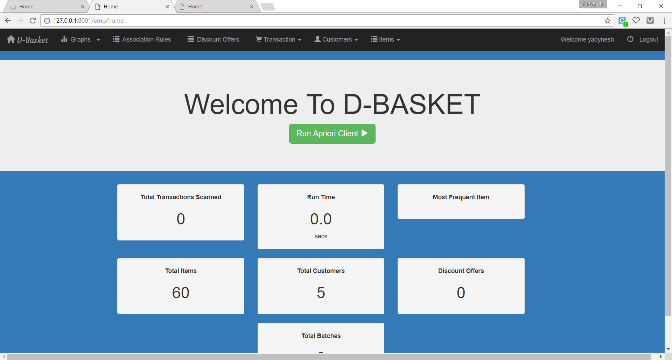

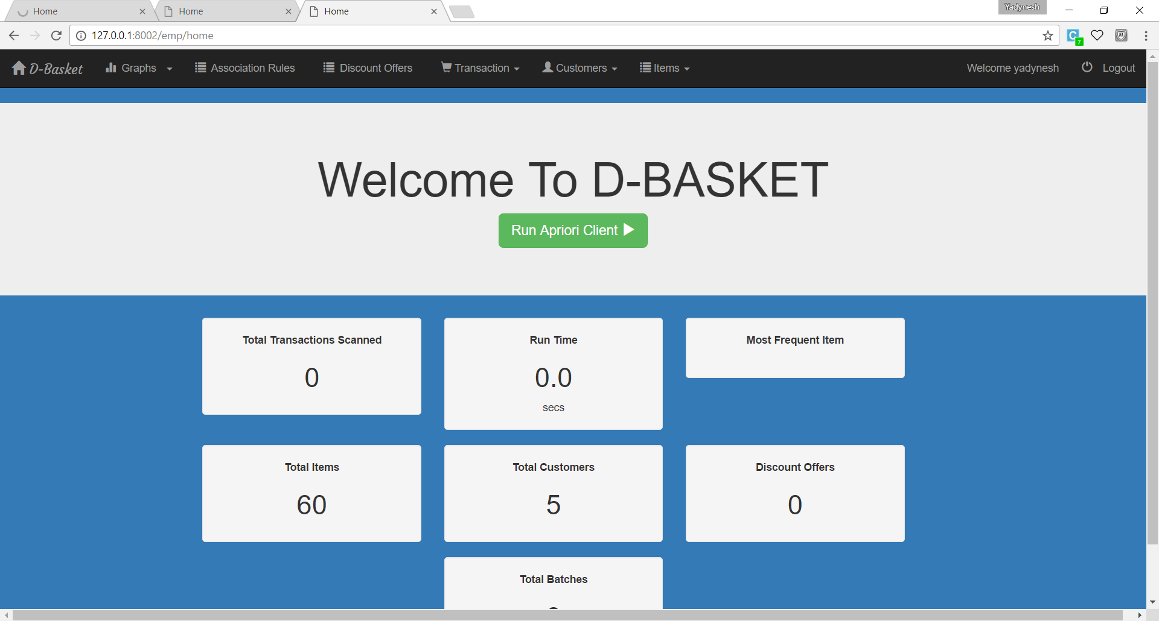

Please make note of the port numbers here. All three web applications running on different ports. (i.e. 8000, 8001 and 8002)

**3) Check the Server**

Once you connect all three clients the process will start and you might see similar output on the server console.

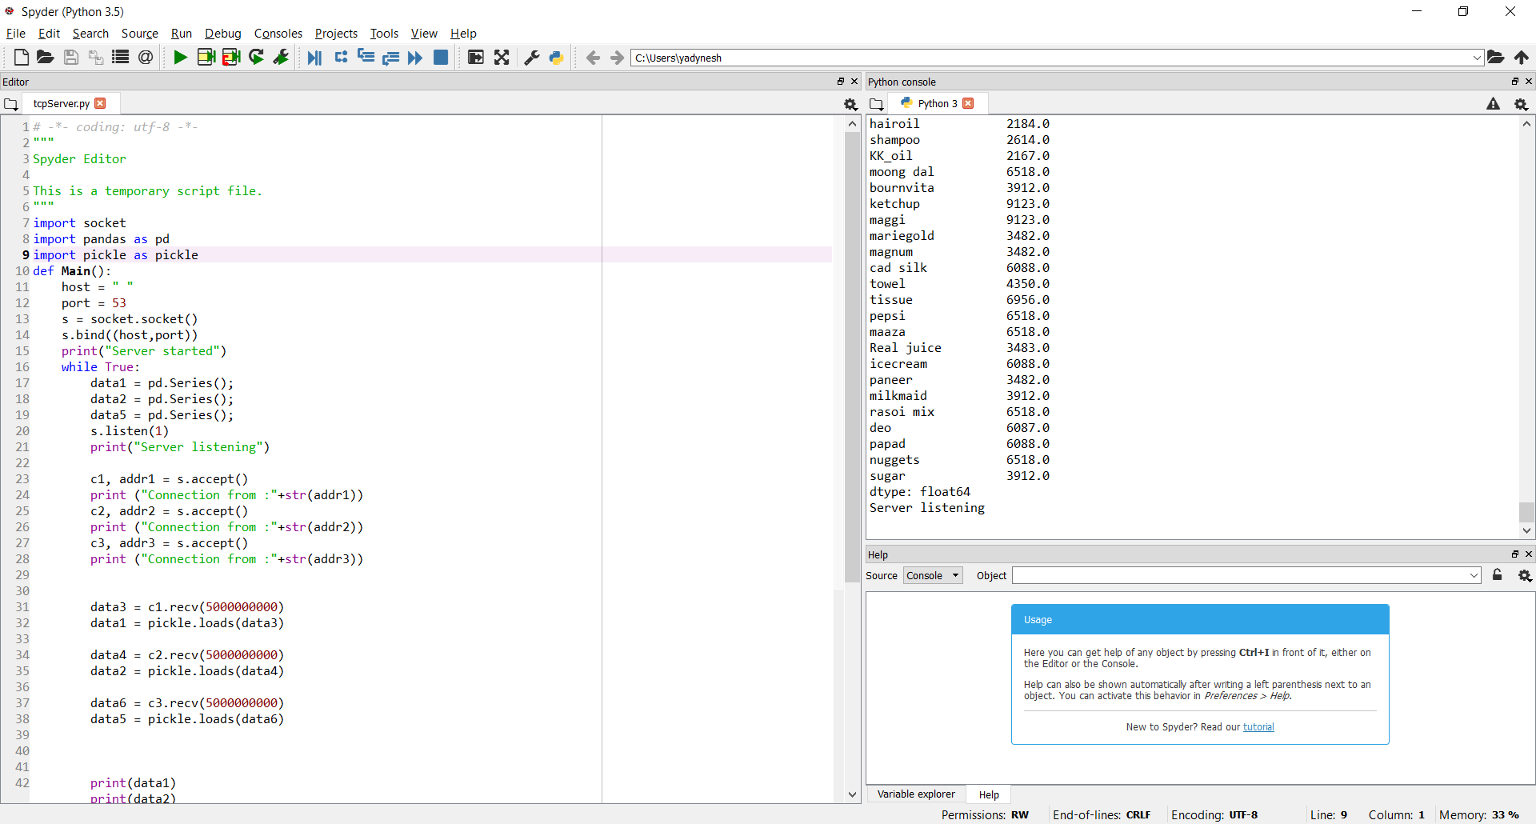

**4) Wait until the implementation of Apriori algorithm finishes.**

Once the algorithm gets implemented you will see the following (or similar) output on the web applications.

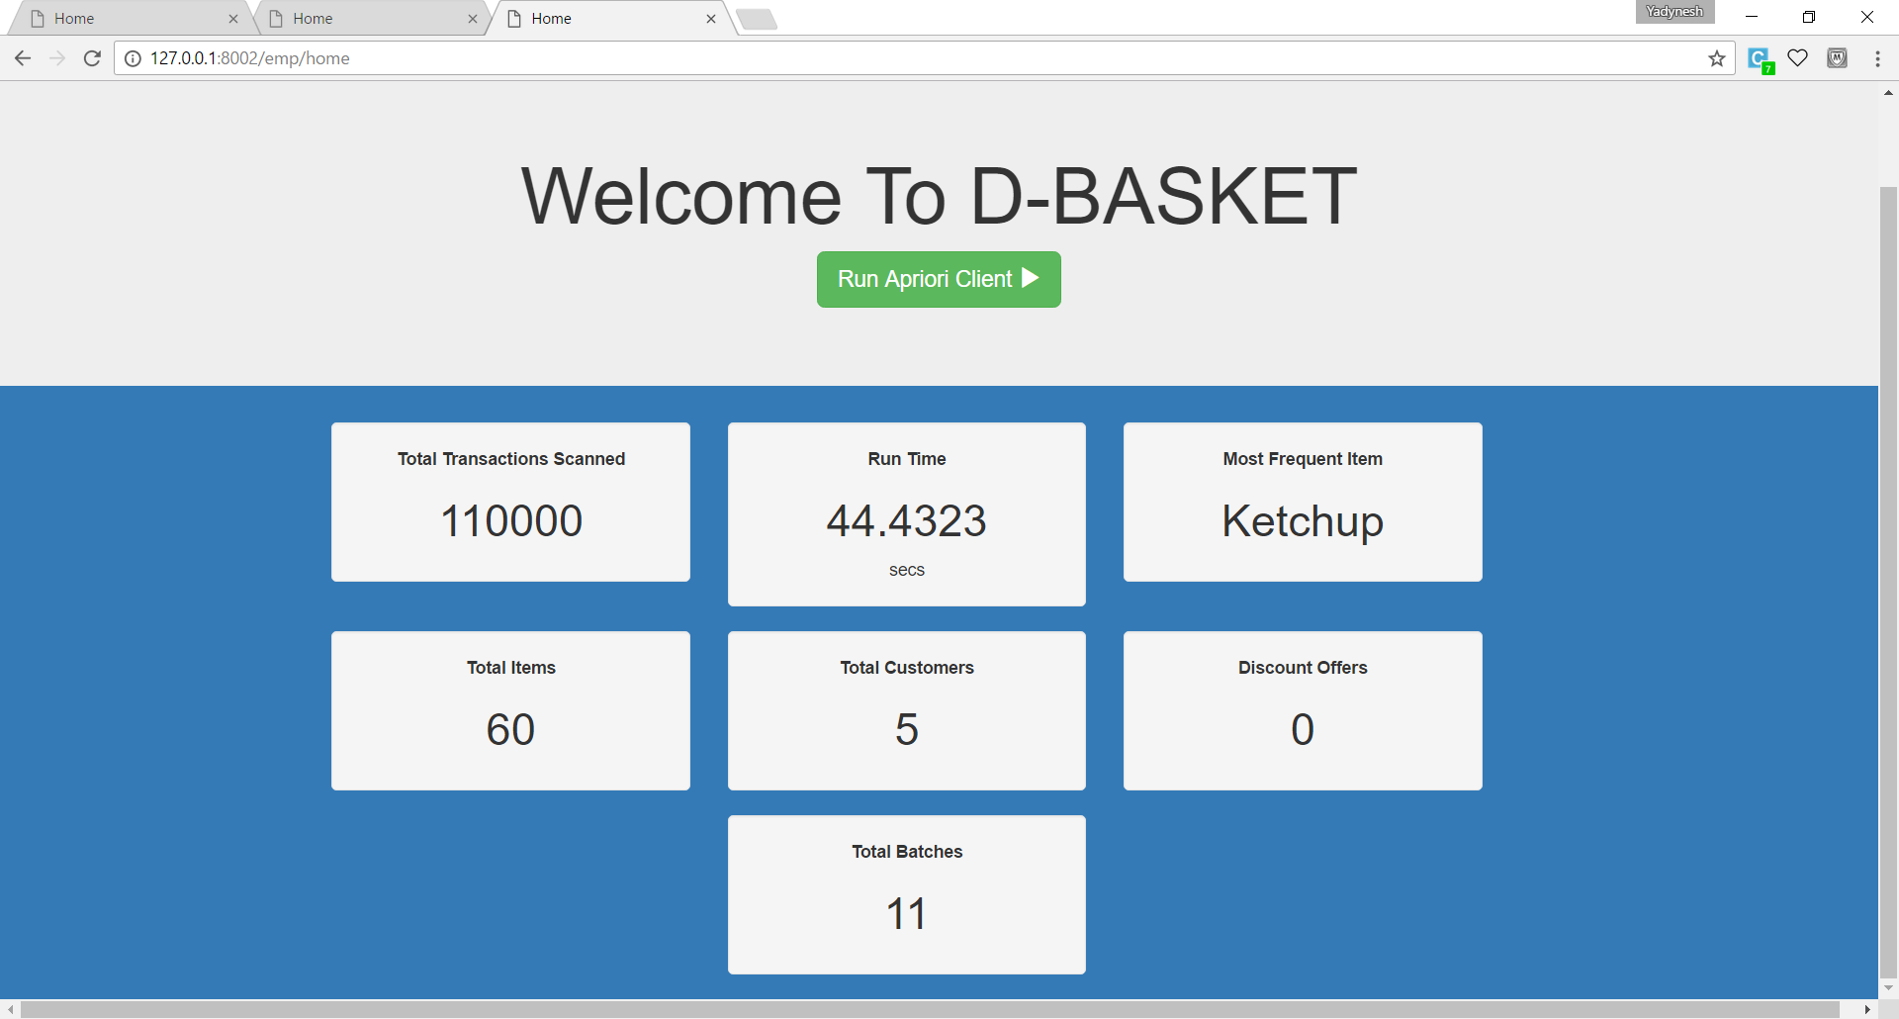

**Reset the clients**

To reset all the things use the following urls –

<http://127.0.0.1:8000/emp/reset>

<http://127.0.0.1:8001/emp/reset>

<http://127.0.0.1:8002/emp/reset>

This will reset all the clients and clear all the batches which were written after implementing the Apriori algorithm.