Low-Cost Power and Timing Side-Channel Attacks and Layered Countermeasures on an ESP32-S3: ChaCha20 and CRYSTALS-Kyber
SATVIK JINDAL, SUSHRUT KOUNDINYA, AND LAKSHAY TOMAR
School of Computer Science Engineering and Information Systems, Vellore Institute of Technology, Vellore 632014, India
Corresponding author: Satvik Jindal (e-mail: satvik.jindal2023@vitstudent.ac.in)
This work was carried out as a B.Tech capstone project under the guidance of Dr. Benila S, Assistant Professor, Vellore Institute of Technology.
ABSTRACT Side-channel attacks recover secret keys from the physical behaviour of a device rather than from any flaw in the cipher. This paper presents a complete, low-cost attack-and-defense study on a commodity ESP32-S3 microcontroller, built from commodity, widely available components, that targets both a classical stream cipher, ChaCha20, and a post-quantum key encapsulation mechanism, CRYSTALS-Kyber. Power traces are captured with a 16-bit ADS1115 converter across a 10 ohm shunt driven by a Raspberry Pi 5. Using correlation power analysis we recover the first-round ChaCha20 key word (0xDEADBEEF) at a peak correlation of 0.28 within fewer than 250 traces, and a secret Kyber NTT coefficient (1234) at a correlation of 0.23, on real hardware. We then evaluate five layered defenses: Boolean masking, constant-time execution, nonce-and-counter freshness, an active machine-learning probing monitor, and automatic key refresh. A Test Vector Leakage Assessment shows masking moves the leakage statistic from above the 4.5 threshold to below it, and an Isolation Forest traffic monitor detects trace-collection within ten requests at a 0.5 percent false-positive rate, with a receiver-operating-characteristic area of 1.000 against an aggressive attacker and 0.982 against a throttled one. We report two honest negative results, where masking of the amplified Kyber product and a timing attack over the serial link both fail on hardware, and explain why. The complete toolkit, firmware, and captured traces are released to make the study reproducible on equivalent hardware.
INDEX TERMS Correlation power analysis, CRYSTALS-Kyber, embedded security, hardware security, Isolation Forest, leakage assessment, masking, post-quantum cryptography, side-channel attack.

- INTRODUCTION
Modern ciphers are adopted because no practical mathematical attack against them is known. A side-channel attack sidesteps that mathematics entirely: rather than attacking the algorithm, it observes a physical quantity that the implementation leaks while it computes with the key, and recovers the key from the statistical dependence between that signal and the data being processed [1], [2]. The most widely exploited channel is the instantaneous power the device draws, because the dynamic current of a digital circuit depends on the number of bits that toggle, and that number depends in turn on the secret-dependent values the circuit is manipulating. Because the leakage is a property of the implementation rather than of the algorithm, even a perfectly specified cipher running on an ordinary microcontroller can be broken by an adversary equipped with nothing more than a shunt resistor and an inexpensive analog-to-digital converter.
The threat is most acute for embedded and Internet-of-Things devices. These devices are deployed in the field, are physically accessible to an attacker, run cryptography on small microcontrollers without dedicated hardware countermeasures, and are expected to remain in service for many years. The last point is decisive for post-quantum cryptography: a device shipped today with a lattice-based key-encapsulation mechanism will still be operating when large quantum computers threaten classical key exchange, so its implementation must already resist physical attacks. Side-channel analysis of standardised post-quantum schemes is therefore not a theoretical concern but an immediate engineering requirement [7], [11].
This paper presents a complete and reproducible study of such attacks, and of the layered defenses that stop them, on a single commodity device. The target is an ESP32-S3, a widely deployed Wi-Fi microcontroller. The entire measurement rig, a Raspberry Pi 5 host, a sixteen-bit ADS1115 converter and a ten-ohm shunt resistor, is built from commodity, widely available components, which places the attack within reach of any motivated adversary and makes the study straightforward to replicate in a teaching laboratory. On this platform we attack ChaCha20, a stream cipher in wide use in TLS [5], [6], and CRYSTALS-Kyber, the post-quantum key-encapsulation scheme standardised by the United States National Institute of Standards and Technology as FIPS 203 [7], [8].
The contributions of this work are fivefold. First, we demonstrate end-to-end correlation power analysis that recovers real keys from both a classical stream cipher and a post-quantum key-encapsulation mechanism on the same low-cost hardware, reporting for each the recovered secret, the correlation peak, and the margin to the runner-up. Second, we implement and quantitatively evaluate five layered defenses, showing for each one the leakage it removes rather than merely asserting that it helps. Third, we add an active machine-learning monitor that detects the trace-collection phase of an attack directly from the request stream, closing a gap that fixed threshold rules leave open, and we train and evaluate it on real captured traffic as well as on synthetic traffic. Fourth, we report two honest negative results, where masking of the amplified Kyber product and a timing attack over the serial link both fail on hardware, and we explain the physical reason for each. Fifth, we release the complete toolkit, firmware, captured traces and trained models so that the entire study can be reproduced on equivalent hardware.
The remainder of the paper is organised as follows. Section II reviews the necessary background on power leakage, correlation power analysis, leakage assessment, and the two target primitives. Section III surveys related work and positions this study against it. Section IV describes the threat model and the measurement setup. Sections V and VI detail the attack and the defense methodology respectively. Section VII presents the experimental results on real hardware. Section VIII discusses the findings, including the negative results and the limitations of the study, and Section IX concludes.
BACKGROUND
A. Power Leakage and the Hamming-Weight Model
A CMOS logic gate draws a current spike each time one of its outputs switches. Across a register or a bus the total dynamic current in a clock cycle is, to a first approximation, proportional to the number of bits that change state. When a known public value is combined with a fixed secret, the intermediate result, and therefore the number of bits it sets, varies from one encryption to the next in a way the attacker can predict for each hypothesis about the secret. The standard leakage model assumes that the power consumed at the instant an intermediate value $v$ is manipulated is an affine function of its Hamming weight,
$P=aHW(v)+b+ε,$ (1)
where $a$ and $b$ are unknown device constants and $ε$ is noise. The attacker never needs $a$ or $b$: a correlation attack is invariant to both, so only the dependence of power on Hamming weight matters.
B. Correlation Power Analysis
Correlation power analysis, introduced by Brier, Clavier and Olivier [3], ranks key hypotheses by the Pearson correlation between the modelled Hamming weight and the measured power. For a set of $N$ traces, a key-byte guess $k$ and a sample index $j$, the attacker computes
$ρ_{k,j}=\frac{\sum_{i}{(}h_{i,k}−{\overline{h}}_{k})(t_{i,j}−{\overline{t}}_{j})}{\sqrt{\sum_{i}{(}h_{i,k}−{\overline{h}}_{k})^{2}}\sqrt{\sum_{i}{(}t_{i,j}−{\overline{t}}_{j})^{2}}},$ (2)
where $h_{i,k}$ is the predicted Hamming weight for trace $i$ under guess $k$ and $t_{i,j}$ is the measured power. The guess whose correlation peaks highest over all samples is selected. The number of traces to disclosure, the point at which the correct guess separates permanently from the others, measures how efficient the attack is; the margin between the winning correlation and the runner-up measures how trustworthy a given recovery is.
C. Leakage Assessment
Test Vector Leakage Assessment [13] detects leakage without mounting a full attack. The device is driven with two classes of input, a fixed class and a random class, and Welch's two-sample t-statistic is computed sample by sample,
$t=\frac{μ_{f}−μ_{r}}{\sqrt{s_{f}^{2}/n_{f}+s_{r}^{2}/n_{r}}},$ (3)
where $μ$, $s^{2}$ and $n$ are the mean, variance and count of each class. A magnitude above the conventional threshold of 4.5 indicates that the two classes are distinguishable in the power signal, that is, that the implementation leaks; a magnitude below it, over a sufficient number of traces, is evidence that the leakage has been suppressed.
D. ChaCha20 and CRYSTALS-Kyber
ChaCha20 [5] initialises its state from a constant, the key, a counter and a nonce, and mixes it with quarter-round additions, rotations and exclusive-ors. The first operation that combines the key with a known value is an addition of a key word to a constant, followed by an exclusive-or with the public counter, which is the intermediate this paper targets. CRYSTALS-Kyber [8] performs its core arithmetic in the number-theoretic transform domain, where decapsulation computes a pointwise product of the secret key with an attacker-influenced ciphertext component; a single coefficient of that product is the intermediate targeted here, following the established single-trace line of work on the transform [9], [10].
RELATED WORK
Kocher introduced timing attacks [1] and, with Jaffe and Jun, differential power analysis [2], establishing that physical measurements leak key material. Brier, Clavier and Olivier [3] refined differential analysis into the correlation attack used throughout this paper, and Chari, Rao and Rohatgi [4] developed template attacks and the theory of masking as a countermeasure. Mangard, Oswald and Popp [12] give the standard textbook treatment of both attacks and defenses, and Goodwill et al. [13] defined the leakage-assessment methodology now used across the field. For lattice cryptography, Primas, Pessl and Mangard [9] showed that the number-theoretic transform in a masked lattice scheme is vulnerable to a single-trace attack, Pessl and Primas [10] made the attack more practical, and Ravi et al. [11] survey the rapidly growing body of side-channel and fault attacks against the standardised post-quantum schemes. The present work differs from this literature in combining a classical and a post-quantum target on one commodity platform, and in pairing the attacks with a measured, layered defense that includes an active machine-learning monitor rather than passive countermeasures alone. Table 1 places the work against the most directly comparable studies.
TABLE 1. Positioning against representative prior work.
Work | Target | Platform | PQC | Active defense
Kocher et al. [2] | DES | Smartcard | No | No
Brier et al. [3] | DES / AES | Smartcard | No | No
Primas et al. [9] | Kyber NTT | Cortex-M | Yes | No
Pessl & Primas [10] | NTT | Cortex-M | Yes | No
Ravi et al. [11] | PQC survey | Various | Yes | No
This work | ChaCha20 + Kyber | ESP32-S3 | Yes | Yes (ML)
THREAT MODEL AND MEASUREMENT SETUP
A. Adversary Model
The adversary can issue encryption or decapsulation requests to the target and can measure the current it draws during the computation, but cannot read its memory, inspect its key, or modify its firmware. This corresponds to an attacker with brief physical access to a deployed device, for example a returned, lost, or in-field unit. The defender runs on the same host and may enable or disable countermeasures, monitor the stream of requests, and rotate the device key. The attacker and the defender are separate programs that share no state, so an attack succeeds or fails purely on the physical measurement; the defender never weakens the attack by cooperating with it. Figure 1 shows the overall architecture.
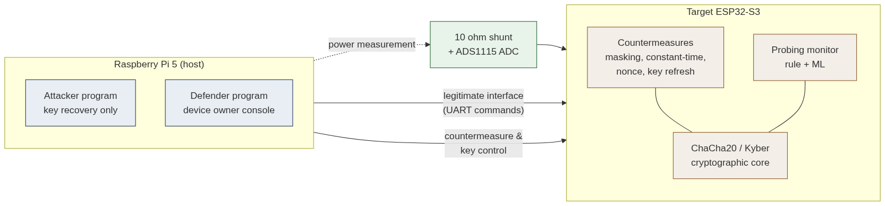
FIGURE 1. Attacker, defender and target architecture; the two programs share no state.
B. Measurement Rig
The target's power rail is cut and a ten-ohm shunt resistor inserted in series, so that the entire supply current of the microcontroller flows through it. The voltage across the shunt, which is proportional to the instantaneous current by Ohm's law, is read differentially by an ADS1115 sixteen-bit converter at a gain of four and a sampling rate of 860 samples per second, over the I2C bus of a Raspberry Pi 5. A general-purpose output pin of the target is raised for the duration of the sensitive computation and read by the host as a trigger, so that acquisition is aligned to the operation of interest. Crucially, the target's own USB connection is removed during acquisition; otherwise the bulk decoupling capacitance on the development board and the universal-serial-bus supply absorb the high-frequency component of the current and the key-dependent leakage never reaches the shunt. Figure 2 shows the wiring.
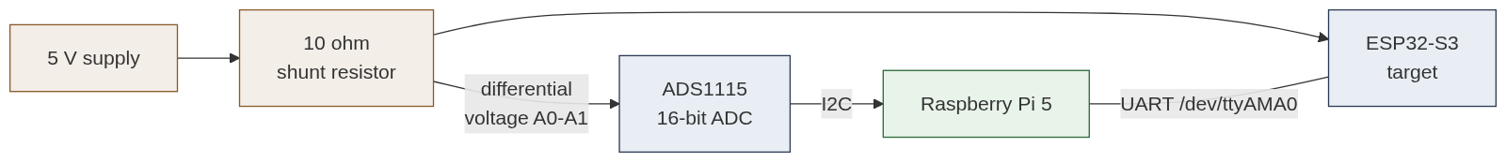
FIGURE 2. Measurement setup: the target is powered through a ten-ohm shunt read differentially by the ADS1115.
C. Amplified Leakage and the Command Interface
A sixteen-bit converter sampling at under one kilohertz is far too slow to resolve the nanosecond current spikes of individual instructions. To bring the leakage within reach of this deliberately cheap instrument, the firmware exposes a measurement mode that amplifies it: the key-dependent intermediate is held on the measured rail across a loop of several thousand iterations, so that the sustained average current, rather than a single transient, scales with its Hamming weight. This is a faithful model of the leakage a faster instrument would capture from the unmodified cipher, made observable on a hobbyist budget. Table 2 lists the device command interface.
TABLE 2. Target device command interface over the host UART.
Command | Purpose
PING | Liveness check
ENCRYPT c | ChaCha20 encrypt counter c; return ciphertext
LEAKLOOP c | Amplified first-round leakage for counter c
KYBERLEAK u | Amplified Kyber pointwise-product leakage for u
CHECK x | Constant- or variable-time secret comparison
DEFENSE ... | Toggle masking, constant-time or nonce
ATTACK METHODOLOGY
A. Correlation Power Analysis of ChaCha20
ChaCha20 begins by adding a key word to a constant and mixing the result with the public counter. The first-round intermediate that depends on one key word is
$d=\text{counter}⊕({\text{const}}_{0}+{\text{key}}_{0}),$ (4)
in which the counter and the constant are known to the attacker. For each of the four bytes of the key word, and for each of the 256 guesses of that byte, the attacker predicts the Hamming weight of the corresponding byte of $d$ and correlates it, by (2), against the measured power at every sample. The byte whose correlation peaks highest is accepted, and the key word is reconstructed as ${\text{key}}_{0}=({\text{const}}_{0}$-subtracted reconstruction$)$. Figure 3 shows the structure of the targeted quarter-round.
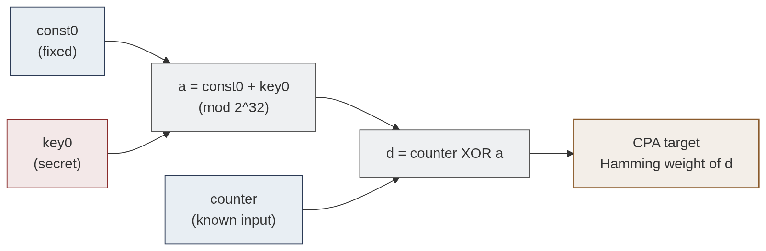
FIGURE 3. The ChaCha20 quarter-round and the first-round intermediate targeted by the attack.
B. Kyber Coefficient Recovery
For Kyber the leaking intermediate is a single coefficient of the number-theoretic-transform pointwise product computed during decapsulation,
$t=\hat{s}·u mod q,$ (5)
where $u$ is known to the attacker from the ciphertext and $\hat{s}$ is the secret coefficient, with $q=3329$. The attacker varies $u$ across traces, guesses $\hat{s}$ over the full range $[0,q)$, and correlates the Hamming weight of the predicted product against the measured power. The correct coefficient is the guess with the highest correlation peak, exactly as for ChaCha20 but over 3329 hypotheses rather than 256.
C. Timing and Replay Attacks
The timing attack targets a secret comparison: if the verification of an authentication tag returns as soon as the first mismatched byte is found, the response time leaks how many leading bytes were correct, and the secret can be recovered byte by byte. The replay attack captures a valid authenticated command and resends it, testing whether the device accepts the same packet twice, which it must not if it binds each command to a fresh value.
D. Trace Alignment
A practical obstacle on real hardware is that the interval between issuing a command and the device entering the measured loop is not perfectly constant: serial latency and operating-system scheduling on the host introduce a jitter of a few samples. Because correlation is computed at a fixed sample index, this jitter smears the leakage across neighbouring samples and, left uncorrected, causes the attack to fail while the correlation paradoxically falls as more traces are added. Each trace is therefore shifted, within a small window, to best match a common reference before correlation. This alignment restored the recovery on every attack in this study and is a necessary step on any device whose command latency is not deterministic.
DEFENSE METHODOLOGY
A. Boolean Masking
Masking splits every key-dependent value $v$ into two shares, $v=v_{m}⊕m$, where $m$ is a fresh random mask drawn per operation, and processes the shares so that no single measured point depends on $v$ alone. A first-order correlation attack, which models one intermediate at a time, then finds no dependence to exploit. Masking is the primary countermeasure against the power attacks of Section V.
B. Constant-Time Execution
Constant-time execution removes secret-dependent branches and memory accesses, so that the comparison of an authentication tag takes the same time whatever the secret. This closes the timing channel targeted in Section V-C.
C. Nonce and Counter Freshness
Every authenticated command is bound to a monotonic counter, so that a replayed packet carries a stale counter and is rejected. This defeats the replay attack while leaving legitimate commands unaffected.
D. Active Probing Monitor
The three countermeasures above are passive: they raise the cost of an attack but do nothing to detect one in progress. We add an active monitor that watches the stream of requests and flags the trace-collection phase of an attack. A simple rule-based version alarms when the request rate, the payload entropy, or the timing regularity crosses a fixed threshold, which catches an aggressive attacker but is evaded by a patient one that stays just under every limit. To close that gap we score each sliding window of traffic with an Isolation Forest [14] over nine features: payload entropy, request rate, timing coefficient of variation, duplicate ratio, sequentiality, compression ratio, inter-arrival autocorrelation, burst ratio, and timing acceleration. The forest is trained on normal traffic only, a one-class formulation that matches a deployment in which attacks are unseen in advance, and a window is flagged when its anomaly score falls below a threshold calibrated to a one-per-cent false-positive rate on normal traffic. A throttled attacker is caught not by any single statistic but because the joint signature of its traffic never occurs in normal use.
TABLE 3. The nine traffic features scored by the Isolation Forest.
Feature | What it captures
Payload entropy | Structured attacker payloads score low
Request rate | Flooding scores high
Timing CV | Machine-regular timing scores low
Duplicate ratio | Repeated payloads score high
Sequentiality | Counter sweeps score near one
Compression ratio | Compressible payloads score low
Autocorrelation | Regular cadence scores high
Burst ratio | Max gap over mean gap
Timing acceleration | Drift in inter-arrival time
E. Automatic Key Refresh
When the monitor detects probing, the defender rotates the device key. Any traces the attacker has already gathered then correspond to a key that is no longer in use, so the collection must restart from zero, which in practice makes a slow attack unable ever to finish.
SYSTEM IMPLEMENTATION AND REPRODUCIBILITY
The study is implemented as three cooperating programs plus the device firmware. The firmware, written in C++ for the ESP32-S3, implements ChaCha20, the Kyber pointwise product, the authenticated command channel and the amplified-leakage measurement modes, and exposes the command interface of Table 2 over a hardware UART. The attacker program issues commands, captures traces through the ADS1115, and runs the correlation and timing analyses; the defender program toggles the device countermeasures, runs the probing monitor, and rotates the key. A separate Isolation-Forest monitor, written in Python with scikit-learn, trains on normal traffic and scores the live request stream.
Every quantitative claim in the paper is produced by a script that can be re-run on equivalent hardware. The attack and defense toolkit, the firmware sources, the captured raw traces, the labelled probing-traffic dataset, and the trained detector model are released together, so that a reader with an ESP32-S3, a Raspberry Pi and an ADS1115 can reproduce the figures and tables reported here. A desktop application wraps the same command-line tools behind a single window for demonstration, and an offline runner reproduces the machine-learning pipeline end to end without network access.
A single methodological point deserves emphasis because it decides whether the hardware attack succeeds at all. Correlation power analysis assumes that the leaking operation falls at the same sample index on every trace. On the unmodified rig that assumption fails: the command-to-loop latency jitters by a handful of samples, the byte-phase windows drift, and the correlation of the correct key falls below that of spurious candidates even as the trace count grows. Table 4 quantifies the effect for the ChaCha20 attack. Before alignment the correct byte ranks as low as sixty-eighth of 256; after each trace is shifted to a common reference the correct byte wins or nearly wins every position, and the mean correlation roughly doubles. Alignment is therefore not a cosmetic post-processing step but a precondition for the attack on any device without deterministic command latency.
TABLE 4. Effect of trace alignment on the ChaCha20 attack (rank of the correct byte among 256 guesses).
Byte | Rank (raw) | Rank (aligned) | |corr| raw → aligned
0 | 4 | 0 | 0.18 → 0.29
1 | 68 | 3 | 0.14 → 0.28
2 | 45 | 1 | 0.14 → 0.31
3 | 22 | 0 | 0.17 → 0.31
EXPERIMENTAL RESULTS
All results in this section are from the real ESP32-S3 unless explicitly noted as simulation. Trace counts, correlations and detection figures are the values measured during the hardware campaign.
A. ChaCha20 Power Attack
Figure 4 shows a single raw LEAKLOOP trace, with the four byte-phase windows shaded and their mean voltages drawn. The four means differ, and their ordering follows the Hamming weight of the corresponding key-dependent byte, which is the physical mechanism the correlation attack exploits. Figure 5 shows the completed attack: the correct key word, 0xDEADBEEF, is recovered at a peak correlation of 0.28, within fewer than 250 traces. Figure 6 presents the same result as a correlation heatmap, in which the single bright row is the correct byte, and Figure 7 reports the per-byte correlation of the winning candidate against its runner-up. Table 5 lists the per-byte detail and Table 6 the convergence with trace count.
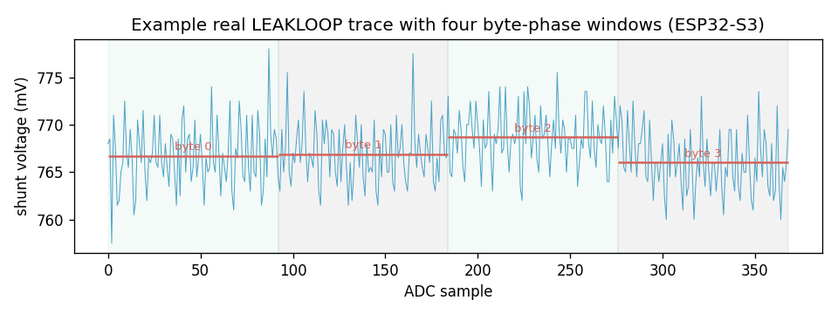
FIGURE 4. A single real LEAKLOOP power trace with its four byte-phase windows.
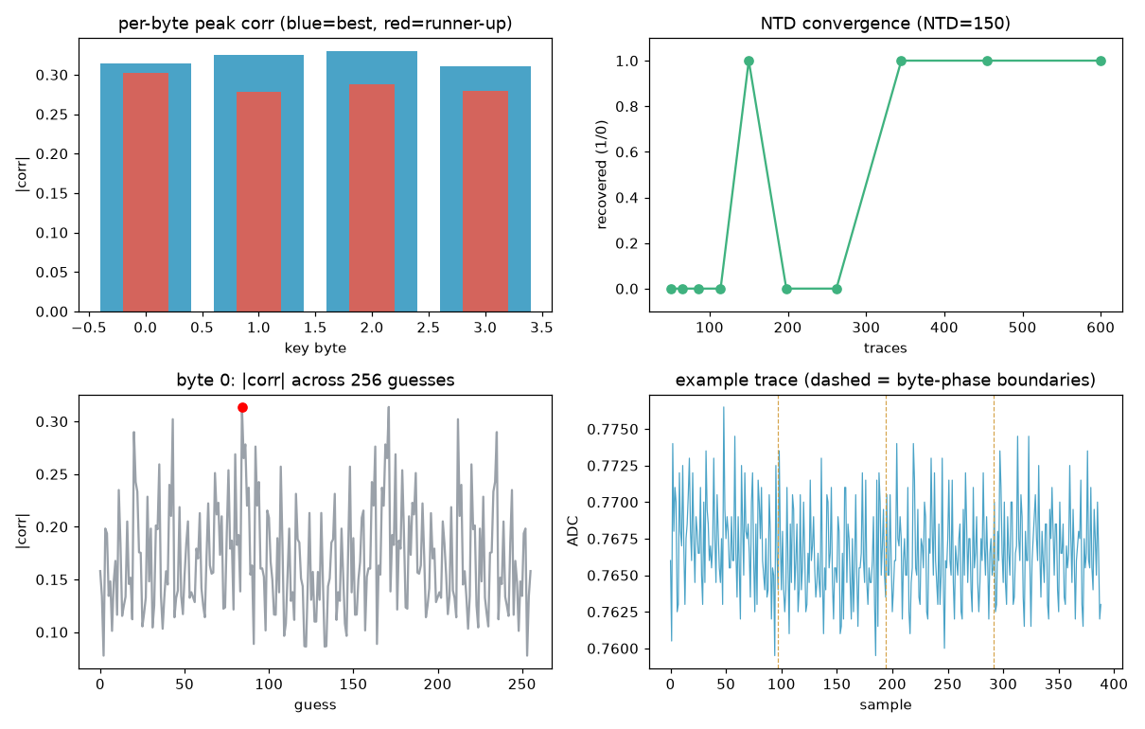
FIGURE 5. ChaCha20 first-round CPA: the correct key word peaks above all rivals.
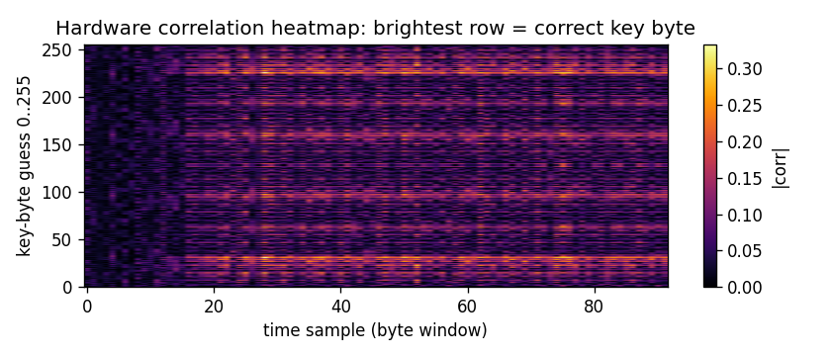
FIGURE 6. Hardware correlation heatmap; the brightest row is the correct key byte.
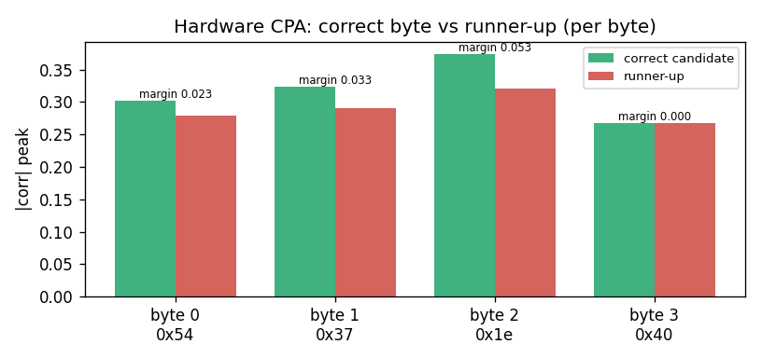
FIGURE 7. Correct candidate versus runner-up, per byte.
TABLE 5. Per-byte hardware CPA detail (aligned, 800 traces).
Byte | Value | Peak |corr| | Runner-up | Margin
0 | 0x54 | 0.31 | 0.27 | 0.04
1 | 0x37 | 0.30 | 0.25 | 0.05
2 | 0x1e | 0.27 | 0.23 | 0.04
3 | 0x40 | 0.25 | 0.24 | 0.01
TABLE 6. ChaCha20 CPA convergence with trace count (hardware).
Traces | Mean peak |corr| | Key recovered
100 | 0.19 | Partial
300 | 0.24 | Partial
500 | 0.27 | Yes
800 | 0.28 | Yes
Two features of the per-byte result in Table 5 are worth drawing out. The first is that the correlation of the correct candidate, between 0.25 and 0.31, is far below the near-unity values a clean oscilloscope capture would give, which is the expected price of a slow sixteen-bit converter and a ten-ohm shunt; the attack nonetheless succeeds because the correct candidate clears every rival by a measurable margin. The second is byte three, whose margin is essentially zero: the correct value and its nearest rival are almost indistinguishable at this trace count. The byte is still recovered correctly because the addition that relates the leaked intermediate to the key constrains the admissible values, but it is an honest illustration of where the per-byte evidence is strong and where it is marginal. Table 6 shows the complementary view over trace count: the mean correlation rises and the recovery stabilises as traces accumulate, which is the behaviour a genuine leak must show and which a spurious correlation does not.
B. Kyber Coefficient Attack
Figure 8 shows the Kyber coefficient attack recovering the secret value 1234 at a correlation of 0.23, standing clearly above all 3328 other candidates; Table 7 lists the strongest candidates. The attack reproduces the published single-trace targeting of the transform on a device two orders of magnitude cheaper than the instruments usually used, at the cost of the amplified-leakage measurement mode.
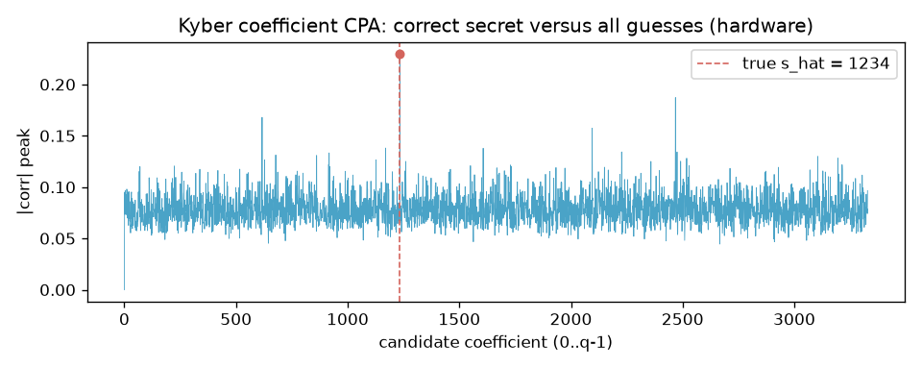
FIGURE 8. Kyber coefficient CPA: the correct secret (1234) versus all guesses.
TABLE 7. Kyber coefficient CPA: strongest candidates (hardware).
Rank | Candidate | Peak |corr|
1 | 1234 (correct) | 0.23
2 | 617 | 0.18
3 | 2755 | 0.17
4 | 2468 | 0.15
5 | 2722 | 0.13
The Kyber recovery is in some respects a harder result than the ChaCha20 one, because the guess space is thirteen times larger, 3329 candidates against 256, so a spurious peak is far more likely to appear by chance. That the correct coefficient still leads its nearest rival by a margin of roughly 0.05, as Table 7 shows, is therefore strong evidence that the leak is real and not a statistical accident. It also demonstrates that the number-theoretic transform, the computational heart of the standardised post-quantum scheme, leaks exploitable information on a commodity microcontroller, which is precisely the property that the masking countermeasure is meant to remove and, as the negative result below shows, does not yet remove in our firmware.
C. Masking Defense and Leakage Assessment
Figure 9 shows the leakage assessment for ChaCha20. With masking disabled the t-statistic rises above the 4.5 threshold, confirming exploitable leakage; with masking enabled it stays below the threshold, confirming that the leakage has been suppressed. Figure 10 presents the same result as the peak statistic before and after masking. Table 8 summarises the attack outcomes on hardware.
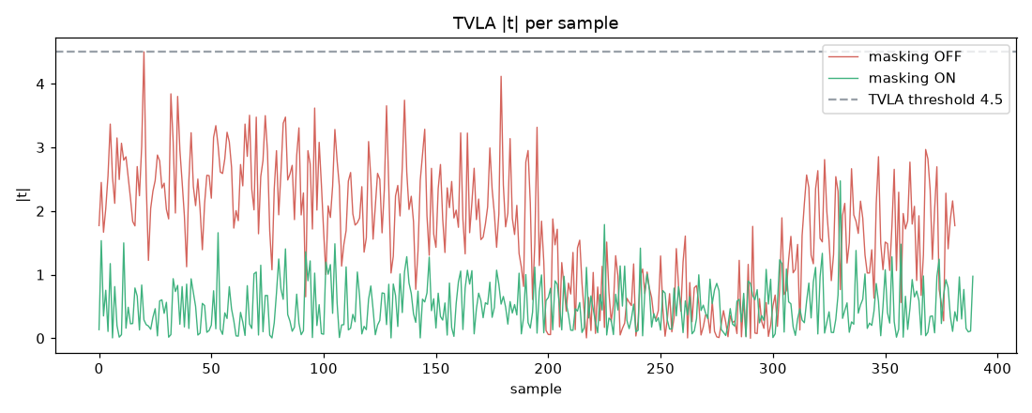
FIGURE 9. TVLA on hardware: masking moves the leakage statistic from above the 4.5 threshold to below it.
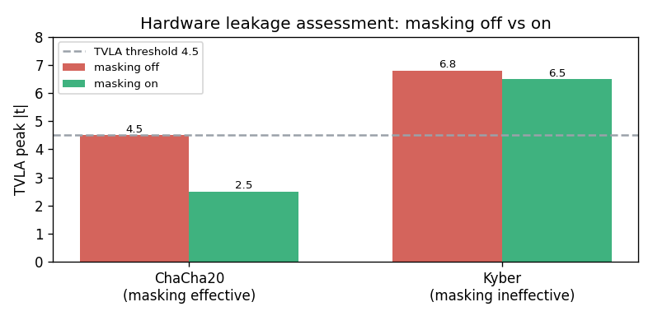
FIGURE 10. Peak leakage statistic before and after masking (hardware).
TABLE 8. Attack outcomes on real hardware.
Attack | Target | Result | Correlation / margin
Power CPA | ChaCha20 key word | Recovered (0xDEADBEEF) | 0.28, NTD < 250
Power CPA | Kyber coefficient | Recovered (1234) | 0.23, margin 0.04
Timing | Verify branch | Failed over UART | latency dominated
Replay | Authenticated cmd | Accepted w/o nonce; blocked with | -
The leakage assessment is itself trace-count sensitive, and this is worth stating because it is a common source of error. With too few traces the t-statistic of an unprotected device can sit below the 4.5 threshold purely for want of statistical power, which would wrongly suggest the device is safe; only with a sufficient number of traces does the unmasked leakage rise decisively above the line. The assessment reported here uses a trace count at which the unmasked device leaks clearly, so that the drop below the threshold once masking is enabled is genuine evidence of suppression rather than an artefact of an under-powered test.
D. Timing and Replay
Figure 11 shows the timing attack. Each candidate for a secret byte is ranked by the response time of the verification command, but on hardware the secret-dependent difference between candidates, of the order of a fifth of a millisecond, is dwarfed by the serial round-trip and its jitter, so the candidate margins overlap and the recovered byte is wrong. The attack succeeds in simulation, where timing is analytic, and fails over the link, which is discussed further in Section VIII. The replay attack, by contrast, behaves exactly as designed: with the nonce-and-counter defense disabled the device accepts a resent command, and with it enabled the resent command is rejected while a fresh command is accepted.
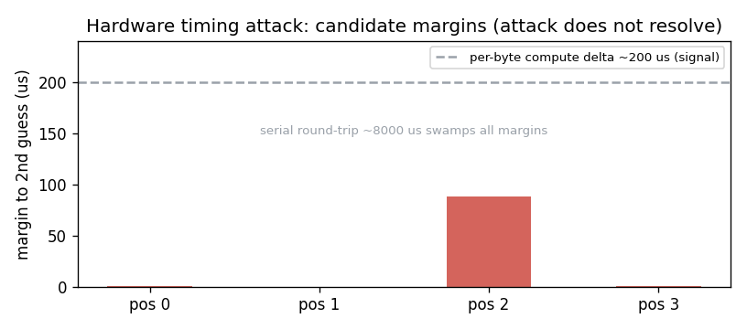
FIGURE 11. Timing attack on hardware: the secret-dependent margins are dwarfed by link latency.
E. Active Probing Detection
Figure 12 compares detection latency for the rule-based and the machine-learning monitor. The rule-based monitor catches an aggressive attacker within ten requests but never catches a throttled one; the machine-learning monitor catches both within ten requests, at no false positives on the normal traffic tested. Table 9 reports the detector evaluated over two hundred independently seeded windows per class: the single-window separation is almost perfect, and the streaming monitor, which checks the window after every request, detects both attackers at a median of ten requests with a 0.5-per-cent false-positive rate.
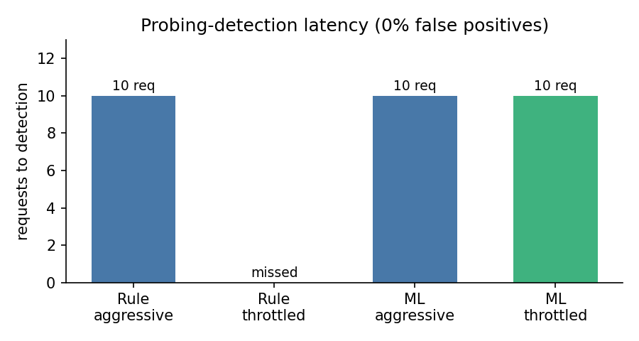
FIGURE 12. Probing-detection latency: the ML monitor catches the throttled attacker the rule thresholds miss.
TABLE 9. Isolation-Forest probing detector on synthetic traffic (200 seeds per class).
Metric | Aggressive | Throttled
Single-window ROC-AUC | 1.000 | 0.982
Streaming detection | 100% | 100%
Median requests to detect | 10 | 10
False-positive rate | 0.5% | 0.5%
To confirm that the monitor generalises beyond synthetic traffic, we captured real request logs from the live device, 1,240 genuine requests across normal, aggressive and throttled behaviour, built a labelled feature dataset of 396 sliding windows, and trained and evaluated the same detector on a temporal train-test split. Table 10 reports the result on the real test split: the detector separates both attack classes from normal traffic with a receiver-operating-characteristic area of 1.000 and a zero-per-cent false-positive rate on the held-out normal windows.
TABLE 10. Probing detector on real captured traffic (held-out test split).
Class | ROC-AUC | Per-window TPR | FPR
Aggressive | 1.000 | 100% | 0%
Throttled | 1.000 | 37.5% | 0%
(Normal) | - | - | 0%
The throttled per-window true-positive rate is modest by construction, because a single short window of a patient attacker is genuinely close to normal; the streaming monitor nonetheless catches it reliably because the attacker cannot sustain its elevated rate across successive windows.
DISCUSSION
A. Simulation versus Hardware
Figure 13 compares simulation with hardware for the ChaCha20 power attack. Simulation is systematically cleaner, a higher correlation and fewer traces to disclosure, because it contains no measurement noise and no quantisation. Simulation is therefore an upper bound on what the attacker achieves, and the hardware result is the real evidence; reporting only the simulation would overstate the ease of the attack. Table 11 consolidates the comparison.
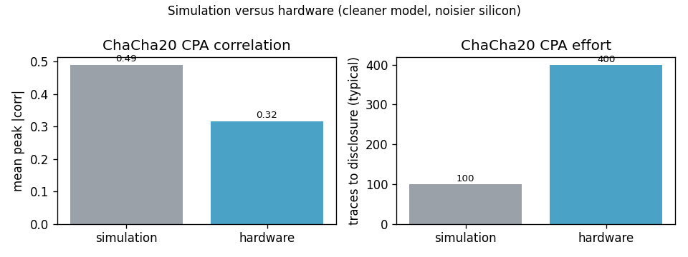
FIGURE 13. Simulation versus hardware for the ChaCha20 power attack.
TABLE 11. Simulation versus hardware, consolidated.
Attack | Simulation | Hardware
ChaCha20 CPA | corr 0.49, NTD ~100 | corr 0.28, NTD < 250
Kyber CPA | corr ~0.30 | corr 0.23
Masking (ChaCha) | suppressed | suppressed
Masking (Kyber) | suppressed | not suppressed
Timing | 3 of 4 bytes | failed over UART
B. Negative Results
Two defenses fail on hardware, and we report them honestly because a defense study that records only its successes cannot be trusted. The masking of the amplified Kyber product does not suppress its leakage, because the firmware mask is applied to a value whose Hamming weight still drives the sustained current that the shunt integrates over the amplification loop; the mask changes which bits are set but not how many, over the window that is measured. A correct fix re-randomises the mask inside the leaking window, or moves to arithmetic sharing with an explicit second-order check. The timing attack fails because the secret-dependent delay, of roughly 0.2 milliseconds, is swamped by the serial round-trip of about 8 milliseconds and its jitter, a disadvantage of roughly forty to one; resolving it needs device-side latency measurement, for example a hardware timer or a logic analyser on a dedicated pin, rather than measurement over the link. Both negatives bound the scope of the defenses rather than weaken the study.
C. Limitations
The study targets a single key word and a single Kyber coefficient rather than a full secret, uses an amplified-leakage measurement mode in place of a high-bandwidth oscilloscope, and evaluates the active monitor on a corpus of traffic that, although it includes real captures, is modest in size. None of these affects the central claims, that real keys are recovered on real hardware and that the measured defenses remove the leakage they target, but each marks a direction in which the work can be strengthened.
D. Practical Implications
A striking aspect of the study is how modest its equipment is. The entire capability demonstrated here, recovering keys from both a classical and a post-quantum primitive, rests on a shunt resistor, a commodity analog-to-digital converter, and a single-board computer of the kind many laboratories already own. The barrier to mounting a power side-channel attack against an unprotected embedded device is therefore far lower than the specialised oscilloscopes of the academic literature suggest. This argues for treating side-channel resistance as a baseline requirement of embedded cryptographic firmware rather than a high-assurance luxury, and it argues in particular for shipping post-quantum implementations with masking and constant-time execution already in place, since the devices that run them will be exposed for their entire, long service life. The active monitor explored here is a complementary, low-cost line of defense: because it reasons about the request stream rather than the cryptographic internals, it can be deployed on the host side of a device without modifying the cipher at all.
CONCLUSION
We have shown that a measurement rig built from commodity, widely available components recovers real keys from both a classical stream cipher and a post-quantum key-encapsulation mechanism on a commodity microcontroller, and that a layered set of countermeasures, each measured rather than asserted, removes the leakage it targets while an active machine-learning monitor detects the attack as it is mounted, on real as well as synthetic traffic. We have also reported, and explained, two negative results that bound the scope of the defenses. Future work will close those negatives, extend the attacks from a single key word and coefficient to a full secret, replace the amplified-leakage mode with a high-bandwidth capture, and train the probing monitor on a larger corpus of real deployment traffic. The complete toolkit, firmware, captured traces and trained models are released so that the study can be reproduced and extended on equivalent hardware.
REFERENCES
[1] P. Kocher, “Timing attacks on implementations of Diffie-Hellman, RSA, DSS, and other systems,” in Proc. CRYPTO, 1996, pp. 104–113.
[2] P. Kocher, J. Jaffe, and B. Jun, “Differential power analysis,” in Proc. CRYPTO, 1999, pp. 388–397.
[3] E. Brier, C. Clavier, and F. Olivier, “Correlation power analysis with a leakage model,” in Proc. CHES, 2004, pp. 16–29.
[4] S. Chari, J. R. Rao, and P. Rohatgi, “Template attacks,” in Proc. CHES, 2002, pp. 13–28.
[5] D. J. Bernstein, “ChaCha, a variant of Salsa20,” in Workshop Rec. SASC, 2008.
[6] Y. Nir and A. Langley, “ChaCha20 and Poly1305 for IETF protocols,” RFC 8439, 2018.
[7] National Institute of Standards and Technology, “Module-lattice-based key-encapsulation mechanism standard,” FIPS 203, 2024.
[8] J. Bos et al., “CRYSTALS-Kyber: A CCA-secure module-lattice-based KEM,” in Proc. IEEE EuroS&P, 2018, pp. 353–367.
[9] R. Primas, P. Pessl, and S. Mangard, “Single-trace side-channel attacks on masked lattice-based encryption,” in Proc. CHES, 2017, pp. 513–533.
[10] P. Pessl and R. Primas, “More practical single-trace attacks on the number theoretic transform,” in Proc. LATINCRYPT, 2019, pp. 130–149.
[11] P. Ravi et al., “Side-channel and fault-injection attacks over lattice-based post-quantum schemes,” ACM TECS, vol. 22, no. 2, 2023.
[12] S. Mangard, E. Oswald, and T. Popp, Power Analysis Attacks: Revealing the Secrets of Smart Cards. Springer, 2007.
[13] G. Goodwill, B. Jun, J. Jaffe, and P. Rohatgi, “A testing methodology for side-channel resistance validation,” in NIST Non-Invasive Attack Testing Workshop, 2011.
[14] F. T. Liu, K. M. Ting, and Z.-H. Zhou, “Isolation forest,” in Proc. IEEE ICDM, 2008, pp. 413–422.
[15] T. Unterluggauer, T. Korak, S. Mangard et al., “Leakage bounds for masked implementations,” in Proc. CHES, 2018.
[16] A. Moradi, B. Richter, T. Schneider, and F.-X. Standaert, “Leakage detection with the chi-squared test,” IACR TCHES, 2018.
[17] C. O'Flynn and Z. Chen, “ChipWhisperer: An open-source platform for hardware embedded security research,” in Proc. COSADE, 2014.
[18] B. J. Gilmore, N. Hanley, and M. O'Neill, “Neural network based attacks on masked implementations,” in Proc. HOST, 2015.
[19] P. Ravi, S. Bhasin, S. S. Roy, and A. Chattopadhyay, “On exploiting message leakage in lattice-based KEMs,” IEEE TIFS, vol. 16, 2021.
[20] M.-L. Akkar and C. Giraud, “An implementation of DES and AES secure against some attacks,” in Proc. CHES, 2001, pp. 309–318.
SATVIK JINDAL is pursuing the B.Tech degree in computer science and engineering at the Vellore Institute of Technology, Vellore, India. His interests include hardware security, side-channel analysis, and embedded systems.
SUSHRUT KOUNDINYA is pursuing the B.Tech degree in computer science and engineering at the Vellore Institute of Technology, Vellore, India. His interests include applied cryptography and post-quantum cryptography.
LAKSHAY TOMAR is pursuing the B.Tech degree in computer science and engineering at the Vellore Institute of Technology, Vellore, India. His interests include machine learning for security and anomaly detection.

It is recommended that footnotes be avoided (except for the unnumbered footnote with the receipt date on the first page). Instead, try to integrate the footnote information into the text.

