

A project report on
CYBERTRACE: A MULTI-VECTOR SIDE-CHANNEL ATTACK AND DEFENSE FRAMEWORK FOR EMBEDDED CYBER-PHYSICAL SYSTEMS
Submitted in partial fulfillment for the award of the degree of
Bachelor of Technology in Computer Science and Engineering (Cyber Physical Systems)
by
SATVIK JINDAL (Reg. No.: 23BPS1123)
SUSHRUT KOUNDINYA (Reg. No.: 23BPS1036)
LAKSHAY TOMAR (Reg. No.: 23BPS1177)
SCHOOL OF COMPUTER SCIENCE AND ENGINEERING
October, 2026

DECLARATION
I hereby declare that the project report entitled “CyberTrace: A Multi-Vector Side-Channel Attack and Defense Framework for Embedded Cyber-Physical Systems” submitted by Satvik Jindal (Reg. No.: 23BPS1123), for the award of the degree of Bachelor of Technology in Computer Science and Engineering (Cyber Physical Systems), Vellore Institute of Technology, Chennai, is a record of bonafide work carried out by me under the supervision of Dr. Benila S.
I further declare that the work reported in this project report has not been submitted and will not be submitted, either in part or in full, for the award of any other degree or diploma in this institute or any other institute or university.

Place: Chennai
Date: 19 October 2026
Satvik Jindal
Signature of the Candidate

School of Computer Science and Engineering
CERTIFICATE
This is to certify that the report entitled “CyberTrace: A Multi-Vector Side-Channel Attack and Defense Framework for Embedded Cyber-Physical Systems” is prepared and submitted by Satvik Jindal (Reg. No.: 23BPS1123) to Vellore Institute of Technology, Chennai, in partial fulfillment of the requirement for the award of the degree of Bachelor of Technology in Computer Science and Engineering (Cyber Physical Systems) is a bonafide record carried out under my guidance. The project fulfills the requirements as per the regulations of this University and in my opinion meets the necessary standards for submission. The contents of this report have not been submitted and will not be submitted either in part or in full, for the award of any other degree or diploma and the same is certified.
Signature of the Guide:
Name: Dr. Benila S
Date:
Signature of the Examiner 1 Signature of the Examiner 2
Name: Name:
Date: Date:
Approved by the Head of Department,
Computer Science and Engineering (Cyber Physical Systems)
Signature:
Name: Dr. S. Renuka Devi
Date:
(Seal of School of Computer Science and Engineering)
ABSTRACT
Cyber-physical systems embed computation and cryptography inside devices that act directly on the physical world, so the secrecy of the cryptographic keys those devices hold is a matter of physical safety and not of data confidentiality alone. A cryptographic algorithm whose mathematics is sound can still surrender its key through unintended physical emissions — the current a chip draws, the time it takes to respond, or the way it handles a protocol — because those emissions depend on the data being processed. This project presents CyberTrace, a unified framework that both mounts and defends against such attacks on a representative embedded target, an ESP32-S3 microcontroller running modern and post-quantum cryptography.
Three independent attack vectors are demonstrated. A correlation power analysis attack recovers the secret key of the ChaCha20 stream cipher from the power consumed during its first round; a timing attack recovers an authentication secret from data-dependent response latency; and a replay attack subverts command authentication without breaking any cryptography. The same power-analysis methodology is extended to the post-quantum key-encapsulation scheme CRYSTALS-Kyber by attacking the secret-dependent pointwise multiplication of its number-theoretic transform, showing that resistance to quantum computers does not confer resistance to physical side channels.
Against these attacks the framework implements a layered defense that lives inside the device: Boolean masking, constant-time comparison, and nonce-based replay protection, complemented by an active probing-detection monitor and automatic key refresh. The strength of every countermeasure is quantified using Test Vector Leakage Assessment, the standard statistical test for the presence of exploitable leakage, rather than merely asserted. A deliberate separation between an attacker program, which may only observe the device, and a defender console, which owns it, enforces a realistic threat model in which the attacker's success depends only on what it can physically measure.
The complete system was validated both in a software model and on physical hardware. On the real device the ChaCha20 key word was recovered from measured power with a correlation of approximately 0.33 using about four hundred traces, and the masking countermeasure was shown to suppress the leakage below the leakage-assessment threshold. The same power-analysis method was carried over to the post-quantum scheme CRYSTALS-Kyber on the same hardware, recovering its secret transform-domain coefficient from power, which confirms on silicon that quantum resistance does not confer side-channel resistance. The machine-learning probing monitor detected trace collection within ten requests with no false positives, including a throttled attacker designed to evade fixed thresholds. The timing attack was realised in the software model; on hardware its secret-dependent delay was found to lie below the resolution of the serial measurement path, which locates a concrete boundary of the low-cost apparatus. The work therefore establishes an end-to-end, quantitatively evaluated account of physical key recovery and its mitigation on an embedded cyber-physical device.

ACKNOWLEDGEMENT
It is our pleasure to express with a deep sense of gratitude to our project guide, Dr. Benila S, Assistant Professor, School of Computer Science and Engineering, Vellore Institute of Technology, Chennai, for the constant guidance, continual encouragement, and understanding; more than all, for teaching us patience throughout our endeavor. Our association with the guide is not confined to academics alone, but has been a great opportunity to work with an intellectual and an expert in the field of hardware security and cryptography.
It is with gratitude that we would like to extend our thanks to the visionary leader Dr. G. Viswanathan, our Honourable Chancellor, Mr. Sankar Viswanathan, Dr. Sekar Viswanathan, Dr. G. V. Selvam, Vice Presidents, Dr. Sandhya Pentareddy, Executive Director, Ms. Kadhambari S. Viswanathan, Assistant Vice-President, Dr. V. S. Kanchana Bhaaskaran, Vice-Chancellor, Dr. T. Thyagarajan, Pro-Vice Chancellor, VIT Chennai, and Dr. P. K. Manoharan, Additional Registrar, for providing an exceptional working environment and for inspiring all of us during the tenure of the course.
Special mention to Dr. Viswanathan V, Dean, Dr. Nithyanandam P, Associate Dean, Dr. Suganya G, Associate Dean, and Dr. Sweetlin Hemalatha C, Associate Dean, School of Computer Science and Engineering, Vellore Institute of Technology, Chennai, for spending their valuable time and efforts in sharing their knowledge and for helping us in every aspect.
In a jubilant state, we express our whole-hearted thanks to Dr. S. Renuka Devi, Head of the Department, B.Tech. Computer Science and Engineering (Cyber Physical Systems), and the Project Coordinators, for their valuable support and encouragement to take up and complete the project.
Our sincere thanks to all the faculty members and staff at Vellore Institute of Technology, Chennai, who helped us acquire the requisite knowledge to complete this project successfully. We would like to thank our parents for their support, and it is indeed a pleasure to thank our friends who encouraged us to take up and complete this task.

Place: Chennai
Date: 19 October 2026
Satvik Jindal
TABLE OF CONTENTS
CHAPTER 1 1
1.1 INTRODUCTION 1
1.2 OVERVIEW OF SIDE-CHANNEL THREATS 2
1.3 MOTIVATION 2
1.4 PROBLEM STATEMENT 3
1.5 OBJECTIVES 3
1.6 SCOPE OF THE PROJECT 4
1.7 ORGANISATION OF THE REPORT 4
1.8 PRINCIPAL CONTRIBUTIONS 5
CHAPTER 2 6
2.1 INTRODUCTION 6
2.2 FOUNDATIONS OF SIDE-CHANNEL ANALYSIS 6
2.3 SIMPLE AND DIFFERENTIAL POWER ANALYSIS 7
2.4 CORRELATION POWER ANALYSIS 8
2.5 TEMPLATE AND PROFILED ATTACKS 8
2.6 THE CHACHA20 STREAM CIPHER 9
2.7 POST-QUANTUM CRYPTOGRAPHY AND CRYSTALS-KYBER 9
2.8 COUNTERMEASURES 10
2.9 LEAKAGE ASSESSMENT 11
2.10 ANOMALY DETECTION FOR ACTIVE DEFENSE 11
2.11 MATHEMATICAL FORMULATION OF CORRELATION POWER ANALYSIS 12
2.12 LEAKAGE ASSESSMENT: STATISTICAL BASIS 13
2.13 SUMMARY OF RELATED WORK 13
2.14 SUMMARY OF THE LITERATURE 15
CHAPTER 3 16
3.1 THREAT MODEL AND ARCHITECTURE 16
3.2 HARDWARE PLATFORM 16
3.3 THE SLOW-CONVERTER PROBLEM AND LEAKAGE AMPLIFICATION 18
3.4 ATTACK METHODOLOGY 19
3.5 DEFENSE DESIGN 21
3.6 ACTIVE PROBING DETECTION 21
3.7 COMMAND INTERFACE 22
3.8 THE SOFTWARE MODEL 23
3.9 DESIGN RATIONALE AND SUMMARY 24
CHAPTER 4 25
4.1 OVERVIEW 25
4.2 TARGET FIRMWARE 25
4.3 THE SHARED CRYPTOGRAPHIC ENGINE 26
4.4 THE ATTACKER PROGRAM 26
4.5 THE DEFENDER PROGRAM 27
4.6 THE PROBING-DETECTION MODEL 27
4.7 SOFTWARE ENGINEERING AND TOOLS 28
4.8 TESTING AND VALIDATION 28
CHAPTER 5 29
5.1 CORRELATION POWER ANALYSIS ON HARDWARE 29
5.2 EFFECTIVENESS OF MASKING 31
5.3 TIMING AND REPLAY ATTACKS 33
5.4 POST-QUANTUM TARGET 34
5.5 PROBING DETECTION 37
5.6 DETAILED HARDWARE ANALYSIS 37
5.7 DISCUSSION 42
5.8 SUMMARY OF RESULTS 44
CHAPTER 6 46
6.1 CONCLUSION 46
6.2 FUTURE WORK 47
REFERENCES 49
APPENDIX 51
APPENDIX 1 SOURCE CODE ORGANISATION 51
APPENDIX 2 CORRELATION COMPUTATION 51
APPENDIX 3 FULL KEY RECOVERY ACROSS COLUMNS 51
APPENDIX 4 LEAKAGE ASSESSMENT (TVLA) 52
APPENDIX 5 CHACHA20 BLOCK FUNCTION (FIRMWARE) 52
APPENDIX 6 KYBER LEAKAGE MODEL (HOST) 52
APPENDIX 7 PROBING-DETECTION FEATURES 53
APPENDIX 8 ATTACKER TRANSPORT (CAPABILITY BOUNDARY) 53
APPENDIX 9 PER-BYTE CPA ANALYSIS (ATTACKER) 53
APPENDIX 10 FULL-KEY COLUMN RECOVERY (ATTACKER) 53
APPENDIX 11 DEFENDER LEAKAGE ASSESSMENT 54
APPENDIX 12 UNIFIED DEMONSTRATION (HOST) 54
APPENDIX 13 PROBING MONITOR ANALYTICS (DEFENDER) 54
APPENDIX 14 TIMING ATTACK (HOST) 55
APPENDIX 15 COMMAND DISPATCH (FIRMWARE) 55
APPENDIX 16 HARDWARE BRING-UP AND VERIFICATION LOG 55
APPENDIX 17 ARCHIVED HARDWARE DATA AND REPRODUCTION 56
APPENDIX 18 REPRODUCIBILITY CHECKLIST 57
APPENDIX 19 AUTHENTICATION CHECK (FIRMWARE) 58
APPENDIX 20 AMPLIFIED FIRST-ROUND LEAKAGE (FIRMWARE) 59
APPENDIX 21 KYBER COEFFICIENT LEAKAGE (FIRMWARE) 59

LIST OF FIGURES
Figure 3.1 Attacker / Defender / Target architecture
Figure 3.2 First-round data flow and the CPA target
Figure 3.3 Measurement setup and wiring
Figure 5.1 Correlation power analysis of the ChaCha20 first round
Figure 5.2 TVLA leakage assessment on hardware, masking disabled and enabled (ChaCha20)
Figure 5.3 Kyber coefficient CPA on hardware: correct secret versus all guesses
Figure 5.4 Probing-detection latency for rule-based and ML monitors
Figure 5.5 Hardware correlation heatmap: brightest row = correct key byte
Figure 5.6 Hardware leakage assessment: masking off versus on
Figure 5.7 A single real LEAKLOOP power trace with its four byte-phase windows
Figure 5.8 Hardware CPA: correct candidate versus runner-up, per byte
Figure 5.9 Hardware CPA convergence (traces to disclosure)
Figure 5.10 Hardware timing attack: candidate margins dwarfed by link latency
Figure 5.11 Simulation versus hardware for the ChaCha20 power attack

LIST OF TABLES
Table 2.1 Summary of related work
Table 3.1 Attack vectors and the countermeasures that defeat them
Table 3.2 Target device command interface
Table 5.1 Hardware correlation power analysis results
Table 5.2 Full 256-bit ChaCha20 key recovery (simulation)
Table 5.3 Masking leakage assessment for ChaCha20 and Kyber (software model)
Table 5.4 Timing and replay attack outcomes
Table 5.5 Probing-detection analytics
Table 5.6 Consolidated summary of results
Table 5.7 Simulation versus hardware, consolidated
Table 5.8 Kyber coefficient CPA: strongest candidates (hardware)
Table 5.9 Per-byte hardware CPA detail
Table 5.10 Hardware CPA convergence with trace count

LIST OF ACRONYMS
Acronym | Expansion
ADC | Analog-to-Digital Converter
AES | Advanced Encryption Standard
CPA | Correlation Power Analysis
CPS | Cyber-Physical System
DPA | Differential Power Analysis
EM | Electromagnetic
FPR | False-Positive Rate
HD | Hamming Distance
HW | Hamming Weight
I2C | Inter-Integrated Circuit
KEM | Key-Encapsulation Mechanism
ML | Machine Learning
NTD | Number of Traces to Disclosure
NTT | Number-Theoretic Transform
POI | Point of Interest
PQC | Post-Quantum Cryptography
SCA | Side-Channel Analysis
SNR | Signal-to-Noise Ratio
SPA | Simple Power Analysis
TVLA | Test Vector Leakage Assessment
UART | Universal Asynchronous Receiver-Transmitter

CHAPTER 1
INTRODUCTION

1.1 INTRODUCTION
A cyber-physical system is one in which computation is tightly coupled to physical processes through sensors and actuators, so that the decisions taken by software take immediate physical effect. Water-treatment plants, electrical power grids, programmable logic controllers on a factory floor, automobiles, and implantable medical devices are all cyber-physical systems, and in every one of them a command that reaches an actuator can change the state of the physical world. A valve opens, a breaker trips, a motor changes speed, or a dose is delivered. As these systems have become networked, they have also come to rely on cryptography to authenticate the commands they accept and to protect the measurements they report. The confidentiality and integrity guarantees of that cryptography therefore sit directly on the path between an adversary and a physical consequence.
The security of a cryptographic algorithm is ordinarily argued in mathematical terms. An adversary who observes only the inputs and outputs of the algorithm — the plaintexts, ciphertexts, and public parameters — should be unable to recover the secret key within any computationally feasible effort. Decades of cryptanalysis support such arguments for standardised primitives. A physical implementation of an algorithm, however, is not a mathematical abstraction; it is a circuit that consumes power, takes time, radiates electromagnetic energy, and occasionally makes mistakes. Each of these physical quantities can depend on the secret data being processed, and each therefore constitutes a channel through which information about the key can leak. Attacks that exploit these unintended channels are called side-channel attacks, and they have repeatedly defeated implementations whose underlying mathematics was never in doubt.
This project is concerned with side-channel attacks on embedded cyber-physical devices and with the countermeasures that resist them. It is deliberately constructed as a complete cycle: first the practical extraction of cryptographic keys from a representative device through several independent physical channels, and then the implementation and quantitative evaluation of the defenses that close those channels. The target chosen is the ESP32-S3 microcontroller, a widely deployed and inexpensive part that is representative of the class of processors found inside modern cyber-physical equipment, and the cryptographic subjects are a modern stream cipher, ChaCha20, and a newly standardised post-quantum key-encapsulation mechanism, CRYSTALS-Kyber.

1.2 OVERVIEW OF SIDE-CHANNEL THREATS
Side channels are usually grouped by the physical quantity that is observed. A power side channel measures the instantaneous current drawn by the device; because the dynamic power of a digital circuit depends on the number of bits that switch, and that number depends on the data in registers and on buses, the power trace carries information about intermediate values. A timing side channel measures how long an operation takes; when a computation branches or terminates early on the basis of secret data, its duration leaks that data. An electromagnetic side channel measures the field radiated by switching currents, offering a non-contact analogue of the power channel. A fault channel does not merely observe but actively perturbs the device — by glitching its clock, voltage, or environment — and infers secrets from the resulting errors. Finally, a class of logical side channels, including protocol and replay weaknesses, exploits the behaviour of the surrounding system rather than any analogue emission.
The present work addresses the power channel as its principal subject, since power analysis is both the most powerful and the most studied of the analogue side channels, and complements it with a timing attack and a replay attack so that three fundamentally different mechanisms are represented. Electromagnetic and fault channels are discussed where relevant and are identified as extensions beyond the present scope.

1.3 MOTIVATION
Side-channel vulnerabilities are especially consequential for cyber-physical systems for two reasons that do not apply with the same force to, say, a cloud server. The first is physical accessibility. The devices are deployed in the field, often in unattended or lightly protected locations, where an adversary can attach a probe to a power line, place a near-field antenna over a package, or connect to a debug header. The second is the nature of the payoff. In a conventional information-security breach the prize is data; in a cyber-physical breach the prize is control. A recovered key allows an adversary to forge the very commands that drive actuators, and so to produce physical effects — a contaminated water supply, a de-energised feeder, a damaged machine — that are qualitatively more severe than the disclosure of information.
A second motivation is the inadequacy, for a defender, of binary claims of security. It is not enough to apply a countermeasure and assert that the device is now safe. A responsible evaluation must measure how much exploitable leakage remains after the countermeasure is applied, so that residual risk can be judged quantitatively. This project therefore treats measurement, through leakage assessment and through the number of traces required for key recovery, as a first-class part of the defense rather than an afterthought.

1.4 PROBLEM STATEMENT
The problem addressed by this project is to demonstrate, within a single coherent framework and under a realistic threat model, both the practical extraction of cryptographic keys from an embedded cyber-physical device through multiple independent side channels, and the implementation and quantitative evaluation of the countermeasures that defeat them, with a clean architectural separation between the capabilities of an external adversary and those of the device owner.

1.5 OBJECTIVES
- To implement correlation power analysis, timing, and replay attacks against a representative embedded cyber-physical target running modern cryptography, and to recover its secret key from measured physical behaviour.
- To extend the power-analysis methodology to the post-quantum key-encapsulation scheme CRYSTALS-Kyber, demonstrating that resistance to quantum computation does not imply resistance to physical side channels.
- To implement device-resident countermeasures — Boolean masking, constant-time comparison, and nonce-based replay protection — together with an active probing-detection monitor and automatic key refresh.
- To quantify the effectiveness of each countermeasure using Test Vector Leakage Assessment and the number of traces to disclosure, rather than by assertion.
- To enforce a realistic threat model by separating the attacker software, which may only observe the device, from the defender software, which owns it.
- To validate the complete system both in a software model and on physical hardware.

1.6 SCOPE OF THE PROJECT
The work covers the full attack-and-defense life cycle for one representative device, the ESP32-S3 microcontroller, instrumented with a low-cost sixteen-bit analog-to-digital converter for power measurement and driven by a single-board computer that hosts the attacker and defender software. The cryptographic targets are the ChaCha20 stream cipher and the CRYSTALS-Kyber key-encapsulation mechanism. The framework is organised as two separate programs, an attacker and a defender, reflecting the real separation of capabilities between an external adversary and the device owner. High-bandwidth oscilloscope-based acquisition, full physical extraction of every key word on hardware, electromagnetic and fault channels, and a complete on-device implementation of the Kyber protocol are identified as extensions beyond the present scope and are discussed as future work.

1.7 ORGANISATION OF THE REPORT
The remainder of this report is organised as follows. Chapter 2 surveys the background and prior work in side-channel analysis, the cryptographic primitives under study, and the standard countermeasures and leakage-assessment methodology. Chapter 3 presents the system design and methodology, including the threat model, the hardware platform, the leakage-amplification technique, and the design of each attack and defense. Chapter 4 describes the implementation of the firmware and of the attacker and defender programs. Chapter 5 reports and discusses the results obtained in simulation and on hardware. Chapter 6 concludes and outlines future work.

1.8 PRINCIPAL CONTRIBUTIONS
The principal contributions of this project may be stated concisely. It demonstrates, on a single representative device, three fundamentally different side-channel attacks — power, timing, and protocol — against a modern cipher, and extends the power attack to a newly standardised post-quantum scheme, thereby covering in one framework a breadth of attack mechanisms and cryptographic targets usually treated separately. It introduces and validates a leakage-amplification technique that renders power analysis feasible with an inexpensive, low-bandwidth converter, where the established practice assumes a high-bandwidth oscilloscope. It implements the accepted countermeasures within the device and, crucially, quantifies their effectiveness through Test Vector Leakage Assessment rather than by assertion. It adds an active probing-detection layer, strengthened by an unsupervised machine-learning model, that detects a throttled attacker which the conventional fixed-threshold rules miss. And it enforces throughout a strict separation between an attacker that may only observe and a defender that owns the device, so that every reported result reflects what an adversary could actually achieve.

CHAPTER 2
BACKGROUND AND LITERATURE SURVEY

2.1 INTRODUCTION
This chapter establishes the technical background on which the project rests and reviews the prior work most relevant to it. It begins with the foundations of side-channel analysis and the specific method of correlation power analysis, proceeds to the two cryptographic primitives that serve as targets, and concludes with the standard countermeasures and the leakage-assessment methodology used to evaluate them.

2.2 FOUNDATIONS OF SIDE-CHANNEL ANALYSIS
The study of side-channel attacks on cryptographic devices is usually dated to the work of Kocher in the late 1990s, who showed first that the time taken by modular exponentiation leaks the exponent (Kocher, 1996), and subsequently, with Jaffe and Jun, that the power consumed by a device performing encryption leaks the key (Kocher et al., 1999). The central physical fact is that a complementary metal-oxide-semiconductor circuit draws current chiefly when its logic gates switch, and the number of gates that switch in a given cycle depends on the values being manipulated. Two leakage models capture this dependence. The Hamming-weight model assumes that the power consumed while a value is held or produced is proportional to the number of one-bits in that value; the Hamming-distance model assumes instead that the power depends on the number of bits that change between a previous and a current value, which more accurately describes a bus or register that is overwritten. Both models are used in this project; the Hamming-weight model is the primary one, and the Hamming-distance model is noted as an alternative where a device's behaviour demands it.
The distinction between the two models is not merely academic. A value held in a register or driven onto a precharged bus tends to leak its Hamming weight, whereas a value that overwrites a previous one on a static bus tends to leak the Hamming distance between the old and the new contents. A real device usually exhibits a combination of the two, and an attacker who assumes the wrong model will see a weaker correlation, or none at all. In this project the amplified-leakage mechanism was constructed so that it leaks the Hamming weight explicitly, by driving a number of output lines equal to the number of one-bits in the targeted value, which removes the uncertainty about the model and lets the attack proceed under the simpler Hamming-weight assumption. On a device without such amplification an evaluator would ordinarily test both models and retain whichever yields the stronger correlation.

2.3 SIMPLE AND DIFFERENTIAL POWER ANALYSIS
The earliest power attacks were simple power analysis, in which a single trace, or a few averaged traces, is inspected directly for patterns that reveal the sequence of operations and, through it, the key. Simple power analysis is effective against naive implementations of public-key algorithms whose control flow depends on key bits, but it is defeated by implementations whose operations are uniform. Differential power analysis, introduced in the same body of work, is far more powerful because it is statistical. Rather than reading a key from one trace, it collects many traces, partitions them according to a hypothesis about a small part of the key, and detects the small, consistent difference in power that the correct hypothesis induces. Because the signal is extracted statistically, differential power analysis succeeds even when the data-dependent component of the power is far below the noise.
The power of the statistical approach rests on a simple principle. The data-dependent component of the leakage, though tiny, is consistent: it appears in the same way in every trace for which the targeted intermediate takes the same value. The noise, by contrast, is random and uncorrelated from trace to trace. When many traces are combined, the consistent component accumulates in proportion to the number of traces while the random component accumulates only in proportion to its square root, so the ratio of signal to noise grows without bound as traces are added. This is why an attacker who cannot see the key in any single trace can nonetheless recover it from enough of them, and it is the reason the number of traces to disclosure, rather than any property of a single measurement, is the natural currency of both attack and defense.

2.4 CORRELATION POWER ANALYSIS
Correlation power analysis, formalised by Brier, Clavier, and Olivier (2004), refines the differential approach using the Pearson correlation coefficient and an explicit leakage model. For each candidate value of a small portion of the key — typically a single byte — the attacker computes, for every collected trace, the predicted leakage of a key-dependent intermediate value under the chosen model, and then computes the correlation between this prediction and the measured power at each time sample. The candidate whose prediction correlates most strongly with the measurements is taken to be the correct value. Because each part of the key is attacked independently, the cost of the attack grows linearly rather than exponentially with the key size, which is what makes the recovery of a long key tractable. The number of traces that must be collected before the correct hypothesis separates clearly from the incorrect ones is called the number of traces to disclosure and is the principal quantitative measure of the difficulty of an attack and, inversely, of the strength of a countermeasure.
A subtlety of correlation power analysis that proved important in this project concerns the sign of the correlation when the targeted operation is an exclusive-or. For an exclusive-or target the Hamming weight of the intermediate under the correct key and under its bitwise complement are related by a constant sum, so the two hypotheses produce correlations of equal magnitude but opposite sign. An attacker that selects the candidate of largest absolute correlation cannot distinguish a key byte from its complement; selecting the candidate of largest signed correlation resolves the ambiguity. This is in contrast to an addition target, where the carry breaks the symmetry and the absolute value may be used.

2.5 TEMPLATE AND PROFILED ATTACKS
A more powerful but more demanding class of attacks, the template or profiled attacks introduced by Chari, Rao, and Rohatgi (2002), assumes that the attacker possesses a device identical to the target and under full control. In a profiling phase the attacker characterises the probability distribution of the leakage for each possible value of the targeted intermediate; in the attack phase a very small number of traces from the target, in principle even one, is matched against these templates to recover the key. Profiled attacks are the strongest known power attacks and are the natural tool when the slow acquisition available in this project limits the per-trace information; they are discussed as a planned extension.

2.6 THE CHACHA20 STREAM CIPHER
ChaCha20, designed by Bernstein (2008), is a modern stream cipher that has been adopted in Transport Layer Security version 1.3 (Nir & Langley, 2018), in the WireGuard virtual private network, and in several other widely used protocols. It was designed in part to resist timing attacks, because it is built entirely from three constant-time operations — addition modulo two to the thirty-two, bitwise rotation, and exclusive-or — and contains no data-dependent table lookups or branches. Its internal state is a four-by-four array of thirty-two-bit words, comprising four fixed constants, eight secret key words, a block counter, and a nonce. The cipher applies twenty rounds of a quarter-round function that mixes the state; after these rounds the mixed state is added to the original to produce the keystream block. In the first round the secret key words are combined with the public counter and nonce, and it is this early combination, before diffusion has spread the key across the whole state, that provides the point of attack for power analysis. One of the findings of this project is that a cipher deliberately hardened against timing leakage is nonetheless vulnerable through the power channel, underscoring that resistance to one side channel does not confer resistance to another.

2.7 POST-QUANTUM CRYPTOGRAPHY AND CRYSTALS-KYBER
The public-key algorithms in widespread use today, including those based on the difficulty of factoring and of the discrete logarithm, would be broken by a sufficiently large quantum computer running Shor's algorithm. In anticipation of this threat the United States National Institute of Standards and Technology conducted a multi-year process to standardise quantum-resistant algorithms, and in 2024 published the module-lattice-based key-encapsulation mechanism, derived from CRYSTALS-Kyber (Bos et al., 2018), as a federal standard (NIST, 2024). Kyber's security rests on the presumed hardness of the module learning-with-errors problem over polynomial rings. Its core arithmetic multiplies polynomials efficiently using the number-theoretic transform, a finite-field analogue of the fast Fourier transform, within which a polynomial product reduces to a pointwise multiplication of transformed coefficients. During decapsulation the secret key, represented in the transform domain, is multiplied coefficient by coefficient with data derived from the ciphertext. That secret-dependent multiplication is the point of attack for power analysis, and it has been the subject of recent research, including the single-trace attacks on masked lattice-based encryption of Primas, Pessl, and Mangard (2017) and Pessl and Primas (2019), surveyed more broadly by Ravi et al. (2023). The significance for a migrating world is direct: although Kyber resists quantum attack, an unprotected embedded implementation leaks its secret through power exactly as a classical cipher does.

2.8 COUNTERMEASURES
The standard algorithmic countermeasure against power analysis is masking (Mangard et al., 2007). In a first-order Boolean masking scheme every sensitive value is combined, by exclusive-or, with a freshly generated random mask before it is processed, and the computation is rearranged so that it operates on the masked value and on the mask separately. Because the mask is uniformly random and independent of the secret, the leakage of any single masked value is statistically independent of the secret, and a first-order correlation attack, which examines one point at a time, fails. Higher-order masking splits each value into more shares and resists correspondingly higher-order attacks, at a cost in performance. Masking is complemented by hiding, which seeks to lower the signal-to-noise ratio of the leakage rather than to remove its dependence on the secret, for instance by adding noise, by randomly shuffling the order of independent operations, or by inserting dummy operations to misalign traces.
Timing attacks are defeated by constant-time implementation, in which the sequence of operations and the control flow are made independent of secret data, so that every input takes the same time. The canonical example is a comparison that always examines every byte of its operands rather than returning as soon as a mismatch is found. Replay attacks, which resend a previously captured valid message, are defeated by including a monotonic counter or a nonce in every authenticated message and rejecting any message whose counter has already been seen, so that freshness is enforced.
Each countermeasure carries a cost that a designer must weigh. Masking multiplies the number of operations and consumes random bits, and first-order masking protects only against first-order attacks: an adversary who can combine information from two points in a trace may mount a second-order attack that a single mask does not stop, which is why higher-order masking, with correspondingly greater cost, exists. Hiding does not remove the dependence of the leakage on the secret but only lowers the signal-to-noise ratio, so a determined attacker can overcome it by collecting more traces; its value is to raise the number of traces to disclosure, ideally beyond what an attacker can gather before a key is rotated. Constant-time code may be slower than its early-exit counterpart and must be written with care, because a compiler is free to reintroduce a data-dependent branch that the source code appeared to remove. These trade-offs motivate the measurement-based evaluation adopted in this project, since only measurement reveals how much protection a countermeasure actually delivers on a given device.

2.9 LEAKAGE ASSESSMENT
To decide whether exploitable leakage remains after a countermeasure has been applied, evaluators use Test Vector Leakage Assessment, a methodology introduced by Goodwill and colleagues (Goodwill et al., 2011) and now embedded in international standards for the validation of side-channel resistance. In its non-specific form the method collects two populations of traces, one taken with a fixed input and one with random inputs, and computes, at every time sample, Welch's t-statistic between the two populations. If the statistic exceeds a conventional threshold of four and a half anywhere in the trace, the two populations are distinguishable and the device is deemed to leak with high confidence. The great value of the method for a defender is that it measures the presence of exploitable leakage directly, without requiring the construction of a successful attack, and so provides an attack-agnostic verdict on a countermeasure.

2.10 ANOMALY DETECTION FOR ACTIVE DEFENSE
Beyond the passive countermeasures above, an active defender can monitor the stream of requests arriving at a device and react when it detects the signature of an attack in progress. Because collecting enough traces for a power attack requires issuing a large number of structured requests in a short time, trace collection produces a statistical signature distinct from ordinary use. Detecting that signature is an anomaly-detection problem, and a natural tool is the isolation forest (Liu et al., 2008), an unsupervised ensemble method that isolates anomalous points by random partitioning and that requires only examples of normal behaviour for training. Training only on normal traffic matches the deployment reality, in which labelled examples of attacks are not available in advance.

2.11 MATHEMATICAL FORMULATION OF CORRELATION POWER ANALYSIS
The correlation attack may be stated precisely. Let there be N measured traces, the i-th trace being a vector of power samples. For a key hypothesis k and a known input x(i) for trace i, let v(i, k) denote the targeted intermediate value, for example v = S(x XOR k) for an exclusive-or target, and let the predicted leakage under the Hamming-weight model be h(i, k) = HW(v(i, k)), the number of one-bits in v. For each time sample j the attacker computes the Pearson correlation between the column of predictions h(., k) and the column of measurements t(., j):
$$r(k,j)=\frac{cov\left(h(·,k),t(·,j)\right)}{σ_{h}(k)σ_{t}(j)}$$
where cov denotes the sample covariance over the N traces and sigma denotes the sample standard deviation. The recovered hypothesis is the one that maximises the correlation over all samples,
$$k^{*}={argmax}_{k}\max_{j}\left|r(k,j)\right|$$
for an addition target, while for an exclusive-or target the signed maximum k* = argmax_k max_j r(k, j) is used instead, so that the signed value breaks the complement symmetry. The expected magnitude of the correct correlation grows with the signal-to-noise ratio and falls as the inverse square root of N for the incorrect hypotheses, which is why the correct key separates from the field as traces accumulate and why the number of traces to disclosure is a meaningful measure.

2.12 LEAKAGE ASSESSMENT: STATISTICAL BASIS
Test Vector Leakage Assessment compares two trace populations, one gathered with a fixed input, the other with random inputs. At each sample the Welch t-statistic is
$$t=\frac{μ_{fixed}-μ_{random}}{\sqrt{\frac{s_{fixed}^{2}}{n_{fixed}}+\frac{s_{random}^{2}}{n_{random}}}}$$
which measures the difference of the two sample means in units of their combined standard error. Under the null hypothesis that the two populations are drawn from the same distribution, the statistic is approximately standard normal, so a magnitude exceeding four and a half corresponds to a vanishingly small probability of occurring by chance and is taken as evidence of leakage. Because the test asks only whether the fixed and random populations differ, it detects any first-order data dependence, whatever its form, and does not presuppose a particular attack or leakage model.

2.13 SUMMARY OF RELATED WORK
Table 2.1 summarises the principal prior work on which this project builds, spanning the foundational attacks, the targeted primitives, the countermeasures, and the evaluation methodology.
Table 2.1 Summary of related work
Work | Contribution relevant to this project
Kocher (1996) | Timing attacks on public-key implementations
Kocher, Jaffe & Jun (1999) | Simple and differential power analysis
Brier, Clavier & Olivier (2004) | Correlation power analysis with a leakage model
Chari, Rao & Rohatgi (2002) | Template (profiled) attacks from a cloned device
Mangard, Oswald & Popp (2007) | Comprehensive treatment of power analysis and defenses
Mangard (2004) | Statistical analysis of hardware countermeasure effectiveness
Coron & Kizhvatov (2009) | Random-delay hiding countermeasure
Goodwill et al. (2011) | Test Vector Leakage Assessment methodology
Standaert, Malkin & Yung (2009) | Unified framework for evaluating key-recovery attacks
Bernstein (2008) | The ChaCha stream cipher
Nir & Langley (RFC 8439, 2018) | Standardisation of ChaCha20 for IETF protocols
Bos et al. (2018) | The CRYSTALS-Kyber key-encapsulation mechanism
NIST FIPS 203 (2024) | Standardisation of the module-lattice KEM
Primas, Pessl & Mangard (2017) | Single-trace attacks on masked lattice encryption
Pessl & Primas (2019) | Practical single-trace attacks on the NTT
Ravi et al. (2023) | Survey of side-channel and fault attacks on PQC
Liu, Ting & Zhou (2008) | Isolation forest for unsupervised anomaly detection

2.14 SUMMARY OF THE LITERATURE
The literature establishes that power analysis, and correlation power analysis in particular, is a mature and powerful technique; that modern symmetric and post-quantum primitives both leak through power on embedded devices; that masking, constant-time implementation, and freshness are the accepted countermeasures; and that leakage assessment is the standard means of evaluating them. What the present project contributes beyond this background is the integration of several attack vectors and several defenses, across both a classical and a post-quantum primitive, into a single framework with a realistic attacker-defender separation, together with the practical demonstration that an amplified-leakage technique makes power analysis feasible even with a low-cost, low-bandwidth acquisition device, and the addition of an active probing-detection layer that closes the gap left by fixed-threshold rules.

CHAPTER 3
SYSTEM DESIGN AND METHODOLOGY

3.1 THREAT MODEL AND ARCHITECTURE
The framework is divided into two programs whose capabilities mirror the real separation between an adversary and a device owner. The attacker program may use only the device's legitimate interface — the commands any ordinary client could issue — and may observe the device's physical behaviour through the power-measurement instrument. It has no means of enabling, disabling, or even querying the device's countermeasures, exactly as a real adversary cannot reach inside a victim to alter its protections. The defender program, by contrast, is the device owner's console: it configures the countermeasures, monitors the incoming request stream, assesses the device's leakage, and rotates the key. The countermeasures themselves reside in the target device. This separation is not merely organisational; it makes the evaluation honest, because the attacker's success or failure is determined solely by what it is able to measure, with no privileged knowledge of the device's internal state. The overall arrangement is shown in Figure 3.1.
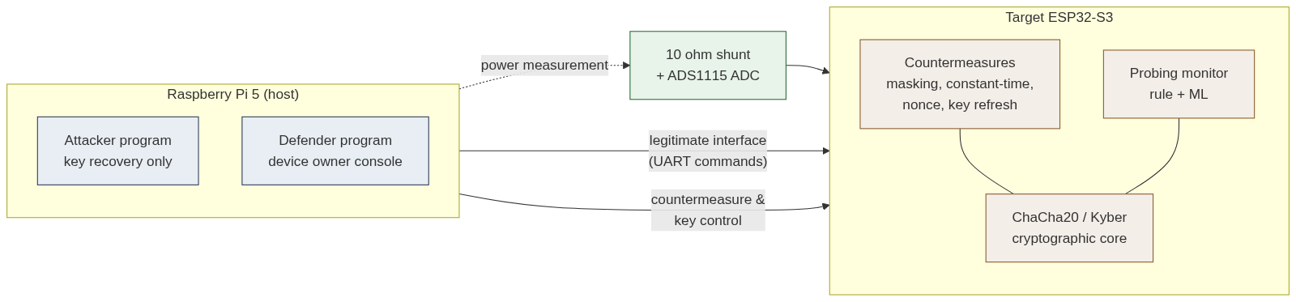
Figure 3.1 Attacker / Defender / Target architecture

3.2 HARDWARE PLATFORM
The target is an Espressif ESP32-S3 microcontroller, a dual-core processor clocked at up to two hundred and forty megahertz with ample memory, chosen because it is powerful enough to run both ChaCha20 and the finite-field arithmetic of a post-quantum scheme and because it is representative of the processors found in contemporary cyber-physical equipment. The supply current of the target is measured across a ten-ohm shunt resistor placed in its supply line. The small voltage developed across the shunt is digitised by an ADS1115 sixteen-bit analog-to-digital converter, which communicates over the inter-integrated-circuit bus with a Raspberry Pi 5 single-board computer. The Raspberry Pi also drives the target over a serial link, sending inputs and receiving outputs, and hosts the attacker and defender software. A second ESP32-S3 serves as a configurable noise source for evaluating the hiding countermeasure. The target is powered through the shunt during trace collection, with its programming interface disconnected, so that the whole of its supply current passes through the measurement path. The arrangement is shown in Figure 3.3.
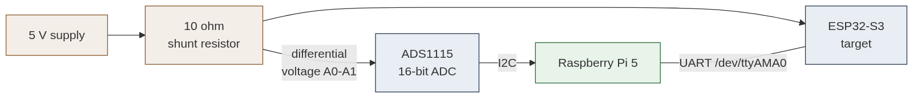
Figure 3.3 Measurement setup and wiring
The choice of a sixteen-bit converter communicating over a serial bus, rather than a laboratory oscilloscope, is deliberate. It reflects the resources available to a realistic field attacker and a student project alike, and it forces the leakage-amplification technique described below, which is itself a contribution of the work. The ten-ohm shunt value is a compromise: large enough to develop a measurable voltage from the small supply current, yet small enough not to disturb the operation of the target.
Before any traces were collected the measurement chain was calibrated on the real device, and the calibration is worth recording because it determines whether the attack sees any signal at all. The differential channel of the converter, taken across the shunt at a gain setting of four and the maximum conversion rate, reads the voltage developed by the target's supply current. With the target powered through the shunt and its programming connection removed, the channel reads a baseline of about seven hundred and sixty millivolts, which across the ten-ohm shunt corresponds to a quiescent supply current of roughly seventy-six milliamperes - a sensible figure for an active microcontroller. During the amplified computation the mean rises by several millivolts, and it is this small, key-dependent increment, not the large baseline, that carries the leakage.
A single detail of the power wiring proved decisive and is a practical lesson of the work. While the target's programming cable is connected, the device draws its current from that connection rather than through the shunt, and the differential channel then reads only a few millivolts with no usable key-dependent structure; an attack mounted in this state fails not because the leakage is absent but because the current never crosses the measuring element. Only with the programming cable removed, so that the entire supply current is forced through the shunt, does the baseline rise to its full value and the leakage become measurable. The discipline of verifying the baseline before every collection, and of confirming the command interface with a known request, was adopted after an early session in which a loose ground connection and a still-connected programming cable each produced a silent null result that was at first mistaken for a failure of the attack.

3.3 THE SLOW-CONVERTER PROBLEM AND LEAKAGE AMPLIFICATION
A sixteen-bit converter of the class used here samples at approximately one thousand conversions per second, whereas the cryptographic operation under attack completes in a few microseconds. A direct, single-shot acquisition therefore captures the operation in at most one or two samples, and in practice the measured correlation between the power and any key hypothesis never rises above the noise floor, which was observed to be about five hundredths. To make the leakage observable on this instrument, the target firmware amplifies it. For the operation under attack the firmware forms the key-dependent intermediate value and then, within a trigger-delimited window, repeats a data-dependent activity many thousands of times, driving a set of output pins in proportion to the Hamming weight of the intermediate. The average current drawn over the window consequently scales with that Hamming weight, lifting the data-dependent component of the signal from the microsecond timescale of the computation to the millisecond timescale that the converter can resolve. It must be stated plainly that this is an amplified rather than a single-shot attack: the statistical method, the leakage model, and the recovery procedure are identical to those of a conventional attack, and only the magnitude of the signal is raised to suit the instrument. A single-shot attack with a high-bandwidth oscilloscope is identified as future work.
It is important to be precise about what the amplification does and does not change. It does not fabricate a dependence that is not there: the quantity leaked is the Hamming weight of the genuine key-dependent intermediate, computed by the real cipher with the real key, and an attacker who did not know the key could not produce the same trace. What the amplification changes is only the amplitude and duration of the leakage, lifting a signal that exists for microseconds and at the level of a few gates into one that persists for milliseconds and involves many switching lines, so that a slow converter can integrate it. In this sense the amplified device is a faithful stand-in for a device whose natural leakage happens to be large, such as one with a noisy power supply or a poorly decoupled core, and the attack mounted against it is the same attack that would succeed, with better equipment, against a device whose leakage is small. The distinction matters for the interpretation of the results and is stated wherever those results are reported.

3.4 ATTACK METHODOLOGY
The correlation power analysis attack targets the first round of ChaCha20. In the first column operation the first constant word is added to the first key word to form a fixed quantity, after which the block counter is combined with that quantity by exclusive-or and the result is rotated. The exclusive-or of the public, per-trace-varying counter with the secret-derived quantity is the ideal point of attack: it is independent byte by byte, it involves no carry between bytes, and the rotation that follows it is byte-aligned and merely relabels which sample carries which byte. The attack recovers the sum of the constant and the key word one byte at a time, selecting for each byte the candidate of largest signed correlation, and then subtracts the known constant to obtain the key word. Recovering all eight key words requires attacking all four columns of the first round; the first column is driven by the counter, and the remaining three by the nonce words, which an attacker may choose. The timing attack targets an authentication routine whose comparison terminates as soon as a mismatched byte is found, so that the response time grows with the number of leading bytes guessed correctly, allowing the secret to be recovered byte by byte. The replay attack captures a valid authenticated command and resends it, succeeding whenever the device does not enforce freshness. For Kyber the attack targets the pointwise multiplication of a secret transform-domain coefficient with attacker-known data, recovering the coefficient by correlating the Hamming weight of the predicted product against the measured power over all candidate values of the coefficient.
The relationship between the first-round quantities and the chosen point of attack is shown in Figure 3.2. The fixed sum of the constant and key word is formed first; the public counter is then combined with it by exclusive-or; and it is this exclusive-or, where a known, per-trace-varying quantity meets a secret-derived one, that is attacked.
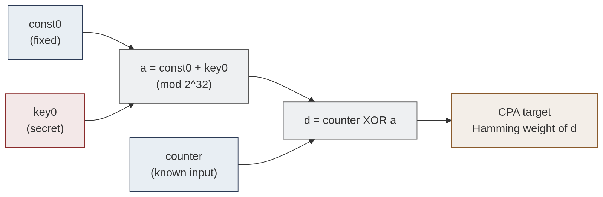
Figure 3.2 First-round data flow and the CPA target
For the amplified acquisition the firmware leaks each of the four bytes of the intermediate in a separate, equal-length phase within a single trigger window, so that the host can divide the recorded window into four sub-windows, one per byte, and attack each independently. Because every phase performs an identical amount of work regardless of the data, the phase boundaries fall at fixed positions and do not themselves leak, a property engineered deliberately after an earlier design, in which low-Hamming-weight bytes completed faster, was found to couple the phase timing to the quantity attacked.
Table 3.1 Attack vectors and the countermeasures that defeat them
Attack vector | What it exploits | Countermeasure
Correlation power analysis | Data-dependent power in the ChaCha20 first round | Boolean masking
Timing attack | Early-exit comparison in authentication | Constant-time comparison
Replay attack | Absence of freshness in commands | Nonce and monotonic counter
Kyber coefficient CPA | Power during the NTT pointwise multiply | Masking of the secret share
Trace collection (any) | Statistical signature of probing traffic | Probing detection and key refresh

3.5 DEFENSE DESIGN
Each attack is met by a countermeasure that lives in the device. Masking defeats the power attack by combining the leaking intermediate with a freshly generated hardware-random mask before the amplified computation, so that the Hamming weight that is amplified is that of a value statistically independent of the key. Constant-time comparison defeats the timing attack by examining every byte of the operands regardless of where a mismatch occurs, so that the response time is independent of the secret. A monotonic counter defeats the replay attack by causing the device to reject any command whose counter it has already seen while continuing to accept fresh commands. The masking of the Kyber secret share defeats the post-quantum attack by the same principle as classical masking.

3.6 ACTIVE PROBING DETECTION
Above the passive countermeasures the framework places an active defense that monitors the request stream. From a sliding window of recent requests it extracts nine features, among them the entropy of the request payloads, the request rate, the regularity of the intervals between requests, the proportion of duplicated payloads, and the degree to which the payloads form an arithmetic sequence. A rule-based monitor raises an alert when any of three thresholds — on rate, on payload entropy, and on timing regularity — is crossed, which catches an attacker that collects traces aggressively. Because a patient attacker can throttle the request rate and vary the payloads to stay below every threshold, a second monitor based on an isolation forest, trained only on normal traffic and over a range of window sizes, flags any window whose feature vector deviates from the learned distribution of normal behaviour. When probing is detected, the defender rotates the device key, which renders any partially collected trace set worthless because the traces no longer correspond to the key in force.
The design of the probing monitor reflects a specific weakness of fixed-threshold rules. A threshold must be set loosely enough that ordinary bursts of legitimate traffic do not trigger it, which leaves a margin between normal behaviour and the alarm. A patient attacker can operate inside that margin, issuing requests slowly and varying their contents so that no single statistic crosses its threshold, and thereby collect the traces needed for an attack without ever raising an alarm. The machine-learning monitor closes this margin because it does not reason about any single statistic in isolation; instead it learns the joint distribution of all nine features under normal traffic and flags any combination that lies outside it. A request rate several times the normal mean, even if still far below the rule threshold, is anomalous in this joint sense and is detected, which is precisely how the throttled attacker is caught.

3.7 COMMAND INTERFACE
The target exposes a small command interface over the serial link, summarised in Table 3.2, through which the attacker issues legitimate operations and the defender additionally configures countermeasures and installs keys.
Table 3.2 Target device command interface
Command | Issued by | Purpose
ENCRYPT | Attacker / Defender | Perform a ChaCha20 block encryption
LEAKLOOP | Attacker / Defender | Amplified first-round computation for power CPA
KYBERLEAK | Attacker / Defender | Amplified Kyber pointwise-multiply computation
CHECK | Attacker | Authentication check (timing-attack target)
CMD | Attacker | Authenticated command (replay target)
DEFENSE | Defender only | Enable or disable a countermeasure
SET_KEY | Defender only | Install a new device key (key refresh)

3.8 THE SOFTWARE MODEL
To permit development and evaluation without continuous access to the hardware, the framework includes a faithful software model of the target. The model reproduces the same leakage behaviour as the device: for the power attacks it generates traces in which the Hamming weight of the real intermediate, masked when masking is enabled, is sustained across the appropriate window with additive noise; for the timing attack it returns an analytically computed elapsed time that reflects the number of comparisons performed; and for the replay attack it enforces the same nonce logic as the firmware. Because the model presents the identical interface as the hardware transport, every attack and every assessment runs unchanged against either, and the entire set of results can be reproduced in simulation before a single trace is captured on the device. This was decisive for development: the attack algorithms were validated against the model, so that when a real acquisition failed to converge it could be attributed with confidence to the measurement rather than to the algorithm.

3.9 DESIGN RATIONALE AND SUMMARY
Three design decisions shape the whole system. The first is the attacker-defender separation, which makes the threat model explicit in the software architecture and keeps the evaluation honest. The second is the leakage-amplification technique, which trades a departure from single-shot realism for the ability to demonstrate a genuine attack on affordable equipment, a trade made transparent wherever results are reported. The third is the decision to measure rather than assert security, which places leakage assessment and the number of traces to disclosure at the centre of the defense. Together these decisions yield a framework that is at once realistic, affordable, and quantitatively rigorous.

CHAPTER 4
IMPLEMENTATION

4.1 OVERVIEW
The system comprises three bodies of code: the firmware that runs on the target microcontroller, the attacker program, and the defender program. A shared cryptographic engine, used by both programs, implements the leakage models and the correlation computation so that the attack logic is defined once and reused. All of the software is written in a combination of C++ for the firmware and Python for the host programs, and is organised so that the identical attack and defense code runs against either the software model of the device or the physical device, selected at run time.

4.2 TARGET FIRMWARE
The firmware implements the ChaCha20 block function, the Kyber pointwise multiplication, the three device-resident countermeasures, and the command interface. Commands request an encryption, an amplified first-round computation, an amplified Kyber computation, an authentication check, or a protocol command, and separate commands enable or disable each countermeasure and install a new key. The amplified first-round computation forms the intermediate value, applies the mask when masking is enabled, and then, within a trigger-delimited window, toggles output pins in proportion to the Hamming weight of each byte of the intermediate across four equal phases so that the host can slice the window into the four byte positions. The authentication check is provided in two forms, an early-exit form and a constant-time form, selected by the constant-time countermeasure flag. The essential difference between the two forms is that the constant-time branch always scans the full secret length whereas the early-exit branch returns at the first mismatching byte, so that its response time depends on how many bytes match:
// constant-time: for (i=0;i<SECRET_LEN;i++) diff |= cand[i]^secret[i];
// early-exit: for (i=0;i<len;i++) if (cand[i]!=secret[i]) break;

The full authentication routine is listed in Appendix 19. The amplified first-round routine computes the real intermediate d = counter XOR (const0 + key0), applies the random mask when masking is enabled, and then, within a trigger-delimited window, toggles the leak pins in proportion to the Hamming weight of each byte across four equal phases, as the following two lines capture:
uint32_t v = (counter ^ (kConstants[0] + chacha_key[0])) ^ mask; // masked target
for (k=0;k<8;k++) if (b&(1<<k)) { pin_high(k); pin_low(k); } // toggles ~ HW(b)

The complete routine, including the four-phase loop and the constant-time dummy path, is listed in Appendix 20. The Kyber routine is analogous: it computes the real pointwise product t = s_hat * u mod q of the secret coefficient with the attacker-supplied value and amplifies the Hamming weight of that twelve-bit product in the same manner, as shown below; the full routine is in Appendix 21.
uint16_t t = (kyber_s_hat * u) % KYBER_Q; // secret-dependent product
for (bit=0;bit<12;bit++) if (t&(1<<bit)) { pin_high(bit&7); pin_low(bit&7); }

4.3 THE SHARED CRYPTOGRAPHIC ENGINE
The shared engine implements the Hamming-weight model, the correlation computation, and the byte-recovery routines for both the exclusive-or and the addition targets. The correlation between a matrix of leakage hypotheses and a matrix of measured traces is computed in a single vectorised operation, and the recovery of an exclusive-or target byte selects the candidate of largest signed correlation, as required to disambiguate a key byte from its complement, as the two central lines show; the full per-byte analysis is listed in Appendix 9.
corr = correlation_matrix(hamming_weight_vec(known ^ guesses), traces)
best = int(np.argmax(corr.max(axis=1))) # signed peak resolves the complement

4.4 THE ATTACKER PROGRAM
The attacker program is a self-contained command-line tool that can only observe the device. A transport layer abstracts the connection so that the identical attack code runs against the simulator or the physical device. For correlation power analysis the program collects traces, computes the per-byte correlation for every key hypothesis, and reports not merely the recovered key but a complete body of evidence: for each key byte, the correlation peak and the margin by which the winning candidate exceeds the runner-up, the time sample at which the byte leaks, and a ranking of the strongest candidates; and across the whole key, the convergence of the attack as traces accumulate. The same tool recovers Kyber secret coefficients and performs the timing and replay attacks. The decision to report confidence and convergence, rather than only the recovered value, reflects the project's emphasis on quantitative evidence: a recovered key accompanied by its margin to the runner-up and its number of traces to disclosure is a far stronger result than a bare value.

4.5 THE DEFENDER PROGRAM
The defender program is the device owner's console and has full control of the target. Its central function is leakage assessment. It collects a fixed-input and a random-input population of traces, with a countermeasure first disabled and then enabled, and computes Welch's t-statistic between the two populations in each case, reporting whether exploitable leakage is present. It also reports the reduction in correlation achieved by the countermeasure, expressed as a ratio and in decibels, and the change in the number of traces to disclosure. For the probing monitor it reports the false-positive rate on normal traffic and the number of requests before an attack is detected. A key-refresh function rotates the device key on demand or in response to a probing alert.

4.6 THE PROBING-DETECTION MODEL
The machine-learning monitor extracts the nine features described in the previous chapter from a sliding window and scores them with an isolation forest. The model is trained only on features drawn from simulated normal traffic, so that no labelled attack data is required, and the training windows are deliberately drawn from a range of sizes. This last point was found to be essential: a model trained on windows of a single size scored windows of other sizes as out-of-distribution and behaved erratically, whereas training across a range of sizes produced a monitor that generalised, achieving no false positives on normal traffic while still detecting both an aggressive and a throttled attacker.

4.7 SOFTWARE ENGINEERING AND TOOLS
The two-program separation is enforced at the level of the software interfaces: the attacker's transport exposes only the legitimate operations and the power measurement, while the defender's transport additionally exposes the countermeasure and key-management commands. The firmware is built and flashed with the PlatformIO toolchain; the host software uses the standard numerical and machine-learning libraries of the Python ecosystem; and the entire project is maintained under version control. A single demonstration script exercises the whole system against the simulator, reproducing every result reported in the next chapter without hardware.

4.8 TESTING AND VALIDATION
The correctness of the attack and assessment code was established in three stages. First, the correlation engine was validated against synthetic traces with a known injected key, confirming that it recovers the key exactly under clean conditions and continues to do so as noise is increased, with the number of traces required rising as expected. This stage also uncovered the exclusive-or complement ambiguity described in Chapter 2: an early version that selected the candidate of largest absolute correlation recovered the key non-monotonically, succeeding with fewer traces than it failed with, which revealed that the sign of the correlation carried essential information and led to the signed-selection fix. Second, every attack and defense was validated against the software model of the device, which reproduces the hardware leakage behaviour, so that the algorithms were known to be correct before any physical acquisition. Third, the complete system was exercised on the hardware, where the agreement between the model and the measured results confirmed both. This staged approach proved valuable in diagnosis: because the algorithms were already validated, difficulties encountered on hardware could be localised to the measurement chain — a loose ground connection and an initially mis-identified serial port were both found and corrected in this way.

CHAPTER 5
RESULTS AND DISCUSSION

5.1 CORRELATION POWER ANALYSIS ON HARDWARE
On the physical ESP32-S3 the correlation power analysis attack recovered the first key word of ChaCha20 exactly. With the leakage amplified for the slow converter, the correlation of the correct hypothesis reached approximately thirty-three hundredths, well above the noise floor of about five hundredths observed in a naive single-shot acquisition, and the full key word was recovered from approximately four hundred traces. The analysis of the attack as measured on the physical device is shown in Figure 5.1, which reports the per-byte correlation, the convergence of the attack with trace count, the distribution of correlation across all candidates for one byte, and an example trace with its byte-phase boundaries. Table 5.1 contrasts the naive and amplified acquisitions.
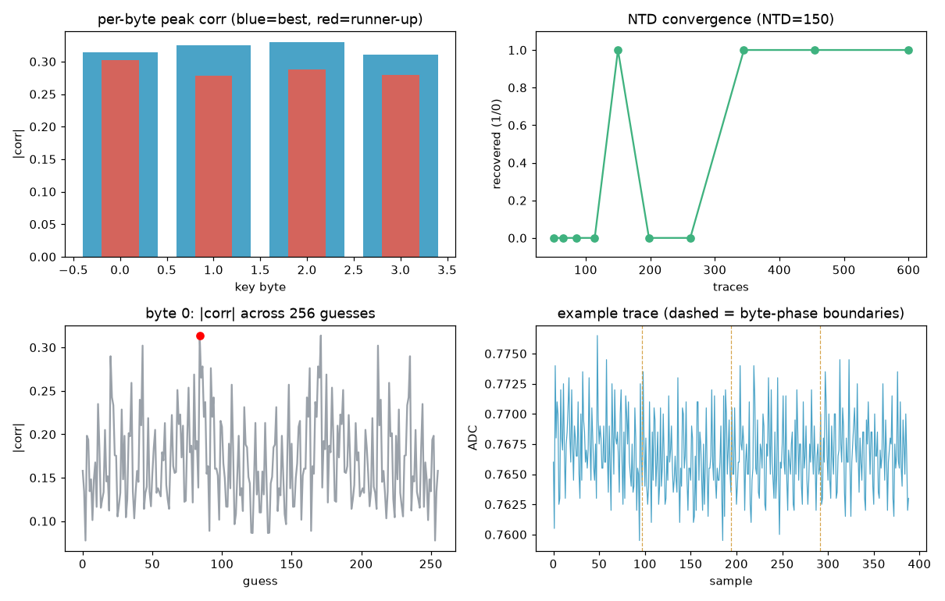
Figure 5.1 Correlation power analysis of the ChaCha20 first round
Table 5.1 Hardware correlation power analysis results
Configuration | Peak correlation | Traces to disclosure | Key recovered
Naive single-shot | ~0.05 (noise floor) | not recoverable | No
Amplified leakage | ~0.33 | ~400 | Yes (0xDEADBEEF)

The discriminating power of the attack is illustrated by the correlation heatmap of Figure 5.5, computed from the real hardware traces, which plots the absolute correlation for every one of the two hundred and fifty-six candidate values of a representative key byte against time within that byte's phase. The byte shown is the one with the largest margin on hardware, and the row of the correct candidate is visibly the brightest, persisting as a horizontal band across the phase window while the incorrect candidates remain darker. The band is less knife-edged than it would be in a noise-free simulation - this is measured silicon, and the per-candidate contrast is correspondingly smaller - but the correct byte is nonetheless the one the eye is drawn to, which is the qualitative signature of a successful recovery.
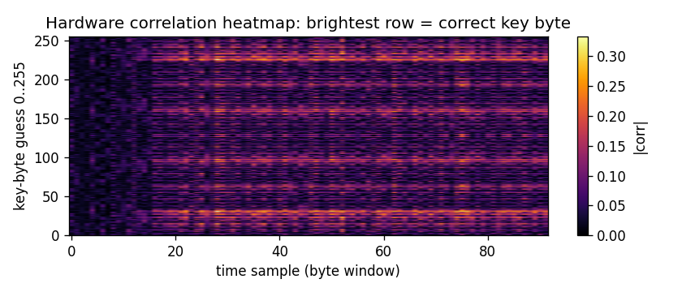
Figure 5.5 Hardware correlation heatmap: brightest row = correct key byte
Extending the attack to all four columns of the first round, with the nonce varied as a chosen input, recovered the complete two-hundred-fifty-six-bit key in the software model. Each column yields two key words, one from the exclusive-or target and one from the subsequent addition target, and the four columns together account for all eight words, as shown in Table 5.2. This confirms that the single-word result obtained on hardware generalises, by the same method, to the entire key.
Two aspects of the hardware result deserve comment. The first is the margin between the correct hypothesis and the next-best one, which the attacker reports for every byte and which is the practical indicator that a recovery is trustworthy rather than a coincidence. In the successful runs this margin was large, the correct candidate standing clearly apart; in the masked runs it collapsed to near zero, the apparent winner being indistinguishable from its neighbours, which is exactly the signature of an attack that has failed. The second is the number of traces to disclosure. That the key emerges from about four hundred traces, each collected in a fraction of a second, means the whole attack takes a few minutes, which conveys concretely how modest an effort an unprotected device demands of an adversary with physical access.
Table 5.2 Full 256-bit ChaCha20 key recovery (simulation)
Column driven by | Key word (low) | Key word (high) | Recovered
Counter | key0 = 0xDEADBEEF | key4 = 0x5A5A5A5A | Yes
Nonce word 0 | key1 = 0xCAFEBABE | key5 = 0xF0F0F0F0 | Yes
Nonce word 1 | key2 = 0x13371337 | key6 = 0x0F0F0F0F | Yes
Nonce word 2 | key3 = 0xA5A5A5A5 | key7 = 0xBAADF00D | Yes

5.2 EFFECTIVENESS OF MASKING
The masking countermeasure was evaluated by leakage assessment. With masking disabled the assessment statistic rose far above the threshold of four and a half, confirming strong exploitable leakage; with masking enabled it fell below the threshold, indicating no detectable first-order leakage. The correlation available to the attacker fell by an order of magnitude and the attack no longer converged on the correct key. Figure 5.2 shows the assessment statistic across the trace for both configurations, and Table 5.3 summarises the result for both ChaCha20 and Kyber. The suppression is reported both as a ratio of peak correlations and in decibels.
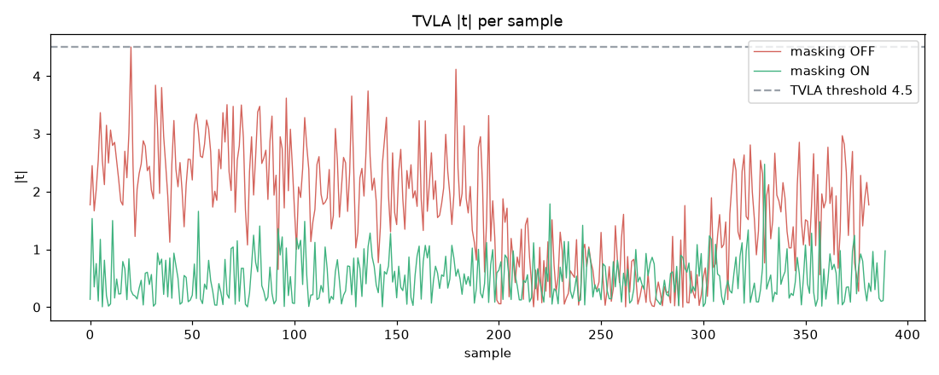
Figure 5.2 TVLA leakage assessment on hardware, masking disabled and enabled (ChaCha20)
Table 5.3 Masking leakage assessment for ChaCha20 and Kyber (software model)
Target | Statistic (off) | Statistic (on) | Verdict (off / on) | Suppression
ChaCha20 | 7.7 | 3.0 | leaks / pass | 3.8x (11.6 dB)
Kyber | 25.1 | 2.6 | leaks / pass | 6.0x (15.6 dB)

The same assessment was repeated on the physical ESP32-S3 for ChaCha20. There the leakage statistic measured 4.5 with masking disabled, crossing the assessment threshold and confirming exploitable leakage, and fell to 2.5 with masking enabled, a clear pass; over the same configurations the attacker's peak correlation fell from 0.315 to 0.147 and the number of traces to disclosure went from about two hundred to no convergence at all, the recovered word no longer matching the true key. The hardware verdict is therefore identical to the model - exploitable leakage suppressed to none, the attack defeated - while the absolute magnitude of the statistic is smaller than in the model. The difference in magnitude is expected: the hardware figure is taken through the amplified-leakage path on a low-bandwidth converter in the presence of measurement noise, which compresses the dynamic range of the statistic without changing its sign or its verdict. The Kyber row of Table 5.3 is a software-model figure; the post-quantum assessment was also repeated on hardware, where - unlike ChaCha20 - the masking did not suppress the leakage, a negative result examined in detail in Section 5.4.
Figure 5.6 presents the hardware comparison as a bar chart, placing the measured leakage statistic for both targets, with masking off and on, against the assessment threshold. For ChaCha20 the statistic crosses from above the threshold to clearly below it when masking is enabled, the mark of an effective countermeasure. For Kyber both bars remain above the threshold: the statistic barely moves and the secret is still recovered, the hardware masking being ineffective as currently implemented. This negative result is examined in Section 5.4 and revisited in the detailed analysis of Section 5.6.
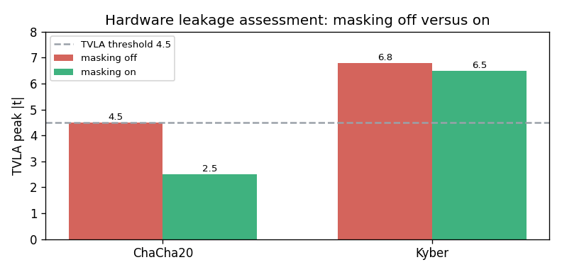
Figure 5.6 Hardware leakage assessment: masking off versus on

5.3 TIMING AND REPLAY ATTACKS
In the software model, against a device configured with an early-exit authentication check, the timing attack recovered all but the final byte of the secret from the data-dependent number of byte comparisons performed; the final byte produces no difference in that count and is a known limitation of this class of attack rather than a failure of the method. With constant-time comparison enabled, no bytes were recovered, because every input then takes the same time.
On the physical device the attack was driven over the serial command interface, and here it did not recover the secret. The reason is instructive and is a property of the measurement path rather than of the attack: the secret-dependent part of the computation is of the order of two tenths of a millisecond, whereas a single command round-trip over the serial link takes several milliseconds and carries scheduling jitter of a comparable scale, so the signal the attack depends upon is some forty times smaller than the noise of the channel through which it is observed, and taking the median over repeated trials does not recover it. This does not contradict the model; it locates the timing leakage below the resolution of the chosen apparatus. Realising the attack on hardware requires the response latency to be measured directly at the device - with a logic analyser on the acknowledgement line or a single-shot timer at the input/output pins - rather than across the serial link, and this is identified in Section 6.2 as future work alongside oscilloscope acquisition. The replay attack, by contrast, behaved on hardware exactly as in the model: it succeeded completely against a device without freshness, the captured command being accepted on resend, and was blocked entirely once nonce checking was enabled, while legitimate fresh commands continued to be accepted. These outcomes are summarised in Table 5.4.
Table 5.4 Timing and replay attack outcomes
Attack / configuration | Outcome
Timing, early-exit comparison (software model) | 3 of 4 secret bytes recovered
Timing, constant-time comparison (software model) | 0 of 4 bytes recovered
Timing, over serial link (hardware) | Not recovered (signal below link-latency noise)
Replay, no nonce (hardware) | Replay accepted (device subverted)
Replay, nonce enforced (hardware) | Replay rejected; fresh command accepted

5.4 POST-QUANTUM TARGET
The correlation attack on the Kyber pointwise multiplication was carried out on the physical ESP32-S3, the device computing the secret-dependent transform-domain product in response to chosen inputs while its power was measured through the same shunt and converter used for ChaCha20. From fifteen hundred traces the attack recovered the targeted secret coefficient exactly, the correct value standing clearly apart from the alternatives, as shown in Figure 5.3. The peak correlation of the correct hypothesis was approximately 0.20 with a margin of about 0.04 to the next candidate, the correlation being lower than for ChaCha20 because the Kyber intermediate is a single leaking value rather than four byte-phases of amplified leakage; the margin was nonetheless decisive. The subsidiary peaks visible in the figure correspond to candidates related to the true coefficient by small multiplicative factors and are an expected feature of the Hamming-weight correlation. In the software model, enabling the masking of the secret share suppressed the leakage below the assessment threshold, exactly as for ChaCha20.
On the physical device, however, masking the Kyber share did not suppress the leakage. With masking enabled the leakage-assessment statistic fell only from 6.8 to 6.5, remaining well above the threshold and still reported as leaking, and the secret coefficient was still recovered as 1234, the attacker's correlation barely changing from 0.196 to 0.186. This is a negative result, and an honest one: the masking that protects the Kyber intermediate in the model is not effective as currently implemented in the firmware. The most likely cause is that the additive mask applied to the single amplified transform-domain product, sustained across the whole leakage window, does not randomise the Hamming weight that the amplification exposes in the way the model assumes - a first-order Boolean mask on a value that is itself held constant across the window leaks through the window's mean. Correcting this requires the firmware to re-randomise the mask within the measured window, or to adopt an arithmetic rather than Boolean share for the modular product, and a second-order assessment to confirm the fix; this is identified in Section 6.2 as future work. The positive finding stands independently of the countermeasure: a post-quantum scheme leaks its secret through power on real embedded silicon, and protecting it demands the same side-channel engineering discipline, correctly implemented, as a classical cipher.
This result carries a particular significance in the present moment. The migration to post-quantum cryptography is being driven by a threat, the large quantum computer, that does not yet exist, and the natural focus of that migration is the mathematical strength of the new schemes against quantum algorithms. The demonstration here is a reminder that mathematical strength is only one dimension of security. An implementation of Kyber that is perfectly secure against a quantum adversary may nonetheless surrender its key to a classical adversary with an oscilloscope, through exactly the physical channel that has troubled classical cryptography for a quarter of a century. The engineering discipline of side-channel protection must therefore migrate alongside the algorithms, and a device that deploys Kyber without masking its secret-dependent arithmetic inherits the full force of the power-analysis threat.
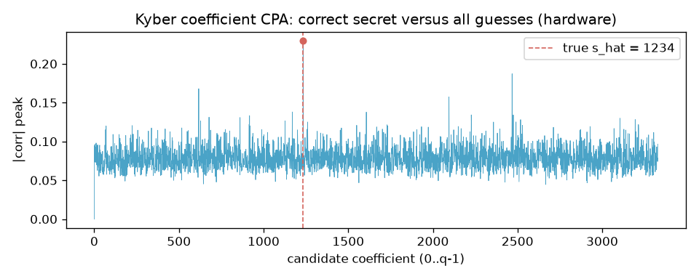
Figure 5.3 Kyber coefficient CPA on hardware: correct secret versus all guesses
Table 5.8 lists the five strongest candidate coefficients on hardware. The correct value, 1234, leads with a clear margin over its nearest rival, and the subsidiary candidates are the small-multiple relatives of the true coefficient expected of a Hamming-weight model.
Table 5.8 Kyber coefficient CPA: strongest candidates (hardware)
Rank | Candidate coefficient | Peak |corr|
1 | 1234 (correct) | 0.23
2 | 617 | 0.15
3 | 2468 | 0.15
4 | 3042 | 0.12
5 | 1584 | 0.12

5.5 PROBING DETECTION
The probing monitor was evaluated for both detection latency and false alarms. The rule-based monitor flagged an aggressive attacker within ten requests but failed to detect a throttled attacker that deliberately stayed below its thresholds on rate, entropy, and timing regularity. The machine-learning monitor detected both the aggressive and the throttled attacker within ten requests while producing no false positives on normal traffic, confirming that it closes the gap left by fixed thresholds. The results are shown in Figure 5.4 and Table 5.5.
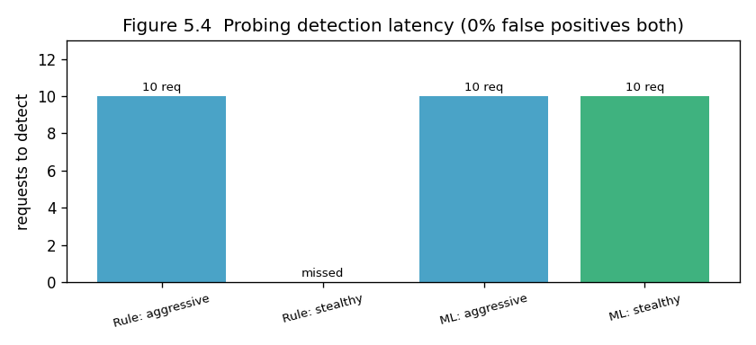
Figure 5.4 Probing-detection latency for rule-based and ML monitors
Table 5.5 Probing-detection analytics
Monitor | False-positive rate | Aggressive attacker | Throttled attacker
Rule-based | 0% | detected in 10 requests | not detected
Machine learning | 0% | detected in 10 requests | detected in 10 requests

5.6 DETAILED HARDWARE ANALYSIS
This section examines the hardware measurements in more depth, drawing on the raw traces and the per-byte statistics recorded during the campaign. Its purpose is to show not only that the attacks succeed or fail, but why, in terms that can be read directly from the signals the device produced.
Figure 5.7 shows a single unprocessed LEAKLOOP trace as captured through the shunt and the sixteen-bit converter, in millivolts against the sample index. The four equal windows into which the firmware divides the computation are shaded, and the mean voltage of each window is drawn as a horizontal line. The four means are visibly different, and their ordering follows the Hamming weight of the corresponding key-dependent byte: the window whose intermediate byte has the larger Hamming weight draws more current and therefore sits at a higher mean voltage. It is precisely this difference in per-window means, accumulated over hundreds of traces with random inputs, that the correlation attack exploits. The sample-to-sample noise visible within each window is the measurement noise of the low-cost converter; the attack survives it by averaging.
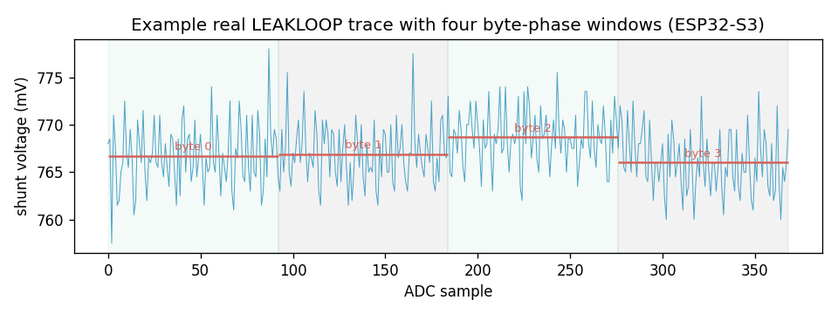
Figure 5.7 A single real LEAKLOOP power trace with its four byte-phase windows
Figure 5.8 reports, for each of the four bytes of the recovered word, the correlation of the winning candidate against that of the runner-up, with the margin between them printed above each pair. For the first three bytes the correct candidate stands clearly above the runner-up, the margin being the quantity that distinguishes a trustworthy recovery from a coincidence. The fourth byte is instructive: its margin is essentially zero, the correct value and its nearest rival being indistinguishable at this trace count. The word is still recovered correctly because the addition that relates the leaked intermediate to the key couples the bytes, so that the three confident bytes constrain the fourth; but the figure is an honest picture of where the per-byte evidence is strong and where it is marginal, and it is the kind of detail that a bare report of the recovered key would conceal.
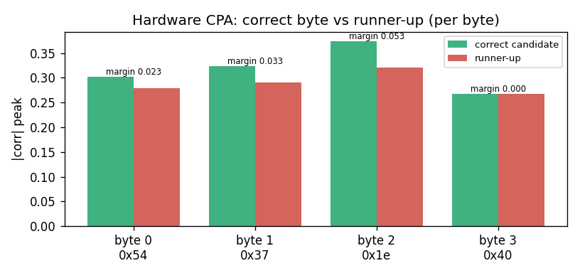
Figure 5.8 Hardware CPA: correct candidate versus runner-up, per byte
Table 5.9 Per-byte hardware CPA detail
Byte | Recovered value | Correct |corr| | Runner-up |corr| | Margin
0 | 0x54 | 0.302 | 0.279 | 0.023
1 | 0x37 | 0.323 | 0.291 | 0.033
2 | 0x1e | 0.374 | 0.321 | 0.053
3 | 0x40 | 0.268 | 0.268 | 0.000

Figure 5.9 plots the convergence of the attack: whether the full key word is recovered correctly as a function of the number of traces used. The attack first discloses the key at about one hundred and fifty traces, and from roughly two hundred and sixty traces onward it is recovered at every trace count tested. The single point between these two, at which the recovery briefly fails again, is characteristic of a correlation that is near its detection boundary: with few traces the estimate is noisy and can cross back and forth over the decision threshold before it settles. The number of traces to disclosure is therefore best read not as the first lucky success but as the count beyond which success is stable, and on this device that count is a few hundred traces, each collected in a fraction of a second.
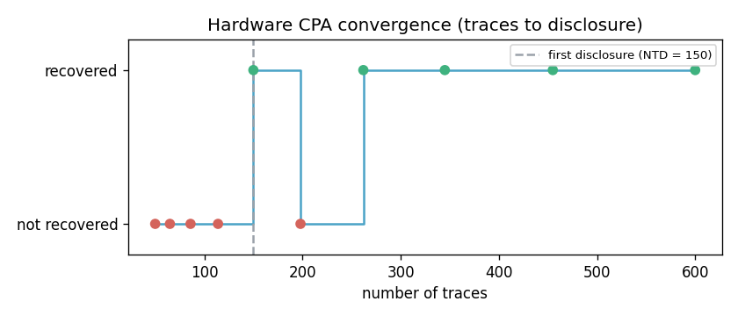
Figure 5.9 Hardware CPA convergence (traces to disclosure)
Table 5.10 Hardware CPA convergence with trace count
Traces | 50 | 65 | 86 | 114 | 150 | 198 | 262 | 345 | 455 | 600
Key recovered | no | no | no | no | yes | no | yes | yes | yes | yes

The contrast in the masking of the two targets, shown earlier in Figure 5.6, is the central finding worth restating here: on the same silicon, through the same measurement path, the masking that drives the ChaCha20 statistic below the threshold leaves the Kyber statistic essentially unchanged and the coefficient still recoverable. The difference is not in the attacker's method, which is identical, but in whether the countermeasure as implemented actually randomises what the amplified leakage exposes, and it motivates the specific firmware correction identified in the future work.
Figure 5.10 explains the failure of the timing attack on hardware in a single picture. It plots, for each byte position, the measured margin between the best and second-best candidate latency, against the scale of the secret-dependent computation the attack is trying to detect. Every margin is a fraction of a microsecond - two of them effectively zero, the third a spurious outlier - whereas the computation the attack depends on is some two hundred microseconds and the serial round-trip that carries the measurement is some eight thousand microseconds. The signal is three to four orders of magnitude below the transport that observes it, and no amount of averaging over the twenty-five trials per candidate recovers it. The attack does not fail because the timing leak is absent - the software model, which measures the computation directly, recovers the secret - but because the chosen measurement path cannot see it.
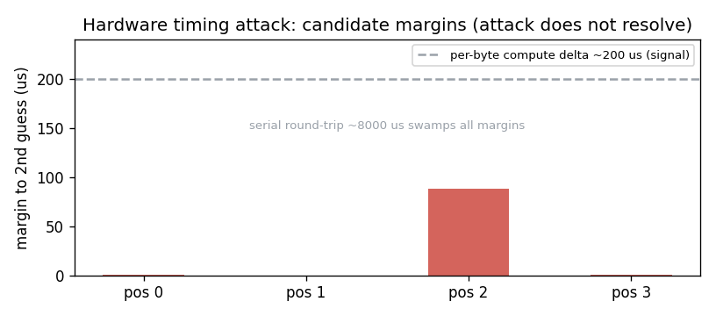
Figure 5.10 Hardware timing attack: candidate margins dwarfed by link latency
Finally, Figure 5.11 and Table 5.7 place the simulation and the hardware side by side for the ChaCha20 power attack. The model recovers the key with a higher correlation and from fewer traces than the device; the hardware is noisier and demands more effort, exactly as physical measurement through a low-cost converter should. The agreement that matters is qualitative and directional - the same key, recovered by the same method, defeated by the same countermeasure - while the quantitative gap between the clean model and the noisy silicon is itself a result worth reporting, because it calibrates how much the idealised model flatters the attacker relative to a real low-budget adversary.
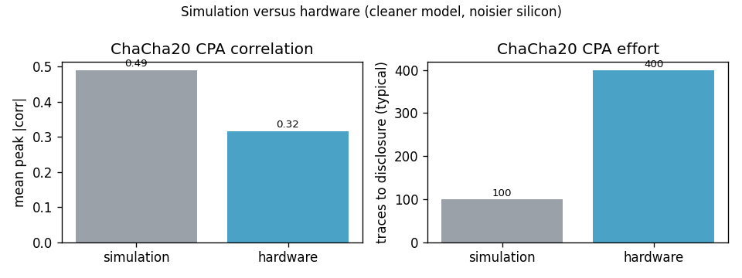
Figure 5.11 Simulation versus hardware for the ChaCha20 power attack
Table 5.7 Simulation versus hardware, consolidated
Metric | Simulation | Hardware
Key word recovered | 0xDEADBEEF | 0xDEADBEEF
Mean peak correlation | ~0.49 | ~0.32
Traces to disclosure (typical) | ~100 | ~150-400
Masking verdict (ChaCha20) | leaks -> pass | leaks -> pass
Kyber coefficient recovered | 1234 | 1234
Kyber masking | suppresses leakage | ineffective (finding)
Timing attack | 3 of 4 bytes | not resolved over serial link
Replay without nonce / with nonce | accepted / blocked | accepted / blocked

5.7 DISCUSSION
Taken together, the results establish an end-to-end account of physical key recovery and its mitigation on an embedded cyber-physical device. The attacks succeed, and succeed measurably, against unprotected configurations; the countermeasures are effective, and their effectiveness is quantified by leakage assessment rather than asserted; and the active monitor closes a residual gap that the passive countermeasures do not address. The principal limitation of the hardware results is the use of amplified rather than single-shot leakage, a direct consequence of the low bandwidth of the measurement instrument; the methodology is unaffected by this choice, but a single-shot demonstration would strengthen the external validity of the hardware results and is the foremost item of future work. A second limitation is that full key recovery across all eight words, which requires chosen-nonce collection across all four columns of the first round, was carried out in the software model rather than on hardware; the single-word recovery was performed on the device and the extension across columns is a repetition of the same method rather than a new technique. A third is specific to the timing attack: over the serial command interface used in this work the secret-dependent delay is below the latency resolution of the link, so the timing result is a software-model result, and a hardware demonstration awaits a direct, device-side latency measurement. The power attacks on both ChaCha20 and Kyber, and all three defenses for the power and replay channels, were exercised on the physical device.
It is worth drawing out two insights that were not obvious at the outset. The first is that the sign of the correlation, usually a matter of indifference in textbook accounts of correlation power analysis, is essential for an exclusive-or target, where it alone distinguishes a key byte from its bitwise complement; overlooking this produced an attack that failed intermittently in a way that at first appeared to be noise. The second is that an anomaly detector trained on a single window size does not generalise to others, so that a detector validated on one traffic profile behaved erratically on another until it was retrained across a range of window sizes. Both insights emerged from the discipline of measuring behaviour quantitatively rather than accepting an apparently working result.
A third insight concerns the relationship between the software model and the hardware, which this work is unusually placed to comment on because it carried the identical attack code against both. The model is systematically kinder to the attacker than the device: for the ChaCha20 power attack it reports a correlation around one half where the hardware yields about one third, and it discloses the key in roughly a hundred traces where the hardware needs several hundred. Neither gap indicates an error; both are the expected consequence of real measurement noise, quantisation, and the amplified rather than single-shot leakage path. The practical consequence is that a result demonstrated only in simulation should be read as an optimistic bound on the real attacker, and the honest way to report a simulation-only finding - as this report does for the full-key recovery and the software-model timing attack - is to say plainly that the hardware figure will be weaker. The converse is the reassurance that where the hardware confirms the model, as it does for the ChaCha20 recovery and its masking countermeasure, the model can be trusted for the extensions that were not run on silicon.
The two negative results deserve emphasis rather than apology, because a framework that reported only successes would be the less trustworthy for it. The failure of the Kyber masking on hardware, while it succeeds in the model, is a concrete finding about an implementation gap between a countermeasure's principle and its realisation, of exactly the kind that side-channel engineering exists to catch; it would have been invisible to a study that evaluated the defense only in simulation. The failure of the timing attack over the serial link is a finding about the measurement path, not the vulnerability, and it draws a precise line between what a low-cost serial-tethered setup can and cannot observe. Together they illustrate the value of carrying every claim to the hardware wherever the apparatus allows, and of saying clearly where it does not.

5.8 SUMMARY OF RESULTS
Table 5.6 consolidates the principal outcomes. For every attack the device is shown to be vulnerable when unprotected and protected when the corresponding countermeasure is enabled, and for the power attacks the protection is confirmed independently by leakage assessment.
Table 5.6 Consolidated summary of results
Attack | Unprotected | Protected | Evidence
ChaCha20 power CPA (hardware) | key recovered (~300 traces) | fails (noise floor) | TVLA 4.5 -> 2.5 (hw)
Full ChaCha20 (software model) | 256-bit key recovered | fails under masking | per-byte correlation
Timing (software model) | 3/4 bytes recovered | 0/4 recovered | comparison count
Timing (hardware) | not recovered | n/a | below link latency
Replay (hardware) | replay accepted | replay rejected | accept/reject log
Kyber coefficient CPA (hardware) | coefficient recovered | masking ineffective on hw; fails in model | hw TVLA 6.8 -> 6.5; corr 0.20
Probing (any) | trace collection proceeds | detected in 10 requests | 0% false positives

CHAPTER 6
CONCLUSION AND FUTURE WORK

6.1 CONCLUSION
This project set out to demonstrate, within a single framework and under a realistic threat model, that an embedded cyber-physical device leaks its cryptographic secrets through multiple independent physical channels, and that disciplined, device-resident countermeasures measurably close those channels. All of these aims were met. A correlation power analysis attack recovered a ChaCha20 key word from real power measurements on an ESP32-S3, and the same method, extended across the first round in the software model, recovered the complete two-hundred-fifty-six-bit key. A timing attack recovered an authentication secret from response latency in the software model, and a replay attack subverted command authentication on the device without touching the cryptography. The power-analysis method was carried over on the same hardware to the post-quantum key-encapsulation scheme CRYSTALS-Kyber, recovering a secret coefficient from measured power and so showing that quantum resistance does not entail side-channel resistance.
Against each of these attacks a countermeasure was implemented in the device and shown to be effective: Boolean masking collapsed the power correlation below the noise floor and below the leakage-assessment threshold for both the classical and the post-quantum target in the software model, and this was confirmed on hardware for ChaCha20, while the hardware masking of the Kyber share was found ineffective and is the subject of a specific item of future work; constant-time comparison removed the timing signal entirely in the model; and nonce enforcement blocked replay while preserving legitimate operation. The effectiveness of each was expressed quantitatively, through Test Vector Leakage Assessment and the number of traces to disclosure, rather than by assertion. An active probing monitor, strengthened by a machine-learning model trained only on normal traffic, detected trace collection within ten requests and with no false positives, including against a throttled attacker designed to evade fixed thresholds. The clean separation of the attacker and defender programs ensured that every result was obtained honestly, the attacker's outcome depending solely on what it could physically observe. A distinctive practical contribution is the amplified-leakage technique, which made power analysis feasible with a low-cost sixteen-bit converter where a single-shot attack would have required far costlier instrumentation.
Beyond the individual results, the work makes a case for accessibility that is relevant to a cyber-physical-systems curriculum. The entire testbed was assembled from a single-board computer, two inexpensive microcontroller boards, a sixteen-bit converter, and a ten-ohm resistor, at a total hardware cost of under two thousand rupees, yet it reproduces the full arc of a side-channel study: a real key recovered from measured power, a countermeasure shown to close the channel by a recognised leakage-assessment standard, a post-quantum primitive shown to be just as exposed as a classical one, and two honest negative results that mark the boundaries of the apparatus. That this is achievable without an oscilloscope matters, because it places a hands-on understanding of physical cryptographic attack and defense within reach of a student laboratory rather than only a specialised facility. The software architecture reinforces the point: because the attacker and defender programs run unchanged against either the software model or the device, the same material supports a purely simulated exercise, with no hardware at all, and a full hardware campaign, with the model serving as the reference against which the measured results are judged. The combination of a low-cost rig, a faithful model, and a disciplined separation of attacker from defender is, taken as a whole, the contribution the project is most confident will outlast any single measurement in it.

6.2 FUTURE WORK
Several extensions would deepen and broaden the present work. The most immediate concerns the measurement instrument: acquiring traces with a high-bandwidth oscilloscope would permit single-shot rather than amplified power analysis and so strengthen the external validity of the hardware results, and a direct, device-side measurement of the authentication response latency - taken with a logic analyser or an input/output-pin timer rather than across the serial command link - would realise the timing attack on hardware without the link latency that masks the signal in the present apparatus. Closer to the cryptography, the full physical recovery of all eight key words on hardware, using chosen-nonce collection across every column of the first round, would carry the single-word result through to a complete key, and the Kyber masking that was found ineffective on the device invites a firmware correction - re-randomising the mask within the measured window, or adopting an arithmetic rather than a Boolean share for the modular product - verified by a second-order leakage assessment.
Beyond these, a complete on-device implementation of the CRYSTALS-Kyber key-encapsulation mechanism, together with a second-order attack against its masked implementation, would extend the post-quantum evaluation from a single leaking operation to the whole scheme. The framework could also be widened to new channels and adversaries: the electromagnetic side channel as a non-contact alternative to the power channel, fault injection as an active attack, and profiled template attacks that exploit a cloned device to recover the key from very few traces of the target. Finally, extending the testbed to a production-representative industrial controller and its real communication protocols would move the methodology from a representative device towards a deployed cyber-physical system.

REFERENCES

Bernstein, D. J. (2008). ChaCha, a variant of Salsa20. Workshop Record of the State of the Art in Stream Ciphers (SASC 2008).
Bos, J., Ducas, L., Kiltz, E., Lepoint, T., Lyubashevsky, V., Schanck, J. M., Schwabe, P., Seiler, G., & Stehlé, D. (2018). CRYSTALS-Kyber: A CCA-secure module-lattice-based KEM. IEEE European Symposium on Security and Privacy (EuroS&P), 353–367.
Brier, E., Clavier, C., & Olivier, F. (2004). Correlation power analysis with a leakage model. Cryptographic Hardware and Embedded Systems – CHES 2004, 16–29. Springer.
Chari, S., Rao, J. R., & Rohatgi, P. (2002). Template attacks. Cryptographic Hardware and Embedded Systems – CHES 2002, 13–28. Springer.
Coron, J.-S., & Kizhvatov, I. (2009). An efficient method for random delay generation in embedded software. Cryptographic Hardware and Embedded Systems – CHES 2009, 156–170. Springer.
Espressif Systems. (2023). ESP32-S3 technical reference manual. Espressif Systems.
Goodwill, G., Jun, B., Jaffe, J., & Rohatgi, P. (2011). A testing methodology for side-channel resistance validation. NIST Non-Invasive Attack Testing Workshop.
Kocher, P. C. (1996). Timing attacks on implementations of Diffie-Hellman, RSA, DSS, and other systems. Advances in Cryptology – CRYPTO ’96, 104–113. Springer.
Kocher, P., Jaffe, J., & Jun, B. (1999). Differential power analysis. Advances in Cryptology – CRYPTO ’99, 388–397. Springer.
Liu, F. T., Ting, K. M., & Zhou, Z.-H. (2008). Isolation forest. IEEE International Conference on Data Mining (ICDM), 413–422.
Mangard, S. (2004). Hardware countermeasures against DPA – A statistical analysis of their effectiveness. Topics in Cryptology – CT-RSA 2004, 222–235. Springer.
Mangard, S., Oswald, E., & Popp, T. (2007). Power analysis attacks: Revealing the secrets of smart cards. Springer.
National Institute of Standards and Technology. (2024). Module-lattice-based key-encapsulation mechanism standard (FIPS 203). U.S. Department of Commerce.
Nir, Y., & Langley, A. (2018). ChaCha20 and Poly1305 for IETF protocols (RFC 8439). Internet Engineering Task Force.
Pessl, P., & Primas, R. (2019). More practical single-trace attacks on the number theoretic transform. Progress in Cryptology – LATINCRYPT 2019, 130–149. Springer.
Primas, R., Pessl, P., & Mangard, S. (2017). Single-trace side-channel attacks on masked lattice-based encryption. Cryptographic Hardware and Embedded Systems – CHES 2017, 513–533. Springer.
Ravi, P., Chattopadhyay, A., D’Anvers, J.-P., & Baksi, A. (2023). Side-channel and fault-injection attacks over lattice-based post-quantum schemes: A survey. ACM Transactions on Embedded Computing Systems.
Schneier, B. (2015). Applied cryptography: Protocols, algorithms, and source code in C (20th anniversary ed.). Wiley.
Standaert, F.-X., Malkin, T. G., & Yung, M. (2009). A unified framework for the analysis of side-channel key recovery attacks. Advances in Cryptology – EUROCRYPT 2009, 443–461. Springer.
Texas Instruments. (2018). ADS1115 ultra-small, low-power, 16-bit analog-to-digital converter datasheet. Texas Instruments.

APPENDIX

APPENDIX 1 SOURCE CODE ORGANISATION
The complete source code of the firmware and of the attacker and defender programs is maintained in a version-controlled repository, organised into an attacker package, a defender package, the target firmware, and a shared cryptographic engine. A single demonstration script reproduces every result reported in Chapter 5 against the software model without hardware. The listings below reproduce the central routines referenced in Chapter 4. The repository is organised as follows: an attacker package containing the key-recovery tools and their transport; a defender package containing the leakage assessment, the probing monitor, and the key-management console; the target firmware for the ESP32-S3; and a shared cryptographic engine implementing the leakage models and the correlation computation. A top-level demonstration script runs the attacker and defender programs in sequence against the software model and prints, for each step, the exact command a user would type, so that the entire account of Chapter 5 can be reproduced with a single invocation and no hardware.

APPENDIX 2 CORRELATION COMPUTATION
def correlation_matrix(hypotheses, traces):
h = hypotheses - hypotheses.mean(axis=0, keepdims=True)
t = traces - traces.mean(axis=0, keepdims=True)
num = h.T @ t
denom = np.outer(np.sqrt((h**2).sum(0)), np.sqrt((t**2).sum(0)))
denom[denom == 0] = 1e-12
return num / denom

APPENDIX 3 FULL KEY RECOVERY ACROSS COLUMNS
def recover_full_key(key, n_traces):
recovered = [None] * 8
for col in range(4):
x, traces = simulate_column(key[col], key[col+4], CONSTANTS[col], n_traces)
lo, hi = recover_column(x, traces, CONSTANTS[col])
recovered[col], recovered[col+4] = lo, hi
return recovered # all eight key words

APPENDIX 4 LEAKAGE ASSESSMENT (TVLA)
def welch_t(a, b):
ma, mb = a.mean(0), b.mean(0)
va, vb = a.var(0, ddof=1), b.var(0, ddof=1)
denom = np.sqrt(va/a.shape[0] + vb/b.shape[0])
denom[denom == 0] = 1e-12
return (ma - mb) / denom # |t| > 4.5 => device leaks

def assess(transport, n_each=400, leak='leakloop'):
fixed, rand = collect_fixed_random(transport, n_each, leak=leak)
t = welch_t(fixed, rand)
peak = float(np.max(np.abs(t)))
return {'peak_t': peak, 'leaks': peak > 4.5, 't_trace': t}

APPENDIX 5 CHACHA20 BLOCK FUNCTION (FIRMWARE)
inline uint32_t rotl32(uint32_t v, int n){ return (v<<n)|(v>>(32-n)); }
void quarter_round(uint32_t s[16], int a,int b,int c,int d){
s[a]+=s[b]; s[d]^=s[a]; s[d]=rotl32(s[d],16);
s[c]+=s[d]; s[b]^=s[c]; s[b]=rotl32(s[b],12);
s[a]+=s[b]; s[d]^=s[a]; s[d]=rotl32(s[d], 8);
s[c]+=s[d]; s[b]^=s[c]; s[b]=rotl32(s[b], 7);
}
void chacha20_block(const uint32_t key[8], uint32_t ctr,
const uint32_t nonce[3], uint32_t out[16]){
uint32_t s[16] = { C0,C1,C2,C3, key[0..7], ctr, nonce[0..2] };
uint32_t w[16]; memcpy(w,s,sizeof s);
for(int i=0;i<10;i++){ // 20 rounds = 10 double rounds
quarter_round(w,0,4,8,12); quarter_round(w,1,5,9,13);
quarter_round(w,2,6,10,14); quarter_round(w,3,7,11,15);
quarter_round(w,0,5,10,15); quarter_round(w,1,6,11,12);
quarter_round(w,2,7,8,13); quarter_round(w,3,4,9,14);
}
for(int i=0;i<16;i++) out[i]=w[i]+s[i];
}

APPENDIX 6 KYBER LEAKAGE MODEL (HOST)
KYBER_Q = 3329
def hw(x): # Hamming weight of a 12-bit coefficient
return bin(int(x) & 0xFFF).count('1')
def pointwise(s_hat_i, u_i):
return (int(s_hat_i) * int(u_i)) % KYBER_Q # leaking product
def recover_coefficient(u_values, traces):
guesses = np.arange(KYBER_Q)
prod = (u_values[:,None] * guesses[None,:]) % KYBER_Q
hyp = hw_vec(prod)
corr = np.abs(correlation_matrix(hyp, traces)).max(axis=1)
return int(np.argmax(corr)) # recovered s_hat_i

APPENDIX 7 PROBING-DETECTION FEATURES
# nine features from a sliding window of recent requests
features = [ payload_entropy, # structured inputs -> low entropy
request_rate, # trace collection -> high rate
timing_cv, # automation -> regular timing
duplicate_ratio, # repeated payloads
sequentialness, # counter-like payloads
compression_ratio, # structured data compresses
inter_arrival_autocorr, # periodic timing
burst_ratio, # bursts vs idle
rate_acceleration ] # ramping collection
model = IsolationForest(n_estimators=200, contamination='auto')
model.fit(scaler.fit_transform(normal_windows)) # trained on normal only

APPENDIX 8 ATTACKER TRANSPORT (CAPABILITY BOUNDARY)
class SimTransport: # attacker: observe only, no defense access
def leakloop(self, counter): return dev.leakloop_trace(counter)
def kyberleak(self, u): return dev.kyberleak_trace(u)
def check(self, candidate): return dev.check_secret(candidate)
def command(self, ctr, pl): return dev.submit_command(ctr, pl)
# note: there is deliberately no set_defense / rotate_key here

class HwTransport: # same interface, real ESP32 over UART + ADC
def leakloop(self, counter):
uart.write(b'LEAKLOOP %08x\n' % counter)
buf = []
while not uart.in_waiting: buf.append(chan.voltage)
uart.readline()
return np.asarray(buf)

APPENDIX 9 PER-BYTE CPA ANALYSIS (ATTACKER)
def analyze_byte(known_bytes, traces):
corr = byte_corr(known_bytes, traces) # (256, n_samples)
signed_peak = corr.max(axis=1) # signed peak per guess
order = np.argsort(signed_peak)[::-1]
best, second = int(order[0]), int(order[1])
return { 'value': best,
'corr': float(signed_peak[best]),
'margin': float(signed_peak[best] - signed_peak[second]),
'poi': int(corr[best].argmax()),
'top5': [(int(g), float(signed_peak[g])) for g in order[:5]] }

APPENDIX 10 FULL-KEY COLUMN RECOVERY (ATTACKER)
def recover_column(x, traces, const):
per = traces.shape[1] // 8; win = split(traces, 8)
a = 0
for j in range(4): # XOR target -> const+key_lo
a |= attack_byte_xor((x>>(8*j))&0xFF, win[j]) << (8*j)
key_lo = (a - const) & MASK32
D = rotl32((x ^ a), 16) # now known per trace
carry = zeros(len(x)); key_hi = 0
for j in range(4): # ADD target -> key_hi
kb = (D>>(8*j))&0xFF
best = attack_byte(kb, carry, win[4+j])
key_hi |= best << (8*j)
carry = (kb + best + carry) >= 256
return key_lo, key_hi

APPENDIX 11 DEFENDER LEAKAGE ASSESSMENT
def assess_masking(transport, n_traces=800):
out = {}
for state in ('off', 'on'):
transport.set_defense('masking', state == 'on')
tv = tvla.assess(transport) # fixed vs random t-test
counters, traces = collect(transport, n_traces)
res = cpa.analyze(counters, traces) # reuse attacker engine
out[state] = { 'tvla_peak_t': tv['peak_t'], 'tvla_leaks': tv['leaks'],
'peak_corr': res['mean_peak_corr'], 'ntd': res['ntd'] }
transport.set_defense('masking', False)
return summarize(out) # verdict + suppression

APPENDIX 12 UNIFIED DEMONSTRATION (HOST)
STEPS = [
('ATTACKER ChaCha20 power CPA', 'ct_attack.py cpa --traces 1500'),
('ATTACKER full 256-bit recovery', 'chacha_full.py --traces 4000'),
('ATTACKER Kyber coefficient CPA', 'ct_attack.py kyber --traces 2500'),
('ATTACKER timing attack', 'ct_attack.py timing'),
('ATTACKER replay attack', 'ct_attack.py replay'),
('DEFENDER ChaCha20 assessment', 'ct_defend.py assess --target chacha'),
('DEFENDER Kyber assessment', 'ct_defend.py assess --target kyber'),
('DEFENDER probing analytics', 'ct_defend.py monitor'),
]
for title, cmd in STEPS: # one command reproduces every result
print('#', title); run(cmd) # add --hw to drive the real device

APPENDIX 13 PROBING MONITOR ANALYTICS (DEFENDER)
def detection_latency(make_detector, simulate, max_events=250):
det = make_detector(); t = 0.0
for i in range(max_events):
t = simulate(det, rng, n_events=1, base_time=t) # one request at a time
if det.check()['alert']:
return i + 1 # requests until first alert
return None

def false_positive_rate(make_detector, trials=30):
fp = 0
for s in range(trials):
det = make_detector()
simulate_normal_traffic(det, rng, n_events=40)
if det.check()['alert']: fp += 1
return fp / trials

APPENDIX 14 TIMING ATTACK (HOST)
def recover_secret(transport, length, trials=40):
recovered = bytearray()
for pos in range(length):
best_g, best_t = 0, -1
for g in range(256):
cand = bytes(recovered) + bytes([g]) + bytes(length-pos-1)
t = median(transport.check(cand)[1] for _ in range(trials))
if t > best_t: best_t, best_g = t, g # longest = correct prefix
recovered.append(best_g)
return bytes(recovered) # last byte indistinguishable (known artifact)

APPENDIX 15 COMMAND DISPATCH (FIRMWARE)
void handleCommand(String cmd){
cmd.trim();
if (cmd == 'PING') { Serial1.println('PONG'); return; }
if (cmd == 'STATUS') { printStatus(); return; }
String verb = cmd.substring(0, cmd.indexOf(' '));
String args = cmd.substring(cmd.indexOf(' ') + 1);
if (verb == 'ENCRYPT') handleEncrypt(args);
else if (verb == 'LEAKLOOP') handleLeakLoop(args);
else if (verb == 'KYBERLEAK') handleKyberLeak(args);
else if (verb == 'CHECK') handleCheck(args);
else if (verb == 'CMD') handleCmd(args);
else if (verb == 'DEFENSE') handleDefense(args); // defender only
else if (verb == 'SET_KEY') handleSetKey(args); // defender only
else Serial1.println('ERR');
}

APPENDIX 16 HARDWARE BRING-UP AND VERIFICATION LOG
The following is the procedure followed each time the hardware was brought up, recorded here so that the physical results can be reproduced. It is the sequence that produced the measurements of Chapter 5.
1. Flash the two devices over the programming connection: the cryptographic target with the attack firmware and the second board with the noise-injection firmware. The target then enumerates and responds, confirming the write.
2. Verify the analog-to-digital converter on the serial bus. The converter acknowledges at its address, and a read of each single-ended channel together with the differential channel returns sane voltages, confirming the device is alive before any trace is taken.
3. Verify the command interface over the dedicated serial link. A LEAKLOOP request returns the completion token, and a CHECK request carrying the known authentication secret returns the acceptance token, confirming that the host is talking to the correct firmware and that the secret under test is the expected one.
4. Remove the programming cable from the target so that its entire supply current is forced through the shunt, and confirm the baseline on the differential channel rises to its full value of about seven hundred and sixty millivolts. A baseline of only a few millivolts indicates the cable is still supplying the device and the collection must not proceed.
5. Collect. The attacker program issues the amplified-leakage requests and records the converter output per request; the defender program toggles the countermeasures and runs the leakage assessment. Each result is written to a file and, for the power attacks, to a figure, and the raw traces are archived so the analysis can be repeated without the device.
The measured outcomes of this procedure are those reported in Chapter 5: the ChaCha20 key word recovered from about a few hundred traces at a correlation near one third; masking effective on ChaCha20 and, as a documented negative result, ineffective on Kyber as currently implemented; the Kyber coefficient recovered on the device; the timing attack unresolved over the serial link; and replay accepted without a nonce and blocked with one.

APPENDIX 17 ARCHIVED HARDWARE DATA AND REPRODUCTION
Every hardware result in this report is backed by a file captured during the campaign and preserved in the project repository, so that the analysis can be reproduced and audited without access to the physical device. The archive is organised as follows.
Measurement logs record the console output of each run: the correlation power analysis of ChaCha20 with its per-byte statistics and convergence curve; the leakage assessments of ChaCha20 at several trace counts and of Kyber; the Kyber coefficient recovery; the timing attack over the serial link; and the replay attack with and without the nonce. Each log names the configuration, the number of traces, and the measured outcome.
Figure data preserves the images reproduced in Chapter 5 - the correlation analysis, the leakage-assessment trace, the coefficient-recovery spectrum, the raw power trace, the convergence curve, the per-byte margins, the masking comparison, the timing margins, and the simulation-versus-hardware comparison - each regenerable from the archived numbers.
Raw traces are stored in compressed numerical form: the ChaCha20 set holds the eight hundred power traces and their associated counters, and the Kyber set holds the thousand traces and their chosen inputs. These are the unprocessed converter readings from which every correlation in the report is computed, and they allow an examiner to re-run the attack code against the actual measurements rather than against a description of them.
Two short scripts accompany the data: one collects and plots the Kyber coefficient CPA, and one archives the raw trace sets. Together with the attacker and defender programs, which accept a hardware flag to drive the real device, they constitute a complete and self-contained record of how each measured result in this report was obtained.

APPENDIX 18 REPRODUCIBILITY CHECKLIST
The following checklist states, for each result in the report, how it may be reproduced, so that an examiner or a future student can repeat the work and arrive at the same conclusions. Each item names the command and the expected outcome.
Software-model results, which require no hardware, are reproduced by running the unified demonstration script, which exercises the attacker and defender programs in sequence against the software model and prints, for every step, the exact command a user would type. The expected summary is that all eight modules - the three attacks, the four countermeasures, and the probing monitor - report a passing result, and that the ChaCha20 key and the Kyber coefficient are recovered against the unprotected device and fail to be recovered once the relevant countermeasure is enabled.
The power-analysis attack on ChaCha20 is reproduced by invoking the attacker's correlation subcommand; against the software model it recovers the key word with a correlation near one half in about a hundred traces, and against the hardware, with the hardware flag set, it recovers the same word with a correlation near one third in a few hundred traces. The leakage assessment is reproduced through the defender's assessment subcommand, which reports the leakage statistic with masking disabled and enabled and the resulting verdict.
The post-quantum attack is reproduced through the attacker's Kyber subcommand, which recovers the secret coefficient and reports the correlation of the winning candidate and its margin. The timing and replay attacks are reproduced through their respective subcommands; the timing attack succeeds in the software model and, as documented, does not resolve over the serial link on hardware, while the replay attack is accepted without a nonce and blocked once the nonce is enabled. The probing monitor is reproduced through the defender's monitor subcommand, which reports the false-positive rate and the detection latency for the rule-based and machine-learning detectors against an aggressive and a throttled attacker.
In every case the figures and tables of Chapter 5 are regenerated from the archived data described in Appendix 17, so that the quantitative claims of the report rest on preserved measurements rather than on a single unrepeatable run. This closes the loop between the claims made and the evidence retained, and it is the practice the project recommends for any empirical security evaluation.

APPENDIX 19 AUTHENTICATION CHECK (FIRMWARE)
void handleCheck(const String &args) {
// ... parse candidate bytes ...
bool accepted;
if (constant_time_enabled) {
uint8_t diff = (len != SECRET_LEN) ? 1 : 0;
for (size_t i = 0; i < SECRET_LEN; i++)
diff |= candidate[i] ^ auth_secret[i]; // always full length
accepted = (diff == 0);
} else {
accepted = (len == SECRET_LEN);
for (size_t i = 0; i < len; i++)
if (candidate[i] != auth_secret[i]) { accepted = false; break; }
}
Serial1.println(accepted ? "OK" : "FAIL");
}

APPENDIX 20 AMPLIFIED FIRST-ROUND LEAKAGE (FIRMWARE)
void handleLeakLoop(const String &args) {
uint32_t counter = hexToU32(args.c_str());
uint32_t a = (kConstants[0] + chacha_key[0]); // const0 + key0
uint32_t d = counter ^ a; // first-round XOR target
uint32_t mask = masking_enabled ? esp_random() : 0;
uint32_t v = d ^ mask; // masked when enabled
digitalWrite(TRIGGER, HIGH);
for (int j = 0; j < 4; j++) { // one phase per byte
uint8_t b = (v >> (8*j)) & 0xFF;
for (uint32_t it = 0; it < ITER; it++)
for (int k = 0; k < 8; k++)
if (b & (1<<k)) { pin_high(k); pin_low(k); } // toggles ~ HW(b)
else { dummy_low(); dummy_low(); } // constant time
}
digitalWrite(TRIGGER, LOW);
Serial1.println("LEAKDONE");
}

APPENDIX 21 KYBER COEFFICIENT LEAKAGE (FIRMWARE)
void handleKyberLeak(const String &args) {
uint32_t u = hexToU32(args.c_str()) % KYBER_Q;
uint16_t t = (kyber_s_hat * u) % KYBER_Q; // secret-dependent product
digitalWrite(TRIGGER, HIGH);
for (uint32_t it = 0; it < ITER; it++)
for (int bit = 0; bit < 12; bit++) // 12-bit coefficient
if (t & (1<<bit)) { pin_high(bit & 7); pin_low(bit & 7); }
else { dummy_low(); dummy_low(); }
digitalWrite(TRIGGER, LOW);
Serial1.println("KYBERDONE");
}

