# School connectivity project in Ethiopia

### Today access to quality education remains limited for the majority of the country. Despite advancements by the Ministry of Education to equip Ethiopian youth with digital, open resources; most Ethiopians still remain in the dark with wifi penetration at only 15%.

# Bridging the Connectivity Gap

The Ministry of Education is planning to connect all schools in Ethiopia with an educational backbone to access e-learning services in their central data center in Addis Ababa and for interconnectivity between the schools.  
  
Expanding connectivity in Ethiopia protects the right to schooling for students regardless of socioeconomic status or geographic location.

# The Solution

Iceaddis created this proposal for supplying a crucial component in this endeavor. With K3 Telecom technology it is intended to bridge the last mile to the schools from the EEP towers and provide high speed connections to the Data center with a guaranteed bandwidth of minimum 300 Mbit per school or receiver.

# The Impact

One K3 tower can cover a surrounding area of 50km and more. Iceaddis conducted a pilot study and analyzed the geographical topology of Addis Ababa to discover the K3 technology can be used to cover all schools and the entire city perimeter with 6 Towers.  
  
Further, the Ministry of Education can broadcast educational content and live lessons to everyone in the vicinity with more than 150 channels.   
  
This project is intended to cover 3,500 secondary schools across Ethiopia.

# GIS Analysis as a Tool

To minimize the infrastructure investment, existing high tension EEP towers (Ethiopian Electric Power Towers) are suggested to be used as a transmission tower. Over 122 EEP towers are identified as potential towers throughout the country.

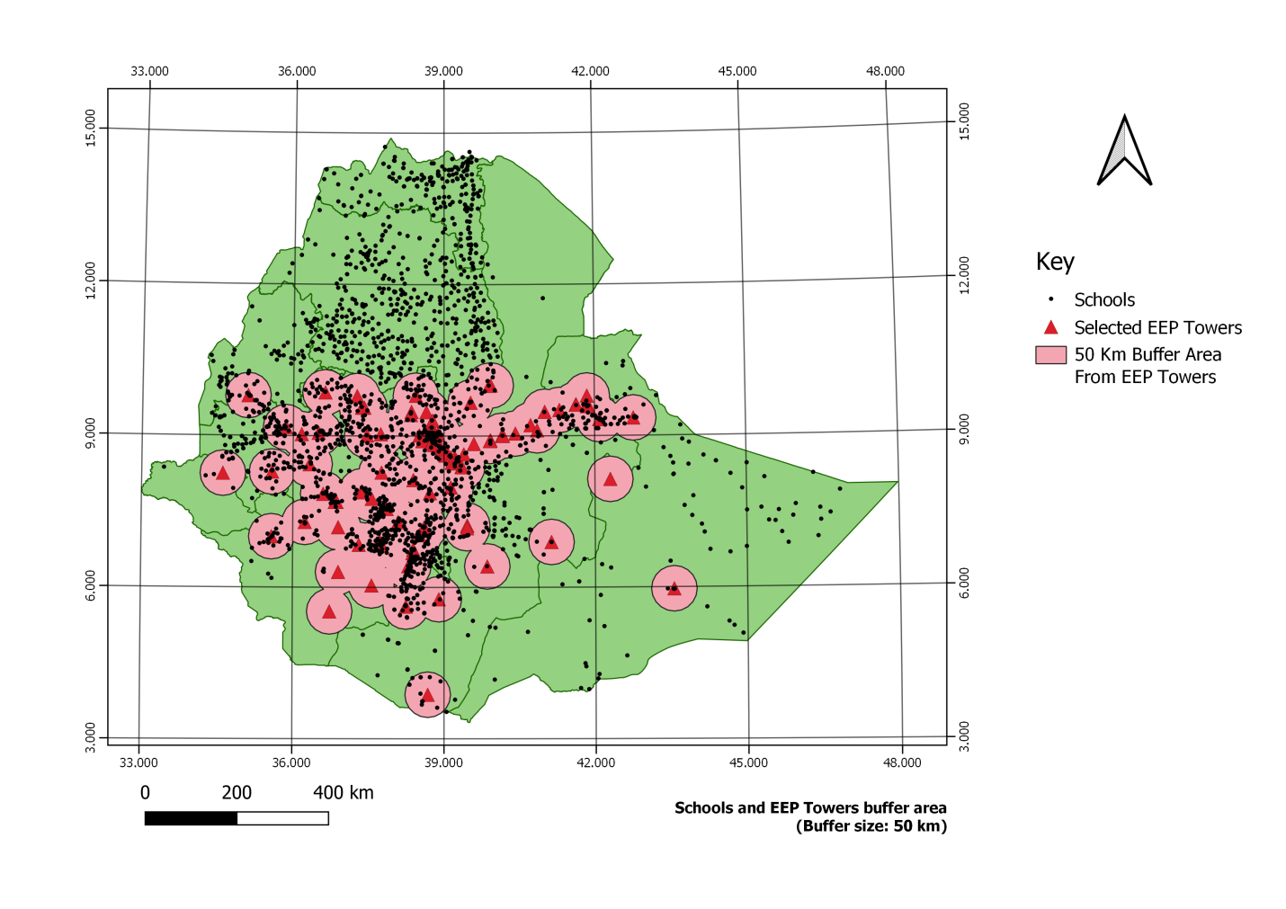

Map shows schools and selected EEP towers. Total area is ~1,131,098 square km. There are over 2,651 schools and selected 122 EEP towers.

With 50km buffer radius from selected 122 EEP towers, 313,782 square km is covered. 1,625 schools fall in these buffer zones.

# Viewshed Analysis

Since barriers between EEP towers and schools are expected due to topography, all schools in the buffer zone are not expected to receive signals. Therefore a viewshed analysis will be used to map those areas in view zone (signal area) and the shade (no signal area). A 30 meter SRTM digital elevation model is used for this analysis. The software package used for this analysis is QGIS specifically viewshed analysis tool.

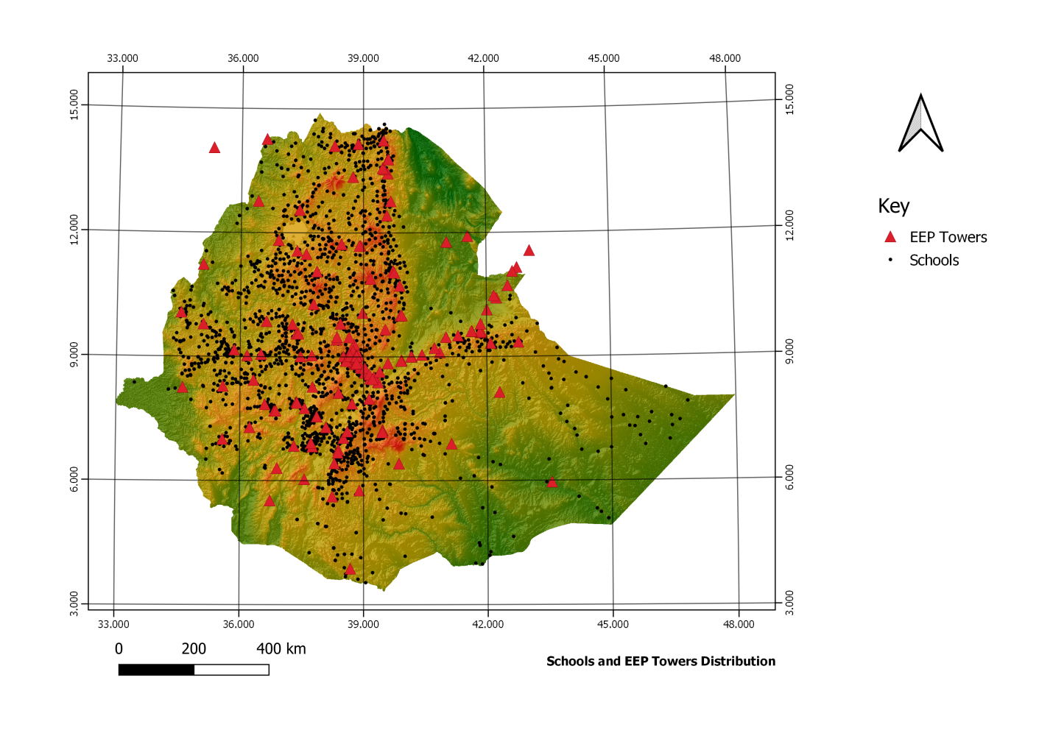

# Output Information

In the viewshed analysis, the towers are assumed to be 28 meters high. Each school is expected to have a 3 meters high receiver antenna. The transmission equipment can cover up to 50 kilometers, for that 50km buffer is used.

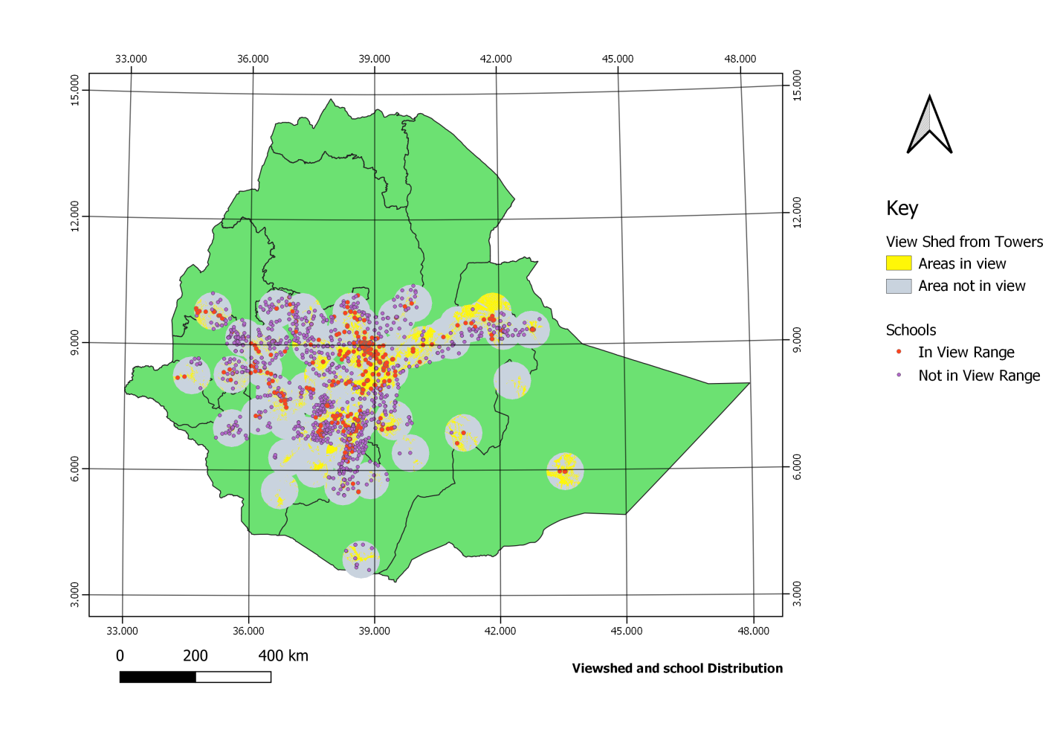

Central part of the country is mountainous. Topographic barriers are expected to be high. Out of 1,625 schools, 628 schools (39%) are in view range.

# Recommendation

This number can improve if schools can use elevated antenna. If 10meters of antenna is used instead of 3meters, the coverage will improve. The rest of the schools which are not covered require new transmission tower. Multiple scenario analysis is required for optimum number of transmission towers and antenna heights.

# Additional Activities

Pilot project is conducted in one zone in southern part of Ethiopia. In these analysis new tower sights are suggested. Suitable tower locations and number of potential schools which can be covered are indicated.

